3GPP TR 33.818 V0.2.0 (2019-03)
Technical Report
3rd Generation Partnership Project;
Technical Specification Group Services and System Aspects;
Security Assurance Methodology (SECAM) and Security Assurance Specification (SCAS) for 3GPP virtualized network products
(Release 16)



The present document has been developed within the 3rd Generation Partnership Project (3GPP TM) and may be further elaborated for the purposes of 3GPP..
The present document has not been subject to any approval process by the 3GPP Organizational Partners and shall not be implemented.
This Report is provided for future development work within 3GPP only. The Organizational Partners accept no liability for any use of this Report.
Specifications and Reports for implementation of the 3GPP TM system should be obtained via the 3GPP Organizational Partners' Publications Offices.

Keywords
5G, Security, Assurance, gNB, product, class

3GPP
Postal address

3GPP support office address
650 Route des Lucioles - Sophia Antipolis
Valbonne - FRANCE
Tel.: +33 4 92 94 42 00 Fax: +33 4 93 65 47 16
Internet
http://www.3gpp.org

Copyright Notification
No part may be reproduced except as authorized by written permission.
The copyright and the foregoing restriction extend to reproduction in all media.

© 2017, 3GPP Organizational Partners (ARIB, ATIS, CCSA, ETSI, TSDSI, TTA, TTC).
All rights reserved.

UMTS™ is a Trade Mark of ETSI registered for the benefit of its members
3GPP™ is a Trade Mark of ETSI registered for the benefit of its Members and of the 3GPP Organizational Partners
LTE™ is a Trade Mark of ETSI registered for the benefit of its Members and of the 3GPP Organizational Partners
GSM® and the GSM logo are registered and owned by the GSM Association
Contents
Foreword 5
1 Scope 6
2 References 6
3 Definitions and abbreviations 6
3.1 Definitions 6
3.2 Abbreviations 7
4 Overview 7
4.0 Introduction 7
4.0.1 Considerations on network product class when using NFV technology 7
4.0.2 Considerations on SECAM of the virtualized network products 8
4.1 Scope of a SECAM SCAS for 3GPP virtualized network products 8
4.1.1 Gap analysis 8
4.1.2 Scope of a SECAM SCAS 9
4.2 Scope of SECAM evaluation for 3GPP virtualized network products 9
4.2.1 Gap analysis 9
4.2.2 Scope of a SECAM evaluation 9
4.3 Scope of SECAM Accreditation for 3GPP virtualized network products 9
4.3.1 Gap analysis 9
4.3.2 Scope of a SECAM Accreditation 9
4.4 Ultimate Output of SECAM Evaluation for 3GPP virtualized network products 9
4.4.1 Gap analysis 9
4.4.2 Ultimate Output of SECAM Evaluation 9
4.5 3GPP virtualized network products evaluation process 10
4.5.1 Gap analysis 10
4.5.2 Virtualized network product evaluation process 10
4.6 Roles in SECAM for 3GPP virtualized network products 10
4.6.1 Gap analysis 10
4.6.2 SECAM Roles Overview 10
4.6.3 Examples of instantiation of roles in SECAM 10
4.7 Operator security acceptance decision for 3GPP virtualized network products 10
4.7.1 Gap analysis 10
4.7.2 Operator security acceptance decision 10
4.8 SECAM Assurance level for 3GPP virtualized network products 11
4.8.1 Gap analysis 11
4.8.2 SECAM Assurance level 11
4.9 Security baseline for 3GPP virtualized network products 11
4.9.1 Gap analysis 11
4.9.2 Security baseline 11
5 Security Assurance Specification (SCAS) Creation 11
5.1 Writing process overview 11
5.2 SCAS documents structure and content 11
5.2.1 General 11
5.2.2 ToE 11
5.2.3 Security Problem Definition (SPD) for 3GPP virtualized network products 12
5.2.4 Security Requirements 12
5.3 Improvement of SCAS and new security requirements 12
6 Vendor development and product lifecycle processes and test laboratory accreditation 12
6.1 Overview 12
6.2 Audit and accreditation of Vendor network product development and network product lifecycle management processes 12
6.3 Audit and accreditation of test laboratories 12
6.4 Monitoring 12
6.5 Dispute resolution 12
7 Evaluation and SCAS instantiation 13
7.1 Security Assurance Specification instantiation documents creation 13
7.2 Evaluation and evaluation report 13
7.2.1 Network product development process and network product lifecycle management 13
7.3 Self-declaration 13
7.4 Partial compliance and use of SECAM requirements in network product development cycle 13
7.5 Comparison between two SECAM evaluations 14
7.6 The evaluation of a new version 14
8 Conclusion 14
8.1 Impact to existing SECAM/SCAS documents 14
8.2 Way forward of SECAM/SCAS for 3GPP virtualized network products 14
Annex <A> (informative): Change history 15

Foreword
This Technical Report has been produced by the 3rd Generation Partnership Project (3GPP).
The contents of the present document are subject to continuing work within the TSG and may change following formal TSG approval. Should the TSG modify the contents of the present document, it will be re-released by the TSG with an identifying change of release date and an increase in version number as follows:
Version x.y.z
where:
x the first digit:
1 presented to TSG for information;
2 presented to TSG for approval;
3 or greater indicates TSG approved document under change control.
y the second digit is incremented for all changes of substance, i.e. technical enhancements, corrections, updates, etc.
z the third digit is incremented when editorial only changes have been incorporated in the document.

1 Scope
The present document studies the SECAM (Security Assurance Methodology) and SCAS (Security Assurance Specification) for 3GPP virtualized network products based on SECAM and SCAS defined in TR33.916[1]. It makes thorough gap analysis between current SECAM/SCAS work in TR 33.916[1] and SECAM/SCAS work for 3GPP virtualized network products. It also identifies, defines ToE and roles of SECAM/SCAS for 3GPP virtualized network products according to deployment scenarios and decoupling ways. Based on the identified ToE and roles, the present document details the needed change or additional work to current security assurance methodology for the creation, evaluation procedure of related SCAS documents, etc. It studies new threats of the identified ToE and identifies the additional security requirements of the ToE, or/and identifies existing relevant/supporting requirements specified in other SDOs. The present document also provides potential new SECAM/SCAS proposals and points out the impact to existing SECAM/SCAS documents (including TR 33.916[1], TR 33.926[2], TS 33.117[3], etc.).

2 References
Editor’s Note: This clause will outline that the present document contains references.
The following documents contain provisions which, through reference in this text, constitute provisions of the present document.
- References are either specific (identified by date of publication, edition number, version number, etc.) or non-specific.
- For a specific reference, subsequent revisions do not apply.
- For a non-specific reference, the latest version applies. In the case of a reference to a 3GPP document (including a GSM document), a non-specific reference implicitly refers to the latest version of that document in the same Release as the present document.
[1] 3GPP TR 33.916: "Security Assurance Methodology (SCAS) for 3GPP network products"
[2] 3GPP TR 33.926: "Security Assurance Specification (SCAS) threats and critical assets in 3GPP network product classes"
[3] 3GPP TR 33.117: “Catalogue of general security assurance requirements”
[4] 3GPP TS 28.500: "Management concept, architecture and requirements for mobile networks that include virtualized network functions"
[5] ETSI GS NFV-SEC 001: "Network Functions Virtualisation (NFV); NFV Security; Problem Statement"

3 Definitions and abbreviations

3.1 Definitions
For the purposes of the present document, the terms and definitions given in 3GPP TR 21.905 [1] and the following apply. A term defined in the present document takes precedence over the definition of the same term, if any, in 3GPP TR 21.905 [1].

Virtualized network product class: A virtualized network product class, in the context of SECAM, is the class of products that implement 3GPP defined network functionalities running on Network Function Virtualization Infrastructure (NFVI). Depending on different deployment scenarios of network operators, there are three types of the class:
- Type 1: implement 3GPP defined functionalities only
- Type 2: implement 3GPP defined functionalities and virtualization layer
- Type 3: implement 3GPP defined functionalities, virtualization layer, and hardware layer
Virtualized network product: A virtualized network product is the instantiation of one or more virtualized network product class(es).

3.2 Abbreviations
For the purposes of the present document, the abbreviations given in 3GPP TR 21.905 [1] and the following apply. An abbreviation defined in the present document takes precedence over the definition of the same abbreviation, if any, in 3GPP TR 21.905 [1].

VNF Virtualized Network Function

4 Overview

4.0 Introduction

4.0.1 Considerations on network product class when using NFV technology
The definitions of network product class and network product were documented in the TR 33.916 [1]. For implementing 3GPP defined functionalities in network products, some functionalities that relate to the supporting platform (e.g. hardware components, operating system, etc.) also need to be implemented. The platform provides execution environment for 3GPP defined functionalities. For physical network products, the platform and the 3GPP defined functionalities are tightly coupled, while for virtualized network products, the platform and the 3GPP defined functionalities are decoupled. The platform of virtualized network products composes of a hardware layer and a virtualization layer, and is common for 3GPP defined deinfed functionalities. Concept of 3GPP VNF is defined in TS 28.500 [x]. According to the concept in [x], a 3GPP VNF is 3GPP network function(s) that runs on a Network Function Virtualization Infrastructure (NFVI), which is the platform of virtualized network products described above.
The realistic deployment scenarios are summarized in ETSI NFV-SEC 001 [y], based on which a 3GPP network operator can deploy 3GPP defined functionalities in three modes:
- Mode 1. A network operator purchases 3GPP VNFs from its vendors and deploys it on a third partyNFVI.
- Mode 2. A network operator purchases 3GPP VNFs and the virtualization layer (e.g. hypervisor) from its vendors, and deploys them on a third party hardware layer.
- Mode 3. A network operator purchases and deploys 3GPP VNFs, the virtualization layer and the hardware layer from its vendors.
Each deployment mode requires the different composition of virtualized network products purchased and deployed by a network operator, which are subject to the testing and evaluation in SECAM scheme. Accordingly, the different compistion of virtualized network products maps to three types of virtualized network product class as depicted in Figure 1:
- Type 1: implement 3GPP defined functionalities only
- Type 2: implement 3GPP defined functionalities and virtualization layer
- Type 3: implement 3GPP defined functionalities, virtualization layer, and hardware layer

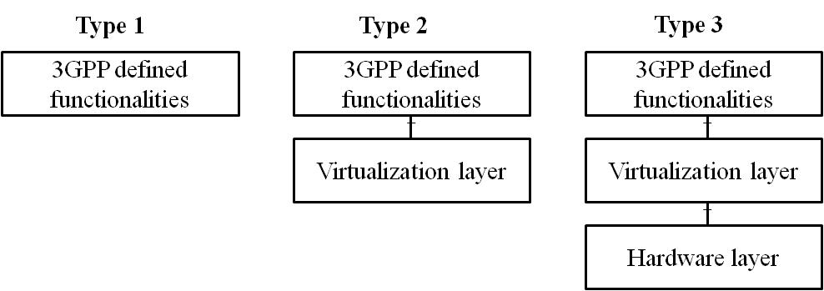
Figure 4.0.1-1: Three types of virtualized network product class
For type 2 and type 3, the 3GPP defined functionalities, the virtualization layer, and the hardware layer can be decoupled from each other and can be provided by different vendors. It implies that the targets of security assurance evaluation could be the decoupled components of a virtualized network product and the security assurance requirements on the interface(s) between components of type 2 and type 3 need to be considered in decoupling scenarios.
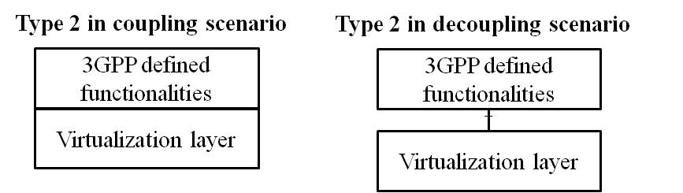
Figure 4.0.1-2: Type2 in coupling and decoupling scenarios
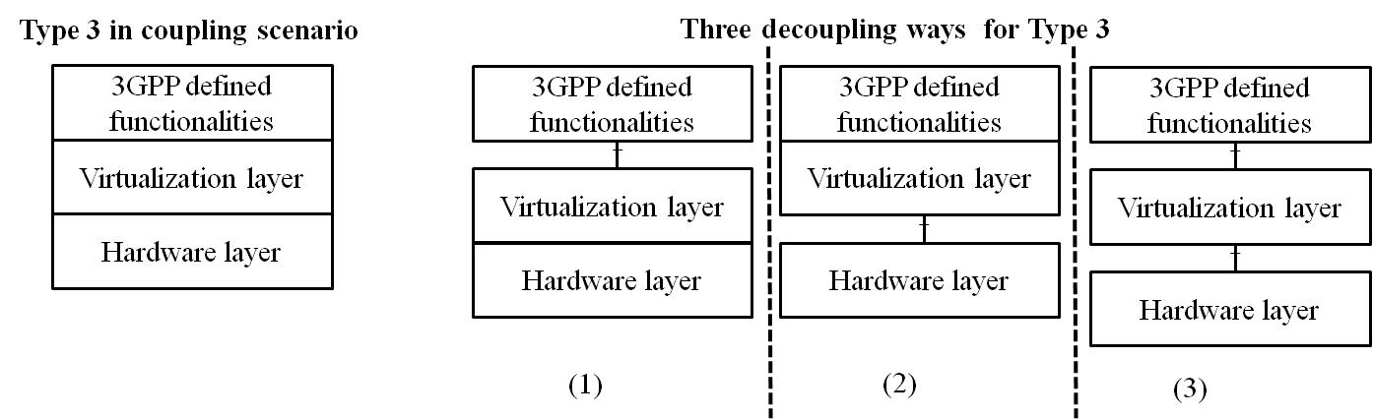
Figure 4.0.1-3: Type3 in coupling and decoupling scenarios
For type 2 in the decoupling scenarion as depicted in Figure 2, a network operator can purchase the 3GPP defined functionalities and the virtualization layer from the same or different vendors. So, it is required to assure the security of the decoupled 3GPP defined functionalities and the virtualization layer separately.
For type 3 in the decoupling scenarion as depicted in Figure 3, there are three decoupling ways. Like type 2 in the decoupling scenarion, the security assurance requirements of the decoupled components need to be considered respectively.
To cover all possible decoupling scenarios, this document suggests that the targets of security assurance evaluation (ToEs) in this study be 3GPP defined functionalities, virtualization layer and hardware layer respectively. The security assurance requirements on the interfaces between componentsof type 2 and type 3 are applied in decoupling scenarios.

4.0.2 Considerations on SECAM of the virtualized network products
The security assurance methodology study in TR 33.916 [1] is a general methodology and already considers virtualized network products in the design of the methodology. The biggest difference between virtualized network products and physical network products is that the former may be run on a common platform, while the latter has a private and exclusive platform. With the current SECAM as the basis, the present document aims to identify and address the gaps when applying the current SECAM to 3GPP virtualized network products as defined in clause 4.0.1.

4.1 Scope of a SECAM SCAS for 3GPP virtualized network products

4.1.1 Gap analysis
Editor’s Note: This clause will identify the gap between scope of SECAM SCAS for physical network products and 3GPP virtualized network products such as gap in ToE etc.

4.1.2 Scope of a SECAM SCAS
Editor’s Note: This clause will summarize scope of SECAM SCAS for 3GPP virtualized network products.

4.2 Scope of SECAM evaluation for 3GPP virtualized network products

4.2.1 Gap analysis
Editor’s Note: This clause will identify the gap between scope of SECAM evaluation for physical network products and 3GPP virtualized network products.

4.2.2 Scope of a SECAM evaluation
Editor’s Note: This clause will summarize scope of SECAM evaluation for 3GPP virtualized network products.

4.3 Scope of SECAM Accreditation for 3GPP virtualized network products

4.3.1 Gap analysis
Editor’s Note: This clause will identify the gap between scope of SECAM accreditation for physical network products and 3GPP virtualized network products.

4.3.2 Scope of a SECAM Accreditation
Editor’s Note: This clause will summarize scope of SECAM accreditation for 3GPP virtualized network products.

4.4 Ultimate Output of SECAM Evaluation for 3GPP virtualized network products

4.4.1 Gap analysis
Editor’s Note: This clause will identify the gap between ultimate output of SECAM evaluation for physical network products and 3GPP virtualized network products.

4.4.2 Ultimate Output of SECAM Evaluation
Editor’s Note: This clause will summarize ultimate output of SECAM evaluation for 3GPP virtualized network products.

4.5 3GPP virtualized network products evaluation process

4.5.1 Gap analysis
Editor’s Note: This clause will identify the gap between evaluation process of physical network products and 3GPP virtualized network products.

4.5.2 Virtualized network product evaluation process
Editor’s Note: This clause will summarize virtualized network product evaluation process.

4.6 Roles in SECAM for 3GPP virtualized network products

4.6.1 Gap analysis
Editor’s Note: This clause will identify the gap between role in SECAM for physical network products and 3GPP virtualized network products.

4.6.2 SECAM Roles Overview
Editor’s Note: This clause will summarize role in SECAM for 3GPP virtualized network products.

4.6.3 Examples of instantiation of roles in SECAM
Editor’s Note: This clause will summarize examples of instantiation of roles in SECAM for 3GPP virtualized network products.

4.7 Operator security acceptance decision for 3GPP virtualized network products

4.7.1 Gap analysis
Editor’s Note: This clause will identify the gap between operator security acceptance decision for physical network products and 3GPP virtualized network products.

4.7.2 Operator security acceptance decision
Editor’s Note: This clause will summarize operator security acceptance decision for physical network products and 3GPP virtualized network products.

4.8 SECAM Assurance level for 3GPP virtualized network products

4.8.1 Gap analysis
Editor’s Note: This clause will identify the gap between SECAM assurance level for physical network products and 3GPP virtualized network products.

4.8.2 SECAM Assurance level
Editor’s Note: This clause will summarize SECAM assurance level for 3GPP virtualized network products.

4.9 Security baseline for 3GPP virtualized network products

4.9.1 Gap analysis
Editor’s Note: This clause will identify the gap between security baseline for physical network products and 3GPP virtualized network products.

4.9.2 Security baseline
Editor’s Note: This clause will summarize security baseline for 3GPP virtualized network products.

5 Security Assurance Specification (SCAS) Creation

5.1 Writing process overview
Editor's Note: This clause will describe writing process overview of SCAS for 3GPP virtualized network products based on the clause 5.1 in the TR33.916 and gap analysis in the clause 4.

5.2 SCAS documents structure and content
Editor's Note: This clause will describe SCAS documents structure and content for 3GPP virtualized network products based on the clause 5.2 in the TR33.916 and gap analysis in the clause 4. This clause will also focus on resolving the identified gap if any gap is identified, e.g. if ToE is virtualization layer, this clause will analyze the security threats and security requirements of virtualization layer.

5.2.1 General
Editor’s Note: This clause will summarize the parts contained in SCAS documents of 3GPP virtualized network products.

5.2.2 ToE
Editor’s Note: This clause will describe ToE of SCAS for 3GPP virtualized network products.

5.2.3 Security Problem Definition (SPD) for 3GPP virtualized network products
Editor’s Note: This clause will describe Security Problem Definition (SPD). It also contains security threat analysis
Of ToE if there are new or additional security threats.

5.2.4 Security Requirements
Editor’s Note: This clause will describe security requirements. It also contains security requirements
Of ToE if there are new or additional security threats.

5.3 Improvement of SCAS and new security requirements
Editor's Note: This clause will describe improvement of SCAS and new security requirements for 3GPP virtualized network products based on the clause 5.3 in the TR33.916 and gap analysis in the clause 4. This clause will also focus on resolving the identified gap if any gap is identified.

6 Vendor development and product lifecycle processes and test laboratory accreditation

6.1 Overview
Editor's Note: This clause will summarize vendor development and product lifecycle processes and test laboratory accreditation for 3GPP virtualized network products based on the clause 6.1 in the TR33.916.

6.2 Audit and accreditation of Vendor network product development and network product lifecycle management processes
Editor's Note: This clause will describe audit and accreditation of vendor network product development and network product lifecycle management processes for 3GPP virtualized network products based on the clause 6.2 in the TR33.916 and gap analysis in the clause 4. This clause will also focus on resolving the identified gap if any gap is identified.

6.3 Audit and accreditation of test laboratories
Editor's Note: This clause will describe audit and accreditation of test laboratories for 3GPP virtualized network products based on the clause 6.3 in the TR33.916 and gap analysis in the clause 4. This clause will also focus on resolving the identified gap if any gap is identified.

6.4 Monitoring
Editor's Note: This clause will describe monitoring for 3GPP virtualized network products based on the clause 6.4 in the TR33.916 and gap analysis in the clause 4. This clause will also focus on resolving the identified gap if any gap is identified.

6.5 Dispute resolution
Editor's Note: This clause will describe dispute resolution for 3GPP virtualized network products based on the clause 6.5 in the TR33.916 and gap analysis in the clause 4. This clause will also focus on resolving the identified gap if any gap is identified.

7 Evaluation and SCAS instantiation

7.1 Security Assurance Specification instantiation documents creation
Editor's Note: This clause will describe security assurance specification instantiation documents creation for 3GPP virtualized network products based on the clause 7.1 in the TR33.916 and gap analysis in the clause 4. This clause will also focus on resolving the identified gap if any gap is identified.

7.2 Evaluation and evaluation report

7.2.1 Network product development process and network product lifecycle management
Editor's Note: This clause will describe Network product development process and network product lifecycle management based on the clause 7.2 in the TR33.916 and gap analysis in the clause 4. This clause will also focus on resolving the identified gap if any gap is identified.

7.2.2 SCAS instantiation evaluation
Editor's Note: This clause will describe SCAS instantiation evaluation based on the clause 7.2 in the TR33.916 and gap analysis in the clause 4. This clause will also focus on resolving the identified gap if any gap is identified.

7.2.3 Security Compliance testing
Editor's Note: This clause will describe Security Compliance testing based on the clause 7.2 in the TR33.916 and gap analysis in the clause 4. This clause will also focus on resolving the identified gap if any gap is identified.

7.2.4 Basic Vulnerability Testing
Editor's Note: This clause will describe Basic Vulnerability Testing based on the clause 7.2 in the TR33.916 and gap analysis in the clause 4. This clause will also focus on resolving the identified gap if any gap is identified.

7.3 Self-declaration
Editor's Note: This clause will describe self-declaration for 3GPP virtualized network products based on the clause 7.3 in the TR33.916 and gap analysis in the clause 4. This clause will also focus on resolving the identified gap if any gap is identified.

7.4 Partial compliance and use of SECAM requirements in network product development cycle
Editor's Note: This clause will describe partial compliance and use of SECAM requirements in network product development cycle for 3GPP virtualized network products based on the clause 7.4 in the TR33.916 and gap analysis in the clause 4. This clause will also focus on resolving the identified gap if any gap is identified.

7.5 Comparison between two SECAM evaluations
Editor's Note: This clause will describe comparison between two SECAM evaluations for 3GPP virtualized network products based on the clause 7.5 in the TR33.916 and gap analysis in the clause 4. This clause will also focus on resolving the identified gap if any gap is identified.

7.6 The evaluation of a new version
Editor's Note: This clause will describe the evaluation of a new version for 3GPP virtualized network products based on the clause 7.6 in the TR33.916 and gap analysis in the clause 4. This clause will also focus on resolving the identified gap if any gap is identified.

8 Conclusion

8.1 Impact to existing SECAM/SCAS documents

Editor's Note: This clause will describe the impact to existing SECAM/SCAS documents (including TR 33.916, TR 33.926, TS 33.117, etc.).

8.2 Way forward of SECAM/SCAS for 3GPP virtualized network products
Editor's Note: This clause will describe the way forward of SECAM/SCAS for 3GPP virtualized network products.

Annex <A> (informative):
Change history
Change history
Date | Meeting | TDoc | CR | Rev | Cat | Subject/Comment | New version
2018.11 | 93 | S3-183825 |  |  |  | TR skeleton and scope as S3-183506 and S3-183824 | 0.1.0
2019.03 | SA3#94adhoc | S3-190950 |  |  |  | Introduction as S3-190951 and S3-190952 | 0.2.0

