**3GPP TSG-SA5 Meeting #159 *S5-250947***

Sophia-Antipolis, France, 17 - 21 February 2025

**Source: Nokia**

**Title: TS28.56 General CCL Model**

**Document for: Approval**

**Agenda Item: 6.19.4.1**

# 1 Decision/action requested

**Group is requested to discuss and agree on the “Detailed Proposal”.**

# 2 References

[1] None

# 3 Rationale

# 4 Detailed proposal

***Start of First change***

# 6 Model

## 6.1 Imported and associated information entities

TBD

### 6.1.1 Imported information entities and local labels

TBD

### 6.1.2 Associated information entities and local labels

TBD

## 6.2 6. Class diagram

#### 6.2.1 Relationships

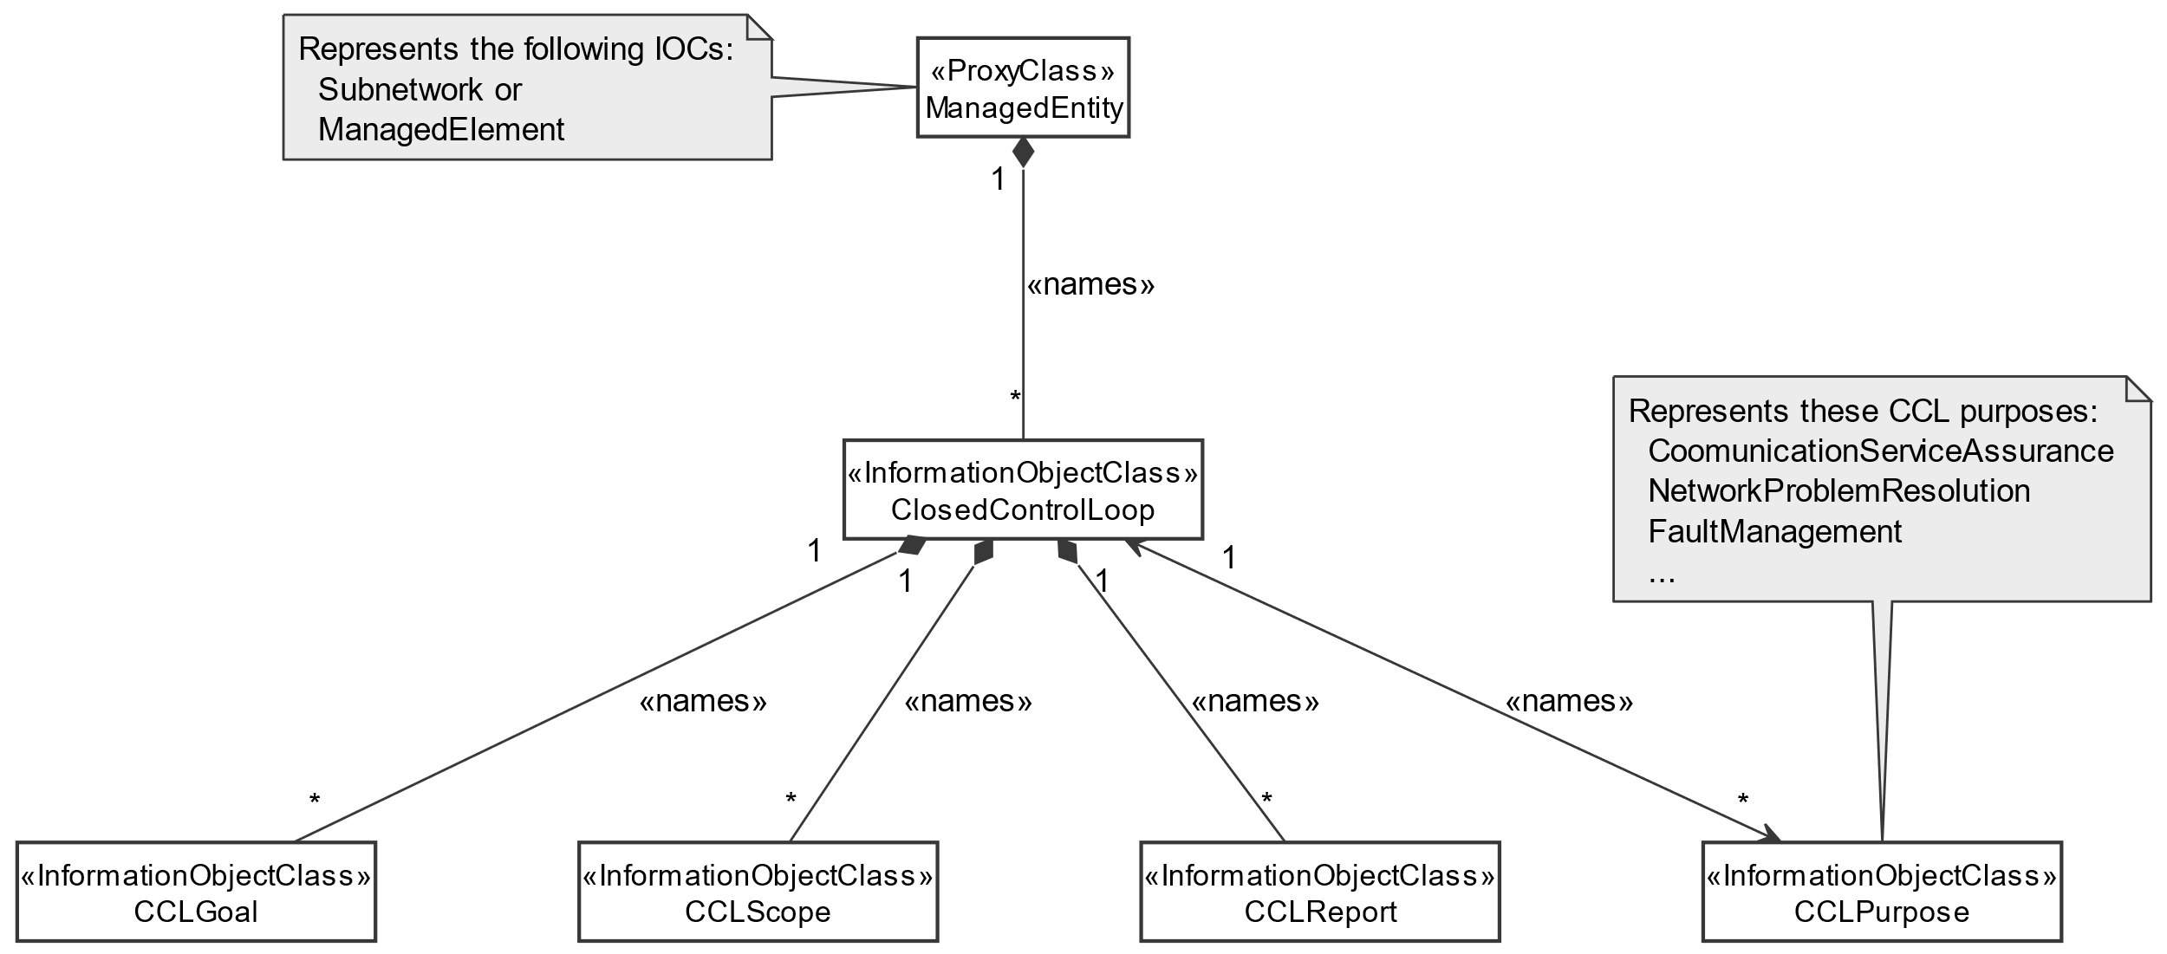

Figure 6.2.1.1-1: Relations for common information models for AI/ML management

#### 6.2.2 Inheritance

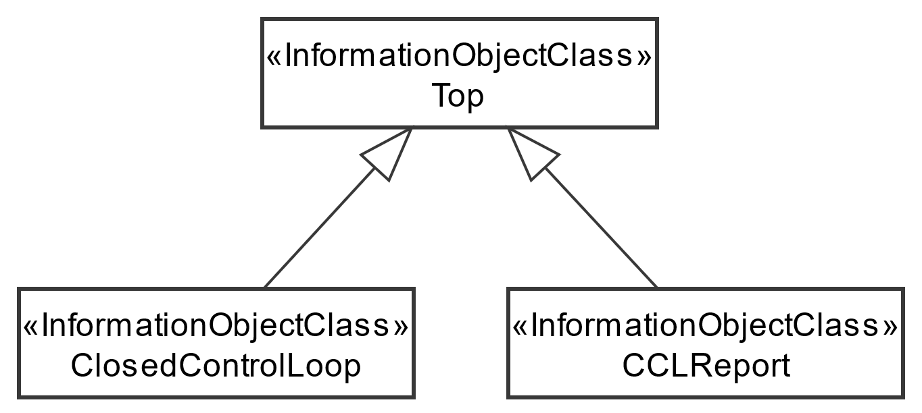

Figure 6.2.1.2-1: Inheritance Hierarchy for Closed Control Loops

### 6.3 Class definitions

#### 6.6.3.1 ClosedControlLoop

##### 6.6.3.1.1 Definition

This IOC represents the closed control loop. It represents the information for controlling and monitoring an closed control loop associated with a stated scope.

The ClosedControlLoop is name-contained by SubNetwork or ManagedElement and is associated with a CCLreport that contans reportedinformation about the CCL. Accordingly, the report about a CCL can existi even when the CCL is deleted.

The capabilities of the CCL are contained in one or more CCLPurposes that describe what the CCL is capable of doing or can be configured to do - including information the network resources for which the CCL can execute decisions and actions. So, the ClosedControlLoop is associated with one or more CCLPurpose(s) that indicate(s) a list of characteristics that describe what a CCL can/is expected to be able do. The purpose describes the type of functionality that can be executed including service assurance, problem recovery and fault management .

The operational information about the CCL is contained in the CCLScope(s) and CCLGoal(s), so the ClosedControlLoop is associated with one or more CCLScope(s) and one or more CCLGoal(s). The CCLScope defines what the CCL has been configured to read, evaluate, control, etc; while the CCLGoal defines what the CCL is required to achieve for the defined scope.

For temporary deactivation of the assurance closed control loop, the MnS consumer can modify the value of the administrative state attribute to “LOCKED”. The MnS producer may disable the assurance closed control loop, for example in conflict situations, by setting the operational state attribute to “disabled”. When a closed control loop is enabled by the MnS producer, the operational state is set again to “enabled”. For the activation of an assurance closed control loop, the MnS consumer can modify the value of the administrative state attribute to “UNLOCKED”.

##### 6.6.3.1.2 Attributes

Table 6.6.3.1.2-1

|  |  |  |  |  |  |
| --- | --- | --- | --- | --- | --- |
| Attribute name | Support Qualifier | isReadable | isWritable | isInvariant | isNotifyable |
| operationalState | M | T | F | F | T |
| administrativeState | M | T | T | F | T |
| controlLoopLifeCyclePhase | M | T | T | F | T |
|  |  |  |  |  |  |
| **Attribute related to role** |  |  |  |  |  |
| CCLPurposeRef | M | T | T | T | T |

##### 6.6.3.1.3 Attribute constraints

##### None

##### 6.6.3.1.4 Notifications

None

##### 6.6.3.2 CCLGoal <<IOC>>

6.6.3.2.1 Definition

This IOC represents goal of a closed control loop.

To express a new goal a closed control loop, the MnS consumer needs to request the MnS producer to create an instance of CCLGoal. MnS producer can also trigger the creation of an instance of CCLGoal.

The attribute “CCLTargets” defines a list of targets that should be achieved by the ClosedControlLoop.

6.6.3.2.2 Attributes

The CCLGoal IOC includes attributes inherited from Top IOC (defined TS 28.622[5]) and the following attributes:

|  |  |  |  |  |  |
| --- | --- | --- | --- | --- | --- |
| Attribute name | S | isReadable | isWritable | isInvariant | isNotifyable |
| CCLTargets | M | T | F | F | T |
|  |  |  |  |  |  |

6.6.3.2.3 Attribute constraints

None.

6.6.3.2.4 Notifications

None

##### 6.6.3.3 CCLScope <<IOC>>

6.6.3.3.1 Definition

It indicates the target for assurance goal in terms of location. A particular ACCL can target for a particular location. The assurance goal status is ascertained based on the appropriately collected performance measurements as per the target location.

The CCLScope includes the attribute scopeType that indicates the type of scope that represented by the particular scope instance.

6.6.3.3.2 Attributes

|  |  |  |  |  |  |
| --- | --- | --- | --- | --- | --- |
| Attribute name | S | isReadable | isWritable | isInvariant | isNotifyable |
| scopeType | O | T | F | F | T |
|  |  |  |  |  |  |

6.6.3.3.3 Attribute constraints

None

6.6.3.3.4 Notifications

None.

##### 6.6.3.4 CCLReport <<IOC>>

6.6.3.4.1 Definition

This class represents the reported outcomes on a CCL instance, e.g., the information about the outcomes on one or multiple CCLGoals and one or multiple CCLTargets. An CCLReport is contained by the entity containing the CCL, since the CCLreport can exist beyond the life of the CCL on which it is reporting.

There is one CCLReport per assurance closed control loop for an observation time. The content of the CCLReport may be different for different observation time.

6.6.3.4.2 Attributes

|  |  |  |  |  |  |
| --- | --- | --- | --- | --- | --- |
| Attribute name | Support Qualifier | isReadable | isWritable | isInvariant | isNotifyable |
|  |  |  |  |  |  |
| **Attributes related to role** |  |  |  |  |  |
| CCLRef | O | T | F | F | T |

6.6.3.4.3 Attribute constraints

No constraints have been defined for this document

6.6.3.4.4 Notifications

None

##### 6.6.3.5 CCLPurpose <<dataType>>

6.6.3.5.1 Definition

This data type represents a single purpose that describes what a CCL can do. The purpose is alist of characteristics that describe the capabilities of the CCL.

6.6.3.5.2 Attributes

|  |  |  |  |  |  |
| --- | --- | --- | --- | --- | --- |
| Attribute name | S | isReadable | isWritable | isInvariant | isNotifyable |
|  |  |  |  |  |  |
|  |  |  |  |  |  |

6.6.3.5.3 Attribute constraints

None..

6.6.3.5.4 Notifications

None

##### 6.6.6.3.6.1 CCLTarget <<dataType>>

6.6.3.6.1.1 Definition

This data type represents a single name-value-pair that needs to be achieved by a CCL. A CCLGoal can contain one or more CCLTargets.

6.6.3.6.1.2 Attributes

|  |  |  |  |  |  |
| --- | --- | --- | --- | --- | --- |
| Attribute name | S | isReadable | isWritable | isInvariant | isNotifyable |
|  |  |  |  |  |  |
|  |  |  |  |  |  |
|  |  |  |  |  |  |
|  |  |  |  |  |  |

6.6.3.6.1.3 Attribute constraints

None..

6.6.3.6.1.4 Notifications

None

### 4.1.2.4 Attribute definitions

Table 4.1.2.4.1.1

| Attribute Name | Documentation and Allowed Values | Properties |
| --- | --- | --- |
| scopeType | It indicates the type of scope that represented by the particular scope instance.  Allowed values: CCLMEASUREMENTSCOPE, CCLTARGETSCOPE, CCLCONTROLSCOPE, CCLIMPACTSCOPE | type: Enum  multiplicity: 1 .. *  isOrdered: N/A  isUnique: N/A  defaultValue: None  isNullable: False |
| CCLCategory | It indicates the type of functionality that the CCL accomplishes. The CCL Category is an enumeration, including to supporting functionality for either service assurance, fault management or analytics problem recovery.  Allowed values: SLICEASSURANCE, ENERGYOPTIMIZATION, ANALYTICSPROBLEMRECOVERY | type: Enum  multiplicity: 1 .. *  isOrdered: N/A  isUnique: N/A  defaultValue: None  isNullable: False |
| observationTime | It indicates the observation period of assuranceGoalStatusObserved and assuranceGoalStatusPredicted.  The assurance goal will be observed from the start of each observation period, then at the end of each observation period, the value for assuranceGoalStatusObserved and assuranceGoalStatusPredicted will be derived and configured.  The observation time is expressed in seconds. | type: Integer  multiplicity: 1  isOrdered: N/A  isUnique: N/A  defaultValue: None  isNullable: False |
| operationalState | It indicates the operational state of the AssuranceClosedControlLoop instance. It describes whether the resource is installed and partially or fully operable (ENABLED) or the resource is not installed or not operable (DISABLED).  allowedValues: "ENABLED", "DISABLED".  The meaning of these values is as defined in 3GPP TS 28.625 [14] and ITU-T X.731 [15]. | type: ENUM  multiplicity: 1  isOrdered: N/A  isUnique: N/A  defaultValue: DISABLED  isNullable: False |
| administrativeState | It indicates the administrative state of the AssuranceClosedControlLoop instance. It describes the permission to use or the prohibition against using the AssuranceClosedControlLoop instance. The administrative state is set by the MnS consumer.  allowedValues: "LOCKED", "UNLOCKED".  The meaning of these values is as defined in 3GPP TS 28.625 [14] and ITU-T X.731 [15]. | type: ENUM  multiplicity: 1  isOrdered: N/A  isUnique: N/A  defaultValue: LOCKED  isNullable: False |

***next change***

Annex A (informative):  
Appendix with UML code for model diagrams

# A.X UML code for CCL management model diagrams

This annex contains the PlantUML source code for the NRM diagrams defined in clause 6.2 of the present document.

# A.X.1 Closed Control Loop NRM fragment (Figure 6.2.1.1-1)

@startuml

skinparam ClassStereotypeFontStyle normal

skinparam ClassBackgroundColor White

skinparam shadowing false

skinparam monochrome true

hide members

hide circle

class ManagedEntity <<ProxyClass>>

class ClosedControlLoop <<InformationObjectClass>>

class CCLPurpose <<InformationObjectClass>>

class CCLGoal << InformationObjectClass >>

class CCLScope << InformationObjectClass >>

class CCLReport <<InformationObjectClass>>

class AssuranceClosedControlLoop <<InformationObjectClass>>

ManagedEntity "1" *-- "*" ClosedControlLoop: <<names>>

ClosedControlLoop "1" <--> "*" CCLPurpose: <<names>>

ClosedControlLoop "1" *-- "*" CCLGoal: <<names>>

ClosedControlLoop "1" *-- "*" CCLScope: <<names>>

ClosedControlLoop "1" *-- "*" CCLReport: <<names>>

note left of ManagedEntity

Represents the following IOCs:

Subnetwork or

ManagedElement

end note

note top of CCLPurpose

Represents these CCL purposes:

NetworkProblemRecovery

FaultManagement

...

end note

@enduml

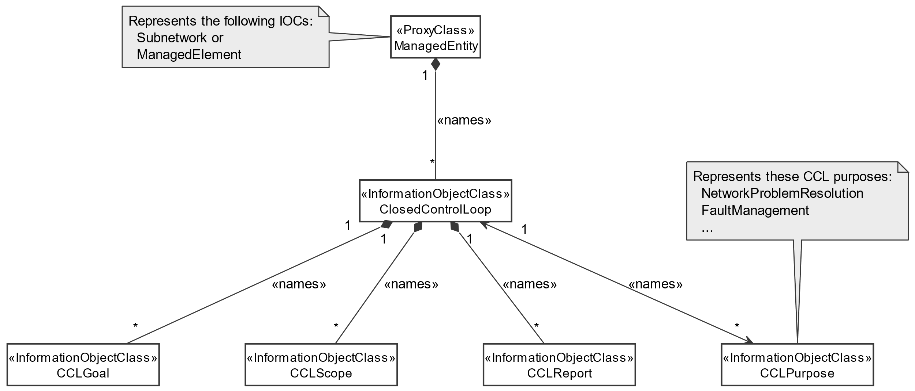

# A.X.2 Closed Control Loop inheritance relationships (Figure 6.2.1.1-2)

@startuml

skinparam ClassStereotypeFontStyle normal

skinparam ClassBackgroundColor White

skinparam shadowing false

skinparam monochrome true

hide members

hide circle

class Top << InformationObjectClass >>

class ClosedControlLoop <<InformationObjectClass>>

class CCLGoal <<InformationObjectClass>>

class CCLReport <<InformationObjectClass>>

class AssuranceClosedControlLoop <<InformationObjectClass>>

class AssuranceGoal <<InformationObjectClass>>

class AssuranceReport <<InformationObjectClass>>

Top <|-- ClosedControlLoop

Top <|-- CCLGoal

Top <|-- CCLReport

ClosedControlLoop <|-- AssuranceClosedControlLoop

CCLGoal <|-- AssuranceGoal

CCLReport <|-- AssuranceReport

@enduml

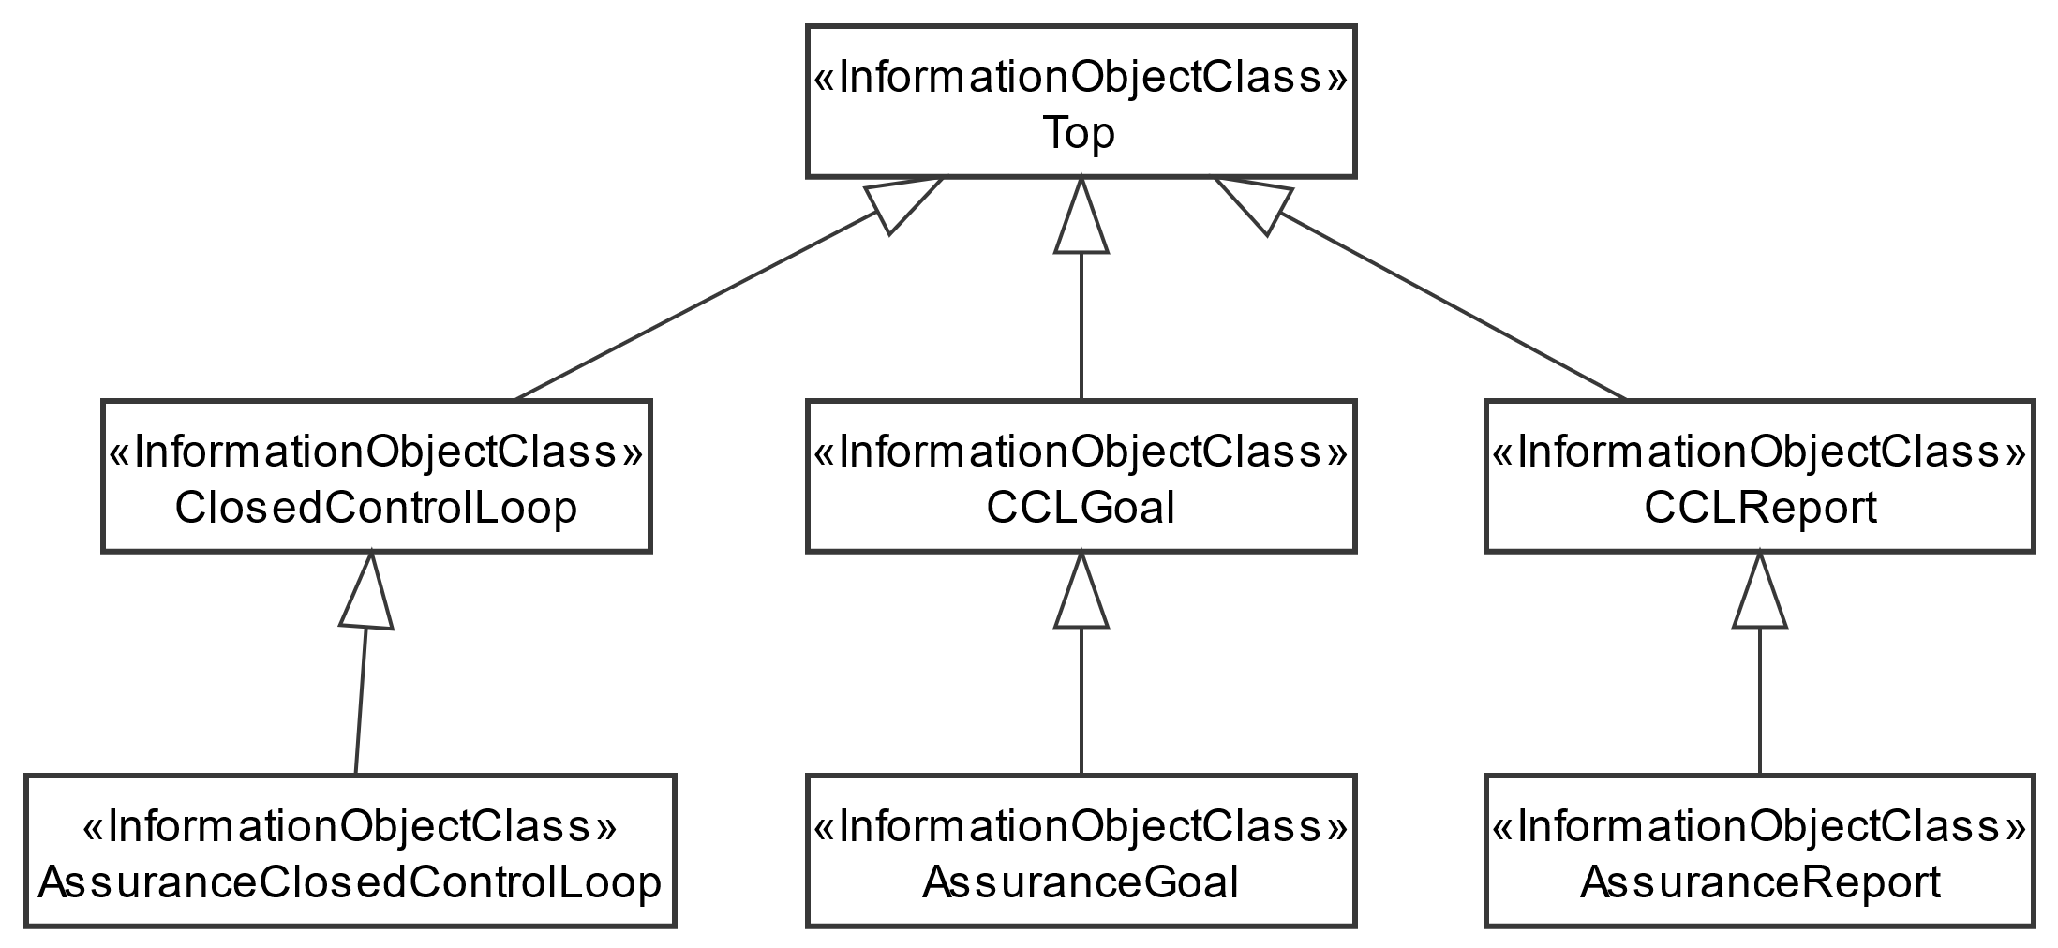

|  |
| --- |
| **End Change** |