3GPP TSG SA WG5 Meeting 137-e rapporteur call TDoc S5-abcd
electronic meeting,

Source: Moderator (SA5 Vice Chair)

Title: S5-abcd post-SA5#137e OAM rapporteur call agenda and notes

Document for: information
Agenda Item:

1. Rapporteur calls plan before SA5#138e
Confirmed topics:
- eMDAS: skeleton and other issues (Yi Zhi, Brendan)
- MANS: (Xuruiyue, Zhuweihong)
- FS_NSCE, FS_MNSAC: clarify the relation between FS_NSCE, FS_MNSAC (Xiaobo, Ping Jing)
- IDMS_MN: Intent concepts (Xuruiyue, Vlad)
- FS_NSMEN: remaining issues which block the conclusion of FS_NSMEN study (Brendan)
- Specification readability improvement (Olaf)
- MADCOL (Olaf)
- FS_YANG (Balazs, Olaf)
- Split of 28.541 (Balazs)

2. Schedule for rapporteur calls:
Rapporteur calls | Date Time | Potential Topics
#137e.1 | Jun.3rd 2021 15:00 CEST~17:00 CEST | - eMDAS (Yi Zhi, Brendan)  - 3039rev2 Add structure for TS 28.104  - S5-213039rev1 pCR Add structure for TS 28.104_Huawei_comments  Jun.3rd Conf call:  - Whether we define dedicate MnS for each MDA use case?  3039:  I/N: use common service.  HW: agree to have common mechanisms for providing reporting/feedback. Like to see the MnS according to the different use cases. (e.g. coverage anlsysis). Like to go for Consumer friendly view.  I: chapter 7 shows capability, chapter 8 show the services which for consumer view.  We allow consumer to use capabilty, also allow consumer to use one or more capability in one service request.  S: there will be overlap between section 7 and 8, how input/ouput defined in section 7 related to section 8?  3039_HW comments:  I: chapter 7 coverage related analysis is not use case, it’s capability. Does not allow send multiple MDA in one request.  NEC: there will be lots or repition of text all over the spec.  HW: dont think there are many duplication, we will use reference to earlier chapter.  - How to define management capability? Whehter define analytics inputs?  I/N: inputs need to be used/defined for generatiing output.  S: sympathy to Huawei proposal for not defining inputs. But also tend to agree with Intel that if there is no input, only output, how do we know the implementability of this mechanism? How to prove it’s workable?  HW: the justification will be brought in the DP when the concrete contributions are provided. But input is not needed to be in the specification.  I: some inputs may need to be enhanced according to the discussion. Agree we should have vendor differentaitaiton.  HW: MDA is different with KPI.  E: no need to define inputs. KPI has fixed formulas and it’s different with MDA.  NEC: list of input is not restrictive. It could be vendor specific, could be differenatiate the diff solutions from vendors. If we dont talk about input, how to make sure the inputs are availble?  I: KPI also does not restrict the related measurements as inputs. This is similar with MDA.  E: inputs is implemetation vendor specific.  S: are we going to restrict the inputs to standardized inputs only ?  HW: if we standardize input and output, we just starndardize algorithm, if we go this way, we no need to talk about AI/ML in MDA.  S: will specify open ended list of input would be useful?  HW: list put in the informative maybe ok, but not normative list.  NEC: the input listed is not restricted, also could recognize some inputs which need to be standardized. Also allow for vendor specific inputs.  NEC: we want an restricted list which is standardized, but still allow vendor specific input.  I: The standardized input which can be used for MDA needs to be added.  VC: Propose to use “8.2 Coverage related analysis” as example, put to two skeletons.  Wayforward:  HW: prefers to keep both common MnS and dedicate MnS.  I: prefers to define only common MnS and show how consumer can use common MnS for different management capacilities. But not define different dedicate MnS.  S: common MnS needs to be clarified.  I: common MnS means common reporting service etc.  continue offline.  - FS_YANG (Balazs, Olaf)  - S5-213676d1 pCR 28.818 Using YANG-Push.doc  - S5-213675d2 pCR 28.818 Functionality of YANG-Push.doc  Jun.3rd Conf call:  375:  E: E made big change in 375d2 compared with d1 according to Nokia’s comments. The content is rearranged according to Nokia’s proposal. Many parts are copied from Nokia’s proposal. Suggest Nokia to comment on the d2.  HW: 4.2.1 why comparing YANG and 3GPP (stage 2), 4,3,22 NtfSubscriptionControl already provided YANG solution set. Do you plan to update stage 2?  E: propose to not use stage2, but use IETF stage 3. Stage1 is missing from notification.  N: It seems E would like to propose new feature in stage 2.  E: we also don’t have stage2 for http.  N: stage2 is either in 28.541 or 28.532 or 28.622.  HW: clarify what extra YANG-PUSH could provide compared with existing YANG SS. Not clear what to compare against in 3GPP.  Clarify on whether the intention is to introduce new stage 2 feature or whether provide YANG solution set for existing stage 2?  E: chapter 4 is about describing what we have today,  chapter 7 is impact on existing specification (e.g. stage2), including provide YANG solution set for existing stage 2.
#137e.2 | Jun.17th 2021 15:00 CEST~17:00 CEST | 1. FS_NSCE, FS_MNSAC: Clarify the relation between FS_NSCE, FS_MNSAC (S5-213394/ S5-213429/ S5-213427) (Xiaobo, Ping Jing)  Discussion paper on network management capability exposure_210616.PPTX  S: Dont think we expose management capability via BSS. We could expose capability directly from operator’s management system.  HW: in 28.530, we defined NOP/NEP/CSP. Need first align the same understanding on which interface we are discussed. E.g. on which layer?  A: would like to focus on NOP BSS-NOP network managemer.  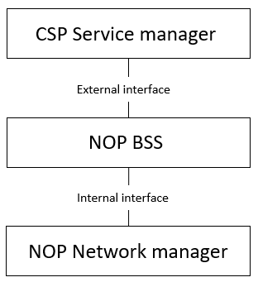  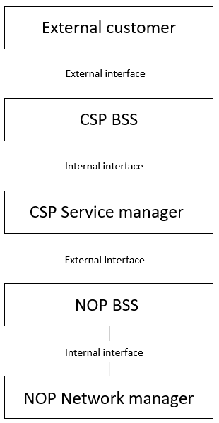  DT: which consumer in this context need to be clarified. It’s not clear how far we would like to go related to BSS. Should be general mechanism across different layers. There are other interfaces apart from NOP BSS-NOP netowrk manager.  O: 1. Any exposure should be exposed via BSS or expose directly .  - NOP BSS means the NOP operator provides products to external. It needs NOP service management layer in between.  E:  S: what does it mean by “via BSS” ? the function which did access control? But for this functionality could reside anyway in the network.  E: different customer has different contract. E do not want to have acccess control per customer per network layer.  A: agree with S to discuss general exposure governance. We no need to mandate the implementation in BSS/OSS.  S: Still need to clarify the relation with access control study.  - exposuring management services to consumer directly or reexpose it?  A: focus on the management service capability, not focus only on the permission control. E.g.discovery functions? Translation the format for consumer.  DT: whether we should discuss together with SA6 (focusing on control plane) ?  A: SA6 works using SA5 as input, and expose to customer. SA6 is focusing on application layer exposure and may provide requirements to SA5. Some internal interfaces in SA5 could be provided to SA6 which may impact external interfaces.  DT: are you planning to send LS to SA6?  S: we have discovery workitem already. Still think it’s duplicated with access control.  O: how external customer interact with CSP? SA2 also discussed network exposure function. We are discussing management exposure function. Whether we consider to reuse SA2 (e.g. NEF?).  N: the exposure should be only from NOP. It’s duplicate with access control.  HW: management exposure should be identified by different layers.  E: suggest to follow ITU-T layers. External customer/BML/SML/NML.  S: access control can work for any layers.  VC: whether access control should differentiate according to different layers?  N: access control has already differerntiate different layers.  VC: The management exposure is not related to NEP, the exposure is related to NOP and CSP.  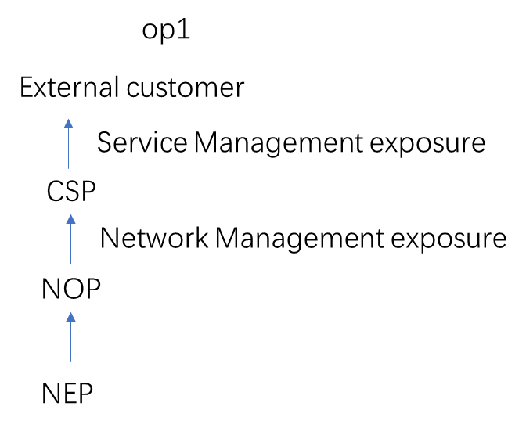  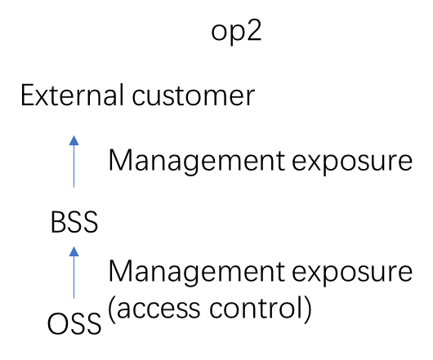  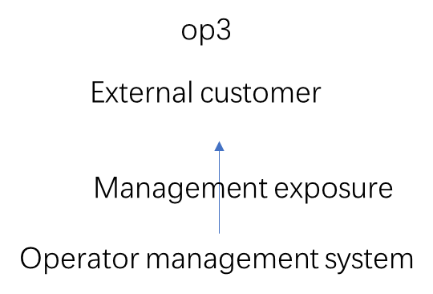  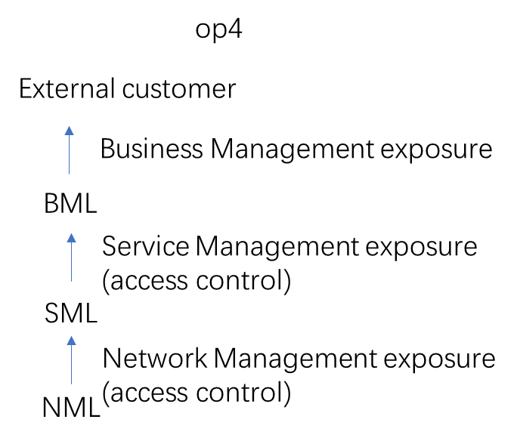  2. FS_NSMEN: Resolve remaining issues which block the conclusion of FS_NSMEN study (Brendan)  Discussion paper on network slice covering multiple networks.doc  S: clarify the relation with existing diagrams.  E: remove the spelling checking from the diagram. Update 4.2-1.  N: need more discussion on alt 2. Dont think Request for RAN coverage is a valid request.  E: we use request not allocate operation in diagram.  N: the lower layer can’t send requrest to upper layer. Company-NA netwrk manager should not send request to BSS.  O: figure 4.1-3, 'networkclicesubnet' should be replaced by 'networkslicesubnet'  HW: the network manager escalates request to BSS.  HW: if company NA orders network slice as service, whehter he could access resource information (e.g. alarm,performance etc.) from company NB? It maybe have some access control.  N: Nokia thinks in this case, only service related to network slice should be exposed. The network slice subnet information should not be accessed.
#137e.3 | Jun.24th 2021 15:00 CEST~17:00 CEST | 1. IDMS_MN: Intent concepts (S5-213165/S5-213288/S5-213169) (Xuruiyue, Vlad)  S5-213XXX IDMS Discussion paper on operations and intent models for intent management.doc  E: too early to discuss CRUD now. intent is not management object managed by 3GPP, it’s received by 3GPP system. Need to take a look at LCM first.  For NRM, CRUD is used to create the object. The intent is created outside the 3GPP system. It’s not same as using of CRUD for object creation.  TMF already has description on LCM of intent. IG 1253 has provided information about intent. The intent is created outside the system and transferred to the system. IG 1253A also has model.  HW: misunderstanding on the CRUD and model. The model is used to capture the requirement of the consumer. We should focus on the interface to be changed between producer and consumer.  N: why intent is different with normal CRUD? Some misunderstanding on the model. Support Huawei for using CRUD operation.  E: The difference is intent is created on consumer side. Similar like creating script.  DT: intent has to be managed in different levels. The discussion seems talk about the consumer should be aware of the details, but not hide the complexity. Need to define the details of intent and levels of intent. TMF has some work maybe reused.  HW: the question is whether we would like to model intent as normal IOC. We could check the existing use cases and how they could be fulfilled.  The intent LCM is how consumer to create intent is the consumer internal behaviour. The discussion here is to talk about the standard interfaces.  Asiainfo: support CURD operation/notification. The CRUD could satisfy the needs from TMF.  O: May need to take a look at TMF operations. There may some interaction between the consumer and producer.  HW: why can we not continue to use CRUD operation?  E: intent is outside of the interfaces. Create intent may need to use other interface.  HW: intent is the requirement/target provided to 3GPP system.  N: don't understand how to separate CRUD operation with LCM? We need to focus on what are the attributes of intent.  HW: TMF Preference/Judge is similar as feasibility check in SA5. Whether function is needed to be provided can be considered.  E: Seems most of companies don't see problems with CRUD. Propose to discuss how intent is modelled first. Then we decide which operations could be used.  S5-213YYY Revision of S5-213167 and S5-213166 pCR TS 28.312 Add concrete RadioNetworkExpectation.doc  E: Need to check what TMF did already to avoid conflict.  HW: the radioNeworkexpection is 3GPP, not in scope of TMF.  E: we may use the format of TMF, need to check the details offline.  DT: whether there is any general intent objects? And from which we can derive further intent objects, if needed.  In addition, the currently proposed attributes should be further investigated whether they are needed in this context and which should be mandatory and which optional. Examinations regarding possible relevant other attributes should be made as well in this context.  N: have concern on the very detailed information on the intent. Agree with E on generic intent. Maybe first discuss the generic intent model and come back to the concrete.  E: the intent attributes may need to reuse existing attributes.  N: clarification on the assumption for the intent use case. If hardware and software can’t satisfy, what to do?  HW: intent only address what consumer wanted.  N: clarify it’s not related with close loop implementation.  HW: how producer implement intent is not addressed.  CMCC: don't think the attributes in this contribution is very detail. It’s very natural for operators to use those attributes to express their requirements for Radio network.  O: How the attributes different with serviceprofile?  HW: This is on network level, serviceprofile is on service level.  VC: Generic intent model or dedicate intent model?  HW: propose to go with dedicate intent models first and then if there are common infromation could be extracted, then we could discuss generic model.  2. MADCOL (Olaf/ Christiane)  Input to Rel-17 DraftCR 28.537 for MADCOL  X.1.2 Requirements:  H: What about the BSS responsibility to transfer user friendly concepts to the network? And what about partly covered area, where is the limit? A lot of complexity here is not considered.  N: Valid question (the second), but we are writing down reqs. here. These are more stage 2 concerns, how we do it in detail. The req. should define the general direction where we want to go.  N: On the BSS question, we have discussed BSS-OSS interfaces before, but this is difficult to comment when we have MnS definitions.  H: If someone wants to use NM they should be aware of the basic concepts. So if you want to have a user friendly version of NM, it is outside our scope.  N: In our latest ToR, we also have responsibility beyond the NM layer. So what is OSS or BSS in a service oriented architecture is a bit philosophical. It becomes an irrelevant question. And as an example. also COSLA should have use cases for optimization related to certain geo areas.  S: MADCOL is about optimising data coll. and discovery, and there is a req. to optimise (requesting) data collection for a specific geo area, right? I don’t see anything wrong with that, and it’s not new. So we can provide an abstract layer to support that.  X.3.2 Requirements:  H: Pls. clarify what is data store. And automatic registration of mgmt data, are you going to collect all data or just some types?  N: Stored data is described by some meta data, put in the registry, but what it is, is left to the more detailed stage 2 discussion. Meta data is high level data like time stamps, possibly related objects, etc. We will specify mechanisms to request and read data from the data store etc. (different from the meta data), and how and where you store the data is for later discussions. E.g. for FM, the alarm list is the data store, and meta data could be “number of alarms with critical severity”. When you store data in the data store, info about the data shall be stored automatically in the registry.  E: First two reqs here are dictating a solution, so they should be removed or rephrased (e.g. remove “to a data store…”). And for the first part of those reqs, it is unclear what they mean.  N: All I want to say is that we have some discovery function, that knows which data is stored where in the system.  H: I see some assumptions here: Data store and discovery should be made inside the 3GPP system, but the requirements seems to say the opposite.  NEC: Don’t agree.  DT: Should clarify what registration and de-reg of mgmt data means.  S5-213199rev3_easy_to_use_API  N: We try to keep it simple and introduce only 5 attributes. We focus on mgmt data type, allowing to limit the data requested, starting with Coverage and Capacity.  E: None of Ericsson’s earlier concerns have been addressed. What happens with the old collection points? So the same concerns remain. It’s an issue how to choose collection point.  N: We added a statement that it is for external consumers (like ORAN or other verticals) that don’t have so detailed knowledge, and existing data coll. jobs are still valid. Existing jobs may run on an NE/NF like before. But we must look at external consumers that don’t know or care about the NRM.  E: But this makes everything more complex, even if you want to simplify the collection for some users.  N: But this is an abstraction layer put on top of the classical things.  H: First, related to Ericsson’s comment, data coll. job is similar as an intent expression. So I think it’s better to have some relation with the intent driven mgmt concept. Secondly, you said that this is for external consumers w/o detailed knowledge, but if they don’t have that, how can they understand the data in 552?  Continue offline.
#137e.4 | Jul.1st 2021 15:00 CEST~17:00 CEST | - Extra rapp. call 5 Aug.?  Ericsson is asked to send the proposed topic to Zou Lan, and the schedule will be updated with a call the 5th Aug.  1. Check the latest OAM action items (Zou Lan) (15 min.)  “S5-213004rev1 OAM&P SWG action list.docx”  Zou Lan went through the list with the objective to clean up some old APs.  114.2: Zou Lan will check it and propose some recommendation.  119.1 Zou Lan will send a reminder to Mirko.  119.3 Can be closed.  120.2: Ericsson to check and come back. Update it to Rel-17.  123.3 Keep open  130e.4 Ask Olaf  All APs with dedicated owner: Zou Lan will send an email to remind them.  131e.1: To be updated to Rel-17 and further updated after today’s call, and merged with 130e.9.  133e.1: Can be closed.  133e.2: Can be closed.  134e.2: Can be closed.  135e.2—4: Can be closed.  137e.3: Merge with 130e.9.  2. Test the new split of 28.541 in Rel-16 and Rel-17 (Thomas) (15 min.)  E: The Word document works and doesn’t’ crash anymore. Some questions:  - There are separate YAML files in the zip but no Yang files, what is the reason? I would like YAML and Yang to be handled in the same way.  - The separation of the Annex chapters is a bit strange. Would have been better to have all SSs for one Stage 2 topic e.g. NR NRM in the same annex. (Not so urgent)  H: Maybe MCC didn’t create separate Yang files because there are so many, about 50?  Conclusion: Leaders to ask Mirko consider and reply to these questions by email.  - 3. SA5 working procedure: stage2 and stage 3 alignment (Thomas, Balazs,Zou Lan) (60 min.)  “S5-213690d1 SA5 Working Procedures_rm-balazs_section-24-proposal_ZL+ email discussion.doc”  E: Aligning stage 2/3 in CRs is an urgent issue that we need to solve. Capability level may be ok but is more difficult to check, but the CR level alignment is most urgent. New CRs should clearly indicate which Stage 3 SS are missing, and there should be a clear reference between each stage 2 and corresponding stage 3 CR.  Chair: MCC/Mirko has said that “missing SS” indication doesn’t belong in any TS, it should be in a separate document.  E: But info about deliberate omissions is not “project planning info”, it is critical information needed for TS implementers. So people who are not SA5 members should also be able to find such information.  S: What use would such information (of missing SS) be for an external implementer?  Chair: There are two reasons for providing this information: 1) To record the gaps so we don’t miss to fill them if that is the goal, and 2) to inform the outside world that we are aware of these gaps, and didn’t miss the SS by mistake. This is a matter of quality perception of our TSs.  E: We also need to start identifying gaps in the existing specs, not only in new CRs.  Chair: Agree we should do that, and we earlier said the TS rapporteurs should be asked to provide this info, it just got delayed because we could not yet agree on the template for this info, and where to put it.  E: OK, but before we decided where to put it, we should at least have this info in a living document.  VC: Personally I still like option 1 because easier to capture the info, and give better overview for external readers. We could follow the clause structure in each TS. Option 2 is very detailed, like a todo-list but cannot provide the overall information. So it is difficult to understand for outside readers.  E: The different options have different purposes. Option 2 is more for planning information in the middle of the release. We could use both options, they both have pros and cons.  VC: It is also interesting to understand how CT and SA2 maintain and indicate the stage 2 / 3 alignment.  E: To have the information updated at the end of the release is not enough; it needs to be maintained for every version of the TS.  NEC: I think both options are good. But some questions: Each stage 2 CR has to include at least one stage 3 SS. Is this clear in the options? (Reply from chair and VC: Yes it is included).  E: We need a solution to next meeting, for how to document missing SSs.  VC: Both options need some effort to maintain. So it is difficult to maintain both options. If we choose option 2 (CR based info), we should keep it in a living document.  E: The CR level table is definitely needed, and I have no strong opinion about the other table.  S: Don’t agree that The CR level table is definitely needed. If a CR doesn’t provide one SS, it is not a mistake. If someone cares about it, they will see that it is missing when looking for it. So it is not needed to document this information anywhere. But I am not going to object to having this info in a living document, however I would object to having it in the TS.  E: This may lead to objections to “incomplete CRs” with one missing SS.  S: This is going in the direction of forcing the authors to provide all SSs for all CRs. We would not need this discussion if we had such a rule.  E: This is also what we would like to see. According to 3GPP working procedures, all TSs shall be consistent.  VC: All this maintenance work should try to improve the efficiency of our discussion. If we only have option 2, I don’t know how to update this information.  E: If we choose option 1, I would at least like to see an additional line in the cover page’s Other comments, indicating if a stage 2 CR has a stage 3 related CR.  NEC: Maybe it is better to indicate “Supported Solution Sets” in the option 1 column instead of “missing”? Because “missing” indicates that something is wrong, while it is not wrong if we have the rule that only one SS must be provided.  Chair: will discuss offline with the VC what to propose for the SA5 WP updates of clause 24 to SA5#138e, based on this discussion.
#137e.5 | Jul.15th 2021 15:00 CEST~17:00 CEST | 1. MANS (Xuruiyue, Zhuweihong)  S5-214abc Discussion on wayforward to support 5G MOCN network sharing scenario  Z: clarify the purpose of the DP. What to put in the standard.  HW: propose to add the scenarios in DP into TR.  Z: have concern on the solution. Dont think adding attribute “PLMNInfoList” in EP_NgC and EP_NgU is needed.  E: agree with ZTE the attribute PLMNInfoList may not be needed. Can be discussed separately from this DP.  Whether there are other requriements missing for picking one solution.  HW: agree we should agree on the requriements first. Backward compatible could be another option to consider.  E: agree with the requirements in the DP.  VC: use the collection of agreed rquirements as startting point for evaluate the potential solutions. Check whether there are other missing requirements.  F1 interface for the multiple cell identidy :  Option1: Both common F1 interface and operator specific interface should be supported.  Option 2: Only common F1 interface should be supported.  Option 3: Only operator specific interface should be supported.  E: prefer option1. Op2 and op3 have limitations. Op1 doesnt limit operator to use any one of the interface.  HW: prefer option1.  Z: Option1 is ok. But support of common interface in Ran3 is optional.  HW: clarification on what does common interface is optional. How to manage in this case? There may be some duplication if putting commmon interface support as optional, and support of specific interface as mandatory.  E: maybe we need to send LS to RAN3.  HW: send LS to RAN3 for clarification on  - whehter common interface/specific interface is optional.  - Whether there is any duplication if both are supported.  HW volunteer to prepare an LS to RAN3 in next meeting.  2. TMF SDO matrix table (Zou Lan)  3GPP SA5 rapporteur question response 20210707-2_Update  NEC: some information in TMF website about 3GPP is not correct. We need to correct them.  VC: Zoulan will contact TMForum for update of the webpage for the correction.  SDO matrix table update_3GPP SA5_d3  E: self management concept is big, 28.313 is only small set of functions.  VC: whether LTE SON related specifications should be added?  NEC: suggest to add the title of the specification.
#137e.6 | Aug.5th 2021 15:00 CEST~17:00 CEST | Topic from Jan (to be updated)

