3GPP TSG SA WG3 Preparation of 6G_SEC at Meeting #125
Conference call, November 5, 2025

Title: Lower layer security study for 6G Radio
Source: ST Engineering iDirect
Type: Discussion

Introduction
In SA#109, the study on 6G security is approved [1], containing a work task about security and privacy aspects of 6G RAN. The draft for TR 33.801-01 is available in S3-253742 [2], which contains a section about RAN security.
In TR 33.801-01 v0.1.0, the study of lower layer security is marked as for further study.
Observation 1: Suggestion from the feature lead to postpone the study of lower layer security.
In this contribution, we provide the motivation why to keep lower layer security in the scope of the study, and why it should not be postponed. It is proposed to have a dedicated section (key issue and solution) dedicated to lower layer security.

Need to study lower layer security
In this section, we discuss the importance to study lower layer security in the 6G security study.

Physical layer security issues in 5G NR
Physical layer security threats of 5G NR are well studied in academia and presented in, inter alia, the following publications.
- A. K. Yerrapragada, et al., "Physical Layer Security for Beyond 5G: Ultra Secure Low Latency Communications," in IEEE Open Journal of the Communications Society, vol. 2, pp. 2232-2242, 2021, doi: 10.1109/OJCOMS.2021.3105185
- Y. Arjoune and S. Faruque, "Smart Jamming Attacks in 5G New Radio: A Review," 2020 10th Annual Computing and Communication Workshop and Conference (CCWC), Las Vegas, NV, USA, 2020, pp. 1010-1015, doi: 10.1109/CCWC47524.2020.9031175
- Y. Wu, et al., "A Survey of Physical Layer Security Techniques for 5G Wireless Networks and Challenges Ahead," in IEEE Journal on Selected Areas in Communications, vol. 36, no. 4, pp. 679-695, April 2018, doi: 10.1109/JSAC.2018.2825560
- Harvanek M, et al., “Survey on 5G Physical Layer Security Threats and Countermeasures” in Sensors, vol. 17, 2024, doi: 10.3390/s24175523
- S. Sullivan, et al., "5G Security Challenges and Solutions: A Review by OSI Layers," in IEEE Access, vol. 9, pp. 116294-116314, 2021, doi: 10.1109/ACCESS.2021.3105396
- M. Mitev, et al., "What Physical Layer Security Can Do for 6G Security," in IEEE Open Journal of Vehicular Technology, vol. 4, pp. 375-388, 2023, doi: 10.1109/OJVT.2023.3245071
Observation 2: Many academic publications highlight physical layer security issues of 5G NR.

Apart from the academic publications, there are also public reports of (exploited) attacks due to vulnerabilities in the lower layers of 5G NR, including but not limited to
- The 2025 false base station attack at KT, South Korea
- The Sni5Gect attack, which allows forcing a UE to downgrade from 5G to 4G without using a false base station, by eavesdropping during initial access (https://mobileidworld.com/new-sni5gect-attack-enables-5g-to-4g-network-downgrade-without-fake-base-stations/)
- The 2022 NetScout DDoS Threat Intelligence Report reported a huge number of DDoS attacks (https://www.netscout.com/threatreport/)
Observation 3: Vulnerabilities of 5G NR are also reported in traditional news media.
It should also be noted that the dependence of 5G NTN on global navigation satellite systems (GNSS) is a major vulnerability. 5G NTN systems rely on GNSS for initial access and time-frequency synchronization. As GNSS systems can be easily jammed (due to their narrowband and low-power nature), this is the easiest way to disable communication between the UE and NTN. In RAN WG1, there is a Rel-20 5G-A study on GNSS resilience of 5G NR NTN. Figure 1 illustrates jamming of the GPS system [3].
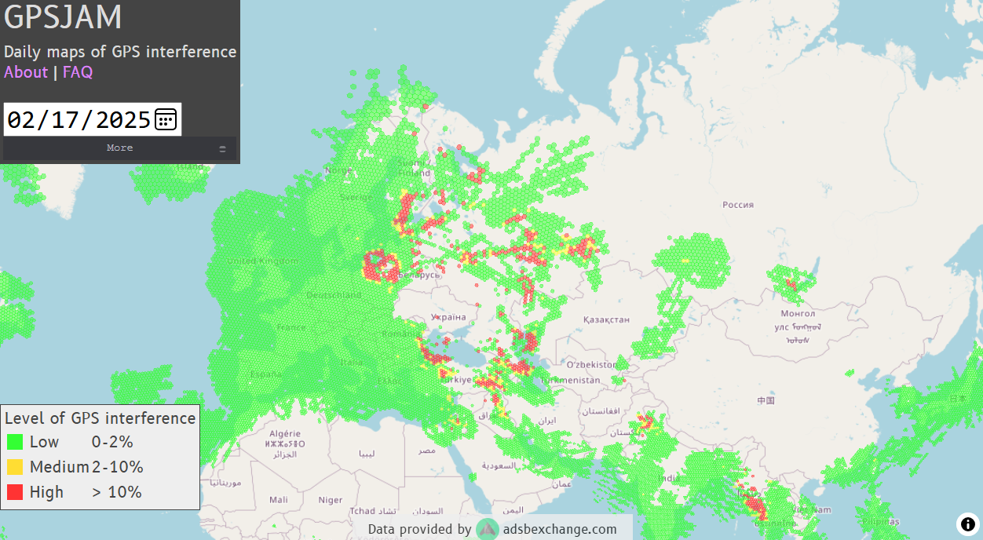
Figure 1. Visualization of GPS jamming on February 17, 2025. When GPS is jammed, a UE will not be able to connect or stay connected to the Rel-19 5G NTN system. Source: [3]
Observation 4: The GPS system is regularly jammed, in which case the Rel-19 5G NTN network cannot be used.

Need for lower layer security in 6G
The goals for 6G include the availability of increased security, integrity, and privacy from day one [4]. This is not only relevant for consumers/end users, but also for operators. Furthermore, the use cases for 6G are not limited to civilian/commercial scenarios but may extend to governmental and even military use [5]. This is illustrated in Figure 2 which shows that some military requirements overlap with capabilities offered by commercial solutions.
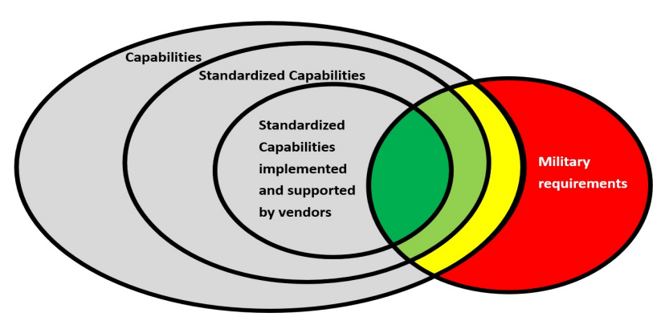
Figure 2. Venn diagram of commercial features overlapping with military. Source: [5]

As an example on how government and defense markets converge with commercial systems, 5G tactical networks were deployed on land and at sea during the NATO’s 2025 Robotic Experimentation and Prototyping with Maritime Unmanned Systems (REPMUS) exercise [6].
Observation 5: As commercial systems can fulfill some military requirements, governmental and defense systems incorporate commercial systems for some use cases.
Many contributions to the 6G Workshop and 6G study item definition in RAN highlighted the need to enhance lower layer security in 6G Radio (6GR), including protection of MAC control elements (CE) and broadcast system information messages. The Annex provides an overview of contributions that highlight the need for increased radio security and physical layer security.
Observation 6: Lower layer security is considered an essential topic for 6G by many companies, and several contributions propose to improve physical layer security.

Reasons not to postpone the study of lower layer security
The CT leadership highlights in [7] that security and authentication requirements impact protocol design and it should thus be given in time. Enhancing lower layer security in 6GR impacts RAN WGs (RAN1, RAN2), and as the 6G study is already ongoing in these WGs, it is proposed to have an early engagement. If we postpone the study on lower layer security, the RAN WG1 study might already have concluded on certain topics.
Observation 7: The 6G study has started in RAN WGs.
Proposal 1: Do not postpone discussion on low layer security.
Proposal 2: Early engagement with RAN WGs, especially RAN1 and RAN2 for lower layer security.
It is proposed to include lower layer security issues in Clause 5.2.3 from TR 33.801-01. Potential solutions to address these issues can be included in Clause 6 of TR 33.801-01. It is proposed to already start collecting a list of potential solutions to increase lower layer security.
Proposal 3: Consider weaknesses and potential solutions for the next draft version of TR 33.801-01.
iDirect is interested in presenting an overview of weaknesses and potential solutions at SA3#125 and will submit a contribution.

Conclusion
In this contribution, the following observations and proposals are made.
Observation 1: Proposal from the feature lead to postpone the study of lower layer security.
Observation 2: Many academic publications highlight physical layer security issues of 5G NR.
Observation 3: Vulnerabilities of 5G NR are also reported in traditional news media.
Observation 4: The GPS system is regularly jammed, in which case the Rel-19 5G NTN network is not operational.
Observation 5: As commercial systems can fulfill some military requirements, governmental and defense systems incorporate commercial systems for some use cases.
Observation 6: Lower layer security is considered an essential topic for 6G by many companies, and several contributions propose to improve physical layer security.
Observation 7: The 6G study has started in RAN WGs.
Proposal 1: Do not postpone discussion on low layer security.
Proposal 2: Early engagement with RAN WGs, especially RAN1 and RAN2 for lower layer security.
Proposal 3: Consider weaknesses and potential solutions for the next draft version of TR 33.801-01.

References
[1] SP-251233, “Study on Security for the 6G System”, SA#109 Plenary, Beijing, China, September 16 – 19, 2025
[2] S3-253742, “3GPP TR 33.801-01 v0.1.0; Study on Security for the 6G System (Rel-20)”, October 2025
[3] RP-250574, “Proposal on improved resilience to GNSS interference”, RAN#107 Plenary, Incheon, Korea, March 12 – 14, 2025
[4] 6GWS-250243, “Chair’s summary of the workshop on 6G”, 3GPP 6G workshop, Incheon, Korea, March 10 – 11, 2025
[5] S. Saha, “Improving Robustness of Commercial Radio Access Networks for Military Operations”, IEEE Military Communications Conference, Los Angeles, USA, October 6 – 10, 2025
[6] REPMUS, https://www.linkedin.com/posts/ericsson_repmus2025-repmus2025-ericsson-activity-7388530222981201920-6FKs
[7] 6GWS-250056, “6G considerations from CT leadership”, 3GPP 6G workshop, Incheon, Korea, March 10 – 11, 2025

Annex: 6G radio security considerations
Many contributions to the 6G workshop (Incheon, March 2025), as well as the 6G study item definition in RAN#108 (Prague, June 2025) highlighted the need for increased lower layer security.
Table 1 provides an overview of contributions that aim for increased radio security.
Table 2 presents an overview of the contributions to the 6G workshop that highlight the need for improved physical layer security of the 6G RAN.
The tdocs that contributed to the 6G study item definition in RAN#108 and that highlight physical layer security aspects are presented in Table 3.

Table 1. 6G Radio security considerations in 6G workshop and RAN study item definition at RAN#108.
Tdoc number | Source | Summary
6GWS-250005 | Nokia | Focus on security, privacy, and trust  - 6G architecture: security by design  - Security blueprint: goal to design the most cyber-resilient and secure network ever  - Design principles: radio security, quantum-resistant, privacy preserving technologies, cloud security, holistic AI-native security and trust framework
6GWS-250203 | Eurecom | RAN security: enhance security of low-level signaling especially during initial access
6GWS-250087 | Kyocera | Re-think overall security architecture for 6G RAT
6GWS-250067  6GWS-250069 | Qualcomm | Uncompromised security  - Resilient design of lower and upper layers, coping with security threats and PQC  - 6G security framework, including MAC CE security
6GWS-250013  6GWS-250008 | ZTE | Enhancements of existing security features  - Update of security key for subscription concealed identifiers (SUCI)  - Quantum security  - RAN security: security protection for MAC CE, support for enhanced PDCP security (e.g., 256-bits algorithm) and low-layer security, integrity protection  AI for security
6GWS-250101 | Sony | Security solution for 6G-IoT, optimized security design tailored for target Massive IoT use cases
6GWS-250019  6GWS-250076 | AT&T | Zero trust and PQC, authentication, and integrity protection  Security controls for confidentiality, integrity, and availability
6GWS-250016  6GWS-250018 | T-mobile | - Increased security, privacy, and trust  - Quantum safe
6GWS-250010 | Deutsche Telekom | Increased security, integrity and privacy for 6G from day one
6GWS-250024  6GWS-250150 | LG U+ | - Secured network, user centric RAN with advanced TRP change (incl. security)  - Quantum-safe security and end-to-end trust
6GWS-250217 | Viasat, Inmarsat | Resilient and secure architectures
6GWS-250106 | BWM | 6G should support trustworthiness including security
6GWS-250109 | Tiami Networks | Top use cases for enterprises for ISAC applications include occupancy sensing and physical security
6GWS-250113 | CableLabs,  Charter, Rogers | Enhanced security and privacy principles as business enablers
6GWS-250122 | NICT | 6G safety and security should be ensured, and trust secured
6GES-250014 | Orange | Security in 6G network operational requirements
6GWS-250144 | CMCC | Security as 6G design principle
6GWS-250148 | Bosch | RAN support for security, privacy, and trustworthiness, coordinated with SA WGs
6GWS-250151 | Telus | Goals for 6G security: robust security of data and users
6GWS-250088 | Telstra | Improvements in network resilience, availability, and security
6GWS-250128 | CATT | Design paradigm to provide security and privacy protection mechanisms
6GWS-250137 | 5G-MAG | - Maintaining secure networks, systems, and data exchange  - Solution to security challenges
6GWS-250156 | Google | Security and privacy by design: E2E secure and trustworthy network with user-centric privacy controls and getting ready for the post-quantum era  RRC and NAS security
6GWS-250174 | MITRE | Security is foundational to 6G
RP-250985 | Tejas | Low-layer security, including protection of broadcasted SIB messages, security for unprotected L2 messages, e.g., MAC CE messages, use of 256 bits (or higher) for encryption and integrity protection
RP-250872 | T-Mobile, Nokia, Ericsson | Security and privacy aspects
RP-251748 | ZTE | Access stratum security aspects including lower layer security and secure system information broadcast (cf. TPR in RP-251747)
RP-251513 | Intel | User and control plane architecture, protocols, and procedures, including 6G security (cf. SA WG3)
RP-251370 | Huawei | AS security aspects, according to requirements from SA3
RP-251311 | Mediatek | Radio interface security, in coordination with SA3
RP-251243 | Sharp | 6G study should aim to support a unified security framework for data and control messages including ciphering and integrity protection of MAC CEs
RP-251038 | Samsung | AS security aspects, in alignment with requirements from SA3,  L2 signaling security (MAC CE and SIB)
RP-250861 | Lenovo | Secure lower layer signaling, and reduced processing need for integrity protection
RP-251353 | Apple | AS security framework and further improvement of security and privacy protection

Table 2. Summary of physical layer security considerations in the contributions to the 6G workshop.
Tdoc number | Source | Summary
6GWS-250235 | Philips | Physical (PHY) layer security, quantum resistant protocols, protection against fake base stations
6GWS-250110 | Apple | - RAN security and privacy enhancements: unified user consent network, L1/L2 security, system information block (SIB) security, PQC, and 256 bits algorithms  - AS security with enhancements
6GWS-250032  6GWS-250033 | Oppo | - Security and privacy framework in Rel-21  - Lower layer security supplement (i.e., PHY layer and MAC layer security)
6GWS-250155 | TCCA | - Detection and protection against electromagnetic threats, standards and solutions ready for quantum safe communications, with means to hide the critical traffic to other traffic  - Radio interface capabilities & enhancements to sustain intentional attacks and non-intentional interference
6GWS-250165 | Indian Institute of Technology Madras | Security mechanisms to secure PHY layer, user information, and signaling
6GWS-250152  6GWS-250153 | Vodafone | - Security enhancements considering the entire system  - Security and early alignment with SA WG3: study the need for additional security for MAC CEs and/or L1 control signaling  - UP integrity protection and encryption

Table 3. Summary of physical layer security considerations in the contributions to the RAN#108 plenary meeting.
Tdoc | Source | Summary
RP-251617 | ST Engineering iDirect | Enhanced PHY layer security, adding secure channels that are resilient against jamming, with the option to hide network activity
RP-250975 | Oppo | Security and privacy for lower layers (L1+L2), as attackers may leverage un-protected data to gain access to private information of users
RP-251142 | Eurecom | Air interface security  - Confidentiality of basic identifiers against man-in-the-middle attacks  - Protection of the random access procedure against flooding-type attacks  - Covert channel scenarios: BWP supporting 2-way channels with low-probability of detection
RP-251610 | Vodafone | TSG RAN should co-ordinate with TSG SA and SA WG3 for the security requirements for L2 and L1 radio interface signaling to be delivered by June 2026
RP-251358 | Aalyria | Need improvements in security and privacy, e.g., control plane intercept protection, resilience to jamming/spoofing, and low-profile operation

