3GPP TSG-SA3 Meeting #117 S3-242xxx
Maastricht, Netherlands 19 - 23 August 2024

Source: Nokia

Title: Missed pCR implementation

Document for: Approval
Agenda Item: 5.10

1 Decision/action requested
Approve the proposed solution for TR 33.700-32.

2 References
[1] 33.702 - Security for mobility over non-3GPP access to avoid full primary authentication
[2] 3GPP TS 33.501 Security architecture and procedures for 5G system
[3] 3GPP TS 23.501 System Architecture for the 5G System
[4] 3GPP TS 23.502 Services and System Aspects Procedures for the 5G System
[5] IETF RFC 4301 Security Architecture for the Internet Protocol (IPSec)
[6] IETF RFC 4306 Internet Key Exchange (IKEv2) Protocol
[7] IETF RFC 4555 IKEv2 Mobility and Multihoming Protocol (MOBIKE)

3 Rationale
pCR S3-241840 (Charter, CableLabs’s pCR solution) was agreed in the Jeju meeting however, I missed to implement the same in the TR. So Mirko asked me to submit the pCR again in the next meeting and it will be approved automatically without debate. Therefore, I am resubmitting the pCR S3-241840.
This pCR proposes a solution for key issue #1 in TR 33.702. The solution is based on IPSec and MOBIKE

4 Detailed proposal
* * * * Start of Change * * * *

6.x Solution #X: IPSec and MOBIKE based solution for IPSec connection optimization between UE and TNGF during re-authentication

6.X.1 Introduction
This solution addresses key issue #1: Security aspect of UE connecting to a new WLAN AP connected via the same TNGF

6.X.2 Solution details

6.X.2.1 Solution overview
In TS 33.501, Sec 7A.2.1 describe the UE authentication for connectivity through a trusted Non-3GPP access with a TNGF. Here it is adapted with minor revisions to provide a solution for IPSec connection optimization between UE and TNGF during re-authentication. This method uses MOBIKE as spefied in IETF RFC 4555 between UE and TNGF.
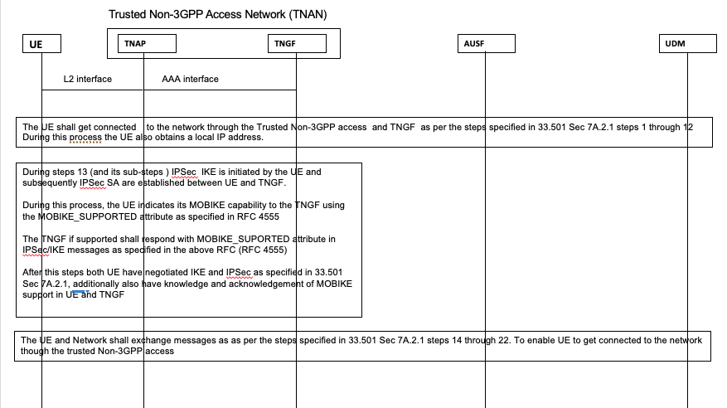
Fig. 6.X.2.1-1 Revised UE authentication procedure with TNGF
The procedure described in 3GPP TS 33.501sec 7A.2.1 with minor updates is used here IPSec reestablishment procedure during UE authentication while connecting with TNGF through a TNAP. These updates enable UE to reestablsih IPSec connection more efficiently when it moves to a different TNAP and get connected with TNGF
- Steps 1 through 12 are followed as is from sec 7A.2.1
- As the device may acquire a new IP address during reassociation with the new AP in step 12 during the DHCP.
- During steps 13 (and its sub-steps ) IPSec IKE is initiated by the UE and subsequently IPSec SA are established between UE and TNGF. During this process, the UE indicates its MOBIKE capability to the TNGF using the MOBIKE_SUPPORTED attribute as specified in RFC 4555. The TNGF if supported shall respond with MOBIKE_SUPORTED attribute in IPSec/IKE messages as specified in the above RFC (RFC 4555)
- After this step both UE have negotiated IKE and IPSec as specified in 33.501 Sec 7A.2.1, additionally also have knowledge and acknowledgement of MOBIKE support in UE and TNGF
- The UE and Network shall exchange messages as as per the steps specified in 33.501 Sec 7A.2.1 steps 14 through 22. To enable UE to get connected to the network though the trusted Non-3GPP access

6.x.2.2 IPSec optimization during UE Re-Authentication Procedure for connectivity with TNGF
The following is a new and optimized procedure for UE optimize IPSec reestablishment during re-authentication while connecting with the same TNGF through a different TNAP.
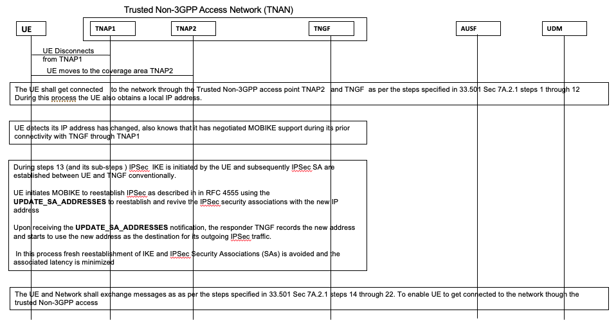
Fig. 6.X.2-2 IPSec optimization during UE Re-authentication procedure with TNGF
The procedure described in 3GPP TS 33.501sec 7A.2.1 with minor updates is used here to optimize IPSec reestablishment procedure during UE re-authentication while connecting with TNGF through a different TNAP.
This critical as the device may acquire a new IP address during reassociation with the new AP in step 12 during the DHCP.
- Steps 1 through 12 are followed as is from sec 7A.2.1
- As the device may acquire a new IP address during reassociation with the new AP in step 12 during the DHCP. Ordinarily this new address necessitates IPSec re-establishment from step-13 onwards, but now it is optimized
- During steps 13 (and its sub-steps ) IPSec IKE is initiated by the UE and subsequently IPSec SA are established between UE and TNGF conventionally. UE initiates MOBIKE to reestablish IPSec as described in in RFC 4555 using the UPDATE_SA_ADDRESSES to reestablish and revive the IPSec security associations with the new IP address Upon receiving the UPDATE_SA_ADDRESSES notification, the responder TNGF records the new address and starts to use the new address as the destination for its outgoing IPsec traffic.
- In this process fresh reestablishment of IKE and IPSec Security Associations (SAs) is avoided and the associated latency is minimized
- The UE and Network shall exchange messages as as per the steps specified in 33.501 Sec 7A.2.1 steps 14 through 22. To enable UE to get connected to the network though the trusted Non-3GPP access

6.X.3 Evaluation
This solution addresses key issue #1. The network function changes needed to support this solution are listed below
TNGF
- TNGF needs to support MOBIKE

WLAN
- No changes needed

UE
- UE needs to support MOBIKE

* * * * End of Change * * * *

