3GPP TSG-SA3 Meeting #117 S3-242xxx
Maastricht, Netherlands 19 - 23 August 2024 (revision of S3-yyxxxx)

Source: Nokia

Title: Discussion paper for Fast BSS details and limitations

Document for: Discussion
Agenda Item: 5.10

1 Decision/action requested
It is requested to discuss the discussion paper on Fast BSS solution issue related to NSWO

2 References
[X]

3 Rationale
Please see details proposal.

4 Detailed proposal
It seems companies are interested in Fast BSS Transition (FT) based solutions for all the KIs. Therefore, we must understand the working of Fast BSS and its limitation.
Fast BSS transition works within a Mobility Domain. According to IEEE 802.11-2020 specification:
- mobility domain: A set of basic service sets (BSSs), within the same extended service set (ESS), that support fast BSS transitions between themselves and that are identified by the set’s mobility domain identifier (MDID).

A Mobility Domain is an area within an ESS (extended service set).
- extended service set (ESS): A set of one or more interconnected basic service sets (BSSs) that appears as a single BSS to the logical link control (LLC) layer at any station (STA) associated with one of those BSSs.
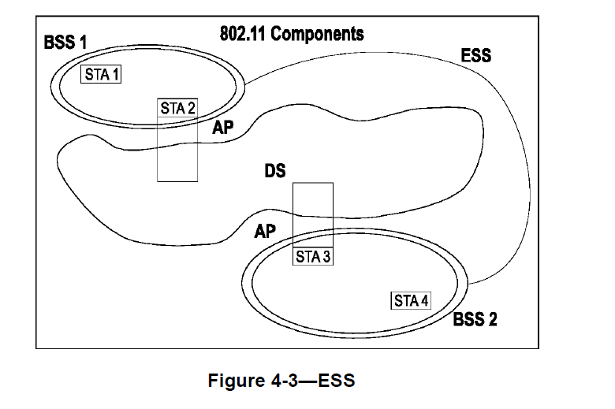
Observation 1 It means, that Fast BSS Transition is restricted to a single Layer 2 broadcast domain.
Observation 2 It means that all connected UEs must be able to send an ARP to their default router or transmit a DHCP request to the server that had previously assigned their address.
Observation3: Even when FT is independent of IP connectivity issues, the specification requires that the IP connectivity can remain unchanged throughout the whole mobility domain.
From a specification standpoint, UEs stay connected to the ESS (bridged network) regardless of their IP address while performing fast transition handover. The network must ensure IP address preservation while UEs are moving.
Observation related to KIs/use cases of the TR:
- TNAP/TWAP Mobility (KI1 and KI3):
  - Fast BSS may work considering a wifi network is planned with proper ESS to cover multiple TNAPs/TWAPs.
  - If UE moves to an AP that does not come into the common mobility (e.g., part of ESS), then Fast BSS will not work, and UE goes for full primary authentication.
- AUN3 device/ RG mobility (KI2):
  - RGs are the cable network; RG works as a standalone AP to provide wifi connectivity to UE. For Fast BSS, UEs stay connected to the ESS (bridged network) via L2 while performing fast transition handover.
  - Between RGs, L2 layer connectivity is not defined, so it is questionable to have fast BSS among RGs.
  - If UE connections break from the RG1 and connect to RG2, then UE may invalidate the R0KH ID, so again, fast BSS will not work.
- NSWO (KI4):
  - ESS is a limited area where a wifi provider may provide common mobility. Secondly, for Fast BSS, UEs stay connected to the ESS (bridged network) via L2 while performing fast transition handover.
  - Currently, the NSWO can be providing to a UE connecting via AP from home country or visiting country. Using the Fast BSS for NSWO will be quite limited, and the solution will work only for a limited area where ESS is defined

5 Conclusions and proposals
Based on the observations made in this paper, fast BSS will work for TNAP mobility, but it may not work for RG and NSWO mobility. Therefore, for RG and NSWO mobility, non Fast BSS based solution should be considered for normative work.

