3GPP TSG-SA3 Meeting #117 S3-24XXXX
Maastricht, Netherlands 19 - 23 August 2024

Source: vivo

Title: 1-Hop Forward Security Solution for LTM

Document for: Approval
Agenda Item: 4.12

1 Decision/action requested
This contribution provides a new solution for LTM.

2 References
None

3 Rationale
This contribution provides a new solution for LTM. The solution could achieve 1-hop forward security.

4 Detailed proposal
Start of Change

3.Y Solution #Y: 1-Hop Forward Security Solution for LTM

3.Y.1 Introduction
This solution consists of two phases: LTM configuration and LTM handover.
During the LTM configuration phase, the proposal is to utilize an N2 handover-like procedure to prepare a new NH for each candidate TgNBs. This approach allows for the achievement of 1-hop forward security, as the SgNB cannot access TgNB’s KgNB.
In the LTM handover phase, the proposal is to employ an Xn handover-like procedure to trigger a path switch for establishing the N3 path.

3.Y.2 Solution details
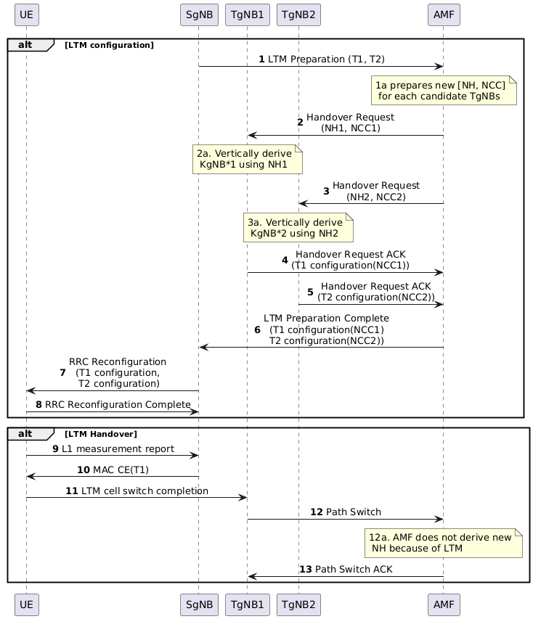
Figure 3.Y.2-1 Procedure for N2 Handover Like Solution on LTM
LTM configuration Phase:
- SgNB selects n candidate TgNBs, the max value of n is 6, because at the initial AS security context setup procedure, the second NH (NCC=1) is not used according to 6.9.2.1.1 in TS 33.501 [xx], so, there are 7 available NCC values. The candidate TgNBs shall be controlled by the same AMF.
- SgNB sends LTM preparation message to the AMF, the message includes candidate TgNB IDs (e.g. T1, T2).
If there is new Kamf and AS key is not sync yet, the AMF may pause LTM process, and trigger UE context modification procedure. After the procedure, the AMF continue LTM process.
The AMF prepares [NH, NCC] for the candidate TgNBs, i.e. for each TgNB, the AMF derive a new NH, and add NCC by 1.
- – 3. The AMF sends Handover Request to the candidate TgNBs, the security context (including NH, NCC, UE security capability, UP security policy) is included.
The candidate TgNBs vertically derive KgNB based on received NH, select algorithm and determine the UP activation based on the received security context, and construct LTM configuration including the NCC, the selected algorithm and the UP activation.
- - 5. The candidate TgNBs reply the Handover Request ACK including the RRC configurations (e.g. T1 configuration, T2 configuration) to the AMF.
- The AMF sends LTM preparation complete to the SgNB including the LTM configurations.
Editor’s Note: LTM preparation and LTM preparation complete are FFS.
- The SgNB sends RRC Reconfiguration message to the UE to indicate the LTM configurations
- The UE stores the LTM configurations and send RRC Reconfiguration Complete message to the SgNB. The UE vertically derives KgNBs based on LTM configurations. In this case, 1 hop forward security is achieved.
LTM handover Phase：
- UE performs L1 measurement and reports to the SgNB.
- The SgNB indicates the UE to LTM handover to TgNB1.
- The UE triggers LTM handover to the TgNB1. The UE applies indicated TgNB’s LTM configuration (e.g. T1 configuration). The UE uses derived KgNBs as depicted in step 8 for AS security.
- The TgNB1 sends Path Switch to the AMF. The AMF does not derive new NH and NCC if the AMF has configured the LTM configurations for the UE.
- The AMF sends Path Switch ACK to the TgNB1, the Path Switch includes current NH and NCC. The TgNB2 ignores the NH, NCC.

3.Y.3 Evaluation
TBA.
End of Change

