3GPP TSG-SA WG2#143E e-meeting S2-210xxxx
Elbonia, 24 February – 9 March 2021

Agenda item: 8.13
Source: Qualcomm Incorporated
Title: Extension of usage of TSCAI for AIS/XR traffic
Document for: Discussion

1. Background
Currently 5G_AIS (5G System Enhancement for Advanced Interactive Services, SP-190564 [1]) work item’s main goal is to define potentially new QoS parameters to address the QoS requirements defined by SA1 NCIS work and by SA4 work on 5G XR. In addition, the SA4’s new Study Item on “Feasibility Study on Extensions to Typical Traffic Characteristics” was approved in by SA#87 in SP-200054 [8] and the latest version of the related report as of SA4#110e is available in S4-201245 [9].
From the initial discussions which took place in SA2#142E, it seems clear that at least the following three types of information are useful to better support AIS/XR application traffic:
- Packet size;
- Periodicity;
- Burst arrival time.
This paper explains why re-using the existing MDBV and TSCAI is the simplest and most efficient way to support AIS/XR traffic.

2. Discussion

2.1 Rel-15 initial discussion on URLLC
Already in SA2#142E [5] it has been brought to the attention of SA2 that some discussions on ultra-reliable and low latency communications (URLLC) initially for EPS and then extended to 5GS took place in Release 15 (see [2-4]).
In particular, the incoming LS S2-176871 [2] from RAN2 indicated that for very low latency communication the following parameters should be known by the RAN in order to make accurate admission control decisions:
- Packet size (Application/IP level SDU size) to be delivered. This is equivalent to a bit rate within a certain short time driven by the latency requirement.
- For Non-GBR – Packet arrival rate: This will enable the RAN to understand roughly how much system capacity would be needed to handle the user and still serve other users in the system. Requiring a packet to be transferred with low latency very frequently would take more toll on system capacity than an infrequent packet transfer.
- For GBR – Activity Factor: the percentage of traffic activity among the underline QoS flow/EPS bearer which can be used together with GBR for system capacity management
- In addition, for non-GBR bearers it would be helpful if SA2 could include an indication if this particular bearer is going to use lower latency feature and at which maximum bit rate the service is supposed to provide
- Whether a certain combination of latency+packet size+reliability is required to be guaranteed or not for the bearer.
In their reply LS S2-178150 [3], SA2 explained that
SA2 have considered RAN2’s request for information on packet size, packet arrival rate, activity factor, and maximum data rates, and SA2 can see the value of having this knowledge within the RAN. However, when considering the EPC, SA2 see significant problems in determining these values accurately (or even approximately) and simply.
An example of these problems is where the same type of cellular modem is built into different types of machinery (e.g. wheeled robot vs lathe) by different firms, and then those machines are sold and used in different types of factories/environments, and then the original builder (e.g. of the lathe’s software application) changes its software (and the packet size and arrival rate) without the knowledge of the HPMLN operator or the factory owner or the cellular modem builder.

2.2 Packet size
While some parameters were standardized (see, e.g., packet size/Maximum Data Burst Volume (MDBV)) others, namely the Activity Factor and the Packet Arrival Time, were not introduced in the normative specifications in Rel-15 because of the unfeasibility for the CN to determine such information (see clause 6 in [4]):
Getting the HSS or PCRF to signal the burstiness of the application to the RAN via the MME still leaves the problem of how this burstiness can be determined.
The MDBV (and later the Extended MDBV), which is equivalent to the packet size, was introduced together with the concept of Delay Critical GBR QoS Flow. See below the excerpt of Table 5.6.12.6-1 of TS 29.512 below:
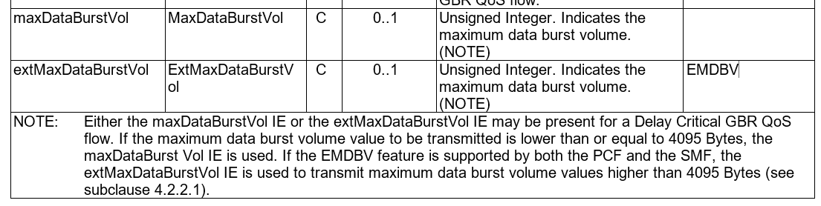
Figure 1: MDBV/EMDBV were introduced together with the Delay Critical GBR QoS flow.
Consideration 1: there is no need to add a new packet size parameter specific to AIS because it was already introduced as MDBV for Delay Critical GBR QoS Flows to support URLLC in Rel-15.

2.3 Activity factor and Packet Arrival Time
More recently, in Release 16 the work on Industrial Internet of Things (IIoT) introduced the support for Time Sensitive Communications (TSC, see clauses 5.27 and 5.28 in TS 23.501). Such an environment allows a better end-to-end system synchronization as well as PCF APIs that allows an AF to provide QoS related information. The TSC Assistance Information (TSCAI) already includes the Periodicity, which can be considered equivalent to the Activity Factor, and the Burst Arrival Time (BAT), equivalent to the Packet arrival rate, that is essential to apply the other information to Admission Control (as required in the original LS from RAN2 in [2]). According to the Stage 3 encoding of the PCC Rules (see TS 29.512, clause 4.1.4.2.1), Periodicity and BAT are optionally provided in the PCC Rules:
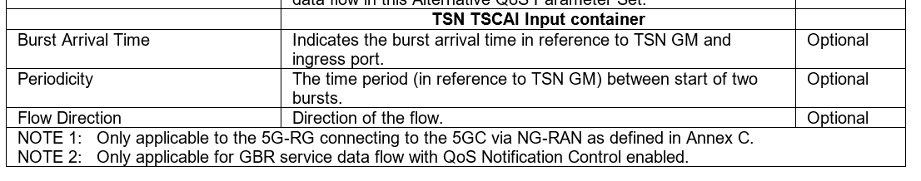
Figure 2: Excerpt of Table 4.1.4.2.1-1 of TS 29.512.

In addition, notice that the Rel-17 FS_IIoT work will also extend the NEF provided APIs so that an AF can provide the above-mentioned parameters to the 5GC (see the conclusions for Key Issue 3A in TR 23.700-20 [7]). Currently the TSCAI is used only for TSN deployments that use Ethernet type PDU Sessions and SSC mode 1. However, the TSCAI is a mere signal mechanism used to provide the RAN with more information for improving resource allocation. Such additional information can be used also with a 'regular' N6 network (i.e., without the need to have TSN functionalities deployed). In other words, nothing should prevent the 5GC to provide the RAN with Burst Arrival Time since time synchronization can be done without using any new enforcement mechanisms at Ethernet level.
Finally, in the email discussion on the draft LS out S2-208998 [6] in SA2#142E, it was mentioned that AIS/XR traffic associated to a single application instance may have more complex patterns than those associated to TSN traffic, i.e., such traffic patterns cannot be described with a single periodicity value (e.g., 100B sent every 10ms for the audio data flow plus 1kB every 33ms for the video data flow). For such cases it was questioned whether the TSCAI can be used to describe the periodicity of the traffic pattern. In that respect, TS 23.502, clause 6.1.3.2.4 reads as follows:
"- when the PCF provisions a PCC rule, and if the PCC rule contains a TSC Assistance Container, the PCC rule is bound to a new QoS Flow and no other PCC rule is bound to this QoS Flow. Whenever the TSC Assistance container of an existing PCC rule is changed, the binding of this PCC rule shall not be re-evaluated."

This means that AIS/XR application data flows with more complex traffic pattern can simply be mapped onto multiple QoS Flows, each of which representing a traffic pattern that can be described with a single periodicity value.
Consideration 2: since Periodicity and Burst Arrival Time were introduced in Rel-16 as optional parameters to support Time Sensitive Communications, they can be re-used to support AIS communication without the need of any TSN deployments.
Consideration 3: since the Rel-17 IIoT normative work will anyway introduce APIs to allow any (non-TSN) AF to provide Periodicity and Burst Arrival Time to the 5GC, what remains to be done is to remove the limitation of application of TSCAI to Ethernet type PDU sessions and extend its usage to IP type PDU sessions.

3. Summary and conclusions
While analyzing the necessary parameters needed to support AIS communication, namely Packet Size, Periodicity and Burst Arrival Time, this paper summarized the enhancements introduced in Rel-15, 16 and 17 for URLLC and IIoT communications and drew the following:
Consideration 1: there is no need to add a new packet size parameter specific to AIS because it was introduced as MDBV for Delay Critical GBR QoS Flows to support URLLC in Rel-15.
Consideration 2: since Periodicity and Burst Arrival Time were introduced in Rel-16 as optional parameters to support Time Sensitive Communications they can be re-used to support AIS communication without the need of any TSN deployment.
Consideration 3: since the Rel-17 IIoT normative work will anyway introduce APIs to allow any (non-TSN) AF to provide Periodicity and Burst Arrival Time to the 5GC, what remains to be done is to remove the limitation of application of TSCAI to Ethernet type PDU sessions and extend its usage to IP type PDU sessions.
Based on the considerations above, it is proposed to:
Proposal 1: extend the usage of TSC Assistance Information to support IP type PDU sessions and approve the associated CR in [8].

4. References
[1] SP-190564, “New WID: 5G System Enhancement for Advanced Interactive Services”
[2] S2-176871, “Reply LS to SA2 on 5QIs for URLLC”, RAN2 LS in, SA2#123
[3] S2-178150, “Reply LS on 5QIs for URLLC”, SA2 LS out, SA2#123
[4] S2-177641, “New QCIs for Low Latency E-UTRAN and E-UTRAN-NR Dual Connectivity: action on reply LSs R1-1715089 and R2-1709976/S2-176871”, Vodafone, SA2#123
[5] S2-2008995, "Enhancements to support XR applications", discussion paper
[6] S2-2008998, "[DRAFT] LS on additional QoS aspects for Advanced Interactive Services"
[7] TR 23.700-20, “Study on enhanced support of Industrial Internet of Things (IIoT) in the 5G System (5GS)”
[8] S2-210xxxx, “Extension of TSCAI to IP PDU Session type”, CR vs. TS 23.501

