3GPP TSG-RAN WG2 #131bis R2-250xxxx
Prague, Czech, 13-17 October 2025

Agenda item: 8.4.1
Source: CATT
Title: List of open issues for LP-WUS 38.304 CR
Document for: Discussion and Decision

Introduction
Per instruction from the chairlady, this document is to collect correction phase open issues identified for Rel-19 LPWUS 38.304 CR. More specifically, please provide here open issues that were identified but not addressed during the running CR review phase or we expect to come from other WGs.
Please provide your input no later than Oct. 31st 1000 UTC. After the deadline, rapporteur will identify issues that are difficult to resolve and should be discussed by contributions, if any, as suggested by the chairlady.

Open issues

LP-WUS in idle/inactive mode
Company | Open issue | Rapporteur response
Xiaomi | A issue is proposed in last meeting:  As agreed in TS 38.300 draft CR:  “ In addition to monitoring a codepoint associated with its subgroup ID, a UE configured with LP-WUS monitoring also monitors a common codepoint associated with all subgroups in a PO.”  Suggest to add a sentence to clarify UE’s behaviour when monitors the 2 type of code points as in LTE’s 36.304:  “ A UE supporting GWUS can be configured to monitor a WUS group and a common WUS. Upon detecting either of them, UE shall monitor POs as defined in clause 7.4.  Rapp’s reply:  As the common codepoint has already been captured in RAN1 specification and the stage 2 specification, we slightly prefer not to capture it in TS 38.304.  Xiaomi’s comment:  Currently, in RAN1, they just captured the definition of code point of subgrouping and the common code point. And in the draft TS 38.300, we have captured:  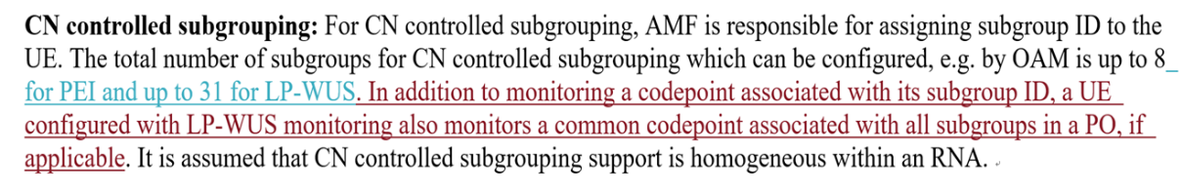  However, UE’s behavior is not captured when UE detects them. I think we need to capture this in RAN2 since it impacts on how to monitoring paging. We can further check we capture it in 38.304 or in 38.300. | There is no description about the codepoint of LP-WUS in TS 38.304. Not sure how to capture it. Companies are encouraged to provide the proposed change.  List it as an open issue 38304-1.
Ericsson | The open issues 38304-2 (R2-2506862) was not discussed during RAN2#131-bis:  Proposal 2: 38304-2: Discuss how to capture the agreement “LR measurement based RX level and cell quality value should be derived by UE implementation in multi-beam operations. We assume this conclusion does not impact the cell reselection procedure.” | The open issue 38304-2 is still valid.
Ericsson | RAN2 should evaluate whether any clarifications are needed for the LO the UE monitors based on the configured time offsets in lpwus-LoFrameOffsetList, see RAN1 LS in R1-2508170. | We have noticed the RAN1 LS. We will update TS 38.304 according to the LS after it is treated online.  List it as an open issue 38304-3.
Ericsson | This part is difficult to read, and maybe incorrect:  - The reference PF/PO is the start of the PF, or the first PF of the PF or PFs (if mapping of POs from multiple PFs to one LO is configured), associated with the LO.  The reference has to be unambiguous, and we do not understand how to interpret “PF/PO” which seems to leave two options open.  We do not understand how to understand: the first PF of the PF | PF/PO is captured according to the RAN1’s agreement. Considering it is frame level offset, we think it is can be changed to “PF”.  “the first PF of the PF or PFs” can be changed to “the first PF(s)” according to RAN1’s agreement.  It’s already updated in the draft CR
Ericsson | We think this is incorrect:  UE supporting LP-WUS is required to stop serving cell measurement offloading according to requirements specified in TS 38.133 [8] if the exit condition for serving cell measurement offloading in clause 5.2.4.12.4 is fulfilled. | Thanks. It’s already updated in the draft CR

RRM relaxation/offloading
Company | Open issue | Rapporteur response

Conclusion
According to clause 2, open issue 38304-2 is still valid.
Proposal 1: The following open issues can be further discussed in RAN2:
- 38304-1: Discuss whether and how to capture the common codepoint in TS 38.304;
- 38304-2: Discuss how to capture the agreement “LR measurement based RX level and cell quality value should be derived by UE implementation in multi-beam operations. We assume this conclusion does not impact the cell reselection procedure.”;
- 38304-3: Discuss whether and how to capture the agreement in RAN1 LS R1-2508170.

