3GPP TSG-RAN WG2 #131bis R2-250xxxx
Prague, Czech, 13-17 October 2025

Agenda item: 8.4.1
Source: CATT
Title: List of open issues for Rel-19 LP-WUS 38.304 CR
Document for: Discussion and Decision

Introduction
Per instruction from the chairlady, this document is to collect correction phase open issues identified for Rel-19 LPWUS 38.304 CR. More specifically, please provide here open issues that were identified but not addressed during the running CR review phase or we expect to come from other WGs.
Please provide your input no later than Oct. 31st 1000 UTC. After the deadline, rapporteur will identify issues that are difficult to resolve and should be discussed by contributions, if any, as suggested by the chairlady.

Open issues

LP-WUS in idle/inactive mode
Company | Open issue | Rapporteur response
Xiaomi | A issue is proposed in last meeting:  As agreed in TS 38.300 draft CR:  “ In addition to monitoring a codepoint associated with its subgroup ID, a UE configured with LP-WUS monitoring also monitors a common codepoint associated with all subgroups in a PO.”  Suggest to add a sentence to clarify UE’s behaviour when monitors the 2 type of code points as in LTE’s 36.304:  “ A UE supporting GWUS can be configured to monitor a WUS group and a common WUS. Upon detecting either of them, UE shall monitor POs as defined in clause 7.4.  Rapp’s reply:  As the common codepoint has already been captured in RAN1 specification and the stage 2 specification, we slightly prefer not to capture it in TS 38.304.  Xiaomi’s comment:  Currently, in RAN1, they just captured the definition of code point of subgrouping and the common code point. And in the draft TS 38.300, we have captured:  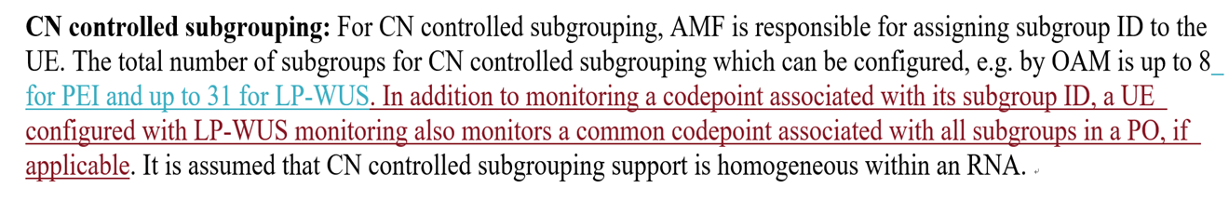  However, UE’s behavior is not captured when UE detects them. I think we need to capture this in RAN2 since it impacts on how to monitoring paging. We can further check we capture it in 38.304 or in 38.300.

RRM relaxation/offloading
Company | Open issue | Rapporteur response

Conclusion

