3GPP TSG-RAN WG2 Meeting #131 R2-250xxxx
Bengaluru, India, August 25th – 29th, 2025
Agenda Item: 8.13.1
Source: Huawei, HiSilicon
Title: Comment collection for RRC (TS 38.331) running CR for NR Sidelink Multihop Relay
Document for:

1 Introduction
This paper collects any further comments for RRC (TS 38.331) running CR for NR Sidelink Multihop Relay
- [Post131][414][Relay] Rel-19 relay 38.331 CR (Huawei)
Scope: Update the CR in R2-2505714 in accordance with decisions of RAN2#131.
Intended outcome: Agreed CR in R2-2506326
Deadline: Short (for RP) – 4th September 12:00 UTC

Please fill in the contact information in the table below
Company | Contact Person | Email Address
CATT | Hao Xu | xuhao@catt.cn
OPPO | Bingxue Leng | lengbingxue@oppo.com
Lenovo | Lianhai | Wulh5@lenovo.com
LG | Seoyoung Back | Seoyoung.back@lge.com

2 Comments for the running CR
This section is used to collect comments for the Merged RRC (TS 38.331) running CR for NR Sidelink Multihop Relay

Company | Issue | Suggestion
CATT | Redundant punctuation mark at the end of the terminology for Last U2N Relay UE in 3.1. | Delete it.  [Rapp] Updated in v01
CATT | Redundant punctuation mark at the end of 5.8.9.9.X. | Delete it.  [Rapp] Updated in v01
CATT | In 5.8.9.10.2, there are some typos. | “ot Last U2N Relay UEs” should be changed to “or Last U2N Relay UE’s”.  [Rapp] Updated in v01
OPPO | In clause 5.8.9.10, our understanding is we have no agreement on this condition:  2> upon reception of an NotificationMessageSidelink from the parent while in RRC_CONNECTED; | Remove the related initiation condition and behaviors  [Rapp] This addition is for the following agreement below and may be due to Uu RLF or HO happening at the last relay UE.  “When the RRC_CONNECTED intermediate relay UE does re-establishment as a remote UE, the intermediate Relay UE sends a notification downstream, with the cause value to be confirmed in CR implementation.”  In this case the most straightforward behaviour for the intermediate relay UE would be to send the notification downstream with the cause value received from the parent.
OPPO | In clause 5.8.9.10.3, for the cause value for relay reselection and cell selection case, we understand during online session, it was said the cause value to be used can be discussed in running CR. Considering both cases are path switching but just different results, i.e., whether PC5 or Uu is available, we prefer to use a single cause value to avoid 2 new cause values for the same case. | Use a single cause value for relay reselection and cell selection, e.g., relayUE-pathSwitcing since they are same case with different results (i.e., whether cell or relay is available)  [Rapp] It is better to keep the cause values separate for the two cases as it will provide necessary information to the remote UE .  The cause value relayUE-CellSelection will implicitly indicate to the remote UE that the hop count is reduced as compared to the cause value relayUE-RelayReselection where the hop count remains the same.
OPPO | The change on change should be removed (e.g., in clause 4.2.2, 5.2.2.2.1, 5.8.3.2) | [Rapp] All the change on changes will be removed in the final version.
OPPO | The Uu threshold needs to be checked by the intermediate relay UE for discovery transmission and SUI initiation as in legacy | In clause 5.8.3.2,  3> if the last transmission of the SidelinkUEInformationNR message did not include sl-TxResourceReqListDisc; or if the information carried by the sl-TxResourceReqListDisc has changed since the last transmission of the SidelinkUEInformationNR message:  4> if the UE is capable of U2N Relay UE or of Last U2N Relay UE, and if SIB12 includes sl-RelayUE-ConfigCommon, and if the U2N Relay UE or if the Last U2N Relay UE threshold conditions as specified in 5.8.14.2 are met; or  4> if the UE is capable of Intermediate U2N Relay UE, and if SIB12 includes sl-RelayUE-ConfigCommonMH and sl-RemoteUE-ConfigCommon, and if the and if the U2N Remote UE threshold conditions as specified in 5.8.15.2 are met; or  In clause 5.8.13.3,  2> if the UE is in RRC_CONNECTED and uses the frequency included in sl-ConfigDedicatedNR within RRCReconfiguration message:  3> if the UE is acting as NR sidelink U2N Relay UE or Last U2N Relay UE and sl-DiscConfig is included in RRCReconfiguration, and if the NR sidelink U2N Relay UE or Last U2N Relay UE threshold conditions as specified in 5.8.14.2 are met based on sl-RelayUE-Config; or3> if the UE is selecting NR sidelink U2N Relay UE / has a selected NR sidelink U2N Relay UE/ configured with measurement object associated to L2 U2N Relay UEs in both single hop or multi hop case and sl-DiscConfig is included in RRCReconfiguration, and if the NR sidelink U2N Remote UE threshold conditions as specified in 5.8.15.2 are met based on sl-RemoteUE-Config; or  3> if the UE acting as Last U2N Relay UE is sending Discovery Response message with Model B as specified in TS 23.304 [65] and if both the NR sidelink multi-hop relay threshold conditions as specified in 5.8.x.2 are met based on sl-RelayUE-ConfigMH and the NR sidelink U2N Relay UE threshold conditions as specified in 5.8.14.2 are met based on sl-RelayUE-Config; or  3> if the UE acting as Intermediate U2N Relay UE is sending Discovery Solicitation message with Model B as specified in TS 23.304 [65] and if both the NR sidelink multi-hop relay threshold conditions as specified in 5.8.x.2 are met based on sl-RelayUE-ConfigMH and the NR sidelink U2N Relay UE threshold conditions as specified in 5.8.14.2 are met based on sl-RelayUE-Config; or  …  2> else if the cell chosen for NR sidelink discovery transmission provides SIB12:  3> if the UE is acting as NR sidelink U2N Relay UE or Last U2N Relay UE and sl-DiscConfigCommon is included in SIB12, and if the NR sidelink U2N Relay UE or Last U2N Relay UE threshold conditions as specified in 5.8.14.2 are met based on sl-RelayUE-ConfigCommon in SIB12; or  3> if the UE is selecting NR sidelink U2N Relay UE / has a selected NR sidelink U2N Relay UE in both single hop or multi hop case and sl-DiscConfigCommon is included in SIB12, and if the NR sidelink U2N Remote UE threshold conditions as specified in 5.8.15.2 are met based on sl-RemoteUE-ConfigCommon in SIB12; or  3> if the UE acting as Intermediate U2N Relay UE has an established PC5 link with the selected parent U2N Relay UE, and if the NR sidelink U2N Remote UE threshold conditions as specified in 5.8.15.2 are met based on sl-RemoteUE-ConfigCommon in SIB12; or  3> if the UE acting as Intermediate U2N Relay UE is sending Discovery Solicitation message with Model B as specified in TS 23.304 [65] and sl-DiscConfigCommon is included in SIB12, and if both the NR sidelink multi-hop relay threshold conditions as specified in 5.8.x.2 are met based on sl-RelayUE-ConfigCommonMH and sl-RemoteUE-ConfigCommon, and if the and if the U2N Remote UE threshold conditions as specified in 5.8.15.2 are met; or  3> if the UE acting as Last U2N Relay UE is sending Discovery Response message with Model B as specified in TS 23.304 [65] and sl-DiscConfigCommon is included in SIB12, and if both the NR sidelink multi-hop relay threshold conditions as specified in 5.8.x.2 are met based on sl-RelayUE-ConfigCommonMH and the NR sidelink U2N Relay UE threshold conditions as specified in 5.8.14.2 are met based on sl-RelayUE-Config; or  [Rapp] These Uu conditions will be checked when the intermediate relay UE establishes itself as a remote UE but is not needed for forwarding the discovery messages.  Therefore, duplicating the Uu threshold check is not necessary during discovery procedure.
OPPO | This agreement is not captured and should be added  Similar to SIB request, a paging information list is introduced for the intermediate relay UE to carry the paging information from the downstream remote UEs. Signalling details can be checked in the ASN.1 review as usual. | TP can be as follows  1> if the UE has paging related information to provide (e.g. the UE has not sent sl-PagingInfo-RemoteUE in the RemoteUEInformationSidelink message to the parent L2 U2N Relay UE before), set sl-PagingInfo-RemoteUE/ sl-PagingInfo-RemoteUE-List as follows:  2> if the L2 U2N Remote UE is in RRC_IDLE:  3> include ng-5G-S-TMSI in the sl-PagingIdentityRemoteUE;  3> if the UE specific DRX cycle is configured by upper layer, set sl-PagingCycleRemoteUE to the value of UE specific Uu DRX cycle configured by upper layer;  2> else if the L2 U2N Remote UE is in RRC_INACTIVE:  3> include ng-5G-S-TMSI and fullI-RNTI in the sl-PagingIdentityRemoteUE;  3> if the UE specific DRX cycle is configured by upper layer,  4> set sl-PagingCycleRemoteUE to the minimum value of UE specific Uu DRX cycles (configured by upper layer and configured by RRC);  3> else:  4> set sl-PagingCycleRemoteUE to the value of UE specific DRX cycle configured by RRC;  2> if any paging information is received from the Child UE:  3> include the received paging information in the sl-PagingInfo-RemoteUE-List;  <…>  RemoteUEInformationSidelink-r17-IEs ::= SEQUENCE {  sl-RequestedSIB-List-r17 SetupRelease { SL-RequestedSIB-List-r17} OPTIONAL, -- Need M  sl-PagingInfo-RemoteUE-r17 SetupRelease { SL-PagingInfo-RemoteUE-r17} OPTIONAL, -- Need M  lateNonCriticalExtension OCTET STRING OPTIONAL,  nonCriticalExtension RemoteUEInformationSidelink-v1800-IEs OPTIONAL  }  RemoteUEInformationSidelink-v1800-IEs ::= SEQUENCE {  sl-RequestedPosSIB-List-r18 SetupRelease { SL-RequestedPosSIB-List-r18 } OPTIONAL, -- Need M  sl-SFN-DFN-OffsetRequested-r18 ENUMERATED { true } OPTIONAL, -- Need R  connectionForMP-r18 ENUMERATED {true} OPTIONAL, -- Need N  sl-DestinationIdentityRemoteUE-r18 SL-DestinationIdentity-r16 OPTIONAL, -- Need N  nonCriticalExtension RemoteUEInformationSidelink-v1900-IEs OPTIONAL  }  RemoteUEInformationSidelink-v1900-IEs ::= SEQUENCE {  sl-PagingInfo-RemoteUE-List-r19 SetupRelease { SL-PagingInfo-RemoteUE-List-r19} OPTIONAL, -- Need M  SL-PagingInfo-RemoteUE-List-r19 ::= SEQUENCE (SIZE (max)) OF SL-PagingInfo-RemoteUE-r17  [Rapp] This is already captured in the CR. Screen shots from the CR Rapp_v00is as shown below.  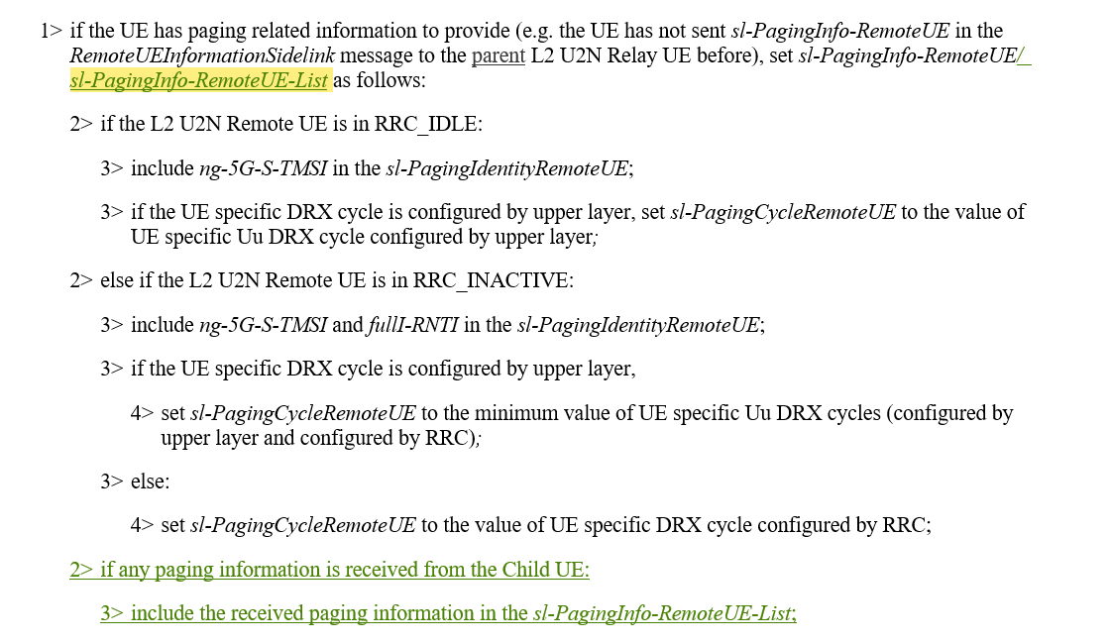  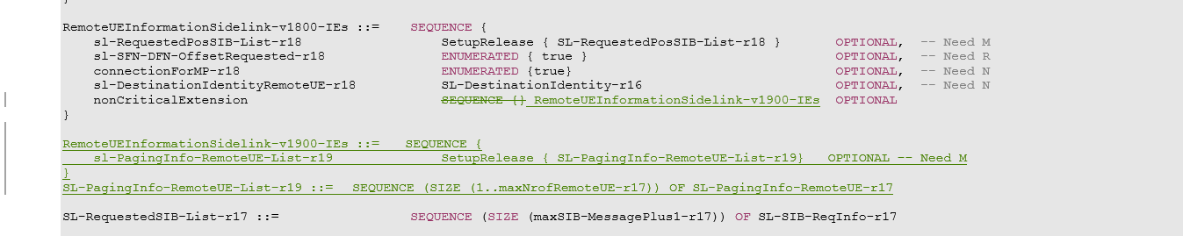
Samsung | Trigger of notification message in case of intermediate relay UE is in IDLE/INACTIVE state. The following agreements are not captured:  In case of notification message triggered by an error (e.g., RLF), for intermediate relay UE in idle/inactive, the intermediate relay UE can send cell/relay reselection cause value to the remote UE in RRC_IDLE/INACTIVE if it successfully performs a recovery action. If recovery action is not successful or if it opts to release the upstream PC5 link, it sends relayUE-PC5-RLF cause value if PC5 RLF is detected by itself or the same cause value received in the notification message from the parent node. | The agreement indicates that the cause of cell/relay reselection is sent after the successful recovery of the intermediate relay UE in idle/inactive; while the cause of relayUE-PC5-RLF is sent after unsuccessful recovery or release of upstream PC5 link, or detection of PC5 RLF by itself, or same cause value is received from the parent node.  However, such agreement is not quite clear. It may need further clarification in the next meeting.  [Rapp] It is implicitly captured in the flow in the procedure text.  The intermediate relay UE will first try to recover from the situation and if the relay reselection or cell selection is performed it will send the notification message with the cause value reflecting that and the other else if branches will not be executed.  If it is not able to perform the recovery only then it will send the notification message with relayUE-PC5-RLF
Samsung | Indication Type in notification message.  In indicationType-r19, only the new cause is needed. | indicationType-r19 ENUMERATED {  relayUE-Uu-RLF, relayUE-HO, relayUE-CellReselection,  relayUE-Uu-RRC-Failure,relayUE-RelayReselection,  relayUE-CellSelection, relayUE-PC5-RLF, spare1  } OPTIONAL, -- Need N  [Rapp] Updated in v01
Sharp | In RRC connection establishment procedure, the following wording has been added:  1> if the UE is acting as L2 U2N Remote UE or is acting as L2 Intermediate U2N Relay UE: | Add the same wording for RRC re-establishment procedure and RRC resume procedure; or remove the added wording in RRC connection establishment procedure.  [Rapp] Same wording added for for RRC re-establishment procedure and RRC resume procedure in v01
Sharp | For multi-hop relay case, sl-L2U2N-MH-Relay should be included in SIB12, before UE using the resource pool(s) for discovery transmission. | Add the description in 5.2.2.4.13 Actions upon reception of SIB12  5.2.2.4.13 Actions upon reception of SIB12  3> if configured to transmit NR sidelink discovery:  4> if the UE is configured by upper layers to transmit NR sidelink L2 U2N relay discovery messages and sl-L2U2N-Relay is included in SIB12; or  4> for multi hop, if the UE is configured by upper layers to transmit NR sidelink L2 U2N relay discovery messages and sl-L2U2N-MH-Relay is included in SIB12; or  <Omitted>  5> use the resource pool(s) indicated by sl-DiscTxPoolSelected, sl-TxPoolExceptional or sl-TxPoolSelectedNormal for NR sidelink discovery transmission, as specified in 5.8.13.3;  [Rapp] Updated in v01
Sharp | Section 5.8.9.8.3 is applied to L2 U2N relay UE  However the condition in yellow is applicable only for last relay UE.  Considering intermediate relay UE in connected state will enter this else part, the condition in yellow should be removed to avoid confusion.  2> else (the UE is in RRC_CONNECTED on an active BWP without pagingSearchSpace configured): | 2> else (the UE is in RRC_CONNECTED on an active BWP without pagingSearchSpace configured):  3> if the sl-PagingInfo-RemoteUE is set to setup:  4> include the received sl-PagingIdentityRemoteUE in SidelinkUEInformationNR message and perform Sidelink UE information transmission in accordance with 5.8.3;  3> else (the sl-PagingInfo-RemoteUE is set to release):  4> initiate transmission of the SidelinkUEInformationNR message to release the sl-PagingIdentityRemoteUE in SidelinkUEInformationNR message in accordance with 5.8.3;  4> release the received paging information in sl-PagingInfo-RemoteUE;  [Rapp] Updated in v01
Lenovo | Two cases are missing in the highlight part.  - upon Intermediate U2N Relay UEs RRC connection failure including RRC connection reject as specified in 5.3.3.5 and 5.3.13.10, and T300 expiry as specified in 5.3.3.7, and RRC resume failure as specified in 5.3.13.5;  - upon the intermediate relay UE receives PC5-S release message from its parent relay UIE.  5.8.9.10 Notification Message  ……  5.8.9.10.2 Initiation  The Relay UE may initiate the procedure when one of the following conditions is met:  1> if the UE is acting as U2N Relay UE or Last U2N Relay UE:  2> upon Uu RLF as specified in 5.3.10;  2> upon reception of an RRCReconfiguration including the reconfigurationWithSync;  2> upon cell reselection;  2> upon L2 U2N Relay UE's ot Last U2N Relay UEs RRC connection failure including RRC connection reject as specified in 5.3.3.5 and 5.3.13.10, and T300 expiry as specified in 5.3.3.7, and RRC resume failure as specified in 5.3.13.5;  1> if the UE is acting as Intermediate U2N Relay UE:  2> upon relay reselection;  2> upon cell selection;  2> upon PC5 RLF with its parent relay UE;  2> upon reception of an RRCReconfiguration including the reconfigurationWithSync;  2> upon reception of an NotificationMessageSidelink from the parent while in RRC_CONNECTED; | Suggest adding two cases see blue part. In addition, the corresponding cause value should be added as well.  1> if the UE is acting as Intermediate U2N Relay UE:  2> upon relay reselection;  2> upon cell selection;  2> upon PC5 RLF with its parent relay UE;  2> upon reception of an RRCReconfiguration including the reconfigurationWithSync;  2> upon Intermediate U2N Relay UEs RRC connection failure including RRC connection reject as specified in 5.3.3.5 and 5.3.13.10, and T300 expiry as specified in 5.3.3.7, and RRC resume failure as specified in 5.3.13.5;  2> upon reception of an NotificationMessageSidelink from the parent while in RRC_CONNECTED;  2> upon PC5 unicast link release indicated by upper layer at Intermediate U2N Relay UE  [Rapp] For the Link release triggered by upper layer at the intermediate relay UE, there is no need to send the notification message first and then trigger the link release. The link release can directly be initiated at the intermediate relay UE.  The RRC Connection failure at the intermediate relay UE may happen if there is problem with the upstream connection and can be handled through PC5 RLF  If needed this can to be further discussed in the next meeting,
LG | Typo in Section 3.1 | Last U2N Relay UE: A U2N Relay UE having both Uu connection to the network and PC5 connection to a child UE for serving a U2N Remote UE in case of L2 U2N Relay communication. The child UE is the U2N Remote UE in case of single-hop L2 U2N Relay communication..  [Rapp] Updated in v01
LG | Typo in Section 4.2.1  - RRC_CONNECTED:  for single hop, or between a single hop source L2 U2N Relay UE and target L2 U2N Relay UEs for multihop, or vice versa; | Multihop multi hop  [Rapp] Updated in v01
LG | In Section 5.3.3.1a,  For L2 U2N Relay UEs in RRC_IDLE, an RRC connection establishment is initiated in the following cases:  1> if any message is received from a L2 U2N Remote UE or from a child U2N Relay UE via SL-RLC0 as specified in 9.1.1.4 or SL-RLC1 as specified in 9.2.4; or  …  NOTE 1: Upper layers initiate an RRC connection (except if the RRC connection is initiated at the L2 U2N Relay UEs upon reception of a message from a L2 U2N Remote UE or from a child U2N Relay UE via SL-RLC0 or SL-RLC1, or upon reception of RemoteUEInformationSidelink message containing the connectionForMP). The interaction with NAS is left to UE implementation. | We think plural(e.g., UEs) should change singular (e.g., UE).  In the approach 1, IDLE/INACTIVE intermediate Relay UE initiates connection establishment sequentially. We guess the plural expression is for multi-hop case, however, we think the expression “if any message is received from a child U2N Relay UE via SL-RLC0” can be cover the case of multi-hop.  The plural expression looks like the connection establishment initiates simultaneously. So, we suggest to remove the plural expression in the sentence.  [Rapp] Updated in v01
LG | In section 5.3.3.3,  NOTE 2: In case the L2 U2N Relay UE initiates RRC connection establishment triggered either by reception of message from a L2 U2N Remote UE or from a L2 U2N Child Relay UE via SL-RLC0 or SL-RLC1, or by reception of message RemoteUEInformationSidelink containing the connectionForMP, as specified in 5.3.3.1a, the L2 U2N Relay UE sets the establishmentCause by implementation, but: (1) for SL-RLC0, it can only set the emergency, mps-PriorityAccess, or mcs-PriorityAccess as establishmentCause if the same cause value is in the message received from the L2 U2N Remote UE or from a L2 U2N Child Relay UE via SL-RLC0; and (2) for SL-RLC1, it sets the establishmentCause to emergency if the message received from the L2 U2N Remote UE or from a L2 U2N Child Relay UE via SL-RLC1 is over PC5 link established for emergency service as indicated by upper layer [72]. | U2N Child Relay UE changed to small character such as “U2N child Relay UE”.  [Rapp] This change is Updated in v01  Overall, the “L2 U2N child Relay UE” and just “child UE” are used mixed. We suggest to align the expression as “child UE” since it is already defined in the “Definitions” section.  [Rapp] This change is Updated in v01

