3GPP TSG-RAN WG2 Meeting #131bis R2-250xxxx
Prague, Czechia, 13th – 17th October, 2025

Agenda Item: 8.13.1
Source: OPPO
Title: Report of [Post131][411][Relay] Rel-19 relay 38.351 CR (OPPO)
Document for: Discussion, Decision

Introduction
The following document is to collect open issues for the following email discussion::
- [Post131][411][Relay] Rel-19 relay 38.351 CR (OPPO)
Scope: Update the CR in R2-2505353 in accordance with decisions of RAN2#131.
Intended outcome: Agreed CR in R2-2506323
Deadline: Short (for RP)

Companies are invited to provide feedback on open issue list by: Sept. 19th 10:00 UTC.

Remaining open issues for specification TS 38.351
Companies are invited to describe any other identified open issues not currently included within this document
SRAP-Issue num (Company) | Identified open issues | Suggested change | Rapp comment
SRAP-1(ASUSTeK) | The handling of the last relay operation for identifying SRB0 of the Child UE is not clearly captured in the current running CR clause 5.2.2.0/5.2.2.2. | In clause 5.2.2.0: 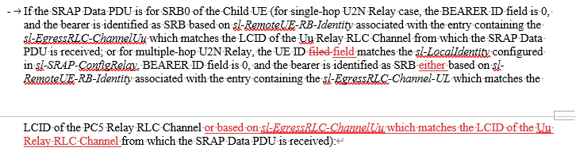  In clause 5.2.2.2:  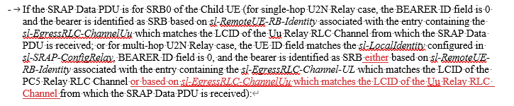 | Agree, will be included in the Rapp CR
SRAP-2 (Huawei) | The egress link determination seems unclear at the relay UE in the procedural text.  The egress link should be determined based on the mapping between the local ID (contained in the SRAP header) and the L2ID of the connected child UE in the downstream.  If we agree for such change here, we will also need to introduce similar change in the RRC spec. | The corresponding change in clause 5.2.2.1 is highlighted:  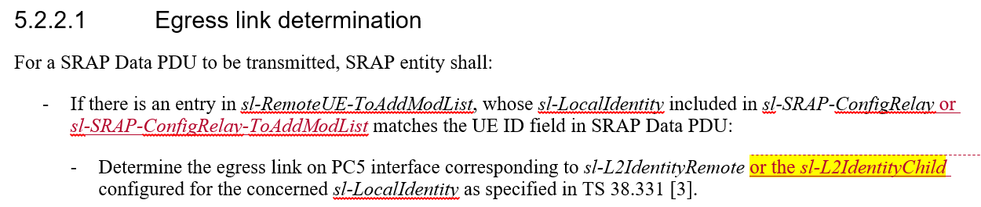
SRAP-3 (Huawei) | The error handling of SRB0 and SRB1 at the intermediate relay UE (except for the first relay UE).  It is possible that the intermediate relay UE does not receive the RRC reconfiguration when receiving the SRB0/SRB1 message from the connected child UE during the RRC setup procedure/the path switch procedure. In the current spec, the intermediate relay may discard the SRB0/SRB1 message in the above case. We need to consider the above case in the error handling clause. | The corresponding change in clause 5.4 is highlighted:  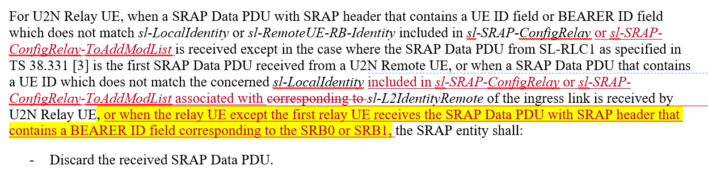

Conclusions
<To be filled after companies have provided feedback to the proposed resolutions for simple issues only. Please include the number of supporting companies (e.g., 18/20]) in brackets within the proposal>
The following proposals have been provided based on feedback to the above document:
[Proposals for easy agreement]
<List all proposals with consensus and/or may be easily agreed based on Rapporteur’s opinion>

[Proposals for discussion]
<List all proposals which will likely require further online/offline discussion to resolve>

References
[1] R2-2506566 Introduction of NR sidelink multi-hop relay in TS 38.351

