3GPP TSG-RAN WG2 Meeting #131bis R2-250xxxx
Prague, Czechia, 13th – 17th October, 2025

Agenda Item: 8.13.1
Source: OPPO
Title: Report of [Post131][411][Relay] Rel-19 relay 38.351 CR (OPPO)
Document for: Discussion, Decision

Introduction
The following document is to collect open issues for the following email discussion::
- [Post131][411][Relay] Rel-19 relay 38.351 CR (OPPO)
Scope: Update the CR in R2-2505353 in accordance with decisions of RAN2#131.
Intended outcome: Agreed CR in R2-2506323
Deadline: Short (for RP)

Companies are invited to provide feedback on open issue list by: Sept. 19th 10:00 UTC.

Remaining open issues for specification TS 38.351
Companies are invited to describe any other identified open issues not currently included within this document
SRAP-Issue num (Company) | Identified open issues | Suggested change | Rapp comment
SRAP-1(ASUSTeK) | The handling of the last relay operation for identifying SRB0 of the Child UE is not clearly captured in the current running CR clause 5.2.2.0/5.2.2.2. | In clause 5.2.2.0: 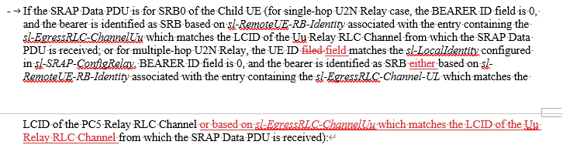  In clause 5.2.2.2:  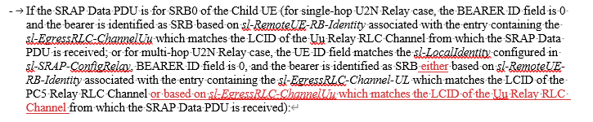 | Agree, will be included in the Rapp CR

Conclusions
<To be filled after companies have provided feedback to the proposed resolutions for simple issues only. Please include the number of supporting companies (e.g., 18/20]) in brackets within the proposal>
The following proposals have been provided based on feedback to the above document:
[Proposals for easy agreement]
<List all proposals with consensus and/or may be easily agreed based on Rapporteur’s opinion>

[Proposals for discussion]
<List all proposals which will likely require further online/offline discussion to resolve>

References
[1] R2-2506566 Introduction of NR sidelink multi-hop relay in TS 38.351

