**3GPP TSG-RAN WG2 Meeting #131bis R2-250xxxx**

**Prague, Czech Republic, Oct. 13-17, 2025**

**Agenda item: 8.11.1**

**Source: Samsung**

**Title: List of Rel-19 SBFD MAC open issues for maintenance**

**Document for: Discussion and Decision**

# Introduction

This offline discussion aims to collect and summarize Rel-19 SBFD MAC open issues/suggested resolutions for maintenance, compared to the agreed Rel-19 SBFD MAC CR [1], according to the instructions from Chairlady captured below.

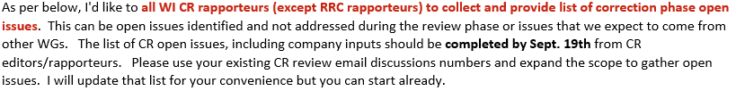

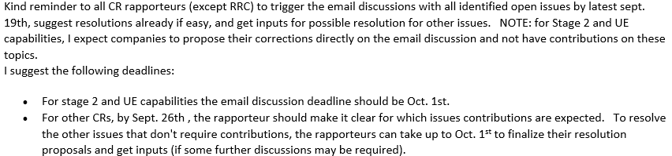

As the result of this discussion, the Rapporteur will provide a summary outlining:

- the issues (if any) requiring further discussion with tdoc contributions in RAN2#131bis, and

- the non-controversial/editorial issues (if any) that will be handled by Rapporteur CR in RAN2#131bis, as well as the draft Rapporteur CR for review before submission deadline.

Kindly provide your input for this discussion, no later than **Sep. 19, 10:00 UTC**.

Please provide your contact information in the table below when responding.

|  |  |  |
| --- | --- | --- |
| **Company** | **Name** | **Email** |
|  |  |  |
|  |  |  |
|  |  |  |
|  |  |  |
|  |  |  |

# Co-existence of SBFD and intra-DU LTM

We have agreed to support the coexistence of SBFD and intra-DU LTM in the last meeting [2], as captured below.

|  |
| --- |
| Email discussion summary  R2-2505364 Summary of [Post130][216][SBFD] Running CR for 38.331 Huawei, HiSilicon discussion Rel-19 NR_duplex_evo-Core   * Noted   *[Proposals for easy agreement]:*  *[Proposal for RRC-2] Not to support that a further different SSB RSRP threshold is indicated/configured for an SSB or a group of SSBs. [13/13]*  *[Proposal for RRC-3] Not to pursue the further optimization of parameter signalling of SBFD RACH configuration. [11/12]*  *[Proposal for RRC-6] (Only) support RACH-based LTM cell change in SBFD symbols [10/11]. Add RO type indication in LTM cell switch command MAC CE.*  *[Proposals for discussion]:*  *[Proposal for RRC-1] For the network indicating RO type, use 1 bit signalling (as in the current RRC running CR) [9/13].*   * Not to support that a further different SSB RSRP threshold is indicated/configured for an SSB or a group of SSBs. * Not to pursue the further optimization of parameter signalling of SBFD RACH configuration.   Discussions  RRC-6  - Samsung object this proposal. Samsung think this should be discussed in LTM session.  - InterDigital think there is majority so we can agree, think we can discuss in SBFD because it is co-existence with Rel-18 LTM. Nokia, LG E, ZTE, CATT agree.  - ZTE think at least for intra-DU case we should be able to agree. QC agree with ZTE, think if we cannot conclude here it is not easy to agree in LTM session either. Ericsson, CATT agree.  - Samsung also has concern because there is RAN3 impact, and it is the last meeting for the WI. ZTE think if we focus on intra-DU, then there is not additional R3 impact.  - Samsung wonder if we agree which WI should handle the necessary MAC spec change.   * Support co-existence of SBFD with intra-DU LTM. Whether to support the co-existence between SBFD and other LTM cases is not discussed in the Rel-19 SBFD WI. |

***Question: Do companies think additional MAC spec change(s) compared to the agreed MAC CR [1] is needed for supporting the co-existence of SBFD and intra-DU LTM? Please provide the suggested change(s) if any.***

|  |  |  |
| --- | --- | --- |
| **Company** | **Any change is needed? (Yes/No)** | **Suggested change(s), if any** |
|  |  |  |
|  |  |  |
|  |  |  |

**Summary**:

# Other MAC open issues for maintenance

Please share any other identified MAC open issues for maintenance, by explaining what the issue is, and the suggested change(s), including editorial improvement. Note that, as the WI has been declared complete, the Rapporteur will not consider the issue(s) involving any further functional changes, for further discussion.

|  |  |  |  |
| --- | --- | --- | --- |
| **Company** | **Identified issues** | **Suggested change(s)** | **Rapp comment** |
|  |  |  |  |
|  |  |  |  |
|  |  |  |  |

**Summary**:

# Conclusions

The following issues have been identified based on the discussion.

**Issues for further discussion with tdoc contributions in RAN2#131bis:**

**…**

**Issues that will be handled by Rapporteur CR for RAN2#131bis:**

**…**

# References

1. R2-2506606 Introduction of Rel-19 Evolution of NR duplex operation (SBFD) for MAC spec, CR#2106, Samsung
2. R2-2506202 Report from session on Rel-18 MIMO, Rel-19 MIMO, LPWUS, SBFD, NR Others RAN2 Vice Chairman (CATT)