**3GPP TSG-RAN WG2 Meeting #131bis R2-250xxxx**

**Prague, Czech Republic, Oct. 13th-17th, 2025**

**Agenda item: 8.12.1**

**Source: Samsung**

**Title: Report of Rel-19 MIMO MAC open issues for maintenance**

**WID/SID: NR_MIMO_Ph5**

**Document for: Discussion and Decision**

# Introduction

This offline discussion aims to collect Rel-19 MIMO MAC open issues for maintenance according to the instruction below indicated in email thread **[POST131][000][Organizational] Schedule and Agenda** and in the RAN2#131bis meeting agenda.

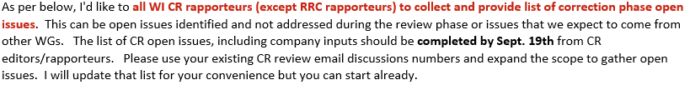

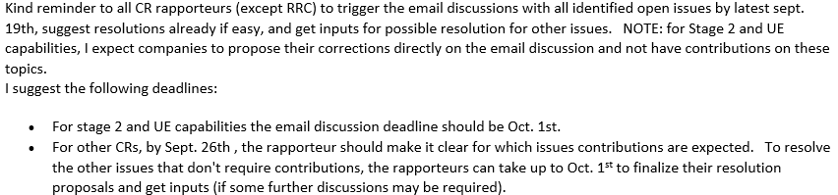

The following CR review offline discussion is used to expand the scope to gather open issues.

* [Post131][217][MIMO_Ph5] CR for TS 38.321 (Samsung)

Intended outcome: ~~Agree the CR for TS 38.321~~ and collect open issues for maintenance.

Deadline: **phase-1 Sep. 19th 1000 UTC; phase-2 Sep. 26th 1000 UTC.**

For phase-1 discussion, companies are invited to provide identified open issues and the corresponding suggested solutions by **Sep. 19th 1000 UTC**, so that Rapporteur can summarize the issues to be discussed in phase-2.

For phase-2 discussion by **Sep. 26th 1000 UTC**, companies please share views on the issues summarized by the Rapporteur. Based on the comments, Rapporteur will list the easy issues with promising solutions and the controversial issues to be further discussed based on tdoc contribution.

Companies are encouraged to spend time early to identify open issues and utilize this offline discussion to provide inputs in order to facilitate the tdoc preparation and the discussion at RAN2#131bis.

# Discussion

For phase-1 discussion by Sep 19th 1000 UTC, please provide the description of the identified issues and the potential solutions. As the outcome of phase-1 discussion, Rapporteur will indicate the issues to be discussed in phase-2. Some easy issues may not need phase-2 discussion.

* The identified issue should have potential MAC impact. Issues can include the ones discussed/proposed in RAN2 before but not solved/concluded, the ones with RAN2 impact caused by other WG (e.g., RAN1) but not identified before, and so on.
* For the proposed solution, companies are encouraged to provide the detailed TP, or if not possible, a high-level proposal at least.

For phase-2 discussion by Sep 26th 1000 UTC, please provide comments on the issues/solutions listed in phase-1 discussion outcome.

Companies are also encouraged to indicate miscellaneous and non-controversial issues (including editorial issues) here. Such issues can be provided until Sep 26th 1000 UTC and will be directly handled in the Rapporteur CR to be submitted to RAN2#131bis.

Please use the template below and fill in each block for one issue.

# [Company name] [Issue-1]

**[Issue Description]**:

**[Proposed Solution]**:

**[Phase-2 Discussion]**:

# [Company name] [Issue-2]

**[Issue description]**:

**[Proposed Solution]**:

**[Phase-2 Discussion]**:

…

# Conclusions

The following open issues are listed with suggested way forward.

…

# References

1. R2-2506202 Report from session on Rel-18 MIMO, Rel-19 MIMO, LPWUS, SBFD, NR Others RAN2 Vice Chairman (CATT)
2. R2-2506539 Introduction of MIMO Rel-19 TS 38.321 CR#2100 Samsung