3GPP TSG-RAN WG2 #131bis R2-250xxxx

Prague, Czech Republic, October 13 – October 17, 2025

Agenda item: 8.7.1 (NR_XR_Ph3-Core)
Source: LG Electronics
Title: List of open issues for Rel-19 XR PDCP CR
Document for: Discussion and Decision

1. Introduction
This document is to discuss open issues in Rel-19 XR PDCP CR (R2-2506337), following the chairlady’s guideline.
Agenda
The agenda has been updated for all Rel-19 features and new AIs have been created for R20 NR features and the 6G Study item.

Please carefully read the instructions.
Kind reminder to all CR rapporteurs (except RRC) to trigger the email discussions with all identified open issues by latest sept. 19th, suggest resolutions already if easy, and get inputs for possible resolution for other issues. NOTE: for Stage 2 and UE capabilities, I expect companies to propose their corrections directly on the email discussion and not have contributions on these topics.
I suggest the following deadlines:
- For stage 2 and UE capabilities the email discussion deadline should be Oct. 1st.
- For other CRs, by Sept. 26th , the rapporteur should make it clear for which issues contributions are expected. To resolve the other issues that don't require contributions, the rapporteurs can take up to Oct. 1st to finalize their resolution proposals and get inputs (if some further discussions may be required).

This discussion will proceed with following schedule:
- Gathering open issues identified from companies. Deadline September 19, 18:00 UTC.
- Discussion on the identified open issues. Deadline September 25, 23:59 UTC.
- Rapporteur resolution/suggestion will be provided on October 1.

2. Contact information
Company | Name | E-mail
LG Electronics | SeungJune Yi | seungjune.yi@lge.com
Huawei, HiSilicon | Yinghao Guo | Yinghaoguo@huawei.com
Nokia | Sunyoung Lee | sunyoung.lee@nokia.com

3. Open issues from PDCP CR (R2-2506337)
Companies are invited to list their identified open issues, using comment identifier (company ID and number), e.g. LGE001.
Comment identifier | Section | Open issue description
H001 | 3.1 | We still think that it is good to align with the definition with the procedure text for non-delay-reporting PDCP SDU, and disagree with the resolution below :  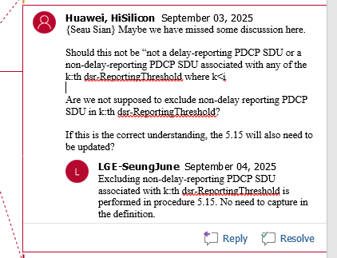  The change can be just as follow :  Non-delay-reporting PDCP SDU: a non-delay-reporting PDCP SDU associated with the DSR-ReportingThreshold is a PDCP SDU that will be transmitted prior to any of the delay-reporting PDCP SDUs associated with the i:th DSR-ReportingThreshold and that is not a delay-reporting or non-delay reporting PDCP SDU associated with any of the k:th DSR-ReportingThreshold where k<i.
N001 | 5.16.1 | During the last review, we pointed out that one agreement seems to be missing from #131 meeting:  (RLC-12) No special handling is needed in R19 for PDCP SN gap report during UE mobility. It can be left to UE implementation whether to re-send the gap report after HO.  Rapportuer explained that this doesn’t need to be specified because we agreed on no additional handling. But our understanding is that, from the current specifiation, the UE cannot tell whether re-sending is even allowed (Rather it could understand that re-sending is not allowed). Thus, it needs to be specified in the clause 5.16.1 at least as a NOTE.

4. Discussion on the identified open issues

5. Summary

