**3GPP TSG-RAN WG2 Meeting #131 R2-250xxxx**

Bangalore, India, 25th – 29th August 2025

**Agenda item: 8.4.2**

**Source: Huawei/HiSilicon**

**Title: Summary of [Post130][222][LPWUS] Potential solution to support enabling/disabling LP-WUS monitoring in IDLEI/NACTVE per UE (Huawei)**

**WID: NR_LPWUS-Core**

**Document for: Discussion and Decision**

# Introduction

This document aims to collect views from companies for the following email discussion:

* [Post130][222][LPWUS] Potential solution to support enabling/disabling LP-WUS monitoring in IDLE/INACTVE per UE (Huawei)

Intended outcome: Summary with proposals

Deadline: Long

Rapporteur would like to organize the email discussion in two phases:

Phase 1: Companies are invited to provide comments to the questions by 4th July.

Phase 2: Rapporteur provides the summary report + proposals by 15th July. Companies can further comment by 31st July; Rapporteur will finalize the summary + proposals by 8th August.

Please provide your contact information when responding.

|  |  |
| --- | --- |
| Company | Contact: Name (E-mail) |
| Ericsson | Martin van der Zee (martin.van.der.zee@ericsson.com) |
| CATT | Da Wang (wangda@catt.cn) |
| InterDigital | Jongwoo Hong (jongwoo.hong@interdigital.com) |
| DOCOMO | Yugen Takahashi (yuki.takahashi.sd@nttdocomo.com) |
| NEC | Rao (shi_rao@nec.cn) |
|  |  |
|  |  |
|  |  |
|  |  |
|  |  |
|  |  |
|  |  |
|  |  |
|  |  |
|  |  |
|  |  |

# Discussion

RAN2 discussed the summary of AT meeting email discussion on enabling/disabling of LP-WUS in RAN2-130. Below is the related excerpt from the chairman notes:

|  |
| --- |
| R2-2504738 Summary of [AT130][204][LPWUS] Proposals on whether/how to enable/disable LP-WUS, e.g. by RRC/NAS Huawei, HiSilicon discussion Rel-19   * Noted   *Proposal 1 (13/17): Support enabling/disabling LP-WUS monitoring in IDLE/INACTVE per UE.*  *Proposal 2 (13/17): A unified solution is preferred to enable/disable LP-WUS monitoring in IDLE/INACTIVE per UE.*  *Proposal 3: FFS how to enable/disable LP-WUS per UE for IDLE and INACTIVE. Following options can be considered: 1) NAS signalling 2) RRC signalling 3) both NAS and RRC signalling 4) No spec changes (i.e., if no convergence on NAS or RRC signalling)*  Discussions  - HW think P3 requires more discussion.  P1  - Samsung think it should be per cell, but do not have objection.  - vivo support P1. As WI rapp, vivo think it is end of the release so it we decided to do so we need to discuss solutions in the post meeting email and we need to inform our conclusion to other TSG/WG (e.g., R3, CT1). ZTE, Ericsson, NEC think this is reasonable.  - QC think before P1 we need to decide on P3 because we do not know what is the solution. QC think this is optimization and nothing is broken without it. Xiaomi, OPPO, Lenovo share this view.  - Xiaomi think SA2 is considering removing restriction for emergency service even for PEI, so in R2 we do not need to do anything.  - ZTE think we can conclude in R2 that we aim to support but keep the solutions open. Interdigital agree.  - Interdigital do not think LS to other WG/TSG is urgent. Ericsson think the impact is rather low.  - Nokia wonders whether it mandates UE to enable/disable. NEC think not.  - Apple think we do not need to do more, and think we do not have time. Lenovo also think so.  - CATT think we can rely on UE implementation and close the issue from R2 point of view.  - WI rapp think the conclusion of this issue does not impact the WID completion.  - DCM think from operator point of view we need to support a solution.   * RAN2 aim at supporting enabling/disabling LP-WUS monitoring in IDLE/INACTVE per UE, if the solution can be concluded in the August meeting.   P3  - Samsung think there is one more option, which is to use CN-based subgrouping. Apple agree. |

As there was no consensus on the solution to support enabling/disabling LP-WUS monitoring in IDLE/INACTIVE per UE, the email aims to collect the views from companies to check if a conclusion can be reached for the next meeting.

Before discussing the issue, let’s revisit the procedures for CN controlled and UE-ID based subgrouping methods described in Stage 2 running CR for LP-WUS [6]. AMF is responsible for assigning CN subgroup ID during the registration procedure as shown in Figure 1. Steps 1 to 3 in the Figure are part of Registration Procedure via NAS signalling.



Figure : Procedure for CN controlled subgrouping (from 38.300 running CR)

For UE-ID based subgrouping, the gNB and UE can determine the subgroup ID based on the UE ID and the total number of subgroups for UE-ID based subgrouping in the cell. The procedure is shown in Figure 2.



Figure : Procedure for UE-ID based subgrouping (from 38.300 running CR)

## Reasons to support enabling/disabling of LP-WUS for a UE

Companies presented different technical arguments on why disabling and re-enabling LP-WUS for a UE is needed. Following is a short summary of the arguments:

* + - Reducing false paging probability or increasing the reachability of the UE: NW (CN or RAN) decides whether to disable LP-WUS based on the conditions in the NW (e.g., radio resources) and/or characteristics of the UE (e.g., paging probability, shorter DRX cycle, etc) [1][2][3]
    - Disabling for UEs with delay-sensitive services: the UEs with delay-sensitive services may not be suitable to monitor LP-WUS considering the possible large wake up latency caused by LP-WUS which may have unexpected impacts on the delay-sensitive service [3][4][5]
    - Power Consumption: if the paging probability is high for some specific UEs, there will be frequent transitions between MR and LR and this impacts the power saving. It’s better these specific UEs do not monitor LP-WUS [3]

## Different solution options to support enabling/disabling of LP-WUS for a UE

There are mainly three directions to disable/re-enable LP-WUS operator for a UE.

* NAS signalling
* RRC signalling
* No NAS/RRC spec changes
  + Apple’s method
  + CATT’s method

The following sections describe each option.

### NAS signalling

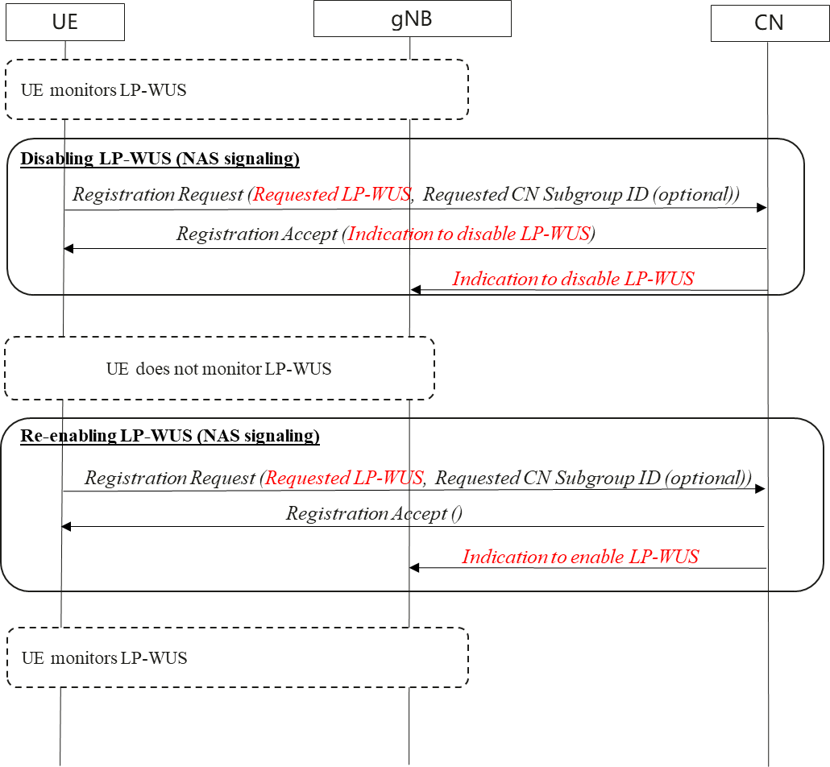

Figure : Disabling/Enabling of LP-WUS with NAS signaling

Assume that the UE is monitoring LP-WUS. CN decides to disable LP-WUS for the UE due to some conditions in the PLMN.

A brief description of the procedure and its impact to other WGs:

* **Disabling LP-WUS:** CN indicates explicitly to the UE to disable LP-WUS in the registration procedure. Even though the solution details are up to CT1, a new parameter “*Requested LP-WUS*” in Registration Request is needed. Otherwise CN is not aware whether UE supports LP-WUS or not if UE does not include the optional parameter “*Requested CN Subgroup ID*”
* **Enabling LP-WUS:** If the conditions in the NW are favourable to re-enable LP-WUS, CN will enable it in the subsequent registration procedure.
* **Impacts to other WGs:**
  + RAN3 and CT1

### RRC Signalling

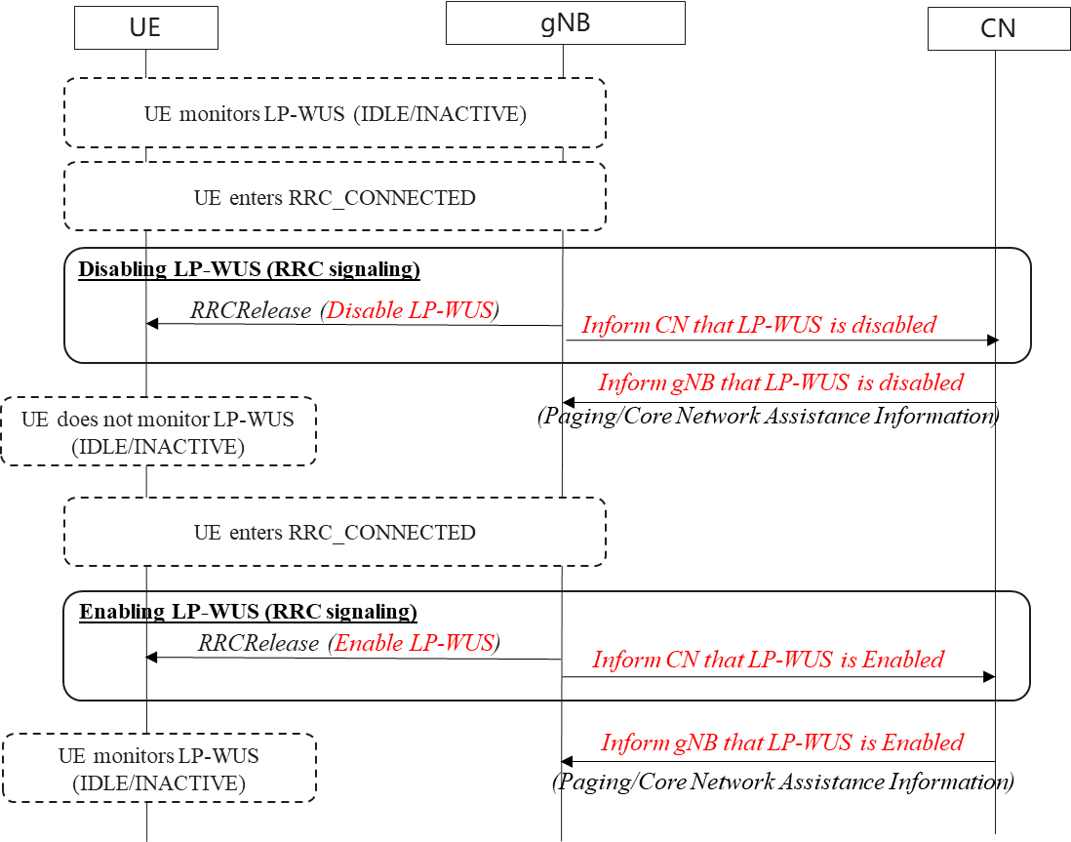

Figure : Disabling/Enabling of LP-WUS with RRC signaling

Assume that the UE is monitoring LP-WUS. RAN decides to disable LP-WUS for the UE due to some conditions in the NW.

A brief description of the procedure and its impact to other WGs:

* **Disabling LP-WUS:** gNB indicates explicitly to the UE to disable LP-WUS in *RRCRelease*. gNB also informs CN that LP-WUS is disabled for the UE so that CN does not use CN subgrouping. CN further informs gNB about disabling of LP-WUS in Paging and Core Network Assistance Information for RRC_INACTIVE.
* **Enabling LP-WUS:** If the conditions in the NW are favourable to re-enable LP-WUS, gNB will enable it in the subsequent *RRCRelease*. gNB informs CN and CN will also include the information for Paging and Core Network Assistance Information procedures.
* **Impacts to other WGs:**
  + RAN3 and CT1

### No NAS/RRC changes

Apple proposed method addresses the issue without any changes to the spec [7].

CATT proposed method addresses the issue without any changes to NAS/RRC spec [8].

#### Apple’s method

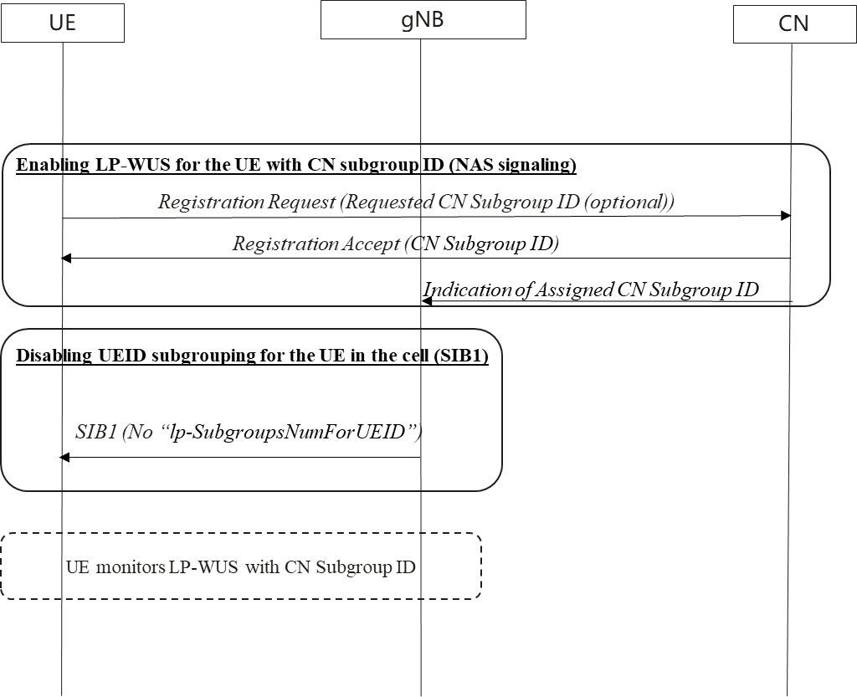

Figure : Enabling UE specific LP-WUS monitoring control by enabling the CN based subgrouping method in a cell

Figure 5 shows enabling UE specific LP-WUS monitoring by enabling CN subgrouping in a cell.

* CN enables CN subgrouping during registration procedure.
* gNB does not include “*lp-SubgroupsNumForUEID*” in SIB1. This implies that UE monitors LP-WUS with CN subgroup ID.

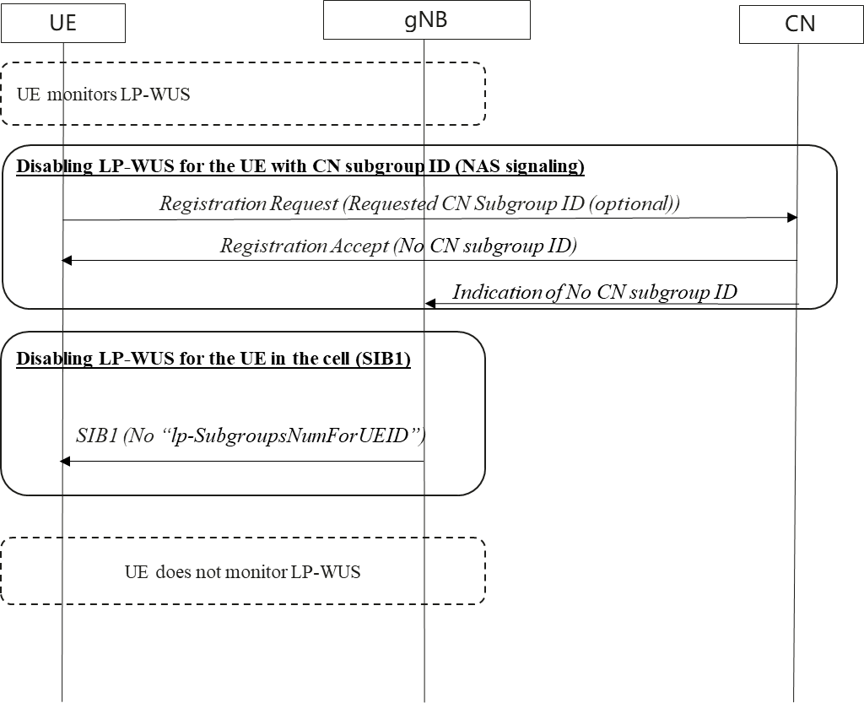

Figure : Disabling UE specific LP-WUS monitoring control for a particular UE by disabling CN based subgrouping method in a cell

Figure 6 shows disabling UE specific LP-WUS monitoring by disabling CN subgrouping:

* CN disables CN subgrouping during registration procedure
* gNB does not include “*lp-SubgroupsNumForUEID*” in SIB1. This implies that UE will not monitor LP-WUS as it is not assigned either CN subgrouping or UE-ID based subgrouping

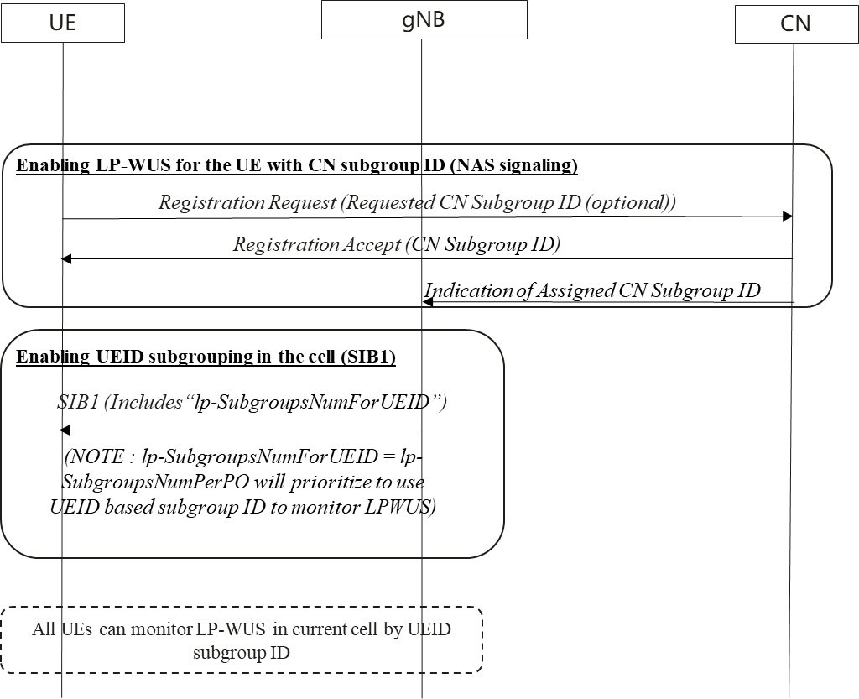

Figure : Enabling UE specific LP-WUS monitoring control in cell level by enabling UE-ID based subgrouping method in a cell

Figure 7 shows the procedure to disable UE specific LP-WUS in a cell (i.e., all UEs can monitor LP-WUS):

* CN enables CN subgrouping during registration procedure
* gNB includes “*lp-SubgroupsNumForUEID*” in SIB1. (NOTE: if *lp-SubgroupsNumForUEID* = *lp-SubgroupsNumForPO, UE-ID based subgrouping will be prioritized to monitor LP-WUS)*
* All UEs can monitor LP-WUS in current cell by UE-ID based subgrouping.

#### 2.2.3.2 CATT’s method

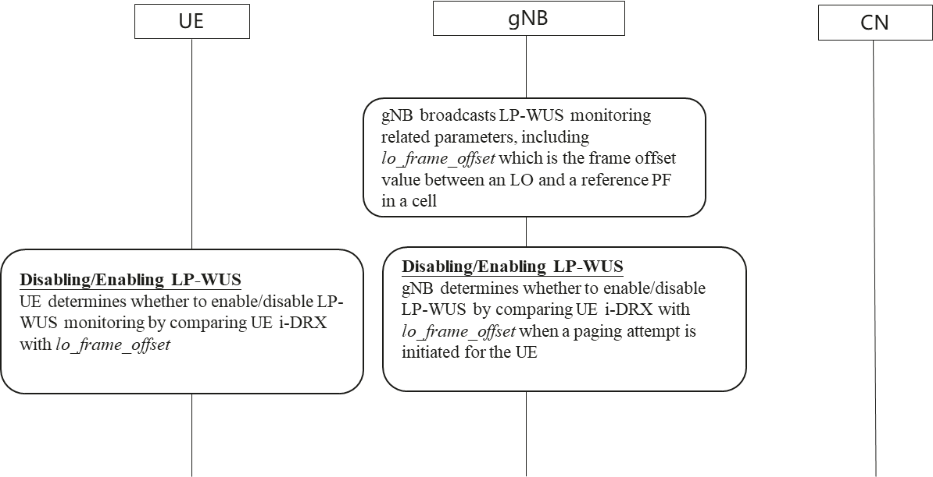

Figure : UE/gNB autonomously decides whether to enable/disabling LP-WUS monitoring

Figure 8 shows the procedure for the UE/gNB to enable/disable autonomously:

* Whether UE is using UE-ID or CN based subgroup does not matter.
* UE/gNB determines whether to enable/disable LP-WUS monitoring by comparing UE i-DRX (i,e., DRX cycle of the UE as specified in TS 38.304) with *lo_frame_offset*. If UE i-DRX is no less than the value of *lo_frame_offset*, the UE/network enables LP-WUS monitoring. Otherwise, the UE/network disables LP-WUS monitoring.
* Impact to other WGs:
* Only impact RAN2 without RRC spec change.

## Questions

#### Q: Which solution option(s) do companies prefer?

|  |  |  |
| --- | --- | --- |
| Company | Preferred Option | Comments |
| Ericsson | NAS signalling |  |
| CATT | CATT’s method | We think the main motivation to support enabling/disabling of LP-WUS for a UE is reduce the possible large wake up latency. Because LP-WUS has maximum 31 sub-groups, so that false paging probability is not a big issue. And if frequent transition between MR and LR impacts the power saving, smart UEs can decide not to monitor LP-WUS with UE implementation.  Thus, we prefer the method in clause 2.2.3.2, i.e., CATT method. UE/gNB determines whether to enable/disable LP-WUS monitoring by comparing UE i-DRX (i,e., DRX cycle of the UE as specified in TS 38.304) with *lo_frame_offset*. This method doesn’t impact other WGs. It only impacts RAN2 in TS 38.304.  For the method in clause 2.2.3.1, i.e., Apple’s method, we wonder how to disable LP-WUS for a UE if the UE doesn’t support CN assigned subgrouping for LP-WUS. |
| InterDigital | NAS signalling and RRC signalling | In our view, to reduce wake-up latency due to LP-WUS monitoring, one method with signalling (RRC-based or NAS-based) is necessary and at least network can control LP-WUS monitoring function for latency reduction purpose.  We support both solutions since both NW entity (CN node or gNB) can control and be involved (i.e., LP-WUS enabling/disabling) with different layers and signalling per a UE. If RAN2 needs to down-select one of them, then prefer RRC signalling, otherwise both approaches are fine. |
| DOCOMO | RRC signalling (and NAS signalling) | We prefer RRC signalling but are open to support NAS signalling in addition to RRC signalling.  RRC_IDLE and RRC_INACTIVE handling is based on gNB. As gNB has more knowledge of the situation in its serving cell and can toggle LP-WUS monitoring on every RRC transition to IDLE/INACTIVE if needed, RRC signalling should be suitable. On the other hand, NAS signalling may be preferrable to disable LP-WUS for power consumption reduction when eDRX cycle length is long because eDRX related parameters are determined by NAS signalling.  Regarding the Apple’s method, we share the same comment as CATT. It seems unclear how to disable LP-WUS if the UE does not support the CN assigned subgrouping.  For the CATT’s method, we think it is more complicated compared to the RRC and NAS signalling method in Section 2.2 as UE/gNB interpretations on the parameters are required. Therefore, we do not prefer it at this moment. However, if it is difficult to converge on the RRC and/or NAS signalling method due to the other WG impact, we would be fine to live with it. |
| NEC | RRC or NAS | We support dedicated enable/disable, can be open for both and will follow the one for which majority support.  BTW, for the method of RRC, one comment for the Figure-4 is that once CN receives LP-WUS enable/disable indication, **CN does not have to send this indication within *Core Network Assistance information for RRC_INACTIVE*** as the gNB itself is aware of whether LP-WUS is enabled or disabled when initiating Uu paging for RRC_INACTIVE UE or initiating Xn RAN paging msg.  The basic principle should be for RRC method, gNB informs CN of LP-WUS status while for NAS method, CN informs gNB of LP-WUS status. And when paging procedure is initiated, LP-WUS enable/disable will be indicated by Xn/Ng paging message (e.g., by UE radio paging capability). |
|  |  |  |

## Summary

TBD

# Conclusions

Based on the inputs from companies, the following proposals are made:

# References

1. R2-2504288 Procedure and configuration of LP-WUS in RRC_IDLE/RRC_INACTIVE, Ericsson

[2] R2-2503900 Further discussion on the LP-WUS in RRC_IDLE/INACTIVE mode, Huawei, HiSilicon

[3] R2-2503568 Discussion on LP-WUS in RRC_IDLE INACTIVE, NEC

[4] R2-2503763 Procedure and configuration of LP-WUS for IDLE and INACTIVE mode, ZTE

[5] R2-2504363 Discussion on LP-WUS operation in RRC_IDLE/INACTIVE modes, InterDigital

[6] Stage 2 running CR for LP-WUS

[7] R2-2503809 LP-WUS in RRC_IDLEINACTIVE, Apple

[8] R2-2503659 Remaining issues on LP-WUS in IDLE and INACTIVE, CATT