**3GPP TSG-RAN2 Meeting # 131R2-250**

**Bangaluru, India, 25 – 29 August, 2025**

**Agenda Item: 8.7.1**

**Source: Huawei, HiSilicon**

**Title: Summary of [POST130][506][XR] RRC running CR and open issues (Huawei)**

**Document for: Discussion and Decision**

# 1 Introduction

This paper summarizes the post meeting email discussion for the RRC running CR

|  |
| --- |
| * **[POST130][506][XR] RRC running CR and open issues (Huawei)**   Scope:   * Update and review the CR * List open issues related to the CR   Intended outcome:   * Running CR for endorsement in the next meeting * List of open issues for discussion at the next meeting   Deadline: Long |

Please fill in the contact information in the table below

|  |  |  |
| --- | --- | --- |
| **Company** | **Contact Person** | **Email Address** |
| Nokia | Chunli Wu | Chunli.wu@nokia-sbell.com |
| Ericsson | Nithin Srinivasan | nithin.srinivasan@ericsson.com |
| Vivo | Chenli | Chenli5g@vivo.com |
| Ofinno | Hsin-Hsi Tsai | htsai@ofinno.com |
| Samsung | Weiping Sun | wp.son@samsung.com |
| Apple | Ping-Heng Wallace Kuo | pingheng_kuo@apple.com |
| Qualcomm | Linhai He | linhaihe@qti.qualcomm.com |
| Futurewei | Yunsong Yang | yyang1@futurewei.com |

2. Discussion

## 2.1 Examining the running CR

In the table below, companies are invited to provide inputs on the issues for the current running CR

***Qustion0: Any issue on the running CR?***

|  |  |  |
| --- | --- | --- |
| **Company** | **Identified issue** | **Comment** |
| Ericsson | Not an issue as such, but would be good to introduce additional values for t-RxDiscard for configuration flexibility. | Introduce some additional values for t-RxDiscard as follows:  T-RxDiscard-r19 ::=  ENUMERATED {ms10, ms20, ms30, ms40, ms50, ms60, ms75, ms100, ms150, ms200, ms250, ms300, ms400, ms500, ms750, ms1000, ms1500, ms2000, ms3000}  [FW]: We don’t quite see the benefit of having some many large values (such as those above ms300) for this timer. T-RxDiscard-r19 is introduced in Rel-19 to avoid unnecessary AM RLC pending retransmission(s) and pending transmission(s) of remaining un-transmitted segment(s), which RAN2 didn’t bother to deal with initially in Rel-18 due to limited gain. In Rel-19, RAN2 decided to deal with this case. However, in our view the gain may worth the trouble only when dealing with XR video traffic. And this timer value should be tightly related to the discardTimer value, which is typically 10 msec for DL XR video traffic (since the UE is the recipient). We don’t see the need for either T-Reassembly or T-RxDiscard-r19 to be so much longer than the discardTimer value. If the intention is to cover the long range for the sake of cautiousness, at least we don’t need to optimize the granularity in the long range by adding new values. |
| Samsung | Add the comments with bubbles in CR file. |  |

## 2.2 Spec implementation issues

### 2.2.1 UE assistance information

During RAN2#130, it has been agreed that a prohibit timer is needed for the UAI carrying the gap cancellation ratio. But it is FFS what is the granularity of the prohibit timer

|  |
| --- |
| * (RRC-06) A prohibit timer is used to limit frequent transmission of the UAI with recommended gap cancellation ratio. FFS the granularity of prohibit timer |

Regarding the granularity of the preference for meas gap cancellation ratio, the following has been agreed during the last R4 meeting and the LS R4-2508312 has been sent to R2

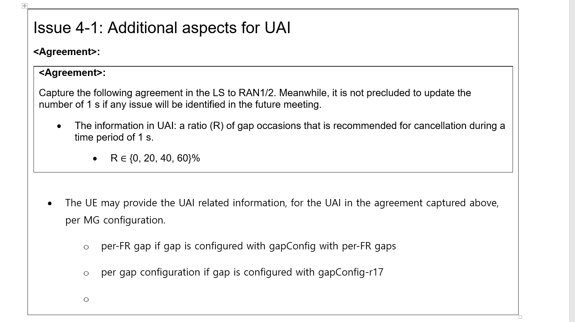

To summarize the above, the agreement means that the preference assistance can be provided per gap configuration

* When per-FR gap is configured, the preferred ratio may be provided per FR gap configuration
* When gapConfig-r17 is configured, the preferred ratio may be provided per gap configuration

Then, returning to the issue of the granularity of the maintenance of the prohibit timer, we need to consider the following question as left as FFS from the last R2 meeting.

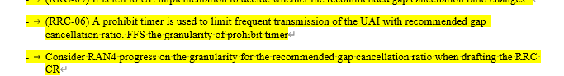

There are two possible granularities for the maintenance of the timer when multiple gap configurations are provided: (a) a single timer is maintained for all the gap configurations (b) the timer is maintained per gap configuration.

***Question1: Companies are invited to down-select the following the granularity for the prohibit timer to be maintained when multiple gap configurations are provided***

***(a) a single timer is maintained for all the gap configurations***

***(b) multiple timers are maintained, one timer for each gap configuration***

|  |  |  |
| --- | --- | --- |
| Companies | Option (a)/(b) | Comments |
| Nokia | (a) | Single timer is easier to maintain for the UE. One potential disadvantage of using single timer is that, if the UE decides to report a preference of gap occasion cancellation ratio for one measurement gap configuration, it is then prevented to report a (change in) preference of gap occasion cancellation ratio for another measurement gap configuration for the duration of the prohibit timer. This can be a limitation in case such change is detected by the UE short after the UE has reported UAI. However, since it is up to UE implementation to determine if the preference for gap occasion cancellation ratio has changed, we think a proper UE implementation can avoid such problem. Hence, we propose a single timer is maintained for all the gap configurations. |
| Ericsson | (a) | Agree with Nokia’s comment |
| vivo | (b) | Option (b) is more flexible than option (a). We believe that after reporting a preferred ratio for one measurement gap configuration, the running prohibit timer should **not** prevent the UE from reporting a preferred ratio for **another** measurement gap configuration.  Besides, following the existing UAI mechanism for other purpose, e.g. Overheating, power saving, etc. each preferred configuration could be controlled by separate prohibit timer. |
| Ofinno | (b) | When the UE does not have preferences for **all** the gap configurations at a given time, option (a) may lead to inefficiencies. To avoid preventing UAI reporting for a specific gap configuration due to the prohibit timer, the UE would either need to report preferences for all the gap configurations at a given time (potentially causing signalling overhead) or wait for the prohibit timer to expire (introducing undesirable delays). Both potential outcomes are suboptimal. Therefore, option (b) is preferred. |
| Samsung | (a) | Agree with Nokia. |
| Apple | (a) | A single timer is sufficient, we do not see the need for such complexity. |
| Qualcomm | (b) | Agree with vivo. Moreover, UE is not expected to be configured with many MG configurations. Hence we do not expect allowing different values for the prohibit timers would not considerably increase complexity of UE implementation. |
| Futurewei | (a) | Agree with Nokia. In addition, setting the prohibit timer allows the NW to control how frequently the UE can sent UAI. Having one timer will guarantee the UE’s compliance with the maximal frequency set by the gNB. Having multiple prohibit timers running independently cannot guarantee the UE’s compliance with the maximal frequency (e.g., the UE may send two UAIs in a roll as some company has suggested above). In this situation, the gNB may be forced to set a longer value for the multiple prohibit timers, which may be undesirable for the UE. |

Furthermore, it has not been discussed whether the prohibit timer configuration shall be released when RRC connection reestablishment or RRC resume procedure is performed. While in the legacy spec for the other fields for UAI, the prohibit timer configuration is released when re-establishment or resume happens. Take the R18 *UL-trafficInfo* as an example.

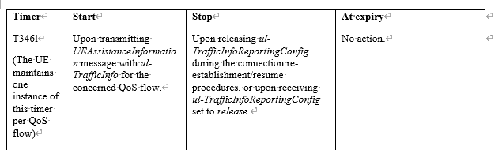

Rapporteur hence would like to ask the following question:

***Question2: Do companies agree that the prohibit timer configuration is released at the initiation of RRC re-establishment or RRC resume procedure or at the cell reselection during RRC re-establishment?***

|  |  |  |
| --- | --- | --- |
| Companies | Yes/No | Comments |
| Nokia | yes | Same as for UL traffic information reporting in Release 18. |
| Ericsson | Yes |  |
| vivo | Yes | Follow the legacy. |
| Ofinno | Yes |  |
| Samsung | Yes |  |
| Apple | Yes |  |
| Qualcomm | Yes |  |
| Futurewei | Yes |  |

The behaviour of the prohibit timer has not been discussed before. While we have also defined the other prohibit timers for other UAI fields and presumably, their behaviours should be similar. The rapporteur would like to confirm by the following question under the spirit of following the legacy spec:

***Question3: Do companies agree that the prohibit timer for the preference for gap occasion cancellation ratio is***

* ***started when UAI carrying the field measOccasionCancelPreference is transmitted***
* ***stopped when releasing the measOccasionPreferenceReportConfig when*** 
  + ***connection reestablishment/resume procedure is initiated or cell reselection happens during reestablishment***
  + ***measOccasionPreferenceReportConfig is set to release***

|  |  |  |
| --- | --- | --- |
| Companies | Yes/No | Comments |
| Nokia | yes | Same as for UL traffic information reporting in Release 18. |
| Ericsson | Yes |  |
| Vivo | Yes | Follow the legacy. |
| Ofinno | Yes |  |
| Samsung | Yes | Note: field name in running CR is “GapOccasionCancelRatioReportConfig”. |
| Apple | Yes |  |
| Qualcomm | Yes |  |
| Futurewei | Yes |  |

Another question on the timer is the configurable values for the prohibit timer. In the legacy, the set of values { s0, s0dot5, s1, s2, s5, s10, s20, s30,s60, s90, s120, s300, s600, spare3, spare2, spare1} have been widely reused for the prohibit timers defined for other features in UAI .

The rapporteur would like to ask the following question

***Question4: Do companies agree that the following candidate values { s0, s0dot5, s1, s2, s5, s10, s20, s30,s60, s90, s120, s300, s600, spare3, spare2, spare1} can be reused for the prohibit timer for preference of gap occasion cancellation ratio?***

|  |  |  |
| --- | --- | --- |
| Companies | Yes/No | Comments |
| Nokia | yes | Same as for UL traffic information reporting in Release 18. |
| Ericsson | Yes |  |
| Vivo | Yes | Follow the legacy. |
| Ofinno | Yes |  |
| Samsung | Yes |  |
| Apple | Yes |  |
| Qualcomm | Yes |  |
| Futurewei | Yes |  |

### 2.2.2 UL rate control

During R2#130, the following has been agreed on the granularity of the prohibit timer for bit rate query MAC CE

|  |
| --- |
| * (RRC-1) The granularity of bit rate query prohibit timer is QoS flow. * FFS The value of the prohibit timer is the same for all flows |

Based on the FFS agreed above, we need to understand whether the value of the prohibit timer is the same for all flows. It should not be noted that in the legacy R15 bit rate query, the value of the prohibit timer can be different for different logical channels, since the prohibit timer is configured per logical channel

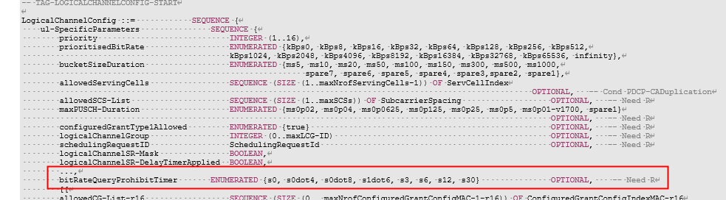

Another aspect of the issue is that in the previous meeting RAN2#129bis, we have agreed that the timer should be configured to implicitly control whether available bit rate query is allowed.

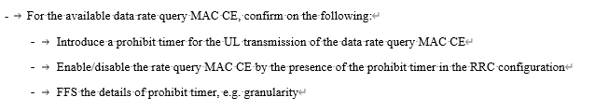

Hence, the rapporteur would like to ask the following question

***Question5: Do companies think that the value of prohibit timer is the same/different for all flows?***

|  |  |  |
| --- | --- | --- |
| Companies | Same/different | Comments |
| Nokia | Same | Basically, the rate control would be up to NW decision. If prohibition is used, we don’t see any good reason to configure different values (for all flows of the UE). But it is acceptable to configure the same values within the LCH. |
| Ericsson | Same | We don’t see a requirement to configure different prohibit timers |
| vivo | Same | No motivation to configure different values for all flows. |
| Ofinno | Different | The Bit Rate Query Prohibit Timer serves to restrict the UE from triggering the Bit Rate Query procedure excessively. Given the agreement that the Bit Rate Query procedure is triggered on a per-QoS flow basis, the network should retain control over the frequency with which the UE is permitted to trigger/send the bit rate query for a specific QoS flow. Furthermore, considering that different QoS flows can be associated with different services, and particularly for urgent services, the prohibition duration should not be too long. Allowing for configurable, per-QoS flow prohibit timer value provides the necessary flexibility to manage reporting frequency based on service requirements. |
| Samsung | Up to NW config | We have agreed that the prohibit timer is configured per QoS flow, to enabling/disabling the rate query for each flow. The configuration of these timers should be up to network, without imposing any constraint on whether the timer values should be the same or different across QoS flows. |
| Apple | Same | We think QFI-specific prohibit timer configuration (as agreed) is flexible enough, a common timer value for their configuration should be suffice. |
| Qualcomm | Same |  |
| Futurewei | Same |  |

Another issue is on the configurable values of the prohibit timer. In the legacy, we have a similar prohibit timer for bit rate query, which is configured per logical channel as the following

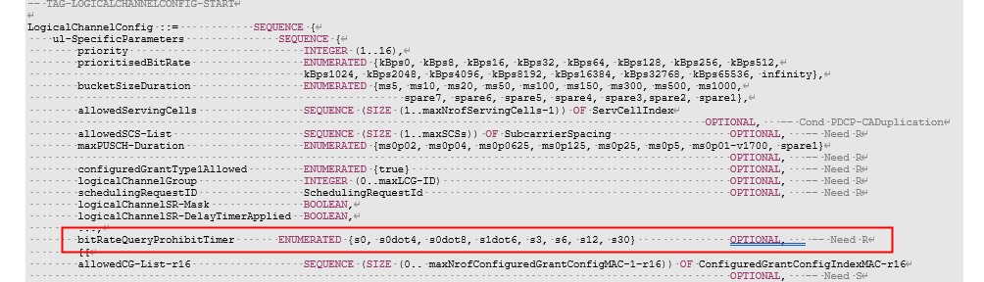

We would like to ask the following question on whether the values of the above timer can be reused.

***Question6: Do companies agree that the candidate values for the UL available data rate query prohibit timer can be { s0, s0dot4, s0dot8, s1dot6, s3, s6, s12, s30}?***

|  |  |  |
| --- | --- | --- |
| Companies | Yes/No | Comments |
| Nokia | Yes |  |
| Ericsson | Yes |  |
| Vivo | Yes |  |
| Ofinno | Yes |  |
| Samsung | Yes |  |
| Apple | Yes |  |
| Qualcomm | - | We are fine with the values proposed by the rapporteur, although it could be better if more values in the lower end can be added, e.g. *s0dot1, s0dot2.*  [FW]: Again, for UL congestion control purpose, we think what really matters is the video traffic. Given the typical video resolutions for UL XR, we think the setting of I-frame frequency will be similar to the typical video traffic on the Internet today, which is about 1 I-frame per second (while 1 I-frame per 2 seconds is not a rare case), with P-frames in between I-frames. No matter how frequent the UE may query, the gNB needs to evaluate whether it has enough capacity to boost the UL data rate for the UE after evaluating the congestion condition for at least one entire (and more likely multiple) I-frame to I-frame cycle; otherwise, evaluating only during a short period of all P-frames may lead to pre-mature rate change. If the gNB needs to take time to properly evaluate and respond to the UE, it seems wasteful to allow the UE to query so frequently that beyond how fast the gNB can properly respond. |
| Futurewei | Yes |  |

### 2.2.3 Parent IE of mg-CancellationDCI-0-3/1-3

In the consolidated list of RRC parameters sent to RAN2 after RAN1#120bis (R1-2503243), the list of RRC parameters after RAN1 functional freeze have been provided. In particular for XR, the placement of the two parameters *mg-CancellationDCI-0-3/1-3* has been left for RAN2 to decide

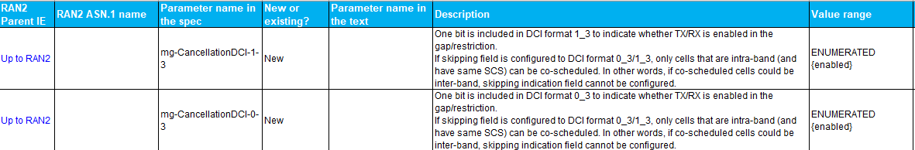

DCI 0-3/1-3 have been introduced for the scheduling multiple PUSCH/PDSCH in multiple cells with a single DCI. For enabling/disabling the MG occasion cancellation for DCI 0-3/1-3, the two options seem to be the following:

* **Option1: Per serving cell configuration** 
  + The two fields *mg-CancellationDCI-0-3/1-3* can be configured under *servingCellConfig*
  + The configuration is applicable for all the BWPs under this serving cell
* **Option2: Per BWP configuration**
  + The field *mg-CancellationDCI-0-3* can be configured under *PUSCH-Config* under *BWP-UplinkDedicated*; The field *mg-CancellationDCI-1-3* can be configured under *PDSCH-Config* under *BWP-DownlinkDedicated.*
  + The configuration is only applicable for the active BWP where PDCCH monitoring is performed and the DCI is received.

Based on the above, rapporteur would like to ask the following question

***Question7: The fields mg-CancellationDCI-0-3/1-3 should be configured per BWP or per Serving Cell?***

|  |  |  |
| --- | --- | --- |
| Companies | Per BWP/Per Serving Cell | Comments |
| Nokia | No strong view | We are wondering if the configurations for all the DCI formats should rather be placed under PDCCH config (even though indicated to be in PDSCH/PUSCH config in the RAN1 parameter list). |
| Vivo | Per-BWP (slightly) | Keep the flexibility as legacy configuration. |
| Ofinno | Per BWP | Follow the same logic as mg-CancellationDCI 0-1/0-2, 1-1/1-2. |
| Samsung | Per BWP | Same view as Ofinno (unless any critical issues encountered in DCI 0-3/1-3). |
| Qualcomm | Per BWP | Same view as Ofinno |
| Futurewei | No strong view |  |

## 2.3 Open issue list

The rapporteur would like to collect views from companies on the list of open issues in the current spec

***Question8: Any comment on the open issue list?***

|  |  |
| --- | --- |
| Company | Open issue |
| Qualcomm | At end of the RAN2#130 meeting, the session chair suggested that companies consider the max number of flows that the rate control MAC CE should be able to indicate. And it can be discussed in the post-meeting email discussion.  We agree with the session chair and think that the online time can be more efficiently used, if companies can have a conclusion on that in this email discussion. |
|  |  |

4. Conclusion

TBD

Annex A: Achieve of discussion in RAN2#130

***Question0: Companies are invited to give comments on the current running CR***

|  |  |  |
| --- | --- | --- |
| **Company** | **Issue** | **Suggestion** |
| Ofinno (01) | In the RLC running CR, the *stopReTxObsoleteSDU*covers both RLC transmission and retransmission case. The RRC field description misses the transmission case.  *[RLC running CR]:*  *If stopReTxObsoleteSDU is set to enabled, when receiving a discard indication for an RLC SDU with SN = x from the upper layer (see TS 38.323 [4]), the transmitting side of an AM RLC entity shall not consider the corresponding RLC SDU or RLC SDU segment for transmission or retransmission.*  *x) stopReTxObsoleteSDU*  *This parameter is used by the transmitting side of each AM RLC entity to determine whether to stop RLC transmission and retransmission of obsolete SDUs (see clause 5.2.3)* | ***stopReTxObsoleteSDU*** Indicates whether the Tx side should stop RLC transmission and retransmission of SDUs when discard indication of the SDUs is received from the PDCP layer as specified in TS 38.323 [5].  [Rapp] OK, corrected |
| Ofinno (02) | Minor comments on wording alignment:  Running CR specified Tx side **of the RLC entity** for both *autonomousReTxTreshold* and *enhancedPollingTheshold*.  However, for the *stopReTxObsoleteSDU*, it was specified Tx side without “of the RLC entity”. For tx-RxDicard, it was also specified receiving side without “of the RLC entity”.  For enhancedPollingTheshold and t-RxDiscard, “**RLC** SDU” is used, but stopReTxObsoleteSDU uses “SDU”.  The “receiving side” could also be updated to “Rx side” for better alignment between different RLC parameters. | ***stopReTxObsoleteSDU*** Indicates whether the Tx side of the RLC entity should stop RLC retransmission of the RLC SDUs when discard indication of the RLC SDUs is received from the PDCP layer as specified in TS 38.323 [5].  ***t-RxDiscard*** Timer for the RLC SDU discard at the Rx side of the RLC entity, see TS 38.322 [4]. Value ms10 means 10 milliseconds, value 20ms means 20 milliseconds, and so on. The value of the field should not be lower than that configured by the field *t-Reassembly* or *t-ReassemblyExt*.  [Rapp] OK, corrected |
| ZTE001 | The ***additionalPriority*** is used to prioritize the scheduling of data with remaining time less than a threshold, it should have higher priority than the legacy *priority.* Usually, use small or large for priority value, and use low or high for priority. And there maybe multiple logical channels configured for a UE, it should be clarified “the value of the field shall be smaller than that of the field *priority”* is for same logical channel configuration, or for UE(e.g. ***additionalPriority*** is smaller than any of the the field *priority* configured for the UE). | Suggest to change to:   |  | | --- | | ***LogicalChannelConfig* field descriptions** | | ***additionalPriority***  The additional priority that overrides the logical channel priority configured by the field *priority* when the logical channel adjustment condition is satisfied as specified in TS 38.321 [3]. For the same logical channel configuration, the value of the field shall be smaller than that of the field *priority*. |   [Rapp] Agree the above change is reasonable. Corrected. |
| Qualcomm (01) | In 5.7.4.1, “UE assistance information related to measurement occasions”:   1. It is redundant to use “UE assistance”. 2. “measurement occasions” is not aligned with the term used in the RAN1 specs, which is “measurement gap cancelation”   #2 above is also applicable to 5.7.4.3. | The purpose of this procedure is for the UE to inform the network of:  **…**  - its preference for measurement gap cancelation (specified in clause 10.6 in [13]).  1> if transmission of the *UEAssistanceInformation* message is initiated to report the assistance information for measurement gap cancelation according to 5.7.4.2:  2> include *measOccasionRatio* in the *UEAssistanceInformation* message.  [Rapp] the original wording was based on RAN4’s LS. But agree that the suggested wording might be better. Corrected. |
| Xiaomi (01) | Editorial:  nonCriticalExtension UEAssistanceInformtion-v19xy-IEs | Typo: Infomtion 🡪 Information  [Rapp] Thanks, corrected |
| Xiaomi (02) | Condition of field *dsr-ReportNonDelayCriticalData-r19* | Our understanding is that *dsr-ReportNonDelayCriticalData-r19* can be only configured if *dsr-ReportingThresList-r19* is configured, e.g. PDCP running CR has the following definition:  **Non-delay-reporting PDCP SDU**: a non-delay-reporting PDCP SDU associated with the i:th *dsr-ReportingThreshold* is a PDCP SDU that will be transmitted prior to the PDCP SDU with the largest COUNT value among the delay-reporting PDCP SDUs associated with the i:th *dsr-ReportingThreshold*.  Suggest to add a condition for *dsr-ReportNonDelayCriticalData-r19*, as below:  dsr-ReportingThresList-r19 SEQUENCE (SIZE (1..maxDSR-ReportingThres-r19)) OF DSR-ReportingThreshold OPTIONAL, --Need R  dsr-ReportNonDelayCriticalData-r19 ENUMERATED {enabled} OPTIONAL -- Cond MultiDSR-Thres   |  |  | | --- | --- | | Conditional Presence | Explanation | | *MultiDSR-Thres* | This field is optionally present, Need R, if *dsr-ReportingThresList-r19* is configured. It is absent otherwise. |   [Rapp] thanks for the good comment. I agree that the issue only exists when multiple reporting threshold is configured. The suggested change has been adopted. |
| Futurewei (01) | Changes 8 and 9:  According to RAN2 agreement “For autonomous retransmission and polling, the remaining time is determined based on discardTimer at PDCP.”, hence evaluating the remaining time is done at the PDCP, just like for SDU discarding. Therefore, AutonomousReTxThreshold-r19 and EnhancedPollingThreshold-r19 should be added as parameters in PDCP-config IE, not in RLC-config. | Add AutonomousReTxThreshold-r19 and EnhancedPollingThreshold-r19 as parameters in PDCP-config IE, not in RLC-config.  [Rapp] My understanding is that the PDCP layer just keeps the discard timer and indicate the value to the RLC layer, while the actual UE procedure for autonomous transmission/polling is performed in the RLC layer.  I cannot see the reason why it should be included in the PDCP layer configuration  Left an FFS for this for further discussion |
| V001 | The Field Description for ***dsr-ReportingThresList*** is not aligned with MAC description. | Suggest to change it as:  Consider to reformulate to: List of ~~remaining time~~ delay reporting thresholds configured in ascending order for reporting delay status information ~~(DSR reporting threshold)~~ in the Enahanced DSR, as specified in TS 38.321 [3]. At least one configured DSR reporting threshold should be not lower than ~~the DSR triggering threshold~~ *remainingTimeThreshold*. Value for the IE *DSR-ReportingThreshold* is in number of milliseconds.  [Rapp] First, there is no delay reporting threshold defined. please also see the reply to Sharp’s comment. And the wording “remaining time” is aligned with the description of the previous DSR triggering threshold. I only adopt the suggestion for lower than *remainingTimeTreshold* |
| V002 | Data volume calculation is in PDCP, not MAC. | Suggest to change the field description for ***dsr-ReportNonDelayCriticalData***  Indicates whether the UE should ~~include~~ consider the non-delay critical data ahead of delay-reporting ~~critical~~ data in the ~~butter size~~ delay-reporting data volume calculation for the Logical Channel Group within the DSR as in TS 38.323 [5] ~~38.321 [3]~~.  [Rapp] OK, corrected. According to PDCP, it should be delay status reporting data volume calculation |
| Sharp01 | In the “Reason for change:”，an agreement is duplicated captured and another agreement is missing, i.e.” *If UE is configured to use R19 DSR, then any LCG with a triggering threshold shall be configured with at least one reporting threshold*” is missing.  **Agreement#2**: Regarding DSR enhancement   * During RAN2#126, , it was agreed that *Enhance DSR to report with multiple pairs of remaining time and buffer size for the LCG*. * During RAN2#127, it was agreed that *Network should be able to configure multiple remaining time thresholds for reporting for each LCG to report multiple pairs of remaining time and buffer sizes per LCG* * During RAN2#129, it was further confirmed that   + *Different LCGs may be configured with different number of reporting thresholds.*   + *Different LCGs may be configured with different number of reporting thresholds*   + *Do not support a configuration of an LCG without any triggering threshold but with DSR reporting threshold(s).* | Replace the duplicated agreement with the missing agreement in the “Reason for change:” and capture the missing agreement in the corresponding IE description.  [Rapp] OK removed |
| Sharp02 | It is a bit ambiguous in the descriptions of ***remainingTimeThreshold***  and ***dsr-ReportingThresList.***   |  | | --- | | ***remainingTimeThreshold***  Remaining time threshold used for triggering DSR (DSR triggering threshold) for the logical channels belonging to this Logical Channel Group, as specified in TS 38.321 [3]. Value in number of milliseconds. When *dsr-ReportingThresList* is not configured for a certain Logical Channel Group, this field also serves are the DSR reporting threshold. | | ***dsr-ReportingThresList***  List of remaining time thresholds configured in ascending order for reporting delay status information (DSR reporting threshold) in the Enhanced DSR, as specified in TS 38.321 [3]. At least one configured DSR reporting threshold should be no lower than the DSR triggering threshold. Value for the IE *DSR-ReportingThreshold* in number of milliseconds.  Editor's NOTE: exact name of the DSR MAC CE introduced in R19 to be further discussed and aligned with the MAC spec. | | Change the “remaining time thresholds” in ***dsr-ReportingThresList*** to “reporting time thresholds” to align with the name and role of the IE ***dsr-ReportingThresList.***   |  | | --- | |  | | ***dsr-ReportingThresList***  List of reporting time thresholds configured in ascending order for reporting delay status information (DSR reporting threshold) in the Enhanced DSR, as specified in TS 38.321 [3]. At least one configured DSR reporting threshold should be no lower than the DSR triggering threshold. Value for the IE *DSR-ReportingThreshold* in number of milliseconds.  Editor's NOTE: exact name of the DSR MAC CE introduced in R19 to be further discussed and aligned with the MAC spec. |   [Rapp] One could also say that wording should be aligned with the R18 description that it is a threshold based on the PDCP discard timer.  While the what is reporting threshold is not defined. NOTE that in the PDCP spec, only the delay reporting PDCP SDU is fined with the remaining time obtained by the PDCP discard timer. i think the current wording is fine. No strong view. |
| N001 | Typo in ASN.1 for t-RxDiscard: “OPTOINAL” | Fix the typo “OPTIONAL”  [Rapp] Corrected |
| N002 | Placement of new IEs autonomousReTxThreshold-r19 and enhancedPollingThreshold-r19  Related to Futurewei (01) | It depends on whether the parameters are per LCH or per DRB. If per LCH, they should be in RLC-config.  [Rapp] As explained above, the parameter is used in the RLC layer, so i also think it is fine to be put under RLC config |
| N003 | “Threshold” mis-spelled in the headings of tabular description of both the new thresholds.  ***autonomousReTxTreshold***  ***enhancedPollingTheshold*** | Fix the typos.  [Rapp] corrected |
| LGE001 | In last meeting, it is agreed as:   * Clarify RAN2#128 agreement as “the UE may also support including non-delay-reporting data ahead of delay-reporting data for buffer size calculation of Rel-19 DSR, based on the capability indication” (the exact terminology to be discussed as part of CR review)   Therefore, the field description of *dsr-ReportNonDelayCriticalData*  Should be clarified whether to include non delay-**reporting** data ahead of delay-**reporting** data | Suggest to change:  ***dsr-ReportNonDelayCriticalData***  Indicates whether the UE should include the non-delay ~~critical~~ reporting data ahead of delay ~~critical~~ reporting data in the butter size calculation for the Logical Channel Group within the DSR as in TS 38.321 [3]  [Rapp] Thanks, also corrected based on VIVO’s comment. |
| LGE002 | In RAN2#129 meeting, it is agreed that if the UE is configured to use R19 DSR, any LCG with triggering threshold should be associated with reporting threshold.   * If UE is configured to use R19 DSR, then any LCG with a triggering threshold shall be configured with at least one reporting threshold.   Therefore, the last sentence of remainingTimeThreshold is not needed in R18 DSR and R19 DSR:   * For R18 DSR, PDCP layer does not consider DSR reporting threshold. It only calculates delay-critical data volume based on triggering threshold.   For R19 DSR, based on the above agreement, reporting threshold will be configured. | Suggest to delete the last sentence in field description of remainingTimeThreshold:  ***remainingTimeThreshold***  Remaining time threshold used for triggering DSR (DSR triggering threshold) for the logical channels belonging to this Logical Channel Group, as specified in TS 38.321 [3]. Value in number of milliseconds. ~~When~~ *~~dsr-ReportingThresList~~* ~~is not configured for a certain Logical Channel Group, this field also serves are the DSR reporting threshold.~~  [Rapp] OK, understood on the explanation in R18, we only have delay critical data volume.  My original intention is to keep it compatible with R18, but due to the reason above, this sentence is not needed |
| Samsung001 | For LGE001, the issues are only partially resolved. | Same suggestion as LGE001, especially, the missing part “… the non-delay ~~critical~~ reporting data ahead of …” |
| Samsung002 | Along with the previous comment, seems the name *dsr-ReportNonDelayReportingData-r19* is more appropriate. | Change the field name to *dsr-ReportNonDelay~~Critical~~ReportingData-r19* |
| Samsung003 | Not a strong view, while it could be better to consider the description of maxDSR-ReportingThres-r19 more concise, since it becomes clear by considering the context how it is used. | Can consider “Maximum number of DSR reporting thresholds per LCG. ~~configurable for enhanced DSR with multiple remaining time.”~~  [Rapp] Thanks, all the above issues have been corrected. |

# Annex B: Achieve of discussion in RAN2#129bis

This section is used to collect comments for the running CR in *R2-250xxxx Running RRC CR for R19 XR_v00_Rapp*.

***Question0: Any comments on the running CR?***

|  |  |  |
| --- | --- | --- |
| **Company** | **Issue** | **Suggestion** |
| CATT | There is one typo in the Coversheet. | Change#8: Add remaining time threshold for autonomous retransmission.  [Rapp] Thanks, corrected. |
| CATT | For the field description of ***lcp-DefaultPriorityFallback***, the wording of first/second phase of the resource allocation among LCP procedure can be improved. | Prefer to use the wording “first/second round of the resouce allocation among LCP procedure”.  [Rapp] OK |
| CATT | For the field description of ***t-RxDiscard***, it stated in the last that “The value of the field should not be lower than that configured by the field *t-Reassembly*.” | In the current specification, beside the *t-Reassembly*, there is also another parameter “*t-ReassemblyExt*” , I just wonder whether we need to further clarify the relationship with parameter ***t-ReassemblyExt***.  [Rapp] we can change the field description to “The value of the field should not be lower than that configured by the field *t-Reassembly* or *t-ReassemblyExt”*  [FW] The values in *t-ReassemblyExt* are {ms210, ms220, ms340, ms350, ms550, ms1100, ms1650, ms2200}. We have a little bit doubt if any of these values are applicable to XR, given the short PDB/PSDB of XR. But we are also fine if we are trying to generalize the notion that ***t-RxDiscard*** should be lower than the corresponding reassembly timer for new use cases in the future.  [Rapp] There is no previous agreement or any discussions regarding the values of t-reassemblyExt |
| FW(01) | In Change#2 IE text description:  Three issues:   1. Unclear what the threshold list is about (time or something else). 2. What are reported are not only remaining times but also data volumes. A simple and better fix is not getting into the details here. 3. Should specify that the values in the list are ordered in ascending order. | Change to the following:  ***dsr-ReportingThresList***  List of remaining time thresholds for reporting the enhanced DSR, as specified in TS 38.321 [3]. Values in number of milliseconds and ordered in ascending order.  Editor's NOTE: exact name of the DSR MAC CE introduced in R19 to be further discussed and aligned with the MAC spec.  [OPPO] We tend to agree with the issues mentioned by FW. The proposed change looks good to us.  [Rapp] I think we can change the description from “remaining time” to “delay status information” to accommodate the case for data volume reporting. It is not quite clear to us why the order matters, at least we have not agreed on this. Proposed an editor’s NOTE for further discussion.  Since there still seem to be some controversies in the name of the MAC CE, I also proposed we discuss it f2f in the next meeting. A proposed is formulated for this as well.  [FW] We are OK to change the original words of “remaining time” in the running CR to “delay status information”. However, we still prefer to change “List of DSR reporting thresholds” to “List of remaining time thresholds”. Because DSR reports both the remaining time and data volume, we’d better make it clear whether the list of thresholds is about the remaining time or about the data volume.  [Rapp] I have changed the field description as follows, hope it is fine for now. The idea is to align with the reporting threshold. Also to make it clear it is thresholds for remaining time.  ***dsr-ReportingThresList***  List of remaining time thresholds for reporting delay status information (DSR reporting threshold) in the Enhanced DSR, as specified in TS 38.321 [3].  About the order, each threshold value in the list (except the first one) works with the value immediately before it to form a closed range (or a bin if you will, considering PDCP SDUs are sorted into the bins formed by the list of thresholds). The first bin begins from zero and ends at the first threshold in the list. The second bin begins from the first threshold and ends at the second threshold in the list, and so on and so forth. Therefore, the thresholds in the list being ordered in the ascending order seems to be a natural thing to do. Please refer to the definition of Delay-reporting PDCP SDU in the PDCP running CR to see how the list of thresholds is used. |
| FW(02) | In Change#8 and Change#9 IE text descriptions:  Editorial: incorrect indefinite articles being used before “RLC”. | Change “a RLC” to “an RLC” in both instances.  [Rapp] Since R is a consonant, we should use a??  [FW] Which indefinite article to use is determined by the first sound actually being made. Although R is a consonant letter, when we say “RLC”, we pronounce it as “ar el ci”, with the first sound made being a vowel sound. The same goes with “F” in “an F1 connection”, “H” in “an HARQ process”, “L” in “an LCID”, “M” in “an MME”, “N” in “an NG connection”, and “S” in “an S-TMSI”. This is also the reason why “an” is used in “an hour” due to the silent “h”.  [Rapp] I checked and you are right. And thanks for the lesson on the English grammar. |
| QC (01) | Editorial comment on the field description of ***additionalPriority*** in Change #1 | ***additionalPriority***  The additional priority that overrides the logical channel priority configured by the field *priority* when the logical channel priority adjustment condition is satisfied as specified in TS 38.321 [3]. If the field is configured, the value of the field shall be lower than that of the field *priority*.  [Rapp] OK, corrected |
| QC (02) | Editorial comment on the field description of ***dsr-ReportingThresList*** in Change #2 | ***dsr-ReportingThresList***  List of DSR reporting thresholds for reporting delay status information in the Enhanced DSR, as specified in TS 38.321 [3]. Value for the IE *DSR-ReportingThreshold* in number of milliseconds.  Editor's NOTE: exact name of the DSR MAC CE introduced in R19 to be further discussed and aligned with the MAC spec. |
| OPPO(001) | In the current CR, both t-RxDiscard and stopReTxObsoleteSDU(i.e. Change#3.1 and #7) are mandatory. | These IEs could be optional since only the UE with such capability needs to support this functionality.  [Xiaomi] Agree with OPPO.  [Rapp] The field is configured as {enabled, disabled} already. If we simply add optional, an additional bit will be wasted.  Change the configuration as ENUMERERATED {enabled} OTPIONAL, and please see if it is OK |
| OPPO(002) | In the field description of stopReTxObsoleteSDU,  Based on our conclusion, Tx side stop transmission of the RLC SDU based on upper layer indication, whether it is because of discard timer expiry or not doesn’t need to be checked by the RLC entity. | Rewording to align with agreement and RLC Running CR “Indicates whether the Tx side should stop RLC retransmission of SDUs when discard indication of the SDUs are received from PDCP~~whose corresponding PDCP discard timer has already expired in the PDCP layer~~.”  [Rapp] No strong view but, OK |
| Xiaomi(01) | Editorial comment for Change#2: “dsr-ReportingThresList-r19 SEQUENCE (SIZE (1.. maxDSR-ReportingThres-r19)) OF DSR-ReportingThreshold”. | The space between “..” and “max” is not needed.  [Rapp] ok |
| Samsung(01) | For the naming of t-RxDiscard: From Rx perspective, it is about to determine an RLC SDU as outdated and abandoning it. The term “discard” may not be suitable for the case when no byte-segment is actually received for an RLC SDU. | Suggest to use “t-RxOutdated” instead of “t-RxDiscard”.  [Rapp] The discard is per gap/per entity not per RLC SDU/PDU/segment. SO i think the comment is not correct.  Keep the current field name. |

## A.1 LCP enhancements

For LCP with additional priority, during RAN2#128, it was agreed that *As an optional capability, the UE can also support to fallback to default priority in the 2nd round of LCP*.

Then, with the introduction of the UE capability, another qustion to ask is whether the network can configure the UE to enable the fallback to the default priority in the 2nd round of LCP

Companies are invited to answer the following question

***Question1: Do companies think we should introduce RRC configuration to enable/disable the fallback to default priority in the 2nd stage of LCP?***

|  |  |  |
| --- | --- | --- |
| **Company** | **Yes/No** | **Comments** |
| CATT | Yes | It is preferred that the LCP related configuration is under gNB’s control, for example, additional priority and remaining time threshold for LCP enhancement are configured by gNB, it is more nature for UE to perform the fallback capability also under gNB’s control. |
| Qualcomm | No | Such a configuration is not needed. If a UE is capable of fallback to default priority in the 2nd round, why should NW hold it back? Use of the additional priority is optional for UE, even when there is priority adjustable data. Why should gNB force UE to use additional priority, even when there is no priority-adjustable data?  If I remember correctly, this issue was discussed online when the UE capability was agreed. It was not agreed. |
| Futurewei | Yes | When the gNB performs UL scheduling with DSR information, knowing whether the UE will fall back or not in the second round may be a part of the consideration. |
| OPPO | Yes | Typically, UE’s behaviour is controlled by NW. Also, the controlling can align the understanding between UE and NW of how the 2nd round resource allocation does. |
| Xiaomi | No | Agree with Qualcomm. Whether to fallback to default priority in 2nd round can be left to UE implementation, without RRC configuration. |
| LG | Yes | Network should configure whether to apply additional priority in the second round of LCP based on UE capability. |
| Ericsson | Yes | Network should know what behaviour that the UE applies.  Comment to QC, we don’t think this statement is true at all “Use of additional priority is optional for UE”. There must be a predictable behaviour so network can estimate what priority the UE applies (which it can e.g. through the DSR). Based on the answers here there seems to be clear majority that network can take the priority into consideration when doing scheduling. |
| Sharp | Yes | We see that NW may want to turn on/off this behaviour, so RRC configuration is needed.  Without the RRC configuration, different UEs in the same cell have different LCP behaviours. It is impossible that the network configures the same UE behaviours for all UEs in the cell. |
| Nokia | Yes | As a general guidance from RAN2 ([R2-2002378](https://www.3gpp.org/ftp/tsg_ran/WG2_RL2/TSGR2_109_e/Docs/R2-2002378.zip)), we should avoid defining any functionality that has no RRC configuration but is dependent on capability bits. |
| Vivo |  | Technically, even we think a network configuration is needed. To be honest, this issue was discuss when we agreed to introduce a UE capability for the priority fallback, and no conclusion was made to introduce a new configuration from NW. |
| Samsung |  | We prefer to leave this issue open, and discuss further in next meeting, considering the three possible options:   1. If NW configuration is supported, UE follows NW configuration. (It is unclear what is the benefit/rationale/justification why NW should control it, considering it is about how the UL grant is used internally within a certain UE.) 2. If NW configuration is not supported, whether to fallback, when the fallback condition is satisfied, is up to UE implementation. (It is unclear why UE should report the capability then.) 3. If NW configuration is not supported, the capable UE should perform the fallback, if the fallback condition is satisfied. (It is unclear why the NW needs to know which UE performs fallback and which UE does not.) |

## A.2 DSR enhancements

For DSR enhancements, during RAN2#128, it was agreed in RAN2 that *The UE may also support including non-delay critical data ahead of delay critical data in the buffer size calculation for DSR, which is a capability indicated to the NW*.

Then, with the introduction of the UE capability, another qustion to ask is whether the network can configure the UE to inlcude the non-delay criticla data ahead of delay critical data in the buffer size calculation for DSR.

Companies are invited to answer the following question

***Question2: Do companies think we should introduce RRC configuration to enable/disable the inclusion of non-delay critical data ahead of delay critical data in the buffer size calculation for DSR?***

|  |  |  |
| --- | --- | --- |
| **Company** | **Yes/No** | **Comments** |
| CATT | Yes | As one of the enhancements for DSR reporting, it is preferring to introduce RRC configuration to enable/disable this inclusion of non-delay critical data ahead of delay critical data in the buffer size calculation. |
| Qualcomm | Yes | This is different from LCP. Because even if a UE supports the inclusion of non-delay-critical data in DSR, it is up to NW scheduler whether it is needed. |
| Futurewei | Yes | The gNB decides what information is needed for it performing the UL scheduling. |
| OPPO | Yes | It can let the NW to decide which information it wants. |
| Xiaomi | Yes | If the NW enables UE to do this, when NW receives the DSR, it will know that the buffer size may include none delay critical data. This can help NW for scheduling. |
| LG | Yes | Network should configure whether to include non-delay critical data ahead of delay critical data based on UE capability. |
| Ericsson | Yes | It makes sense to have control of this behaviour from network side. |
| Sharp | Yes | Similar to the LCP issue, NW may want to turn on/off the feature. We think a common UE behaviour for all UEs in the cell is important. |
| Nokia | Yes | Same as Q1. |
| vivo | See comment | Our understanding is it could be up to UE implementation to do it or not. |
| Samsung | Yes | NW may want to unify the operation among the UEs for fairness, when there are UEs with and without such capability coexisting, since the reported buffer size is used in determining UL grant size. |

Currently, the maximum number of entries in the reporting threshold configuration is 4 as a placeholder, i.e., as many as 4 reporting thresholds can be configured by the RRC.



Companies are invited to provide their view on the maximum number of thresholds for the list of reporting thresholds. Rapp recommends that issues like MAC CE size, PSDB, report accuracy should be considered

***Question3: What should be the maximum number of configurable reporting thresholds in the enhanced DSR configuration?***

|  |  |  |
| --- | --- | --- |
| **Company** | **Maximum number of thresholds (e.g., 4, 8)** | **Comments** |
| CATT | 4 | The intention of introducing this multi reporting threshold is to supply more finer information about the delay for the related service, also we need to further balance with the overheads, from this point of view, we think 4 is enough. |
| Qualcomm | 4 or 8 | No strong view. Since the R19 DSR MAC CE does not use bitmap for reporting thresholds, the value of this maximum does not matter much. We trust NW would not configure too many reporting thresholds to cause excessive overhead. |
| Futurewei | 4 | Integrity handling of PDU Set requires that all PDUs belonging to a same PDU Set are handled together. Therefore, thresholds should be set to separate between PDU Sets, not within a PDU Set. After 4 PDU Sets, the oldest PDU Set will most likely be obsolete and discarded already. |
| OPPO | 4 | No strong view. While considering the reporting overhead, maybe 4 is enough as the max value for finer information provision. |
| Xiaomi | 4 | No strong view. 4 is enough. |
| LG | 4 | 4 should be sufficient. |
| Ericsson | 8 | 4 seem a bit limiting as a maximum possible value. It may be enough in many cases but there is no apparent reason to not allow more a maximum. It is anyway up to network to configure how many thresholds that will be used (which may in many cases be a lower number). The DSR is not only used for reporting PDU Sets and data may thus be more spread in time where finer granularity can be beneficial.. |
| Sharp | 4 or 8 | No strong view, but we prefer 2 to the power of n, i.e. 4 or 8. |
| Nokia | 4 | 4 could be enough as it is unlikely the NW scheduler would have so fine granularity for scheduling. |
| Vivo | 4 or 2 | No strong view. Even 2 is enough. |

## A.3 Available data rate query

Regarding to the bit rate query, during RAN2#129, it was agreed as a working assumption that

**Working assumption:**

* **Support rate query MAC CE with the target to use same design that we will agree for rate indication MAC CE.**
* **The rate query MAC CE is configurable by the network, i.e. the network may turn it off completely (same as legacy).**

In legacy R15, for the support of recommended bit rate query, the following was supported in the MAC spec

|  |
| --- |
| If the MAC entity has UL resources allocated for new transmission the MAC entity shall:   1. for each Recommended bit rate query that the Recommended Bit Rate procedure determines has been triggered and not cancelled:   2> if *bitRateQueryProhibitTimer* for the logical channel and the direction of this Recommended bit rate query is configured, and it is not running; and  2> if the MAC entity has UL resources allocated for new transmission and the allocated UL resources can accommodate a Recommended bit rate MAC CE plus its subheader as a result of LCP as defined in clause 5.4.3.1:  3> instruct the Multiplexing and Assembly procedure to generate the Recommended bit rate MAC CE for the logical channel and the direction of this Recommended bit rate query;  3> start the *bitRateQueryProhibitTimer* for the logical channel and the direction of this Recommended bit rate query;  3> cancel this Recommended bit rate query. |

Then, in the RRC spec, the bit rate query prohibit timer was introduced in the logical channel configuration.

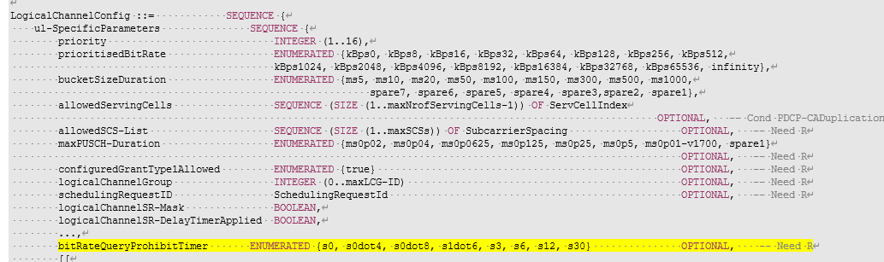

Following the agreement in this meeting (to follow the legacy configurability in the RRC by the network), rapp would like to ask the following question

***Quesiton4: Do companies think we should follow the legacy, i.e.,***

1. ***to introduce a prohibit timer for the UL transmission of the data rate query MAC CE?***
2. ***to enable/disable the rate query MAC CE by the presence of the prohibit timer in the RRC configuration?***

|  |  |  |  |
| --- | --- | --- | --- |
| **Company** | **(a)**  **Yes/No** | **(b)**  **Yes/No** | **Comments** |
| CATT | Yes | Yes | There is no distinguish motivation forseen from our point of view. |
| Qualcomm | Yes | Yes | We are fine with reusing the legacy behavior |
| Futurewei | Yes but also see comment | Yes | If the query also includes a data rate recommended by the UE, just having the prohibit timer may be insufficient, because if the timer is set to be too long, rate control mechanism may not be adaptive enough. On the other hand, if the timer is set to be too short, it will allow the UE to request a small delta rate adjustment, e.g. for every 1% rate improvement according to the new data rate table. A threshold on the delta data rate should be introduced to regulate the minimal delta rate adjustment that the UE can request so that the UE will not send a request, e.g., for every 1% possible rate improvement. |
| OPPO | Yes | Yes | Fine to follow the legacy way. |
| Xiaomi | Yes | Yes | OK to follow legacy behavior. |
| LG | Yes | Yes | OK to follow legacy behavior. |
| Sharp | Yes | Yes | It’s ok to align with legacy procedure. |
| Nokia | Yes | Yes | As legacy. |
| Vivo | Yes | Yes | As legacy. |

we have agreed that the available data rate indication shall be carried in the granularity of QoS flow level, with two possible options pending for further discussion

|  |
| --- |
| 3. Rate indication from gNB to the UE on a per QoS flow level is supported. FFS the details, e.g. if: 1) flows are indicated by MAC CE or 2) by RRC while MAC CE is per DRB. |

If the answer to the qustion4 is yes, the rapporteur would like to ask the following question

***Quesiton5: If the answer to the question above is yes, should the prohibit timer be configured in the QoS flow level?***

|  |  |  |
| --- | --- | --- |
| **Company** | **Yes/No** | **Comments** |
| CATT | Yes, but | The granulirity of the forhibit timer should be align with the granulirity of the final adopt MAC CE. This issue can be postponed until the FFS on the details part is solved. |
| Qualcomm | - | We have the same comment as CATT |
| Futurewei | - | Agree to postpone it. |
| OPPO | Yes, but | Prefer to have the same granularity for prohibit timer configuration and the final adopted MAC CE indication. We are fine to postpone the discussion. |
| Xiaomi | - | Agree with CATT. |
| LG | - | Agree with CATT. |
| Sharp | No, but | We can see the same per-LCH prohibit timer can be used for all QFs of the LCH. Anyway, we agree with CATT that we can wait until the conclusion of the MAC CE format. |
| Nokia | - | Postpone. |
| vivo | Yes |  |
| Samsung | - | Agree with CATT. |