3GPP TSG-RAN WG2 #129bis R2-250xxxx

Malta, May 19th – 23st, 2025

Agenda Item: X.X.X
Source: Ericsson
Title: Remaining RRC open issues for NR NTN Rel-19
Document for: Discussion, Decision

1 Introduction
The following document includes a list of open issues according to the following email discussion:
- [Post129bis][305][R19 NR NTN] RRC CR (Ericsson)
Scope: discuss the running RRC CR
Intended outcome: Endorsed CR and list of open issues
Deadline: long

Companies are invited to provide feedback on open issue list by: May 1st 2025

2 Remaining open issues for specification TS 38.331

DL coverage enhancements
SMTC configuration and granularity
RAN2 has agreed to consider the support of multiple SMTC periodicities to cater the extended SSB periodicity and beam hopping introduced in Rel-19 NR NTN enhancements. This extension applies to UEs in all RRC states (idle, inactive and connected). In addition, RAN2 has agreed that more than 4 SMTCs can be configured for RRC_IDLE/INACTIVE mode and location assistance information may be provided to the UE to assist in the STMC selection.
The final confirmation for these enhancements depends on the response from RAN4, thus these open issues have not yet been captured in the rapporteur’s CR. In any case, RAN2 can still make some progress ironing out the following stage 3 details:
- Backwards compatibility of multiple periodicities.
- Maximum number of SMTCs that need to be supported (e.g., 6).
- Association of SMTC with location/beam information (e.g. serving cell SSB index, reference location).

For the first issue, when the new SMTC periodicity is included in system information broadcast, the rapporteur has identified to possible options:
- 1) Backwards compatible: ensures that legacy UEs can still (somewhat) operate within the cell and perform neighbour cell measurements. Here, rapporteur proposes two alternatives:
  - 1a) The new SMTC periodicity is provided as an extension of SMTC4 list.
  - 1b) A new field is introduced (e.g., SMTC5) to be used by Rel-19 UEs which support DL coverage enhancements. Network may still configure SMTC4 for legacy UEs and Rel-19 DL CE NTN UEs should ignore SMTC4 when SMTC5 is configured.
- 2) Non-backwards compatible: A new field is introduced (e.g., SMTC5) to be used by Rel-19 UEs which support DL coverage enhancements. Network is not expected to configure legacy SMTC4. Legacy UEs may have limited operation in the cell in terms of neighbour cell measurements.

Companies are invited to provide feedback regarding the above open issue and possible proposed resolution:
Company | Option | Other comments
CATT | 1a) or 1b) | From our perspective, there seems to be no need to prevent NW from configuring the SMTC(s) used for legacy UEs, using the legacy SMTC4 list. Although under system-level beam hopping deployment such SMTC4 list configuration may not be optimal, we on the other hand haven't decided to bar the legacy UE either, thus not prohibiting such deployment serving legacy UEs. So better to support some forms of BC handling, if possible (even though not optimal).  Regarding 1a) vs. 1b), this depends on whether NW can/should/need configure an SMTC configuration that can be shared by the legacy UEs and Rel-19 DL CE capable UEs. We currently slightly prefer option 1b), but can depend on majority's view from a NW deployment perspective.
Apple | 1a) | 1a) seems the simplest one.  There is no significant need to introduce a brand new complete SMTC configuration with multiple periodicities included.
vivo | 1b) | Option 1b is the preferable choice since it has the potential to minimize the impacts on legacy UEs. In any case, considering RAN4 has not yet given its confirmation, we believe it is advisable to defer addressing this issue.
OPPO | 1b) | Based on current agreement, there is no need to bar legacy UE from SMTC enhanment perspective. So backwards compatible manner is preferred. For Opiton 1 a) and 1b), it seems 1b) is a clear way for legacy UE and DL CE UE which do not have impact on legacy UE.
Sharp | 1b) | It is preferable to introduce new SMTC with backwards compatible manner to eliminate impacts on legacy UEs.
Qualcomm | 1a) | Probably it is not good idea to make some UEs use different SMTC offsets and network has to repeat same 4 SMTCs+list of cells in two different list. If RAN4 does not confirm, there is even no motivation of 1b).
Xiaomi | 1a) | Network can configured the periodicity of smtc to be multiple of new periodicity for one or more of the smtcs in smtc4list. In this way, Legacy UE using larger periodicity and new UEs using new smaller periodicity (corresponding to actual neighbor cell SSB periodicity) would both work fine. And we agree with QC that, configuring different SMTC offsets for legacy UE and new UE doesn't make sense.
Huawei, HiSilicon | 1a) or 1b) | We also think 1a) is simpler. We only need a new list of additional SMTCs on top of the existing 4 SMTCs, and the additional SMTC parameter can have a separate SMTC periodicity (as RAN2 agreed there will be no more than 2 periodicities).  1b) provides more flexibility (allowing more combintations of SMTC configuration), but the NW needs to configure SMTC4list for legacy UE and the new SMTC list for R19 UEs, not sure if the spec needs to mandate the NW to configure consistenly in both lists (otherwise it could be possible that two different configurations are provided for the same neighbor cell?)
Fujitsu | 1b) | 1b) is clear way to go for supporting different release UEs.  Both Legacy UE and Rel-19 UE are allowed to access the cell based on current agreement. When SMTCs with different periodicities are configured, with 1a), legacy UE will always assume the periodicity configured in smtc1 as the periodicity for all the SMTCs, which is not correct and will introduce confusion to the legacy UE.
ZTE | 1a) or 1b) | We don’t see there is a need to prevent NW from configuring legacy SMTC4 list. If are going to introduce more enhancements, 1(b) seems to be a cleaner approach, which provides more flexibility. As we see it, there is no need to make any assumption on relationship between SMTC4 and the new SMTC list if 1b is used, NW can configure the same or different values in the list, which is up to NW implementation.

For the remaining two issues, a more thorough analysis is needed, and the rapporteur suggests that companies provide contributions to the following meeting. In their analysis, companies are encouraged to provide potential deployment scenarios and clarify the advantages and disadvantages of the already discussed options.

Intended Service Area for MBS NTN
Mapping between ISA and TMGI
RAN2 agreed that for each MBS service we include one or more intended service area IDs into MCCH. From implementation perspective, there are different ways to achieve this. The rapporteur has suggested a way forward in the running RRC CR, namely, to include the mapping in the MBSBroadcastConfiguration IE. The main reason being that this a high-level IE that includes multiple MBS broadcast configuration parameters and it is easily extendable.
Companies are invited to provide feedback regarding the proposed rapporteur’s way forward to capture the mapping between TMGI and ISA ID and possible alternatives:
Company | Agree? | Other comments
CATT | Yes
Apple | See comments | Current way looks clean though. May I wonder why not introducing another list, associated with mbs-SessionInfoList-r17? Is it because the list is too huge (1024 entries) thus referring to existing list could be also signaling consuming if there are not many MBS sessions are associated with intended service area? However, if too many MBS sessions have associated intended service area(s), repeating the TMGI(s) would be also signaling consuming.
vivo | No | TMGI may cost an overhead of 50 bits. It is not wise to list each related TMGI again in MCCH (This is precisely the primary reason why we have refrained from adopting the SIB-based solution). We propose  MBSBroadcastConfiguration-r17-IEs ::= SEQUENCE {  mbs-SessionInfoList-r17 MBS-SessionInfoList-r17 OPTIONAL, -- Need R  mbs-NeighbourCellList-r17 MBS-NeighbourCellList-r17 OPTIONAL, -- Need S  drx-ConfigPTM-List-r17 SEQUENCE (SIZE (1..maxNrofDRX-ConfigPTM-r17)) OF DRX-ConfigPTM-r17 OPTIONAL, -- Need R  pdsch-ConfigMTCH-r17 PDSCH-ConfigBroadcast-r17 OPTIONAL, -- Need S  mtch-SSB-MappingWindowList-r17 MTCH-SSB-MappingWindowList-r17 OPTIONAL, -- Need R  lateNonCriticalExtension OCTET STRING OPTIONAL,  nonCriticalExtension MBSBroadcastConfiguration-v19xy-IEs OPTIONAL  }  MBSBroadcastConfiguration-v19xy-IEs ::= SEQUENCE {  mbs-SessionAreaList-r19 SEQUENCE (SIZE (1..maxNrofMBS-Session-r17)) OF mbs-AreaInfoList-r19 OPTIONAL, -- Need R  nonCriticalExtension SEQUENCE {} OPTIONAL  }  mbs-AreaInfoList-r19 SEQUENCE (SIZE (1.. maxNrofMBS-SessionPerArea-r19)) OF MBS-IntendedAreaID-r19
OPPO | See comment. | In current running CR, it seems can only configure one MBS session with related intended service ID list. So the mbs-SessionAreaMapping-r19 should at least be changed to a list to enable configure multiple MBS sessions associating with a intended service ID list.  However, the current design will introduce the signalling overhead due to the multiple TMGIs. We think we can discuss how to avoid configuring the TMGI repeatly.
Sharp | See comments | Duplicated TMGI field should be avoided as other companies mentioned. So, to avoid duplicate TMGI fields and to keep the backward compatible behavior (for not ISA capable UEs), we think MBS sessions indicated by MBSBroadcastConfiguration-r17-IEs should not be associated with any ISAs (i.e. whole cell is a service area), and MBSBroadcastConfiguration-r19-IEs includes MBS-SessionInfoList-r19 which sessions are associated with ISA, and ISA mapping information is included in each session info.
Qualcomm | See comments | We can simply extend mbs-SessionInfoList-r17 to associate area ID.  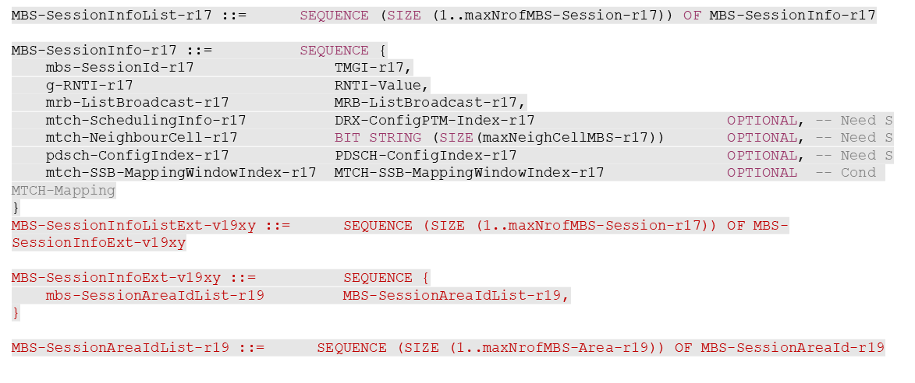
Xiaomi | See comments | Share the same view that we should avoid duplicating the TMGI field to reduce signaling overhead. It could be better to extend the MBS-SessionInfoList-r17.
Huawei, HiSilicon | See comment | We also prefer to avoid repeating TMGI. Vivo’s proposal looks good. Besides, it needs to be clarified in the field discrption that the new list has a one-to-one mapping relationship with the existing MBS-SessionInfoList-r17.  On Qualcomm’s version, it is unclear to us where MBS-SessionInfoListExt-v19xy is referenced.
Fujitsu | See comments | Rapporteur’s way is fine, but if we want to avoid the TMGI duplicat, adding the ISAs into MBS-SessionInfo would be better. Considering there is no extension IE reserved in current MBS-SessionInfo-r17, we think new MBS-SessionInfo should be introduced, with the ISAs and all the existing IEs of MBS-SessionInfo-r17 included:  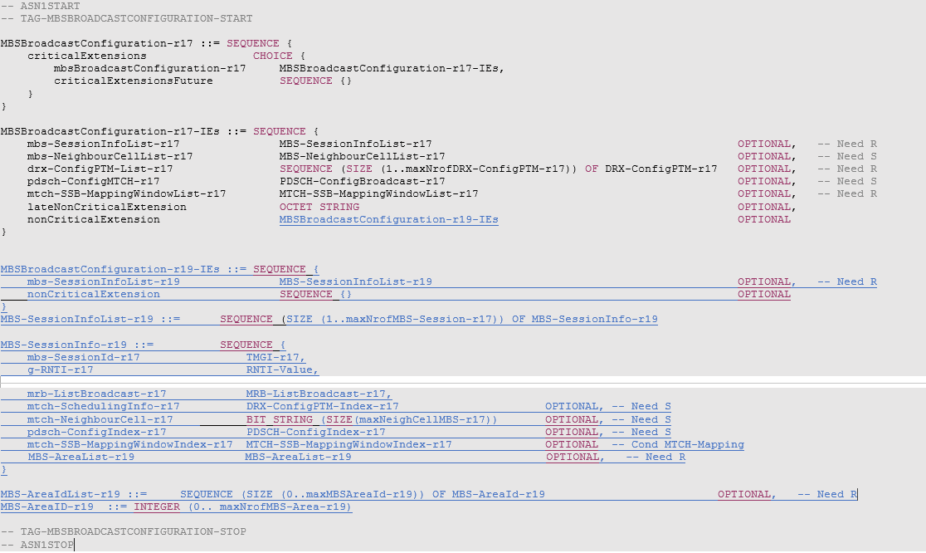
ZTE | See comments | Agree with companies’ that TMGI seems to consumes too much signalling overhead. We can add the the list of ISA ids per each MBS session. Vivo’s comments together with huawei’s suggestion on field description clarification shall be sufficient.

Service continuity
Last meeting, the topic of service continuity was extensively discussed and RAN2 agreed that a UE may prioritize the frequency(ies) for an interested service when UE can only receive the service on those frequency(ies) and the UE is in intended service area associated with the service provided in the frequency(ies). It remains to be decided whether and how the association between intended service area and frequencies is acquired.
From rapporteur’s perspective, this is a complex issue that is very scenario dependent. Thus, the suggestion is that companies provide contributions to the following meeting focusing on clarifying the target scenarios and necessary enhancements (if any), for example:
- Multiple frequencies, served by the same satellite, illuminating the same geographical area. Each frequency provides a different MBS service. These services are not being broadcast in the serving cell.
- Multiple frequencies, served by the same or different satellites, but not covering the same geographical area (they are neighbour cells). Each frequency provides a different MBS service. These services are not being broadcast in the serving cell.
Companies are also welcome to comment whether other scenarios should be taken into consideration:
Company | Other scenarios
CATT | We prefer to not further complicate the scenarios.
Apple | Our understanding is it could be either the same or differnet serivces supported by different frequencies.  Of course we would bring a contribution to clarify it more.
vivo | We think at least the above-mentioned cases should be considered.
Sharp | We think a consideration for above scenarios is the baseline.
Qualcomm | Here the frequency may be of a neighbor cell from same satellite or different satellite.
Xiaomi | We prefer to focus on the above two scenairos.
Fujitsu | Our understanding is same MBS service can be provided by different frequencies. The multiple frequencies, served by the same or different satellites, covering same or different geographical area.
ZTE | Share the same view as Apple.

3 Other identified open issues
Companies are invited to describe any other identified open issues not currently included within this document
Company | Other identified open issues? (please describe)

4 Conclusions
The following proposals have been provided based on feedback to the above document:
[Proposals for easy agreement]

[Proposals for discussion]

