3GPP TSG-RAN WG2 #130 R2-250xxxx

St Julian, Malta, 19-23 May 2025

Agenda Item: 8.7.1
Source: Qualcomm Incorporated
Title: List of open issues in MAC
Document for: Discussion

1. Introduction
This document is to collect open issues related to the MAC running CR.
You are welcome to provide additional open issues in the tables blow.

2. Issues

2.1 LCP
- [MAC-01] Impact of priority adjustment on SR priority determination
- [MAC-02] Impact of congestion (i.e. PSI-based SDU discard) on priority adjustment
- [MAC-13] Priority fallback with consideration of PDU Set integrated handling
- Additional issues:
Company | Open issues
Apple | - Priority fallback with consideration of PDU Set integrated handling: Should the UE fallback the priority, if there is no more PDCP SDU with PDCP discard timer remaining value smaller than the threshold, but there is still at least one PDCP SDU with PDU Set Remaining Time smaller than the threshold ?  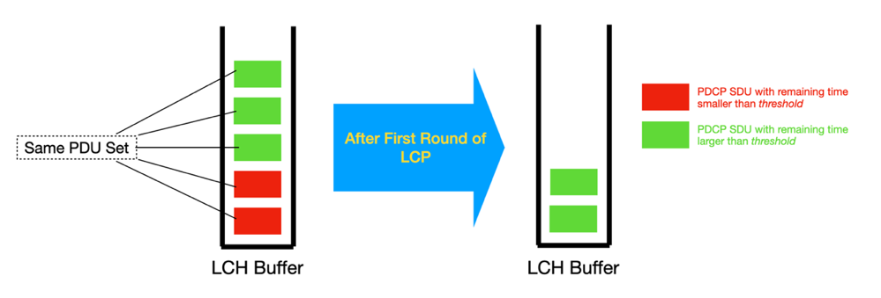  [Rapp] Please see other companies’ comments on this issue in the running CR.  [Apple] We think the comments from the companies have created more confusions and ambiguity. Clearly, we do not have a common understanding in RAN2. In particular, there are some contradictory views:  - LGE thinks PDU Set should not be considered for LCH priority adjustment.  - Huawei thinks the current wording is already applicable to PDU Set.  So, is it applicable or not applicable to PDU Set? We think RAN2 should at least clarify what would be the intended UE behavior in this case.  Since LCH priority adjustment and LCP procedures are both MAC functionalities, and the remaining time threshold for LCH priority adjustment is also configured in MAC layer, we tend to think it should be clarified in TS 38.321.  [Ericsson] As with all handling of PDU Set it is only a modelling decision to have multiple timers running, in essence there is one timer for all data in the PDU Set. For this issue it is only a matter of describing the behavior clearly in specification (which was unfortunately made more complicated by the decision to have multiple timers running for a PDU Set).

2.2 DSR
- [MAC-03] DSR cancelation in DC configuration
- Additional issues:
Company | Open issues
Huawei | In the Buffer Size description in Section 6.1.3.72, we think that there is still different understanding on the need to configure every LCG with reporting threshold in order to use the R19 MAC CE from the companies’ comments (in v23).  At the moment, it requires that the total amount of delay reporting data has to be associated with a reporting threshold. Even though we have an agreement (and also an FFS):  If UE is configured to use R19 DSR, then any LCG with a triggering threshold shall be configured with at least one reporting threshold  FFS New DSR MAC CE will (always) be used when at least one LCG is configured with multiple thresholds.  We think such restriction is not necessary from the network pov as it will require that every LCG needs to be configured with reporting threshold in order to use the Rel-19 MAC CE, which will result in unnecessary overhead.

2.3 XR rate control
- [MAC-04] Which type of ID should be used to identify a QoS flow, e.g. DRB ID + QFI ID or some other identifier
- [MAC-05] Whether the Rate Control MAC CE includes single or multiple QoS flows
- [MAC-06] Any additional fields that should be included in the Rate Control MAC CE
- [MAC-07] Format of the Rate Control MAC CE
- [MAC-08] Handling of triggered UL rate queries (e.g. multiplexing, transmission and cancelation, etc)
- [MAC-09] How UE should handle the Rate Control MAC CE in DC configuration
- [MAC-10] Behavior of bitRateQueryProhibitTimer
- [MAC-11] Whether to apply the same design for UL rate control design to DL data transmission
- [MAC-12] How to indicate in the Rate Control MAC CE that a query from UE is for available bit rate.
- Additional issues:
Company | Open issues
Ofinno | (1) Whether to introduce the bitRateQueryProhibitTimer. Granularity of the configured bitRateQueryProhibitTimer.  [rapporteur] It has already been agreed to introduce this timer. The granularity of this timer is being discussed in the RRC running CR.  (2) Whether the UL bit rate query MAC CE can query the available/recommended bit rate without the desired bit rate.  [rapporteur] This feature is already in the endorsed 300 and 321 running CR from the last meeting.  (3) What’s the purpose when bit rate query indicates index “0” in the bit rate table.  [rapporteur] Per the chair’s guideline, as this is a minor issue, companies are invited to discuss it in the running CR review instead of online.  (4) What’s the UE behaviour if the UL resources cannot accommodate the Rel-19 UL bit rate MAC CE.  (5) The cancellation conditions of the triggered bit rate query.  [rapporteur] #4 and #5 will be added under “Handling of triggered UL rate queries”
vivo | 1. The details behaviour for bitRateQueryProhibitTimer is missing the current MAC running CR.  [Rapp] Agree. Added it to the list  2. In RAN#106, it was agreed RAN2 firstly focus on rate control for UL data transmission and evaluate any issues when apply same solution for DL data transmission and send LS to SA2/SA4/RAN3 accordingly.  We assume we need to send LS to check with other WGs for DL rate control after we have complete design.  With this, we suggest to add one more open issue for DL rate control.  [Rapp] Agree. Added it to the list.  3. In legacy RBR, it was captured like:  The recommended bit rate procedure is used to provide the MAC entity with information about the bit rate which the gNB recommends. The bit rate is the recommended bit rate of the physical layer. Averaging window of default value 2000 ms will apply as specified in TS 26.114 [13].  For Rate control here, whether we need to define a averaging window or just leave this to NW and UE implementation? Just for clarification.  [Rapp] In rapporteur’s view, this requirement does not need to be captured in the MAC spec.

3. Summary
Based on the discussion above, the following is the list of open issues for discussion at the RAN2#130 meeting.
- [MAC-01] SR priority adjustment
The current agreement is to evaluate the potential spec impact of SR priority adjustment and then decide whether to adopt it (i.e. only if it is simple enough to capture). Companies can use the following TP as the baseline for further discussion:
For the MAC entity configured with lch-basedPrioritization, the MAC entity shall for a pending SR:
1> if the SR is triggered by a logical channel configured with additionalPriority; and
- if the smallest remaining value of the running PDCP discardTimers among the data available for transmission in this logical channel, evaluated at the time of the first symbol of the next PUCCH transmission for the SR, is below or at priorityAdjustmentThreshold configured for the logical channel:
2> consider additionalPriority as the priority of the PUCCH transmission.
- [MAC-02] Impact of congestion (i.e. PSI-based SDU discard) on priority adjustment
- [MAC-03] DSR cancelation in DC configuration
- [MAC-04] Which type of ID should be used to identify a QoS flow, e.g. DRB ID + QFI ID or some other identifier
- [MAC-05] Whether the Rate Control MAC CE includes single or multiple QoS flows
- [MAC-06] Any additional fields that should be included in the Rate Control MAC CE
- [MAC-07] Format of the Rate Control MAC CE
- [MAC-08] Handling of triggered UL rate queries (e.g. multiplexing, transmission and cancelation, etc)
- [MAC-09] How UE should handle the Rate Control MAC CE in DC configuration
- [MAC-10] Behavior of bitRateQueryProhibitTimer
- [MAC-11] Whether to apply the same design for UL rate control design to DL data transmission
- [MAC-12] How to indicate in the Rate Control MAC CE that a query from UE is for available bit rate
- [MAC-13] Priority fallback with consideration of PDU Set integrated handling

