**3GPP TSG-RAN WG2 Meeting #129bisR2-250xxxx**

**Wuhan, China, 7th - 11th April 2025**

**Agenda item: 8.4.1**

**Source: CATT**

**Title:  [Post129][212][LPWUS] Running CR for TS 38.304 (CATT)**

**Document for: Discussion and Decision**

# Introduction

This document is the report of the following discussion:

* [Post129][212][LPWUS] Running CR for TS 38.304 (CATT)

Intended outcome: Running CR for submission to the next meeting

Deadline: Long (Mar. 21st 10:00 UTC)

Please provide your comments by Thursday March 20th 10:00 UTC to allow 24h for the rapporteur to update the CR before the deadline.

Companies providing input to this email discussion are requested to leave contact information below.

|  |  |  |
| --- | --- | --- |
| **Company** | **Delegate name** | **Email address** |
|  |  |  |
|  |  |  |
|  |  |  |
|  |  |  |
|  |  |  |
|  |  |  |
|  |  |  |
|  |  |  |
|  |  |  |
|  |  |  |

# Discussion

## How to capture RRM relaxation and offloading in TS 38.304

According to RAN2 agreements, RAN2 focus on specifying the offloading and relaxation criteria.

Rel-16 relaxed RRM measurements mechanism in idle/inactive, i.e. the possible configuration options and the possible combinations of fulfilment of low mobility and/or not-at-cell-edge, were captured in both TS 38.304 and TS38.133. In [1] it mentioned this duplication had led to many LS exchanges between RAN2 and RAN4. Furthermore the way captured was different in TS 38.304 and 38.133 which made it difficult to compare them, as shown below.

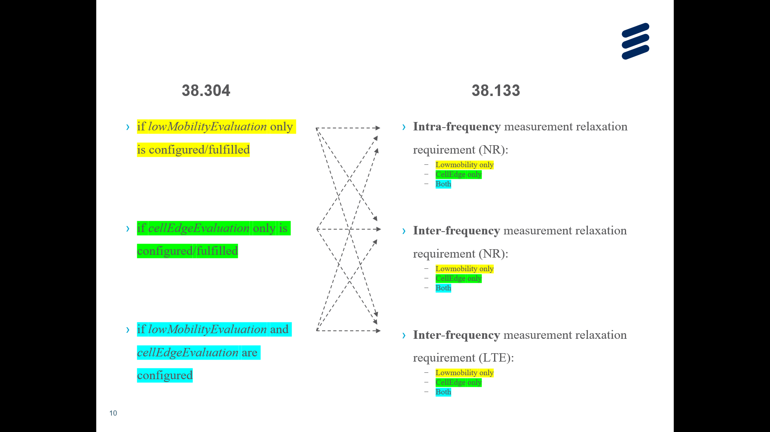

In [1], to avoid overlap between RAN2 and RAN4 specification, it is proposed that RAN2 captures the relaxation and offloading criteria while RAN4 captures different use cases that can be identified based on the configuration and which criteria are fulfilled.

Rapporteur shares the same view. In addition, in Rel-16 relaxed RRM measurements mechanism in idle/inactive in TS38.304, it also distinguishes intra-frequency case and NR inter-frequency/ inter-RAT frequency cases, as shown below [2]:

|  |
| --- |
| - if *cellEdgeEvaluation* is configured and *lowMobilityEvaluation* is not configured; and  - if the relaxed measurement criterion in clause 5.2.4.9.2 is fulfilled:  - the UE may choose to perform relaxed measurements for intra-frequency cells according to relaxation methods in clauses 4.2.2.9 and 4.2C.2.7 in TS 38.133 [8];  - if the serving cell fulfils Srxlev ≤ SnonIntraSearchP or Squal ≤ SnonIntraSearchQ:  - the UE may choose to perform relaxed measurements for NR inter-frequency cells or inter-RAT frequency cells according to relaxation methods in clauses 4.2.2.10, 4.2.2.11 and 4.2C.2.8 in TS 38.133 [8]; |

Rapporteur proposes to discuss how to capture RRM relaxation and offloading in TS 38.304 and TS 38.133 in advance. RAN2 can capture the general description on RRM relaxation and offloading for LP-WUS (e.g. not to capture intra-frequency, inter-frequency or inter-frequency cases) and criteria of RRM relaxation and offloading for LP-WUS. Other details are captured in RAN4.

**Proposal 1: The general description on RRM relaxation and offloading for LP-WUS (e.g. not to capture intra-frequency, inter-frequency or inter-frequency cases) and criteria of RRM relaxation and offloading for LP-WUS are captured in TS 38.304. Other details of RRM relaxation and offloading for LP-WUS are captured in RAN4.**

Companies are invited to give comments on proposal 1.

|  |  |  |
| --- | --- | --- |
| **Company** | **Yes/No on proposal 1** | **Comments** |
|  |  |  |
|  |  |  |
|  |  |  |

## Comments on TS 38.304 running CR

Companies can provide comments and suggestions to the uploaded running CR in this table. Please do not add changes, suggestions, or comments directly to the draft CR document.

|  |  |  |
| --- | --- | --- |
| Company + Issue Number (e.g., C001) | Detailed comments | Rapporteur response |
|  |  |  |
|  |  |  |
|  |  |  |
|  |  |  |
|  |  |  |

# Conclusion

TBD

# References

1. R2-2501094, LP-WUS and RRM measurements, Ericsson , discussion, RAN2#129
2. 3GPP TS 38.304: "NR; User Equipment (UE) procedures in Idle mode and RRC Inactive state", v18.4.0