**3GPP TSG-RAN WG2 Meeting #129 R2-250**

**Athens, Greece, 17th – 21st Feb, 2025**

**Agenda Item: 8.xx**

**Source: Huawei, HiSilicon**

**Title: Summary of [POST128][108][MOB] RRC running CR (Huawei)**

**Document for: Discussion and Decision**

# 1 Introduction

This paper summarizes the post meeting email discussion for the RRC running CR

**[POST128][108][MOB] RRC running CR (Huawei)**

**Scope:** For L1 event-driven MR, prepare 38.331 running CR capturing all RAN2 agreements, identify stage 3 issues (possibly with rapporteur’s suggestion) that need to be discussed, and discuss them.

**Intended outcome:** 38.331 running CR, to be endorsed next meeting, and discussion summary.

**Deadline: Long email discussion**

Based on the companies' inputs, the proposals have been formulated at the conclusion section.

Please fill in the contact information in the table below

|  |  |  |
| --- | --- | --- |
| **Company** | **Contact Person** | **Email Address** |
| Ericsson | Antonino Orsino | antonino.orsino@ericsson.com |
| CATT | Rui Zhou | zhourui@catt.cn |
| Nokia | Jedrzej Stanczak | jedrzej.stanczak@nokia.com |
| Xiaomi | Yujian Zhang | zhangyujian@xiaomi.com |
| OPPO | Xin YOU | youxin@oppo.com |
| Sharp | Takaki Nomura | nomura.takaki@sharp.co.jp |
| vivo | Jing LIANG | liangjing@vivo.com |
| ZTE | Liujing | [liu.jing30@zte.com.cn](mailto:liu.jing30@zte.com.cn) |
| Apple | Fangli Xu | fangli_xu@apple.com |

# 2. Discussion

## 2.1 Resource configuration

Regarding the resource configuration, the current draft running CR is implemented as follows.

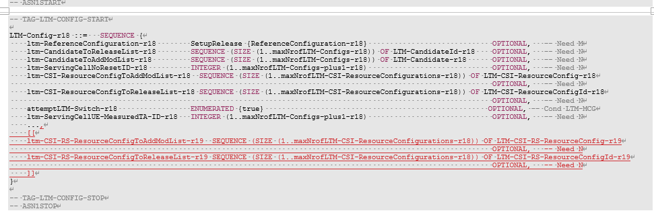

The reason why we introduce the CSI-RS configuration in parallel with the SSB configuration is that within the legacy field *LTM-CSI-ResourceConfig*, the field *LTM-SSB-CSI-Config* is configured as mandatory. Then, it is impossible to add CSI-RS configuration under this IE anymore.

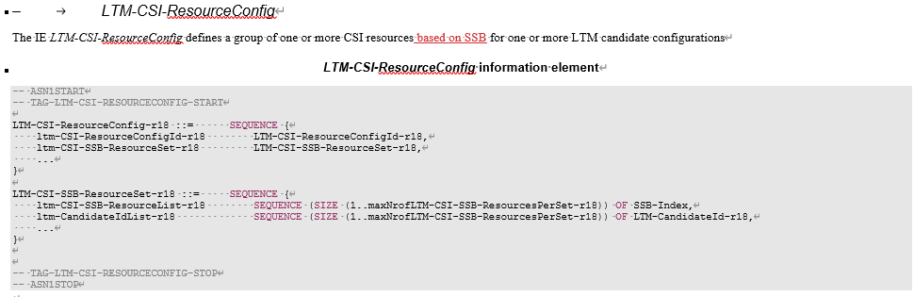

So, the solution is

* The R18 *LTM-CSI-ResourceConfig* is used to configure CSI resources based on SSB for LTM
* We introduce a new R19 field *LTM-CSI-RS-ResourceConfig-r19* for configuring the CSI resources based on CSI-RS for LTM

During the RAN2 meeting 127bis, the following agreement regarding the resource configuration has been reached.

|  |
| --- |
| RAN2#127bis  3. For measurement resource configuration, R18 LTM CSI resource configuration is reused if possible. If CSI-RS resource only IE needs to be defined, we can revisit it in the stage 3. |

The rapporteur observes that change per above agreement may have the following issues:

* In the legacy IR for *LTM-CSI-ResourceConfig,* the field *ltm-CSI-SSB-ResourceSet* is mandatory. If we reuse the existing LTM CSI configuration, it would mandatorily include the SSB configuration. While for R19 LTM, CSI-RB-based measurement is supported for both event-triggered report by MAC CE and legacy CSI report. It does not make sense to mandatorily support SSB for event-triggered measurement report or CSI-based report
* If we introduce the resource for event-triggered measurement report by MAC CE within the *LTM-CSI-ResourceConfig*, it is hard to see which resource is configured for report by CSI and which is for report by MAC CE. We could potentially by-pass the issue by what is currently being done in IE description that (a) the resource configuration associated with *LTM-ReportConfig* configured with *periodic/semi-persistentOnPUCCH/semi-persistentOnPUSCH/aperiodic* report type is for CSI report and (b) resource configuration associated with *LTM-ReportConfig* configured with *event-triggered* is for MAC CE report. But, the adding suffix like this makes the spec hard to read. For example, the current RAN1 spec (like TS 38.214 as an example in the figure below) for measurement report by CSI extensively uses the field name *LTM-CSI-ResourceConfig*

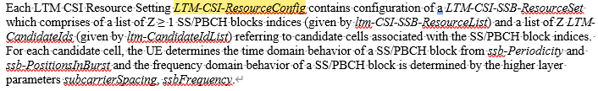

* The name of the IE and the fields within the IE still include the "CSI" part, which is not applicable for event-triggered measurement report by MAC CE anymore
* Limitation on the resource configuration Id and the number of *SSB-Index* and *LTM-CandidateId* with the introduction of event-triggered measurement report.

Based on the above observations and to revisit the issue during stage3, we would like to ask the following question:

***Question1: Do companies agree that, we add the resource configuration for event-triggered measurement report separately from the configuration for CSI resource?***

|  |  |  |
| --- | --- | --- |
| **Company** | **Yes/No** | **Comment** |
| Ericsson | No | Even if what is proposed it works, it will make the spec a bit more complex. For us a simpler solution to introduce CSI-RS would be to re-use the existing LTM-CSI-ResourceConfig. The following change (in red) it will avoid creating 4 new IEs.  LTM-CSI-ResourceConfig-r18 ::= SEQUENCE {  ltm-CSI-ResourceConfigId-r18 LTM-CSI-ResourceConfigId-r18,  ltm-~~CSI-~~SSB-ResourceSet-r18 LTM-~~CSI-~~SSB-ResourceSet-r18,  ...,  [[  ltm-CSI-RS-ResourceSet-r19 LTM-CSI-RS-ResourceSet-r19 OPTIONAL --Need R  ]]  }  LTM-~~CSI-~~SSB-ResourceSet-r18 ::= SEQUENCE {  ltm-~~CSI-~~SSB-ResourceList-r18 SEQUENCE (SIZE (1..maxNrofLTM-CSI-~~SSB-~~ResourcesPerSet-r18)) OF SSB-Index,  ltm-CandidateIdList-r18 SEQUENCE (SIZE (1..maxNrofLTM-CSI-~~SSB-~~ResourcesPerSet-r18)) OF LTM-CandidateId-r18,  ...  }  LTM-CSI-RS-ResourceSet-r19 ::= SEQUENCE {  ltm-CSI-RS-ResourceList-r19 SEQUENCE (SIZE (1..maxNrofLTM-CSI-ResourcesPerSet-r19)) OF FFS,  ltm-CandidateIdList-r19 SEQUENCE (SIZE (1..maxNrofLTM-CSI-ResourcesPerSet-r19)) OF LTM-CandidateId-r18,  ...  }  And in the field description of *ltm-CSI-RS-ResourceSet* we can clarify that if this field is present the UE shall ignore the field *ltm-CSI-SSB-ResourceSet*.  This will simplify by a lot the implementation in current spec. |
| CATT | No | We think a new R19 IE is needed to include the csi-rs and/or the SSB due to the SSB is mandatory present in R18 IE *LTM-CSI-ResourceConfig,* But a separate resource configuration is not needed for event- triggered measurement report. The difference between the event triggered measurement report and legacy measurement report is only the way of reporting, not the measurement RS. |
| Nokia | No | Agree with Ericsson. The same parent IE should be reused and support of CSI-RS resource set should be added there. |
| Xiaomi | No | Agree with Ericsson, whose proposal is simpler. The issue of mandatory presence of SSB can be addressed with field description. |
| OPPO | No | Similar view with companies above. Rel-18 IE *LTM-CSI-ResourceConfig* can be reused to provide Rel-19 CSI-RS resource set configuration. |
| Sharp | No | The spec implementation should be simplified. So, we agree with Ericsson’s proposal. |
| vivo | No | We share the same view with Ericsson that the current *LTM-CSI-ResourceConfig* could be updated to add the CSI-RS configuration.  Also, it is easy to clarify in the field description that UE can ignore that mandatory field as suggested by Ericsson.  With this method the spec is easier to read. |
| ZTE | No with comments | We generally agree with Ericsson that existing LTM-CSI-ResourceConfig can be reused, but on whether the UE shall always ignore the SSB configuration, we think RAN2 can wait more on the CSI-RS configuration from RAN1.  Similar to L3 CSI-RS measurements, we understand the UE may also need to detect the SSBs of candidate cell to obtain timing info, and “associatedSSB” may also be needed for L1 CSI-RS measurements, so maybe the SSB configuration in the same resourceConfig can be useful.  If RAN1 decides to follow L3 MO configuration to obtain the timing info (e.g. L1 CSI-RS must require L3 CSI-RS measurement config), or the timing info are indicated in CSI-RS resource configuration, then we can specific the “ignore” behaviour as Ericsson proposed. |
| Apple | No | Prefer Ericsson’s approach of reusing the existing LTM-CSI-ResourceConfig as it’s much simpler.  Regarding whether it’s feasible to only configure CSI-RS without SSB (as ZTE’s comment), we can make it FFS and and wait for RAN1 progress. |

Based on the views from the above, we propose the following:

***Proposal1a: Confirm on the previous agreement that "For measurement resource configuration, R18 LTM CSI resource configuration is reused if possible".***

***Proposal1b: Continue to carry the bits for SSB resouce set when CSI-RS resource set is configured. FFS whether CSI-RS can be configured without SSB (up to R1 to decide).***

The resource configuration in the current running CR is caputured as follows. An FFS is kept for how to indicate the CSI-RS resource. We need to downselect between two choices, whether to indicate in the resource set level or in the resource level

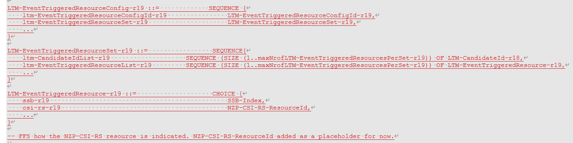

***Question2: How should the CSI-RS resource be indicated in the resource set for event-triggered measurement report ? (a) resource set id (b) resource id***

|  |  |  |
| --- | --- | --- |
| **Company** | **(a)/(b)** | **Comment** |
| Ericsson | See comment | If we do the way we suggest in question 1, there is no need to create a new resource configuration for the event triggered measurements as the resources will be the one specified within *LTM-CSI-ResourceConfig*.  But regardless, we see no need to create a new resource configuration just for the event triggered measurements. |
| CATT |  | See our comment to Q1. |
| Nokia |  | Aligned with Ericsson’s and CATT’s opinion here. |
| Xiaomi |  | Agree with above comments that there is no need to define separate resource configuration for event-triggered measurements. |
| OPPO |  | Agree with comments above. |
| Sharp |  | No need new IEs for event-triggered report specific resource configuration. |
| vivo |  | Agree with comments by companies. |
| ZTE |  | Same comments as above companies. |
| Apple |  | Same comments as above companies. |

Based on the feedback from companies, we propose the following.

***Proposal2: Do not create a new resource configuration just for the event triggered measurements.***

## 2.2 Report configuration

Another issue to revisit is the configuration of report configuration for event-triggered report. Regaring the placement of the report configuration, we have agreed on the following in our previous RAN2 discussion.

|  |
| --- |
| 4. For measurement reporting configuration, R18 LTM-CSI-ReportConfig is reused if possible. We can revisit it in the stage 3 if needed. |

Current running CR implemented the previous agreement as follows:

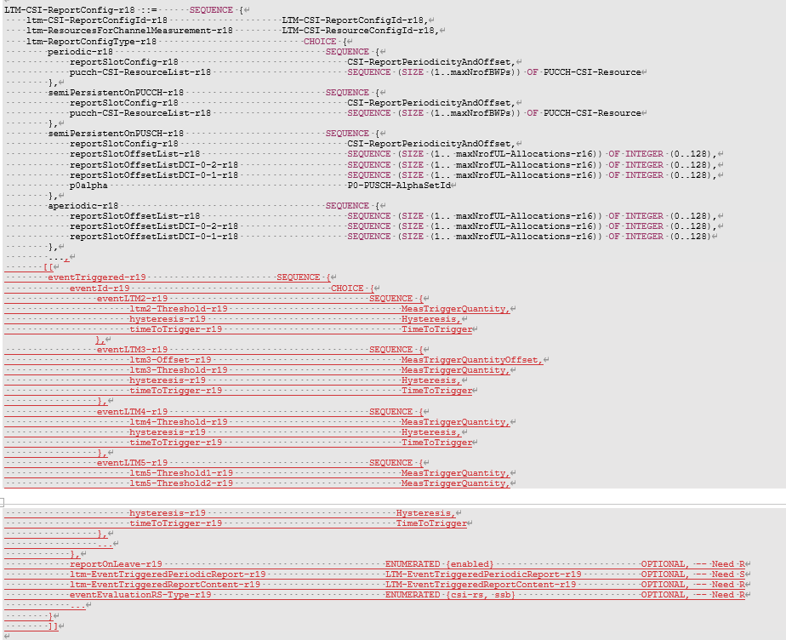

Similar issue as report config also exists that

* In other groups’ spec, the name *LTM-CSI-ReportConfig* is extensively used for report by CSI, either as periodic, semi-persistent on PUSCH, semi-persistent on PUCCH or aperiodic. While if we want to keep the current structure, RAN1/4 would be required to change their spec by adding suffix to the procedure text that uses the name *LTM-CSI-ReportConfig*, restricting that the ReportConfigType set to *periodic, semi-persistent, aperiodic*.

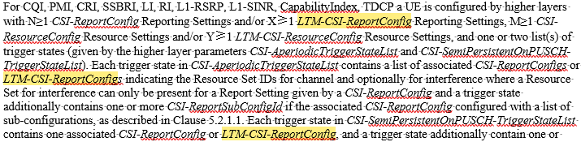

* Same issue on the report config id and that the name CSI is not applicable for report by MAC CE

Based on the above, we would like to ask the following question:

***Question3: Do comapnies agree that we add report configuration for event-triggered measurementr report separately from the R18 LTM-CSI-ReportConfig?***

|  |  |  |
| --- | --- | --- |
| **Company** | **Yes/No** | **Comment** |
| Ericsson | No | Current implementation seems fine with the only difference that we don’t need to create a new resource configuration for the event triggered measurements.  If we go as we suggest in Question 1, the resource are already references with the existing *ltm-ResourcesForChannelMeasurement-r18* (also the field *eventEvaluationRS-Type-r19* will not be needed). |
| CATT | No | No critical issue found by using R18 LTM-CSI-ReportConfig  -for the impacts to other groups, whether there is a issue and how to address it should be discussed in the corresponding WG  For issue on the report config id and that the name CSI is not applicable for report by MAC CE, we do not see any issue here. |
| Nokia | No | We see no reason behind this proposal. Event-triggered reporting should be one form of CSI reporting carried in MAC CE. |
| Xiaomi | No | We think reusing Rel-18 *LTM-CSI-ReportConfig* is fine. We could revisit if RAN1/RAN4 identify any issues.  We do not see the issue of report config ID, given the discussion on Question 1. |
| OPPO | No | We see no issue to reuse Rel-18 IE *LTM-CSI-ReportConfig.* There is no need to introduce a new report config IE for event triggered. |
| Sharp | No | We don’t see critical issue. Current report configuration can include new configuration for event-triggered report. |
| vivo | No | Share the view with companies that current spec is fine, and we think there is no difference for the R18 and R19 basic reporting scheme except for the triggering type. |
| ZTE | Yes with comments | We think this question is related to Q6, please see our response to Q6.  One question for clarification, for LTM-2, which resource configure ID is supposed to be configured in LTM-CSI-ReportConfig? |
| Apple | No | We donot see any critical issues, then we should stick to the RAN2 agreements to reuse the R18 LTM-CSI-ReportConfig.   * *For measurement reporting configuration, R18 LTM-CSI-ReportConfig is reused if possible. We can revisit it in the stage 3 if needed.(RAN2#127bis)* |

Based on the proposal above, we propose the following:

***Proposal3: Confirm on the previous agreement "For measurement reporting configuration, R18 LTM-CSI-ReportConfig is reused if possible".***

One of the original reasons to keep the report configuration on the level of serving cell configuration is to reuse the legacy field and to reduce the workload. If we reached agreement on the above question that report and resource confifguration does not need to reuse the legacy field, the above reason does not hold anymore.

Beside, if the report is sent by MAC CE, it is not reasonable either to configure the report configuration on the serving cell level, since MAC CE should be permitted to transmit on whichever cell with UL grant. We would like to ask the following question

***Question4: Do companies agree that the report configuration should be configued in the CG level rather than the serving cell level?***

|  |  |  |
| --- | --- | --- |
| **Company** | **Yes/No** | **Comment** |
| Ericsson | See comment | We see no issue in keeping the current structure (or at least we don’t really get what the issue is). The CG configuration can be used regardless on how these configurations are provided. |
| CATT | No | It should be serving cell level as in our understanding,   * Currently we only support SpCell LTM mobility based on L1 measurement, so it is only need to configure the LTM report configuration in the servingCellConfig of the SpCell * the event triggering should involve the serving cell and the candidate cell, so if it is configured in the CG level, which cell is the serving cell for the involved event is not clear. so the event should be cell level * currently the CSI report configuration is not restricted to use the resource of currently serving cell, e.g. PUCCH resource * CG level will introduce more spec impact |
| Nokia |  | Current reporting framework should work without any issues. I.e. no need to allow reporting on different serving cell/within CG. |
| Xiaomi |  | We are OK that the resource configuration is on the serving cell level. |
| OPPO |  | L1 measurement for candidate cell monitoring is only configured for SpCell, we understand providing report configuration in the *servingCellConfig* of the SpCell is sufficient. |
| Sharp | No | Even if measurement reports are sent via MAC CE, there is no motivation to change the structure of the current spec. |
| vivo | Not agree | We think the report could be configured in cell level rather than in CG level, since the event triggered L1 measurement is only for PCell. Besides, reusing the R18 LTM CSI report configuration is simpler, and it could work well for R19. |
| ZTE |  | The event report is only applicable for SpCell, it is up to implementation to ensure the reporting configure is only provided in the CSI-MeasConfig of SpCell in candidate configuration. The current signalling framework can be reused. |
| Apple | No | As we agree to reuse the existing R18 LTM-CSI-ReportConfig as much as possible, it should be still serving cell level.  We also share CATT’s understanding that CG level configuration will make the spec complex. |

Since most of the companies think that we can confirm on the previous question, there is no need to formulate any proposal with proposal 3 above.

In the current draft CR, the following FFS has been kept for further studying the issue.



It needs to be further discussed the maximum number of measurement results can be reported for the beams.

***Question5: What should be the maximum number of beam measurement results can be reported?***

|  |  |  |
| --- | --- | --- |
| **Company** | **Maximum# of beams (e.g., 256, 128, etc)** | **Comment** |
| Ericsson | Wait for RAN1? | Hard to decide now, maybe we can leave the FFS for the time being. We think that maybe RAN1 can decide this and thus we can wait for them to decide. |
| CATT |  | Level it to RAN1 or RAN4. |
| Nokia |  | We see no strong reason to change the numbers we have for Rel-18, just because now the reporting happens via MAC CE. But it is also fine to leave this aspect to RAN1. |
| Xiaomi | Wait for RAN1 | Agree that we can leave this issue for RAN1 to decide. |
| OPPO |  | We can check with RAN1. |
| Sharp |  | Up to RAN1 |
| vivo |  | Agree to leave it to RAN1/RAN4. |
| ZTE |  | Wait for RAN1/RAN4. |
| Apple |  | We can wait for RAN1/RAN4. |

***Proposal4: Ask RAN1 what should be the maximum number of beam measurement results that can be reported in event-triggered measurement report.***

## 2.3 Linkage between resource and report configuration

In the legacy L3 measurmenet configuration, a meas ID is configuerd as the linkage between the measurment object configuration and measurement report configuration. This allows for flexible assocaition between MO and MR config and reduces the signaling overhead.

In the legacy LTM confifguration, a resource id is included in the report configuration to establish the association between the resource configuration and report configuration. In R19 LTM discussion, we have agreed on the following

|  |
| --- |
| For association between measurement resource configuration and measurement reporting configuration, R18 LTM way is reused if possible. We can revisit it in the stage 3 if needed. |

Hence, we would like to ask the following question

***Question6: Which option do companies prefer for association between measurement resource configuration and measurement reporting configuration,***

* ***(a) R18 LTM way is reused, ie., by adding resource id into report configuration***
* ***(b) Legacy L3 way is reused, ie., by a measurement id liking resource and report id***

|  |  |  |
| --- | --- | --- |
| **Company** | **(a)/(b)** | **Comment** |
| Ericsson | (a) with comments | If we go the way we suggested in question 1, the existing linkage between a resource configuration and a report configuration can be completely re-used without any modification. We don’t see the need to do something more or add new IEs. |
| CATT | a | a is aligned with Q3 and the RAN2 agreement.  We do not see the critical issue to revisit the agreement |
| Nokia | a | No need to deviate from Rel-18 framework |
| Xiaomi | (a) | Rel-18 framework is fine. |
| OPPO | a | a is aligned with agreement. |
| Sharp | a |  |
| vivo | a | Basically, R18 LTM way should be reused and enhancement could be further discussed if needed e.g. whether different report configuration can include same resource ID etc. |
| ZTE | b | We understand option a) works, but in our view, b) is more flexible for NW implementation and reduces signalling overhead, because one reporting configuration can be linked to multiple RS resource configurations. |
| Apple | a | Let’s follow RAN2 agreements. |

***Proposal5: Confirm on the previous agreement that "For association between measurement resource configuration and measurement reporting configuration, R18 LTM way is reused if possible".***

## 2.4 Confirmation of the RAN1/4 aspects

During RAN2#126, it was agreed that

|  |
| --- |
| 1. For event triggered L1 measurement, use of beam level measurement result for event evaluation is baseline. FFS for the cell level measurement. |

In the current running CR, the RSRP values is captured as a separate IE from the legacy, as it is used in both event-triggered and L3 measurement as the triggering quantity.

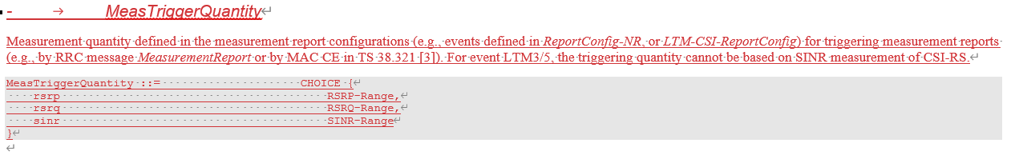

Then, in the definition of RSRP-Range, the following has been captured

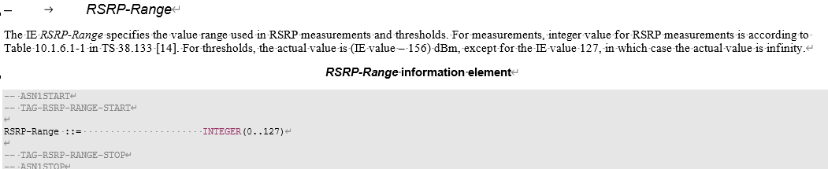

In the RAN4 spec TS 38.133, the following table has been captured on the mapping between the integer value and the real RSRP value.

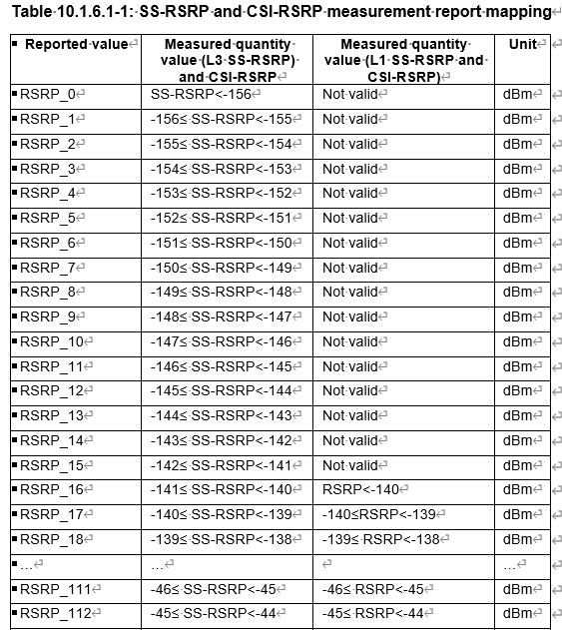

Since this table has been reused for R15 L1 measurement and R18 LTM measurement report by CSI, for R19 event-triggered measurement report, it can be still assumed that they are reused. Rapp would like to ask the following question.

***Question7: Confirm that the legacy RSRP values used for L1 measurement report can be reused for L2 measurement report***

|  |  |  |
| --- | --- | --- |
| **Company** | **Yes/No** | **Suggestion** |
| Ericsson | Yes | We are fine to re-use, but good to wait or confirm this with RAN4. |
| CATT | see comment | We agree to check with RAN1/4 about the value. But we only support L1-RSRP report, whether it is needed to reuse the IE defined for RSRP, RSRQ and SINR. |
| Nokia |  | We see no justification behind the introduction of new RSRP values. So likely the same (existing) RSRP tables should be used The same for differential RSRP, if it is supported. |
| Xiaomi | Yes | We are fine with the reuse. We can revisit if RAN4 identifies any issue. |
| OPPO |  | Prefer to check with RAN1/RAN4. |
| Sharp | Yes | We agree to wait for RAN4 confirmation. |
| vivo | Yes |  |
| ZTE | Yes | We can reuse the value range now, if RAN4 defines something different, they will inform us and RAN2 can update accordingly. |
| Apple | Yes | There is no intention to change the legacy L1-RSRP value range. But it’s fine to check and confirm with RAN1. |

***Proposal6: Reuse the existing RSRP values and RSRP offset values and their interpretations in TS 38.133 for event-triggered measurement report. Can revisit if RAN4 identifies any issue.***

# 3 Examining the running CR

This section is used to collect comments for the running CR in *Introduction of event-triggered L1 report for RRC spec_v00*.

***Question8: Any comments on the running CR?***

|  |  |  |
| --- | --- | --- |
| **Company** | **Issue** | **Suggestion** |
| Ericsson | Introduction of new IEs: *LTM-CSI-RS-ResourceConfig, LTM-CSI-RS-**ResourceConfigId, LTM-EventTriggeredResourceConfig, LTM-EventTriggerResourceConfigId* | We think that introducing these new IEs is not necessary as what we want to achieve can be done by simply doing this change (in red):  LTM-CSI-ResourceConfig-r18 ::= SEQUENCE {  ltm-CSI-ResourceConfigId-r18 LTM-CSI-ResourceConfigId-r18,  ltm-CSI-SSB-ResourceSet-r18 LTM-CSI-SSB-ResourceSet-r18,  ...,  [[  ltm-CSI-SSB-ResourceSet-r19 LTM-CSI-SSB-ResourceSet-r19 OPTIONAL --Need R  ]]  }  LTM-CSI-SSB-ResourceSet-r18 ::= SEQUENCE {  ltm-CSI-SSB-ResourceList-r18 SEQUENCE (SIZE (1..maxNrofLTM-CSI-SSB-ResourcesPerSet-r18)) OF SSB-Index,  ltm-CandidateIdList-r18 SEQUENCE (SIZE (1..maxNrofLTM-CSI-SSB-ResourcesPerSet-r18)) OF LTM-CandidateId-r18,  ...  }  LTM-CSI-RS-ResourceSet-r19 ::= SEQUENCE {  ltm-CSI-RS-ResourceList-r19 SEQUENCE (SIZE (1..maxNrofLTM-CSI-SR-ResourcesPerSet-r19)) OF FFS,  ltm-CandidateIdList-r19 SEQUENCE (SIZE (1..maxNrofLTM-CSI-RS-ResourcesPerSet-r19)) OF LTM-CandidateId-r18,  ...  }  And in the field description of *ltm-CSI-RS-ResourceSet* we can clarify that if this field is present the UE shall ignore the field *ltm-CSI-SSB-ResourceSet*.  [Rapp] The issue addressed by Proposal 1 and 2 above. |
| Ericsson | Introduction of *ltm-NZP-CSI-RS-xyz* fields within *LTM-Candidate-r18*. | We already have these field within *ltm-TCI-Info* which is also inside *LTM-Candidate*. We think that the existing field can be re-used without the need of replication. Current signalling already allows the network to signal such fields and thus there is no need to re-introduce them again.  [Rapp] See the comment from Nokia below and Rapp’s reply |
| Nokia | Introduction of *ltm-NZP-CSI-RS-xyz* fields within *LTM-Candidate-r18* | We agree with Huawei’s proposed approach (in the CR) and disagree with Ericsson’s suggestion.  In Rel-18, LTM-NZP-CSI-RS-xyz was added within the LTM-TCI-Info structure because CSI-RS was only utilized to provide information about TRSs associated with TCI states.  In Rel-19, with the introduction of CSI-RS-based L1 measurements, the scope of CSI-RSs is significantly expanded. Reusing the Rel-18 structure in this context is no longer logical.  [Rapp] Same view. Besides it is also a bit weird to configure the CSI-RS resource under the IE related to the TCI info configuration. |
| Nokia | eventEvaluationRS-Type-r19 under eventTriggered-r19 | This is not needed, as per the following agreement, candidate RS is configured, and the serving beam RS would be determined based on the candidate RS type such that the same type of RSs are used for evaluation:  “Either CSI-RS or SSB could be configured as candidate beam and the measurement RS of the serving cell beam is determined based on the candidate beam to ensure same RS type, i.e. the RS for current beam of serving cell is same as or QCLed with the QCL RS of the indicated TCI state, according to what is agreed in RAN1.”  [Rapp] Good comment, This RS type indication should only be applicable for serving cell and only in case of event LTM 2 is configured. This can be clarified by adding the field only for the IE for event LTM 2. |
| Xiaomi | *MeasTriggerQuantityOffset*: “Values in the unit of 'dBm'.” | The unit should be dB, not dBm.  [Rapp] Thanks for the comment, you’re right that it should be dB |
| Xiaomi | Field description for *ltm3-Offset-r19* | Whether we need to add “The actual value is field value * 0.5 dB.” similar to *a3-Offset* and *a6-Offset*, i.e. whether the granularity is 0.5 dB instead of 1 dB?  [Rapp] This can be further discussed. Added an FFS for this. |
| Xiaomi | Field *ltm3-Threshold-r19* | We are wondering whether field *ltm3-Threshold-r19* is needed in IE *eventLTM3-r19*. There is no threshold in the related definition: *Event LTM3: Beam of candidate cell becomes amount of offset better than beam of serving cell*. Event LTM3 should be similar to event A3, which does not have a threshold either.  [Rapp] Right, removed |
| Sharp | eventEvaluationRS-Type-r19 under eventTriggered-r19 | Agree with Nokia (not needed).  [Rapp] See the reply above |
| Sharp | LTM-EventTriggeredPeriodicReport-r19 ::= SEQUENCE {  reportInterval-r19 ReportInterval, | We understand Rapp’s intention is re-use report interval of L3 measurement report. However, it may be too long interval time for L2 (event triggered L1) measurement report. RAN2 need to check with RAN1/4 about it.  [Rapp] Good comment. We can leave it for RAN4 to decide since this might be mostly related to RRM and the performance requirements?  Formulated a proposal7 for discussing this\ |
| Sharp | LTM-EventTriggeredPeriodicReport-r19 ::= SEQUENCE {  reportInterval-r19 ReportInterval,  reportAmount-r19 ENUMERATED {r2, r4, r8, r16, r32, r64, infinity},  ...  } | Current L3 report amount configuration is below;  reportAmount ENUMERATED {r1, r2, r4, r8, r16, r32, r64, infinity},  We understand “r1” indicates that there is no periodic report. It is preferred to align the structure with current spec.  [Rapp] The need code for the field ltm-EventTriggeredPeriodicReport-r19 is currently captured as need S and we add in the field description the default behaviour. So it should be fine. |
| Sharp | reportMaxNumOfBeams | This IE name doesn't describe the character of the IE.  “allowReportAnyBeams” is suggested.  [Rapp]Thanks, changed |
| Sharp | Field description of maxNumberOfReportedBeams | >This field defines number of beams whose measurements should be reported …  If a number of available measurement results is below of the value, UE cannot report N(=maxNumberOfReportedBeams) beams.Therefore, it should be modified as below;  >This field defines number of beams whose measurements can be reported …  [Rapp] Thanks, corrected |
| Sharp | Field description of reportAmount | > Number of measurement reports needs to be transmitted after the event is triggered as specified in TS 38.321 [3]. Value 'r2' means the report is sent twice, ’r2’ means the report is sent three times, and so on.  Second ‘r2’ may be ‘r3’.  [Rapp] Corrected |
| Sharp | Value of TimeToTrigger | Rapp suggests to reuse the value of L3 measurement report in the CR. However, short period may be needed because it is event triggered L1 measurement report. Details should be check with RAN1/4.  [Rapp] Agree, we can ask RAN1/4 this question along with the issue for reportInterval  [ZTE] It is unclear to us why TTT and reportInterval should be checked with RAN1/4? For L3 measurement event, RAN4 defines measurement period e.g. 200ms for FR1, but still we have specified TTT=0, 40ms,64ms, 80ms… for L3 events. |
| vivo | Introduction of *ltm-NZP-CSI-RS-xyz* fields within *LTM-Candidate-r18* | Agree with Ericsson that the CSI-RS resource configuration exits in *ltm-TCI-Info* inside *LTM-Candidate*. We think the duplication is not needed.  [Rapp] See replies to the comment from E// and Nokia above |
| vivo | eventEvaluationRS-Type-r19 under eventTriggered-r19 | Agree with Nokia that the eventEvaluationRS-Type-r19 is not needed, since only one RS type will be configured for a *ltm-CSI-ResourceConfigId*, then the evaluation RS type for this event is just the RS type associated with the *ltm-CSI-ResourceConfigId*.  [Rapp] See replies to the comment from Nokia above |
| Apple | *MeasTriggerQuantity* and *MeasTriggerQuantityOffset* | As the two parameters are described as the individual information elements, which also cover that under the *ReportConfigNR* config. It’s better to remove the duplicated part from *ReportConfigNR.*    [Rapp] It seems that they are already removed in the current running CR?? |

4 Conclusion

Based on the discussion above, we propose that

Potentially easy to agree

***Proposal1a: Confirm on the previous agreement that "For measurement resource configuration, R18 LTM CSI resource configuration is reused if possible".***

***Proposal1b: Continue to carry the bits for SSB resouce set when CSI-RS resource set is configured. FFS whether CSI-RS can be configured without SSB (up to R1 to decide).***

***Proposal2: Do not create a new resource configuration just for the event triggered measurements.***

***Proposal3: Confirm on the previous agreement "For measurement reporting configuration, R18 LTM-CSI-ReportConfig is reused if possible".***

***Proposal4: Ask RAN1 what should be the maximum number of beam measurement results that can be reported in event-triggered measurement report.***

***Proposal5: Confirm on the previous agreement that "For association between measurement resource configuration and measurement reporting configuration, R18 LTM way is reused if possible".***

***Proposal6: Reuse the existing RSRP values and RSRP offset values and their interpretations in TS 38.133 for event-triggered measurement report. Can revisit if RAN4 identifies any issue.***

Requires further discussion

***Proposal7: Ask RAN4 whether the values of reportInterval and TimeToTrigger of L3 measurement report can be reused for event-triggered measurement report for LTM.***

5 Reference

1. RP-240299, Revised Work Item: NR mobility enhancements Phase 4;
2. TS 3GPP 38.331 V18.4.0