3GPP TSG-RAN WG2 #128 R2-240xxxx
Orlando, US, November 18-22, 2024

Agenda Item: 8.13.2
Source: LG Electronics Inc.
Title: Report of [Post127][401][Relay] Multi-hop relay discovery and (re)selection (LG)
Document for: Discussion and decision

Introduction
This is the trigger of the following email discussion:
- [Post127][401][Relay] Multi-hop relay discovery and (re)selection (LG)
Scope:
  - Discovery message initiating/forwarding condition at intermediate relay UE
  - PC5 AS conditions for discovery at the last relay UE
  - Reselection triggers for all UEs
  - (Re)selection criteria for all UEs (considering discovery models A/B and whether criteria beyond the first hop are considered)
  - Whether to support cross-path topologies, e.g., whether (physically) different remote UE can select each (physically) different last relay UE via one (physically same) intermediate relay UE
Intended outcome: Report to RAN2#128
Deadline: Very long (for RAN2#128)

The purpose of the first phase of email discussion is to address the basic subjects within the scope and gather companies’ opinions on any missing parts that should be discussed. In the second phase, the Rapporteur makes summary proposals and can discuss additional subjects based on the companies’ inputs from the first phase email discussions. Also, throughout the email discussion, we will consider extensibility over 2-hops based on the WID of Rel-19 multi-hop relay.
The deadline for this email discussion will be as follows:
- Phase 1 Deadline 2024-10-21 UTC 10:00
- Phase 2 Deadline 2024-11-04 UTC 10:00

Contact information
Company | Email address
LG | seoyoung.back@lge.com
Ericsson | Min.w.wang@ericsson.com
OPPO | lengbingxue@oppo.com
Sharp | kawano.takuma@sharp.co.jp
Apple | Zhibin_wu@apple.com
CATT | xuhao@catt.cn
ZTE | Wang.mengzhen@zte.com.cn
Huawei,HiSilicon | Jagdeep Singh (jagdeep.singh6@huawei.com)
TCL | Zhe21.chen@tcl.com
Fraunhofer | julian.popp@iis.fraunhofer.de
Spreadtrum | Shannen.cao@unisoc.com
Kyocera | henry.chang@kyocera.com
ASUSTeK | Shawn_Hung@asus.com
Samsung | ww1016.wang@samsung.com
vivo | liangjing@vivo.com

2. Phase 1 Discussion

2.1 Discovery message initiating/forwarding condition at intermediate Relay UE
(The condition to be intermediate Relay UE)
The agreement for the last Relay UE to have upper and lower Uu threshold bound was made at the last meeting as the followings:
- If the Uu RSRP measurement of the serving cell is above a low threshold and below a high threshold, the last relay UE can perform discovery transmission.
However, it’s not made an agreement related to the Uu threshold condition for the intermediate Relay UE.

[Question 2.1-1] Do you think the intermediate Relay UE has the upper and/or lower bound of the Uu threshold? Please check your opinion and you can describe the reason if you want.
Company | Need upper bound | Need lower bound | Need both bounds | Need none of them | You can write down the reason for your answer if you want.
Ericsson | No | No | No | Yes | For the remote UE, the intermediate relay UE is not mandated to be in RRC_CONNECTED. In addition, the intermediate relay UE may be OOC. However, this doesn’t exclude the case where the intermediate relay UE itself may need a relay connection for itself to transmit its own data to the network. In this case, the intermediate relay UE will operate as a remote UE for its own traffic.
OPPO | Yes | No | No | No | For lower bound, it is not needed for the intermediate Relay since it can either in-coverage or out-of-coverage;  For upper bound, it is needed since the intermediate relay should not in the very cell centre (since in that case, it should be the last relay).
Sharp | Yes | No | No | No | If the intermediate relay UE can act as a Last Relay UE, it should act as a Last Relay UE. And upper bound is configured for the legacy relay UE. Therefore, upper bound should be configured (but it is up to NW how to configure the threshold which value can be set to infinity).  [Sharp2] In LTE U2N relay, upper bound for relay UE was introduced to avoid wasteful relay UE operation since remote UE’s position should be cell edge or OOC. So, in accordance with this principle, upper-bound is needed.  For OOC/non-relay-support cell case, the upper bound is not configured via SIB/dedicated RRC signalling. In this case, UE can act as intermediate relay UE (it might be new condition).
Apple | No | No | No | Yes | For OOC intermediate UE, bounds are not needed. For an intermediate relay UE in coverage, the reason it does not acting as a last relay UE is that its own serving cell does not support relay. So, in that case, it will not be subject to bounds configuration either. So, in all cases, there is no need for bounds.
CATT | No | No | No | Yes | In RAN2#127 meeting, RAN2 concluded that the intermediate relay UEs on a multi-hop indirect path can be inside or outside the network converage. We think there is no doubt about the OOC case. But for the IC case, the proponent of upper bound raised that the intermediate relay UE should be considered to avoid too close to the cell centre. Logically correct, but in case the last relay UE and the intermediate relay are under different network coverage/PLMN case, introduing this upper bound will make the situation more complexity. All in all, we think it is not necessary to introduce any Uu threshold for intermediate Relay UE for discovery message initiating condition.
ZTE | No | No | No | Yes | We think an upper bound to prevent a relay UE to act as an intermediate relay UE or to mandate the relay UE to act as a Last relay is not needed. Even if the Uu link quality is good, it is up to UE implementation (considering other factors) to whether to act as an intermediate relay or not. That is, as long as the relay UE decides to not act as a Last relay UE, it is naturally it could be an intermediate relay even it is at the centre of the cell.
Huawei, HiSilicon | Yes | No | No | No | It makes sense to have upper-bound for intemediate relay UE as the it should not be allowed to operate in the cente of the cell.  Alternatively if the intermediate relay UE is connected to the last relay UE like a remote UE, the Uu threshold condition for the remote UE can be reused for the intermediate relay UE
TCL | Yes | No | No | No | Agree with SHARP
Fraunhofer | Opt. | No | No | Yes | The intermediate relay can make use of an upper bound, if configured. As an intermediate relay, it is not mandated to be in-coverage.  If the intermediate relay becomes RRC_CONNECTED it will most likely act as a U2N relay (last relay) and will be configured with an upper bound.
Spreadtrum | No | No | No | Yes
Lenovo | Yes | No | No | Yes | Intermediate relay UE is not located at cell center. Therefore, it makes sense to configue an upper-bound for intemediate relay.  Regarding OOC case, both threshoulds are not needed.
Kyocera | No | Yes | No | No | We assume if the intermediate relay UE’s RSRP is below a configured low Uu threshold it can transmit discovery, similar to remote UE. We also assume if this relay UE is above the threshold it should serve as a last relay UE which is different from requirements for intermediate relay UE.
Samsung | Yes | No | No | No | The intention of multi-hop SL relay is to extend coverage of the cell, especially, for the case that some of UEs are OOC. If without upper bound, it means that each UE can start the discovery procedure, even for the UEs in the center of cell. This will cause the burden at UEs side. On the other hand, it may increase the number of hops of E2E paths since the relay UEs with good signal quality may become the intermediate UEs.  Thus, it is better to have an upper bound to restrict the UEs performing discovery.
vivo | Yes | No | No | No | Intermediate U2N relay UE can be both in-coverage or out-of-coverage, so we understand for Intermedia U2N relay UE, there is no need of any lower limit for Uu threshold condition.  For upper bound, we slightly prefer to have a upper bound, because if we look at the ‘Intermediate Relay UE <-> last relay UE <-> gNB’ path, the Intermediate Relay UE is like the Rel-17 U2N remote UE, which has the upper limit for Uu threshold. Meanwhile, if the Intermediate Relay UE is too close to gNB (i.e. has a very high Uu RSRP), it is questionable why it is not serving as the last relay directly.

(discovery message initiation at intermediate Relay UE)
The conclusion in SA2 TR 23.700-03 and the subclause 6.3.2.5.2/3 in TS 23.304, it looks like the intermediate Relay UE does not initiate a discovery announcement message broadcast in discovery model A and discovery model B.
[Conclusions on SA2 TR 23.700-03]
- When Model A discovery is performed, the Remote UE may choose the Intermediate Relay based on the announcement message sent by the Intermediate Relay.
- When Model B discovery is performed, the Remote UE selects both the UE-to-Network Relay and the path to reach the UE-to-Network Relay. To perform link management, the DCR message is unicasted between Relays according to the path information included in the message. The path information is an (ordered) list of User Info ID of Relays in the selected path. The Remote UE sends the selected path information to the Intermediate UE-to-Network Relay for communication setup.
However, considering multi-hop extensibility over 2-hops, additional schemes can be required in the discovery procedure. For example, the intermediate Relay UE may be required to initiate the discovery procedure when the RLF happens or the RSRP threshold is below the configured threshold among the hops between intermediate Relay UEs or between the intermediate Relay UE and the last Relay UE. It may be helpful to fast recovery of the multi-hop relay link as the hop counts increase. However, it’s not sure whether intermediate Relay UE can initiate the discovery procedure. Also, it’s not sure whether this issue can be discussed in the RAN2, not SA2.

[Question 2.1-2] Do you think discovery procedure should be initiated at the intermediate Relay UE considering multi-hop extensibility over 2-hops? If your answer is ‘yes’, describe how to handle this issue.
Company | Yes/No | Describe how to handle this issue
Ericsson | No | In Rel-19, it is sufficient to assume a baseline mechanism, i.e., it is only remote UE that triggers relay reselection. If there is RLF detected on an intermediate hop, it is enough that the RLF info is relayed to remote UE.  In our view, allowing intermediate relay UE to initiate discovery, is an optimization, which can be delayed to future releases.
OPPO | See comments | After checking SA2 colleagues, our understanding on SA2 conclusion is intermediate relay UE should not generate discovery message for multi-hop relay without information source (i.e., the discovery message has to be generated based on the info from Last relay or remote UE). But it doesn’t restrict the discovery transmission after link establishment for link monitoring purpose.
Sharp | No | We think it should be discussed in SA2 if needed.  And, in our view, if we assume that the intermediate relay UE also acts as a remote UE, the intermediate relay UE can initiate discovery procedure for recovery.
Apple | See comment | We do not understand this question.  SA2 said “……based on the announcement message sent by the Intermediate Relay”. We think this means the relay UE does initiate model-A discovery message by itself although the contents are generated based on the information collected from remote UE or last relay UE via discovery process. SA2 has already agreed that the relay UE can generate discovery message transmission itself.  Does the question intend to ask for the case of relay reselection instead?
CATT | No | What we discudiscussed here is foucus on MH initial path discovery instead of MH path maintence. In the current agreed CR of SA2, for discovery model A, only the last relay UE will initiate the discovery procedure, and for discovery model B, only the remote UE will initiate the discovery procedure.
ZTE | No | Not sure the intention of this question and what conclusion could reach.  Maybe we/SA2 should first discuss whether intermediate relay could/should initiate discovery procedure/perform relay reselection when the PC5 RLF happens or the PC5 RSRP is below a threshold among PC5 hops.
Huawei, HiSilicon | See Comments | There could be different scenarios  - For the discovery procedure before the PC5 connection establishment phase, the intermediate relay UE does not initiate a discovery announcement message, it just forwards the Discovery Anouncement message as described in 6.1.2.1.1 of SA2 TR 23.700-03.  - After the PC5 connection is established between the intermediate relay UE and the last Relay UE supporting multihop relay, the intermediate Relay can send the discovery anouncement message to the other remote UE so that they can use the path for multihop.  - After the unicast data transmission has started or is on going there could be a situation that RLF between the hops is encounted or the RSRP threshold is below the configured threshold among the hops between intermediate Relay UEs or between the intermediate Relay UE and the last Relay UE, then the intermediate relay UE can also perform disccovery.
TCL | Yes
Fraunhofer | No | Agree with CATT
Spreadtrum | No
Lenovo | See comments | When Model A discovery is performed, the Remote UE may choose the Intermediate Relay based on the announcement message sent by the Intermediate Relay.  Based on the above, the intermediate relay UE transmits discovery message itself. The content of the discovery could be from the received discovery message based on the SA2 progress. The above is called as ‘forwarding’ in this document and SA2 TR.  However, in 23.700, there is the following description. It seems the ‘forwarding’ is also described as ‘initiates’ in 23.700.  - The 5G ProSe intermediate Relay initiates Model A discovery only when it has found a UE-to-Network Relay, which has a connection to the network.  NOTE: The 5G ProSe intermediate Relay initiates Model A discovery only when it has found a UE-to-Network Relay, which has a connection to the network. The intermediate Relay may decide the maximum number of hops considering the hops to UE-to-Network Relays it has found.
Kyocera | No | In the case of SL-RLF between the intermediate relay UE and the last relay UE, the intermediate relay UE should inform the remote UE of the failure, then the remote UE can request the intermediate relay UE to perform discovery on behalf of the remote UE. If the remote UE can find another intermediate relay UE that has a path towards the gNB, there’s no need for the current intermediate relay UE to perform discovery.
Samsung | No
vivo | Yes with comments | According to the description above the question ‘For example, the intermediate Relay UE may be required to initiate the discovery procedure when the RLF happens or the RSRP threshold is below the configured threshold among the hops between intermediate Relay UEs or between the intermediate Relay UE and the last Relay UE’  We understand the intention is to ask whether the relay UE can act as a remote UE to trigger e.g. relay reselection. If that is the case, we understand there is benefits to support this scenario especially considering multiple hops may be considered.

(discovery message forwarding at intermediate Relay UE)
For the discovery model A, the following agreement was made for relay UE to initiate discovery announcement message broadcast.
- For Model A discovery, the relay UE should only announce the neighbour UEs for which the SD-RSRP/SL-RSRP between the relay UE and the neighbour UE is above a configured threshold in a discovery announcement message.
In Rel-19 multi-hop U2N relay operation, SD-RSRP/SL-RSRP seems to be considered as condition for the discovery announcement message forwarding at intermediate Relay UE.

[Question 2.1-3] Do you think the discovery announcement message can be forwarded at the intermediate Relay UE when the SD-RSRP or SL-RSRP is above a configured threshold?
Company | Yes/No | Reason, if you want to describe.
Ericsson | Yes
OPPO | See comments | We understand the channel quality between the intermediate relay and its parent relay needs to be evaluated but may not in form of discovery transmission condition. It is more like a relay selection condition, i.e., the intermediate relay selects its parent relay UE based on the RSRP, and forward the discovery announcement message from the selected parent relay UE.
Sharp | Yes
Apple | Yes
CATT | No | For multi-hop relay discovery Model A, there is no AS channel condition should be considered for intermediate relay UE when announcing the discovery message. Since according to SA2’s agreed CR, it stated that the intermediate U2N relay had already been authenticated and established a connection to the network before serving the remote UE (for discovery or connection). That is to say, before the intermediate relay UE forwards the announcing discovery message, the PC5-S link between the intermediate relay UE and its parent relay UE had been established in advance. Considering the PC5-link is already standby, the reason to further consider PC5 quality seems not needed.
ZTE | Yes | For Model A discovery, from AS layer perspective, the intermediate relay UE forwards/propagates the discovery message only if the PC5 RSRP between the relay UE and the UE from which the discovery message is received is above a threshold. That is, if the PC5 link quality is not good, the intermediate relay should not forward discovery message. Otherwise, message storm may be happened and other mechanism is needed to ensure the PC5 link quality of each hop / to select a proper relay path that each hop has good PC5 link quality to avoid failure.
Huawei, HiSilicon | No | We have the following additional comments  - SA2 never intend to reuse the U2U relay solution in their TR, including the discovery procedure then why RAN 2 needs to discuss U2U based procedures alone. Please see the comment for the rappotuer on this  - The above agreement was for R18 U2U relay discovery for two hops between two remotes UEs and the same principle should not be applied to the Multi hop U2N relay scenario as the R18 U2U can only support 2 hops and if we are thinking of having extensibility of more than 2 hops it will not be possible to support it with R18 U2U mechanisms and they will have to be extended in R19 which we dont think is needed.  - Moreover SA2 has concluded that Remote UE either selects the Intermediate Relay (for Model A) or selects both the UE-to-Network Relay and the path to reach the UE-to-Network Relay (Model B) as mentioned above it would be appropriate to forward the SD-RSRP or SL-RSRP information in discovery announcement message for Model A or in Relay Discovery Response message for Model B to the remote UE to select the path to reach the UE-to-Network Relay rather than dropping the message.  - The other apporach is that the first relay UE already connects to the network via the last relay UE in this case, the first relay UE does not need to forward the discovery message since the first relay UE has already established the sidelink with the last relay UE. The first relay UE can perform model A or model B based on ”direct discovery” to let the remote UE find it.
TCL | Yes
Fraunhofer | Yes
Spreadtrum | Yes
Lenovo | No with comments. | Four cases are analyzed as follows.  - Case#1: if the intermediate relay UE is in RRC connected state, this condition is no needed.  - Case#2: if the intermediate relay UE is idle/inactive, it has PC5 connection towards its parent relay UE. This condition is not needed.  - Case#3: the UE can meet the condition of being an intermediate relay UE. But the intermediate relay UE has selected its parent relay UE. This condition is not needed.  - Case#4: The UE can meet the condition of being an intermediate relay UE. But the intermediate relay UE has not selected its parent relay UE. This condition could be needed. But in this case, the condition could be a condition of parent relay UE selection as Oppo mentioned.
Kyocera | Yes | We assume for Rel-19, the “neighbour UE” from the Rel-18 agreement can be mapped to the last relay UE. It would be necessary for the PC5 connection between the two relay UEs to be good enough before the intermediate relay UE forwards the discovery announcement; otherwise the path to the gNB with this intermediate relay UE cannot be properly established if it were chosen by the intermediate relay UE.  We further assume that it is for the intermediate relay UE to determine if the SD-RSRP/SL-RSRP threshold is met.
Samsung | Yes
vivo | Yes | Our first understanding is that the Rel-18 U2U principle may be used here, and the link quality between relay UEs should be evaluated anyway.  But we agree to further discuss whether/how to process this and also this may need SA2 confirmation.

[Question 2.1-4] Do you have any further ideas other than threshold of SD/SL-RSRP about the AS condition for forwarding the discovery announcement message at the intermediate Relay UE? If you have anyone, you can add it freely and describe the reason.
Company | You can describe AS conditions other than SD/SL-RSRP threshold for forwarding discovery announcement message.
Huawei, HiSilicon | Since SA2 has concluded (Conclusions on SA2 TR 23.700-03) that Remote UE either selects the Intermediate Relay (for Model A) or selects both the UE-to-Network Relay and the path to reach the UE-to-Network Relay (Model B) as mentioned above, it would be appropriate to forward the SD-RSRP or SL-RSRP information in discovery announcement message for Model A or in Relay Discovery Response message for Model B to the remote UE for it to select the path to reach the UE-to-Network Relay rather than dropping the message.
Kyocera | We assume if the two relay UEs are PC5-RRC connected the intermediate relay UE may also forward the discovery announcement.

For the discovery model B, the following agreements was made at Rel-18 U2U relay operation.
- For Model B, the relay UE forwards the solicitation message only if the PC5 RSRP between the relay UE and the source remote UE is above a threshold.
- For Model B discovery, upon discovery response messages reception, the source remote UE considers a relay UE as a candidate relay UE if the SD-RSRP towards the relay UE is above a configured threshold.
- For Model B, no AS criterion is needed for the relay UE to forward the response message to the source Remote UE.
The same principle seems to be reused for the multi-hop U2N relay operation as the followings:
- For Model B, the intermediate Relay UE forwards the solicitation message only if the PC5 RSRP between the Remote UE (or intermediate Relay UE) and the intermediate Relay UE is above a threshold.
- For Model B discovery, upon discovery response messages reception, the Remote UE considers an intermediate Relay UE(s) as a candidate relay UE(s) along the path to the last Relay UE if the SD-RSRP towards the first intermediate Relay UE is above a configured threshold.
- For Model B, no AS criterion is needed for the intermediate Relay UE(s) to forward the response message to the Remote UE.

[Question 2.1-5] Do you think the above descriptions (in the box) about discovery message forwarding conditions are available for the multi-hop operation in discovery model B? If you have any other view, you can describe it.
Company | Yes/No | If the answer is ‘No’, please describe your opinions.
Ericsson | Yes | But, the second bullet needs to be updated as  - For Model B discovery, upon discovery response messages reception, the Remote UE considers an intermediate Relay UE(s) as a candidate first relay UE(s) along the path to the last Relay UE if the SD-RSRP towards the first intermediate Relay UE is above a configured threshold.
OPPO | No for 1  Yes for 2/3 | For 1, it is not needed since same as U2N Relay case, there is no channel quality condition defined for Relay UE to determine whether to respond the solicitation message from the remote UE.
Sharp | Yes
Apple | Yes for 1, 3, No for 2 | I think for 2, we have to differ from U2U relay case, because the checking of RSRP threshold has to be done by adjacent UEs, which may not have remote UE involved. So, the bullet 2 has to be rephrased to reflect R19 scenario.
CATT | Yes | For model B discovery message forwarding conditions discussion, it seems reasonable to discuss the relay discovery for multi-hop U2N relay with an analogy to Rel-18 U2U relay design for intermediate relay UE. Hence, we support it.
ZTE | Yes for 1 | The first bullet is needed. It is wasteful for intermediate relay to forward discovery solicitation message if the PC5 link quality towards the UE the discovery solicitation message is received is not good and may cause message storm. And other mechanism is needed to ensure the PC5 link quality of each hop / to select a proper relay path that each hop has good PC5 link quality to avoid failure.  The second bullet is not a forwarding condition at intermediate relay. It is a condition for relay (re)selection.  In multi-hop SL relay, since there are more hops along the path than R18 single hop U2U relay, it is safer for the intermediate relay to forward the discovery response message by checking the PC5 RSRP again.
Huawei, HiSilicon | No | The above agreement was for R18 U2U relay discovery and the same principle should not be applied to the Multi hop U2N relay scenario given that we have a well established U2N discovery procedures described multiple solutions in SA2 TR .  Furthermore SA2 never intend to reuse the U2U relay solution, including the discovery procedure hence we think RAN 2 should not adopt U2U based dicovery mechanisms for multihop given that we have a U2N Relay discovey procedures described in the TR.  See the reasons given in answer to Question 2.1-3.
TCL | Yes
Fraunhofer | Yes | Agree with Apple.  While in a Rel-17/18 U2N case, a relay supporting to reach the destination is quite easy to discover. Introducing multi-hop for U2N connections adds U2U complexity to the U2N case. Thus, reusing U2N alone is not suitable.
Spreadtrum | Yes
Lenovo | No for 1.  Yes for 2,3 | No for 1: see the comments for Question 2.1-3. The intermediate relay UE may have PC5 connected already towards its parent relay UE.
Kyocera | Yes
Samsung | Yes
vivo | Yes | We didn’t see real problems to reuse those Rel-18 U2U principle. This can be further confirmed by SA2 if needed.

2.2 PC5 AS conditions for discovery at the last Relay UE
In the legacy Rel-17 U2N Relay operation, the U2N Relay UE has upper and lower Uu thresholds bound to act as a U2N Relay UE. For example, the Rel-17 U2N Relay UE can initiate discovery procedure when the Uu RSRP threshold is below a configured upper bound and/or above a configured lower bound.
In multi-hop U2N Relay UE operation, the last Relay UE has a similar condition to act as the last Relay UE as the following agreement.
- If the Uu RSRP measurement of the serving cell is above a low threshold and below a high threshold, the last relay UE can perform discovery transmission, as in Rel-17/18 (subject to how the gNB configures one or both thresholds).
Meanwhile, some other companies think that PC5 AS condition can be additionally needed in the case of the last Relay UE in multi-hop. However, it’s not clear which PC5 AS condition can be specified for the last Relay UE. So, we’d like to listen to the PC5 AS condition for discovery at the last Relay UE

[Question 2.2-1] Do you think PC5 AS condition is needed for discovery at the last Relay UE? If your answer is ‘yes’, describe the reason of the necessity in detail.
Company | Yes/No | Describe your opinions freely
Ericsson | No
OPPO | No | As we replied in Question 2.1-5, in single hop U2N relay, there is no PC5 AS condition defined for the relay UE to determine whether to respond the solicitation message from the remote UE.
Sharp | Yes | In Rel-17/18, PC5 AS condition for the last relay UE (i.e. PC5 link quality between the remote UE and the last relay UE) can be evaluated by the remote UE since it was single-hop. However, in multi-hop case, the remote UE cannot evaluate PC5 AS condition for the last relay UE.  For discovery model A, PC5 AS condition is NOT needed since intermediate relay UE which directly receives discovery announce message from the last relay UE can evaluate PC5 AS condition for the last relay UE when the intermediate relay UE determines whether to forward it.  However, for discovery model B, PC5 AS condition is needed since there is no UE which evaluates PC5 link quality between the intermediate relay UE and the last relay UE if the relay UE doesn’t evaluate PC5 AS condition.  This is similar idea with the agreement of R18 U2U relaying as follows;  “For Model-B discovery, after receiving a discovery message from a relay UE, a target remote UE transmits the discovery response message only if the PC5 RSRP between the target remote UE and the relay UE is above a configured threshold.”  Therefore, we think PC5 AS condition is needed for Model B discovery at the last relay UE.
Apple | Yes | Same understanding as Sharp.
CATT | No | It seems reasonable to discuss the relay discovery for multi-hop U2N relay with an analogy to Rel-17 U2N relay design for the last relay UE. In Rel-17 U2N relay, for relay discovery related discussion, there is no PC5 AS conditions captured yet for discovery message initiating/forwarding condition.
ZTE | Yes | In R17 single hop U2N relay, since there is only one hop, there is no big problem that relay UE sends discovery response message without checking PC5 link quality with the remote UE in Model B discovery, as the remote UE could evaluate the PC5 link quality toward the relay UE after receiving the response message, though actually the relay UE does not need to send the response message.  However in multi-hop case, the problem is more serious without checking the PC5 link quality when the Last relay sends response message in Model B, i.e. it is wasteful to send discovery response message if the PC5 link quality is not good and may cause message storm as commented above, and other mechanism is needed to ensure the PC5 link quality of each hop / to select a proper relay path that each hop has good PC5 link quality to avoid failure.  So for the Last relay UE, upon receiving a discovery solicitation message from an intermediate relay, the Last relay UE should consider the PC5 link quality towards the intermediate relay when deciding whether to response the intermediate relay.
Huawei, HiSilicon | No
TCL | Yes | Agree with SHARP
Fraunhofer | Yes | Agree with SHARP
Spreadtrum | No
Lenovo | No | If intermediate relay UE is one of idle/inactive/connected state, the intermediate relay UE has evaluated it already.
Kyocera | No | For Model A discovery additional PC5 AS condition is not needed. For Model A discovery, additional PC5 AS condition can be specified for the intermediate UE’s upon receiving the discovery announcement from the last relay UE (see response for Question 2.1-3).  For Model B discovery, we assume the response to the solicitation message at the last relay UE doesn’t require the last relay UE to check PC5 AS condition before sending.
Samsung | Yes
vivo | Yes | Agree with Sharp that we can consider to reuse the R18 U2U principle.

2.3 (Re)selection triggers for all UEs
Based on the Rel-17 U2N Relay (re)selection triggering conditions in subclause 5.8.15.3 in TS 38.331, the Rel-19 Remote UE for multi-hop may reuse them for relay (re)selection such as the following:
[Relay (re)selection triggering conditions for Remote UE]
- If the Remote UE has no serving cell;
- If the Remote UE does not have a selected intermediate Relay UE;
- If the SL-RSRP of the currently selection intermediate Relay UE is below a configured threshold;
- If the SD-RSRP of the currently selected intermediate Relay UE is below a configured threshold;
- If the upper layer indicates not to use the currently selected intermediate Relay UE;
- If the upper layer of the selected intermediate Relay UE requests the release of the PC5-RRC connection;
- If the RLF is detected on the PC5-RRC connection with the current intermediate Relay UE;
- If the Remote UE receives a notification message from the (first) intermediate Relay UE caused by one of the following:
h-1) if intermediate Relay UE detects PC5 RLF between intermediate Relay UE and last Relay UE (or serving intermediate Relay UE)
h-2) if intermediate Relay UE receives RRCReconfiguration message for HO
h-3) if intermediate Relay UE performs cell reselection
h-4) if intermediate Relay UE fails Uu RRC connection establishment/Resume via last Relay UE
h-5) if intermediate Relay UE receives PC5-RRC connection release between intermediate Relay UE and last Relay UE (or serving intermediate Relay UE)

[Question 2.3-1] Do you think the above relay (re)selection triggering conditions (from (a) to (h) in the box) based on the legacy Rel-17 U2N can be reused for Rel-19 Remote UE? You can answer exclude and include conditions separately among them. You can add other triggering conditions with reason, if you want.
Company | include conditions | Exclude conditions with reason | Additional conditions with reason (other than the above conditions)
Ericsson | a),b),c),d),e),g) h-1  in addition,  f and h-5 may be generalized as “remote UE receives a message from intermediate relay UE indicating PC5 link release” | h-2,h-3, and h-4  the intermediate relay UE is not mandated to be in RRC_CONNECTED | PC5 signal strength between the intermediate relay UE and the L2 last U2N Relay UE is below a (pre)configured signal strength threshold.  Cell reselection, handover, Uu RLF, or Uu RRC connection establishment/resume failure has been indicated by last U2N Relay UE.
OPPO | a) with some rewording  c)-h) | a): Can be covered by “Direct Uu signal strength of current serving cell of the U2N Remote UE is below a configured signal strength threshold  ”  b): We understand the intention while “has no selected intermediate relay UE” seems not the trigger condition for relay selection, but the diff between relay selection and relay reselection. | the Remote UE receives a notification message from the (first) intermediate Relay UE caused Uu RLF at the intermediate relay UE  Direct Uu signal strength of current serving cell of the U2N Remote UE is below a configured signal strength threshold  Indicated by upper layer of the U2N Remote UE.
Sharp | A,b,c,d,e,f,g,h as baseline.  And further details should be discussed later.  For condition (f/g/h), “intermediate relay UE” could be changed to “first relay UE” for clarification for now.  For condition (f) it can be integrated to condition (e) from AS perdpective. |  | Condition: SL/SD-RSRP of the currently selected first(intermediate) relay UE is above a configured threshold.  Reason: If the PC5 link between the remote UE and the first (intermediate) relay UE is very good (i.e., they are almost in the same location), it is reasonable for the remote UE to switch to the intermediate (last) relay UE, from delay perspective.  [comments] For condition (c), what is the intention of “the SL-RSRP of the currently selection intermediate Relay UE”? We think “the SL-RSRP of the currently selected intermediate Relay UE” is align with legacy and condition (d). If there is no difference, please ignore this comment.
Apple | All except f | For f, our understand is that this is the upper layer of intermediate relay UE, so this cannot be used as a remote UE trigger. | 1) Receiving a notification message from PC5-RRC for any path disruption occurred in one or more hops (Uu RLF, SL RLF or both…)  2) Any upper layer reasons to trigger path (re)selection
CATT | b)-h) | For a), In RAN2#127 meeting, the below had been agreed to under condition of discovery,  “If the RSRP measurement of the serving cell is below a Uu threshold, or the Remote UE could not find a serving cell, the Remote UE can perform discovery transmission, as in Rel-17/18.” Have we ever accepted that one condition can simultaneously trigger both discovery and relay (re)selection?
ZTE | It is better to differentiate triggers for relay selection and re-selection.  - for relay selection;  c) - h) for relay re-selection; | b), same view as OPPO. | Additional triggers for relay selection:  - Direct Uu signal strength of current serving cell of the U2N Remote UE is below a configured signal strength threshold;  - Upper layer of the Remote UE indicates to select (multi-hop) relay;  Additional triggers for relay re-selection:  - remote UE receives the notification of cell reselection, handover, Uu RLF, or Uu RRC connection establishment/resume failure of the last relay UE propagated along the multi hops;  - remote UE receives the notification of PC5 RLF or PC5 RSRP degradation of an intermediate relay (not only the first intermediate relay);
Huawei, HiSilicon | a)/b) for relay selection  c) /d)/ e)/ f)/ g)/ h) for relay (reseleciton)
TCL | A,b,c,d,e,f,g,h,
Fraunhofer | a), b), c), d), e), f), g) h-1, h-5 | h-2, h-3, h-4 | Similar to ZTE, we would like to differentiate triggers and also include triggers based on further intermediate relays.
Spreadtrum | All | No | Cell reselection, handover, Uu RLF, or Uu RRC connection establishment/resume failure has been indicated by last U2N Relay UE.
Lenovo | a-h |  | In condition h, the remote UE receives one of a notification message or a PC5-S release message from the (first) intermediate Relay UE.  Therefore, the PC5-S release message is missing in condition h.
Kyocera | a) to h) can be included as baseline. |  | The intermediate relay UE may receive notification msg from the last relay UE (e.g., Uu RLF) which should also be forwarded to the remote UE.
ASUSTeK | All |  | The intermediate Relay UE sends a notification message to the Remote UE if the serving cell of the intermediate Relay UE is changed due to notification message from the last (/serving intermediate) relay UE.
Samsung | a)- g)  h) may need some clarification |  | For h), can remote UE receive the notification message from other intermediate relay UEs(except the first intermediate relay UE)?
vivo | a),b),c),d),e),f),g),h-5  for h-1, may be further considered whether to be applied to remote UE or intermediate Relay UE | h-2 to h-4 can be further discussed

The intermediate Relay UE may reuse similar conditions for relay (re)selection. The relay (re)selection conditions for intermediate Relay UE can be suggested like the following:
[Relay Triggering conditions for intermediate Relay UE]
- If the intermediate Relay UE has no serving cell;
- If the intermediate Relay UE does not have a selected last (/serving intermediate) Relay UE;
- If the SL-RSRP of the currently selection last (/serving intermediate) Relay UE is below a configured threshold;
- If the SD-RSRP of the currently selected last (/serving intermediate) Relay UE is below a configured threshold;
- If the upper layer indicates not to use the currently selected last (/serving intermediate) Relay UE;
- If the upper layer of the selected last (/serving intermediate) Relay UE requests the release of the PC5-RRC connection;
- If the RLF is detected on the PC5-RRC connection with the current last (/serving intermediate) Relay UE;
- If the intermediate Relay UE receives a notification message from the last (/serving intermediate) Relay UE caused by one of the following:
h-1) if last Relay UE detects Uu RLF
h-2) if serving intermediate Relay UE detects PC5 RLF
h-3) if last (/serving intermediate) Relay UE receives RRCReconfiguration message for HO
h-4) if last (/serving intermediate) Relay UE performs cell reselection
h-5) if last (/serving intermediate) Relay UE fails Uu RRC connection establishment/Resume
h-6) if last (/serving intermediate) Relay UE receives Uu connection release between gNB and last (/serving intermediate) Relay UE
h-7) if serving intermediate Relay UE receives PC5-RRC connection release between last (/the other serving intermediate) Relay UE and the serving intermediate Relay UE

[Question 2.3-2] Do you think the above suggested relay (re)selection triggering conditions (from (a) to (h) in the box) based on the legacy Rel-17 U2N can be used for intermediate Relay UE? You can answer exclude and include conditions separately among them. You can add other triggering conditions with reason, if you want.
Company | include conditions | Exclude conditions with reason | Additional conditions with reason (other than the above conditions)
Ericsson | None, in our view, intermediate relay has no need to trigger relay (re)selection, it is an optimization.
OPPO | a) h-1) with some rewording  c)-h) | a): Can be covered by “Direct Uu signal strength of current serving cell of the U2N Remote UE is below a configured signal strength threshold  ”  b): We understand the intention while “has no selected intermediate relay UE” seems not the trigger condition for relay selection, but the diff between relay selection and relay reselection. | Direct Uu signal strength of current serving cell of the U2N Remote UE is below a configured signal strength threshold  Indicated by upper layer of the U2N Remote UE.  For h-1), it should be “if last(/serving intermediate) Relay UE detects Uu RLF” since intermediate relay may also detect Uu RLF.
Sharp | [comment]  If RAN2 assumes that the intermediate relay UE also act as a remote UE, no condition is needed. We consider this assumption helps keep the specification simple and also achieves the same effect as if the intermediate relay UE were to perform relay reselection.
Apple | None | Intermediate relay UE shall not trigger relay reselection by itself, basically, it need just send notification message towards the remote UE about RLF.
CATT | None
ZTE | None | When intermediate relay triggers relay reselection, all the downstream UEs are impacted. The reselected path by the intermediate relay may be not the good path for all the downstream UEs. It may be better for each multi-hop remote UE to know the link status of the intermediate hops and to decide whether to trigger relay reselection by itself.
Huawei, HiSilicon | The behavior can be simialr to the remote UE in R17
TCL | Non, agree with Ericsson
Fraunhofer | None | Agree with ZTE
Spreadtrum | None | Same view with sharp
Lenovo | a-h. the intermediate relay UE can be considered as Rel-17 relay UE. |  | In condition h, the intermediate relay UE receives one of a notification message or a PC5-S release message from its parent Relay UE.  Therefore, the PC5-S release message is missing in condition h.
Kyocera | None |  | Upon detecting one of the conditions from a) – h), the remote UE should be notified by the intermediate relay UE and the remote UE may request the intermediate relay UE to perform relay reselection, if needed.
Samsung | At least h) |  | The intermediate relay UE can receive the notification message from its serving node. This can trigger the (re)selection.
vivo | c),d),g),FFS h)  Consider two additional hop case, it may be easier to allow last relay UE reselection by Intermediate Relay UE especially when only the link between them deteriorates  We can limit the case to only reselection. For selection, may be performed by remote UE as in SA2 discussion.

2.4 (Re)selection criteria for all UEs (considering discovery models A/B and whether criteria beyond the first hop are considered)
In the Rel-18 U2U Relay, the following agreements are generated.
- SL-RSRP and SD-RSRP can be used for relay selection/reselection criteria.
- In both cases, it is left to remote UE implementation whether to use SL-RSRP or SD-RSRP for relay (re)selection trigger evaluation in case of no data transmission.
- Besides the PC5 link quality, RAN2 does not pursue other AS criteria for relay (re)selection.
The Rel-18 U2U relay (re)selection criteria may be reused to the Rel-19 multi-hop U2N relay (re)selection criteria.

[Question 2.4-1] Do you think the above Rel-18 relay (re)selection criteria, from (1) to (3) in the box, can be reused for relay (re)selection criteria for the Rel-19 multi-hop?
Company | Yes/No | Reason
Ericsson | Yes
OPPO | Yes
Sharp | Yes
Apple | Yes
CATT | Yes
ZTE | Yes
Huawei, HiSilicon | No with comments | SA2 never intend to reuse the U2U relay solutions in their TR, including the discovery procedure or reslection procedures for multihop.  We can simply focus on reusing the R17 U2N solutions and principles for the U2N multi hop relays
TCL | Yes
Fraunhofer | Yes | The criteria can be reused as long as the overall path is also considered when re-selecting.
Spreadtrum | Yes
Lenovo | Yes
Kyocera | Yes
ASUSTeK | Yes
Samsung | Yes
vivo | Yes

[Question 2.4-2] If you think that the other relay (re)selection criteria other than SD-RSRP or SL-RSRP are needed for the multi-hop relay, please write them down along with the reason.
Company | Describe other criteria, if it exists | Reason
Fraunhofer | Path quality, e.g. based on RSRP values of the hops | Selection of the first relay and intermediate relay(s) until the last relay are currently independent steps. The overall path should be considered when remote UE chooses the relay.

2.5 Whether to support cross-path topologies, e.g., whether (physically) different remote UE can select each (physically) different last Relay UE via one (physically same) intermediate Relay UE
According to the Rel-19 WID, it’s clear that one Remote UE has one indirect path. However, it’s not clear whether the intermediate Relay UE can have one indirect path or not. Considering this issue, we can consider which topologies can be excluded or included.
In the contributions by Qualcomm (R2-2407102), several cases of the multi-hop topologies, which we have to treat, are displayed. Based on Qualcomm’s contribution, Rapporteur will display further topologies cases that we should include and exclude. All the remote UEs have only one indirect path in the provided topologies. In the figures, the red or green color means the link to support multi-hop U2N relay from Remote UE and gNB. The big blue circle means physically one Relay/Remote UE.
For each question, you can answer in terms of Rel-19 U2N relay should handle these topologies.
- Case-A
  - The red link from gNB to Remote UE(1) is for supporting multi-hp U2N relay operation.
  - The green link from gNB to Remote UE(2) is for single-hop U2N relay operation.
  - In Figure 2.5A-1, the big blue circle means the L2 ID(D) and L2 ID(D’) belong to the physically same last relay UE. And L2 ID(C) and L2 ID(C’) belong to the physically same intermediate Relay UE. However, the physically one intermediate Relay UE acts as an intermediate Relay for the Remote UE(1) and also acts as Remote UE(2) by itself. The intermediate Relay UE has one C-RNTI value because the UE is physically one UE regardless of acting as intermediate Relay UE and Remote UE simultaneously. In this case, the intermediate Relay UE has two different indirect paths via physically one last Relay UE by using different PC5 connections.
  - In Figure 2.5A-2, the big blue circle at the last Relay UE means the L2 ID(D) and L2 ID(D’) belong to the physically one UE. However, L2 ID(D) and L2 ID(D’) has connection with each physically different intermediate Relay UE and Remote UE(2). In this case, it doesn’t look like there is any problem with just the figure.
  - In Figure 2.5A-3, the big blue circle at the intermediate Relay UE means the L2 ID(C) and L2 ID(C’) belong to physically the same UE. The intermediate Relay UE acts as an intermediate Relay UE for supporting Remote UE(1) and acts as Remote UE(2) by itself simultaneously. The intermediate Relay UE has two indirect connections with gNB via physically different last Relay UE(s) (i.e., via last Relay UE(1) and last Relay UE(2)). Each last Relay UE(1) and last Relay UE (2) is connected to the same gNB/cell.
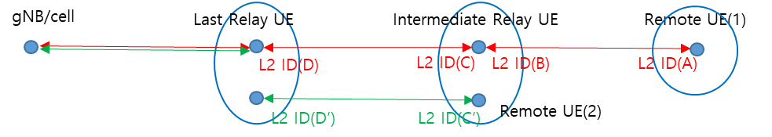

(Figure 2.5A-1)
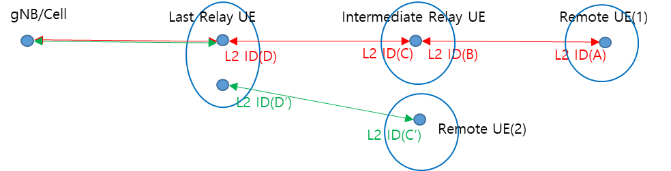
(Figure 2.5A-2)
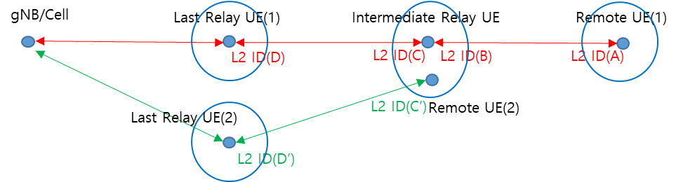
(Figure 2.5A-3)

[Question 2.5A-1] In Figure 2.5A-1 and 2.5A-2, do you think the last Relay UE of a multi-hop relay operation can also act as last Relay UE of a single-hop relay operation simultaneously?
Company | Yes/No | Reason
Ericsson | Yes with comments | We are open for discussion to identify the potential design efforts to support this case.
OPPO | Yes
Apple | Yes | A relay UE cannot be limited to only support a single scenario.
CATT | Yes | There is no issue forseen that provent the last Relay UE of a multi-hop relay operation can also act as last Relay UE of a single-hop relay operation simultaneously.
ZTE | Yes | We agree that the last Relay UE of a multi-hop relay operation can also act as last relay UE of a single-hop relay operation simultaneously at least that the relay UE uses the same L2 ID. But it does not mean the case in Figure 2.5A-1 is supported.
Huawei, HiSilicon | Yes | Last relay UE can provide relaying service for multiple remote UE, which is similar to R17
TCL | Yes
Fraunhofer | Yes | We don’t see a technical reason for not suppurting this case.
Sharp | yes
Spreadtrum | Yes
Lenovo | Yes
Kyocera | Yes with comments | Although this can be supported we should get clarification from SA2 whether it is intended to be supported in Rel-19.
ASUSTeK | Yes
Samsung | Yes | We see no difference from R17 relay if only one hop is established.
vivo | Yes

[Question 2.5A-2] In Figure 2.5A-1, do you think the intermediate Relay UE of multi-hop relay operation can act as a Remote UE of single-hop relay operation simultaneously?
Company | Yes/No | Reason
Ericsson | Yes with comments | We are open for discussion to identify the potential design efforts to support this case.
OPPO | No if different L2 ID are used for the two roles as shown in the figure 2.5A-1  But Yes if the same ID are used for the two roles (e.g., using the red line to play the two roles simultaneously) | For L2 U2N Relay, different L2 ID means different links, allowing intermediate Relay UE of multi-hop relay operation acting as a Remote UE of single-hop relay operation simultaneously means we support multi-path with 2 indirect legs, which is out of both R18 and R19 scope.
Apple | Yes | There is no real technical obstacles for this. The UE can be a remote UE and a relay UE at the same time
CATT | Yes | There is no issue forseen that provent the intermediate Relay UE of multi-hop relay operation can act as a Remote UE of single-hop relay operation simultaneously.
ZTE | See comments | When we discuss the two roles of a physical UE, it should be assume the same L2 ID is used for the two roles. Otherwise, different L2 IDs means different PC5 links, as OPPO commented, multi-path with 2 indirect paths is not in the WI scope.
Huawei, HiSilicon | Yes | The intermediate relay UE should as a remote UE. This can reduce the complexity of the multi-hop relay, since all the remote UE and intermediate relay UE connects to the cell of the last relay UE
TCL | Yes
Fraunhofer | Yes
Sharp | yes
Spreadtrum | Yes
Lenovo | Yes with comments | The single PC5 connection is used for intermedidate relay UE which is also acted as remote UE.
Kyocera | Yes | From the Rel-18 U2U relay perspective it is already possible for a relay UE to serve as a relay UE for two source remote UEs connecting to the same destination remote UE using multiple PC5 links towards the destination remote UE. The same principle for multiple relay should be applicable.
ASUSTeK | Yes with comments | We share the same view as OPPO in terms of multi-path with 2 indirect legs concern.  Besides, according to Note 5 in subclause 6.4.3.6 of TS23.304, a single PC5 unicast link is established between a 5G ProSe Layer-2 UE-to-Network Relay and a 5G ProSe Layer-2 Remote UE, as specified in TS 38.300, for supporting PDU sessions of the 5G ProSe Layer-2 Remote UE. Furthermore, the 5G ProSe Layer-2 U2N Relay provides forwarding functionality that can relay any type of traffic over the PC5 link as specified in section 5.4.2 of TS 23.304.  The above statements in TS23.304 imply one single PC5 unicast link between the Intermediate Relay UE and the Last Relay UE can support multiple PDU sessions of different Remote UEs. Therefore, if there exists a PC5 unicast link between the Intermediate Relay UE and the Last Relay UE, the Intermediate Relay UE can use the same PC5 unicast link to support a new Remote UE instead of establishing a new PC5 unicast link with the Last Relay UE.
Samsung | Yes | To be an intermediate node, such relay UE should be remote UE first.
vivo | Yes | We don’t really understand why different L2 IDs can lead to multi-path with 2 indirect paths, as the intermediate relay UE is logically two UEs based on different L2 IDs and the links also runs independently. Maybe SA2 can confirm this.

[Question 2.5A-3] As Figure 2.5A-1, do you think one physical UE which acts as both intermediate Relay UE and Remote UE can have two indirect connections with different PC5 connections via physically the same last Relay UE?
Company | Yes/No | Reason
Ericsson | Yes | We are open for discussion to identify the potential design efforts to support this case.
OPPO | No | The multi-path with 2-indirect path is out of WI scope.
Apple | Yes
CATT | No | It is a little bit confused that why two indirect connections with different PC5 connections via physically the same last Relay UE are needed? Since multi-path relay is not in the scope of Rel-19 MH Relay.
ZTE | No | Out of the WI scope.
Huawei, HiSilicon | No | In figure 2.5 A-1, there should be only one connection between intermediate relay UE and the gNB, and the remote UE can share the link since the intermediate relay UE provideds the relaying service
TCL | No | Agree with oppo
Fraunhofer | Yes | This will need some discussion to understand the impact. In general this could be supported.
Sharp | No
Spreadtrum | Yes
Lenovo | No | Agree with Oppo.
Kyocera | maybe | It depends if the physical UE’s operation as an Intermediate relay UE and a remote UE can be operated independently.
ASUSTeK | No | Agree with OPPO.
Samsung | No
vivo | Yes | Similar as comment in last question maybe this can be confirmed by SA2

[Question 2.5A-4] As Figure 2.5A-2, do you think physically one last Relay UE can have two connections with one intermediate Relay UE and one Remote UE (the intermediate Relay UE and Remote UE are physically different UE)?
Company | Yes/No | Reason
Ericsson | Yes | In the same cell, there may be both R17 remote UE and R19 remote UE, connecting to the same last relay UE. We are open for discussion to identify the potential design efforts to support this case.
OPPO | Yes
Apple | Yes
CATT | Yes
ZTE | Yes
Huawei, HiSilicon | Yes | Last relay UE can provide the relaying service to multiple remote UE which can be connected via U2N relay or multi-hop relays
TCL | YES
Fraunhofer | Yes
Sharp | yes
Spreadtrum | Yes
Lenovo | Yes
Kyocera | Yes
ASUSTeK | Yes
Samsung | Yes
vivo | Yes

[Question 2.5A-5] As Figure 2.5A-3, do you think one intermediate Relay UE, which also acts as Remote UE, can have two different indirect connection via physically different last Relay UE?
Company | Yes/No | Reason
Ericsson | comments | We are open for discussion to identify the potential design efforts to support this case.
OPPO | No | The multi-path with 2-indirect path is out of WI scope.
Apple | Yes | The two last relay UE may only support one different RSC code for each of them, so this is a valid case.
CATT | No | We think it belongs to multi-path and multi-hop combination which is not in the scope of RAN2 WID.
ZTE | No | Out of the WI scope.
Huawei, HiSilicon | No | Out of the WI scope.
TCL | NO | As our last comment, out of scope of WI scope
Fraunhofer | Yes | From the use case point of view (public safety communication) this is beneficial.
Sharp | No
Spreadtrum | No
Lenovo | No | See above comments.
Kyocera | maybe | It depends if the physical UE’s operation as an Intermediate relay UE and a remote UE can be operated independently.
ASUSTeK | No | Agree with OPPO.
Samsung | No
vivo | No

[Question 2.5A-6] If your answer to the [Question 2.5A-3] or [Quest 2.5A-5] was 'NO', do you have any ideas on how to prevent these topologies? Because the AS layer can only see L2 ID(s), the AS layer cannot differentiate whether the different L2 ID(s) belong to the same physical UE. It seems like it should be controlled from the upper layer, but if you have any idea, you can describe it freely.
Company | Describe how to prevent
OPPO | Similar issue has been discussed in R17 single-hop U2N Relay. In single-hop relay, for L2 U2N Remote UE, to prevent 2-indirect path connection, each remote UE can only have one relay UE, and according to state-2 specification, a single unicast link is established between one L2 U2N Relay UE and one L2 U2N Remote UE.  Therefore, we can make the similar restriction in MH case, i.e., each UE can only have a single parent node, and a single unicast link is established between the UE and its parent UE in L2 MH U2N Relay case.  And also restriction, if needed, can be facilitated by upper layer (S2 spec).
CATT | We prefer to leave it to SA2.
ZTE | Agree with OPPO.
Huawei, HiSilicon | We can adopt approach 1 of the email discussion as the baseline and assume that when intermediate relay UE connects to the last relay UE as a remote UE, meanwhile it has the capability to act as a relay, it can perform the discovery procedure to let the multi-hop remote UE find it. This can guarantee the intermediate is always connected to one last relay UE, and meanwhile can act as the intermediate relay UE for multiple remote UE.
TCL | Each remote UE can only have one first relay UE.  Also the intermediate relay UE as a remote UE can only has one last relay UE.
ASUSTeK | Agree with OPPO.

[Question 2.5A-7] If your answer was ‘yes’ for one of the questions 2.5A-3, 2.5A-4, or 2.5A-5, do you have any preference on which topology should be handled priori than others for Rel-19 multi-hop? If you have any preference, you can describe it with reason.
Company | Preference with reason
Ericsson | 2.5A-3 2.5A-2 2.5A-1 (follows a decreasing priority order)
Apple | All. No differentiation in priority.
Fraunhofer | 2.5A-3, 2.5A-1, 2.5A-2
Kyocera | Topology 2.5A-1 should be prioritized over topologies 2.5A-2 or 2.5A-3.

- Case-B
  - The red link from gNB to Remote UE(A) is for multi-hop U2N relay operation.
  - The green link from gNB to Remote UE(B) is for multi-hop U2N relay operation.
  - In Figure 2.5B-1, the big blue circle at the intermediate Relay UE means the L2 ID(B) and L2 ID(B’) belong to the physically one intermediate relay UE. Each physically different Remote UE has an indirect path via the same intermediate Relay UE and the same last Relay UE. It looks link no problem.
  - In Figure 2.5B-2, the big blue circle at the last Relay UE means the L2 ID(D) and L2 ID(D’) belong to the physically one last Relay UE. The big blue circle at the intermediate Relay UE means the L2 ID(C) and L2 ID(C’) (/L2 ID(B) and L2 ID(B’)) belong to the physically one intermediate Relay UE. Each physically different Remote UE(A) and Remote UE(B) has an indirect path via the same intermediate Relay UE and last Relay UE. However, comparing Figure 2.5B-1, the intermediate Relay UE and last Relay UE have connections via different PC5 connections to support each Remote UE.
  - In Figure 2.5B-3, the big blue circle at the intermediate Relay UE means the L2 ID(C) and L2 ID(C’) (/L2 ID(B) and L2 ID(B’)) belong to the physically one UE. The intermediate Relay UE has two different PC5 connections with physically different last Relay UE(A) and last Relay UE(B). Each last Relay UE(A) and last Relay UE (B) is connected to the same gNB/cell. The intermediate Relay UE has one C-RNTI when it is CONNECTED because the intermediate Relay UE is physically one UE. It looks like one intermediate Relay UE has two different indirect paths via physically different last Relay UE(s).
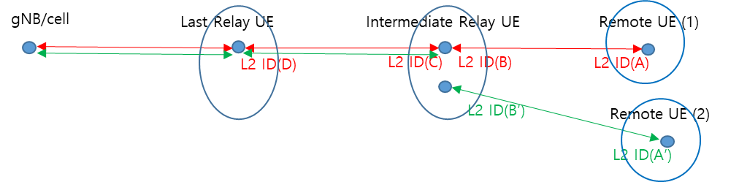
(Figure 2.5B-1)
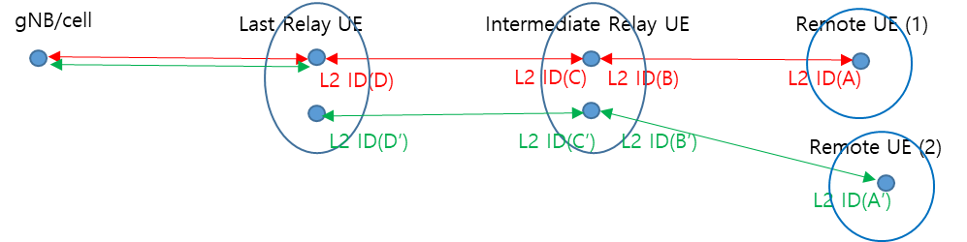
(Figure 2.5B-2)
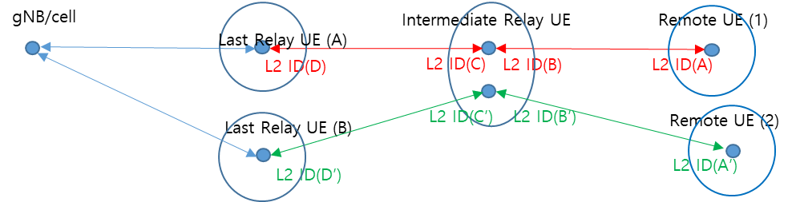
(Figure 2.5B-3)

[Question 2.5B-1] As Figure 2.5B-1, do you think two physically different Remote UE(s) can have each indirect path via the same intermediate Relay UE and the same last Relay UE? If your answer is ‘no’, please describe the reason.
Company | Yes/No | Reason
Ericsson | No | Not sure understand this scenario, but it seems that the intermediate relay UE and last relay UE use the same PC5 connection to carry two indirect paths, which may require additional design complexity which should be avoided.
OPPO | Yes | Compared to Figure 2.5B-2, we assume the difference here is the intermediate Relay UE and last Relay UE have a single PC5 connections to support each physically different Remote UE
Apple | Yes | This is a valid case.
CATT | Yes | From our point of view, this is no additional design complexity to support this case.
ZTE | Yes | It is reasonable that one PC5 link between the intermediate relay and the last relay can serve different remote UEs.
Huawei,HiSilicon | Yes | Like a tree structure.
TCL | No | Not sure about the benefit of this scenario
Fraunhofer | Yes | Valid case, could depend on QoS and Application
Sharp | yes
Spreadtrum | No
Lenovo | Yes
Kyocera | Yes | We assume the PC5 connection means it will be mapped to one PC5-RRC connection after the PC5 connection is established.
ASUSTeK | Yes
Samsung | Yes
vivo | Yes

[Question 2.5B-2] As Figure 2.5B-2, do you think two physically different Remote UE can have each indirect path via the physically same intermediate Relay UE and physically same last Relay UE? Here, the intermediate Relay UE and last Relay UE have two different PC5 connections to support each physically different Remote UE.
Company | Yes/No | Reason
Ericsson |  | We are open for discussion to identify the potential design efforts to support this case.
OPPO | No | The connection between intermediate relay UE and the last relay UE has to be the same link, otherwise multi-path with 2-indirect path cannot be avoided, which is out of WI scope.
Apple | Yes
CATT | No | It is a little bit confused that why two indirect connections with different PC5 connections via physically the same last Relay UE are needed?
ZTE | No | Multi-path with 2 indirect path is out of the WI scope.
Huawei,HiSilicon | No | Agree with OPPO
TCL | No | Not sure about the benefit of this scenario
Fraunhofer |  | Not sure about the benefits, but would be open to discuss.
Sharp | No
Spreadtrum | Yes
Lenovo | No | Single PC5 connection can be used for different remote UEs.
Kyocera | No (maybe) | We assume this topology means there will be two different PC5-RRC connections between the last relay UE and the intermediate relay UE once the links are established.
ASUSTeK | No | Agree with OPPO.
Samsung | No
vivo |  | Not sure about this 2-indirect path as the L2 IDs for intermediate relay UE are different. We can further discuss about this.

[Question 2.5B-3] As Figure 5B-3, do you think two physically different Remote UE can have each indirect path via the physically same intermediate Relay UE and physically different last Relay UE(s)? i.e., physically one intermediate Relay UE has connections with physically two different last Relay UE(s) to support physically different Remote UE(s).
Company | Yes/No | Reason
Ericsson |  | We are open for discussion to identify the potential design efforts to support this case.
OPPO | No | The connection between intermediate relay UE and the last relay UE has to be the same link, otherwise multi-path with 2-indirect path cannot be avoided, which is out of WI scope.
Apple | Yes | This is a valid case, the intermediate relay UE be chose to use different last relay UE for different remote UE.
CATT | No | We think it belongs to multi-path and multi-hop combination which is not in the scope of RAN2 WID.
ZTE | No | Out of the WI scope.
Huawei,HiSilicon | No | Agree with OPPO
TCL | No | Not sure about the benefit of this scenario
Sharp | No
Spreadtrum | No
Lenovo | No | Out of scope.
Kyocera |  | We assume the intermediate relay UE could potentially forward discovery messages from different last relay UE supporting different RSC values. Whether this can be supported should be confirmed by SA2.
ASUSTeK | No | Agree with OPPO.
Samsung | No
Vivo | No

[Question 2.5B-4] If your answer of the [Question 5B-2] or [Quest 5B-3] was “NO”, do you have any idea to prevent happening these topologies? The answer to this question may be the same as the answer to [Question 5A-6]. However, if you want to describe further for the solution to prevent these topologies, you can write down.
Company | Describe how to prevent
OPPO | like replied in Q2.5A-7
CATT | We prefer to leave it to SA2.
Huawei,HiSilicon | See our comments for Q2.5A-6
ASUSTeK | Agree with OPPO.

[Question 2.5B-5] If your answer was ‘yes’ for one of the questions 2.5B-1, 2.5B-3, or 2.5B-3, do you have any preference on which topology should be handled priori than others for Rel-19 multi-hop? If you have any preference, you can describe it with reason.
Company | Preference with reason
Ericsson | 2.5B-3 2.5B-2 (following decreasing priority order)
Apple | All. No preference of priority.
Fraunhofer | No preference
Kyocera | Topology 2.5B-1 or 2.5B-2 (if applicable) should be prioritized

- Case-C
  - The red and green link from gNB to Remote U are for multi-hop U2N relay operation.
  - In Figure 2.5C-1, the big blue circle at the last Relay UE means the L2 ID(D) and L2 ID(D’) belong to the physically same last relay UE. The big blue circle at the intermediate Relay UE means the L2 ID(C) and L2 ID(C’) (/L2 ID(B) and L2 ID(B’)) belong to the physically same intermediate Relay UE. And, the big blue circle at the Remote UE means the L2 ID(A) and L2 ID(A’) belong to the physically same Remote UE. Each indirect link belongs physically same last Relay UE, intermediate Relay UE, and Remote UE. However, each indirect link has its own PC5 connection (i.e., has its own L2 ID pair) to support the multi-hop relay path. Each last Relay UE, intermediate Relay UE, and Remote UE has each only one C-RNTI when they are connected.
  - In Figure 2.5C-2, each last Relay UE(A) and last Relay UE(B) is physically different last Relay UE. The big blue circle at the Remote UE means the L2 ID(A) and L2 ID(A’) belong to the physically same Remote UE. The big blue circle at the intermediate Relay UE means the L2 ID(C) and L2 ID(C’) (/L2 ID(B) and L2 ID(B’)) belong to the physically same intermediate Relay UE. Each indirect link belonging to the physically same Remote UE has connections with gNB via physically different two last Relay UE(s) and the physically same intermediate Relay UE. Each last Relay UE(A) and last Relay UE (B) is connected to the same gNB/cell. Each indirect path has its own PC5 link(s) and Uu links to support the multi-path.
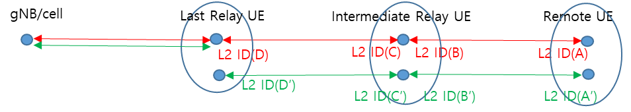

(Figure 2.5C-1)
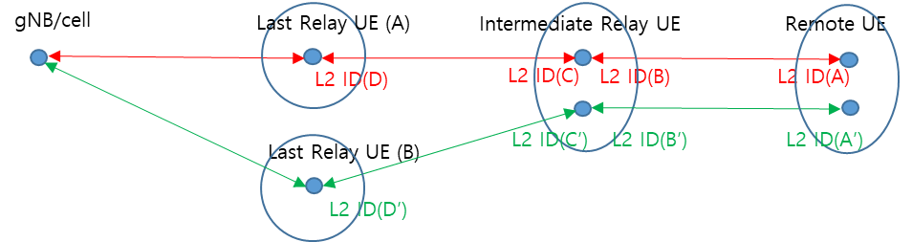
(Figure 2.5C-2)

[Question 2.5C-1] As Figure 2.5C-1, do you think two different indirect links at the physically same Remote UE can have connections with the gNB via the physically same intermediate Relay UE and physically same last Relay UE?
Company | Yes/No | Reason
Ericsson | No | This seems to be a multi-path scenario for remote UE, which is not in the scope
OPPO | No (if the L2 ID is different) | This is excluded by the conclusion for single hop U2N Relay, i.e., a single unicast link is established between one L2 U2N Relay UE and one L2 U2N Remote UE.
Apple | No
CATT | No | We fail to see the benefit to support this scenario.
ZTE | No | As single hop L2 U2N relay, the remote UE can only have one PC5 unicast link with the parent relay.  The following cases are just different combinations of before cases, do not need to discuss repeatedly.
Huawei, HiSilicon | No | A single path is enough. We dont see any benefits of having 2 paths
TCL | No | Not sure about the benefit of this scenario
Fraunhofer |  | No strong view.
Sharp | No
Spreadtrum | No
Lenovo | No | For a single remote UE, only one single indirect path is allowed.
Kyocera | No
ASUSTeK | No | Agree with OPPO.
Samsung | No
vivo | No

[Question 2.5C-2] As Figure 2.5C-2, do you think two different indirect links at the physically same Remote UE can have connections with the gNB via the physically same intermediate Relay UE and physically different last Relay UE?
Company | Yes/No | Reason
Ericsson | No | This seems to be a multi-path scenario for remote UE, which is not in the scope
OPPO | No (if the L2 ID is different) | This is excluded by the conclusion for single hop U2N Relay, i.e., a single unicast link is established between one L2 U2N Relay UE and one L2 U2N Remote UE.
Apple | No
CATT | No | We think it belongs to multi-path and multi-hop combination which is not in the scope of RAN2 WID.
ZTE | No
Huawei,HiSilicon | No
TCL | No | Not sure about the benefit of this scenario
Fraunhofer | No | Unsure about the benefit.
Sharp | No
Spreadtrum | No
Lenovo | No
Kyocera | No
ASUSTeK | No | Agree with OPPO.
Samsung | No
vivo | No

[Question 2.5C-3] If your answer of the [Question 2.5C-1] or [Question 2.5C-2] was “NO”, do you have any idea to prevent happening these topologies? The answer to this question may be the same as the answer to [Question 2.5A-6] or [Question 2.5B-4]. However, if you want to describe further for the solution to prevent these topologies, you can write down.
Company | Yes/No | Reason
Ericsson |  | We can include restriction in stage 2 spec.
OPPO | like replied in Q2.5A-7 | like replied in Q2.5A-7
Apple |  | We can ask SA2 for how to do this
CATT |  | We prefer to leave it to SA2.
ASUSTeK |  | Agree with OPPO.

[Question 2.5C-4] If your answer was ‘yes’ for one of the questions 2.5C-1, or 2.5B-2, do you have any preference on which topology should be handled priori than others for Rel-19 multi-hop? If you have any preference, you can describe it with reason.
Company | Preference with reason

- Case-D
  - Figure 2.5D-1, 2.5D-2 and 2.5D-3 are the similar to the Figure 2.5A-3, 2.5B-3 and 2.5C-2 except that each multi-hop indirect path have connect with different cells in the same gNB.
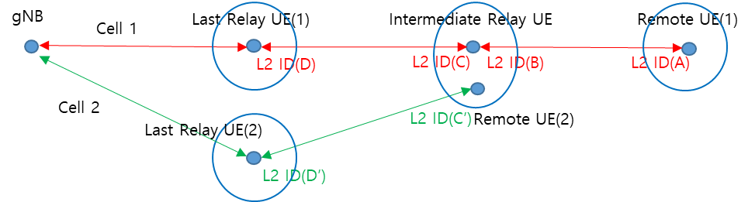
(Figure 2.5D-1)
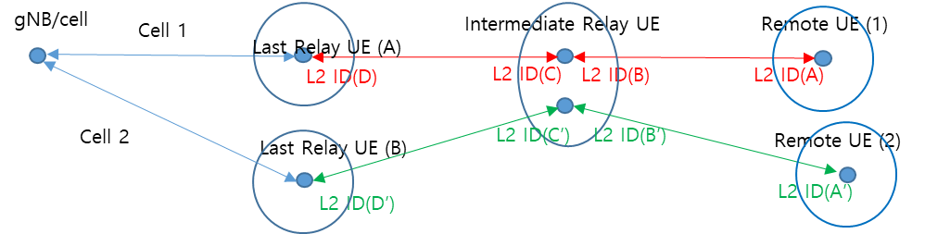
(Figure 2.5D-2)
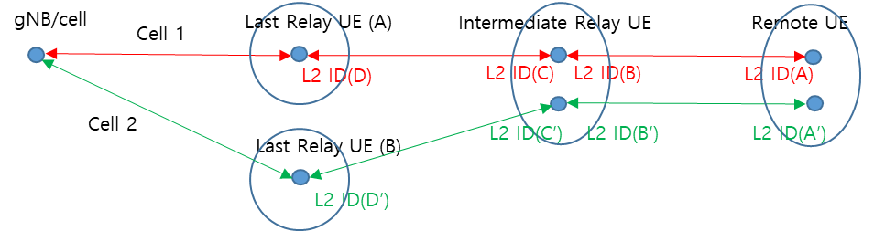
(Figure 2.5D-3)

[Question 2.5D-1] For each figure, i.e., Figure 2.5D-1, 2.5D-2, 2.5D-3, do you think these three cases should be considered for Rel-19 multi-hop topologies?
Company | For Figure 2.5D-1  (Yes/No) | For Figure 2.5D-2  (Yes/No) | For Figure 2.5D-3  (Yes/No) | Reason
Ericsson | Maybe Yes | Maybe Yes | No | D-3 seems to be a multi-path scenario for remote UE, which should be avoided.
OPPO | No | No | No | Out of R19 WI scope.
Apple | Yes | Yes and Yes also for different gNB case | Maybe
CATT | No | No | No | Belong to optimization.
ZTE | No | No | No
Huawei, HiSilicon | NO | No | No
OPPO | No | No | No | Out of R19 WI scope.
Fraunhofer | Yes | Yes | Maybe
Sharp | No | No | No
Spreadtrum | No | No | No
Lenovo | No | No | NO
Kyocera | No | No | No
ASUSTeK | No | No | No
Samsung | No | No | No
vivo | No | No | No

2.6 Others

[Question 2.6] If there is further issue we should handle in this email discussion but missing, you can describe it freely.
Company | Other issues that should be handled
Apple | We need also cover the case that the last relay UES are served by different gNB for case 2.5D-2.

3. Phase 2 Discussion
[TDB]

Conclusion and recommendation
In conclusion, Rapporteur recommends agreeing the following proposals:
[TDB]

Annex A: RAN2 Agreements on Multi-hop Relay

RAN2#127
- From RAN2 perspective, models A and B can both be supported.
- Reuse existing AS discovery protocol to transmit discovery message for multi-hop U2N relaying.
- Reuse SL-SRB4 to transmit discovery message for multi-hop U2N relaying
- Reuse existing resource pools defined for discovery message transmission and reception
- Both of resource allocation mode 1 or mode 2 can be supported as in Rel-17/18 at least by relay UEs; FFS mode 1 for remote UE
- Configuration can be provided by SIB/dedicated message or pre-configured as in Rel-17/18.
- If the RSRP measurement of the serving cell is below a Uu threshold, or the Remote UE could not find a serving cell, the Remote UE can perform discovery transmission, as in Rel-17/18.
- If the Uu RSRP measurement of the serving cell is above a low threshold and below a high threshold, the last relay UE can perform discovery transmission, as in Rel-17/18 (subject to how the gNB configures one or both thresholds).
- FFS discovery conditions for the intermediate relay UEs.
- The following connections are assumed as a baseline to be needed:
  - From last Relay UE perspective:
    - A direct (non-relayed) PC5 connection with the first or an intermediate Relay UE, and
    - A direct (non-relayed) Uu connection with serving gNB, if in RRC_CONNECTED.
  - From intermediate relay UE perspective (including first relay UE):
    - A direct (non-relayed) PC5 connection with each of two adjacent (remote or relay) UEs, and
    - An end-to-end Uu connection with serving gNB, if in RRC_CONNECTED.
    - FFS what RRC states are supported for the intermediate relay UE
  - From U2N Remote UE perspective:
    - A direct (non-relayed) PC5 connection with Intermediate Relay UE, and
    - An end-to-end Uu RRC connection with serving gNB, if in RRC_CONNECTED.
- The multi-hop CP protocol stack is end-to-end for Uu-PDCP and above and hop-by-hop for SRAP and below (as in Rel-17/18)
- The multi-hop UP protocol stack is end-to-end for Uu-PDCP and above and hop-by-hop for SRAP and below (as in Rel-17/18).

