Company | Comment | Rapp Response
OPPO | 5.22.1.1  3> else if one or more HARQ retransmissions are selected and the selected resource pool is not Dedicated SL-PRS resource pool and no resources were selected for more than one transmission opportunities:  This addition would lead to consequence that if MCSt is used, there is no chance for UE to enter into the HARQ re-transmission branch, which is wrong, since based on the NOTE below, there is for sure a case where even if MCSt is used, HARQ re-transmission is also used  NOTE 3Aa: For Multi-consecutive slots transmission as specified in clause 8.1.4 of TS 38.214 [7], during resource (re)selection, leave it to UE implementation, regarding whether to calculate the number of HARQ retransmissions from the allowed numbers based on the number of MCSt transmissions, or the number of slot(s) within Multi-consecutive slots transmission.  And thus the following part is confusing, since for MCSt, the decision of N (see the following note) and the decision of HARQ re-transmission number is two independent decisions, now seems we mix them together?  6> randomly select the time and frequency resources for one transmission opportunity from, or for more than one opportunities corresponding to the selected number of HARQ retransmissions (if MAC entity decides a number of consecutive slots for Multi-consecutive slots transmission other than SL-PRS larger than 1), the resources indicated by the physical layer as specified in clause 8.1.4 of TS 38.214 [7] which occur within the SL DRX Active time, if configured, as specified in clause 5.28.2 of the destination UE selected for indicating to the physical layer the SL DRX Active time above, according to the amount of selected frequency resources, the remaining PDB of SL data available in the logical channel(s), and the remaining SL-PRS delay budget of the SL-PRS transmission(s), if available, allowed on the carrier.  NOTE 3Ae: MAC entity, based on UE implementation, decides whether to indicate the number of consecutive slots for Multi-consecutive slots transmission as specified in clause 8.1.4 of TS 38.214 [7] larger than 1.
OPPO | 5.22.1.1  NOTE 3B8: UE is not expected to be (pre-)configured with both random selection and sl-NRPSSCH-EUTRA-ThresRSRP-List in the same resource pool applies only to NR SL normal resource pool. This does not apply to the NR SL exceptional pool.  It seems more a restriction to be captured by RRC? But no strong view, if we go with MAC, some minor rewording.  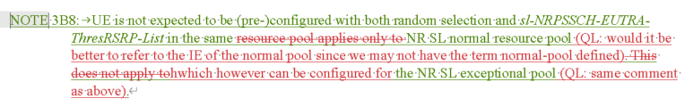
OPPO

