Company | Clause (if comment on CR) or RIL number (if comment on RIL list) | Suggested Change / Comment | Rapp Response
Xiaomi | 5.8.9.1a.6.2 | 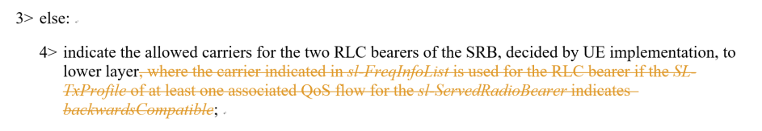  The above change should be withdrawn. | Failed to recall the reason for this change.. let’s withdrawn it. Thanks for catching it.
ZTE | 6.3.5 | The name of “sl-RLC-BearerToAddModListSizeExt” and “sl-RLC-BearerToReleaseListSizeExt” are so strange. From my view, I think it should be “sl-RLC-BearerToAddModListExt”, i.e. “size” should be removed from the IE name, like “sl-FreqInfoToAddModListExt”. | The naming is to follow ASN1 guidance in A4.3.6
Nokia | 2 | [xx] 3GPP TS 24.588: "Technical Specification Group Core Network and Terminals; Vehicle-to-Everything (V2X) services in 5G System (5GS); User Equipment (UE) policies; Stage 3".  Missing space before “Stage 3” | Thanks, will correct in the next iteration.
Nokia | 5.8.6.2 | 4> for each freqneucy which is used for NR sidelink communication/discovery, if the UE detects one or more SLSSIDs for which the PSBCH-RSRP exceeds the minimum requirement defined in TS 38.133 [14] by sl-SyncRefMinHyst and for which the UE received the corresponding MasterInformationBlockSidelink message (candidate SyncRef UEs), or if the UE detects GNSS that is reliable in accordance with TS 38.101-1 [15] and TS 38.133 [14], or if the UE detects a cell, select a synchronization reference according to the priority group order as defined in 5.8.6.2a:  We think it may be easier to read if the “for each” is independent from the “if the UE detects...” and this is then level 5  “freqneucy” should be changed to “frequency” | Thanks, will correct in the next iteration.
Nokia | 5.8.6.2 | 2> else if the concerned frequency(ies) are included in sl-FreqInfoToAddModList/sl-FreqInfoToAddModListExt in sl-ConfigDedicatedNR within RRCReconfiguration message or included in sl-ConfigCommonNR within SIB12, and sl-SyncPriority for concerned frequency(ies) are not configured or are set to gnss, and GNSS is reliable in accordance with TS 38.101-1 [15] and TS 38.133 [14]; or if the concerned frequency(ies) are included in SL-PreconfigurationNR, and sl-SyncPriority in SidelinkPreconfigNR is set to gnss and GNSS is reliable in accordance with TS 38.101-1 [15] and TS 38.133 [14]:  For readability, we would suggest the “; or if the concerned frequencies” would be separate bullet. But, we also understand this is the legacy way in the spec | Considering it is legacy, I assume companies may have a view to keep, so let’s try to keep it as a baseline? Will observe if any other view on this.
 |  | 5> select the synchronisation reference source(s) o according to the following priority group order as defined in 5.8.6.2a;  Missing deletion of “o” in “n each concerned” | Thanks, will correct in the next iteration.
Nokia | 5.8.6.2b | 1> perform a full search (i.e. covering all subframes and all possible SLSSIDs) on each indicated frequency to detect candidate SLSS, in accordance with TS 38.133 [14]  Missing “;” | Thanks, will correct in the next iteration.
Nokia | 5.8.9.1a.5.1 | For NR sidelink communication, additional sidelink RLC bearer release is initiated in the following cases:  1> for sidelink DRB, the release conditions are met as in clause 5.8.9.1a.1.1 for the associated sidelink DRB; or  1> for sidelink SRB, the release conditions are met as in clause 5.8.9.1a.3 for the associated sidelink SRB; or  1> for sidelink DRB, if SL-RLC-BearerConfigIndex (if any) of the sidelink DRB is included in sl-RLC-BearerToReleaseList in RRCReconfigurationSidelink;  1> for sidelink DRB, if SL-RLC-BearerConfigIndex (if any) of the additional Sidelink RLC Bearer is included in sl-RLC-BearerToReleaseListSizeExt in sl-ConfigDedicatedNR; or  Missing “or” in the third bullet, excess “or” in fourth bullet | Thanks, will correct in the next iteration.
Nokia | 5.8.9.1b.1.1 | For NR sidelink communication, sidelink carrier release is initiated in the following cases:  1> for unicast, if sl-Carrier-Id of the sidelink carrier is received in sl-CarrierToReleaseList in the RRCReconfigurationSidelink; or  1> for unicast, if a sidelink carrier failure has been indicated by MAC layer; or  1> for unicast, if the sidelink carrier release was triggered due to the configuration received within the sl-ConfigDedicatedNR, SIB12, SidelinkPreconfigNR or upper layer; or  1> for unicast, if the sidelink SRB(s), DRB(s) or additional sidelink RLC bearer(s), which was associated with the sidelink carrier(s), are released according to clause 5.8.9.1a.3.1, 5.8.9.1a.1.1 or 5.8.9.1a.5.1;  Would suggest to have all conditions under a single “for unicast” bullet level as this would mean easier reading in case other cast types exists.  Similar comment for 5.8.9.1b.1.2, 5.8.9.1b.2.1, and 5.8.9.1b.2.2 | This is to follow legacy manner as in 5.8.9.1a.1.1, 5.8.9.1a.2.1, so let’s try to keep it as a baseline? Will observe if any other view on this.
Nokia | 6.3.4 | sl-SyncPriority  This field indicates synchronization priority order, as specified in clause 5.8.6. The same value is configured in sl-SyncPriority across all carrier frequencies configured for UEs performing NR sidelink communication on multiple carrier frequencies.  We think a better wording may be “sl-SyncPriority is configured with the same value across all carrier frequencies...”  Also “sl-SyncPriority” should be in cursive | Thanks, will correct in the next iteration.
Nokia | 6.3.4 | ue-ToUE-COT-SharingED-Threshold  Indicates the energy detection threshold that is a UE uses to initiate a channel occupancy with other UE(s), and the other UE(s) that shares the initiated channel occupancy shall use this configured parameter for accessing the channel(s) as specified in TS 37.213 [48], clause 4.5.5 for sidelink channel access. Unit in dBm. Value -85 corresponds to -85 dBm, value -84 corresponds to -84 dBm, and so on (i.e. in steps of 1dBm).  Excessive “is” after “Indicates the energy detection threshold that is” | Thanks, will correct in the next iteration.
Nokia | 6.3.4 | harq-ACKFeedbackRatioforCW-AdjustmentGC-Option2  Indicates the ratio threshold for contention window adjustment for SL groupcast option 2 as specified in TS 37.213 [48], clause 4.5.4. Unit is percentage.  We believe that there is a missing hyphen between ACK and Feedback | Thanks, will correct in the next iteration.
Nokia | 5.8.3.2 | Regarding:  A UE capable of NR sidelink operation that is in RRC_CONNECTED may initiate the procedure to report the Destination Layer-2 ID and QoS profile(s) associated with its interested service(s) that sidelink DRX is applied, and to report the frequency(ies) and Tx Profile associated with each QoS flow, for NR sidelink groupcast or broadcast reception.  Comment: Wouldn’t it be better to change ‘and’ to ‘or’? | Is the concern on “and” due to the assumption that DRX related func cannot co-ex with CA related func? Not sure we can draw a conclusion in this post. How about we disc this issue, if any, further in the coming meeting? i.e., even using “and”, I did not try to hint the two can co-ex, it is just to list all related functions.
Nokia | 5.8.9.1.2 | Regarding  1> for each carrier that is to be released, according to clause 5.8.9.1b.1.1:  2> set the entry included in the sl-CarrierToReleaseList corresponding to the sidelink carrier;  1> for each carrier that is to be added, according to clause 5.8.9.1b.2.1:  2> set the entry included in the sl-CarrierToAddModList corresponding to the sidelink carrier;  Comment: In our view, setting the entry included in blabla is not for each carrier that is to be released/added. Wouldn’t it be better to rephrase like below?  1> set the entry included in the sl-CarrierToReleaseList corresponding to the sidelink carrier(s) that is to be released according to clause 5.8.9.1b.1.1;  1> set the entry included in the sl-CarrierToAddModList corresponding to the sidelink carrier that is to be added according to clause 5.8.9.1b.2.1; | The current split (1> for each … according to clause xxx, 2> [action]) follows the other part of the spec, but agree now the wording is not quite comprehensive, how about the rewording like  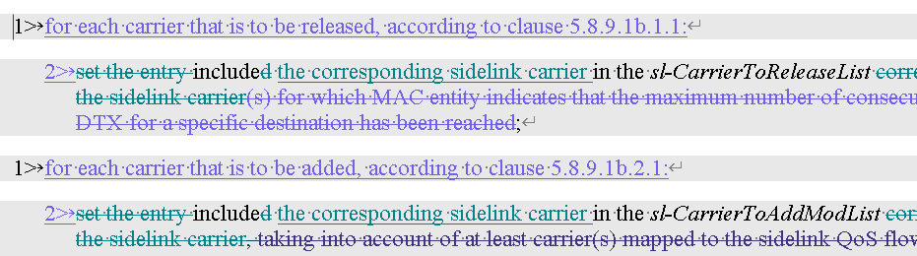
Nokia | Overall | Comment: I see a few texts in wrong style e.g., ‘B1+(Asian) DengXian’ in S5.8.9.1b.1.1. | Thanks for catching this, re-checked the CR to avoid similar issue. But welcome to double-check^^

