Company | Clause (if comment on CR) or RIL number (if comment on RIL list) | Suggested Change / Comment | Rapp Response
Xiaomi | 5.8.9.1a.6.2 | 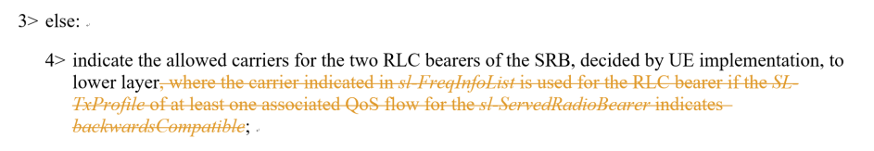  The above change should be withdrawn. | Failed to recall the reason for this change.. let’s withdrawn it. Thanks for catching it.
ZTE | 6.3.5 | The name of “sl-RLC-BearerToAddModListSizeExt” and “sl-RLC-BearerToReleaseListSizeExt” are so strange. From my view, I think it should be “sl-RLC-BearerToAddModListExt”, i.e. “size” should be removed from the IE name, like “sl-FreqInfoToAddModListExt”.

