Company | Clause (if comment on CR) or RIL number (if comment on RIL list) | Suggested Change / Comment | Rapp Response
Xiaomi | 5.8.9.1a.6.2 | 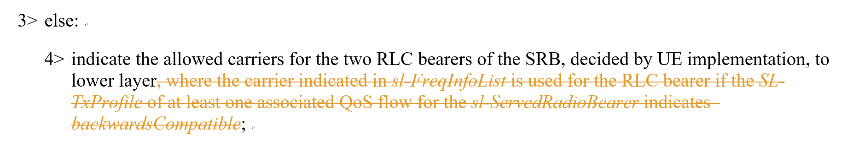  The above change should be withdrawn. | Failed to recall the reason for this change.. let’s withdrawn it. Thanks for catching it.

