3GPP TSG-RAN WG2 Meeting #124 R2-23xxxxx
Chicago, IL, US, November 13 – 17, 2023

Agenda item: 7.2.1
Source: Qualcomm Incorporated
Title: Summary of [Post124][413][POS] Rel-18 positioning 38.305 CR (Qualcomm)
Document for: Discussion and Decision

1. Introduction
This document summarizes the following email discussion:
- [Post124][413][POS] Rel-18 positioning 38.305 CR (Qualcomm)
Scope: Finalise and check the Rel-18 positioning 38.305 CR.
Intended outcome: Agreed CR
Deadline: Short (for RP)

The Stage 2 from RAN2#124 (R2-2312786) has been updated (version _v07; changes were made as Word User "_v07"):
- Alignments with latest Stage 3 CRs:
- Addition of sections 8.12.3.1.2.1a and 8.12.3.1.2.2a
- Additions of sections 8.15 (and sub-sections)

2. Comments on _v07 of the running CR
Companies are invited to provide their comments on the current version (_v07) of the 38.305 CR in the table below.
Company | Section (in _v07) | Comments | Rapporteur Comments
CEWiT | 7.12 | Since multiple UE roles are agreed to be indicated in the discovery metafield, the SL server UE discovery and selection can be performed in step 2 itself if UE1 does not support SL Server UE functionality.  The following figure shall be considered.  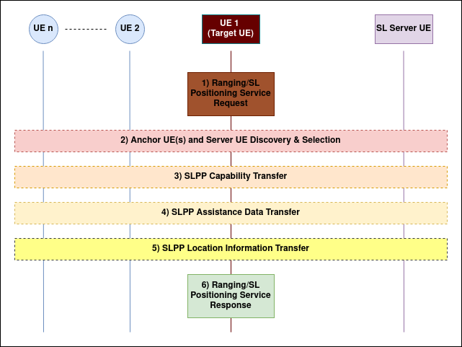
Huawei, HiSilicon | 4.3.16.3 Sidelink Time Difference of Arrival (SL-TDOA) | SL-RSTD measurements between a target UE and multiple peer UEs can be used to determine the location of the target UE relative to the locations of the peer UEs (e.g., anchor UEs).  For SL-TDOA, is it only applicable for absolute positioning? If so, it is not clear here it says the location of the target UE relative to the location of the peer UEs.  The same question also applies for SL-TOA
Huawei, HiSilicon | 4.3.1 Introduction | Perhaps it would also be beneficial to clarify the mapping between different SL positioning methods and relative location/absolute location/range and direction/velocity  Table 4.3.1-2: Supported versions of SL positioning and ranging methods.  Method SL-Target UE-based SL-Target UE-assisted, server-based  SL-RTT Yes Yes  SL-AoA Yes Yes  SL-TDOA Yes Yes  SL-TOA Yes Yes
Huawei, HiSilicon | 6.2.5 Sidelink Positioning Protocol (SLPP) | SLPP session id is only applicable for the case when an SLPP session is terminated between two UEs?  An SLPP Session is used between UEs or between a UE and an LMF to fulfil a ranging/sidelink positioning service request. A SLPP Session comprises one or more SLPP transactions. A UE may simultaneously participate in multiple SLPP sessions. A SLPP Session ID is used to identify all SLPP transactions belonging to an SLPP session. The SLPP Session ID enables SLPP endpoints to uniquely distinguish SLPP messages for one session from SLPP messages for other sessions.
Huawei, HiSilicon | 7.3 Service Layer Support using combined LPP and NRPPa Procedures | Editror’s NOTE needs to be removed after this version  Editor's Note: FFS whether the below sections require updates for sidelink positioning. Will be updated later, depended on SA2 progress.  SA2 seems to have made some progress in this meeting?
Huawei, HiSilicon | 7.6.2 On-Demand PRS transmission procedures | It has also been agreed in the last meeting that CA positioning can be supported for on-demand PRS request
Huawei, HiSilicon | 7.3A.1 General | Editror’s NOTE needs to be removed after this version  Editor's Note: The below sub-clauses may need further alignment/confirmation with e.g., SA2 23.273.
Huawei, HiSilicon | 7.12 General UE-only sidelink positioning and ranging procedure | Based on the endorsed TP in SA2, the signlaing between target UE and SL server UE seems to be based on SS message, although it is not completely clear to me what does it mean by SS SLPP message. Ref S2-2313889  - SA2 Agreement 5: Message from Target UE to Located UE to request Located UE’s absolute location, i.e. step 17 of 6.20.1 in TS 23.273 (CR 0416 of TS 23.273) is transferred as Supplementary RSPP signalling message over SR5  Editor’s NOTE should also be removed
Huawei, HiSilicon | 8.12.3.1.2.1a LMF initiated Periodic Assistance Data Delivery | Have we agreed on periodic assistance data delivery for DL-TDOA? Although I understand that this is to mimick the RTK-like periodic AD delivery
Huawei, HiSilicon | 8.15.1 SL-PRS transmission and reception | The wording in the previous RAN1 agreement is SL-PRS dedicated/shared resource pool  A sidelink resource pool which can be used for transmission of both, SL-PRS and SL data is referred to as shared resource pool. A sidelink resource pool which can be used for transmission of SL-PRS and cannot be used for transmission of SL data is referred to as dedicated SL-PRS resource pool.
 | 8.15.2.1 General | For SL-RTT, the pair of UEs may transmit and receive SL-PRS once (also referred to as "single-sided RTT") or multiple times (also referred to as "double-sided RTT"). A UE may report multiple SL Rx-Tx time difference measurements for the same SL-PRS transmission and up to 4 different SL-PRS receptions, or report multiple SL Rx-Tx time difference measurements for the same SL-PRS reception and up to 4 different SL-PRS transmissions, or both.  The highlighted part above does not seem to be quite clear. How can a UE report measurements for a SL-PRS it transmits?
InterDigital | 8.12.3.1.2.2a | 1. “UE initiated Periodic Assistance Data Transfer” : Since the request can include both periodic and aperiodic, thus the title should be changed to “UE initiated Assistance Data Transfer.” Same comment is applied for the title of the figure in the subclause.  2. In Step (1), “This request includes an indication of which specific assistance data are requested together with additional information such as desired periodicity for sending the assistance data and a duration for ending the periodic assistance data delivery session.” We are not sure if this fully captures aperiodic data transfer agreed in R1-2312434. Suggseted change is the following “This request includes an indication of which specific assistance data are requested together with additional information such as desired periodicity, including aperiodic transfer, for sending the assistance data and a duration for ending the periodic assistance data delivery session.”  3. Should “which specific assistance data are requested” in Step (1) be an open issue? We did not have time to discuss the details of the content that the UE can request.
InterDigital | 8.15.1 | 1. Wording  Include the term “NR” in the “over the NR PC5 interface” in the first paragraph.  “the UE autonomously selects…” -> “The UE autonomously selects….” In the last sentence.  2. Include coverage information for clear understanding in the second parapraph:  A UE can be configured with one or more sidelink resource pools via system information or dedicated signalling while inside NG-RAN coverage or by pre-configuration while outside NG-RAN coverage as specified in TS 38.331 [14]. The description is referred by stage 2 (38.300, section 16.9.3.3)
InterDigital | 4.3.16.1  4.3.16.2  4.3.16.3  4.3.16.4 | Wording (adding hyphen)  “SL PRS-RSRP”, ->“SL-PRS-RSRP”  “SL PRS-RSRPP” -> “SL-PRS-RSRPP”

3. Summary of Open Issues
 | Section | Issue | Way Forward
1 | 7.3 Service Layer Support using combined LPP and NRPPa Procedures | Editor's Note: FFS whether the below sections require updates for sidelink positioning .Will be updated later, depended on SA2 progress. | Furter updates will be handled in the maintenace phase and/or company contributions, dependent on SA2 progress.
2 | 7.3A Service Layer Support for Sidelink Positioning | Editor's Note: The below sub-clauses may need further alignment/confirmation with e.g., SA2 23.273. | Furter updates will be handled in the maintenace phase and/or company contributions, dependent on SA2 progress.
3 | 7.12 General UE-only sidelink positioning and ranging procedure | Editor's Note: The above is a transcript of clause 6.8 in TS 23.586. However, there may be some concerns with this general procedure (as discussed in multiple contributions to previous RAN2 meetings), e.g., with steps 2 or 3 which probably should include also the SL Server UE, etc. Therefore, the above is FFS. | Furter updates will be handled in the maintenace phase and/or company contributions, dependent on SA2 progress.
4 | 8.10.3.1.3.1  8.12.3.1.3.1 | Editor's Note: FFS which Multi-RTT measurements are performed within the time windows.  Editor's Note: FFS which DL-TDOA measurements are performed within the time windows. | Will be updated later, based on LPP progress.
5 | 8.15 SL positioning and ranging | TBD | Furter updates will be handled in the maintenance phase and/or company contributions.

