Note: Corrections related to TX carrier (re-)selection in Section “5.22.1.11” will be reflected in MAC specification at the next meeting when UE behavior for the issues below becomes clear. Therefore, please do not submit comments about the issues below in this email discussion.
- Issue 1. Procedure’s structure (e.g., procedure order: carrier filtering considering HARQ attribute, of resource pool selection for CBR measurement, carrier selection, resource pool selection for grant creation) for TX carrier (re-)selection
- Issue 2. Whether Procedure “Pool selection for CBR measurement” and procedure “Pool selection for grant creation” are decoupled
- Issue 3. How to consider HARQ attribute in the TX carrier (re-)selection procedure

Company | Clause | Comment | Rapp Response
Sharp | 5.22.1.1  5.22.1.3.1 | 5.22.1.1  In the latest RAN1#115, for NOTE 3A10, the referred WA has been updated, thus, the corresponding updates are needed.  Agreement  Confirm the below working assumption on Type 1 LBT blocking with following modifications.  Working assumption (RAN1#114bis)  For Type 1 LBT block issue (inter-UE case), the following option 2 and option 1 are supported separately based on UE capability  - Option 2: If transmission in slot(s) at least Tproc,0SL before a reserved resource is able to share its initiated COT to the reservation, UE may prioritize/select resource(s) in the slot(s) for transmission.  - (pre)configuring enabling/disabling option 2 is supported  - Option 1:  - UE may avoid selection of N consecutive resource(s) before a reserved resource when the L1 SL priority value for the transmission is higher than the L1 SL priority value of the reserved resource.  - The value of N can be selected from {0, 1, 2}  - The selection of the value of N is up to UE implementation  - UE may avoid selection of M consecutive resource(s) after a reserved resource when the transmitting symbols of the reserved resource overlap with LBT of the selected resource.  - The value of M can be selected from {0, 1, 2}  - M is determined based on UE implementation  - (pre)configuring enabling/disabling option 1 is supported  - Note: both option1 and option2 are optional UE features  5.22.1.3.1  For NOTE 5, from our perspective, it prohibits MAC layers to select NACK-only based HARQ-ACK if the size of the group is not larger than the number of PSFCH resources provided by upper layers. While NOTE 5 seems not prohibiting the “else” branch. Therefore, we think NOTE 5 can be updated as “NOTE 5: UE operating in SL unlicensed does not use negative-only acknowledgement for groupcast HARQ and UE expects the group size is not greater than the number of candidate PSFCH resources.” Furthermore, as one PSSCH transmission is associated with candidate PSFCH resources in N consecutive slots as agreed in RAN1 due to LBT failure and UE transmits PSFCH in a later slot only if all the prior PSFCH occasions fail, we think further clarification e.g. “6> if both a group size and a member ID are provided by upper layers and the group size is not greater than the number of candidate PSFCH resources in a slot associated with this sidelink grant:  7> select either positive-negative acknowledgement or negative-only acknowledgement.” is needed. | NOTE3A10: Corrections reflecting updates will be reflected in the next Rapp version.  5.22.1.3.1, NOTE 5: According to NOTE, the UE does not select NACK only. Additionally, there is no agreement on whether to capture the UE behavior of the suggestion. The agreement in RAN2 is simply to capture the following sentence in the MAC/stage-2 CR.  - "NACK-only is not supported for SL-U"  So I don't think any additional corrections are needed.  5.22.1.3.1: The suggestions below make sense. I will reflect this in the next Rapporteur version.  - “6> if both a group size and a member ID are provided by upper layers and the group size is not greater than the number of candidate PSFCH resources in a slot associated with this sidelink grant:”
Huawei, HiSilicon | 5.22.1.4.1.2 | " RAN2 assumes that V2X layer provides intersection of mapped carrier sets of all possible QoS flow(s) to AS layer. So correction is not needed. ":  There seems misunderstanding on this.  Upper layer provides carriers set for each QoS flow, the upper layer can not know what QoS flow(s) will be mapped into SLRB, so the intersection is handled in AS layer, the intersection is not provided by upper layer. What the upper layer shall do is to make sure there are appropriate number of carriers per QoS flow such that intersection in AS for SLRB is meaningful regarding CA operation.  The carrier set can be configured by upper layers according to TS 38.331 and TS 23.287 (i.e. RRC_CONNECTED case and RAN2 thinks there are no issues here). For RRC_INACTIVE/RRC_ILDE/OOC case (usable carrier set not configured), it should be determined by the intersection handling. | I see your point. In next rapp_version, I will add UE behavior that considers intersection in LCP.
OPPO | 5.22.1.3.1a | 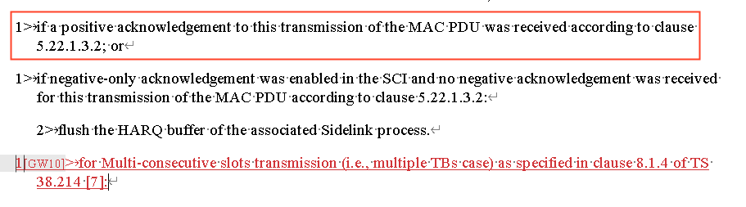  Even though seems the Rapp intention is to use the newly added text to help MCSt to keep performing the Re-Tx, rather than flushing buffer as for legacy cases, the legacy text above (for ACK case) has already flush the buffer? So maybe somehow the MCSt case has to be excluded in the ACK-case If-condition above, to avoid unexpected result? Rely on the Rapp for the detailed wording decision | Thanks for pointing this out and suggestion. Please check the fixes in the next version. Even if I correct it with the suggestion, I'm not sure if I should delete UE behaviour of "3> perform retransmission as specified in clause 5.22.1.1 in the resource(s) of the remaining slot(s) indicated in the sidelink grant as specified in clause 5.22.1.1.".
 | 5.22.1.4.1.2 | 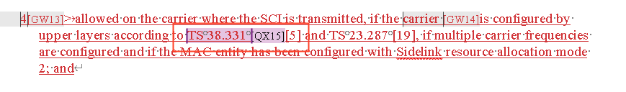  Just for my clarification, is the 38331 indicated carrier also includes the case of PDCP duplication, where the per-LCH carrier set is to be indicated to MAC layer? | That's how I understand it, but am I misunderstanding it?
 | 5.31.2 | A minor issue  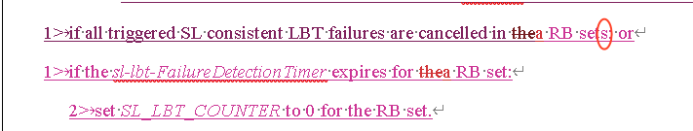  Seems the “s” should be removed, considering the action is for the individual RB-set | Thanks
Apple | 5.22.1.4.1.2 | On below Rapporteur’s comment, we agree with Huawei that this understanding is NOT correct:  “" RAN2 assumes that V2X layer provides intersection of mapped carrier sets of all possible QoS flow(s) to AS layer. So correction is not needed. ":”  As Huawei mentioned, V2X layer provides carriers set for each QoS flow, the V2X layer cannot know what QoS flow(s) will be mapped into SLRB, so the intersection can only be handled in AS layer. Thus, we should capture below RAN2#124 agreement as AS layer operation in this section:  Agreements on QoS flows mapping to carriers:  - Intersection among QoS flow ids belonging to a SLRB is considered in LCP. RAN2 understand NW/upper layer provides appropriate intersections if the service wants CA/PDCP duplication.  As spec change, we suggest to add below NOTE in this section:  NOTE: A LCH is allowed in a carrier based on whether this selected carrier is within a subset of frequencies associated with all the PC5 QoS flows allowed to be mapped to this LCH based on RRC configuration.  Please note that above NOTE has been agreed by majority companies in RAN2#123b post-meeting email discussion#113 (R2-2311791 Summary of [POST123bis][113][V2XSL] QoS flows mapping to carriers (OPPO)). | Same response as the reply to HW’s comment above. And thanks for your suggestion.
Xiaomi | 5.22.1.3.1a | We have similar concern as OPPO. The current structure can not prevent UE from flushing the HARQ buffer. | Thanks. Please check the fixes in the next rapp_version.
 | 5.22.1.4.2 | Is there any agreement for the following new added part?  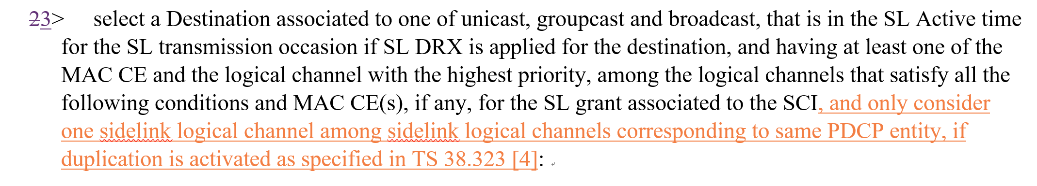 | Text will be removed in next_rapp_version.
 | 6.2.4 | After link establishment, SRB 1/2/3 can be duplicated. So besides SRB3, SRB1/2 should have corresponding LCID for duplication, e.g., 20 for SRB1, 21 for SRB 2 and 22 for SRB3. Duplicated DRB should use 23-38.  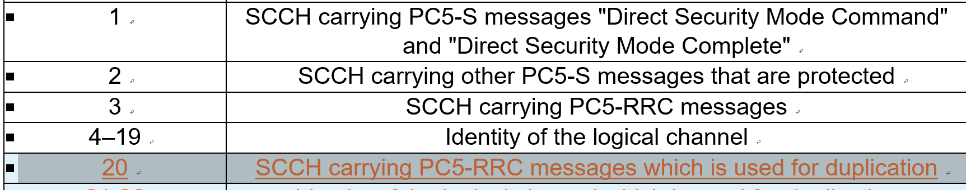 | Thanks. Correction will be reflected in the next rapp_version.
ZTE | 5.22.1.3.1a | Regarding this agreement, and corresponding normative text, we think current wording is not aligned with legacy UE procedure. In current specification, both in Uu and SL, we do not have normative text to describe whether to still perform re-transmission or not. As long as the HARQ buffer is not empty and SL grant available, UE will perform re-transmission. This agreement, we think, is just an high level principle which is not appropriate to be captured into normative text.  #124  MCSt (multiple TB case):  - For remaining slot(s) in case transmission is successful for one TB in MCSt (multiple TB case), the UE still performs retransmission for this TB in the remaining slot(s).  As you can see, current text will flush HARQ buffer in 5.22.1.3.1a and clear re-transmission grant in 5.22.1.1. Therefore, suggest to discuss how to capture this agreement in open issue list.  5.22.1.3.1a:  1> if sl-MaxTransNum corresponding to the highest priority of the logical channel(s) in the MAC PDU has been configured in sl-CG-MaxTransNumList for the sidelink grant by RRC and the number of transmissions of the MAC PDU has been reached to sl-MaxTransNum; or  1> if a positive acknowledgement to this transmission of the MAC PDU was received according to clause 5.22.1.3.2; or  1> if negative-only acknowledgement was enabled in the SCI and no negative acknowledgement was received for this transmission of the MAC PDU according to clause 5.22.1.3.2:  2> flush the HARQ buffer of the associated Sidelink process.  5.22.1.1  1> if a selected sidelink grant is available for retransmission(s) of a MAC PDU which has been positively acknowledged as specified in clause 5.22.1.3.3:  2> clear the PSCCH duration(s) and PSSCH duration(s) corresponding to retransmission(s) of the MAC PDU from the selected sidelink grant. | Same response as the reply to OPPO’s comment above.

