3GPP TSG-RAN WG2 Meeting #124 R2-230xxxx

Chicago, U.S.A, 13th-17th November, 2023

Agenda item: 7.3.1
Source: InterDigital (Rapporteur)
Title: [POST124][037][NES] 38.321 CR (InterDigital)
Document for: Discussion and Decision

Introduction
This document collects the comments received during the following email discussion on the MAC CR for the NES feature:

- [POST124][037][NES] 38.321 CR (InterDigital)
Intended outcome: Agree to CR
Deadline: 2 weeks (December 1st)

Contact information:
Company | Delegate Name | Email
vivo | Wenjuan Pu | wenjuan.pu@vivo.com
Apple | Peng Cheng | Pcheng24@apple.com
Xiaomi | Shukun Wang | Wangshukun3@xiaomi.com
Huawei | Marcin Augustyniak | marcin.augustyniak@huawei.com

Discussion on TS 38.321 running CR
Companies can provide comments and suggestions to the uploaded running CR in this table. Please do not add changes, suggestions, or comments directly to the draft CR document.
Company + Issue Number (e.g., ID001) | Issue | Comments and proposed changes
v001 | For PD/SD NES features:  Capture the below RAN2#124 agreement in section 5.18.6.  Agreements:  Legacy MAC CE can be used when activating only configuration without sub-configuration and when gNB is de-activating all sub-configurations. | We think this agreement should be reflected in section 5.18.6 to clarify the NW behaviour. From this agreement, two clarifications on correct NW behaviour should be captured:  when at least one CSI report is configured with csi-ReportSubConfigList for the concerned serving cell id and BWP ID,  - 1) new MAC CE should be used by the network even for activating the CSI report without sub-configurations.  [Rapp]: This is already captured in section 5.18.6 by “The network may activate and deactivate the configured Semi-persistent CSI reporting on PUCCH of a Serving Cell by sending the SP CSI reporting on PUCCH Activation/Deactivation MAC CE described in clause 6.1.3.16 or the Enhanced SP CSI reporting on PUCCH Activation/Deactivation MAC CE described in clause 6.1.3.x.”  and in section 6.1.3.x by “The S_{i} field is set to 1 to indicate that the corresponding Semi-Persistent CSI report configuration shall be activated. The S_{i} field is set to 0 to indicate that the corresponding Semi-Persistent CSI report configuration i shall be deactivated;”  - 2) legacy MAC CE can be used to deactivate all sub-configurations for all CSI report.  [Rapp]: Added the following in v1 in section 5.18.6: “For a Semi-persistent CSI reporting on PUCCH configuration configured with csi-ReportSubConfigList, the network may deactivate all configured sub configurations by sending the SP CSI reporting on PUCCH Activation/Deactivation MAC CE. The network is not expected to activate a Semi-persistent CSI reporting on PUCCH configuration configured with csi-ReportSubConfigList using the SP CSI reporting on PUCCH Activation/Deactivation MAC CE.”
V002 | For PD/SD NES features, a new eLCID for new MAC CE is missing. | A new eLCID for new MAC CE should be introduced in Table 6.2.1-1b.  [Rapp]: Added in v1. Thanks.
A001 | For PD/SD NES features:  We agree with vivo that the agreement to use legacy MAC CE needs to be captured.  But different from NW behaviour clarification (as suggested by vivo), we think the UE behavior should be captured in section 5.18.6 | Suggest to capture below UE behaviours, per 2nd half of RAN#124 agreement:  - When at least one CSI report is configured with csi-ReportSubConfigList for the concerned serving cell id and BWP ID, upon reception of legacy MAC CE with at least one S_i as “0”, the UE deactivates all sub-configurations.  [Rapp]: this is captured in section 6.1.3.16 by “If the Semi-Persistent CSI report configuration i is configured with csi-ReportSubConfigList, the S_{i} field is set to 0 to additionally indicate that all SubConfigurations within csi-ReportSubConfigList shall be deactivated.”  Suggest to capture below UE assumption, per 1st half of RAN#124 agreement:  - When one CSI report (e.g. corresponding to S_i) is configured with csi-ReportSubConfigList for the concerned serving cell id and BWP ID, the UE is not expected to receive legacy MAC-CE with its S_i as “1”.  [Rapp]: For the network behaviour, it’s captured per the addition mentioned under V001. For the UE behaviour the following note is added in v1 in section 6.1.3.16 per your suggestion and H003: “NOTE: If a Semi-Persistent CSI report configuration i is configured with csi-ReportSubConfigList, the MAC entity is not expected to receive the corrisponding S_{i} field set to 1.”
X001 | How to receive legacy MAC CR as RAN2 agreed in last RAN2 meeting, the corresponding text should be captured in the spec. | [Rapp]: Added per the additions explained under V001 and A001
X002 | General comments about the style.  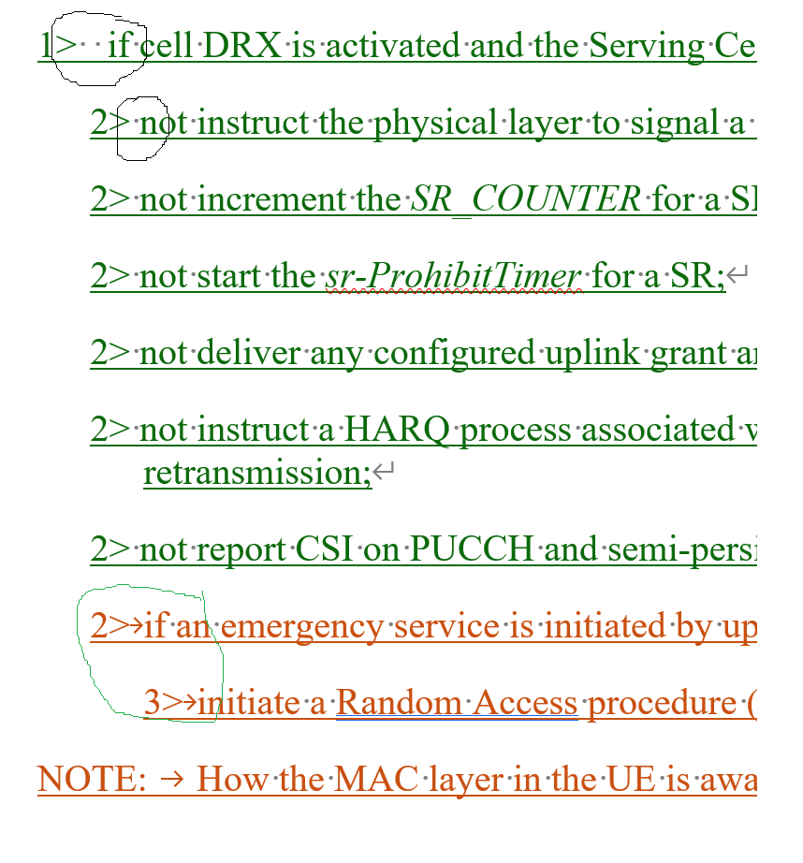 | Some Word format issues need to be modified, such as whether to use the tab or space bar. For example, circled in the figure, the first two circles are incorrect, and the last one is correct.  [Rapp]: fixed in v1. Many thanks for pointing it out.
H001 | 2> not report CSI on PUCCH and semi-persistent CSI configured on PUSCH.  This should reflect the RAN1 agreement:  - From RAN1 point of view, Rel-18 UE supporting cell DRX is not expected to transmit the following signals/channels to the gNB during non-active periods of cell DRX  - Periodic/Semi-persistent CSI report | We think it should be “periodic CSI”, also maybe the  “configured on PUSCH” is not needed as it can also be on PUCCH.  [Rapp]: the "not report CSI on PUCCH" includes both "periodic CSI" and "SP-CSI on PUCCH". And the second part additionally covers the "SP CSI on PUSCH"  I essentially used the same wording in the C-DRX section “3> not report CSI on PUCCH and semi-persistent CSI configured on PUSCH in this DRX group.” which captures the R1 agreement and is correct.
H002 | As noted by others, the agreement on legacy MAC CE usage should be reflected in section 5.18.6. | [Rapp]: Added per the additions explained under V001 and A001
H003 | We also suggest to reflect the legacy MAC CE agreement in 6.1.3.16 | It can be done e.g. by adding a NOTE: If a UE receives the SP CSI reporting on PUCCH Activation/Deactivation MAC CE when configured with sub-configuration(s) in a CSI report configuration, such sub-configuration(s) is not activated.  [Rapp]: A note is added per A001

Conclusion
TBD

Annex A: R2 agreements affecting TS 38.321
Fully implemented
partially implemented but additional agreements/FFSs needed before conclusion
Doesn’t impact MAC spec or already specified

RAN2#121
Agreements
- There will be no impact to RACH, paging, and SIBs in idle/inactive for both gNB and Rel-18 and legacy UEs
- Rel-18 NES capable CONNECTED UE(s) can perform RACH and receive SIBs in non-active duration of cell DTX and/or DRX (i.e., same behavior for cell DTX and cell DRX). No further enhancements for CBRA and CFRA will be pursued.
- Pattern configuration for cell DRX/DTX is common for Rel-18 UEs in the cell. FFS whether we have DTX UE specific inactivity timer . FFS on configuration signaling and stage 3.
- Confirm study item agreement that we can have separate DTX and DRX configuration. We will focus on designing DTX/DRX for at least single configuration. FFS whether multiple configuration of cell DTX or DRX will be supported.

RAN2#121-bis

Agreements
- A periodic cell DTX/DRX configuration is explicitly signalled to the UEs.
- A periodic cell DTX/DRX pattern is configured by UE specific RRC signalling.
- The Cell DTX/DRX configuration contains at least: periodicity, start slot/offset, on duration.
- As a baseline Cell DTX/DRX is activated/deactivated implicitly by RRC signalling, i.e. activated immediately once configured by RRC and deactivated once the RRC configuration is released.
- From RAN2 point of view, majority companies see a benefit with L1 signalling for Cell DTX/DRX activation/deactivation, send a LS to RAN1 (email 308) with our preference and ask about feasibility and design details. Ask about feasibility and reliability of using L1 signaling. Clarify that the question is about activation/deactivation copy the agreement from last meeting that we are focusing on single configuration. Extract a few key benefits of dynamic signaling from email discussion and online discussions
- As baseline, UE doesn’t monitor SPS occasions during Cell DTX non-active period. As baseline, gNB is assumed to be not transmitting PDSCH to that UE on such SPS occasions during the Cell DTX non-active period
- As baseline, UE does not transmit on CG occasions during Cell DRX non-active periods
- As baseline, UE does not transmit SR occasions overlapping with Cell DRX non-active periods, e.g. SR transmissions are dropped during the non-active period
FFS: whether we will allow to configure the UE per SR configuration with whether SR can be transmitted during Cell DRX non-active period to to support high priority traffic
- (for the SRs that will be dropped) If SR is not to be transmitted on an PUCCH occasion during Cell DRX non-active time, the UE keep the SR pending, i.e., the UE delays the SR transmission till the Cell DRX active period without triggering RACH. For the FFS case there may be some exceptions.
- The understanding for the gNB scheduling behaviour for new transmissions during Cell DTX non-active period is that the gNB does not schedule UE-specific dynamic grants/assignments, even if the UE is in C-DRX Active Time. UE doesn’t monitor PDCCH for dynamic grants/assignments for new transmissions during Cell DTX non-active period, even if the UE is in C-DRX Active time. FFS how to deal with any exceptions (e.g. SR if agreed and RACH).
FFS how to deal with retransmissions

RAN2#122
Agreements:
1 UE monitors PDCCH for RAR during Cell DTX non-active time. The ra-ResponseWindow could be started as legacy.
2 UE monitors PDCCH for msg4 during Cell DTX non-active time. The ra-ContentionResolutionTimer could be started as legacy.
3 Working assumption: When the retransmission timer is running (if C-DRX is configured), the UE is expected to monitor PDCCH, like in legacy. It is up to the network whether it schedules retransmissions out of the Cell DTX active period, i.e., when the DRX retransmission timer is running, the UE should monitor PDCCH regardless of the Cell DTX.
4 Once gNB recognizes there is an emergency call or public safety related service (e.g. MPS/MCS), the NW should ensure there is no impact to the emergency call (e.g. may deactivate Cell DTX/DRX). The behavior is captured in stage 2 spec
5 When an DG grant is received, by the gNB during cell DRX/DTX, the UE follows the grant assignment (i.e. like in legacy). This includes DL HARQ feedback.

RAN2#123

Agreements:
1 Activation/deactivation is per serving cell. FFS if the configuration is per cell or per MAC entity
2 RAN2 will reuse the start timer formula of the onDurationTimer from UE C-DRX (including SlotOffset) to specify the start of cellDTX-onDurationTimer (and cellDRX-onDurationTimer) in 38.321.
3 The gNB should ensures that there is at least partial overlapping between UE C-DRX on-duration and cell DTX/DRX on-duration. It is up to network implementation to ensure the alignment. We will capture this in stage 2 specification.
Understanding is that alignment means that the cell DTX/DRX and C-DRX periodicity should be multiple of each other. FFS if we anything needs to be specified in stage 3 (i.e. in IE description)
4 As a baseline legacy C-DRX reconfiguration is used to change UE C-DRX configuration once Cell DTX/DRX is activated/deactivated.
5 RAN2 specifies cellDTX-onDurationTimer (and cellDRX-onDurationTimer) to have the same value range as UE C-DRX on-duration timer.
6 RAN2 specifies cellDTX-Cycle (and cellDRX-Cycle) to have the same value range as UE C-DRX Long cycle.
7 Separate DTX and DRX configuration means that the features can be enabled separately (i.e. Cell DTX can be configured without Cell DRX)
8 On-duration and Cycle parameters are common between cell DTX and DRX, when both are configured. FFS if we have different start offset configuration for cell DTX and cell DRX
9 RAN2 will not introduce a MAC CE for cell DTX/DRX (de)activation.
10 Confirm working assumption, when the retransmission timer is running (if C-DRX is configured), the UE is expected to monitor PDCCH, like in legacy. It is up to the network whether it schedules retransmissions out of the Cell DTX active period, i.e., when the DRX retransmission timer is running, the UE should monitor PDCCH regardless of the Cell DTX.
11 We focus on the case where DTX in RRC can only be configured when C-DRX is configured. We will not optimize for the case where C-DRX is not configured.

RAN2#123bis
Agreements
1. Cell DTX/DRX configuration is provided per Serving Cell with the following restrictions:
- A maximum of two cell DTX/DRX patterns can be configured per MAC entity
- The two configured patterns are aligned,
o The start and slot offset are common for the two patterns.
o one periodicity is an integer multiple of the other.
2. Working assumption: UE triggers RACH upon determining that an emergency call is initiated during the cell DTX/DRX non active period. We rely on the UE implementation to determine whether an emergency call is initiated. We will take time to check until next meeting to confirm the WA.
=> Rapporteur will specify the alignment in the field description in his CR (stage 3 alignment description)
1. Introduce explicit activation/deactivation in RRC once DTX/DRX is configured (i.e. not for dynamic activation/deactivation). This reverses previous agreement on implicit activation.
2. Start offset and slot offset configuration is also common between Cell DTX and Cell DRX when both are configured
3. Standalone cell DRX configuration is possible to configure
4. Multiple configurations of Cell DTX/DRX are not pursued in Rel-18 for serving cell.
=> The rapporteur will implement all fields as optional and companies can review to see if there is any issues (cellDTX-config)
=> Rapporteurs will capture it in RRC (the focus was on the case where cell DTX in RRC can only be configured when C-DRX is configured)
1. The case that Cell DRX activation is received between delivering a configured grant to the HARQ entity and HARQ processing for the CGO will not be addressed by RAN2, as it is not valid for the MAC model.

Others
Agreements
1. Design a new MAC CE for activating/deactivating SP CSI report configurations and selecting N out of L subconfigurations for each CSI reportconfiguration.
2. The new MAC CE can be used to activate/deactivate configuration and sub-configuration. One new bit per sub-configuration will be added to activate/deactivate.

RAN2#124
Agreements on RRC open issues:
- Confirm no other features have legacy impact (for cell selection and reselection purposes)
- Refer to UE capability of cell DTX/DRX (NES Cell DTX/DRX)
- Add a flag to event configuration (as in the current running CR) for NES specific CHO execution

Agreements on MAC open issues
- It is up to RAN1 whether to allow partial transmission of a configured grant bundle in case a part of the bundle overlaps with cell DRX Active Period
- As a baseline, add the implementation in section 3.2 (R2- 2313021) for the Enhanced SP CSI reporting on PUCCH Activation/Deactivation MAC CE into the TS 38.321 running CR (i.e., in sections and 6.1.3 and 5.18).
- The following timers are not affected by activation of cell DRX/DTX. Proper configuration of these timers (i.e., to account for cell DRX and non-active period) is left to NW implementation.
- CG timer
- CG retransmission timer
- SCellDeativation timer
- BWP-InactivityTimer
- C-DRX timers
- No new timer as a Cell DTX/DRX specific UE inactivity timer is introduced. The UE already monitors PDCCH during the non-active period when C-DRX retransmission timer is running, during RACH and when SR is pending.

Agreements on RAN2 UE capabilities
- A new optional UE capability (e.g. nesBasedCondHandoverWithDCI-r18) is defined to identify Rel-18 UEs supporting NES CHO execution condition based on source cell NES mode via DCI format 2_9, and the UE indicating support of this feature shall also indicate the support of condHandover-r16.
- A new optional UE capability (e.g. eventA4BasedCondHandoverNES-r18) is defined to identify Rel-18 UEs supporting Event A4 to be configured as a CHO execution condition, and the UE indicating support of this feature shall also indicate the support of condHandover-r16
- The UE capability of eventA4BasedCondHandoverNES-r18 is per band, no FDD-TDD DIFF, and no FR1-FR2 DIFF. UE shall set the capability value consistently for all FDD-FR1 bands, all TDD-FR1 bands, all TDD-FR2-1 bands and all TDD-FR2-2 bands respectively
- From UE capability’s perspective, the supported number of cell DTX/DRX patterns per cell group is two, regardless of each pattern is for cell DTX only, cell DRX only, or both (i.e. remove the FFS)

Agreements:
1. RAN2 will capture the NES-RNTI monitoring behavior in February meeting (once discussion is finalized)

Agreements
- Confirm WA emergency call: UE triggers RACH upon determining that an emergency call is initiated during the cell DTX/DRX non active period
- In running MAC CR, capture a NOTE similar to section 5.3.13.2 of TS 38.331 (i.e., “NOTE: How the MAC layer in the UE is aware of an ongoing emergency service is up to UE implementation.”)
- No need to explicitly specify that the UE keeps monitoring PDCCH for followed transmission after successful completion of RA, i.e., it is left to NW implementation to complete followed transmission (e.g., emergency call) after RA (e.g., initiate followed transmission when the retransmission timer is running)
- No need to restrict that the cell DRX is only configured when C-DRX is configured
- Adopt the TP to capture the RAN2 requirement “UE doesn’t monitor PDCCH for dynamic grants/assignments for new transmissions during Cell DTX non-active period, even if the UE is in C-DRX Active time”.
For each Serving Cell configured with cell DTX and each configured downlink assignment, the MAC entity may:
- if cell DTX operation is activated and the Serving Cell is not in the cell DTX Active Period:
- not monitor PDCCH irrespective of the requirements of clause 5.7, unless explicitly stated otherwise in this clause;

Agreements
- We will not optimize for the case where DTX/DRX is activated simultaneously with multicast/broadcast

Agreements
1. Legacy MAC CE can be used when activating only configuration without sub-configuration and when gNB is de-activating all sub-configurations.

Annex B: R1 agreements affecting TS 38.321

RAN1#112bis
Agreement
From RAN1 point of view, Rel-18 UE supporting cell DRX is not expected to transmit the following signals/channels to the gNB during non-active periods of cell DRX. The list of signals/channels may be updated based on RAN2/RAN4 input and other signals/channels are not precluded from further discussions.
- Periodic/Semi-persistent CSI report
- Periodic/Semi-persistent SRS
  - FFS: SRS for positioning
- FFS:
  - HARQ feedback for SPS PDSCH
- FFS whether there will be exception case(s) for UE transmitting listed signals/channels during non-active periods of DRX
- FFS Whether the listed signals/channels can be configurable by gNB
- FFS: Whether the same or different UE behavior is applicable with or without C-DRX
FFS: RAN1 to consider impact on system if the channels/signals are not transmitted during non-active period

RAN1#113
Agreement
For N>=1 CSI reporting corresponding to N out of L sub-configurations in one reportConfig where each sub-configuration corresponding to an SD adaptation pattern or/[and] a powerControlOffset value,
- For A-CSI and SP-CSI on PUSCH report, support DCI-based triggering
  - For A-CSI-RS, CPU and CSI-RS resource/port counting depend on N indicated sub-configurations
    - FFS: How to do the counting
  - FFS: For P-CSI-RS/SP-CSI-RS, CPU and CSI-RS resource/port counting depend on L or N sub-configurations
- For SP-CSI on PUCCH report, support MAC-CE-based triggering
  - FFS: For P-CSI-RS/SP-CSI-RS, CPU and CSI-RS resource/port counting depend on L or N sub-configurations
Note: UE complexity reduction is not precluded
- For DCI-based triggering,
  - Alt 1: A triggering state corresponding to N sub-configurations is indicated via the existing CSI request field in DCI. Different triggering states could represent different subsets of L sub-configurations.
    - The DCI is UE specific (in this case, legacy DCI format applies)
- For MAC-CE based triggering
  - Opt 2: An indication to select to N sub-configurations in a MAC-CE is supported
    - It is up to RAN2 to decide the signaling designs of the MAC-CE (including whether it is a new MAC CE or an existing MAC CE)
    - Only one MAC CE is used for this triggering

RAN1#114bis
Agreement
Send LS to RAN2 to ask to consider the following RAN1 agreements and ask RAN2 to capture them in RAN2 specification appropriately.
- Agreement (from RAN1 #114)
  - Rel-18 UE supporting cell DTX is not required to monitor the following signals/channels from the gNB, during non-active periods of cell DTX
    - PDCCHs associated with DCI format 2_0 – DCI Format 2_5
- Conclusion:
  - HARQ-ACK of SPS PDSCH transmitted is not impacted by non-active period of cell DRX.
- Conclusion
  - The following channels are not impacted by non-active period of cell DRX
    - HARQ-ACK of a DCI format without scheduling a PDSCH
- Part of the Agreement (from RAN1 #112-bis-e)
  - From RAN1 point of view, Rel-18 UE supporting cell DRX is not expected to transmit the following signals/channels to the gNB during non-active periods of cell DRX.
    - Periodic/Semi-persistent CSI report
Include a note saying that for the conclusions, RAN1 does not expect any specification impact.

RAN1#115
Agreement
UE transmits a subset of the repetitions in a CG bundle that do not overlap with the cell DRX non-active period

Agreement
UE is expected to monitor DCI format 2_9 during active periods of C-DRX

Conclusion
There is no consensus in RAN1 on whether or not the UE is expected to monitor DCI format 2_9 during non-active periods on C-DRX

Agreement
Send an LS to RAN2 to ask RAN2 to decide whether/how to capture the following agreement. Final LS in R1-2312409.

Agreement
Cell DTX/DRX operation is only supported for sTRP.

