3GPP TSG-RAN WG2#124 R2-23XXXXX
Chicago, US, 13 – 17 November, 2023

Agenda Item: 7.3.1
Source: Huawei, HiSilicon
Title: Report of [POST124][036][NES] 38.331 CR (Huawei)
Document for: Discussion and decision

1 Introduction
This document is the report of the following discussion:
- [POST124][036][NES] 38.331 CR (Huawei)
Intended outcome: Agree to CR
Deadline: 2 weeks (December 1st 10:00 UTC)

Please provide your comments by Thursday November 30th 10:00 UTC to allow 24h for the rapporteur to update the CR before the deadline.

Companies providing input to this email discussion are requested to leave contact information below.
Company | Delegate name | Email address
vivo | Wenjuan Pu | wenjuan.pu@vivo.com
Fujitsu | Katsunari Uemura | u-katsunari@fujitsu.com
Xiaomi | Shukun wang | Wangshukun3@xiaomi.com

2 RRC CR for NES
The post-RAN2#124 RRC CR for NES, a document for providing comments and the most recent RAN1 parameter list are provided in the discussion folder. Changes from the previously endorsed CR are made as user “RAN2_124”. Please don’t change the CR text or insert comments to the CR file. Please use the table below for comments and suggestions on procedures or wording changes for clarity of the CR tdoc. If you want to highlight several issues please use numbers, i.e. “issue 1)”, “issue 2)” etc. so it is easier for the rapporteur to respond.

Concerning the positionInDCI-cellDTRX parameter, after checking with RAN1 we understand that it should be signalled per serving cell and not included in the cellDTRX-DCI-config IE, which is signalled per cell group. Therefore, it was moved to the ServingCellConfig IE.

Company | Detailed comments | Rapporteur response
vivo | Issue 1: related to NES cell bar feature.  For the below text in section 5.2.2.4.1:  2> if the access is not for NTN or the UE is not capable of NTN or the UE is not capable of NES cell DTX/DRX; and  It is unclear whether the below UEs will consider it fulfils this condition:  - The UE only support cell DTX (which means the UE is not capable of Cell DRX);  - The UE only support cell DRX (which means the UE is not capable of Cell DTX).  In our understanding, if the UE neither support cell DTX or cell DRX, the UE considers it fulfils this condition (i.e., legacy UE). If this is the case, then we suggest the following:  “2> if the access is not for NTN or the UE is not capable of NTN or the UE is not NES-capable UE”.  And we can add the definition of NES-capable UEs in section 3.1 like:  NES-capable UE: a UE that supports NES Cell DTX/DRX as specified in clause 4.2.6 in TS 38.306 [24].
vivo | Issue 2: related to NES cell bar feature.  For the below text in the Running CR:  2> if cellBarredNES is absent in the acquired SIB1 and the cellBarred in the acquired MIB is set to barred:  The condition “the cellBarred in the acquired MIB is set to barred” is not needed here as this condition will anyway be satisfied, according to the below note in the running CR:  NOTE 2: A UE capable of NES cell DTX/DRX should acquire SIB1 to determine the cell barring status when the cellBarred in MIB is set to barred.
vivo | Issue 3: related to NES cell bar feature.  For the below filed:  cellBarredNES-r18 ENUMERATED {notBarred}  Since there is only one codepoint, whether it should be ENUMERATED {true}?
vivo | Issue 4: related to NES cell bar feature.  For the filed description of cellBarredNES-r18:  cellBarredNES  Value notBarred means that the cell is allowed for UEs supporting NES cell DTX/DRX. If not present, the UEs supporting NES cell DTX/DRX shall follow the MIB cellBarred indication. This field is only applicable to UEs supporting NES cell DTX/DRX.  - There is only one codepoint, so from ASN.1 precoding perspective, the UE will only check whether this field is present or not. So, we suggest to change the wording of the first sentence as follows:  “If present, the cell is allowed for NES-capable UEs.”  - The last sentence seems not needed.
vivo | Issue 5: related to NES CHO feature.  For the filed description of nesEvent:  nesEvent  Indicates the event is an NES-specific CHO event and the CHO execution condition is only considered to be satifisfied if indication from lower layers is received indicating the applicability of NES-specific CHO event. This field can only be configured for event A3, A4 and A5.  Suggest the below rewording and clarification:  “Indicates the event is an NES-specific CHO event and the event CHO execution condition is only considered to be satisfied satifisfied if indication from lower layers is received indicating the applicability of NES-specific CHO event and the related entry condition(s) is fulfilled. This field can only be configured for event A3, A4 and A5.”
Fujitsu | Issue 6: poweroffset-r18  According to the parameters list:  Note 3: A sub-configuration always contains at least one of 1) and 2).  In RAN1, either parameter 1 or 2 can be included in CSI-ReportSubConfig-r18. And if parameter 1 (CSI report config) is included, 1a or 1b is also indicated. It does not intend that parameter 2 (power offset) is mandatory, shown in the current 38.214.  - A sub-configuration can be configured with a power offset provided by [powerOffset].  But in the current RRC CR, the powerOffset-r18 is mandatory if the CSI-reportSubConfig is configured. Hence, it should be fixed as follows:  powerOffset-r18 INTEGER(0..23) OPTIONAL, -- Need R
Fujitsu | Issue 7: Field description of nesEvent  As nesEvent is configured only for conditional events, it would be clarified in the field description.  nesEvent  Indicates the event is an NES-specific CHO event and the CHO execution condition is only considered to be satifisfied if indication from lower layers is received indicating the applicability of NES-specific CHO event. This field can only be configured for cond event A3, A4 and A5.
Apple | Issue 1: Procedure text of CHO in section 5.3.5.13.4:  “2> if event(s) associated to all measId(s) within condTriggerConfig for the applicable cell are fulfilled, and none of the event(s) is configured with nesEvent:  3> consider the applicable cell, associated to that condReconfigId, as a triggered cell;  3> initiate the conditional reconfiguration execution, as specified in 5.3.5.13.5;  2> if event(s) associated to all measId(s) within condTriggerConfig for a target candidate cell within the stored condRRCReconfig are configured with nesEvent and fulfilled:  3> consider the target candidate cell within the stored condRRCReconfig, associated to that condReconfigId, as a triggered cell;  3> initiate the conditional reconfiguration execution, as specified in 5.3.5.13.5;”  We are not sure whether it is necessary to separately specify the case of the case of 2 NES events and case of 2 normal events. Please note that previous part has specified whether one event configured with nesEvent is fulfilled or not. And the case of 2 NES events and case of 2 normal events share the same “AND” operation. Thus, we think above two parts can be simplified like below:  2> if one of the events associated to the measIds within condTriggerConfig for a target candidate cell within the stored condRRCReconfig is not configured with nesEvent, and the other event associated to the measIds within condTriggerConfig for a target candidate cell within the stored condRRCReconfig is configured with nesEvent, and at least one of them is fulfilled:  3> consider the target candidate cell within the stored condRRCReconfig, associated to that condReconfigId, as a triggered cell;  3> initiate the conditional reconfiguration execution, as specified in 5.3.5.13.5;  2> if event(s) associated to all measId(s) within condTriggerConfig for the applicable cell are fulfilled, and none of the event(s) is configured with nesEvent:  3> consider the applicable cell, associated to that condReconfigId, as a triggered cell;  3> initiate the conditional reconfiguration execution, as specified in 5.3.5.13.5;
Apple | Issue 2: IE CellDTXDRX-Config  The IE CellDTXDRX-Config is type of need M but two IEs within it (cellDTXDRXconfigType-r18 and CellDTXDRX-Config) are mandatory. Then, if CellDTXDRX-Config is absent, it is not clear what value the two IEs (cellDTXDRXconfigType-r18 and CellDTXDRX-Config) should take.
Apple | Issue 3: field description of referenceCell  referenceCell  Indicates the reference cell, i.e. the cell which provides the timing reference and AGC source for the SSB-less SCell. If the reference cell is an SCell or PSCell, it should be an activated SCell or activated PSCell.  We think there are two issues:  - We think the highlighted part can be updated with the terminology in RAN4 LS, i.e., for the concerned serving cell if neither absoluteFrequencySSB nor SMTC configuration is configured.  - Since the type is “need S”, the UE behavior when this IE is absent should be included in field description.
Apple | Issue 4: field description of port-subsetIndicator  We are wondering whether below RAN1 agreement needs to be captured:  “• For report of N CSI(s) in one SP-CSI report where each CSI corresponds to one sub-configuration, the maximum value of N is no larger than 4 for semi-persistent CSI reporting on PUCCH.”
Xiaomi | nesEvent  Indicates the event is an NES-specific CHO event and the CHO execution condition is only considered to be satifisfied if indication from lower layers is received indicating the applicability of NES-specific CHO event. This field can only be configured for event A3, A4 and A5.  The highlight part should be “CondEvent A3, CondEvent A4, CondEvent A5”
Xiaomi | 3> else:  4> if indication concerning NES-specific CHO execution condition NES mode indication is received from lower layers, indicating that the NES-specific CHO execution condition is enabled; and  4> if the entry condition(s) applicable for this event associated with the condReconfigId, i.e. the event corresponding with the condEventId(s) of the corresponding condTriggerConfig within VarConditionalReconfig, is fulfilled for the applicable cells for all measurements after layer 3 filtering taken during the corresponding timeToTrigger defined for this event within the VarConditionalReconfig:  5> consider the event associated to that measId to be fulfilled;  here we can used the indication in DCI directly.
Xiaomi | cellDTXDRXactivationStatus-r18 ENUMERATED {activated, deactivated}  this IE should be optional need R, because other parameters in CellDTXDRX-Config can be modified, but this IE should be not included again.
Xiaomi | referenceCell-r18 ServCellIndex OPTIONAL -- Need S  this IE should be conditional present IE, it can be configured only if the absoluteFrequencySSB is not present.  referenceCell  Indicates the reference cell, i.e. the cell which provides the timing reference and AGC source for the SSB-less SCell. If the reference cell is an SCell or PSCell, it should be an activated SCell or activated PSCell.  it is not clear whether the activated scell can be in dormancy.  it is also not clear whether the SSB-less SCell or reference cell can be Async SCell. If so, some text is need in the field description.
Xiaomi | CSI-ReportSubConfig-r18 ::= SEQUENCE {  reportSubConfigId-r18 CSI-ReportSubConfigId-r18,  portSubsetIndicator-r18 CHOICE {  p2 BIT STRING (SIZE (2)),  p4 BIT STRING (SIZE (4)),  p8 BIT STRING (SIZE (8)),  p12 BIT STRING (SIZE (12)),  p16 BIT STRING (SIZE (16)),  p24 BIT STRING (SIZE (24)),  p32 BIT STRING (SIZE (32))  } OPTIONAL, -- Need R  nzp-CSI-RS-ResourceList-r18 SEQUENCE (SIZE (1..maxNrofNZP-CSI-RS-ResourcesPerSet)) OF NZP-CSI-RS-ResourceIndex  OPTIONAL, -- Need R  powerOffset-r18 INTEGER(0..23)  }  NZP-CSI-RS-ResourceIndex ::= INTEGER (0..maxNrofNZP-CSI-RS-ResourcesPerSet-1-r18)  - According to RAN1 RRC parameters below, the red highlight paramters are missing.  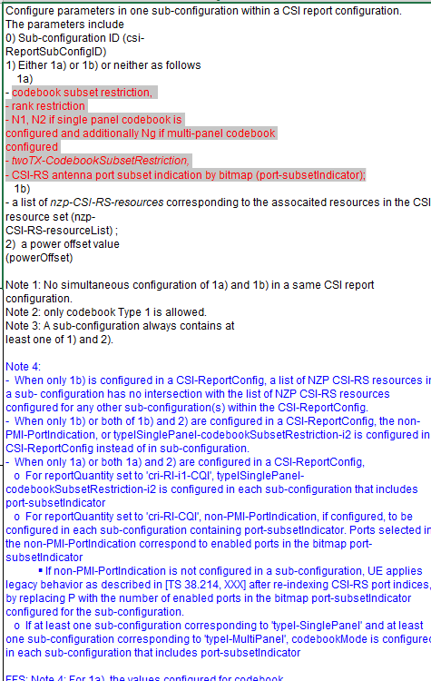  - The type 1 and type 2 for SD can not configured together. i.e., portSubsetIndicator-r18 and nzp-CSI-RS-ResourceList-r18 cannot be configured together.  portSubsetIndicator-r18 CHOICE {  p2 BIT STRING (SIZE (2)),  p4 BIT STRING (SIZE (4)),  p8 BIT STRING (SIZE (8)),  p12 BIT STRING (SIZE (12)),  p16 BIT STRING (SIZE (16)),  p24 BIT STRING (SIZE (24)),  p32 BIT STRING (SIZE (32))  } OPTIONAL, -- Need R  nzp-CSI-RS-ResourceList-r18 SEQUENCE (SIZE (1..maxNrofNZP-CSI-RS-ResourcesPerSet)) OF NZP-CSI-RS-ResourceIndex  OPTIONAL, -- Need R  - In the field description of powerOffset , the text for “the power offset after calculation should be (-8,15)” is needed.
Xiaomi | maxNrofCSI-ReportSubconfigPerCSI-ReportConfig-r18 INTEGER ::= 8 -- Maximum number of CSI report subconfigurations per CSI report configuration  maxNrofCSI-ReportSubconfigPerCSI-ReportConfig-1-r18 INTEGER ::= 7 -- Maximum number of CSI report subconfigurations per CSI report  -- configuration minus 1  For periodical case, the L is 4, not 8. The below is RAN1 agreement.  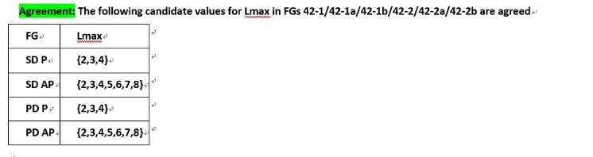
Xiaomi
Xiaomi

