3GPP TSG-RAN WG2 Meeting #123bis R2-23xxxxx
Xiamen, China, October 9-13, 2023

Source: Apple
Title: Summary of [Post123][407][Relay] Path addition/change in multi-path for scenario 1 (Apple)
Agenda Item: 8.9.4
Document for: Discussion and Decision

1. Introduction
This is for the summary of the following email discussion:
- [Post123][407][Relay] Path addition/change in multi-path for scenario 1 (Apple)
Scope: Discuss issues on the path addition and change procedures:
- For direct path, order of RRC reconfigurations to relay UE and remote UE
- For indirect path, order of RRCReconfigurationComplete and PC5-RRC message triggering RRC establishment by the relay UE
- For indirect path, case where the idle/inactive target relay UE establishes an RRC connection with a “wrong” cell (no inter-gNB multi-path in Rel-18)
- For indirect path, PC5-RRC signalling to trigger RRC establishment by the relay UE (which PC5-RRC message, triggering condition, contents)
- Which path can be configured for RRCReconfigurationComplete
- Related timer conditions (T304, T420-like)
Intended outcome: Report to next meeting
Deadline: Sep. 22, 2023, 20:00UTC

1.1 Contact Points
Respondents to this email discussion are kindly asked to fill in the following table for contact information.
Company | Name | Email Address

2. Discussion

2.1 Direct Path Addition/Change

2.1.1 Order of RRCReconfiguration
For the direct path addition in Scenario 1, there was some initial debate on the order of RRCReconfiguration messages in Post-122 email discussion (R3-2308950) [1]. The current running CR for stage-2 [2] has captured the diagram for path addition as follow:

Figure 1: Direct Path addition diagram in Stage-2 Running CR

The step 3 and step 4 are described as below in [2]:
3. The gNB sends an RRCReconfiguration message to the L2 MP Relay UE to update the indirect path configuration, if necessary.
4. The gNB sends the RRCReconfiguration message to the L2 MP Remote UE via the L2 MP Relay UE. The contents in the RRCReconfiguration message includes at least a target cell, direct path addition configuration .

For the remote UE, the NW definitely need to reconfigure it with a multi-path configuration. But for the relay UE in the indirect path, whether/when the relay UE is reconfigured due to direct path addition as shown in Step 3 is a bit controversial. First, it is possible that the relay UE indirect path configuration can remain unchanged during path addition. Even if some of the SRAP mapping and/or Uu/PC5 Relay RLC channel configurations are no longer needed as some UP/CP traffic will be shifted to the direct path, but nothing is broken if relay UE still keeps the old configuration and only serves the remaining DRBs or split RBs which configured to use indirect path. But if Uu/PC5 Relay RLC channel configurations in the indirect path are released in step 3, (i.e., before step 4), then relay UE and remote UE may have incompatible configurations, and messages such as RRCReconfguration and SidelinkUEInformationNR will not be able to be delivered end-to-end. Therefore, it seems safer to arrange the indirect path reconfiguration of relay UE to be after the reconfiguration of remote UE. On the other hand, some companies view the order of step3/4 can be left to NW implementation.

Question 1-1: What is your company’s view of the order of RRCReconfiguration of Relay UE and Remote UE in direct path additional signalling procedure?
a) First Relay UE, then Remote UE
b) First Remote UE, then Relay UE
c) Up to NW implementation

Company’s name | Option(s) | Comments, if any

Then, for the direct path change in Scenario 1, there are similar steps for RRCReconfiguration procedures for remote UE and relay UE, as shown in Figure 2.
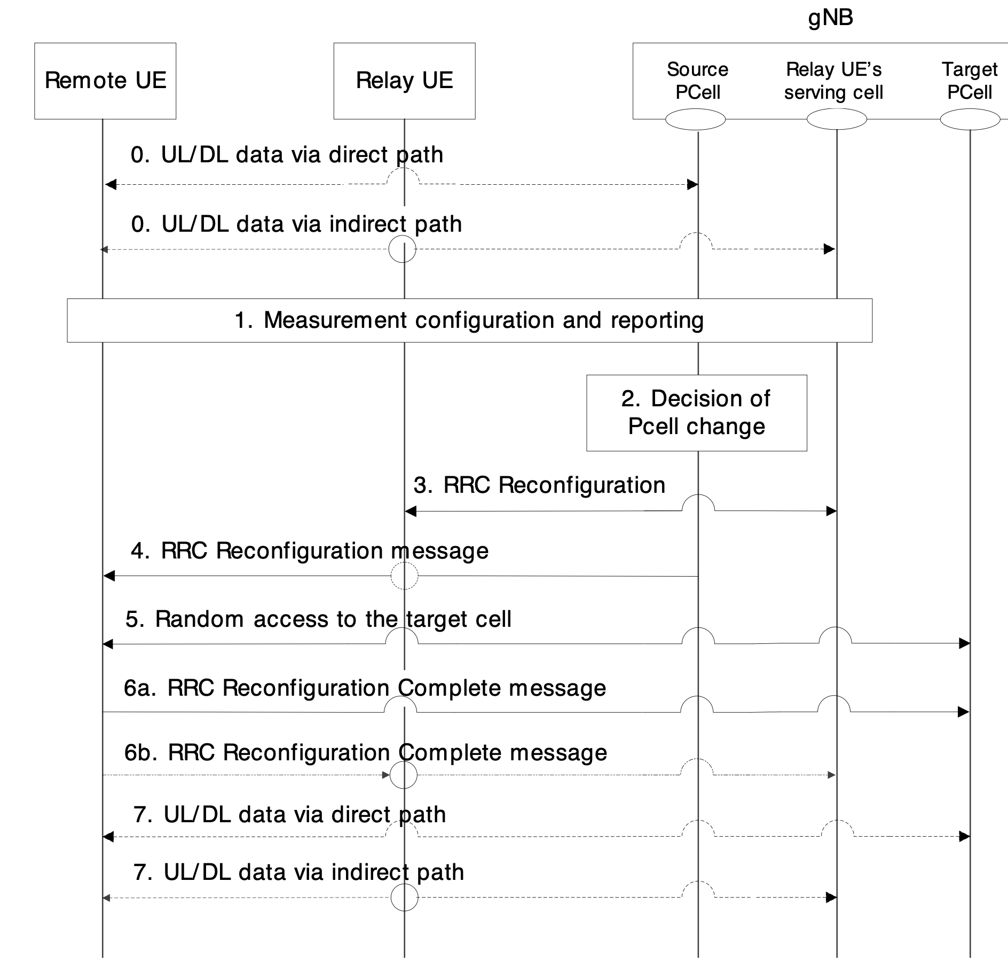
Figure 2. Direct Path change diagram in Stage-2 Running CR

The rapporteur think the conclusion reached for the path addition can be also applied here. There is no need of have a separate solution.

Question 1-2: Does your company agree the order of RRCReconfiguration of Relay UE and Remote UE in direct path change procedure can reuse the same solution as direct path addition case discussed in Q1-1?

Company’s name | Yes/No | Comments, if any

2.1.2 T304 timer
RAN2#123 [3] has agreed that “T304 timer is reused for the direct path addition/change.” The follow-up question is whether the legacy T304 conditions can be reused. The rapporteur thinks the start/stop conditions can be simply reused.

Question 1-3: Does your company agree that the legacy start condition of T304 timer as “Upon reception of RRCReconfiguration message including reconfigurationWithSync for the MCG which does not include sl-PathSwitchConfig“ and the stop condition as “Upon successful completion of random access on the corresponding SpCell” can be reused for T304 timer in direct path addition/change in MP Scenario 1?

Company’s name | Yes/No | Comments, if any

But when T304 timer expires, there are several different options on how remote UE shall behave. Some company think RRCReestablishment should not be triggered. But some company argue that SRB1 transmission on indirect path may also not be feasible at this time and RRC reestablishment is then needed. Also, which configuration to be used by the remote UE after the timer expiry and whether the failure case needs to be reported can be discussed. All those options are summarized in the following proposal in R2-2308949 [8].
Proposal 4.1.3: For the expiry of the new T304-like timer, RAN2 discuss the followings:
- In which condition the UE reports the failure of the direct path addition/change
- In which condition the UE reverts to the prior path operation
- In which condition the UE initiates RRC connection re-establishment

Let us check company view on each of the above proposed behaviour.

Question 1-4: Should the remote UE fall back to the configuration/operation prior to direct path addition/change at the expiry of T304 timer? If yes, on which condition? (NOTE: if no condition is provided, then it means it is always triggered)

Company’s name | Yes/No | Please specify the condition, if any

Question 1-5: Should the remote UE reports the failure of direct path addition/change at the expiry of T304 timer to gNB? If yes, on which condition? (NOTE: if no condition is provided, then it means the reporting is always triggered)

Company’s name | Yes/No | Please specify the condition, if any

Question 1-6: If company choose yes in Q1-5, what is the information to be included in the report?
a) indication of failure (of direct path addition or change)
b) Other, please specify

Company’s name | Option(s) | Comments

Question 1-7: Should the remote UE initiate the RRC reestablishment procedure at the expiry of T304 timer? If yes, on which condition? (NOTE: if no condition is provided, then it means the this is always triggered)

Company’s name | Yes/No | Please specify the condition, if any

2.2 Indirect path addition/change

2.2.1 Order of RRCReconfigurationComplete and PC5-RRC trigger
It has been agreed in RAN2#121 [4] that:
For bringing the idle/inactive relay UE to RRC_CONNECTED, the legacy Rel-17 behaviour (Alt 1 in the proposal) is not disabled for indirect path addition when split SRB1 is configured. A PC5-RRC trigger is specified at least for other cases.
Also, in RAN2#121bis [5], there are following RAN2 agreements:
- When split SRB1 with duplication is configured, the remote UE sends the RRCReconfigurationComplete message to gNB via both paths for Scenario 1.
- When one of the following conditions is met, the remote UE sends the RRCReconfigurationComplete message to gNB via the direct path for Scenario 1. FFS on need for additional condition.
o when primary RLC entity of split SRB1 is on direct path
o when non-split SRB1 is configured on direct path

Based on the above agreements, the PC5-RRC trigger is at least used when the RRCReconfigurationComplete is sent in the direct path case. So, we focus the discussion on the ordering for this case. During the post-122 email discussion about stage-2 procedures in R2-2308950 [1], companies have different view on the remote UE’s timing of sending PC5-RRC triggering message and the transmission of RRCReconfiguraitonComplete message in the direct path. Our understanding the transmission of RRCReconfigurationComplete in direct path is feasible at any time after receiving the path addition command (RRCReconfiguration) from the gNB. The reason to hold/delay this transmission is that the remote UE may not want to prematurely declare the completion of procedure while the establishment of indirect path is still pending and uncertain. There could be some benefit to send RRCReconfigurationComplete later than the PC5-RRC message triggering RRC establishment by the relay UE. It can also be argued that the transmission of RRCReconfigurationComplete message should be linked with the stop of new T420-like timer, so this can be discussed together with the new T420 timer stop condition.

Question 2-1: What is your company view about the order of remote UE sending of PC5-RRC trigger (for triggering relay UE enter CONNECTED) and the transmission of RRCReconfigurationComplete in the direct path, for the indirect path addition/change case when PC5-RRC trigger is needed?
a) Remote UE sends RRCReconfigurationComplete before PC5 link establishment
b) Remote UE sends RRCReconfigurationComplete before the transmission of PC5-RRC triggering message, but after PC5 link establishment.
c) Remote UE only send RRCReconfigurationComplete after sending PC5-RRC message triggering RRC establishment by the relay UE
d) Remote UE send RRCReconfigurationComplete after the new-T420 timer stops (i.e., following the new-T420-timer stop condition).
e) Other, please specify.

Company’s name | Option(s) | Comments, if any

2.2.2 Idle/inactive target relay UE establishes an RRC connection with a “wrong” cell
The stage-2 running CR contains an FFS issue about the indirect path addition/change as: “Editor’s Notes: FFS: Whether/How to avoid/handle the case when the target L2 MP Relay UE establishes a RRC connection with a different gNB than the gNB serving the target cell, noting that the inter-gNB multipath case is not supported in Rel-18.”
The case described in the editor’s note can happen when the target relay UE reselects a different cell/gNB after the remote UE report this candidate IDLE/INACTIVE relay to the gNB. While some company believes this is a corner case, some company think this case needs to be avoided or handled.
Note that there is no inter-gNB multi-path support in Rel-18 scope. In principle, another gNB shall not be involved accidently for multi-path configuration scenarios. It is also worth noting that when this occurs, the gNB of “wrong cell” may not detect anything wrong. This is because different from Rel-17, there is probably no RRCReconfigurationComplete message delivered to the wrong gNB in the wrongly-established indirect path. Thus, the gNB serving the “wrong” cell will not be triggered to take any further action (e.g., dropping the “wrong” RRC Connection) to dismantle this wrong path.
If companies are interested in addressing this problem, the rapporteur think this can be either:
- avoided (e.g., prevent relay UE from establishing RRC connection with a wrong cell in the first place, such as requiring remote UE verifying the relay discovery message, if any) or;
- handled (e.g., remote UE and/or relay UE and/or gNB detect & drop the wrongly-established indirect path after RRC establishment).
The rapporteur wants to check the company view on this:

Question 2-2: What is your company view about “whether/how to avoid/handle the case when the target L2 MP Relay UE establishes a RRC connection with a different gNB than the gNB serving the target cell”?
a) Yes, (i.e., need provide a way to avoid/handle this case).
b) No. (e.g., this is a corner case, no need to specify anything).
c) Other, please specify.

Company’s name | Option(s) | Comments, if any

Question 2-3: For companies supporting to have a solution (e.g., Option a in Q2-2) for this issue, we would like to further check your preference about how to solve this issue, i.e., whether prefer the approach to avoid this issue or handle this issue and some details about the solution.
Company’s name | Avoid  (Yes/No) | Handle  (Yes/No) | Solution details, if any

2.2.3 PC5-RRC Message triggering relay UE entering CONNECTED state
Let us begin with which PC5-RRC message is to be used for this purpose. There are some existing PC5-RRC signaling candidates if companies prefer to reuse the existing signaling. For example, RemoteUEInformationSidelink is used for one-way notification from remote UE to relay UE to convey some information about remote UE in Rel-17. RRCReconfigurationSidleink can be considered if a two-way communication is preferred. This is particularly useful if we consider the PC5-RRC trigger is a sort of request and need a response message to be sent back by the relay UE to acknowledge that the relay is entering or has already entered CONNECTED state for the sake of confirming the success of indirect path setup. Finally, a new PC5-RRC message could also be introduced as a signaling dedicated for this purpose.

Question 2-4: Which PC5-RRC message should be used for PC5-RRC triggering procedure?
a) RemoteUEInformationSidelink,
b) RRCReconfigurationSidelink.
c) UEAssistnaceInformationSidelink.
d) New PC5-RRC message (one-way)
e) New PC5-RRC message(s) (two-way e.g., request/response)
f) Other, please specify

Company’s name | Option(s) | Comments, if any

Then, we would like to consider what is to be included in the PC5-RRC triggering message. If the existing PC5-RRC message is to be reused, then at least some information to distinguish the trigger from legacy usage needs to be included. Regarding any extra information in this PC5-RRC message, one particular information may be useful is the “target cell” information. This can enable the IDLE/INACTIVE relay to examine whether it is still able to connect to the original cell under the same gNB which is enclosed in the relay discovery message, so that the “wrong” cell scenario discussed earlier can be avoided. It was also proposed in [9] that RRC establishment/resume cause value to be included in PC5-RRC trigger. Another proposal in [9 ] is that the indirect path bearer configuration from gNB is shared to relay UE in this message, although the rapporteur is not sure why this is needed because gNB will configure relay UE anyway after relay UE is triggered to enter RRC_CONNECTED state.

Question 2-5: What is your company’s suggestion for the information to be included in the PC5-RRC message used to trigger relay UE to enter CONNECTED?
a) Target cell information
b) cause value (e.g., RRC establishment/resume cause)
c) indirect path configuration from gNB
d) nothing extra (besides the information to distinguish the trigger from legacy usage if existing PC5-RRC signalling is reused)
e) Other, please specify.

Company’s name | Option(s) | Comments, if any

Finally, we need discuss the triggering conditions of this PC5-RRC message. There are two main aspects of this issue:

Whether the triggering is associated with the RRC state of relay UE. Logically, the message is needed for IDLE/INACTIVE target relay. However, since there is no explicit signaling for remote UE to know the state of target relay UE, it may be also fine to just let remote UE to send PC5-RRC trigger to CONNECTED relay UE too. And the CONNECTED relay would just skip the RRC establishment procedure as it is already in CONNECTED state.
- Whether the triggering is linked to SRB1 configuration. In the previous RAN2 agreement, it is said “For bringing the idle/inactive relay UE to RRC_CONNECTED, the legacy Rel-17 behaviour (Alt 1 in the proposal) is not disabled for indirect path addition when split SRB1 is configured. A PC5-RRC trigger is specified at least for other”. Therefore, we need decide that even for SRB1 with duplication configuration, should the remote UE be allowed to use PC5-RRC trigger or not. This may be also related to whether the PC5-RRC message contain extra information to be useful for the relay UE, so that even when (a duplicated copy of) RRCReconfigurationComplete can be sent via indirect path, the PC5-RRC trigger is still used.

Question 2-6: What is your company view about the relationship between triggering conditions for PC5-RRC message and the RRC state of target relay UE?
a) PC5-RRC message is always triggered, regardless of RRC state of target relay UE.
b) PC5-RRC message is only triggered if target relay UE is in IDLE/INACTIVE.
c) Other, please specify.

Company’s name | Option(s) | Comments, if any

Question 2-7: For companies choose option b in Q2-6, how s remote UE knows the RRC state of target relay UE?

a) gNB indicates the RRC state of target relay UE in RRCReconfiguration (i.e., as part of the indirect path configuration)
b) RRC state is enclosed in PC5 Relay Discovery message sent by the relay UE.
c) Other, please specify.

Company’s name | Option(s) | Comments, if any

Question 2-8: whether PC5-RRC trigger is allowed to be used when (the duplicated) RRCReconfiguraitonComplete is sent via indirect path?

Company’s name | Yes/No | Comments, if any

2.2.4 New T420-like timer
The rapporteur assume that the start condition of the new timer can be largely reused with the following minor change according to the new Rel-18 IE introduced in the running RRC CR [7]:
“Upon reception of the RRCReconfiguration message including sl-PathSwitchConfig sl-IndirectPathAddChange”
Question 2-9: Does you company agree on the start condition of new T420-like timer as “Upon reception of the RRCReconfiguration message including sl-IndirectPathAddChange” ?

Company’s name | Yes/No | Comments, if any

Then, for the timer stop condition of the New T420-like timer, various options are proposed by company contributions in RAN2#123 and summarized in R2-2308949 [8] as follows:
- Option 1. Reuse T420 condition, i.e., upon successful sending of RRCReconfigurationComplete message
- Option 2. When PC5-RRC connection establishment is completed
- Option 3. When relay UE is successfully connected to the gNB
- Option 4. When PC5-RRC connection establishment completes, and relay UE is successfully connected to the gNB

Regarding the difference between Option 3 and Option 4, the rapporteur understands that for CONNECTED target relay UE case, the remote UE using Option 3 will stop the timer immediately if it receives the RRCReconfiguration message indicating that a CONNECTED relay UE is chosen. For IDLE/INACTIVE relay UE case or for the case when remote UE is agnostic to the RRC state of target relay UE, there is no difference between Option 3 and Option 4.
Given that the companies may have different options for stopping conditions for IDLE/INACTIVE relay and CONNECTED relay case, the rapporteur will check the views for different RRC state respectively, given that there may be some solution to allow remote UE to know the RRC state. Of course, company prefer the same single stopping condition can choose the same option for those two cases in the answering table.

Question 2-10: What is your company’s view on the stop condition of new T420-like timer?
a) Reuse T420 condition, i.e., upon successful sending of RRCReconfigurationComplete message
b) When PC5-RRC connection establishment is completed.
c) Reuse T420 condition, i.e., upon successful sending of RRCReconfigurationComplete message
d) When PC5-RRC connection establishment completes, and relay UE is successfully connected to the gNB.
e) Other, please specify.

Company’s name | IDLE/INACTIVE  relay | CONNECTED  relay | Comments, if any

Similar to T304 timer, when the new T420-like timer expires, there are several different options on how remote UE should behave, as captured in the following proposal in R2-2308949 [8].
Proposal 4.2.4: For the expiry of the T420 timer, Ran2 discuss the followings:
- In which condition the UE reports the failure of the indirect path addition/change
- Whether or if yes, in which condition the UE reverts to the prior path operation
- In which condition the UE initiates RRC connection re-establishment
- Whether additional information needs to be reported to the gNB

In rapporteur's view, RRCReestablishment should not be triggered, because at least SRB1 on the direct path is always feasible even when indirect path addition/change fails. Anyway, let us check company view on each of the above proposed behaviour.

Question 2-11: Should the remote UE fall back to the configuration/operation prior to indirect path addition/change at the expiry of new T420-like timer? If yes, on which condition? (NOTE: if no condition is provided, then it means it is always triggered)

Company’s name | Yes/No | Please specify the condition, if any

Question 2-12: Should the remote UE reports the failure of indirect path addition/change at the expiry of T420-new like timer to gNB? If yes, on which condition? (NOTE: if no condition is provided, then it means the reporting is always triggered)

Company’s name | Yes/No | Please specify the condition, if any

Question 2-13: If company choose yes in Q2-12, what is the information to be included in the report?
a) indication of failure (of indirect path addition or change)
b) the reason which caused the failure (PC5 hop establishment failure, Uu establishment failure, etc.)
c) Other, please specify

Company’s name | Option(s) | Comments

Question 2-14: Should the remote UE initiate the RRC reestablishment procedure at the expiry of new T420-like timer? If yes, on which condition? (NOTE: if no condition is provided, then it means the this is always triggered)

Company’s name | Yes/No | Please specify the condition, if any

2.3 Path(s) for RRCReconfigurationComplete
It is worth noting that in RAN2#121bis-e [5], there have been agreements on this issue as follow:
- When split SRB1 with duplication is configured, the remote UE sends the RRCReconfigurationComplete message to gNB via both paths for Scenario 1.
- When one of the following conditions is met, the remote UE sends the RRCReconfigurationComplete message to gNB via the direct path for Scenario 1. FFS on need for additional condition.
  - when primary RLC entity of split SRB1 is on direct path
  - when non-split SRB1 is configured on direct path
Then, it has been further agreed in RAN2#123 [3] that
- For scenario 1, non-split SRB on the indirect path is not supported.
- For scenario 1, primary path of the split SRB1 and SRB2 is always configured on direct path.
Based on the latest agreements in RAN2#123, we can safely conclude that there is no case for indirect path usage except the earlier agreed case of “split SRB1 with PDCP duplication”. Basically, the direct path is always used for RRCReconfigurationComplete for path addition/change in Scenario 1. And the indirect path is only used when SRB1 with PDCP duplication is configured by NW in path addition/change command. Hence, there is no more remaining open issue for the path to be used for RRCReconfigurationComplete. Maybe we can just double-check this understanding among the companies.

Question 3-1: Does your company agree “For path addition/change cases in MP Scenario 1, RRCReconfgurationComplete is always transmitted in direct path. Only if NW configures split SRB1 with PDCP duplication, RRCReconfigurationComplete message is sent to gNB via both paths“?

Company’s name | Yes/No | Comments, if any

3 Conclusion
TBD

Reference
[1] R2-2308950 Report of [Post122][403][Relay] Procedures for multi-path relay (LG) LG Electronics France report Rel-18 NR_SL_relay_enh
[2] R2-230XXXXX Running CR for TS 38.300, Rel-18 SL relay enhacements, LG Electronics
[3] Chairman’s Note, RAN2#123
[4] Chairman’s Note, RAN2#121
[5] Chairman’s Note, RAN2#121bis
[6] Chairman’s Note, RAN2#122
[7] R2-2308949 Offline 402 on A.I 7.9.4 Multi-path relaying Nokia discussion
[8] R2-230XXXXX Running CR for TS 38.331 (Multi-path), Rel-18 SL relay enhacements, Huawei
[9] R2-2307227 Discussion on multi-path Xiaomi discussion

