3GPP TSG-RAN WG2 Meeting#121bis-e R2-23xxxxx
Electronic Meeting, 17 – 26 April, 2023

Agenda Item: 8.11.2.1
Source: Apple
Title: Report of [Post121][607][eMBS] UP issues for Multicast in RRC Inactive (Apple)
Document for: Discussion and Decision

Introduction
This document captures the outcome of the following email discussion:
- [Post121][607][eMBS] UP issues for Multicast in RRC Inactive (Apple)
Scope: Based on the companies’ contributions identify and discuss the potential UP issues that need to be resolved to support Multicast in RRC Inactive. Identify potential impact on RAN2 UP specifications and impact to other WGs, e.g. RAN1, RAN3.
Outcome: Report
Deadline: Long

Please provide your comments before 04/05/2023 23:59 UTC.

Discussion
Rapporteur encourages the participating delegates to provide their contact information in this table.
Company | Contact: Name (E-mail)
ZTE | QI Tao (qi.tao3@zte.com.cn)
TD Tech, Chengdu TD Tech | limei.wei@td-tech.com
Nokia | Subin Narayanan (subin.narayanan@nokia.com)
Samsung | Sangkyu Baek (sangkyu.baek@samsung.com)
CATT | Rui Zhou(zhourui@catt.cn)
vivo | Stephen (yitao.mo@vivo.com)
Lenovo | Mingzeng Dai (daimz4@Lenovo.com)
MediaTek | Xiaonan(xiaonan.zhang@mediatek.com)
LGE | Seong Kim (sj117.kim@lge.com)
Qualcomm | Umesh Phuyal (uphuyal@qti.qualcomm.com)
Intel | Yujian Zhang (yujian.zhang@intel.com)
Sharp | Fangying Xiao(fangying.xiao@cn.sharp-world.com)

CFR configuration
In Rel-17, the multicast CFR configuration and broadcast CFR configuration are different.
- Multicast CFR is configured within the UE dedicated BWP for RRC_CONNECTED UE;
- Broadcast CFR is configured with the BW fully overlapping with CORESET0 and with the same numerology as CORESET0 as indicated in the following 3 cases (i.e. case A/C/E) in Figure 1. the configuration is used for MTCH and MCCH transmission to UE in all RRC states.
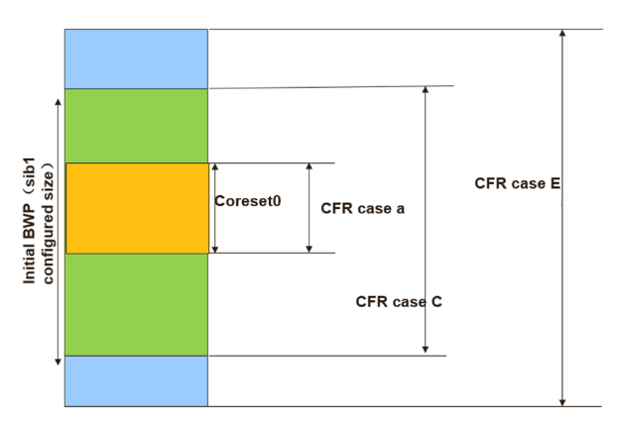
Figure 1: CFR cases for MBS broadcast [12]
For multicast reception in RRC_INACTIVE in Rel-18, RAN2 has agreed to introduce new SIB and new MCCH to provide the multicast configuration for multicast reception in RRC_INACTIVE. If R17 broadcast CFR design (3 cases) can be reused for multicast reception, RRC_INACTIVE UEs can receive SIBs/paging and MBS multicast without BWP switching.

Q1: [CFR] Do you agree to follow R17 MBS broadcast CFR principle to provide multicast CFR configuration in RRC_INACTIVE?
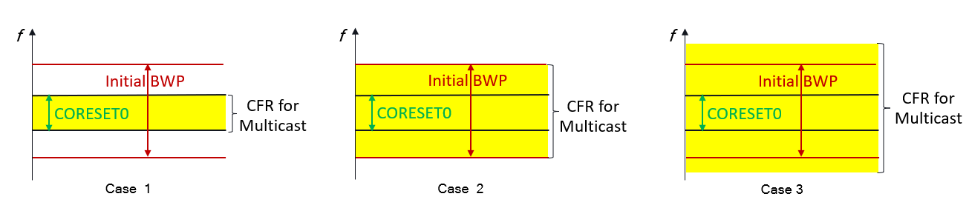
Figure 2: CFR for Rel-18 Multicast reception in RRC_INACTIVE [3]

Company | Yes or No | Comment if any
ZTE | Would love to.. but | There is at least one issue if we follow the restrictions of CFR for Rel-17 BC:  - for Rel-17 Multicast, we don't have any limitation as of any case above, the SCS might not even be the same as the initial BWP for the broadcast, theoretically. What if UE was configured otherwise, do they need to be re-configured, all at once, at the moment network enables the multicast reception in RRC_INACITVE?  Other than that, the following question may need some further discussion in later stage.  - does broadcast and multicast for RRC_INACTIVE UEs use the same CFR configuration? it seems unnecessary. how to guide UE mobility from other cell to get the PTM config in multicast MCCH shall be discussed.  - does all multicast received in RRC_INACTIVE use the same CFR? And for a certain multicast service, is the same CFR configuration used in RRC_INACTIVE and RRC_CONNECTED state? Probably so, but there no need to limit network implementation.  - Is the same CFR configuration for both multicast MCCH and MTCH? Better not. We shall have capability limited UE in mind, e.g., MCCH can be of narrower band, and MTCH of per service.  - etc..
TD Tech, Chengdu TD Tech | Yes
Nokia, NSB | Partially | We support the cases in the figure, BUT  What is called as Case B and D before are also supported by the standards, where  - the CFR can be smaller than the CORESET#0 and  - smaller than Initial BWP and larger than CORESET#0:  These are missing in the figure.  Btw. the CFR also depends on the delivery options, i.e., whether we have 1 DCI to  schedule both UEs in RRC_INACTIVE and RRC_CONNECTED; or we have 1 DCI to schedule  UEs in RRC_INACTIVE and 1 DCI to schedule UEs in RRC_CONNECTED.  In latter case, it would be enough that some portion of CFR overlaps between RRC_CONNECTED  and RRC_INACTIVE UEs, whereas in the former,we perhaps need a full overlap.  More discussions are needed.
NEC | See comments | We share the same understanding as Nokia. Meanwhile there may be possibility to allocate two CFRs, one for connected UEs and the other for RRC_INACTIVE UEs
Samsung | Yes | Rel-18 WI does not have RAN1 TU, so RAN2 should try to avoid RAN1 issue. In that sense, reusing broadcast CFR would make sense.
CATT | Yes | Similar as MBS broadcast, it is also necessary to avoid BWP switching when receiving multicast in INACTIVE
vivo | Yes | We can just reuse the Rel-17 broadcast CFR principle, considering that the use cases are nearly the same when the UE is in RRC INACTIVE state (e.g. monitoring MCCH/MTCH PDCCH and the corresponding MTCH(s), as well as SSB measurement/paging monitoring). We fail to see the necessity to introduce more enhancements (e.g. separate CFRs for MCCH and MTCH(s)).
Lenovo | Yes | For Rel-18 multicast MBS, it would be straight forwards to use the same CFR as broadcast. One reason in it can avoid BWP switching for acquiring paging and system information or triggering RA procedure. On the other side, by proper network configuration, the CFR configuration can be same for both RRC_CONNECTED and RRC_INACTIVE UEs to avoid BWP switching during RRC state transition.
MediaTek | See comment | A clarification is be needed that whether this proposal contradicts the previous agreement:  - The following is taken as baseline: we assume the same PDCCH/PDSCH resources (e.g. resources used for MTCH) can be used for all UEs (including UEs in CONNECTED and/or INACTIVE states) for receiving the same multicast session.  If R17 MBS broadcast CFR principle is reused for multicast in INACTIVE state, it probably uses the different PDCCH/PDSCH resources compared with Rel-17/Rel-18 UE receiving multicast in CONNECTED.
LGE | No | If we follow the broadcast CFR principle, the SCS of the multicast CFR should be the same as the initial BWP and the multicast sessions that can be received in RRC_INACTIVE would be highly limited. Furthermore, it requires gNB to configure a separate multicast CFR for the same multicast session, if the multicast CFR for RRC_CONNECTED is not overlapped with the initial BWP.
Qualcomm | Yes to the principle  (No to simply reusing CFR configured for r17 broadcast) | Our assumption is the question is only about the ‘principle’ from R17 broadcast, not about reusing broadcast CFR for multicast.  We agree with the principle of allowing similar cases for multicast in INACTIVE as cases a, c and e for broadcast. Note that does not mean always reusing the R17 broadcast CFR for R18 multicast CFR.  Multicast CFR for RRC_INACTIVE UEs should have the BW same or larger than CORESET#0, fully overlapping with CORESET#0 and with the same numerology as CORESET#0  Consequently, when the UE needs to receive R17 broadcast as well as R18 multicast in INACTIVE simultaneously, then:  - Both the CFRs need to fully contain CORESET#0  - One of the two CFRs need to be fully contained (or overlapping) with the other CFR, as illustrated in the figure below. (This enables UE to just monitor the larger CFR and able to receive both services without BWP switch).  Similar to r17 broadcast, if CFR for multicast is not configured, the default should be same as CORESET#0. (One may argue the default can be same as Broadcast CFR but not all UEs are required to support broadcast.)  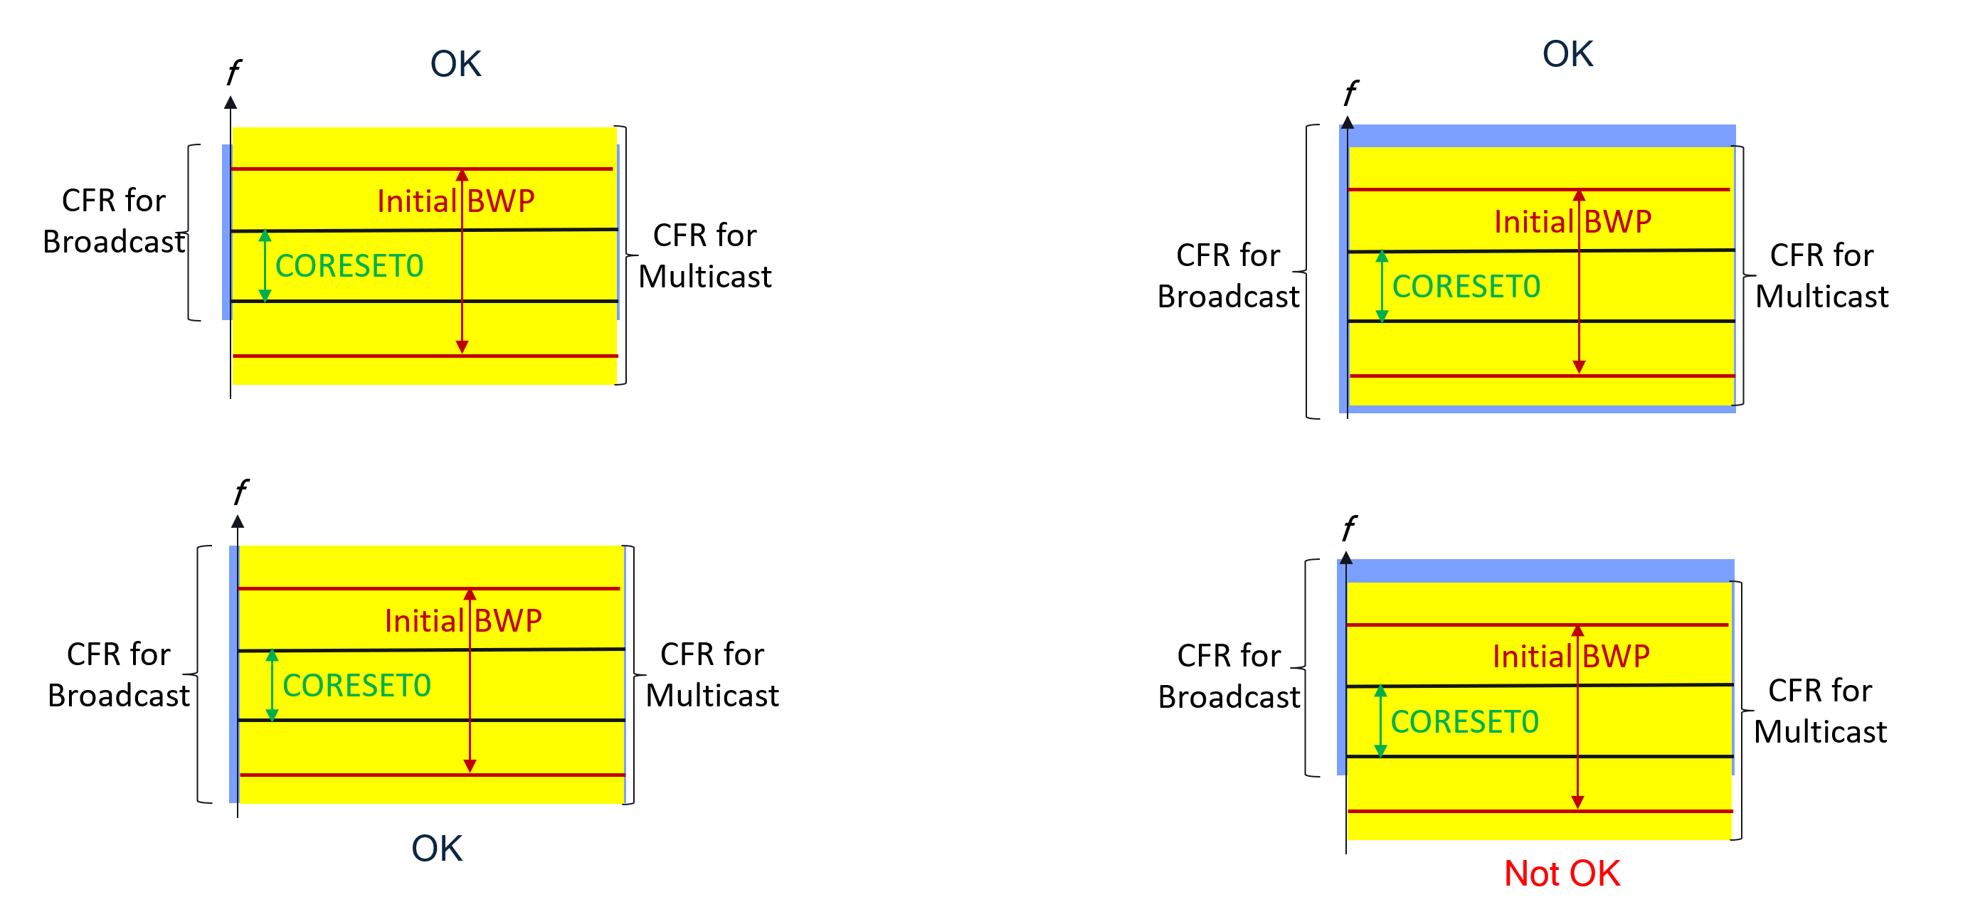
Intel | Yes | We prefer to reuse broadcast CFR for multicast reception in RRC_INACTIVE.
Sharp | Yes
Xiaomi | Yes

MAC related issues

HARQ operation and scheduling DCI
In Rel-17, the DCI format and HARQ operation used for MBS multicast and broadcast are different.
 | MBS multicast (MTCH) | MBS broadcast (MTCH) and MCCH
DCI format | - DCI format 4_1/4_2 | - DCI format 4_0
Applicable RRC states | - RRC_CONNECTED | - All RRC states
HARQ operation | - NW provides HARQ scheduling information (i.e., NDI, HARQ process number, HARQ feedback resources and timing, etc).  - HARQ process ID is explicitly indicated in DCI.  - Support NDI based HARQ retransmission. | - NW does not indicate HARQ process ID.  - UE selects the HARQ process ID by itself.  - NDI based HARQ retransmission is not supported.
Beam for transmission | - The TCI state for PDSCH and the TCI state for PDCCH are UE specific TCI state, which is based on UE specific beam management.  - The DCI format 4_2 for multicast MBS contains the TCI state for PDSCH reception;  - The DCI format 4_1, the same TCI state as TCI state for unicast PDCCH will be used. | - The transmission is via beam sweeping based on SSB index.

DCI Format 4_0 | DCI Format 4_1 | DCI Format 4_2
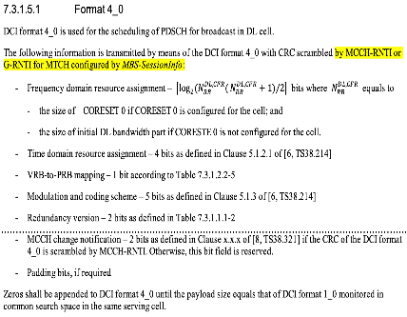 | 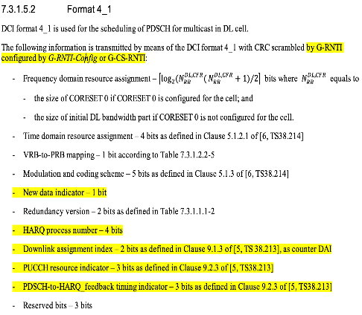 | 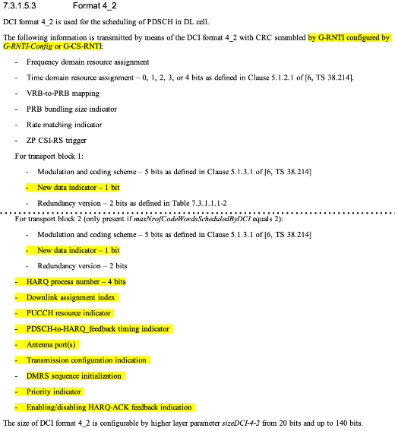

As we agreed in RAN2#119 meeting as below, the baseline is to use the same PDCCH/PDSCH resource for the multicast for both RRC_INACTIVE and RRC_CONNECTED UEs.
- The following is taken as baseline: we assume the same PDCCH/PDSCH resources (e.g. resources used for MTCH) can be used for all UEs (including UEs in CONNECTED and/or INACTIVE states) for receiving the same multicast session. Different configuration/resources are not precluded as well. FFS what exactly can be common and what not (e.g. HARQ, SPS etc.) and what is needed in addition (to legacy PTM config).

Following R17 PDCCH design on MBS multicast in RRC_CONNECTED, DCI format 4-1/4-2 will be considered for the multicast to RRC_INACTVE UE. But looking into the fields in DCI format 4-1/4-2, for the multicast reception in RRC_INACTIVE, whether the fields related to the following functions are needed or not are still open for discussion:
- 1) HARQ feedback
- 2) HARQ operation
- 3) Beam information.

<HARQ feedback>
In RAN2#119 meeting, RAN2 agreed that HARQ feedback and PTP are not supported for multicast reception in RRC_INACTIVE.
- HARQ feedback and PTP are not supported for multicast reception in RRC_INACTIVE.

Therefore, HARQ feedback resources and timing information in the DCI is not used for multicast transmission to RRC_INACTIVE UEs. In other words, if DCI format 4-1/4-2 is used for MBS multicast in RRC_INACTIVE, UE ignores the HARQ feedback related fields.

Q2: [HARQ FB] Do you agree that HARQ feedback related information in the DCI is not needed for multicast transmission to RRC_INACTIVE UE?
- If DC format 4-0 or new DCI format is used, NW doesnot provide the feedback info in DCI;
- If DCI format 4-1/4-2 is used, NW provides the feedback info in DCI but UE ignores it.

Company | Yes or No | Comment if any
ZTE | Yes but | We prefer to reuse at least DCI format 4-1 and FFS 4-2, for a certain multicast, the same DCI shall be used for all UEs (in RRC_CONNECTED or UE in RRC_INACTIVE states, and UE from Rel-17).  - the UE behaviour on how to ignore certain bits in DCI will be defined in physical layer, i.e., RAN1 shall be aware of this. We can do this together with the Beam related issue, in a single LS to RAN1.  And whether network enables HARQ Feedback for UEs in RRC_CONNECTED, we can keep it open for now.
TD Tech, Chengdu TD Tech | Yes
Nokia | Yes | No need to introduce a new DCI format.
NEC | Yes | Meanwhile, we expected that RRC_INACTIVE UE will not provide feedback. But the UE may need to have a mechanism to handle the unintended HARQ retransmission.
Samsung | Yes | Considering our basline in RAN2#119, we prefer 4-1 and 4-2. In any case, RAN1 should confirm it.
CATT | Yes | Agree with companies above that same DCI should be used for UEs in INACTIVE and in CONNECTED. And it is expected the UE in INACTIVE ignores some information in format 4-1 and 4-2.
vivo | Yes with comments | We are generally fine with the rapporteur’s proposal. But, we are wondering about the necessity of using format 4_2 for INACTIVE state which is basically intended for 2 codewords transmission requiring MIMO configuration (e.g. nrofPorts) and CSI-RS measurement. Anyway, we have to check with RAN1.
Lenovo | Yes | The DCI format should be same for both RRC_CONNECTED and RRC_INACTIVE UEs.
MediaTek | Yes | We may ask RAN1 to decide what DCI format should be used, and further discuss which field should be ignored (if DCI4-1/ 4-2 is used).
LGE | Yes | We think that use of DCI format 4_1/4_2 is more feasible because the same PDCCH/PDSCH resources can be used for both RRC_CONN UEs and RRC_INACTIVE UEs. Also, it is noted that UE does not provide HARQ feedback for multicast when harq-FeedbackEnablerMulticast is absent.
Qualcomm | Yes
Intel | Yes
Sharp | Yes
Xiaomi | Yes

<HARQ operation>
About the necessity to carry the HARQ process ID and NDI fields in DCI for multicast reception in RRC_INACTIVE, it depends on which HARQ operation we would like to support. There are two options on the HARQ operation:
- Option 1: Same as MBS broadcast
- UE select the HARQ process ID for multicast transmission by itself.
- NDI based HARQ retransmission is not supported.
- HARQ process ID and NDI in the DCI are not indicated.
- Option 2: Same as MBS multicast in RRC_CONNECTED state
- NW explicitly indicates the HARQ process ID for multicast transmission.
- NDI based HARQ retransmission is supported.
- HARQ process ID and NDI in the DCI are indicated.

Q3: [HARQ] Which option of the HARQ operation do you support for multicast reception in RRC_INACTIVE?
- Option 1: Same as MBS broadcast.
- Option 2: Similar as MBS multicast in RRC_CONNECTED state.
Company | Option | Comment if any
ZTE | 2 | this follows Q2 on which DCI format to go.
TD Tech, Chengdu TD Tech |  | Comments: depend on the specific cases.  Case 1: all UEs in RRC_INACTIVE state  Case 2: some UEs in RRC-INACTIVE state with different PTM configurations for RRC_INACTIVE UEs and RRC_CONNECTED UEs  Case 3: same PTM configurations for RRC_INACTIVE UEs and RRC_CONNECTED UEs with retransmission of a TB on a PTM PDSCH with PTP mode  Case 1: option 1  Case 2: option 1  Case 3: option 2  Under case 3, in order to support retransmission of a TB on a PTM PDSCH with PTP mode, the TB on a PTM PDSCH is sent on a assigned HARQ process with the NDI field indicating a new TB.
Nokia | Option 2 | UE receiving MBS multicast in RRC_INACTIVE should be able to receive  the HARQ retransmissions requested by UEs in RRC_CONNECTED.
NEC | Option-1 | For Option-2, the UEs in RRC_INACTIVE may experience a bit complicated HARQ receptions, which may contradictory for power saving
Samsung | Option 2 | Considering our basline in RAN2#119, we prefer 4-1 and 4-2. In any case, RAN1 should confirm it.
CATT | Option 2 | As commented to Q2, if same DCI is used for all UEs, UE can follow the general HARQ operation similar as MBS multicast in RRC_CONNECTED state. But for NDI based HARQ retransmission, it is related to DRX handling, whether it is feasible needs more discussion.
vivo | Option 2 | Currently, in 38.321, descriptions for broadcast and multicast are separate. It is good to keep them independent in Rel-18 from the modeling point of view. Besides, reusing the Rel-17 multicast method is good and it is feasible to support retransmission continuity from INACTIVE to CONNECTED. In conclusion, We fail to see any pros if using Option 1.
Lenovo | Option 2 | The DCI format should be same for both RRC_CONNECTED and RRC_INACTIVE UEs.
MediaTek | Option2 | This is related to which DCI format is used and we should ask RAN1 for more details.
LGE | Option 2 | Option 2 seems benficial for HARQ contiuation during RRC state transition (RRC_CONN <-> RRC_INACTIVE) mentioned in Q14.
Qualcomm | Option 2 | Some UEs in the cell may be in CONNECTED, while others in INACTIVE receiving the same multicast service, so the same method as in CONNECTED should apply so that all UEs can receive the service.  We assume this question is only for MTCH. For multicast MCCH, option 1 is ok – aligned with r17 broadcast.
Intel | Option 2 | This allows that both legacy UEs in RRC_CONNECTED and Rel-18 UEs can receive the same multicast service.
Sharp | Option 2 | This follows the DCI format to be used.
Xiaomi | Option2

<Beam information>
About the beam information carried in DCI for multicast transmission in RRC_INACTIVE, since UE specific beam management is not supported for RRC_INACTIVE UE, network can only support the multicast transmission in RRC_INACTIVE via beam sweeping based on SSB index like boradcast MBS.

Q4: [Beam] Do you agree that the multicast transmission RRC_INACTIVE is performed via beam sweeping based on SSB index like broadcast MBS (i.e. beam information is not need in DCI)?
Company | Yes or No | Comment if any
ZTE | Yes | Network has to blindly broadcast the data as in Rel-17 BC by beam sweeping.
TD Tech, Chengdu TD Tech | Yes
Nokia | Yes but  not only | It is up to network whether it uses beam sweeping or not but the network  should indicate that to the UEs both in RRC_INACTIVE and  RRC_CONNECTED. UE (including RRC_CONNECTED) can save power if it knows that beam sweeping is used.
NEC | Yes
Samsung | Yes
CATT | Yes
vivo | Yes | TCI-state updating seems impossible as there is no CSI reporting in INACTIVE. Thus, sweeping becomes the only way.
Lenovo | Yes
MediaTek | Yes
LGE | Yes
Qualcomm | Yes | If DCI 4_2 is used, UE should ignore the TCI state info as that is meaningless for INACTIVE UEs.
Intel | Yes
Sharp | Yes
Xiaomi | Yes

Q5: [DCI] Do you think we should request RAN1 to confirm whether it is feasible to reuse the same DCI format of R17 multicast (i.e. DCI format 4-1/4-2) for dynamic scheduling of multicast in RRC INACTIVE?
Company | Yes or No | Comment if any
ZTE | Yes | As in Q2, there will be re-defining of UE behaviour if we follow the same DCI format 4-1 or 4-2, and RAN1 may need to further check if there will be other issues:  - is it possible to configure RRC_CONNECTED UEs with Rel-17 multicast way, and configure UE in RRC_INACTIVE with common signaling in MCCH, to enable them to receive the same PDSCH resources?  But do we really need 4-2? We don't need separate beam for PDCCH/PDSCH (as in 4-0), either other features (port, priority, etc.).
TD Tech, Chengdu TD Tech | Yes
Nokia | Yes but not only | In our contribution [10], we have provided the advantages/disadvantages and  needed UE behaviour when reusing DCI format 4-1/4-2 and DCI format 4_0  to schedule UEs in RRC_INACTIVE state. We can ask RAN1 the feasibility  of both options, at least covering all the mentioned issues in our contribution.
NEC | Yes
Samsung | Yes | RAN1 confirmation is required.
CATT | Yes | Need to confirm with RAN1 on the feasibility.
vivo | Yes | LS to RAN1 for confirmation is needed.
Lenovo | Yes
MediaTek | Yes
LGE | Yes
Qualcomm | Yes | Ok to ask RAN1.  Also, for multicast MCCH, it is better to reuse DCI format 4_0. We should also include this question to RAN1.
Intel | Yes
Sharp | Yes
Xiaomi | Yes

SPS
In RAN2#119 meeting, RAN2 agreed that HARQ feedback and PTP are not supported for multicast reception in RRC_INACTIVE. But whether to support SPS for multicast reception in RRC_INACTIVE is still open.
- HARQ feedback and PTP are not supported for multicast reception in RRC_INACTIVE.

In Rel-17, to support SPS for multicast in RRC_CONNECTED, UE is required to support the following aspects:
- Support SPS configuration via UE dedicated RRC signaling.
In Rel-17, DL MBS SPS is configured by dedicated RRC signaling on serving cell per BWP.
- Support L1 signaling for SPS activation and deactivation mechanism.
In Rel-17, for DL MBS SPS, a DL assignment is provided by PDCCH with G-CS-RNTI, and UE store or clear it based on L1 signalling indicating SPS activation or deactivation.
- Support L1 signaling for SPS HARQ retransmission mechanism.
In Rel-17, for DL MBS SPS, a DL assignment is provided by PDCCH with G-CS-RNTI is to explicitly indicate the HARQ retransmission.
- Support DCI format 4-1/4-2.
In Rel-17, DCI format 4-1/4-2 is configured for the PDCCH for SPS activation/deactivation and SPS HARQ retransmission.
- Support to use specific HARQ process for MBS SPS transmission.
In Rel-17, for DL MBS SPS, the HARQ process used for the SPS config is explicitly indicated in SPS-config. UE can support multiples SPS configurations.
If SPS is supported for multicast in RRC_INACTIVE state, enhancements are needed from the above aspects.

Q6: [SPS] Do you support SPS for multicast reception in RRC_INACTIVE?
Company | Yes or No | Comment if any
ZTE | No | How to enable/disable SPS, with the risk that UE may lose such indication, will be a problem. We can simply follow BC in Rel-17, i.e., no SPS.
TD Tech, Chengdu TD Tech | Yes
Nokia | Yes | Rel-17 UEs will be configured with SPS reception, where we need  a counterpart for UEs in RRC_INACTIVE to receive the same transmission.
NEC | No
Samsung | Yes | We think using SPS resource is a simple way of resource allocation for RRC_INACTIVE UE.  As ZTE mentioned, there is a risk that UE may not detect PDCCH. The same risk exists for dyanmic grant allocation. SPS can reduce the risk by not sending PDCCH every time.  Practically, frequent SPS activation/deactivation is not expected for RRC_INACTIVE UE. Also, gNB can send PDCCH mutiple times for activation/deactivation. There will be no problem.
CATT | Yes | As previously agreed, the same PDCCH/PDSCH resources (e.g. resources used for MTCH) can be used for all UEs (including UEs in CONNECTED and/or INACTIVE states) for receiving the same multicast session, and SPS can be used for UEs in CONNECTED, so it is straightforward SPS also needs to be support for multicast reception in RRC_INACTIVE. Otherwise, we need to limit the use of SPS for UEs in CONNECTED.
vivo | Yes | The existing mechanism can be reused so that PDCCH overhead can be saved.
Lenovo | Yes
MediaTek | No strong view | Supporting SPS is beneficial to resources and power saving, but it may not be feasible in the case we do not support HARQ feedback.
LGE | Yes | We have similar view with CATT. If mutlicast session is served by SPS in RRC_CONNECTED, the SPS PDSCH resources can be shared with RRC_INACTIVE UEs according to the agreement of R2-119 captured in 2.2.1. Support of SPS for multicast MBS in RRC_INACTIVE is needed.
Qualcomm | No | Support SPS for multicast reception in RRC_INACTIVE would mean G-CS-RNTI is not configured for UE to receive multicast in INACTIVE.  This would also mean to support a service with same DL resources, network should not configure SPS for CONNECTED UEs for that service in that cell.  Supporting SPS in INACTIVE comes with more issues, e.g. how to send HARQ feedback to (de)activation command from INACTIVE.
Intel | No | SPS is coupled with HARQ feedback, which is not supported for multicast reception in RRC_INACTIVE. It is challenging to support SPS without RAN1 involvement, however there is no RAN1 TU for Rel-18 MBS.
Sharp | No strong view
Xiaomi | Yes

Q7: [SPS] If your answer to Q6 is YES, what do you think of the SPS operation for multicast reception in RRC_INACTIVE?
Company | How to SPS operation (e.g. from the 5 aspects listed above?)
TD Tech, Chengdu TD Tech | Further study is needed.
Nokia | Since UE in RRC_INACTIVE cannot acknowledge SPS activation/deact, network should repeat the SPS activation/deact to increase the probability of receiving it correctly.  Otherwise, the SPS operation should be the same as in RRC_CONNECTED.  In our view, we do not need to stick to 1 to 5 above. SPS could mean to support the above,  but further discussions are needed by RAN2.
Samsung | 1,2,4,5  3: If HARQ feedback is not supported, retransmission may not be efficient.
CATT | 1) SPS configuration should be included in multicast MCCH  2), 4) Follow the same activation/deactivation mechanism for inactive SPS multicast
vivo | 1,2,4 without HARQ feedback/confirmation for the activation/deactivation.
Lenovo | We think the above 5 aspects can be re-used for multicast reception in RRC_INACTIVE.  Even though there is no HARQ feedback, but HARQ retransmission may be beneficial.
LGE | Further discussion is needed. SPS mechanism like CG type 1 can be included in the discussion considering that only CG type 1 is used in RRC_INACTIVE for SDT.
Qualcomm | See above

DRX
For multicast reception in RRC_INACTIVE, since HARQ feedback and PTP are not supported, in DRX operation, RRC_INACTIVE UE does not need to start drx-HARQ-RTT-TimerDL-PTM and drx-RetransmissionTimerDL. Therefore, the DRX operation for multicast in RRC_INACTIVE is same as the DRX for MBS broadcast. About the spec impact, the simple way is to extend the DRX for MBS broadcast (section 5.7a in MAC) to cover DRX for MBS multicast reception in RRC_INACTIVE.
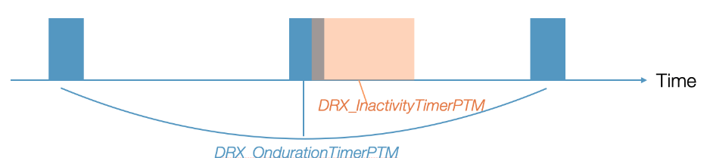
Figure 3: DRX operation for MBS broadcast

Q8: [DRX] Do you agree that the DRX operation for multicast reception in RRC_INACTIVE reuses MBS broadcast DRX design?
Company | Yes or No | Comment if any
ZTE | no | or we follow multicast framework, while always considering the re-tx is disabled?
TD Tech, Chengdu TD Tech | No | Comments: depend on the specific cases.  Case 1: all UEs in RRC_INACTIVE state  Case 2: some UEs in RRC-INACTIVE state with different PTM configurations for RRC_INACTIVE UEs and RRC_CONNECTED UEs  Case 3: same PTM configurations for RRC_INACTIVE UEs and RRC_CONNECTED UEs with retransmission of a TB on a PTM PDSCH with PTP mode
Nokia | No | UE in RRC_INACTIVE receiving MBS multicast should be able to receive  HARQ retransmissions requested by UEs in RRC_CONNECTED.  Therefore, also HARQ_RTT and Retransmission timers should be used.
NEC | No
Samsung | No | Agree with ZTE. We can try to reuse multicast DRX but HARQ RTT Timer and RetransmissionTimer do not need to start.
CATT | No | Agree with ZTE and Samsung, DRX cycle of multicast in CONNECTED is reused and need special handling on some timers related to HARQ retransmission.
vivo | No | From spec modeling point of view, it is not good to mix multicast up with broadcast. Besides, we think the existing modeling for multicast can be reused. Thus, it seems a spontaneous logic to reuse the legacy multicast approach.
Lenovo | NO | Agree with Nokia, HARQ retransmission may be beneficial for RRC_INACTIVE UE.
MediaTek | No | Agree with ZTE that we can reuse multicast DRX and always assume HARQ is disabled.
LGE | Comment | We see no difference between DRX for broadcast MBS and DRX for multicast MBS except for HARQ retransmission related operation. Considering spec. implementation, the section of DRX for multicast MBS is proper place for the related text changes such as ignoring DRX operation for HARQ retransmission in RRC_INACTIVE.
Qualcomm | See comment | In principle, intent seems ok. But in terms configuration and spec impact, the DRX configuration needs to be provided dedicatedly for CONNECTED UEs. And a separate section 5.7b can be created instead of capturing multicast in 5.7a. That can be decided in the CR stage.
Intel | No | Since HARQ feedback is not enabled for multicast reception in RRC_INACTIVE, multicast DRX operation (as defined in TS 38.321 clause 5.7b) is basically similar to broadcast DRX (defined in clause 5.7a).
Sharp | No | We can reuse the multicast DRX but disable the timers that not needed.
Xiaomi | No

LCID
In Rel-17, the LCID space used for MBS broadcast and MRB multicast is different.
- Multicast MRB and unicast DRB share the common LCID space.
- Broadcast MRB/MCCH and unicast DRB use the different LCID spaces.
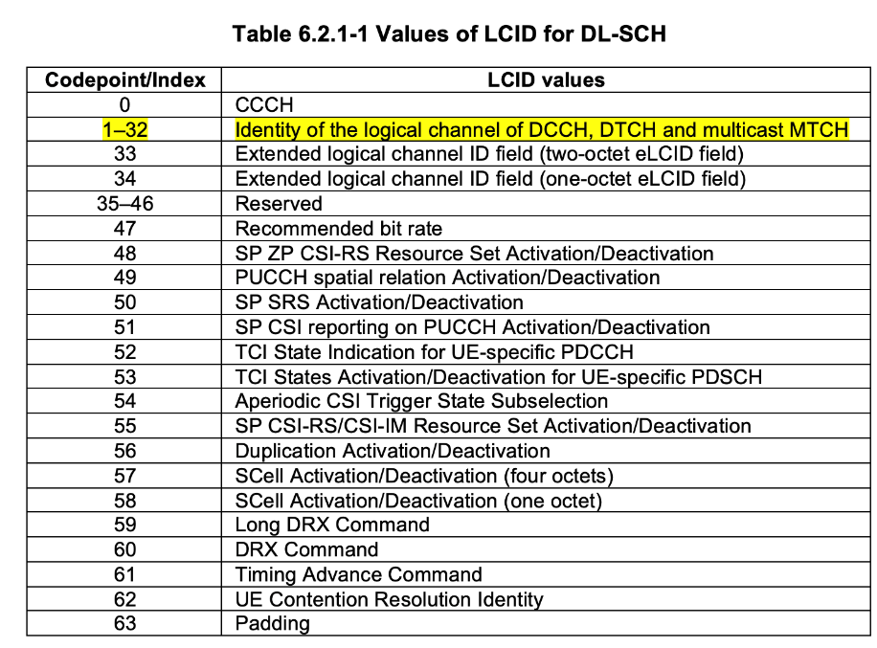
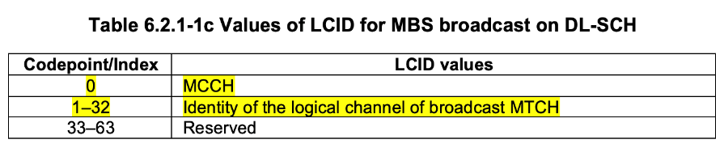

For multicast reception in RRC_INACTIVE in Rel-18, for the same multicast session, the RLC and PDCP configuration of the multicast MRB should be same (at least for the same cell) for RRC_CONNECTED and RRC_INACTIVE UEs. Since the LCID is provided in RLC configuration, the LCID configuration for multicast MRB should follow the same rule as that in R17 multicast configuration in CONNECTED state, i.e. using the common LCID space with unicast DRB.

Q9: [LCID-MTCH] Do you agree that the common LCID space is used for multicast MRB and unicast DRB regardless of UE RRC state (i.e. no change on the LCID table for MTCH)?
Company | Yes or No | Comment if any
ZTE |  | it is too complicated and we need more time on this..
TD Tech, Chengdu TD Tech |  | Further study is needed.
Nokia | Yes
NEC | Yes
Samsung | Yes | For PDCP continuity, common LCID is better. It seems that there is no issue.
CATT | Yes | It is straightforward to follow R17 principle as the same multicast session targeted for UEs in CONNECTED and in INACTIVE.
vivo | Yes
Lenovo | Yes
MediaTek | Yes
LGE | Yes | The same PDCCH/”PDSCH” can be used for both RRC_CONN UEs and RRC_INACTIVE UEs. The policy for LCID should be same for RRC_CONN and RRC_INACTIVE for multicast MBS.
Qualcomm | Yes
Intel | Yes | This is needed for backward compatibility with Rel-17 UEs receiving multicast.
Sharp | Yes
Xiaomi | Yes

For MCCH, RAN2 agreed to introduce the new MCCH for multicast in INACTIVE, I think it’s straightforward to introduce the new LCID and new RNTI for the multicast MCCH channel transmission.
- We introduce a new MCCH logical channel for multicast in INACTIVE (different from broadcast MCCH)

Q10: [LCID-MCCH] Do you agree to introduce a new LCID in Table 6.2.1-1c for multicast MCCH?
NOTE: TP is provided as below for example.
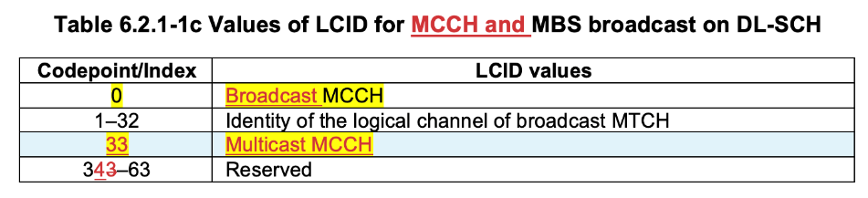
Company | Yes or No | Comment if any
TD Tech, Chengdu TD Tech | NO | We need to introduce a new RNTI. For example use MMCCH-RNTI to indicate RNTI for multicast MCCH.  LCID of 0 can be used for Multicast MCCH.
Nokia | No | LCID for multicast MCCH should be introduced into Table 6.2.1-1, not to MBS broadcast table.
NEC | No | We have the understanding as Nokia. LCID for multicast MCCH should be introduced into Table 6.2.1-1, not to MBS broadcast table, since there are two different LCID spaces.
Samsung | Yes
CATT | No | Agree with companies above LCID of multicast MCCH is not in the same LCID space of broadcast as there will be new RNTI to identify multicast MCCH.
vivo | No | The serving requirements for broadcast MCCH or multicast MCCH are assumed to be similar. In this sense, why should we introduce separate LCH for each?
Lenovo | No | Share the same with with Nokia.
MediaTek | No | Agree with Nokia.
LGE | No | First, we don’t prefer to introducing a new LCID for multicast MCCH.  Second, we don’t prefer to defining LCID for multicast in Table 6.2.1-1c because the table is for values of LCID for MBS broadcast. We think that LCID for multicast is defined in Table 6.2.1-1 (Values of LCID for DL-SCH).
Qualcomm | Yes | Since MCCH scheduling is provided in SIB similar to bcast, it seems the shown TP would be fine even though new RNTI may be needed. In any case the DL channel is DL-SCH.
Intel | No | The new RNTI is sufficient as broadcast MCCH and multicast MCCH can be differentiated by RNTIs.
Sharp | No | Agree with Nokia.
Xiaomi | No

Q11: [RNTI-MCCH] Do you agree to introduce a new RNTI in Table 7.1-1 for multicast MCCH?
NOTE: TP is provided as below for example.
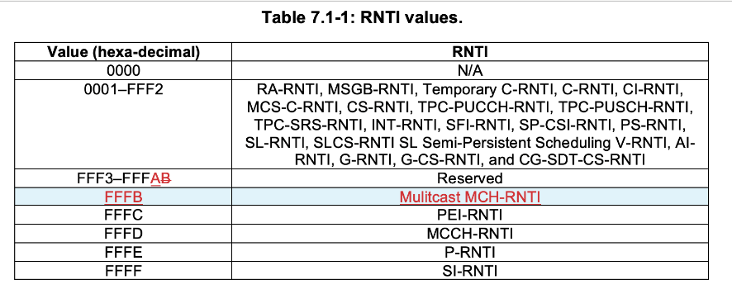
Company | Yes or No | Comment if any
TD Tech, Chengdu TD Tech | Yes
Nokia | Yes | We agree that new RNTI should be added, but  FFS whether MCCH-RNTI is be configurable or a fixed value
NEC | Yes
Samsung | Yes | But RAN1 confirmation is needed.
CATT | Yes
vivo | Yes | It is possible that the same CSS would be used for both multicast MCCH  and broadcast MCCH. So it is good to use different RNTI to distinguish them  to avoid mutual imapcts.
Lenovo | Yes
MediaTek | Maybe no | There may be different mechanism for multicast MCCH since it is designed per service. In that case, we may consider one multicast MCCH scrambled by different G-RNTI for different services.
LGE | Yes
Qualcomm | Yes | Typo: the name should be “Multicast MCCH-RNTI”  Further, existing MCCH-RNTI FFFD can be renamed to “Broadcast MCCH-RNTI” for clarity.
Intel | Yes
Sharp | Yes
Xiaomi | Yes

L2 handling during RRC state transition
The following is the current spec description on L2 handling during the RRC state transition from RRC_CONNECTED to RRC_INACTIVE.
For the MBS multicast in Rel-17, when UE enters RRC_INACTIVE, UE will stop the related MAC timer , flush the soft buffers for the DL HARQ process being used for MBS multicast, and suspend the multicast MRB.
5.3.8.3 Reception of the RRCRelease by the UE
The UE shall:
==omit some text==
1> if the RRCRelease includes suspendConfig:
2> reset MAC and release the default MAC Cell Group configuration, if any;
2> apply the received suspendConfig except the received nextHopChainingCount;
==omit some text==
2> suspend all SRB(s) and DRB(s) and multicast MRB(s), except SRB0;
2> indicate PDCP suspend to lower layers of all DRBs and multicast MRBs;
==omit some text==
2> indicate the suspension of the RRC connection to upper layers;
2> enter RRC_INACTIVE and perform cell selection as specified in TS 38.304 [20];
5.12 MAC Reset
If a reset of the MAC entity is requested by upper layers or the reset of the MAC entity is triggered due to SCG deactivation as defined in clause 5.29, the MAC entity shall:
==omit some text==
1> if upper layers indicate SCG deactivation and bfd-and-RLM with value true is configured for the deactivated SCG:
2> stop (if running) all timers except beamFailureDetectionTimer associated with PSCell and timeAlignmentTimers.
1> else:
2> stop (if running) all timers, except MBS broadcast DRX timers;
==omit some text==
1> flush the soft buffers for all DL HARQ processes, except for the DL HARQ process being used for MBS broadcast;
1> for each DL HARQ process, except for the DL HARQ process being used for MBS broadcast, consider the next received transmission for a TB as the very first transmission;

In Rel-18, if UE is configured with multicast reception in RRC_INACTIVE, when UE enters RRC_INACTIVE, UE should not stop the multicast MRB, and in MAC layer UE should not stop multicast related MAC timers used in RRC_INACTIVE. About whether to flush the soft buffers for the multicast reception, it depends on whether we would like to support HARQ continuation for MBS multicast during RRC state transition.

Q12: [ST-MRB] For multicast reception in RRC_INACTIVE, do you agree that UE doesnot suspend the multicast MRB when entering RRC_INACTIVE state?
Company | Yes or No | Comment if any
ZTE | not sure | What if UE is already receiving the MRB of an active multicast session and is being released?
TD Tech, Chengdu TD Tech |  | It depends on the different cases
Nokia | Yes | UE would not suspend multicast MRBs when entering RRC_INACTIVE, only if it receives them in RRC release command with suspendConfig. If there are MRBs that are not in RRC release, UE can suspend them as in Rel-17. The UE can check out MCCH and reconfigure the missing MRBs, if needed, in the future.
NEC | Yes
Samsung | Yes | At least PDCP should be continued.
CATT | Yes but | Only for case that UE continue to receive multicast in INACTIVE with the same multicast configuration as that is used in CONNECTED.
vivo | Yes with comments | The principle is okay. Further, we are wondering whether it is possible that only part of MRBs (mapped to some given services) are allowed in INACTIVE (while the others are not applicable for multicast reception in INACTIVE)?
Lenovo | Yes | the UE suspends the PDCP entities of all DRBs expect the multicast MRB. i.e. the UE does not suspend the PDCP entity of the multicast MRB:  - the UE does not stop and reset the t-reordering if running;  - the UE continues to use the existing value of RX_NEXT and RX_DELIV, i.e. the UE does not set RX_NEXT and RX_DELIV to the initial value.
ZTE2 | see comments | The reason we feel reluctant to provide our view is, RAN2 had an agreement in last meeting:  =>When network configures UE to receive multicast in INACTIVE state, RRCRelease message with suspendconfig can be used to deliver the PTM configuration. Other dedicated RRC messages will not be used to provide PTM configuration for MBS multicast for INACTIVE.  There may be different understanding to the highlighted part:  - if UE is already receiving the MRB of an active multicast session and is being released, and if UE continues the reception based on the config in RRC Reconfig, is it going against above agreement?  If we follow above principle, the PTM configuration shall always be obtained from RRCRelease, and UE will always suspend the old PTM configuration and use the new config to receive multicast in RRC_INACTIVE.  Otherwise, we should in RRC Release indicate UE to continue certain Multicast service (there may be multiple service UE has joined in), and as commented by companies, to continue the UP and physical layer reception.
MediaTek | Yes
LGE | Yes
Qualcomm | Yes
Intel | Agree with comments | For the multicast MRB whose configuration is provided for reception in RRC_INACTIVE, the UE does not suspend it when entering RRC_INACIVE.
Sharp |  | It depends on the state of the session when UE is released to RRC_INACTIVE. If the session is in activated state, MRB should not be suspended. Otherwise, it should be suspended.
Xiaomi | Yes

Q13: [ST-MAC Timer] For multicast reception in RRC_INACTIVE, do you agree that UE doesnot stop the MAC timers used for multicast reception in RRC_INACTIVE (i.e. drx-onDurationTimerPTM or drx-InactivityTimerPTM) when entering RRC_INACTIVE state?
Company | Yes or No | Comment if any
ZTE | not sure | same as above.
TD Tech, Chengdu TD Tech |  | It depends on the different cases.
Nokia | Yes
NEC | Yes
Samsung | Yes | It depends on which DRX is used. If multicast DRX is used for INACTIVE, those timers do not need to stop.
CATT | Yes but | Same comments as Q12
vivo | Yes
Lenovo | Yes | The basic pricinple is that the UE continues the multicast reception of PTM leg in RRC_INACTIVE with continuing using the PTM configuration.
MediaTek | Yes
LGE | Yes | We think that the same DRX timer values are used for RRC_INACTIVE and RRC_CONN except for timers related to PTM retransmission.
Qualcomm | Yes
Intel | Agree with comments | Same comments as Q12.
Sharp |  | The DRX functionality is configured per G-RNTI or per G-CSRNTI. So if the session is in activated state, UE should not stop the corresponding MAC timer. Otherwise, UE should stop the corresponding MAC timer for power saving purpose..
Xiaomi | Yes

Q14: [ST-HARQ] For multicast reception in RRC_INACTIVE, do you support HARQ continuation for MBS multicast reception (i.e. not flushing the soft buffer used for MBS multicast) during the RRC state transition?
Company | Yes or No | Comment if any
ZTE | not sure | same as above.
TD Tech, Chengdu TD Tech |  | It depends on the different cases.
Nokia | Yes
NEC | Maybe | This depends if the UE uses the same number of HARQ process for its reception
Samsung | Yes | In broadcast, HARQ buffer is not flushed at MAC Reset. We can have a similar UE behaviour.
CATT | No | Keeping the HARQ buffer does not make much sense, as anyway UE in INACTIVE does support HARQ feedback and retransmission, so soft combination is not possible.
vivo | Yes with comments | The necessity from RRC CONNECTED to RRC INACTIVE seems not so valid, as the network generally releases the UE only after data reception (there is no need to practice soft combination from RRC CONNECTED to RRC INACTIVE ).
Lenovo | Yes | the UE does not flush the soft buffers for DL HARQ processes related to the multicast PTM transmission, i.e. the UE only flushes the soft buffers for all DL HARQ process related to unicast SRBs and DRBs
MediaTek | Yes | From our understanding, at least the on-going HARQ feedback can be continued. The HARQ feedback can be switched off later when the on-going PDUs is received(or lost)
LGE | Yes
Qualcomm | Leave up to UE | It should be left to UE whether to flush or combine.
Intel | Agree with comments | Same comments as Q12.
Sharp | Yes
Xiaomi | Yes

L2 handling during RRC_INACTIVE mobility

In Rel-17, PDCP COUNT continuity is supported for multicast reception during handover. For multicast reception in RRC_INACTIVE in Rel-18, PDCP COUNT continuity should be also supported during INACTIVE mobility. As indicated in [12], if PDCP COUNT of source cell and target cell cannot be synchronized in network side, network will explicitly inform UE to re-initialize the PDCP parameters by providing the initialRX-DELIV from the target cell.

Q15: [Mobility] For multicast reception in RRC_INACTIVE, do you agree that UE does not need to re-establish PDCP entity (i.e. re-initiate the PDCP variables) of the multicast MRB if PDCP COUNT can be sync between source and target cell during INACTIVE mobility?
Company | Yes or No | Comment if any
ZTE | No | 1 - considering current spec is written in a such flexible manner, we propose that we shall consider the baseline or the common case shall be the PDCP SN is not synced.  2 - and UE might not be able to know whether it is synced.  3 - the safe way is re-establish everything upon cell re-selection.  // And we do have a concern on how the PDCP shall be initialized, based on UE implementation as BC, or based on the network provided initial value? Then does network need to update the MCCH every time as such value is always being updated? We dont think so.
TD Tech, Chengdu TD Tech |  | It depends on the different cases.
Nokia | Yes | If they are in sync, no re-establishment is required. The COUNT value is assigned by the CN, and hence the COUNT continuity is supported during the mobility.
NEC | Yes
Samsung | Yes | In case of SN synchronization between source and target, SN continuation seems natural. Anyway, it’s up to NW.
CATT | No | UE does not know whether the PDCP COUNT is synced or not between source cell and target cell.  And in R17 MBS broadcast, how to handle the UP during cell reselection is up to UE implementation, and because the expected QoS for inactive multicast reception can be comparable to MBS broadcast. it is not necessary to optimize it for inactive multicast.
vivo | Yes | The PDCP COUNT values come from a DL MBS QFI Sequence Number provided on NG-U. So we think sync is possible if the mapping between QoS flow and MRB is the same in both source and target cell. Then in this case, there is no need to re-establish the PDCP.
Lenovo | Yes | In order to support minimisation of data loss between cells for PTM reception in RRC_INACTIVE, the continuity of PDCP variables (e.g., RX_DELIV) of an MRB is needed among different cells if PDCP COUNT is synchronized.
MediaTek | Yes | In case they are in-sync.
LGE | Yes | If PDCP COUNT is synchronized between a source cell and a target cell, no PDCP re-establishment is needed.
Qualcomm | Yes | This is similar to Rel17
Intel | Comments | Agree that PDCP reestablishment is not needed if PDCP COUNT is synchronized. However so far UE does not have mechanism to determine whether there is PDCP COUNT synchronization during cell reselection.
Sharp | Not sure
Xiaomi | Yes

Q16: [Mobility] For multicast reception in RRC_INACTIVE, do you agree that NW explicitly informs UE to re-establish PDCP entity (i.e. re-initialize the PDCP variables) of a cell the UE reselects to in case PDCP COUNT is not sync between source and target cell?
Company | Yes or No | Comment if any
ZTE | No | a network itself does not know whether a neighbour node is synced with him or not.  as in Q15, we can simply assume they are not synced.
TD Tech, Chengdu TD Tech |  | It depends on the different cases.
Nokia |  | How does NW explicitly inform the UE if NW does not know when the UE  reselects a new cell?
NEC |  | Same question as Nokia
Samsung | No | In this case, we think the UE needs to transit to RRC_CONNECTED.
CATT |  | Similar question as Nokia, Since cell reselection is pure procedure at UE side without NW involvements, so NW cannot know when the UE will reselect to which new cell.
vivo | No | Agree with Nokia.
Lenovo | Yes | - When UE moves to a cell of which PDCP sync is supported, the PDCP COUNT continuity can be performed, and the PDCP variables are not reset to initial value when UE moves one cell to another cell.  - when UE reselects to a cell of which PDCP sync is supported, the UE may release the PDCP entity of the MRB and acquires MCCH from the new cell. And then perform PDCP establishment according to the MRB configuration in the MCCH
MediaTek | - | Agree with Nokia that NW may not know which cell UE is camping or whether it is synced or not. In this case, UE need to request to resume RRC to obtain the RX_DELIV or obtain it from MCCH of the new reselected cell.
LGE | Comment | We have a few question.  How does UE know whether or not PDCP COUNT is synchronized between the source cell and the target cell?  How does gNB know that UE reselects to/from a cell?  How does gNB send the indication explicitly to the RRC INACTIVE UE?
Qualcomm | - | It is unclear how the NW knows when the UE reselects to new cell.
Intel | Comments | This issue is not so clear as UE does not know whether there is PDCP COUNT synchronization during cell reselection, and gNB does not know cell reselection performed by UE.
Sharp | Not sure
Xiaomi |  | Have the same questions with above companies, how to re-initialize the PDCP variables needs further discussion.

Others

Q17: If companies have any UP issues which are not listed as above, please add the issues in the following table.
Company | Comment if any
vivo | - Whether PDSCH aggregatiopn is supporte (HARQ related)?  [QC] we think this should be supported for INACTIVE also (as this is supported for both multicast and broadcast in CONN)  - Whether separate CSS for R18 multicast MCCH/MTCH is supported (CFR configuration related)?  [QC] This is related to DCI formats. So, can be discussed in detail later. Our initial view is type-3 CSS (same as in CONN) should be used in INACTIVE.
ZTE | as in Q15, how is PDCP initialized may be worth some further check.
Nokia | Whether PDSCH aggregation is supported (HARQ related)? A Rel-17 UE may be configured to receive blind repetitions via RRC signalling (and DCI) for multicast and for broadcast. Same would be needed for RRC_INACTIVE UEs.
Qualcomm | 1. Is Rel-18 MBS UE in CONNECTED expected to receive and use multicast MCCH?  [Qualcomm] it should not be needed/expected as otherwise it might be NBC to rel17 UEs in the same cell.

Conclusion
Based on the above discussion, we propose that:

Reference
[1] RAN2#121 MBS session notes
[2] R2-2300286 Discuss on PTM configuration for multicast in RRC INACTIVE MediaTek inc.
[3] R2-2300335 PTM configuration and mobility aspects for multicast reception in RRC_INACTIVE Qualcomm
[4] R2-2300178 Discussions on PTM Configuration and Mobility CATT, CBN
[5] R2-2300100 Discussion on multicast reception in RRC_INACTIVE state OPPO
[6] R2-2300243 Discussion on Mixed Approach from PHY Aspect vivo Mobile Com. (Chongqing)
[7] R2-2300283 Analysis of MCCH for sending PTM configuration TD Tech, Chengdu TD Tech
[8] R2-2300672 Discussion on PTM configuration and mobility NEC Corporation
[9] R2-2300735 PTM Configuration and Mobility for INACTIVE Multicast Reception Apple
[10] R2-2300876 PTM configuration aspects and mobility Nokia, Nokia Shanghai Bell
[11] R2-2300947 PTM configuration and mobility for multicast reception in RRC_INACTIVE Lenovo
[12] R2-2301162 PTM configuration and mobility for multicast reception in RRC_INACTIVE Huawei, HiSilicon
[13] R2-2301843 PTM Configuration delivery for multicast reception in RRC_INACTIVE ZTE, Sanechips
[14] R2-2300877 Notifications and RRC state transitions Nokia, Nokia Shanghai Bell
[15] R2-2300252 HARQ operation during RRC state transitions for multicast reception NEC
[16] R2-2301236 Discussion on notification for RRC_INACTIVE multicast reception Ues CMCC
[17] R2-2301587 Notification and RRC state transition aspects on multicast reception in RRC INACTIVE Kyocera
[18] R2-2301038 Available multicast CFR in RRC_INACTIVE LG Electronics Inc.
[19] R2-2301070 Ensuring desired level of reliability for an MBS session in RRC_INACTIVE InterDigital Inc.

Annex: RAN2 Agreements

RAN2#121 Agreements
Multicast reception in RRC_INACTIVE
- PTM configuration aspects and mobility
- UE shall join in the multicast session before receiving multicast in RRC INACTIVE.
- If network finds it useful, the PTM configuration for the (single) serving cell can be configured to UE before the session activation, and UE stores the configuration. When session is activated, UE can receive multicast in INACTIVE state by applying the configuration without going back to RRC_CONNECTED, if not updated by MCCH after being configured.
- When network configures UE to receive multicast in INACTIVE state, RRCRelease message with suspendconfig can be used to deliver the PTM configuration. Other dedicated RRC messages will not be used to provide PTM configuration for MBS multicast for INACTIVE.
- We introduce a new MCCH logical channel for multicast in INACTIVE (different from broadcast MCCH)
- Multicast MCCH configuration is provided via new SIB.
- Optionally, Multicast MCCH configuration for the serving cell can also be provided in dedicated signalling. Understanding is we are not optimizing mobility case because of this.
- Serving cell will not provide the PTM configuration of neighbour cells from other gNBs.
- FFS whether the network can provide PTM configuration for intra-gNB cells.

Shared processing for MBS broadcast and Unicast reception
- Indicate the capability of receiving MBS broadcast from a non-serving cell. FFS whether the granularity is at FeatureSetDownlink or FeatureSetDownlinkPerCC level.
- FFS Whether to include additional information in MII can be controlled by the network. Should consider whether this would be two-step procedure or one-step procedure (e.g. having more info in SIB1)

RAN2#120 Agreements
Multicast reception in RRC_INACTIVE
- PTM configuration and PTM reconifguration during mobility
- We will have a mixed approach and we start with the following:
    - When NW configures UE to continue the multicast reception in INACTIVE state, NW provides the PTM configuration for the activated multicast session via the RRC dedicated signalling, at least for the serving cell (FFS other cases).
    - MCCH is used in case there is a need to indicate a PTM configuration in case there is a need for change in PTM config or during mobility beyond serving cell / gNB. FFS session status change and other indications.
    - We assume that the UE can only receive multicast service after it joined the session.
    - FFS whether MCCH configuration is initially provided to the UE via dedicated signalling.

RAN2#119bis Agreements
Multicast reception in RRC_INACTIVE
- The following general description is taken as baseline for PTM configuration delivery Option 1:
(1-a) PTM configuration(s) (i.e., configurations used for multicast reception in RRC_INACTIVE) of one or more multicast sessions for at least one cell are provided via dedicated RRC signaling to a UE.
(1-b) The RRC message for this includes RRCReconfiguration and/or RRCRelease and/or RRCResume (details FFS)
(1-c) UE stores the received configurations while it is in RRC_INACTIVE, and if there is a need to update some or all the configurations, the UE is notified of such changes and may trigger RRC connection resume to obtain the updated configurations. In case of mobility in RRC_INACTIVE, the UE triggers RRC connection resume if the configuration of the session is not available for the new cell.

- The following general description is taken as baseline for PTM configuration delivery Option 2:
(2-a) PTM configurations (i.e., configurations used for multicast reception in RRC_INACTIVE) are provided via an MCCH-like channel (same or different as used for MBS broadcast), and information regarding MCCH scheduling is provided via SIB, FFS dedicated signalling
(2-b) UE can receive such configurations when it is in RRC_INACTIVE, FFS whether it is allowed/needed to also receive when UE is in RRC_CONNECTED
(2-c) If there is a need to update some or all the received configurations, UE does not need to resume RRC connection but is notified of such changes (e.g. via MCCH DCI) and obtains the updated configurations via MCCH.
- Dedicated RRC signalling (i.e. RRC release message with suspendConfig) is used for switching a multicast receiving UE from RRC_CONNECTED to RRC_INACTIVE and continue multicast reception (details FFS).
- For both option 1 and option 2, as a baseline, group paging can be used to switch UEs receiving multicast from RRC_INACTIVE to RRC_CONNECTED, and UEs continue the multicast reception in CONNECTED. FFS if there is any potential issue if Rel-17 group paging is reused. FFS if there are other cases when UE triggers resume. FFS if MCCH can also be used in case of option 2.
- Rel-18 UE in INACTIVE can be informed when the session is activated (Details FFS).
- As a baseline, group paging can be used to inform Rel-18 UE(s) about the session activation (Details FFS, e.g., UE behavior when receiving such group notification).
- If a UE is in RRC_INACTIVE and is configured to receive a multicast session in RRC_INACTIVE, the UE may be notified when the multicast session is deactivated. FFS how (e.g., informed via group paging, MCCH, or other ways).
- Rel-17 mechanism (NAS-based indication) is applicable for multicast session release. FFS if any enhancement is needed.
- FFS how UE determines whether it can receive the multicast session in RRC_INACTIVE or not when the session is activated, taking into account the following solutions (can further update the descriptions if needed, and several solutions may be needed, some solutions may apply only for certain configuration options)
1. When the multicast session is activated, UE can receive the multicast session in RRC_INACTIVE if the PTM configuration used in RRC_INACTIVE for the session is available to the UE and the UE has joined the session already (e.g., configuration provided to UE via dedicated RRC signaling or via MCCH), otherwise it goes back to RRC_CONNECTED to receive the multicast session.
2. When the multicast session is activated, UE is indicated by group paging whether it can receive the multicast session in RRC_INACTIVE or not (detailed signaling FFS).
3. UE is configured "whether it can receive the multicast session in RRC_INACTIVE" by dedicated signaling before UE is released. When the multicast session is activated, UE stays in RRC_INACTIVE or resumes RRC connection accordingly (detailed signaling FFS).

- If option 1 is supported for PTM configuration
As a baseline, group paging may be used to inform the UE when network changes the PTM configurations, and UE upon reception triggers RRC connection resume procedure to obtain the updated configurations (details of group paging can be FFS).
FFS whether and how to solve the issue in signalling/system load when a large number of UEs in the cell need PTM configuration update.

- FFS if there is an issue that a UE can obtain all the PTM configurations for a multicast service via Option 2 without/before joining the multicast session on the condition that security is enabled by service layer. And if yes FFS how to solve the issue (e.g., dedicated configuration + MCCH).

Shared processing for MBS broadcast and Unicast reception
- For shared processing we adopt the following as a baseline:
1) new IE is added in system information to control whether MBSInterestIndication for shared processing can be sent or not;
2) MBSInterestIndication message content and related procedure is updated for shared processing.
- New IE to control whether MBSInterestIndication for shared processing can be sent or not is added to SIB1.

- In MBSInterestIndication, for a broadcast service that the UE is receiving or is interested to receive, at least the following information can be signalled: broadcast frequency, subcarrier spacing, and bandwidth. FFS details/exact parameters and other information. FFS in which scenarios the UE reports this information (e.g. intra-PLMN case, inter-PLMN case)
- FFS whether UE capability is needed to enable shared processing.

RAN2#119 Agreements
Multicast reception in RRC_INACTIVE
- General assumptions, scenarios
- In Rel-18, multicast reception for UEs in INACTIVE supports at least the following scenarios, with the assumption that the UE already has a valid PTM configuration:
- Scenario 1: a UE has been receiving multicast in CONNECTED, and it enters INACTIVE and continues the multicast reception.
- Scenario 2: a UE has joined a multicast session and has been directed to INACTIVE, the UE starts to receive the multicast session
FFS for state changes, e.g. due to service being not provided in INACTIVE anymore etc.

- It is up to gNB to decide whether a multicast session may be received by UE(s) in INACTIVE. FFS what information gNB may be provided to form such decision (related to SA2 discussion).
- It is supported that gNB transmit one multicast session to both UEs in CONNECTED and INACTIVE in the same cell. FFS how the gNB configures this.
- It is assumed the network can choose which UEs receive in RRC INACTIVE and which in RRC Connected and can move UEs between the states for Multicast service reception.
- The following is taken as baseline: we assume the same PDCCH/PDSCH resources (e.g. resources used for MTCH) can be used for all UEs (including UEs in CONNECTED and/or INACTIVE states) for receiving the same multicast session. Different configuration/resources are not precluded as well. FFS what exactly can be common and what not (e.g. HARQ, SPS etc.) and what is needed in addition (to legacy PTM config).

- PTM configuration for RRC_INACTIVE
- For PTM configuration delivery, RAN2 further investigates the following solutions:
Option 1: Dedicated signalling
Option 2: Solution based on SIB+MCCH
We do not preclude some “mix” of the options
- HARQ feedback and PTP are not supported for multicast reception in RRC_INACTIVE.

- Mobility support
- Multicast service continuity after cell reselection in RRC_INACTIVE state (i.e. without resuming RRC connection) will be supported (if the configuration of the new cell is available for the UE). FFS whether there are cases where the UE needs to resume the connection. FFS RAN3 impacts due to inter-gNB mobility.
- Upon cell reselection to neighbour cells during active multicast session, if the configuration of the session is not available for the new cell for UEs in INACTIVE, then the UE is required to resume RRC connection to get the Multicast MRB configuration.

Shared processing for MBS broadcast and Unicast reception
- RAN2 focuses on solutions taking multi-Rx UEs (i.e. no specific enhancements for 1Rx UEs).

