3GPP TSG-RAN2 Meeting #118-e R2-220xxxx

Electronic, 9th – 20th May, 2022

Source: Email discussion Rapporteur (Huawei, HiSilicon)
Title: Summary for [Post118-e][604] 38.321 Positioning CR (Huawei)
Agenda item: 6.6.2
Document for: Discussion and Decision

General
This document contains the list of comments made during the review of the MAC CR for Positioning

Contacts
Name | Company | Email address
Xiaolong Li | Xiaomi | lixiaolong1@xiaomi.com
Jianxiang Li | CATT | lijianxiang@catt.cn

Comments
Companies | Brief description of the issue | Suggested resolution/company comments | Proposed way forward by rapporteur
Xiaomi | We are not clear why UE needs to cancel triggered Positioning Measurement Gap Activation/Deactivation Request MAC CE, in our understanding, the UE shall not cancel it. | Suggest to remove the sentence marked with yellow.  The MAC entity shall,  1>if Positioning Measurement Gap Activation/Deactivation Request MAC CE has been triggered, and not cancelled:  2> if indication from upper layer has been received that the triggered Positioning Measurement Gap Activation/Deactiation Request MAC CE should be cancelled:  3> cancel the triggered Positioning Measurement Gap Activation/Deactivation Request MAC CE.  2> if UL-SCH resources are available for a new transmission and these UL-SCH resources can accommodate the Positioning Measurement Gap Activation/Deactivation Request MAC CE plus its subheader as a result of logical channel prioritization:  3> instruct the Multiplexing and Assembly procedure to generate the Positioning Measurement Gap Activation/Deactivation Request MAC CE according to the upper layer's request;  3> cancel triggered Positioning Measurement Gap Activation/Deactivation Request MAC CE.  2> else:  3> trigger a Scheduling Request for Positioning Measurement Gap Activation/Deactivation Request MAC CE. | This is based on the following agreement in R2#117  Agreements:  For triggering condition for the UL MAC CE, reuse current RRC condition for Rel-16 PRS gap request, taking into account preconfigured MG. If the preconfigured MG is there and can satisfy the UE’s requirement, the UE uses MAC CE, otherwise RRC message as in Rel-16. The selection is specified in RRC. Reuse the “not configured or not sufficient” language from Rel-16.  Proposal 4.1: UL MAC CE for MG activation and deactivation is triggered by upper layers.  Proposal 4.3: LPP signalling for LMF to indicate to UE whether to send/not send the UL MAC CE for positioning MG activation request is not defined.  Proposal 4.5: the following options to cancel a triggered UL MAC CE for MG activation and deactivation should be captured in the spec; other options can be discussed in the running CR discussion.  • When the MAC CE is transmitted  • When a request from upper layers to transmit a new request to gNB for a new/modified gap configuration is received  • When an indication from upper layers that the gaps are not needed any more or a gap with a new id needs to be activated is received  • On MAC reset
Xiaomi | The reference clause should be 5.26.2. | The MAC entity shall, if the TA of the configured Positioning SRS is valid according to clause 5.26.2:  - transmit Positioning Periodic SRS or Semi-Persistent SRS defined in TS 38.214 [7]. | Corrected
CATT | 6.1.3.42  Does N in the numEntry description mean the N in Oct N in Figure 6.1.3.42-1: PPW Activation/Deactivation Command MAC CE?  If so, the description of numEntry should be updated as N, not N-1.  If not, please use another number, such as M without confusion with the existing N in this MAC CE. | - numEntry: This field indicates the number of entries N in the MAC CE. 00 indicates that N equals to 2; 01 indicates that N equals to 3 and so on. The length of the field is 2 bits; | 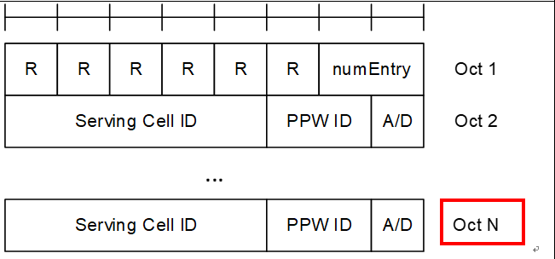  N denotes this number here

