GPP TSG-RAN WG2 Meeting #115-e R2-21xxxxx

Online, 9th – 27th August, 2021

**Agenda Item: 8.5.3**

**Source: MediaTek Inc.**

**Title: Summary of [Post114-e][510][URLLC/IIoT] Open issues for UCE (Mediatek)**

**Document for: Discussion and decision**

# 1 Introduction

This email discussion focusses on the remaining open issues associated with IIoT operation over unlicensed controlled environments (UCE), following the following agreements reached at R2#114e [1].

***Agreements:***

1. *When both of lch-based Prioritization and cg-RetransmissionTimer are configured, HARQ processes sharing between multiple CG configurations are allowed. No specification change is required.*
2. *RAN2 confirm that neither autonomous transmission nor autonomous retransmission is triggered if UL grant is prioritized and LBT fails while AutonomousTx is configured and cg-RetransmissionTimer is not configured. No specification change is required.*
3. *RAN2 confirm that autonomous retransmission is triggered if UL grant is prioritized and LBT fails while AutonomousTx is not configured and cg-RetransmissionTimer is configured. No specification change is required*
4. *RAN2 confirm that autonomous retransmission is triggered if UL grant is prioritized and LBT fails while AutonomousTx and cg-RetransmissionTimer are configured. No specification change is required.*
5. *RAN2 confirm that autonomous transmission is triggered if UL grant is deprioritized while AutonomousTx is configured and cg-RetransmissionTimer is not configured. No specification change is required.*
6. *RAN2 confirm that autonomous transmission is triggered if the transmission of the obtained MAC PDU has not been completely performed and if UL grant is deprioritized while AutonomousTx and cg-RetransmissionTimer are configured. No specification change is required.*
7. *The HARQ process is kept as pending even if a CG is de-prioritized while the HARQ state of the associated HARQ process is pending (i.e. MAC PDU hasn’t been transmitted). No specification change is required*
8. *When cg-RetransmissionTimer and lch-basedPrioritization are configured, for overlapping CGs, the MAC entity prioritizes the initial transmission of higher priority data over autonomous retransmission of lower priority data. FFS how to implement this in Rel-17 after some of the Rel-16 discussion takes place*

# 2 Discussion

## 2.1 Mechanism for HARQ process ID selection

In R2#112e, the following was agreed [2]:

* *When cg-RetransmissionTimer is configured, Rel-16* *NR-U mechanism is used for HARQ process ID and RV selection.*
* *When cg-RetransmissionTimer is not configured, Rel-16 URLLC mechanism may be used for HARQ process ID and RV selection.*

This topic was discussed in [3], and RAN2 decided to wait for RAN1 to progress further on the topic before reaching a decision [1]. The discussion in RAN1 has progressed in R1#105e, with the following agreement [4]:

***Agreement:***

* *Option 1 is taken in the following agreement:*

*Agreement:*

*Down-select one of the following options (target RAN1#104-e):*

* *Option 1: Both “CG-UCI based procedures” and “CG-DFI based procedures” are enabled or disabled for unlicensed using one RRC parameter i.e. cg-RetransmissionTimer-r16.*
* *Option 2-a: “CG-UCI based procedures” and “CG-DFI based procedures” are independently enabled or disabled for unlicensed using respective RRC parameter, i.e. new parameter X and cg-RetransmissionTimer-r16, respectively.*
  + *If cg-RetransmissionTimer-r16 is configured, “CG-UCI based procedures” should also be enabled by X.*
* *Note: Procedures based on CG-UCI rely on UE including CG-UCI in CG PUSCH at least as in Rel-16 where the values of the respective fields of CG-UCI are decided by UE.*
* *Note: Procedures based on CG-DFI rely on automatic re-transmission on CG configuration and reception of CG downlink feedback information (DFI) in DCI for re-transmissions*

With the option that’s agreed in RAN1, effectively if cg-RetransmissionTimer is not used, the CG-UCI is also not used. From this agreement, it is fairly obvious that if cg-RetransmissionTimer is not configured, the NR-U mechanism for HARQ process ID and RV selection cannot be used, as the NR-U mechanism requires the use of CG-UCI. Therefore the rapporteur proposes the following modification to the earlier RAN2 agreement:

***Proposal: When cg-RetransmissionTimer is not configured, Rel-16 URLLC mechanism is used for HARQ process ID and RV selection.***

*Question 1: Do companies agree with the modified proposal above? If not, please provide further details on how you foresee HARQ process ID selection to work alongside RAN1’s agreement.*

|  |  |  |
| --- | --- | --- |
| Company | Yes/No | Comments |
|  |  |  |
|  |  |  |
|  |  |  |
|  |  |  |
|  |  |  |
|  |  |  |
|  |  |  |

## 2.2 HARQ process ID selection details

The NR-U behaviour has been further clarified for Rel-16 as below [5]:

For configured uplink grants configured with *cg-RetransmissionTimer*, the UE implementation selects an HARQ Process ID among the HARQ process IDs available for the configured grant configuration. For HARQ Process ID selection, the UE shall prioritize retransmissions before initial transmissions.

This update to the specification clarifies that the statement ‘*UE shall prioritize retransmissions before initial transmissions*’ only applies to HARQ process ID selection done by the UE.

### 2.2.1 Single CG configuration

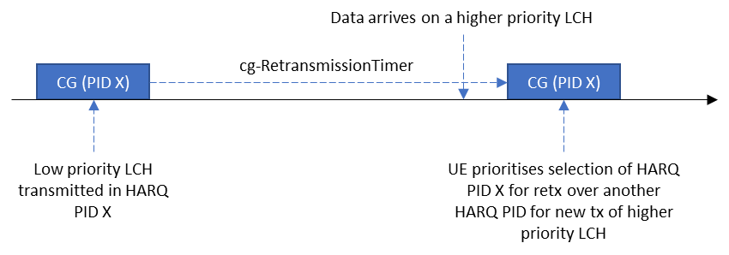

Figure 1: Rel-16 behaviour for HARQ PID selection with a single CG

In this section, we focus on the single CG configuration case. As per the Rel-16 agreement, the baseline behaviour for NR-U is as illustrated in Figure 1.

In case of IIoT operation in UCE, when lch-basedPrioritization and cg-RetransmissionTimer are jointly configured, the question is whether we need to change this baseline NR-U behaviour. This was discussed in [3] along with the various means to do so. Therefore, the following question is posed:

*Question 2: What should the HARQ process ID selection behaviour be in the MAC entity for a single configured grant configuration, when lch-basedPrioritization and cg-RetransmissionTimer are both configured?*

*Option 1: No change to the Rel-16 baseline (MAC entity prioritises the selection of HARQ process IDs for retransmissions over the selection of HARQ processes for initial transmissions)*

*Option 2: MAC entity prioritises the selection of a free HARQ process ID (if available) to transmit higher priority data (if present).*

*Option 3: NW configures whether to follow Option 1 or Option 2*

*Option 4: Other (please explain)*

|  |  |  |
| --- | --- | --- |
| Company | Preferred option(s) | Comments |
|  |  |  |
|  |  |  |
|  |  |  |
|  |  |  |
|  |  |  |
|  |  |  |
|  |  |  |

### 2.2.2 Multiple overlapping CG configurations without shared HARQ processes

From [3], it was unclear whether the current specifications support the following agreed behaviour:

*When cg-RetransmissionTimer and lch-basedPrioritization are configured, for overlapping CGs, the MAC entity prioritizes the initial transmission of higher priority data over autonomous retransmission of lower priority data. FFS how to implement this in Rel-17 after some of the Rel-16 discussion takes place*

Therefore, we break the problem down further. In this section, we focus on the case where the UE is configured with multiple overlapping CGs, where HARQ processes are not shared between different CGs

In this scenario, the Rel-16 rule to prioritise selection of a HARQ PID for retransmission over a HARQ PID for a new transmission only applies within a CG configuration (as HARQ processes are not shared). Therefore, in the example shown in Figure 2, the UE chooses a HARQ PID X for CG1 and a different HARQ PID Y for CG2. Following this HARQ process selection procedure, LCH prioritisation rules determine whether CG1 or CG2 is transmitted, depending on which CG carries higher priority LCH data.

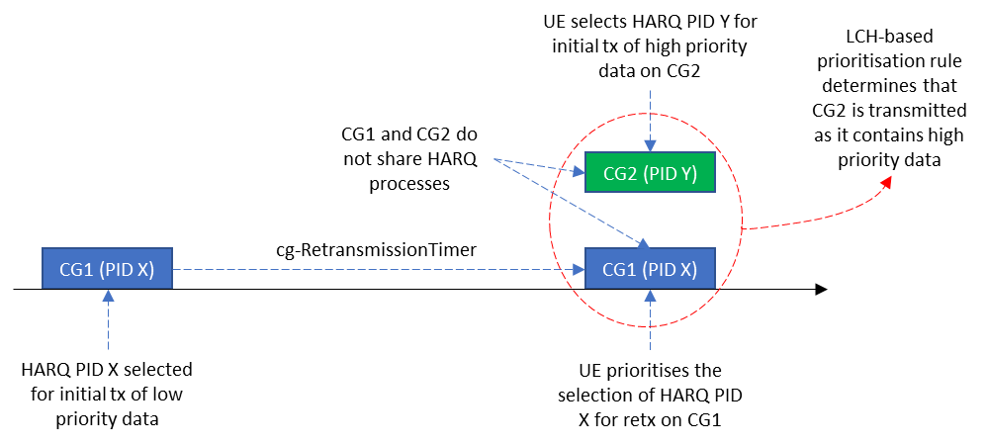

Figure 2: Multiple overlapping CGs without shared HARQ processes

*Question 3: When lch-basedPrioritization and cg-RetransmissionTimer are configured, and multiple overlapping CGs do not share HARQ processes, do companies agree that the following behaviour is already supported by the current specifications:*

1. *The HARQ PID selection rule (which may be updated as per Question 2) applies to HARQ PID selection for each CG occasion*
2. *lch-basedPrioritization rules determine the CG that will be prioritised for transmission by the MAC entity*

*If not, please provide further details on how the current specifications would work.*

|  |  |  |
| --- | --- | --- |
| Company | Yes/No | Comments |
|  |  |  |
|  |  |  |
|  |  |  |
|  |  |  |
|  |  |  |
|  |  |  |
|  |  |  |

*Question 4: As a follow-up to Question 3, do companies foresee the need for further changes to implement the following agreement for the case where HARQ processes are not shared between CGs? If yes, please explain what further changes are needed.*

*Agreement: When cg-RetransmissionTimer and lch-basedPrioritization are configured, for overlapping CGs, the MAC entity prioritizes the initial transmission of higher priority data over autonomous retransmission of lower priority data.*

|  |  |  |
| --- | --- | --- |
| Company | Yes/No | Comments |
|  |  |  |
|  |  |  |
|  |  |  |
|  |  |  |
|  |  |  |
|  |  |  |
|  |  |  |

### 2.2.3 Multiple overlapping CG configurations with shared HARQ processes

In this section, we focus on the case where the UE is configured with multiple overlapping CGs, where HARQ processes are shared between different CGs.

In the Rel-16 NR-U discussions, the case of overlapping configured grants were not considered. However, when lch-basedPrioritization is configured, overlapping configured grants can exist. Going through the current spec, the following specification conditions would be applicable in the case where cg-RetransmissionTimer and lch-basedPrioritization are both configured:

If *cg-RetransmissionTimer* is configured, retransmissions with the same HARQ process may be performed on any configured grant configuration if the configured grant configurations have the same TBS.

…

For configured uplink grants configured with *cg-RetransmissionTimer*, the UE implementation selects an HARQ Process ID among the HARQ process IDs available for the configured grant configuration. For HARQ Process ID selection, the UE shall prioritize retransmissions before initial transmissions.

…

NOTE 6: If the MAC entity is configured with *lch-basedPrioritization* and if there is overlapping PUSCH duration of at least two configured uplink grants whose priorities are equal, the prioritized uplink grant is determined by UE implementation.

When multiple overlapping CGs share HARQ processes and have the same TBS, the UE prioritises the selection of a HARQ PID that is for retransmission over the selection of a PID for a new transmission. Since both CGs prioritise the same HARQ PID, they carry the same data and the condition in Note 6 would apply, i.e. the UE implementation determines which CG is to be transmitted. This is illustrated in Figure 3 below.

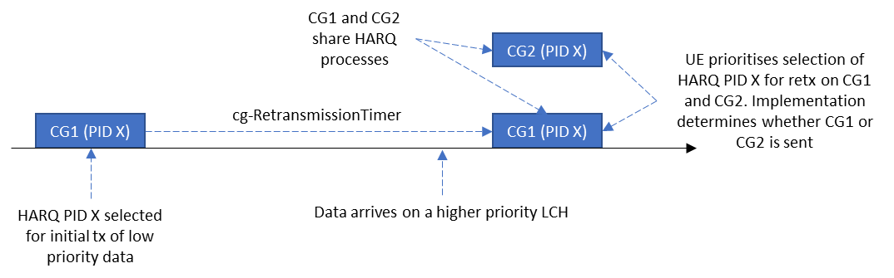

Figure 3: Current behaviour when multiple overlapping CGs share HARQ processes

*Question 5: When HARQ processes are shared between multiple overlapping CG occasions with the same TBS, do companies agree that the same HARQ PID selection rule (which may be updated as per Question 2) applies to all CGs?*

|  |  |  |
| --- | --- | --- |
| Company | Agree/Disagree | Comments (including the need for further specification changes) |
|  |  |  |
|  |  |  |
|  |  |  |
|  |  |  |
|  |  |  |
|  |  |  |
|  |  |  |

*Question 6: If the answer to Q5 is yes, do companies agree that the same HARQ PID would be selected for all overlapping CG occasions and it is up to UE implementation to determine which CG is transmitted?*

|  |  |  |
| --- | --- | --- |
| Company | Agree/Disagree | Comments (including the need for further specification changes) |
|  |  |  |
|  |  |  |
|  |  |  |
|  |  |  |
|  |  |  |
|  |  |  |
|  |  |  |

## 2.3 Deprioritised UL grant when autoTx is not configured and CGRT is configured

At R2#113e [6], we reached the following agreement:

* *AutoTx and CGRT are responsible for deprioritized MAC PDU and LBT-failed MAC PDU, respectively. If CGRT is not configured, LBT-failed MAC PDU is not retransmitted. If AutoTx is not configured, deprioritized MAC PDU is not retransmitted.*
* *the MAC entity stops cg-RetransmissionTimer when the CG resource associated with the timer is deprioritized due to LCH-based prioritization.*

As per the current specifications, if the configuredGrantTimer is running and the cg-RetransmissionTimer is not running, the UE triggers autonomous retransmissions. Also, if the UE is not configured with autonomousTx, the configuredGrantTimer will run even if a MAC PDU is deprioritised.

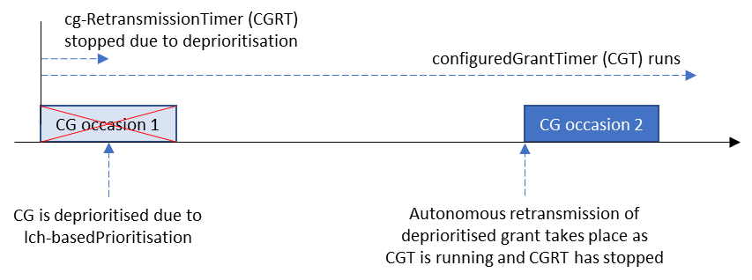

Figure 4: Current behaviour if cg-RetransmissionTimer is stopped when an UL CG is deprioritised

Therefore, if we follow the second agreement above, transmission of the deprioritised MAC PDU takes place on the next CG occasion as the cg-RetransmissionTimer would not be running, as illustrated in Figure 4 above. This behaviour contradicts the first highlighted agreement above i.e. ‘if AutoTx is not configured, deprioritized MAC PDU is not retransmitted’. This was discussed extensively in [3] with the following proposal made:

*Proposal 10: (Out of 20, 7 for no preferred option, 11 for option 2, 2 for option 3, 1 for option1) RAN2 further discuss whether option 2 or no option is needed if UL grant is de-prioritized while AutonomousTx is not configured and cg-RetransmissionTimer is configured.*

*- Option 2. If a CG is not configured with autonomousTx, the cg-RetransmissionTimer is not stopped when the associated CG is deprioritized [13]*

It should be noted that even if we follow option 2 above, it only delays the autonomous retransmission to after the expiry of the cg-RetransmissionTimer, but a retransmission of the deprioritised PDU will still take place in contradiction with the first highlighted agreement, i.e. ‘if AutoTx is not configured, deprioritized MAC PDU is not retransmitted’. This is illustrated in Figure 5 below.

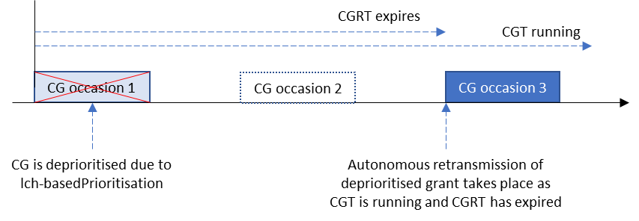

Figure 5: Current behaviour if cg-RetransmissionTimer is not stopped when an UL CG is deprioritised

Going back to first principles, it would be good to agree the expected UE behaviour, and the discussion on how to implement this behaviour in the specification can follow. Therefore the following question is posed:

*Question 7: Which option do companies prefer?*

*Option 1: If autoTx is not configured, confirm the earlier agreement that a deprioritised MAC PDU is not retransmitted autonomously*

*Option 2: If autoTx is not configured, modify the earlier agreement to allow autonomous retransmission of a deprioritised MAC PDU*

|  |  |  |
| --- | --- | --- |
| Company | Preferred option | Comments (reasons for preference, implementation details) |
|  |  |  |
|  |  |  |
|  |  |  |
|  |  |  |
|  |  |  |
|  |  |  |
|  |  |  |

## 2.4 Others

Companies are encouraged to raise any issues that warrant further discussion in this section.

|  |  |
| --- | --- |
| Company | Issue |
|  |  |
|  |  |
|  |  |
|  |  |
|  |  |
|  |  |
|  |  |

# 3 Conclusion

To be generated following the conclusion of this email discussion

# 4 Contact information

|  |  |  |
| --- | --- | --- |
| Company | Name | email address |
|  |  |  |
|  |  |  |
|  |  |  |
|  |  |  |
|  |  |  |
|  |  |  |
|  |  |  |

# 5 References

1. R2-21069xx - Report of 3GPP TSG RAN WG2 meeting #114-e (ETSI MCC)
2. R2-2100001 - Report of 3GPP TSG RAN WG2 meeting #112-e (ETSI MCC)
3. R2-2106396 - Summary of [POST113bis-e][505][R17 IIoT] URLLC in UCE (LG Electronics)
4. Chair's Notes RAN1#105-e final.docx
5. R2-2105865 - Clarification on prioritization of retransmission over initial transmission for HARQ PID selection in NR-U (Nokia)
6. R2-2102601 - Report of 3GPP TSG RAN WG2 meeting #113-e (ETSI MCC)