3GPP TSG-RAN WG2 Meeting #113bis-e draftR2-210xxxx
Elbonia, 12th-20th April, 2021

Agenda item: 8.10.3.3
Source: Intel Corporation
Title: Report of [post113-e][108][NTN] SMTC and measurement gap (Intel)
WID/SID: NR_NTN_solutions-Core - Release 17
Document for: Discussion and Decision

Introduction
This document captures measurement related proposals submitted in RAN2#113-e ([1]-[9]) for further discussion as described in this email discussion:
- [POST113-e][108][NTN] SMTC and measurement gaps (Intel)
Scope: Based on RAN2#113-e contributions, discuss measurement framework, SMTC and measurement gaps
Intended outcome: email discussion summary
Deadline: Long
This email discussion is divided in two phases:
- Phase I with the deadline on Tuesday March 23 1100 UTC (3am PST) for companies to provide their views.
- Phase II with deadline on Friday March 26 1100 UTC (3am PST) for companies to provide their views on the summary and suggested proposals.

Discussion
The following agreements were made for measurement in Rel-17 NTN WI:
Agreements
- Reconfiguration with sync is the baseline for connected mode mobility in NTN (the use of legacy RLF and re-establishment mechanism are not excluded)
- The CHO can be used in NTN for both moving cell and fixed cell scenarios, and the CHO procedure and execution condition defined in Rel-16 is the baseline for NTN CHO.
3. NTN specific CHO execution condition can be further discussed.
4. The existing measurement framework (e.g. measurement configuration, execution and reporting) is the baseline, and all the existing measurement criteria and event can be used in NTN. Support for new measurement is not excluded.
5. Legacy SSB periods (as in TN) shall be supported in NTN

Agreements via email - offline 106:
- RAN2 understanding that UE shall not be forced to detect the SSB burst outside the corresponding configured SMTC window in NTN, just like the principle in TN.

Agreements:
- SMTC and gap configuration in NTN are configured based on the timing of PCell
- RAN2 can first identify the scenarios and discuss how serious the impact is before addressing any enhancement for SMTC configuration in NTN.
- RAN2 can’t assume that the network will always have UE accurate location info for SMTC window configuration in NTN
- UE along with the network in NTN should also have the same understanding of the timing, including the timing for measurement gap, to avoid any un-synchronized scheduling between UE and the network, just like the way we have in TN

Issue identification
In NTN, due to different propagation delay from different satellites to different UEs, the SMTC duration may have different timing at different UEs. Figure 1 (left side) illustrates an example of 3 different satellite cells and 2 UEs [1]. For simplicity, it is assumed that for all 3 cells, the SMTCs are sent at the same time with the same periodicity. The table below in Figure 1 (right side) depicts the timing of the SMTC window for both UEs and for all cells.

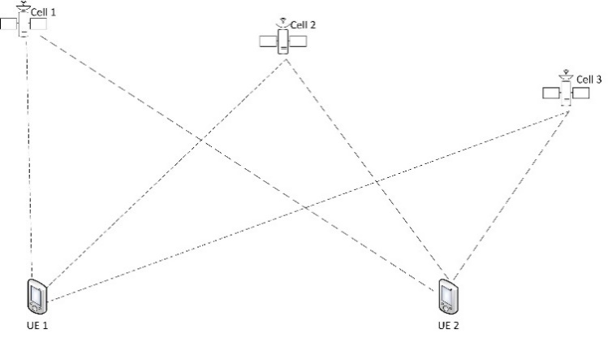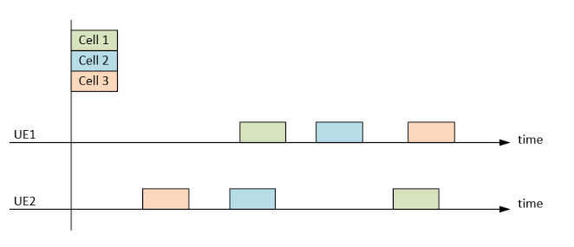
Figure 1: example of 3 satellite cells and two UEs in different locations [1]
The following exemplary scenario [1] assumes that T1 represents the time when SMTC was transmitted at the network side and Pij is the propagation delay between UE i and cell j. Figure 1 (right side) shows that UE 1 measures cell 1 SMTC at T1+P11 while UE 2 measures cell 1 SMTC at T1+P21. If a given UE needs to perform measurement, the measurement gap will need to cover the serving cell and neighbor cell SMTC window considering the propagation delays between different cells and the UEs. Otherwise, the UE will miss the measurement. The minimum propagation delay is 4ms and maximum is 541.46ms; this range tells us that the legacy measurement gap window cannot cover the large range of propagation delay.
Moreover, it is also indicated in [2] that static SMTC window duration is insufficient to accommodate propagation delay variability between serving and neighbor cells towards a stationary UE.
- Do companies agree that there may be an issue with the SMTC configuration and UE measurement gap configuration for NTN scenarios considering the different propagation delays between different cells and UEs? justify your response and if you agree, please add foreseen RAN2 impacts.
Company | Yes/No | Comments
APT | Yes | If the smtc measurement gap configuration does not consider the propagation delay difference, the UE may miss the SSB/CSI-RS measurement window and will thus be unable to perform measurements on the configured reference signals.  If smtc is absent, for RRC_CONNECTED, UEs may use the default smtc configured in the measObjectNR having the same SSB frequency and subcarrier spacing. However, the default smtc, e.g., smtc1, might not guarantee UE to find the target SSB. This is because of some reasons given below.  - One reason is that propagation delay change may go with the satellite movement, which makes any received smtc1 configuration becomes outdated after few seconds, especially when the smtc window duration is set to the minimum value of 1 subframe.  - Another reason is that NTN may need to trigger an inter-gNB HO for a feeder link switch, i.e., UE connects to the same satellite without losing the service link, but the satellite has to connect to a new gateway. In this case, the HO decision is not made according to the measurement result from the smtc1 but based on the limit of the elevation angle on the feeder link.  If the propagation delay difference between target and serving cells is larger than the configured smtc window duration, e.g., 5ms, one single smtc window may be impossible to measure both cells. This may fall to trigger the CHO events, e.g., the CHO event A5: a serving cell becomes worse than absolute threshold1 and a target cell becomes better than another absolute threshold2.
Nokia | Yes | The problem is depicted in Figure 1, could be especially problematic when different cells come from different satellites. Foreseen RAN2 impact may include the changes to SMTC configuration, to allow longer/shifted window duration. It shall account for the feeder link delays also (i.e. not only the service link, as shown in the figure).
OPPO | Yes | RAN2 needs to study the mechanism to configure SMTC and measurement gap to cover different NTN neighbour cells.
LGE | Yes | Agree with the rapporteur’s analysis. The separate SMTC configuration may be required for satellite cells in the example. If they are on the same frequency, this means that more than one SMTC configuration should be allowed for a single frequency.
MediaTek | Depends on cell-size | Propogation delay for each satellite is known to the network. Hence, the network can compensate for the propagation delay diference between serving and neighbour satellite when configuring the SMTC.  Following propagation delay compensation by the network, the only additional aspect that needs to be considered is a further change in propagation delay difference between the two satellites as they move. In order for the SSB to fall out of the 5ms measurement window the propagation delay after compensation must differ by 1500 kms from when propagation delay was originally compensated. For a LEO satellite at 600kms orbit, this will take around 55seconds. This corresponds to a distance of around 415kms on the ground. Hence, if the cell-size is smaller than 415kms there is no problem. However, for LEO cells with size more than 415 kms, the SSB may fall outside of the SMTC window 55 seconds after SMTC configuration is provided to the UE.

SMTC configuration
Assuming that companies agree on the issue explained in Discussion point 1), this section discusses how to address the concerns raised for the SMTC configuration. The following list includes solutions proposed by companies:
- Rely on network implementation.
- Enhancements of SMTC configuration [4][6][7]:
  - Multiple SMTC configurations with multiple offsets [4][7].
  - Single SMTC configuration per group cell [6][7].
  - Other approaches.
- Transmit additional number of SSBs [2][5]
  - Target cell may increase them during the cell switch time [2].
  - An additional SSB close in time to the existing SSB [5].
- Other approaches.
The following discussion points 2-5 address each of the solutions listed above separately to have better understanding on how they work and whether they may solve or not the concern raised for the SMTC configuration.

Option 1) Rely on network implementation
For Option 1), NTN relies on network implementation to provide a suitable SMTC configuration (i.e. no change of SMTC configuration is required for NTN). This option 1) relies on legacy features to address the related issue for NTN.

- Do companies think that option 1) “rely on network implementation” is a preferable approach to solve the issue described in Discussion point 1)? Please justify your response.
Company | Yes/No | Comments
APT | Not sure | It seems infeasible because NW has no RTT information between UE and a target satellite. Especially, if NW has no UE location, which has been agreed NW shall not assume to have UE accurate location info for SMTC window configuration in NTN, how NW provides a suitable SMTC configuration.
Nokia | No | Network implementation cannot solve the issue entirely. Hard to expect the NW will make frequent, UE-specific adjustments of the SMTC configuration.
OPPO | No | One SMTC cannot cover the large range of propagation delay.
LGE | No | If NW can calculate the propgairon delay based on the accurate location of neighbour satellites and UEs, it can be done by NW implementation. Howeve, it was already concluded that that RAN2 can’t assume that the network will always have UE accurate location info for SMTC window configuration in NTN. It seems near impossible for network to (re-)configure the accurate SMTC depending on the movements of the satellites and UEs. Even though NW can calculate the accurate propgairon delay, single SMTC canot cover the satellites having different propagation delay.
MediaTek | Depends on cell-size | As mentioned in our response to Question 1, if the cell-size is smaller than 415kms there is no problem. However, for LEO (at 600 kms altitude) cells with size more than 415 kms, the SSB may fall outside of the SMTC window 55 seconds after SMTC configuration is provided to the UE.

Option 2) Enhancements of SMTC configuration
For option 2), the SMTC configuration is enhanced for NTN scenarios. Different sub-options have been proposed on how to enable this:
- Multiple SMTC configurations with multiple offsets [4][7].
- Single SMTC configuration per group cell [6][7].
- Other approaches.

For option 2.a), it is explained in [4] that separate SMTC can be configured per neighbour satellite, with each corresponding to a separate offset of the measurement window. Therefore, network can configure the offset of the measurement window by considering the propagation delay difference between serving satellite and neighbour satellite.
For option 2.b), it is explained in [6] that SMTC should be configured per NTN cell or group of NTN cells, not per frequency.
It was also proposed that network can provide a list of cells that need +/- offset to the SMTC configured by smtc1 in [7], which we understand that it may be aligned to both options, 2.a) and 2.b).

- Do companies think that option 2) “enhancements of SMTC configuration” is a preferable approach to solve the issue described in Discussion point 1)? Please justify your response indicating, if possible, your reasoning to support (or not) each of the proposed options.
Company | Yes/No | Comments
APT | Yes | A single SMTC window may not cover the propagation delay difference between serving satellite and neighbor satellite. Therefore, we support the principle that multiple SMTC windows either per cell or per satellite can be considered.
Nokia | Yes | We think the UE should be allowed to shift its observed window by a configurable offset (a sort of Option 2a) and notify the network about the shift, to ensure synchronization. We do not think individual SMTC configuration per cell (i.e. not per frequency) is a feasible approach, as the same cell would still be measured with a different propagation delay by different UEs.
OPPO | Yes | Signaling options for SMTC configuration should allow to configure different SMTC for NTN cells with different propagation delay. We think option 2.a) and 2.b) are equivalent.
LGE | Yes | Unless all satellites on the same frequency have the same propagation delay, a single SMTC cannot cover all SSBs transmitted by different satellites.
MediaTek | Yes (Different Satellite) | As pointed out in Option 2a) each SMTC window can be configured for each neighbour satellite after compensating for propagation delay difference.

Option 3) Transmit additional number of SSBs
For Option 3), NTN increases or provides additional number of transmitted SSBs [2][5]. Different sub-options have been proposed on how to enable this:
- For earth-fixed cell scenario, the target cell may increase the number of transmitted SSBs during the cell switch time [2].
- An additional SSB close in time to the existing SSB can be configured to ensure that at least one neighbour cell SSB will always fall within the serving cell measurement window (SMTC/measurement gap) [5]. This is explained as a non-uniform SSB burst pattern.
- Do companies think that option 3) “transmit additional SSBs” is a preferable approach to solve the issue described in Discussion point 1)? Please justify your response indicating, if possible, your reasoning to support (or not) each of the proposed options.
Company | Yes/No | Comments
APT | No | Option 3.a) this is like using a short SSB period. Note that without additional SSBs, the simplest solution for the SMTC issue is to only support a 5ms SSB period in NTN as discussed in R2-2010795. However, companies have agreed that legacy SSB periods (as in TN) shall be supported in NTN to prevent non-necessary power consumption at the gNB side.  Option 3.b) this will need UE location or RTT between UE and a target satellite.
Nokia | Yes | Option 3.a (our proposal) could work for Earth-fixed cell scenario since the cell switch takes place during a known time. The network may increase the number of transmitted SSBs (i.e. shorter SSB periodicity) from the target cell during the cell switch time. Such a procedure will increase the likelihood that a target cell SSB is received within the UE’s preconfigured SMTC window.
OPPO | No | Increasing SSB transmission has RAN1’s impact as this changes the SSB burst pattern.
LGE |  | If additional SSBs are transmitted, it whould be helpful for UE to find the SSB within the configured SMTC, though there is some error about the SMTC configuration.  However, if the SMTC configuration is not enhanced, the successful measurement cannot be guaranteed even though additional SSBs are transmitted.
MediaTek | Yes | Option 3b) is simple and needs only one additional SSB transmission close to original SSB transmission.  The purpose of additional SSB in Option 3b) is to ensure that one SSB always fall within the measurement window. The additional SSB allows for a drift in SMTC timing of 10ms, i.e. a propagation delay drift of 3,000km. It would take about 132seconds for LEO satellite at 600 kms to drift by this amount, which would cover the maximum cell size of 1,000 kms on the ground. Hence, it does not need UE’s location information, instead it considers the worst case (maximum) propagation delay drift in a cell.

Option 4) Other approaches
- Companies are welcome to add other solutions if previous ones are not suitable.
Company | Solution 4.x) | Description of new solutions and/or comments
APT |  | NW needs RTT information between UE and a target satellite which can be provided by 1) UE reports the timing difference, e.g., using the legacy System Frame Number (SFN) and frame timing difference (SFTD); and 2) NW shall provide target satellite’s ephemeris and let UE configure SMTC autonomously.
LGE |  | Even though the measurement window is precisely configured based on the UE location and the ephemeris information of the satellites, the propagation delay can change dynamically according to the movement of UE or satellite. Therefore, it would be almost impossible that the network updates the accurate measurement window according to the continually changing propagation delay for all UEs.  If the inaccuracy needs to be considered for the measurement window configuration in NTN, UE should be able to determine whether the neighbour satellite is properly measured within the configured measurement window, and it needs to inform gNB of the measurement failure along with the information required to reconfigure the proper measurement window, when the UE fails to measure the satellite within the configured measurement window so that the gNB can update the measurement window for the UE.

Measurement gap configuration
Assuming that companies agree on the issue explained in Discussion point 1), this section discusses how to address the concerns raised for the measurement gap configuration. TS 38.331 defines in MeasGapConfig that the measurement gap length (mgl) can be 1.5, 3, 3.5, 4, 5.5, 6ms, and in Rel-16 also added 10, 20ms. The following list includes solutions proposed by companies:
- Rely on network implementation [1]
- Extended measurement gap window [1][3].
- Multiple measurement gap patterns [1][4][6].
- Periodic adjustment of measurement gap [7].
- Up to UE implementation [1]
- Other approaches.
The following discussion points 6-11 address each of the solutions listed above separately to have better understanding on how they work and whether they may solve or not the concern raised for the measurement gap configuration.

Solution 1) Rely on network implementation
For solution 1), it is left up to the network to ensure that the SSB frequency/duration overlaps with the UE measurement window taking, or not, into account the different propagation delays from the configured satellites to the different UEs. This solution 1) relies on legacy features to address the related issue for NTN.
- Do companies think that solution 1) “rely on network implementation” is a preferable approach to solve the issue described in Discussion point 1)? Please justify your response.
Company | Yes/No | Comments
APT | No | NW implementation might be difficult due to the lack of UE RTT/location information.
Nokia | Likely No | That would require from the serving cell to know the propagation delay between each UE and its neighbouring cells. Probably no such means exist in the standard and the NW does not have such knowledge.  In general, we think the measurement gap related solution should be aligned with what is discussed above, for SMTC. It would be counter-productive to agree on multiple different solutions.
OPPO | No | As analysed before discussion point 1), the legacy measurement gap window cannot cover the large range of propagation delay
LGE | No | If NW can calculate the propgairon delay based on the accurate location of neighbour satellites and UEs, it can be done by NW implementation. Howeve, it was already concluded that that RAN2 can’t assume that the network will always have UE accurate location info for SMTC window configuration in NTN. Therefroe, it seems near impossible for network to (re-)configure the accurate measurement gap depending on the movements of the satellites and UEs.
MediaTek | Depends on cell-size | As mentioned in our response to Question 1, if the cell-size is smaller than 415kms there is no problem. However, for LEO (at 600 kms altitude) cells with size more than 415 kms, the SSB may fall outside of the measurement gaps 55 seconds after measurement gap configuration is provided to the UE.

Solution 2) Extended measurement gap window
Solution 2) allows the network to configure a longer measurement gap window to accommodate multiple propagation delay from the configured satellite to be measured by the UE [1][3]. The motivation of extending the measurement gap window is to cover legacy occurrences of the required SSBs of neighbour satellites. On other hand, extending the measurement gap duration beyond current standardized limits will increase UE energy consumption and limit network scheduling flexibility and end user data rates, as explained in [2]. Therefore, this solution increases the chances of legacy SSBs to lay within the measurement gap window in trade-off of efficiency. It is pointed in [7] that this solution results in more interruption in UL/DL transmissions.
- Do companies think that solution 2) “extended measurement gap window” is a preferable approach to solve the issue described in Discussion point 1)? Please justify your response.
Company | Yes/No | Comments
APT | No | Measurement gap window shall provide useful information to help UE find a better measurement timing rather than putting a useless limitation on reception and transmission.
Nokia | No | This is a simple solution, but has multiple drawbacks, as indicated above and in our [2]. Thus, in our opinion, should be avoided.
OPPO | No | This is inefficient in configuring a longer measurement gap to cover a few sporadic SSB bursts with large propagation delay difference. The measurement gap may cover a longer period where there are no SSB bursts transmitted at all.
LGE | No | If the purpose of the extending the gap is to cover multiple SSBs transmitted by different satellites, it would be better to allow multiple gaps to be overlapped.
MediaTek | No

Solution 3) Multiple measurement gap patterns
Solution 3) allows the network to configure multiple measurement gap patterns to a single UE [1][4][6]. This solution 3 is aligned to the work ongoing in RAN4 to enable operation of multiple measurement gaps in Rel-17 NR. It is also explained in [6] that measurement gap can be configured per NTN cell or group of NTN cells, instead of only per UE or per FR. It is pointed in [7] that this solution results in more interruption in UL/DL transmissions which is the similar to extending measurement gap window.
- . Do companies think that solution 3) “multiple measurement gaps” is a preferable approach to solve the issue described in Discussion point 1)? Please justify your response.
Company | Yes/No | Comments
APT | Yes | A single measurement gap may not cover the timing difference between a serving satellite and a target satellite.
Nokia |  | Can be considered if associated rules when each configuration is applied are defined. As pointed out in [7], otherwise it will end up with similar constraints as Solution 2 has. It may be especially problematic if the cell is large. In such case the gaps will not be aligned with the time certain UE receives SSB.
OPPO | Yes | Compared to extending measurement gap window, this can result in less interruption in UL/DL transmissions, with proper configuration of gap patterns.
LGE | Yes | Unless all satellites on the same frequency have the same propagation delay, a single measurement gap cannot cover all SSBs transmitted by satellites having different propagation delay.
MediaTel | Yes (different satellite)

Solution 4) Periodic adjustment of measurement gap
Solution 4) proposes that network provides a periodic adjustment of measurement gap [7]. For example, a time period is defined where no MGTA is applied (e.g., for measurement in LEO) and the other time period is defined where MGTA is applied (e.g., for measurement in GEO or TN) as shown in Figure below. This would reduce the signalling required for updating the measurement gap.
Figure 2. Issue of differential propagation delays in SMTC and measurement gap configuration [7]
- Do companies think that solution 4) “Periodic adjustment of measurement gap” is a preferable approach to solve the issue described in Discussion point 1)? Please justify your response
Company | Yes/No | Comments
APT | Not sure | Too early to consider signaling overhead reduction.
Nokia | Likely No | Is it based on network signalling? If so, the NW needs to be aware of UE’s exact location, in our understanding.
OPPO | No | We are not sure how this solution works. Is the TA applied to the gap specific to some neighbour cell? In our understanding, both UE and network should be aligned for the timing of measurement gap, in order not to impact data transmission/reception. In this solution, does this imply that serving cell needs to track neighbor cell’s TA change?
LGE | Not sure | Same view as APT.
MediaTek | No | As pointed out in our response to Question 1, a change could only be needed after 55seconds of configuration. It seems unnecessary to optimize for this long duration.

Solution 5) Up to UE implementation
Solution 5) leaves the handling up to UE implementation. For this solution, the UE may have to skip measurements or skip reception of data if UE were to perform measurements which are outside of the measurement gap window, i.e. adjusting measurement gap. UE may also take into account for the propagation delay. It is important to highlight that RAN2 agreed “RAN2 understanding that UE shall not be forced to detect the SSB burst outside the corresponding configured SMTC window in NTN, just like the principle in TN.” On other hand, the UE autonomous adjustments of the SMTC window would still require that the network is notified about any window change to facilitate scheduling, as explained in [2]. This solution 5) relies on legacy features to address the related issue for NTN.
- Do companies think that solution 5 “up to UE implementation” is a preferable approach to solve the issue described in Discussion point 1)? Please justify your response
Company | Yes/No | Comments
APT | Yes | NW may provide the window length and UE may adjust the starting time of the window by itself. This will align with the current RAR window design in NTN.
Nokia | No | The use of measurement gaps needs to be synchronized with the network. So it cannot be left up to the UE implementation, as the NW needs to be made aware.
OPPO | No | We think solution 5) will cause misalignment between UE and network on the applied gap period.
LGE | No | The solution 5 is against the previous RAN2 agreement that UE along with the network in NTN should also have the same understanding of the timing, including the timing for measurement gap, to avoid any un-synchronized scheduling between UE and the network, just like the way we have in TN.
MediaTek | No

Solution 6) Other approaches.
- Companies are welcome to add other solutions if previous ones are not suitable.
Company | Solution 6.x) | Description of new solutions and/or comments

How network configures SMTC and measurement gap
The network requires to provide SMTC and measurement gap configuration that is overlapping with each other. Therefore, the network needs to account for the longer UE propagation delay in NTN scenarios. The following list includes options proposed by companies:
- Rely on legacy operation [1]
- UE assistance for network to properly (re)configure the SMTC and/or measurement gap [1][4][6][8]
  - UE reports location information [1][6].
  - UE reports propagation delay from neighboring cells [1][4][8]
  - Other UE assistance information.
- UE updates SMTC window based on relative movement of neighbor cell’s SSB [2].
- Other approaches
The following discussion points 12-15 address each of the solutions listed above separately to have better understanding on how they work and whether they may be desirable or not for the network to configure correctly the SMTC window and the measurement gap.

Option a) Rely on legacy operation
Option a) relies on existing SFTD mechanism [1]. This option a) relies on legacy features to address the related issue for NTN.
- Do companies think that option a) “rely on legacy operation” is a preferable approach for the network to configure correctly the SMTC window and the measurement gap? Please justify your response.
Company | Yes/No | Comments
APT | Yes | SFTD shall provide NW a better understating of RTT between UE and a target satellite
Nokia | No | SFTD can help, but it does not solve the issue entirely. UE’s individual propagation delay cannot be addressed individually.
OPPO | No | As propagation delay changes in time, frequent SFTD measurement may require more idle periods for the UE, which is costly and may not always be available.
LGE | Not enough | SFTD can be useful for NW to understand the difference of the propagation delay, but not sure whether the existing SFTD mechanism is sufficient to measure the ever-changing propagation delay for all neighbour satellites.
MediaTek | Not enough | SFTD can be useful but does not consider the propagation delay at cell edge. The network needs to additionally compensate for the propagation delay at cell edge.

Option b) UE assistance for network to properly (re)configure the SMTC and/or measurement gap
For option b), UE assistance information is suggested for network to properly (re)configure the SMTC and/or measurement gap. Different sub-options have been proposed on how to enable this:
- UE reports location information [1][6].
- UE reports propagation delay from neighboring cells [1][4][8]
- Other UE assistance information.
For Option b.1), UE reports location information so network can calculate/estimate propagation delay from neighboring cells [1] [6]. However, it was also pointed in [2] that the usage of UE location to configure and update SMTC configuration frequently is not feasible.
For Option b.2), UE reports propagation delay from neighboring cells [1][4][8]. It is clarified in [4] that the propagation delay difference in service link can be calculated by UE utilizing UE location information and ephemeris, and the feeder link propagation delay difference can be acquired by the gNB. However, it was also pointed in [2] that a UE cannot rely on its own location and ephemeris to configure and update SMTC windows, because it will lack information on varying feeder link delay.
- Do companies think that option b) “UE assistance for network to properly (re)configure the SMTC and/or measurement gap” is a preferable approach for the network to configure correctly the SMTC window and the measurement gap? Please justify your response indicating, if possible, your reasoning to support (or not) each of the proposed options.
Company | Yes/No | Comments
APT | Yes | For Option b.1), a rough UE location can be obtained via multiple RTT measurements by NW if companies have a concern about UE privacy.  For Option b.2) feeder link delay will be provided by NW because UE needs to maintain UE-gNB RTT at least for drx-HARQ-RTT-TimerDL and RAR window.
Nokia | No | The UE can report the adjustments it has applied (as discussed in section 2.2 and below, in 2.4.3), based on its own measurements of the propagation shift.
OPPO | Yes | Option b.2) can address the concern about UE privacy. Reporting propagation delay difference can help network to take it into account when configuring SMTC and measurement gap.
LGE | Yes | We think some reporting from UE can be useful for NW to update accurate SMTC, but as pointed in [2], the frequent reporting is not feasible, and the UE should report the useful information to network only when the SMTC needs to be updated.  Basically, NW should be able to estimate the propagation delay between satellites and UEs, and configure the SMTC based on the estimated propagation delay. (rather than completely relying on UE reporting) to avoid excess reporting.
MediaTek | No | UE location information is unnecesarry. If propagation delay at cell edge is compensated, all UEs at cell edge will have correct measurement timing. Only UEs at cell edge need to perform handover.

Option c) UE updates SMTC window based on relative movement of neighbor cell’s SSB
For Option c) a UE can track the relative movement of neighbor cell’s SSB within the SMTC window and update the window when the time-wise movements exceed a threshold [2]. This is explained in [2] with the exemplary scenario shown in Figure 2. Assume the UE is configured with an SMTC window for measuring a neighbor cell’s SSB. At time 1, the UE receives the SSB and detects that the SSB is further than a threshold (thr) from the center of the SMTC window. Therefore, the UE moves the time-wise location of the SMTC window prior to the next measurement instance. When the UE has detected the need to move the window, it will also have to notify the network about the window movement such that UE and network has the same understanding of the SMTC window’s time-wise location. At time 2 the SSB is received, by the UE, and noted to be within the threshold, i.e. no SMTC window update is needed.
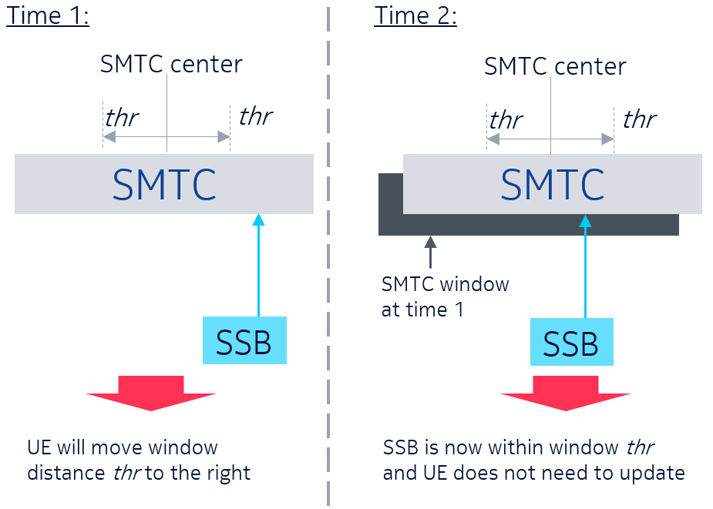
Figure 3. Example of UE autonomous tracking of neighbor cell's SSB location within SMTC window [2]
- Do companies think that option c) “UE updates SMTC window based on relative movement of neighbor cell’s SSB” is a preferable approach for the network to configure correctly the SMTC window and the measurement gap? Please justify your response.
Company | Yes/No | Comments
APT | No | This seems an implementation manner when the SMTC window can be adjusted by UE itself. If this is a correct understanding, we prefer to align with the current RAR window design in NTN.
Nokia | Yes | Proponent.  Regarding APT’s comment, this is not an ‘implementation manner’. This is based on the configuration from the NW (i.e. thr) and the UE is expected to report to the NW when it applies this shift. This is stated in the description preceding the figure.
OPPO | No | When SMTC are currently configured for a set of neighbour cells, UE’s detection of SSB transmitted from different neighbour cell within the SMTC window may suggest the different SMTC adjustment. In addition, more details need to be specified. E.g. how to determine when a SSB is detected? It seems necessary to introduce a new threshold for SSB measurement.
LGE | No | Though UE informs the network of the window movement, NW may not accept the the window movement. So if UE can detect the need to move the measurement window, UE should be able to request to update the window configuaiotn to network.
MediaTek | No | The UE does not need to know about window movements if the network has already compensated for the propagation delay at cell edge.

Option d) Other approaches.
- Companies are welcome to add other solutions if previous ones are not suitable.
Company | Option d.x) | Description of new solutions and/or comments

RRM requirements
In NTN, the chances of measuring neighboring cells may be small due to propagation delay. The UE may miss measurements when SMTC duration is not aligned with the measurement gap. In addition, the propagation delay to different cells changes over time due to the mobility of both UE and satellite. Therefore, the measurement gap window configuration may need to change over time. This makes it even harder for the UE to measure during SMTC window of the neighboring cells. On summary, it may be difficult for the NTN UE to achieve the same RRM requirements as in TN [1][7].
- Do companies think that UE RRM requirements for NTN should be changed in comparison to legacy TN ones? please indicate your preference and whether RAN4 should be contacted on this regard.
Company | Yes/No | Comments
APT | Not sure | Too early to conclude. Wait for more discussion in RAN1.
Nokia |  | This is a RAN4 topic, we think there is no need to contact RAN4 via explicit LS, at least not yet.
OPPO |  | This is the RAN4 topic which we think RAN4 will look into.
LGE |  | It is RAN4’s scope.
MediaTek | Out of Scope | It is RAN4 topic and out of scope of RAN2

Conclusions
<To be updated>

References
- R2-2100384 Measurement framework to support NTN Intel Corporation 3GPP TSG-RAN WG2 Meeting #113e
- R2-2100530 On SMTC and measurement gaps for NTN Nokia, Nokia Shanghai Bell 3GPP TSG-RAN WG2 Meeting #113e
- R2-2100336 Consider on measurement in NTN system CATT 3GPP TSG-RAN WG2 Meeting #113e
- R2-2100164 Discussion on mobility management for connected mode UE in NTN OPPO 3GPP TSG-RAN WG2 Meeting #113e
- R2-2100258 Efficient Configuration of SMTC and Measurement Gaps in NR-NTN MediaTek Inc. 3GPP TSG-RAN WG2 Meeting #113e
- R2-2100580 Further considerations on CHO, location reporting, and measurement window in NTN LG 3GPP TSG-RAN WG2 Meeting #113e
- R2-2100745 SMTC and measurement gap configuration Qualcomm Incorporated 3GPP TSG-RAN WG2 Meeting #113e
- R2-2101128 Considerations on measurements in NTN Lenovo, Motorola Mobility 3GPP TSG-RAN WG2 Meeting #113e
- R2-2101859 SMTC and measurement gap configuration in NTN Rakuten Mobile, Inc 3GPP TSG-RAN WG2 Meeting #113e

Annex: companies’ point of contact
Company | Point of contact | Email address
Intel Corporation | Marta Martinez Tarradell | marta.m.tarradell@intel.com
Nokia | Jedrzej Stanczak | jedrzej.stanczak[at]nokia.com
OPPO | Haitao Li | lihaitao@oppo.com
LG Electronics | Sangwon Kim | sangwon7.kim@lge.com
MediaTek | Abhishek Roy | Abhishek.Roy@mediatek.com

