3GPP TSG-RAN WG2 Meeting #113 electronic R2-21xxxxx
Online, January 25th – February 5th 2021

Agenda Item: X.X.X
Source: Sharp
Title: [Post112-e][254][R16 MOB] Issue on failure handling of handover without key change for the UE configured with attemptCondReconfig (Sharp)
Document for: Discussion, Decision

1 Introduction
This document is to collect companies comment in the following email discussion:
- [Post112-e][254][R16 MOB] Issue on failure handling of handover without key change for the UE configured with attemptCondReconfig (Sharp)
Scope: Discuss issues raised by R2-2010205 and discussed in email [AT112-e][211][MOB] as per R2-2010719 to understand whether there are security issues and if there are, what can be done to mitigate them.
Intended outcome: Summary + agreeable CRs (if any)
Deadline: Long

For this email discussion, it is proposed to have the following two phases:
Phase 1: Discuss whether there are security issues on handover failure handling for the UE configured with attemptCondReconfig. (Deadline: Jan 04, 23:59UTC)
Phase 2: If the issue is confirmed in Phase 1, discuss detailed specification changes to solve the issue and prepare agreeable CR. (Deadline: Jan 12, 23:59UTC)

2 Discussion

2.1 Phase 1
In Phase 1, an example scenario which would cause a security issue (reuse of the same key stream) is introduced in the subclause 2.1.1, and it is discussed whether the example scenario is valid and the security issue is caused in the subclause 2.1.2.

2.1.1 Background
In the AS security section (subclause 5.3.1.2) in TS 38.331 [1], it is explained that using the same COUNT value for the same security key (at the same radio bearer), i.e. the same keystream, is not allowed.

5.3.1.2 AS Security

…
For each radio bearer an independent counter (COUNT, as specified in TS 38.323 [5]) is maintained for each direction. For each radio bearer, the COUNT is used as input for ciphering and integrity protection.
It is not allowed to use the same COUNT value more than once for a given security key. As specified in TS 33.501 subclause 6.9.4.1 [11], the network is responsible for avoiding reuse of the COUNT with the same RB identity and with the same key, e.g. due to the transfer of large volumes of data, release and establishment of new RBs, and multiple termination point changes for RLC-UM bearers and multiple termination point changes for RLC-AM bearer with SN terminated PDCP re-establishment (COUNT reset) due to SN only full configuration whilst the key stream inputs (i.e. bearer ID, security key) at MN have not been updated. In order to avoid such re-use, the network may e.g. use different RB identities for RB establishments, change the AS security key, or an RRC_CONNECTED to RRC_IDLE/RRC_INACTIVE and then to RRC_CONNECTED transition.
…

However in the following example scenario (illustrated in Figure 1), the same key stream may be used by SRB1 (which was also introduced in [2][3]).
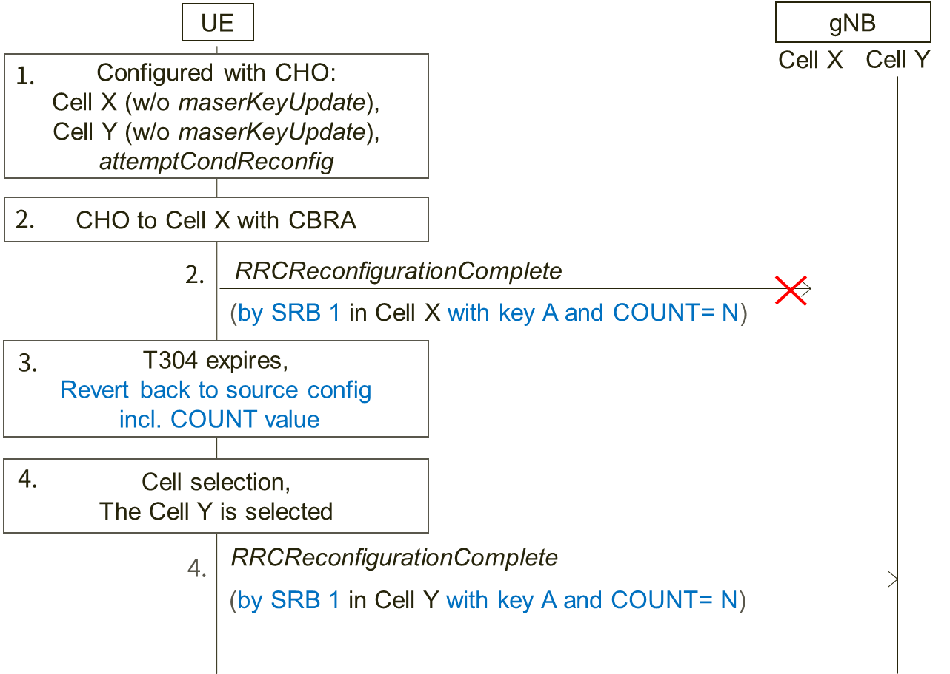
Figure 1: Example scenario 1
Step 1. The UE is configured with CHO candidate cells: Cell X and Cell Y which are both not configured with key change (i.e., masterKeyUpdate). Also, the UE is configured with attemptCondReconfig. The UE holds COUNT value 'N' and security key A in source cell just before performing CHO in the step 2.
Step 2. CHO condition to Cell X is met and the UE performs CHO to the candidate Cell X without key change. If contention based random access is applied, COUNT value 'N' with key A is used for transmitting RRCReconfigurationComplete message as Msg3 by SRB1, and COUNT value is incremented to 'N+1'.
Step 3. However if the handover fails, the UE reverts back to the source configuration that was used just before the handover execution and performs the RRC re-establishment procedure. According to NOTE 1 of 5.3.5.8.3, all state variables, i.e. including COUNT value, are reverted. This means COUNT value becomes 'N' again.
Step 4. If the selected cell during the RRC re-establishment procedure is the candidate Cell Y, the UE initiates CHO because attemptCondReconfig is configured as assumed in the step 1. As Cell Y is configured without key change, the UE does not update the key and the same COUNT value 'N' with the same key A to transmit RRCReconfigurationComplete massage by SRB1.
Consequently, the same key stream is used.

2.1.2 Phase 1 discussion
Regarding the above example scenario:
Question 1: Do companies agree that the assumed configurations and conditions in the step 1 are valid?
Step 1. The UE is configured with CHO candidate cells: Cell X and Cell Y which are both not configured with key change (i.e., masterKeyUpdate). Also, the UE is configured with attemptCondReconfig. The UE holds COUNT value 'N' and security key A in source cell just before performing CHO in the step 2.
Company | Yes/No | Comments
Ericsson | Yes
ZTE | Yes
Intel | Yes
Nokia | Yes | The procedure for T304 expiry seems to state the UE reverts back to the configuration in the source PCell. This is in principle fine, but maybe it could be considered if the state variables should also be reverted (even though, as per the current NOTE, they are).
LG | Yes
MediaTek | Yes
ITRI | Yes
Apple | Yes
Samsung | Yes
Huawei, HiSilicon | Yes
CATT | Yes

Question 2: Do company agree that the scenario in the step 2 could happen?
Step 2. CHO condition to Cell X is met and the UE performs CHO to the candidate Cell X without key change. If contention based random access is applied, COUNT value 'N' with key A is used for transmitting RRCReconfigurationComplete message as Msg3 by SRB1, and COUNT value is incremented to 'N+1'.
Company | Yes/No | Comments
Ericsson | Yes | Also data could be transmitted on DRBs in MSG3 if the UL grant is large enough and the UE has pending data in its UL buffer. Wouldn’t the same issue then also apply for the DRBs?
ZTE | Yes | Agree with Ericsson that the same issue may also apply for DRBs.
Intel | Yes | Agree it is applied for both SRB and DRBs.
Nokia | Yes
Sharp | Yes | Agree with Ericsson data could be transmitted on DRBs in Msg3. So this is applied for both SRB and DRB.
LG | Yes
MediaTek | Yes | Agree that this discussion should be applied for both SRB and DRB.
ITRI | Yes
Apple | Yes
Samsung | Yes
Huawei, HiSilicon | Yes
CATT | Yes

Question 3: Do companies agree that the procedure described in the step 3 will happen according to the current specification [1]?
Step 3. However if the handover fails, the UE reverts back to the source configuration that was used just before the handover execution and performs the RRC re-establishment procedure. According to NOTE 1 of 5.3.5.8.3, all state variables, i.e. including COUNT value, are reverted. This means COUNT value becomes 'N' again.
Company | Yes/No | Comments
Ericsson | Yes
ZTE | Yes
Intel | Yes
Nokia | Yes | Side comment: we wonder why this important behaviour was captured in the NOTE.
LG | Yes
MediaTek | Yes
ITRI | Yes
Apple | Yes
Samsung | Yes
Huawei, HiSilicon | Yes
CATT | Yes

Question 4: Do companies agree that the procedure described in the step 4 will happen according to the current specification [1]?
Step 4. If the selected cell during the RRC re-establishment procedure is the candidate Cell Y, the UE initiates CHO because attemptCondReconfig is configured as assumed in the step 1. As Cell Y is configured without key change, the UE does not update the key and the same COUNT value 'N' with the same key A to transmit RRCReconfigurationComplete massage by SRB1.
Company | Yes/No | Comments
Ericsson | Yes
ZTE | Yes
Intel | Yes
Nokia | Yes | If the COUNT is not reset but reverted.
LG | Yes
MediaTek | Yes
ITRI | Yes
Apple | Yes
Samsung | Yes
Huawei, HiSilicon | Yes
CATT | Yes

Question 5: Do companies agree that there is the security issue (reuse of key stream) in the example scenario?
Company | Yes/No | Comments
Ericsson | Yes | Today the security may not be that severe but if more information gets added to the RRCReconfigurationComplete in the future it could be a problem. So we think this issue should be fixed.  If data can be sent in MSG3 as noted in our answer to question 2 the problem would be worse.
ZTE | Yes
Intel | Yes
Nokia | Yes, but | we do not think the scenario would be very common, but agree that it may occur, according to the current specification
LG | Yes, but | We think that this issue can be avoided by network implementation. For example, if the network always changes the security key for CHO, this issue does not happen.  Considering above, if the spec change is needed, we can add a note that the network always changes the security key for CHO.
MediaTek | Yes | This may not be a very common case but we should try to fix the problem. Also, we think CHO without security key change should be supported.  One simple way is that the network never set attemptCondReconfig for handover without key change. This prohibits “CHO recoverd by CHO” witout key change, but should be fine since CHO is more robust and rarely fails. But for scenario 2 below, there may be concern to prohibit “HO recovered by CHO” if security key is not changed.
ITRI | Yes, but | Agree with LG that the reuse of key stream can be avoided by network implementation.
Apple | Yes, but | We also agree with LG that the problem could be avoided by NW implementation.
Samsung | Yes | We agree with LG’s observation that it can be handled by NW implementation. The problem could be avoided by changing the security key for CHO if configured together with attemptCondReconfig.
Huawei, HiSilicon | Yes, but | We share the same view as LG that the problem can be solved if the network always includes the masterKeyUpdate for the CHO candidate cell.
CATT | Yes | Agree with LG that the issue can be avoided if the network always change the security key for CHO.

The example scenario in Figure 1 only focuses on CHO failure case. However the same key stream reuse issue may also occur in normal handover failure case as illustrated in Figure 2 below.
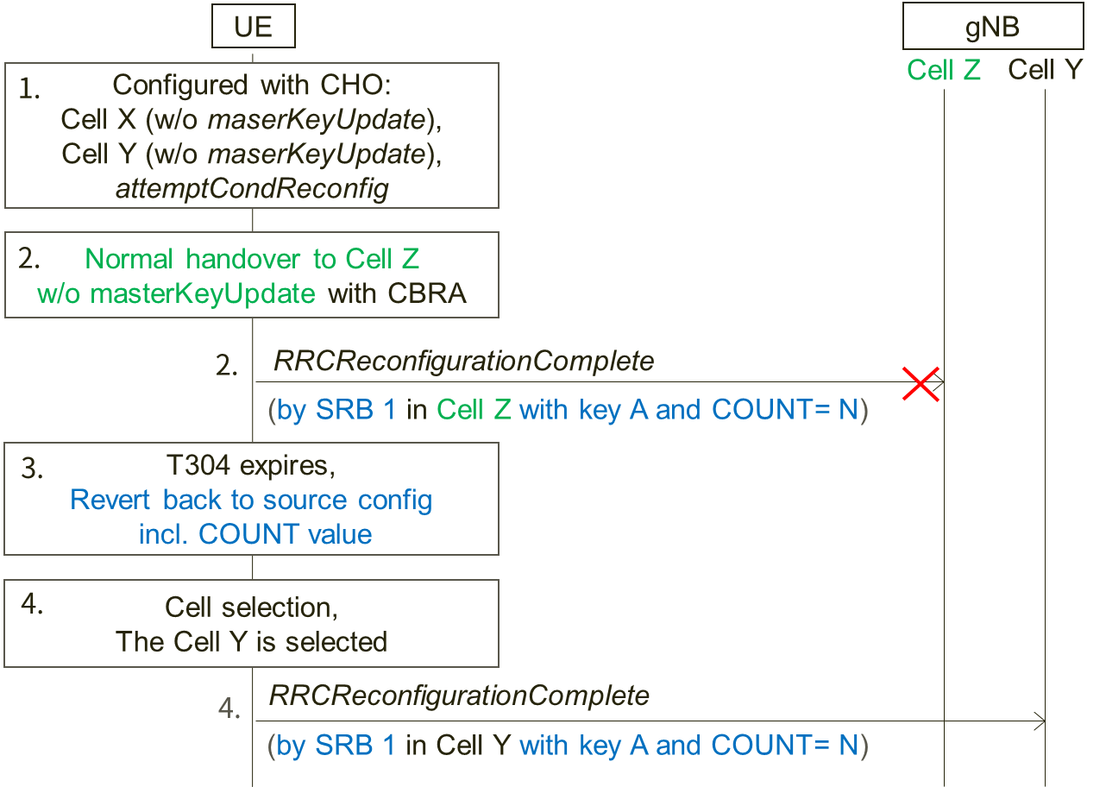
Figure 2: Example scenario 2
The difference between Figure 1 and Figure 2 is the UE receives RRCReconfiguration message with reconfigurationWithSync (without masterKeyUpdate) in the step 2 and performs normal handover without key change to Cell Z which may or may not a CHO candidate cell. And the other assumptions from the step 1 to the step 4 are the same with the example in Figure 1 (including contention based random access is applied in the step 2).
Question 6: Do companies agree that there is also the security issue (reuse of key stream) in the example scenario in Figure 2?
Company | Yes/No | Comments
Ericsson | Yes
ZTE | Yes
Intel | Yes
Nokia | Yes | This issue does not seem to depend on whether CHO or HO was attempted.
LG | Yes but | If the network always changes the security key, the example scenario will not happen.
MediaTek | Yes
ITRI | Yes, but | The reuse of key stream can be avoided by network implementation.
Apple | Yes, but | Agree with LG.
Samsung | Yes | We have same understanding as LG that it can be avoided by NW like in the previous issue
Huawei, HiSilicon | Yes, but | The problem can be solved if the network always includes the masterKeyUpdate for the CHO candidate cell.
CATT | Yes

Question 7: Do companies have any other comments?
Company | Comments
Ericsson | Keystream reuse can also occur even if the handover is performed with key change if handover is executed to the same cell twice.  - UE performs CHO or normal handover to cell X (with key change) and sends the handover complete message in MSG3 using key B and COUNT = 0  - The first handover fails and the UE performs cell selection  - In the cell selection, the UE selects the same cell as for which the handover just failed, i.e. cell X.  - Since X is CHO candidate, the UE performs CHO handover to cell X (with key change) and sends the handover complete message in MSG3 using key B and COUNT = 0.  As the handover complete message in both handovers are encrypted with the same key and COUNT there is keystream reuse.
ZTE | We share the same view with Ericsson that keystream reuse issue may also occur in case the handover is executed to the same cell twice. At RAN2#111e meeting, we submitted papers (R2-2007700) on this issue and proposed to prohibit the UE to attempt a second CHO execution in the same cell failed in the first handover execution. But companies thought it can be up to the UE implementation to handle this. Perhaps we could reconsider the handling of this keystream reuse issue on cell re-selection in this email discussion.
Nokia | How likely it is the UE will select again the same cell towards which it has failed to complete the HO? Perhaps the scenario is not the most common one?
Sharp | As ZTE explained, the issue raised by Ericsson was already discussed in RAN2#111e meeting and concluded it is up to UE implementation.  For ZTE proposed to reconsider the issue in this email discussion, we (as rapporteur) propose not to re-open the topic here because we have limited time to conclude the original scope.
LG | We think that this issue can be avoided by network implementation.
MediaTek | The issue raised by Ericsson can be resolved by UE implementation. However, if companies still have concerns, we may add some NOTE, e.g. in this case UE should avoid selecting the same cell for CHO.
ITRI | We think the scenarios raised by the rapporteur may happen but can be avoided by network implementation.
Apple | We also think the issue can be solved by propoer NW implementation.
Samsung | The issue seems not significant. Moreover, security concern arise only if the contents are different (i.e. if ReconfigurationComplete in step 1 and in step 4 are same, there is no security problem)
Huawei, HiSilicon | It seems that Ericsson’s scenario has been discussed in previous RAN2 meetings and there was a conclusion, so we may not need to re-open it again.
Intel | For the issue mentioned by Ericsson and ZTE, considering the UE sends the same message with same counter, same key stream to the same target cell, Should not it same as retransmission? And therefore should not be security problem.
CATT | As this issue was already discussed and there is a conclusion, we think it does not need to be reopened.

2.1.3 Phase 1 summary
In the phase 1 discussion, eleven companies confirmed a keystream reuse issue might happen for both SRB and DRB in the following case.
The UE configured with attemptCondReconfig performs normal handover or CHO without masterKeyUpdate to Cell X and contention based random access is applied for the handover. After the handover fails, during RRC re-establishment procedure, the UE select one of the CHO candidate cell of which configuration doesn't include masterKeyUpdate.
Four companies commented the issue should be solved by network implementation, i.e., masterKeyUpdate should be always set in CHO configuration. Two companies commented the issue could be solved if the network never set attemptCondReconfig in CHO configuration without masterKeyUpdate.
We propose to discuss the solution including the above comments in Phase 2.
Also, one company addressed other keystream reuse issue which was discussed and noted in the RAN2#111e (based on R2-2007700). Eight companies commented it could be solved by implementation, and also in the RAN2#111e some companies commented the same. We propose not to reopen the issue in this email discussion.
Observation 1: The companies who participated in Phase 1 discussion confirmed a keystream reuse issue might happen for both SRB and DRB in the following case.
The UE configured with attemptCondReconfig performs normal handover or CHO without masterKeyUpdate to Cell X and contention based random access is applied for the handover. After the handover fails, during RRC re-establishment procedure, the UE select one of the CHO candidate cell of which configuration doesn't include masterKeyUpdate.
Proposal 1: To discuss the solution in Phase 2 including comments (possible solutions) received in Phase 1.
Proposal 2: Not to reopen the issue discussed in RAN2#111e based on R2-2007700 in this email discussion.

2.2 Phase 2

2.2.1 Phase 2 discussion
During Phase 1 discussion, the following solution to avoid keystream reuse.
- The network always sets masterKeyUpdate in condRRCReconfig.
- The network never sets attemptCondReconfig in ConditionalReconfiguration if any of condRRCReconfig doesn't include masterKeyUpdate.
In addition, we propose that the state variables for radio bearers are maintained (not reverted) when the UE configured with attemptCondReconfig reverts back to the source configuration if the previous handover was not required key change.
Question 1: Which solution(s) do companies support to solve the keystream reuse issue confirmed in Phase 1?
Solution A. The network always sets masterKeyUpdate in condRRCReconfig.
Solution B. The network never sets attemptCondReconfig in ConditionalReconfiguration if any of condRRCReconfig doesn't include masterKeyUpdate.
Solution C. The state variables for radio bearers are maintained (not reverted) when the UE configured with attemptCondReconfig reverts back to the source configuration if the previous handover was not required key change.
Solution D: Other
Company | Solution(s) | Comments
LG | Solution A
CATT | Solution A
Qualcomm | Solution B | Solution A is not preferable since there is no reason to restrict the case when attemptCondReconfig is not used.

Question 2: Do companies agree that the specification change is necessary with the supported solution(s)?
Company | Yes/No | Comments
LG | No | If the spec change is needed, the NOTE is enough.
CATT |  | We also think, a Note is sufficient to clarify this.
Qualcomm |  | It can be added as a Note in RRC or captured as the expected NW implementation option in Chair notes.

Question 3: Do companies have any idea for specification change? If yes, please provide the proposed specification change.
Company | Proposed specification change
LG | If the NOTE is needed, we can add it in 38.300 as follows.  RRC managed handovers with and without PDCP entity re-establishment are both supported. For DRBs using RLC AM mode, PDCP can either be re-established together with a security key change or initiate a data recovery procedure without a key change. For DRBs using RLC UM mode and for SRBs, PDCP can either be re-established together with a security key change or remain as it is without a key change. For CHO, a security key is always updated.
CATT | LG proposal seems fine to us.

Question 4: Do companies have any other comments?
Company | Comments

3 Conclusion
To be added

References
[1] TS 38.331 v16.2.0
[2] R2-2010205, "Issue on failure handling of handover without key change for the UE configured with attemptCondReconfig", Sharp
[3] R2-2010719, "Summary of discussion [211][MOB] CHO/CPC RRC corrections (Intel)", Intel

Annex Contact Information
In order to ease possible offline discussions, all delegates having provided input in this document are requested to fill the following table.

Company | Name(s) | Email Address(es)
Sharp (Rapp.) | Takako Sanda | sanda.takako@sharp.co.jp
ZTE | Mengjie Zhang | zhang.mengjie@zte.com.cn
Nokia | Jedrzej Stanczak | jedrzej.stanczak@nokia.com
LG | Geumsan Jo | Geumsan.jo@lge.com
Apple | Yuqin Chen | yuqin_chen@apple.com
Huawei | Jun Chen | jun.chen@huawei.com

