3GPP TSG-RAN2 Meeting #113-e R2-20xxxxx

Elbonia, 25 Jan - 05 Feb, 2021

**Agenda Item: 6.16**

**Source: Apple**

**Title: [Post112-e][063][NR TEI16] RRC processing time with segmentation**

**Document for: Discussion and Decision**

# Introduction

In RAN2#112e meeting, RAN2 agreed to extend the RRC processing time for RRC and to discuss the detailed solution via post meeting email discussion.

|  |
| --- |
| **RAN2 agreement**   * [029] Extending RRC processing time for RRC message segmentation is supported, to discuss detailed solution via long term email disc until next meeting. |

This is the email discussion report on below email discussion:

* [Post112-e][063][NR TEI16] RRC processing time with segmentation (Apple)

Scope: Make progress based on R2-2009488 and related discussion at R2 112-e.

Intended outcome: Report, agreeable CR

Deadline: long

According to the chair’s guidance, this report will be based on the summary R2-2010985 and try to figure out the majority interest on the proposals. The document consists of phase-1 and phase-2, the deadline of each phase is outlined as follow:

- **Phase-1:** collecting views on the detailed proposals, deadline: **Friday Dec. 11, 2020.**

- **Phase-2:** collecting views on the summary and the text proposal, deadline: **Friday Jan. 8, 2021.**

# Discussion

## Background

### Current RRC processing delay requirement

In current 38.331 section 12 defines the processing delay requirements for RRC reconfiguration/resume procedure as following:

|  |  |  |  |
| --- | --- | --- | --- |
| **Procedure title:** | **Network -> UE** | **UE -> Network** | **Value [ms]** |
| **RRC Connection Control Procedures** | | | |
| RRC reconfiguration | *RRCReconfiguration* | *RRCReconfigurationComplete* | 10 |
| RRC reconfiguration (scell addition/release) | *RRCReconfiguration* | *RRCReconfigurationComplete* | 16 |
| RRC reconfiguration (SCG establishment/ modification/ release) | *RRCReconfiguration* | *RRCReconfigurationComplete* | 16 |
| RRC resume | *RRCResume* | *RRCResumeComplete* | 6 or 10 |

### The impact of RRC processing time by DL RRC segmentation

In [1], it is observed that RRC processing time is increased when RRC message size increases. Figure-1 explains the relation between received configuration size and relative processing time.

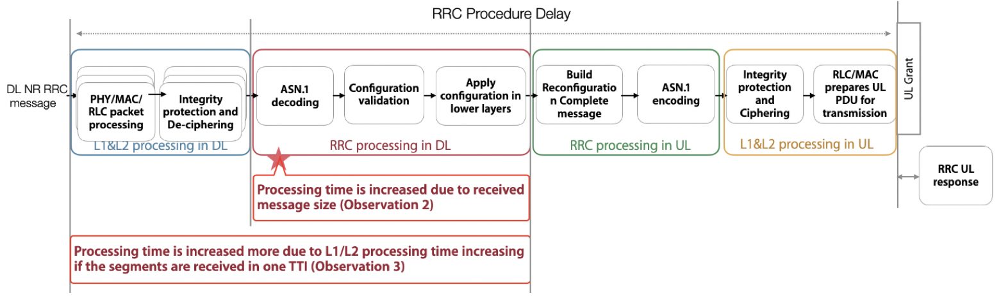

Figure-1. Impact on the UE processing on DL RRC message

## Detailed solutions

About the detailed solution to define the RRC processing time requirement for DL RRC message with segmentation, following options were proposed during the offline discussion [2]:

* Option 1: 16ms*Nseg.
* Nseg is number of RRC segments
* Option 2: 16ms + (Nseg*X)
* Nseg is number of RRC segments
* 16ms includes the processing time of UE functionalities which is needed only once for all received segments and no impact by the message size.
* X is the additional processing time per segment, e.g. DL processing, extra processing time for ASN.1 decoding, configuration application.
* X time in milli-seconds required to process an RRC segment.
* Option 3: fix value
* Define one fix value to cover all cases, including the case of the max segment number.
* The value should be the max value of the options in the function form.
* Option 4: (16+Y) + Nseg*X
* Nseg is number of RRC segments
* Y = scale up delta to accommodate for the difference in size between max size for legacy RRC message (e.g. 9 KB) and max size of new RRC message (e.g. 45KB)
* X time in milli-seconds required to process an RRC segment

Take the RRC Reconfiguration message with 5 segments as the example, the processing time for each option is provided in the table below.

|  |  |  |
| --- | --- | --- |
| Options | Definition | Processing time |
| 1 | 16ms*Nseg | 16*5 = 80ms |
| 2 | 16ms + (Nseg*X) | 16 + 5X |
| 3 | Fix value | Max of |
| 4 | (16+Y) + Nseg*X | (16+Y) + 5X |

#### **Question 1: Which solution do you prefer?**

|  |  |  |
| --- | --- | --- |
| **Company** | **Preference** | **Comments** |
|  |  |  |
|  |  |  |
|  |  |  |
|  |  |  |

#### **Question 2: If Option 2 (i.e. 16ms + (Nseg*X)) is your preference, what do you think is the value of X?**

|  |  |  |
| --- | --- | --- |
| **Company** | **Preferred X value** | **Comments** |
|  |  |  |
|  |  |  |
|  |  |  |
|  |  |  |

#### **Question 3: If Option 4 (i.e. (16+Y) + Nseg*X) is your preference, what do you think is the value of X and Y?**

|  |  |  |
| --- | --- | --- |
| **Company** | **Preferred X, Y value** | **Comments** |
|  |  |  |
|  |  |  |
|  |  |  |
|  |  |  |

#### **Question 4: If Option 3 (i.e. fix value) is your preference, do you agree the value should cover the latency of the max segment number?**

|  |  |  |
| --- | --- | --- |
| **Company** | **Agree or not?** | **Comments** |
|  |  |  |
|  |  |  |
|  |  |  |
|  |  |  |

## RAN5 Impact

The test cases are currently defined in 38.523 for checking the RRC processing delay (see Annex). Since the RRC processing delay is extended for the RRC message with segmentation, the defined test case is not applicable for the RRC message with segmentation. Therefore, it’s better to inform RAN5 to exclude the RRC message with segmentation from current test cases.

#### **Question 5: Do you agree to inform RAN5 about the RRC processing time extension for the RRC message with segmentation?**

|  |  |  |
| --- | --- | --- |
| **Company** | **Agree or not?** | **Comments** |
|  |  |  |
|  |  |  |
|  |  |  |
|  |  |  |

# Summary

# Conclusion

The followings are proposed:

**Proposal 1: ?**

# Reference

1. R2-2009488 Discussion on RRC processing delay Apple discussion Rel-16 TEI16
2. R2-2011176 [AT112-e][029][NR TEI16] Misc Corrections II (ZTE) ZTE Corporation

# Annex: RAN5 test case in TS38.523

**8.1.5.8** Processing delay

8.1.5.8.1 Processing delay / RRC_Idle to RRC_Connected / RRC_Inactive to

RRC_Connected / Success / Latency check

8.1.5.8.1.1 Test Purpose (TP)

(1)

with { UE in NR RRC_IDLE state and has sent an RRCSetupRequest message }

ensure that {

when { UE receives RRCSetup message and after 10ms receives an UL grant }

then { UE successfully transmits RRCSetupComplete message }

}

(2)

with { UE in NR RRC_CONNECTED state }

ensure that {

when { UE receive a SecurityModeCommand message and after 5ms receives an UL grant }

then { UE successfully transmits SecurityModeComplete }

}

(3)

with { UE in NR RRC_CONNECTED state }

ensure that {

when { UE receive a RRCReconfiguration message to establish DRB that is not part of the current UE

configuration and after 10ms receives an UL grant }

then { UE successfully transmits RRCReconfigurationComplete message }

}

(4)

with { UE in NR RRC_CONNECTED state }

ensure that {

when { UE receives an UECapabilityEnquiry message and after 80ms receives an UL grant }

then { UE successfully transmits an UECapabilityInformation message }

}

(5)

with { UE in NR RRC_INACTIVE state and has sent an RRCResumeRequest message }

ensure that {

when { UE receives RRCResume message and after 10ms receives an UL grant }

then { UE successfully transmits RRCResumeComplete message }

}

(6)

with { UE in NR RRC_CONNECTED state }

ensure that {

when { UE receives an RRCReconfiguration message containing sCellToAddModList with a SCell

addition and after 16ms receives an UL grant }

then { UE successfully transmits RRCReconfigurationComplete message }

}

**8.2.6.2** Processing delay

8.2.6.2.1 Processing delay / PSCell addition / SCG DRB / Success / Latency check / ENDC

8.2.6.2.1.1 Test Purpose (TP)

(1)

with { UE in RRC_CONNECTED state with EN-DC, and, MCG(s) (E-UTRA PDCP) only }

ensure that {

when { UE receives an RRCConnectionReconfiguration message to add PSCell with SCG DRB and after 20

subframes receives an UL grant }

then { UE successfully configures the PSCell with SCG DRB and sends an

RRCConnectionReconfigurationComplete message }

}

# Contact Information

|  |  |  |
| --- | --- | --- |
| **Company** | **Name** | **Email** |
|  |  |  |