**3GPP TSG-RAN WG2 Meeting #105bis R2-19xxxxx**

**Xi’an, China, April 8th – 12th, 2019**

**Agenda item:** 11.10.3

**Source:** Ericsson (Rapporteur)

**Title:** Email discussion [105#53] [LTE_NR_DC_CA_enh-Core] Early measurements Signaling

**Document for:** Discussion

# **Introduction**

This document contains email discussion:

* [103bis#53][NR/eCA-DC] – Signaling (Ericsson)

Discuss signalling for measurement reporting and identify options for:

When availability of measurements is indicated

When measurement results are provided

Discussion should consider NR IDLE mode and INACTIVE mode separately

Intended outcome: Suggested proposals for next

Deadline: Before the next meeting

# **2. Discussion**

The purpose of this email discussion is to identify the different options available for signaling the availability of early measurements as well as the actual sending of the early measurements. The options identified here are based on the contributions [1]-[14] in RAN2#105 and the online discussion during the meeting. Companies are also welcome to include other viable options that are not covered here.

*Disclaimers:*

* As per the agreements in the meeting, the IDLE and INACTIVE mode handling will be discussed separately.
* Since both EN-DC and NR-DC are within the scope of this WI, the discussion is targeting both LTE and NR specifications. For the sake of brevity, the example signaling diagrams show only the NR case (the LTE case can simply be derived by replacing the message with the LTE version, e.g. *RRCConnectionResumeRequest* instead of *RRCResumeRequest*).
* Like in the LTE euCA case, it is possible to configure IDLE/INACTIVE measurements via SIB signaling instead of dedicated configuration in RRC Release. As the measurement configuration is not part of this email discussion, only the case where the UE is configured with dedicated configuration upon release is described below for the sake of brevity.

# **3. IDLE to CONNECTED transition in LTE/NR**

In this section, we discuss the different solutions identified for early measurement reporting for IDLE mode. By IDLE mode here we refer to both NR IDLE mode and LTE IDLE mode (without suspension)

## **3.1 Solution 1: LTE rel-15 euCA solution**

Figure 1 shows the LTE rel-15 euCA solution applied to the NR IDLE mode. The UE is configured with a measurement configuration upon going to IDLE (the content of which is being discussed in email discussion [105 #54]), and the UE performs the measurement in IDLE mode using this configuration. When the connection is established again, the UE will check if the target supports early measurement reporting by reading the SIB and if so, it will indicate that it has early measurement reporting in msg5 (i.e. *RRCSetupComplete*). Once the security is activated, the network may request the UE via *UEInformationRequest* to send the early measurements and the UE does so using *UEInformationResponse* message.

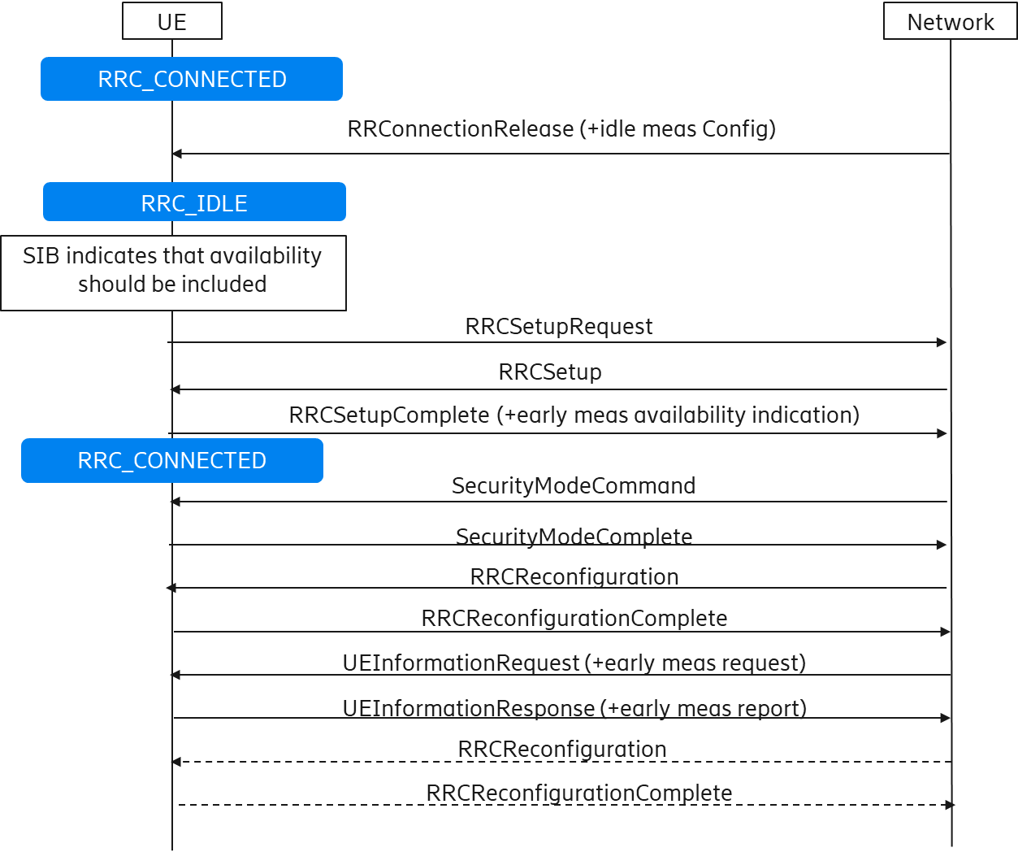

**Figure 1: Early measurement reporting according to LTE rel-15 euCA during transition from IDLE to CONNECTED**

**Question 3.1: What are companies’ views regarding adopting the LTE rel-15 euCA solution for the reporting of early measurements during the transition from IDLE to CONNECTED?**

***NOTE: This question is applicable only to NR as LTE rel-15 already support this solution.***

|  |  |
| --- | --- |
| **Company** | **Comments** |
|  |  |
|  |  |
|  |  |

**Summary:**

## **3.2 Solution 2: reporting early measurements before security activation**

In both NR and in LTE, measurement configurations in RRC_CONNECTED may be provided before security is activated, while measurements shall not be reported until security is activated. Hence, during an IDLE to CONNECTED transition, the UE first needs to complete the initial security activation to be able to transmit a measurement report.

However, for early measurements, it has been argued that this requirement could be revisited (e.g. [12] and Figure 2 shows such a solution where the UE reports the idle measurements even before security activation. The initial steps are like solution 1 but the UE will indicate that it has early measurement reporting in msg3 (i.e. *RRCSetupRequest*) instead of msg5. The network requests the UE, via an indication in the msg4 (i.e. *RRCSetup*), to send the measurement report and the UE does so by including it in msg5 or multiplexing it with msg5. One possible advantage (claimed in [12]) of sending the measurements before security activation is that if the network receives the measurements before sending RRC Reconfiguration, it can use that information to configure CA/DC in the first reconfiguration message, thereby reducing the latency required to setup CA/DC (while in solution 1, two extra RTTs are required before CA/DC can be configured via the early measurements).

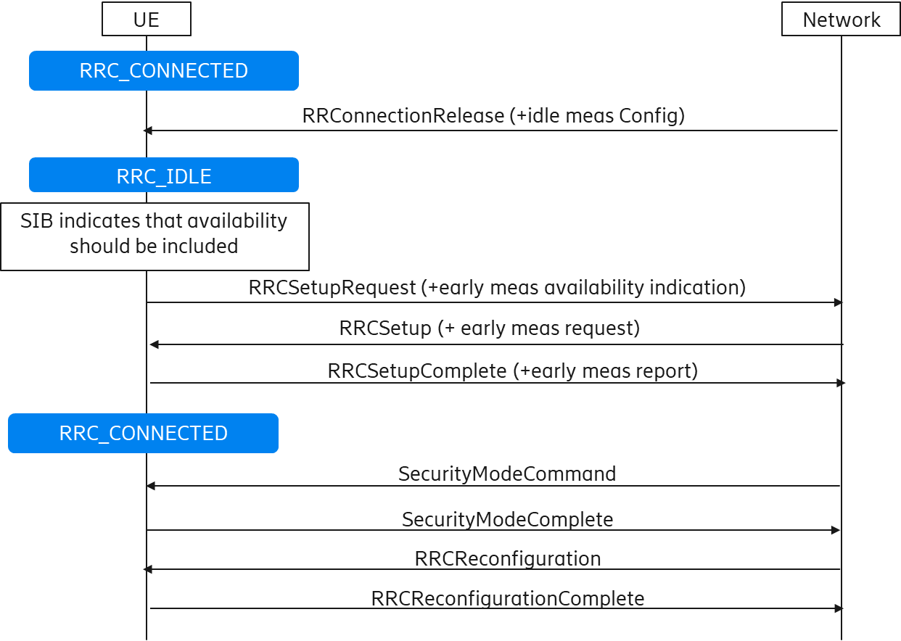

**Figure 2: Early measurement reporting before security activation during transition from IDLE to CONNECTED**

**Question 3.2a: NR: What are companies’ views regarding solution 2 where the early measurement reports are sent (multiplexed with) msg5 during the transition from IDLE to CONNECTED?**

|  |  |
| --- | --- |
| **Company** | **Comments** |
|  |  |
|  |  |
|  |  |

**Summary:**

**Question 3.2b: LTE: What are companies’ views regarding applying solution 2 also to LTE?**

|  |  |
| --- | --- |
| **Company** | **Comments** |
|  |  |
|  |  |
|  |  |

**Summary:**

In current IDLE to CONNECTED transition, security is not activated until SMC is performed. According to security requirements, measurement configurations can be received without security activation, while measurement reports can be sent only after security activation. Some companies (e.g. [12]) have argued that the idle mode measurements are different from connected mode measurements and do not necessarily mandate security activation because only the bare minimum information can be sent to facilitate CA/DC setup without risking security problems such as tracing location.

**Q3.2c: What are companies’ views concerning the existing security requirements and their applicability to sending early measurements as in solution 2?**

***NOTE: This question applies to both LTE and NR.***

|  |  |
| --- | --- |
| **Company** | **Comments** |
|  |  |
|  |  |
|  |  |

**Summary:**

## **3.3 Solution 3: reporting early measurements after security activation but before the first RRC reconfiguration**

An intermediate solution between solution 1 and 2 is to send the early measurements after security activation but before the reception of the first RRCReconfiguration message. This could have the possible advantage of solution 2 (i.e. measurements available before RRC reconfiguration is sent), without the need to reconsider the current security requirements for measurement reporting. This is illustrated in Figure 3. The initial steps are like solution 1 and the UE will indicate that it has early measurement reporting in msg5. The network requests the UE, via an indication in the *SecurityModeCommand* message, to send the measurement report and the UE does so by including it in the *SecurityModeComplete* message or multiplexing it with that message. There can also be variants of this solution (e.g. availability can be indicated in msg3 as in solution 2, *UEInformationRequest* can be multiplexed with SMC, etc.), as long as measurements can be available at the network before the *RRCReconfiguration* is sent.

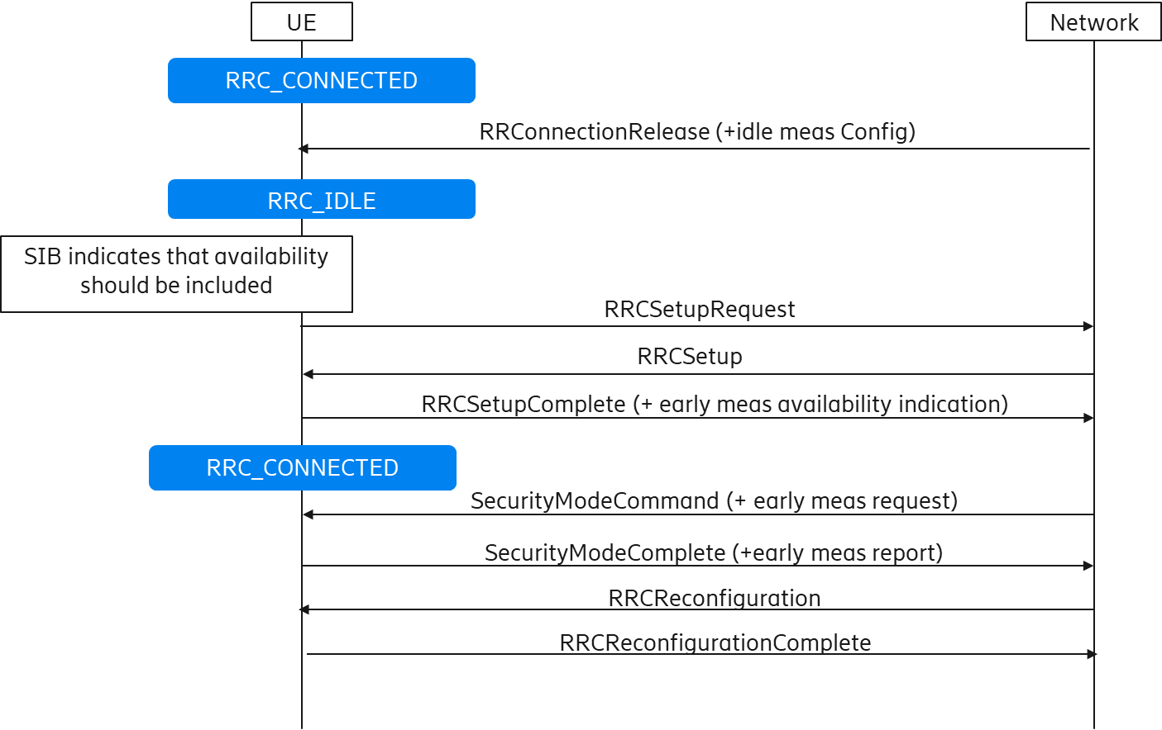

**Figure 3: Early measurement reporting after security activation but before RRC reconfiguration during transition from IDLE to CONNECTED**

**Question 3.3a: NR: What are companies’ views regarding solution 3 where the early measurement reports are sent after security activation but before the first RRC reconfiguration during the transition from IDLE to CONNECTED?**

|  |  |
| --- | --- |
| **Company** | **Comments** |
|  |  |
|  |  |
|  |  |

**Summary:**

**Question 3.3b: LTE: What are companies’ views regarding applying solution 3 also in LTE?**

|  |  |
| --- | --- |
| **Company** | **Comments** |
|  |  |
|  |  |
|  |  |

**Summary:**

## **3.4 Other solutions**

Here, companies are welcome to propose alternative solutions for the reporting of early measurements in the transition from IDLE to CONNECTED mode.

**Question 3.4: Are there any other alternate solutions for the reporting of early measurement reports during the transition from IDLE to CONNECTED?**

***NOTE: This question applies to both LTE and NR.***

|  |  |
| --- | --- |
| **Company** | **Alternate solution** |
|  |  |
|  |  |
|  |  |

**Summary:**

## **3.5 Summary of solutions for IDLE mode**

# **4. INACTIVE to CONNECTED transition in NR and resuming a suspended connection in LTE**

## **4.1 Solution 1: LTE rel-15 euCA solution**

Figure 4 shows the LTE rel-15 euCA solution applied to the NR INACTIVE mode. The UE is configured with idle measurement configuration upon suspension and the UE performs the measurement in INACTIVE mode using this configuration. When the connection is resumed, the UE will check if the target supports early measurement reporting by reading the SIB and if so, it will indicate that it has early measurement reporting in msg5 (i.e. *RRCResumeComplete*). The network requests the UE via *UEInformationRequest* to send the early measurements and the UE does so using *UEInformationResponse* message.

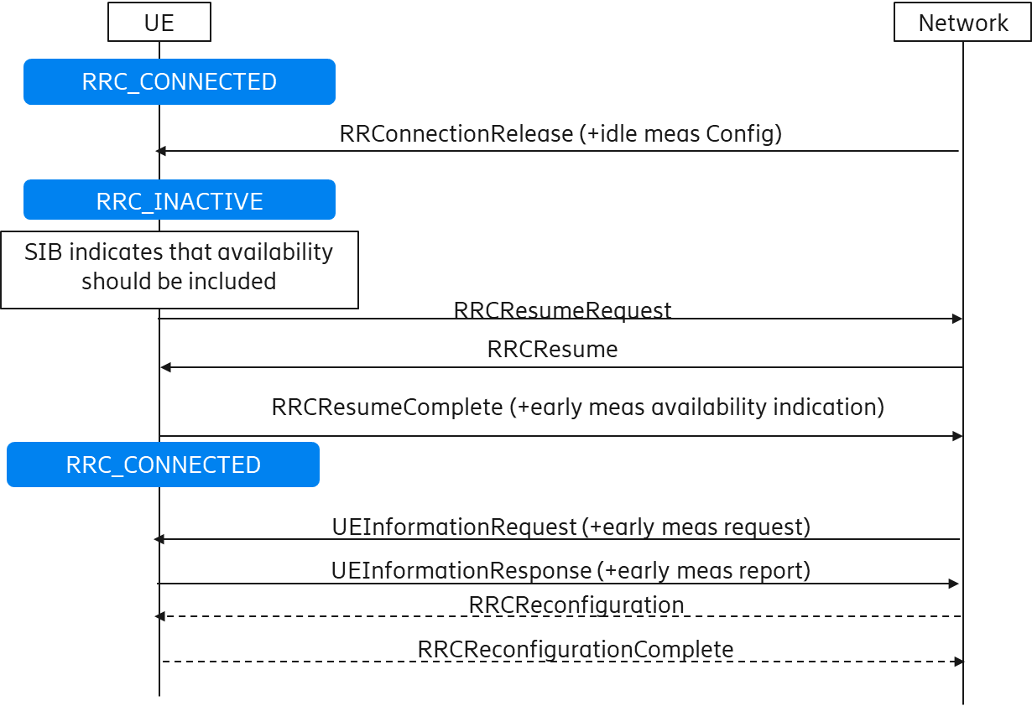

**Figure 4: Early measurement reporting according to LTE rel-15 euCA during transition from INACTIVE to CONNECTED**

**Question 4.1: What are companies’ views regarding adopting the LTE rel-15 euCA solution as is for the reporting of early measurements during the transition from INACTIVE to CONNECTED?**

***NOTE: This question is applicable only to NR as LTE rel-15 already support this solution.***

|  |  |
| --- | --- |
| **Company** | **Comments** |
|  |  |
|  |  |
|  |  |

**Summary:**

## **4.2 Solution 2: reporting early measurements (multiplexed) with msg5**

Figure 5 shows a solution where the UE can report early measurements (multiplexed) with msg5. The initial steps are like solution 1, but the UE indicates the availability of inactive measurements in msg3 (i.e. *RRCResumeRequest*). Upon receiving resume request the network may request the UE to send the early measurement in msg4 (i.e. *RRCResume*) or multiplexed with msg4 (e.g. *UEInformationRequest*) and the UE does so using msg5 or multiplexing it with msg5 (e.g. *UEInformationResponse*). Unlike the case of the transition from IDLE to CONNECTED, there are no security concerns in the INACTIVE case (and also resuming from suspended mode in LTE) as the security is activated by the time the UE sends msg5.

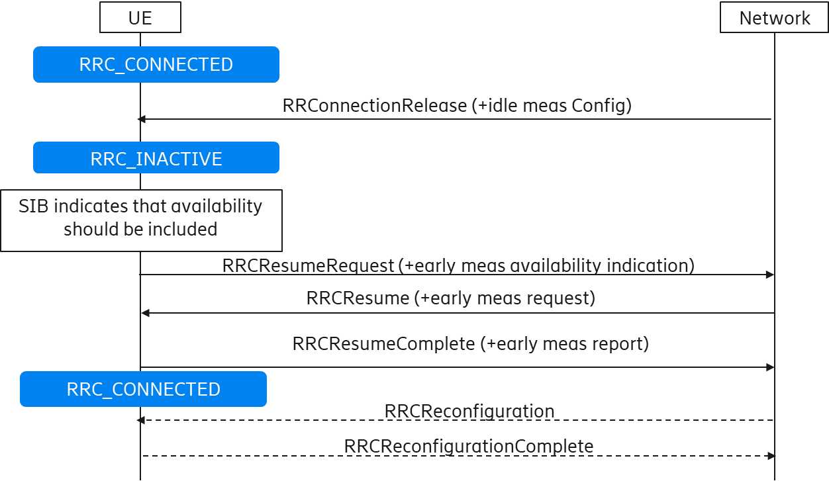

**Figure 5: Early measurement reporting with msg5 during transition from INACTIVE to CONNECTED**

**Question 4.2a: NR: What are companies’ views regarding the reporting of early measurements (multiplexed) with msg5 during the transition from INACTIVE to CONNECTED?**

|  |  |
| --- | --- |
| **Company** | **Comments** |
|  |  |
|  |  |
|  |  |

**Summary:**

**Question 4.2b: LTE: What are companies’ views regarding supporting solution 2 also during resuming a suspended connection in LTE?**

|  |  |
| --- | --- |
| **Company** | **Comments** |
|  |  |
|  |  |
|  |  |

**Summary:**

## **4.3 Solution 3: reporting early measurements multiplexed with msg3**

Figure 6 shows a solution where the UE can report early measurements (multiplexed) with msg3. The UE is configured with idle measurement configuration upon suspension and the UE performs the measurement in INACTIVE mode using this configuration. When the connection is resumed, the UE will check if the target supports early measurement reporting by reading the SIB and if so, it may indicate that it has early measurement reporting in msg1 (i.e. Random Access), e.g. as in Early Data Transmission (EDT) LTE Rel-15. The network may then request the UE to send the early inactive measurement in msg2 (i.e. Random Access Response) and the UE does so by multiplexing it with msg3.

In NR, unlike the case of the transition from IDLE to CONNECTED, there are no security concerns in the INACTIVE case as the security is activated by the time the UE sends msg3. One of the advantages of this solution is the possibility to resume and/or configure CA/DC in the *RRCResume* message based on reported early measurements.

On the other hand, for the suspended RRC connection in LTE, there are similar security concerns as in the IDLE case as the security is not resumed before the reception of the *RRCConnectionResume* message.

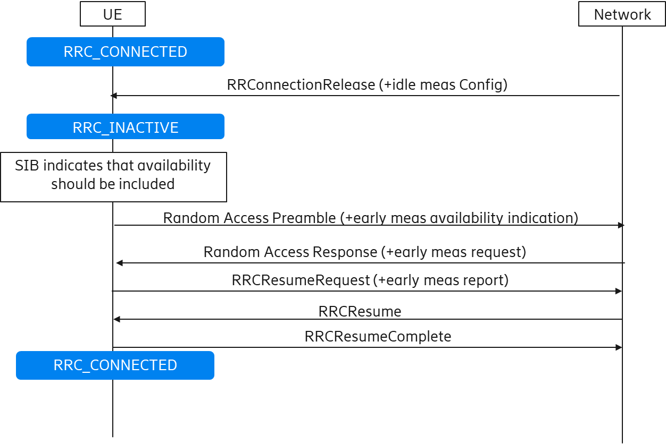

**Figure 6: Early measurement reporting with msg3 during transition from INACTIVE to CONNECTED**

**Question 4.3a: NR: What are companies’ views regarding the reporting of early measurements multiplexed with msg3 during the transition from INACTIVE to CONNECTED?**

|  |  |
| --- | --- |
| **Company** | **Comments** |
|  |  |
|  |  |
|  |  |

**Summary:**

**Question 4.3b: LTE: What are companies’ views of applying solution 3 also during resuming a suspended connection in LTE?**

|  |  |
| --- | --- |
| **Company** | **Comments** |
|  |  |
|  |  |
|  |  |

**Summary:**

**Q4.3c: LTE: What are companies’ views concerning the existing security requirements and their applicability to sending early measurements using solution 3 when resuming a suspended connection in LTE?**

|  |  |
| --- | --- |
| **Company** | **Comments** |
|  |  |
|  |  |
|  |  |

**Summary:**

## **4.4 Other solutions**

Here, companies are welcome to propose alternative solutions for the reporting of early measurements in the transition from INACTIVE to CONNECTED mode.

**Question 4.4: Are there any other alternate solutions for the reporting of early measurement reports during the transition from INACTIVE to CONNECTED in NR or resuming a suspended connection in LTE?**

|  |  |
| --- | --- |
| **Company** | **Alternate solution** |
|  |  |
|  |  |
|  |  |

**Summary:**

## **4.5 Summary of solutions for INACTIVE mode (NR) / suspended (LTE)**

# **5. Summary**

# **6. References**

[1] R2-1900104, Supporting early measurement reporting in NR, Qualcomm Incorporated, RAN2 #105

[2] R2-1900771, Discussion on RAN2 scoping of the DC/CA enhancements for NR and MR-DC, Intel Corporation, RAN2 #105

[3] R2-1901613, Early measurement configuration/reporting in LTE and NR RRC_INACTIVE, Huawei, HiSilicon, RAN2 #105

[4] R2-1900261, Measurement in Idle and Inactive States, vivo, RAN2 #105

[5] R2-1900207, Considerations on Early Measurement Reporting, CATT, RAN2 #105

[6] R2-1900437, Early measurement reporting from IDLE/INACTIVE to CONNECTED, Mediatek Inc., RAN2 #105

[7] R2-1900465, Considerations on early measurement report, OPPO, RAN2 #105

[8] R2-1900693, Signaling of early measurements for CA-DC setup, Ericsson, RAN2 #105

[9] R2-1900801, Early measurement reporting for RRC idle and inactive state, ZTE Corporation, Sanechips, RAN2 #105

[10] R2-1900932, Early measurement reporting in RRC_INACTIVE and RRC_IDLE, Spreadtrum Communications, RAN2 #105

[11] R2-1901612, Early measurement configuration/reporting in LTE and NR RRC_IDLE, Huawei, HiSilicon, RAN2 #105

[12] R2-1902014, Fast setup MR-DC and NR CA with early measurement reporting, LG Electronics Inc., RAN2 #105

[13] R2-1902193, Fast setup MR-DC and CA with IDLE and INACTIVE modes, LG Electronics Inc., RAN2 #105

[14] R2-1902218, Non-connected measurements, defining initial baseline, Samsung Telecommunications, RAN2 #105