3GPP TSG RAN WG1 #98 R1-xxxxx
Prague, CZ, 26th – 30th August, 2019

Agenda Item: xxxx
Source: Fraunhofer IIS
Title: Ultra-wideband measurement results on path loss for indoor industrial scenarios with multiple TX heights and visibility conditions
Document for: Discussion

1 Introduction
The extension of the 3GPP TR 38.901 model to industrial scenarios requires the characterization of multiple parameters [1]. In that regard, we have performed ultra-wideband measurements at 6.75 GHz with the capability of analysing delay spreads (DSs), coarse direction of departure (DoD), polarization, and path-loss. In the present document, we present our path-loss measurement results in LOS and NLOS conditions with TX below and above clutter level.

2 Methodology
We have performed with the TU Ilmenau and Huawei an ultra-wideband measurement campaign at 6.75 GHz (from 3.375 GHz to 10.125 GHz in an indoor industrial scenario with TX above and below clutter level, both in LOS and NLOS conditions. The measurement scenario is a 61 m x 22 m x 9 m machine hall equipped with multiple machines and walls separating different compartments (see Fig. 2).
The channel sounder consists of two different 15-bit M-Sequence units with a null-to-null bandwidth of 6.75 GHz, as shown in Fig. 1. After calibration, the bandwidth is reduced to approx. 4 GHz (from 4.75 GHz to 8.75 GHz). This provides the system with a high resolution in the time domain, about 0.75 cm per delay sample. More details on the channel sounder can be found in [2, 3], and results in multi-band measurements in indoor scenarios in [4] and in V2V scenarios in [5].
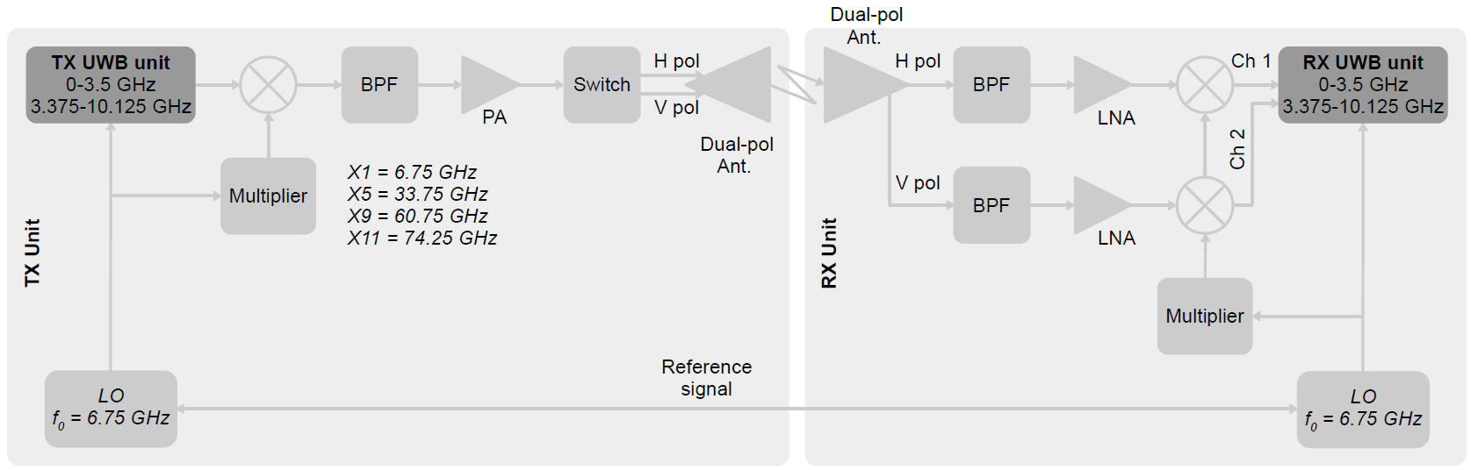
Fig.1: channel sounder architecture operating at X1 = 6.75 GHz

The TX (BS) was located at 1.78 m height (below clutter level) and at 3.54 m height (above clutter level) as shown in the figure below. Two RX stations were measured simultaneously at 1.34 m height (see Fig. 3), one in LOS, and the other one in NLOS. At the TX side, we have used two dual-polarized horn antennas with 30° HPBW stacked one on the top of each other. We have scanned from -60° to 60° with 30° steps in azimuth, and from -30° to 0° in elevation, also with 30° steps. At the RX side, we have used one omni antenna covering up to 40 GHz. Since there was no change of the RX position between the measurements of the different bands, accurate multi-band comparisons can be conducted using this set-up. The channel sounder also takes a picture at the TX on every direction it measures. The panorama picture made out of these pics are can be seen in Fig. 2.

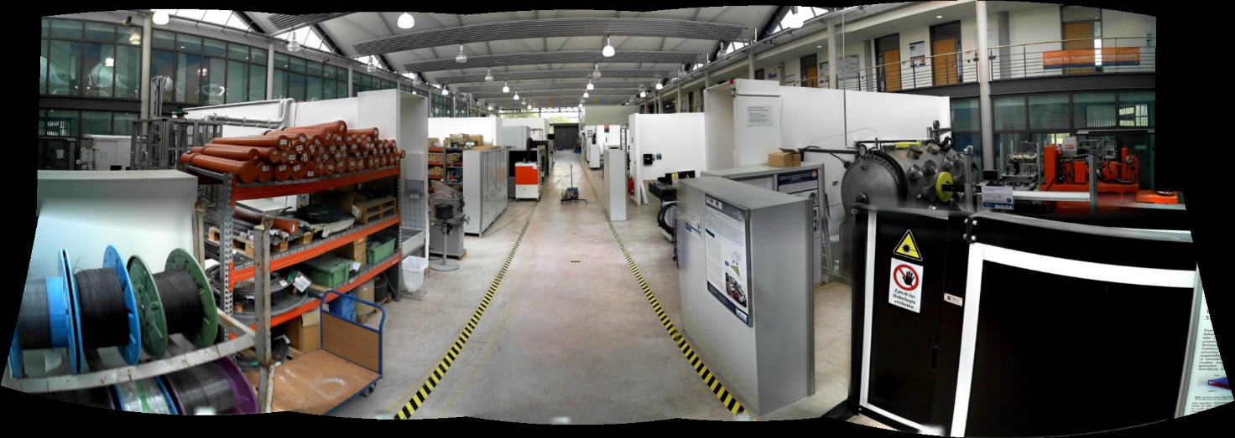
- TX below clutter level
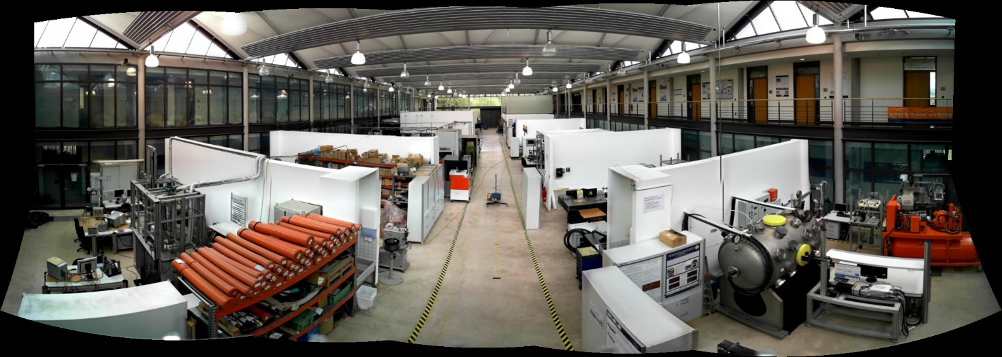
- TX above clutter level
Fig. 2: view from the TX in the position (a) below and (b) above clutter level.

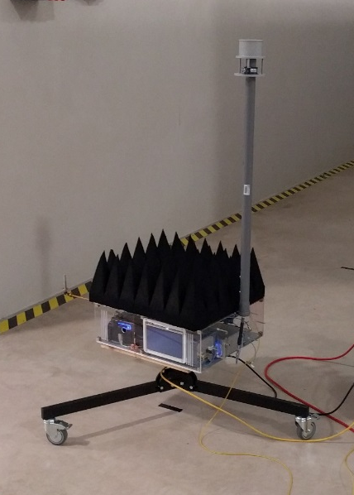
Fig. 3: RX unit.
In total, 76 RX positions were measured in LOS (19) and NLOS (19), and with BS above and below clutter level. The LOS positions were in a line in the main corridor as shown in Fig. 4, moving the RX unit every 2 m (see Fig.5). The NLOS positions were on the compartments on the sides. They were also located in a grid every 2 m, as shown in Fig. 5.
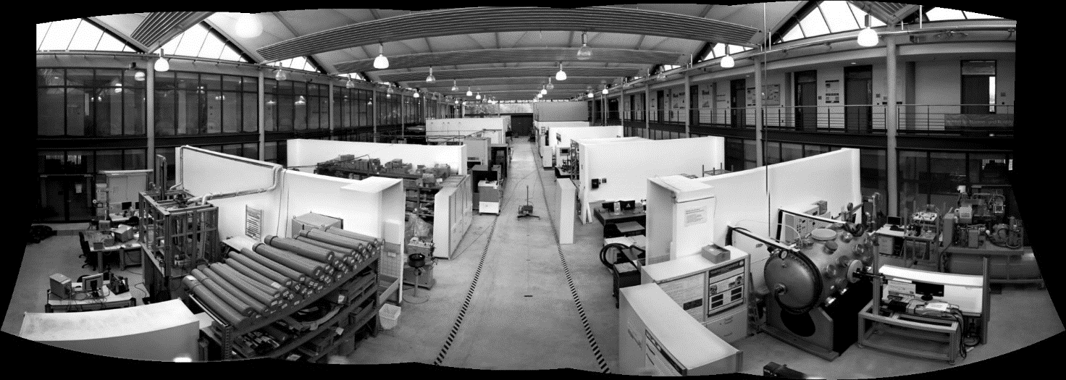
Fig. 4: View from the TX (BS). Location of RX in LOS (green) and NLOS (red).

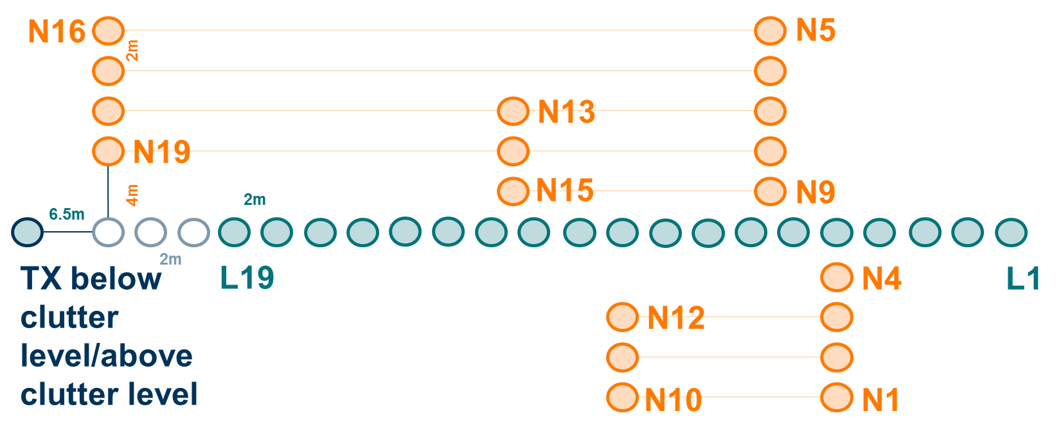
Fig. 5: schematic of the grid location of the TX (BS) and the RX in LOS and NLOS.

2 Results
Since in this document there is no analysis on the angular and polarimetric domain, the synthetic PDP is calculated by averaging the PDP measured in each direction and polarization,
$${PDP}_{SO}\left(τ\right)= \frac{1}{N_{p}N_{ϕ}N_{θ}}\sum_{∀ϕ,θ,p}{{PDP}^{p}(τ,ϕ,θ)},$$
where p is the TX-RX polarization (VV, HV), $ϕ$ and $θ$ are the scanned angles in azimuth and elevation, respectively, and $N_{p}, N_{ϕ}, and N_{θ}$ are the number of polarimetric channels, scans in azimuth, and elevation, respectively. The RX power is calculated as the integration of the complete measured ${PDP}_{SO}\left(τ\right)$,
$$P\left(d\right)= \sum_{∀τ}{{PDP}_{SO}(τ)}.$$

2.1 Temporal analysis
The figures below show the ${PDP}_{SO}\left(τ\right)$in LOS and NLOS for two selected positions. We can observe specular components and a lot of diffuse power between these specular clusters. In the NLOS case, it can be observed more diffuse power when the TX is below clutter level.
PDP for LOS position 11 at 6.75 GHz with TX below clutter level | PDP for LOS position 11 at 30 GHz with TX above clutter level
PDP for NLOS position 11 at 6.75 GHz with TX below clutter level | PDP for NLOS position 11 at 6.75 GHz with TX above clutter level

The figures below show the evolution of the ${PDP}_{SO}\left(τ\right)$over the different RX positions, in LOS with the TX below and above clutter level. Stronger specular components can be observed when the TX is above clutter level.
Reflection from the back wall of the hall
back reflections
PDP over distance with BS below clutter level
More crowded than at BS below clutter level
PDP over distance with BS above clutter level

2.2 Path Loss
The path-loss was calculated using the CI model
$$PL_{CI}\left(d,f_{c}\right)=10⋅{n⋅log}_{10}{(}d)+ 32.44+ 20⋅\log_{10}{(}f_{c} )+χ_{σ},$$
where $f_{c}$ is the carrier frequency in GHz, and $σ$ is the standard deviation of the shadow fading. Since there is not an absolute power measurement reference, we refer all the measurements to the position RX16. The only parameter to be estimated is the path-loss exponent (PLE) $n$.
2.2.1 Line of Sight
The measured PL considering the complete measured PDP, the fit to the CI model, and the FSPL in LOS is shown in the following figure. The PLE was estimated independently for each sub-scenario.

TX below clutter level in LOS | TX above clutter level in LOS

2.2.2 Non-Line of Sight
The measured PL considering the complete measured channel impulse response, the fit to the CI model, and the FSPL in NLOS is shown in the following figure. The fit has shown a higher PLE for BS below clutter level. However, the shadow fading is considerably higher with the BS above clutter level due to the further RX positions with higher PL.

TX below clutter level in NLOS | TX above clutter level in NLOS

 |  | LOS |  | NLOS
 | Band | PLE | $$σ$$ | PLE | $$σ$$
BS below clutter level | 4.75 GHz – 8.75 GHz | 1.93 | 0.79 | 2.37 | 3.01
BS above clutter level | 4.75 GHz – 8.75 GHz | 1.91 | 0.98 | 2.20 | 3.76

3. Conclusions
We have conducted ultra-wideband measurements in an industrial scenario with BS below and above clutter level and under LOS and NLOS conditions. Specular clusters have been observed in the different sub-scenarios, and a richer amount of diffuse power in comparison to similar measurements in smaller indoor scenarios [4].
We have obtained a path-loss exponent smaller than 2 in LOS and slightly higher in NLOS.

References
- 3GPP TR 38.901 (V15.0.0): “Study on channel model for frequencies from 0.5 to 100 GHz".
- R. Müller, R. Herrmann, D. A. Dupleich, C. Schneider and R. S. Thomä, "Ultrawideband multichannel sounding for mm-wave," The 8th European Conference on Antennas and Propagation (EuCAP 2014), The Hague, 2014, pp. 817-821.
- R. Muller et al., "Ultra-Wideband Channel Sounder for Measurements at 70 GHz," 2015 IEEE 81st Vehicular Technology Conference (VTC Spring), Glasgow, 2015, pp. 1-5.
- D. Dupleich et al., " Multi-band Indoor Propagation Characterization by Measurements from 6 to 60 GHz," 13th European Conference on Antennas and Propagation (EuCAP 2019), Krakow, 2019, pp. 1-5.
- D. Dupleich et al., "Multi-band spatio-temporal characterization of a V2V environment under blockage," 12th European Conference on Antennas and Propagation (EuCAP 2018), London, 2018, pp. 1-5.

