11 Evaluations and measurement results
<For sections 11.1 and 11.2 see draft update of main part of TR>

11.3 Capacity analysis
This section summarises the SL resource allocation Mode 1 and Mode 2 PRR evaluation results based on the simulation profiles defined in Table A.1-1. In each table, the average PRR is shown in the range (n×20, (n+1)×20) meters from the transmitter, where n=15 for the highway case and n=7 for the urban case. Details of the evaluation assumptions and results of each source can be found in Annex B. It is noted that no system-level calibration was performed.

11.3.1 Resource allocation Mode 1
Evaluation results for resource allocation Mode 1 are summarised in this section. Where a sourcing company provided results for more than one grant type, they appear in respective rows of a table.
Table 11.3.1-1: Average PRR for unicast V2V (a=n×20, b=(n+1)×20 m)
 | Grant type | SL frequency (GHz) | SCS (kHz) | Highway (n=15) |  | Urban grid (n=7)
 |  |  |  | Periodic traffic | Aperiodic traffic | Periodic traffic | Aperiodic traffic
Source 1 (Huawei) | Dynamic | 6 | 15 | 0.9988 | 0.9976 | 0.9824 | 0.9618
Source 1 (Huawei) | Dynamic | 6 | 30 | 0.9996 | 0.9984 | - | -
Source 1 (Huawei) | Dynamic | 6 | 60 | 0.9998 | 0.9974 | 0.9625 | 0.9416
Source 2  (vivo) | Dynamic | 6 | 15 | 0.9996 | 0.9998 | 0.9381 | 0.9058
Source 2  (vivo) | Dynamic | 6 | 30 | 0.9996 | 0.9997 | 0.9337 | 0.8803
Source 2  (vivo) | Dynamic | 6 | 60 | 0.9995 | 0.9996 | 0.9134 | 0.8897
Source 3  (ZTE) | Dynamic | 6 | 15 | 0.9931 | 0.9966 | 0.9259 | 0.9637
Source 3  (ZTE) | Dynamic | 6 | 30 | 1.000 | 1.000 | 0.9157 | 0.9825
Source 4  (InterDigital) | Dynamic | 6 | 15 | - | - | 0.9523 | -

Table 11.3.1-2: Average PRR for groupcast V2V (a=n×20, b=(n+1)×20 m)
 | Grant type | SL frequency (GHz) | SCS (kHz) | Highway (n=15) |  | Urban grid (n=7)
 |  |  |  | Periodic traffic | Aperiodic traffic | Periodic traffic | Aperiodic traffic
Source 1 (Huawei) | Dynamic | 6 | 15 | 0.9969 | 0.9965 | 0.9811 | 0.96
Source 1 (Huawei) | Dynamic | 6 | 30 | 0.9981 | 0.9985 | - | -
Source 1 (Huawei) | Dynamic | 6 | 60 | 0.9984 | 0.9977 | 0.9612 | 0.9335
Source 2  (vivo) | Dynamic | 6 | 15 | 0.9991 | 0.9988 | 0.7428 | 0.7600
Source 2  (vivo) | Dynamic | 6 | 30 | 0.9999 | 0.9988 | 0.6995 | 0.7313
Source 2  (vivo) | Dynamic | 6 | 60 | 0.9991 | 0.9978 | 0.6636 | 0.7037
Source 3  (ZTE) | Dynamic | 6 | 15 | 0.9985 | 0.9485 | 0.7007 | -
Source 3  (ZTE) | Dynamic | 6 | 30 | 1.000 | 0.9928 | 0.7039 | 0.8251
Source 5  (Fujitsu) | Configured grant (TFRP-based) | 6 | 30 | 0.9671 | 0.9406 | - | -

Table 11.3.1-3: Average PRR for broadcast V2V (a=n×20, b=(n+1)×20 m)
 | Grant type | SL frequency (GHz) | SCS (kHz) | Highway (n=15) |  | Urban grid (n=7)
 |  |  |  | Periodic traffic | Aperiodic traffic | Periodic traffic | Aperiodic traffic
Source 1 (Huawei) | Dynamic | 6 | 15 | 0.9914 | 0.9942 | 0.9265 | 0.8336
Source 1 (Huawei) | Dynamic | 6 | 30 | 0.9919 | 0.9972 | - | -
Source 1 (Huawei) | Dynamic | 6 | 60 | 0.9904 | 0.9968 | 0.8477 | 0.74
Source 2  (vivo) | Dynamic | 6 | 15 | 0.9989 | 0.9992 | 0.7139 | 0.7075
Source 2  (vivo) | Dynamic | 6 | 30 | 0.9992 | 0.9993 | 0.6689 | 0.7028
Source 2  (vivo) | Dynamic | 6 | 60 | 0.9996 | 0.9985 | 0.6192 | 0.693
Source 3  (ZTE) | Dynamic | 6 | 15 | 0.9985 | 0.9458 | 0.7007 | -
Source 3  (ZTE) | Dynamic | 6 | 30 | 1.000 | 0.9928 | 0.7039 | 0.8251

The following observations are made from the evaluation results:
- In the highway case at 320 m range, depending on the grant type and SCS, SL resource allocation Mode 1 achieves:
- In the range 99.88% - 100% PRR for unicast periodic traffic and 99.73%- 100% PRR for unicast aperiodic traffic at 6 GHz.
- In the range 99.69% - 100% PRR for groupcast periodic traffic and 94.85% - 99.88% PRR for groupcast with dynamic grants for aperiodic traffic at 6 GHz. Configured grant Type 1 performs within this range.
- In the range 99.04% - 100% PRR for broadcast periodic traffic and 94.58% - 99.93% PRR for broadcast aperiodic traffic at 6 GHz.
- In the urban grid case at 150 m range, depending on the grant type and SCS, SL resource allocation Mode 1 achieves:
- In the range 91.34% - 98.23% PRR for unicast periodic traffic and 88.03%- 98.25% PRR for unicast aperiodic traffic at 6 GHz.
- In the range 66.36%- 98.10% PRR for groupcast periodic traffic and 70.37% - 96.00% PRR for groupcast aperiodic traffic at 6 GHz.
- In the range 70.07% - 92.64% PRR for broadcast periodic traffic and 69.30% - 83.35% PRR for broadcast aperiodic traffic at 6 GHz.

11.3.2 Resource allocation Mode 2
Evaluation results for resource allocation Mode 1 are summarised in this section. Refer to the following notes for a summary of how each sourcing company has modelled Mode 2, and to the documents referenced in Annex B for full details. Where a sourcing company provided results for more than one version of Mode 2, they appear in respective rows of a table.
NOTE 1: Based on R1-1901540: Mode 2c based on (pre-)configured TFRPs .
NOTE 2: Based on R1-1901540: Long-term sensing similar to LTE-V2X Mode 4.
NOTE 3: Based on R1-1901540: Short-term sensing based on listen before talk (LBT).
NOTE 4: Based on R1-1903166: Reservation of both initial and retransmission of a TB.
NOTE 5: Based on Scheme 1 of R1-1902997. With slot aggregation and up to 3 transmissions per TB. No reservation for initial transmission, and chained reservations for re-transmissions.
NOTE 6: Based on R1-1903337: Mode 2d with resource coordination based on receiver sensing.
NOTE 7: Based on Scheme 2 of R1-1902484. LBT-like short term sensing
NOTE 7a: Based on Scheme 1 of R1-1902484. Long-term sensing similar to LTE-V2X Mode 4.

NOTE 7b: Based on Scheme 6 of R1-1902484. Long term sensing similar to LTE-V2X Mode 4 plus short term sensing with double control channel capacity.
NOTE 8: Based on R1-1901880.
NOTE 9: Based on R1-1902576: Sensing based resource selection (LTE V2V) with SPT for periodic traffic and forward SA based resource selection for aperiodic traffic.
NOTE 10: Based on R1-1901945: Long-term sensing similar to LTE-V2X Mode 4
NOTE 11: Based on R1-1901945: Mode 2c based on (pre-)configured TFRPs.
NOTE 12: Based on R1-1902389 (Option A): Short-term sensing (STS) baseline scheme based on LTE-sidelink mode 4 with sensing period and resource selection window both set to 50ms. Based on sensing results, an available PSSCH resource is randomly selected then a PSCCH resource is also randomly selected for the pre-emption indication message (SCI) within the resource selection window but before the selected PSSCH resource.
NOTE 13: Based on R1-1902389 (Option B): STS-5ms is based on the above STS-baseline scheme, where pre-emption indication message (SCI) is transmitted in an available PSCCH resource within 5ms.
NOTE 14: Based on R1-1902389 (Option C): STS-2PSCCH is based on the above STS-baseline scheme, where the PSCCH / pre-emption indication message is repeated and transmitted twice before the PSSCH to improve detection performance, instead of once in the baseline scheme.
NOTE 15: Based on R1-1902389 (Option D): STS-continuous sensing is based on the above STS-baseline scheme, where Tx UE continued to perform SA reading and sensing before the associated PSCCH / pre-emption SCI is transmitted. If potential Tx collision is detected, PSSCH resource is re-selected among the remaining available resources.
NOTE 16: Based on R1-1902389 (Option E): Sidelink resource sensing and (re)selection to transmit V2X packets is based on Rel-15 LTE-V2X mode 4 scheme.
NOTE 17: Based on R1-1902389 (Option F): Sidelink resources are randomly selected within a selection window for V2X packet transmissions.
NOTE 18: Based on R1-1902283: Short term sensing based on LBT.
NOTE 19: Based on R1-1902283: Long-term sensing similar to LTE-V2X Mode 4.
NOTE 20: Based on R1-1902283: Random resource selection among 6 time-domain patterns.
NOTE 21: Based on R1-1902801: Mode 2d.
NOTE 22: Based on R1-1902801: LTE V2X Mode 4 for periodic traffic, random resource selection for aperiodic traffic.
NOTE 23: Based on R1-1901933: Short-term sensing based on LBT.
NOTE 24: Based on R1-1901995: Sensing with one shot for aperiodic traffic and sensing with SPS for periodic traffic.
NOTE 25: Long-term sensing similar to LTE-V2X Mode 4.

Table 11.3.2-1: Average PRR for unicast V2V (a=n×20, b=(n+1)×20 m)
Source | NOTE | SL frequency (GHz) | SCS (kHz) | Highway (n=15) |  | Urban grid (n=7)
 |  |  |  | Periodic traffic | Aperiodic traffic | Periodic traffic | Aperiodic traffic
1  (Huawei) | 1 | 6 | 60 | 0.9841 | 0.9845 | 0.9863 | 0.9756
1  (Huawei) | 2 | 6 | 60 | 0.9603 | 0.9334 | 0.9497 | 0.9122
1  (Huawei) | 3 | 6 | 60 | 0.9692 | 0.9435 | 0.9421 | 0.9064
2  (Ericsson) | 4 | 6 | 30 | 0.9951 | 0.9775 | 0.4126 | 0.4061
3  (Qualcomm) | 5 | 6 | 60 | 0.9987 | 0.9994 | 0.9963 | 0.9973
4  (vivo) | 6 | 6 | 15 | 0.9987 | 0.9983 | - | -
4  (vivo) | 6 | 6 | 30 | 0.9978 | 0.9960 | - | -
4  (vivo) | 6 | 6 | 60 | 0.9882 | 0.9896 | - | -
5  (Intel) | 7 | 6 | 30 | 0.9929 | 0.9903 | 0.8703 | 0.7913
6  (ZTE) | 8 | 6 | 15 | 0.971 | 0.9460 | 0.9033 | 0.9373
6  (ZTE) | 8 | 6 | 30 | 0.9900 | 0.9556 | 0.9008 | 0.9086
7  (Nokia) | 9 | 6 | 15 | 0.9782 | 0.9723 | 0.5732 | 0.3921

Table 11.3.2-2: Average PRR for groupcast V2V (a=n×20, b=(n+1)×20 m)
Source | NOTE | SL frequency (GHz) | SCS (kHz) | Highway (n=15) |  | Urban grid (n=7)
 |  |  |  | Periodic traffic | Aperiodic traffic | Periodic traffic | Aperiodic traffic
1  (Huawei) | 1 | 6 | 60 | 0.9934 | 0.9932 | 0.9893 | 0.9821
1  (Huawei) | 2 | 6 | 60 | 0.9671 | 0.9528 | 0.9687 | 0.9305
1  (Huawei) | 3 | 6 | 60 | 0.9614 | 0.9536 | 0.9366 | 0.9086
2  (Ericsson) | 4 | 6 | 30 | 0.9067 | 0.8466 | 0.3322 | 0.3201
3  (Qualcomm) | 5 | 6 | 60 | 0.9991 | 0.9985 | 0.9450 | 0.9587
4  (vivo) | 6 | 6 | 15 | 0.9903 | 0.9988 | - | -
4  (vivo) | 6 | 6 | 30 | 0.9894 | 0.9832 | - | -
4  (vivo) | 6 | 6 | 60 | 0.9808 | 0.9531 | - | -
5  (Intel) | 7 | 6 | 30 | 0.9979 | 0.9974 | 0.9132 | 0.8983
6  (ZTE) | 8 | 6 | 15 | 0.9283 | 0.9237 | 0.5403 | -
6  (ZTE) | 8 | 6 | 30 | 0.9790 | 0.9055 | 0.5725 | 0.7253
7  (Nokia) | 9 | 6 | 15 | 0.9389 | 0.9521 | - | -
8  (Fujitsu) | 10 | 6 | 15 | 0.9267 | 0.8212 | - | -
8  (Fujitsu) | 11 | 6 | 15 | 0.9571 | 0.9206 | - | -

Table 11.3.2-3: Average PRR for broadcast V2V (a=n×20, b=(n+1)×20 m)
Source | NOTE | SL frequency (GHz) | SCS (kHz) | Highway (n=15) |  | Urban grid (n=7)
 |  |  |  | Periodic traffic | Aperiodic traffic | Periodic traffic | Aperiodic traffic
1  (Huawei) | 1 | 6 | 60 | 0.9938 | 0.9960 | 0.8357 | 0.7682
1  (Huawei) | 2 | 6 | 60 | 0.9615 | 0.9481 | 0.8392 | 0.7750
1  (Huawei) | 3 | 6 | 60 | 0.9577 | 0.9447 | 0.7973 | 0.7293
2  (Ericsson)) | 4 | 6 | 30 | 0.9471 | 0.9232 | 0.1698 | 0.1818
3  (Qualcomm) | 5 | 6 | 60 | 0.9969 | 0.9951 | 0.9279 | 0.9295
4  (vivo) | 6 | 6 | 15 | 0.9974 | 0.9985 | - | -
4  (vivo) | 6 | 6 | 30 | 0.9940 | 0.9896 | - | -
4  (vivo) | 6 | 6 | 60 | 0.9842 | 0.9733 | - | -
5  (Intel) | 7a | 6 | 30 | 0.9815 | 0.8972 | 0.6747 | 0.6155
5  (Intel) | 7b | 6 | 30 | 0.9893 | 0.9569 | 0.7873 | 0.7171
6  (ZTE) | 8 | 6 | 15 | 0.8879 | 0.9226 | 0.5003 | -
6  (ZTE) | 8 | 6 | 30 | 0.9471 | 0.8995 | 0.5542 | 0.7111
7  (Nokia) | 9 | 6 | 15 | 0.9389 | 0.9520 | 0.4434 | 0.4050
9  (OPPO) | 12 | 6 | 15 | - | 0.8607 | - | -
9  (OPPO) | 13 | 6 | 15 | - | 0.9489 | - | -
9  (OPPO) | 14 | 6 | 15 | - | 0.9026 | - | -
9  (OPPO) | 15 | 6 | 15 | 0.9695 | 0.9670 | - | -
9  (OPPO) | 16 | 6 | 15 | 0.9828 | 0.8081 | - | -
9  (OPPO) | 17 | 6 | 15 | 0.8714 | 0.8219 | - | -
10  (Samsung) | 18 | 6 | 15 | - | 0.8558 | - | 0.6486
10  (Samsung) | 19 | 6 | 15 | - | 0.7458 | - | 0.6477
10  (Samsung) | 20 | 6 | 15 | - | 0.6644 | - | 0.6997
11  (NTT DCM) | 21 | 6 | 15 | 0.9590 | 0.9057 | 0.9014 | 0.8829
11  (NTT DCM) | 22 | 6 | 15 | 0.8684 | 0.6737 | 0.8666 | 0.7281
12  (LG) | 23 | 6 | 30 | - | 0.9494 | - | 0.6512
13  (CATT) | 24 | 6 | 30 | 0.8472 | 0.6060 | - | -
14  (Sony) | 25 | 6 | 15 | - | - | 0.6730 | -

Table 11.3.2-4: Average PRR for mixed traffic V2V (a=n×20, b=(n+1)×20 m)
Source | NOTE | SL frequency (GHz) | SCS (kHz) | Highway (n=15) | Urban grid (n=7)
1  (Huawei) | 1 | 6 | 60 | 0.9908 | 0.9227
1  (Huawei) | 2 | 6 | 60 | 0.9539 | 0.8959
1  (Huawei) | 3 | 6 | 60 | 0.9550 | 0.8754
2  (Ericsson) | 4 | 6 | 30 | 0.9113 | 0.2721
7  (Nokia) | 9 | 6 | 15 | 0.9548 | -

The following observations are made from the evaluation results, where a range of different versions of Mode 2 have been simulated according to the notes indicated in the preceding tables.
- In the highway case at 320 m range, depending on the design basis and SCS, SL resource allocation Mode 2 can achieve:
- In the range 96.03% - 99.87% PRR for unicast periodic traffic and 93.33% - 99.93% PRR for unicast aperiodic traffic at 6 GHz, respectively.
- In the range 90.69% - 99.91% PRR for groupcast periodic traffic and 82.12% - 99.87% PRR for groupcast aperiodic traffic at 6 GHz, respectively.
- In the range 84.72% - 99.73% PRR for broadcast periodic traffic and 60.6% - 99.84% PRR for broadcast aperiodic traffic at 6 GHz, respectively.
- In the range 91.13% - 99.08% PRR for mixed traffic at 6 GHz.
- In the urban grid case at 150 m range, depending on the design basis and SCS, SL resource allocation Mode 2 can achieve:
- In the range 41.26% - 99.62% PRR for unicast periodic traffic and 39.2% - 99.73% PRR for unicast aperiodic traffic at 6 GHz, respectively.
- In the range 33.22% - 98.93% PRR for groupcast periodic traffic and 32.01% - 98.93% PRR for groupcast aperiodic traffic at 6 GHz, respectively.
- In the range 16.98% - 92.78% PRR for broadcast periodic traffic and 18.18% - 92.94% PRR for broadcast aperiodic traffic at 6 GHz, respectively.
- In the range 27.21% - 92.27% PRR for mixed traffic at 6 GHz.

11.4 Synchronization performance

11.4.1 S-SSB detection
Link-level evaluations of the S-SSB design combinations in Table 11.4.1-1 are shown in this section. It is noted that no link-level calibration is performed. Tables 11.4.1-2 shows the one-shot joint detection probability of S-PSS/S-SSS is achieved at -6 dB SNR with a UE speed of 240 km/h. Details of the evaluation assumptions and results of each source, including other UE speeds, can be found in Annex C.1.
Table 11.4.1-1: S-SSB design combinations
Combination | Number of S-PSS symbols | S-PSS length | Number of S-SSS symbols | S-SSS length | Number of RBs | Bandwidth containing S-SSB (MHz)
 |  |  |  |  |  | 15 kHz SCS | 30 kHz SCS | 60 kHz SCS | 120 kHz SCS
1 | 2 | 127 | 2 | 127 | 11 or 12 | 2.5 | 5 | 10 | 20
2 | 2 | 127 | 2 | 127 | 20 | 5 | 10 | 20 | 40
3 | 1 | 127 | 1 | 127 | 20 | 5 | 10 | 20 | 40
4 | 1 | 255 | 1 | 255 | 24 | 5 | 10 | 20 | 40

Table 11.4.1-2.1: One-shot joint detection probability of S-PSS/S-SSS at -6 dB SNR of combination 1
Source | S-SSB design combination | SL frequency (GHz) | SCS (kHz) | One-shot joint detection probability
1  (Huawei) | 1 | 6 | 15 | 92.23%
2  (Qualcomm) | 1 | 6 | 30 | 97.08%
3  (ZTE) | 1 | 6 | 15 | 87.80%
3  (ZTE) | 1 | 6 | 30 | 87.86%
3  (ZTE) | 1 | 6 | 60 | 87.01%
4  (LG) | 1 | 6 | 15 | 76.93%
4  (LG) | 1 | 6 | 30 | 78%
4  (LG) | 1 | 6 | 60 | 78.3%
5  (Intel) | 1 | 6 | 15 | 76.88%
6  (InterDigital) | 1 | 6 | 15 | 69.59%
6  (InterDigital) | 1 | 6 | 30 | 84.26%
6  (InterDigital) | 1 | 6 | 60 | 92.31%

Table 11.4.1-2.2: One-shot joint detection probability of S-PSS/S-SSS at -6 dB SNR of combination 2
Source | S-SSB design combination | SL frequency (GHz) | SCS (kHz) | One-shot joint detection probability
1  (Huawei) | 2 | 6 | 15 | 92.23%
2  (Qualcomm) | 2 | 6 | 30 | 97.08%
3  (ZTE) | 2 | 6 | 15 | 87.01%
3  (ZTE) | 2 | 6 | 30 | 87.86%
3  (ZTE) | 2 | 6 | 60 | 88.01%
4  (LG) | 2 | 6 | 15 | 76.93%
4  (LG) | 2 | 6 | 30 | 78%
4  (LG) | 2 | 6 | 60 | 78.3%
5  (Intel) | 2 | 6 | 15 | 76.88%
6  (InterDigital) | 2 | 6 | 15 | 86%
6  (InterDigital) | 2 | 6 | 30 | 95.2%
6  (InterDigital) | 2 | 6 | 60 | 99.24%
7  (vivo) | 2 | 6 | 15 | 93.67%
7  (vivo) | 2 | 6 | 30 | 95.6%
8  (Samsung) | 3 | 6 | 15 | 97.27%

Table 11.4.1-2.3: One-shot joint detection probability of S-PSS/S-SSS at -6 dB SNR of combination 3
Source | S-SSB design combination | SL frequency (GHz) | SCS (kHz) | One-shot joint detection probability
1  (Huawei) | 3 | 6 | 15 | 88.04%
3  (ZTE) | 3 | 6 | 15 | 86.10%
3  (ZTE) | 3 | 6 | 30 | 87.01%
3  (ZTE) | 3 | 6 | 60 | 87.89%
5  (Intel) | 3 | 6 | 15 | 76.88%
6  (InterDigital) | 3 | 6 | 15 | 78.76%
6  (InterDigital) | 3 | 6 | 30 | 90.77%
6  (InterDigital) | 3 | 6 | 60 | 94.11%
7  (vivo) | 3 | 6 | 15 | 88.12%
7  (vivo) | 3 | 6 | 30 | 93.16%
9  (CATT) | 3 | 6 | 15 | 35.84%
9  (CATT) | 3 | 6 | 30 | 51.12%

Table 11.4.1-2.4: One-shot joint detection probability of S-PSS/S-SSS at -6 dB SNR of combination 4
Source | S-SSB design combination | SL frequency (GHz) | SCS (kHz) | One-shot joint detection probability
8  (CATT) | 4 | 6 | 15 | 54.96%
8  (CATT) | 4 | 6 | 30 | 80.08%

The following observations are made from the evaluation results:
- S-SSB design combination 1 can have a one-shot joint detection probability of between 76.9% and 97.1% at -6 dB SNR.
- S-SSB design combination 2 can have a one-shot joint detection probability of between 76.9% and 99.2% at -6 dB SNR.
- S-SSB design combination 3 can have a one-shot joint detection probability of between 76.9% and 94.1% at -6 dB SNR according to most sources. One source found significantly lower detection probability.
- Although the ranges of detection probability are similar across design combinations 1-3, individual results show that S-SSB design combinations 1 and 2 offer higher detection probabilities than combination 3 for a given set of simulation assumptions.

11.4.2 PSBCH decoding
Link-level evaluations of the PSBCH decoding probability in the S-SSB design combinations in Table 11.4.1-1 are shown in this section. Tables 11.4.2-1, -2 and -3 show the SNR at which a 10⁻² BLER of one-shot decoding probability of PSBCH is achieved with a UE speed of 240 km/h. Details of the evaluation assumptions and results of each source, including other UE speeds, can be found in Annex C.2.
Table 11.4.2-1: SNR for 10⁻² BLER of one-shot decoding of PSBCH of combination 1
Source | S-SSB design combination | SL frequency (GHz) | SCS (kHz) | PSBCH bits | SNR (dB)
1  (Huawei) | 1 | 6 | 15 | 56 | -5.0
1  (Huawei) | 1 | 6 | 30 | 56 | -4.5
1  (Huawei) | 1 | 6 | 60 | 56 | -4.5
2  (Qualcomm) | 1 | 6 | 15 | 72 | -
2  (Qualcomm) | 1 | 6 | 30 | 72 | -5.5
2  (Qualcomm) | 1 | 6 | 60 | 72 | -
4  (LG) | 1 | 6 | 15 | 40 | -3.5
4  (LG) | 1 | 6 | 30 | 40 | -3.0
4  (LG) | 1 | 6 | 60 | 40 | -2.0

Table 11.4.2-2: SNR for 10⁻² BLER of one-shot decoding of PSBCH of combination 2
Source | S-SSB design combination | SL frequency (GHz) | SCS (kHz) | PSBCH bits | SNR (dB)
1  (Huawei) | 2 | 6 | 15 | 56 | -4.0
1  (Huawei) | 2 | 6 | 30 | 56 | -3.5
1  (Huawei) | 2 | 6 | 60 | 56 | -4.0
4  (LG) | 2 | 6 | 15 | 40 | -2.5
4  (LG) | 2 | 6 | 30 | 40 | -2.5
4  (LG) | 2 | 6 | 60 | 40 | -3.0
7  (vivo) | 2 | 6 | 15 | 56 | 0.5
7  (vivo) | 2 | 6 | 30 | 56 | 1.0
7  (vivo) | 2 | 6 | 60 | 56 | -

Table 11.4.2-3: SNR for 10⁻² BLER of one-shot decoding of PSBCH of combination 3
Source | S-SSB design combination | SL frequency (GHz) | SCS (kHz) | PSBCH bits | SNR (dB)
1  (Huawei) | 3 | 6 | 15 | 56 | -4.0
1  (Huawei) | 3 | 6 | 30 | 56 | -3.5
1  (Huawei) | 3 | 6 | 60 | 56 | -4.0
7  (vivo) | 3 | 6 | 15 | 56 | -2.5
7  (vivo) | 3 | 6 | 30 | 56 | -2.0
7  (vivo) | 3 | 6 | 60 | 56 | -

The following observation is made from the simulation results.
- Results for S-SSB design combination 1 suggest it operates at lower SNR than combinations 2 and 3. However, if S-SSB and physical channels are TDM’d, the EPRE of combination 1 is approximately 1.8 times higher than for combinations 2 and 3.

Annex B: Detailed evaluation results for resource allocation

B.1 Resource allocation Mode 1

B.1.1 Simulation assumptions
Table B.1.1-1: Simulation assumptions used in resource allocation Mode 1 evaluations
Description |  | Source 1 | Source 2 | Source 3 | Source 4 | Source 5
Carrier frequency (GHz) |  | 6 | 6 | 6 | 6 | 6
Bandwidth (MHz) |  | 20 | 20 | 20 | 20 | 20
Resource allocation |  | NR mode 1, dynamic | NR mode 1, dynamic | NR mode 1, dynamic | NR mode 1, dynamic | NR mode 1, configured grant
Number of antennas |  | 2Tx/4Rx | 2Tx/4Rx | 2Tx/4Rx | 2Tx/2Rx | 1Tx/4Rx
PHY packet size(bytes) |  | Periodic 800/1200  Aperiodic 200-2000 | Periodic 800/1200  Aperiodic 200-2000 | Periodic 800/1200  Aperiodic 200-2000 | 1672 or 2088 bits | Periodic 800/1200  Aperiodic 200-2000
Modulation and code rates | Highway-periodic | QPSK(0.34)-  16QAM(0.54) | QPSK(0.44-0.59) | QPSK(0.53-0.8) | - | 16 QAM (0.42-0.64)
Modulation and code rates | Highway-aperiodic | QPSK(0.085)-  64QAM(0.46) | QPSK(0.12)-  16QAM(0.48) | QPSK(0.667) | - | 16QAM (0.24-0.58)
Modulation and code rates | Urban-periodic | QPSK(0.34-0.54) | QPSK(0.44-0.59) | QPSK(0.53-0.8) | 16 QAM  0.42 for 1672 bits  0.54 for 2088 bits | -
Modulation and code rates | Urban-aperiodic | QPSK(0.085)-  16QAM(0.59) | QPSK(0.12)-  16QAM(0.48) | QPSK(0.667) | - | -
Waveform |  | CP-OFDM | CP-OFDM | CP-OFDM | CP-OFDM | CP-OFDM
CP length |  | Normal | Normal | Normal | Normal | Normal
Channel estimation |  | Ideal | Ideal | Ideal | Ideal | Ideal
Number of retransmission and combining |  | None | None | 1 transmission | Up to 3 retransmissions, chase combining | Initial + 1 re-transmission, chase combining
TX scheme (e.g. TxD scheme if applied) |  | SFBC | None | None | 1 layer precoding | Single antenna
UE receiver algorithm |  | MMSE-IRC | MMSE-IRC | MMSE | MMSE-IRC | -

B.1.2 Detailed results

B.1.2.1 Unicast
Highway periodic scenario
Source 1
Source 2
Source 3
Highway aperiodic scenario
Source 1
Source 2
Source 3

Urban periodic scenario
Source 1
Source 2
Source 3

Urban aperiodic scenario
Source 1
Source 2
Source 3

B.1.2.2 Groupcast
Highway periodic scenario
Source 1
Source 2
Source 3

Source 5

Highway aperiodic scenario
Source 1
Source 2
Source 3
Source 5
Urban periodic scenario
Source 1
Source 2
Source 3

Urban aperiodic scenario
Source 1
Source 2
Source 3

B.1.2.3 Broadcast
Highway periodic scenario
Source 1
Source 2
Source 3
Highway aperiodic scenario
Source 1
Source 2
Source 3

Urban periodic scenario
Source 1
Source 2
Source 3

Urban aperiodic scenario
Source 1
Source 2
Source 3

B.2 Resource allocation Mode 2

B.2.1 Simulation assumptions
Table B.2.1-1: Simulation assumptions used in resource allocation Mode 1 evaluations, sources 1-5
Description |  | Source 1 | Source 2 | Source 3 | Source 4 | Source 5
Number of antennas |  | 2Tx/4Rx | 2TX/4RX | 2TX/4RX | 2Tx/4Rx | 1TX/4RX, X-Pol
Subcarrier spacing |  | 60 kHz | 30 kHz | 60 kHz | 15/30/60kHz | 30KHz
PHY packet size | aperiodic | 200-2000bytes | Medium intensity (as in TR 37.885, and following the profile agree in RAN1#94bis) | uniformly distributed between  [200, 400, 600, 800, 1000, 1200, 1400, 1600, 1800, 2000] bytes  100% of UEs generate packets  Latency requirement = 100ms | Uniformly random in the range between 200 bytes and 2000 bytes with the quantization step of 200 bytes | • Packet size: Uniformly random in the range between 200 bytes and 2000 bytes with the quantization step of 200 bytes  • Inter-packet arrival time: 50 ms + an exponential random variable with the mean of 50 ms  • Latency: 50 ms
PHY packet size | periodic | 800/1200bytes |  | 1200 bytes with prob 0.2;  800 bytes with prob 0.8  50% of UEs generate packets | 1200 bytes with probability of 0.2 and 800 bytes with probability of 0.8 | • Packet size: 1200 bytes with probability of 0.2 and 800 bytes with probability of 0.8  • Inter-packet arrival time: 50 ms  • Latency: 50ms
Modulation and code rates | aperiodic | 64QAM(0.5) | PSCCH: QPSK, R<0.1;  PSSCH: 16QAM, R<0.85 | Unicast and Groupcast:  16QAM  CR = 0.3 to 0.8  Broadcast:  16QAM  CR = 0.3 to 0.7 | QPSK(0.12) for 200 bytes  QPSK(0.19) for 400 bytes  QPSK(0.3) for 600 bytes  QPSK(0.44) for 800 bytes  QPSK(0.44) for 1000 bytes  QPSK(0.59) for 1200 bytes  QPSK(0.59) for 1400 bytes  16QAM(0.37) for 1600 bytes  16QAM(0.48) for 1800 bytes  16QAM(0.48) for 2000 bytes | Data packets:  • 200 Byte:QPSK (CR_TTI = 0.33)  • 400 Byte:QPSK (CR_TTI = 0.67)  • 600 Byte:16-QAM (CR_TTI = 0.5)  • 800 Byte: 16-QAM (CR_TTI = 0.66)  • 1000 Byte: 16-QAM (CR_TTI = 0.83)  • 1200 Byte: 16-QAM (CR_TTI = 1)  • 1400 Byte: 16-QAM (CR_TTI = 1.16)  • 1600 Byte: 16-QAM (CR_TTI = 1.33)  • 1800 Byte: 16-QAM (CR_TTI = 1.5)  • 2000 Byte: 16-QAM (CR_TTI = 1.67)  Control packets:  • 64 bit: QPSK (CR_TTI=0.26)
Modulation and code rates | periodic | 64QAM(0.5) | PSCCH: QPSK, R<0.1;  PSSCH: 16QAM, R<0.85 | 16QAM  CR = 0.3 to 0.7 | QPSK(0.44) for 800 bytes  QPSK(0.59) for 1200 bytes | Data packets:  • 800 Byte: 16-QAM (CR_TTI = 0.66)  • 1200 Byte: 16-QAM (CR_TTI = 1)  Control packets:  • 64 bit: QPSK (CR_TTI=0.26)
Waveform |  | OFDM | CP-OFDM | CP-OFDM | CP-OFDM | SC-FDMA
CP length |  | NCP | NCP | ECP (4.16µs) | Normal | Normal CP
Channel estimation |  | non-ideal | Ideal | practical (MMSE-based) | ideal | Perfect channel estimation
Number of retransmission and combining | aperiodic | 1retransmission | Unicast and Groupcast:  Up to 4, Incremental redundancy  Broadcast:  4, Incremental redundancy | Unicast and Broadcast:  3Tx  Groupcast:  4Tx | No retransmission | Number of data packet retransmissions:  • 200 Byte: 2 TTI  • 400 Byte: 2 TTI  • 600 Byte: 2 TTI  • 800 Byte: 2 TTI  • 1000 Byte: 3 TTI  • 1200 Byte: 3 TTI  • 1400 Byte: 4 TTI  • 1600 Byte: 4 TTI  • 1800 Byte: 5 TTI  • 2000 Byte: 5 TTI  Number of control packet retransmissions:  • Same as used for referred data packet  Retransmissions combining:  • Data: Incremental Redundancy  HARQ  • Control: No HARQ combining
Number of retransmission and combining | periodic |  |  |  |  | Number of data packet retransmissions:  • 800 Byte: 3TTI  • 1200 Byte: 3TTI  Number of control packet retransmissions:  • Same as used for referred data packet  Retransmissions combining:  • Data: Incremental Redundancy  HARQ  • Control: No HARQ combining
TX scheme (e.g. TxD scheme if applied) |  | SFBC | none | SCDD | None | Single antenna port
UE receiver algorithm |  | MMSE-IRC | MRC | MMSE | MMSE-IRC | Receiver:  MMSE-IRC Receiver  Single SCI decoding at each SCI resource in slot  Single Data decoding per data resource in average per slot  Resource Selection:  Scheme 2 from R1-1902484

Table B.2.1-2: Simulation assumptions used in resource allocation Mode 1 evaluations, sources 6-10
Description |  | Source 6 | Source 7 | Source 8 | Source 9 | Source 10
Number of antennas |  | 2Tx4Rx(1, 2, 2, 1, 1) | 2T4R | 1T4R | 1T2R | 2Tx/2Rx
Subcarrier spacing |  | 30k | 15kHz | 15kHz | 15 kHz | 15kHz
PHY packet size | Aperiodic | Uniformly random in the range between 200 bytes and 2000 bytes with the quantization step of 200 bytes | 200~2000 bytes | 100ms inter-packet arrival, 100% vehicles generate packets (200, 400, 600, 800, 1000, 1200, 1400, 1600, 1800, 2000bytes) | -- | Model 1 (medium traffic intensity)
PHY packet size | Periodic | 1200 bytes with probability of 0.2 and 800 bytes with probability of 0.8 | 800 and 1200 bytes | 50ms inter-packet arrival, 50% vehicles generate packets (1200byte packet 20%、800byte packet 80%) | Option 1: 200 bytes  Option 2:  1200 bytes with probability of 0.2 and 800 bytes with probability of 0.8 | --
Modulation and code rates | Aperiodic | 16QAM, coderate 0.6667 | 16QAM, 1/2 LDPC | 18, 36, 54, 72[RBs], depending on the packet size. | -- | MCS:16QAM  CR:0.5
Modulation and code rates | Periodic | 16 QAM  Code Rate {0.44,0.67} for {800bytes, 1200 bytes } | 16QAM, 1/2 LDPC | 40[RBs], 800byte：  per CB, code length 14582bit, TBS 6144bit (16QAM)  40[RBs], 1200byte：  per CB, code length 9600bit, TBS 6144bit (16QAM) | QPSK (0.15) for 200 bytes  16QAM(0.44) for 1200 bytes  16QAM(0.3) for 800 bytes | --
Waveform |  | CP-OFDM | CP-OFDM | -- | CP-OFDM | OFDM
CP length |  | Normal CP | NCP | -- | normal | normal
Channel estimation |  | Ideal | Ideal | -- | Non-ideal | Ideal channel estimation
Number of retransmission and combining |  | 2 transmission | No retransmission | Repetition combining: chase combining with the same number of sub-channels as initial Tx | None | 1 transmission
TX scheme (e.g. TxD scheme if applied) |  | -- | None | -- | None | one layer precoding
UE receiver algorithm |  | MMSE | MRC | -- | MMSE | MRC

Table B.2.1-3: Simulation assumptions used in resource allocation Mode 1 evaluations, source 11-14
Description |  | Source 11 | Source 12 | Source 13 | Source 14
Number of antennas |  | 2TX/4RX | 2TX/4RX | 2TX/4RX | 2Tx/4Rx
Subcarrier spacing |  | 15 kHz | 30 kHz | 30KHz | 15kHz
PHY packet size | Aperiodic | Uniformly random in the range between 200 bytes and 2000 bytes with the quantization step of 200 bytes | Medium traffic intensity (according to TR 37.885 and simulation profile agreed in RAN1#94bis) | 400-2000bytes | --
PHY packet size | periodic | 1200 bytes with probability of 0.2 and 800 bytes with probability of 0.8 | -- | 800/1200 bytes | 80% probability of 800 / 20% probability of 1200
Modulation and code rates | Aperiodic | 16QAM, 0.5 | PSCCH: QPSK w/ R=0.125  PSSCH: QPSK w/ 0.18≤R≤0.36 and 16QAM w/ 0.27≤R≤0.45 | SA: QPSK(0.125)  Data:16QAM(0.45/0.65) | --
Modulation and code rates | periodic | 16QAM(0.5) for 1200 bytes packet | -- | SA: QPSK(0.125)  Data:16QAM(0.45/0.67) | QPSK (0.57) for 800-byte packet/ QPSK (0.38) for 1200 byte packet
Waveform |  | CP-OFDM | CP-OFDM | CP-OFDM | OFDM
CP length |  | Normal | Normal | Normal CP | Normal
Channel estimation |  | Practical | Ideal | Non-ideal | Ideal
Number of retransmission and combining |  | None | Up to 3 reTX (1 reTX for QPSK, 1/2/3 reTX for 16QAM) and IR combining | 1 retransmission | 1 blind retransmission
TX scheme (e.g. TxD scheme if applied) |  | None | None | None | precoder cycling
UE receiver algorithm |  | MMSE | MMSE | MMSE | MMSE

B.2.2 Detailed results

B.2.2.1 Unicast
Highway periodic scenario
Source 1

Source 2
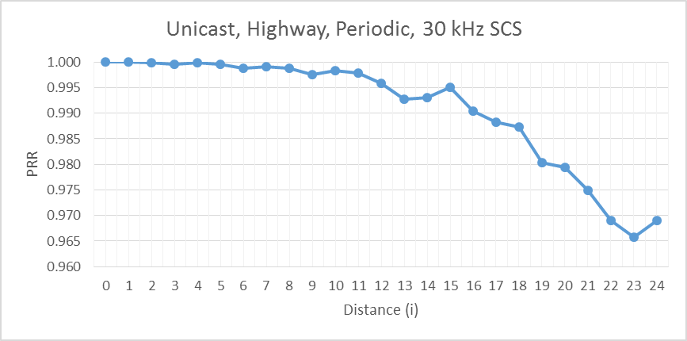
Source 3
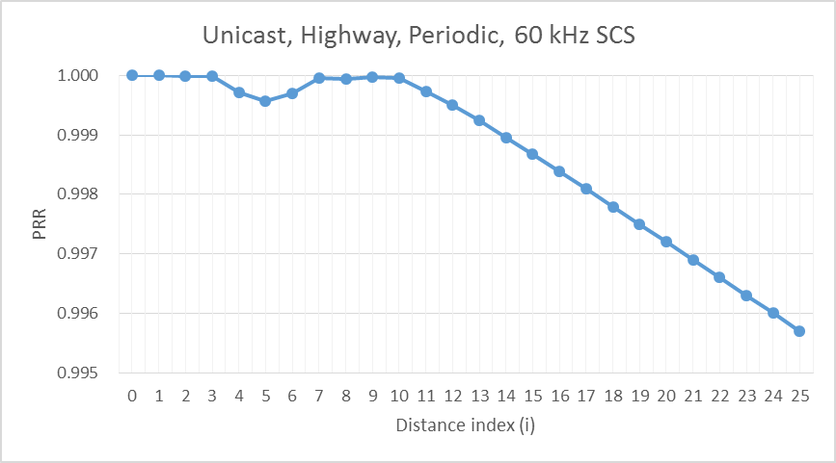
Source 4
Source 5
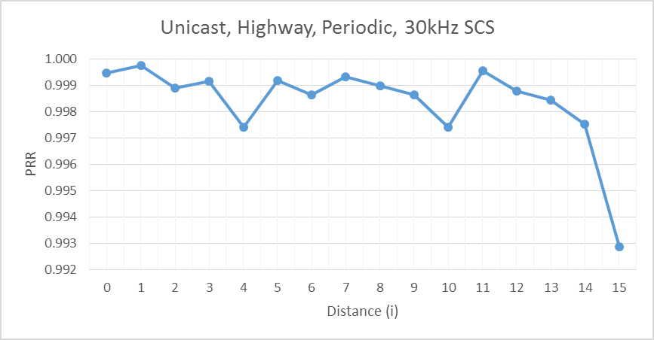
Source 6
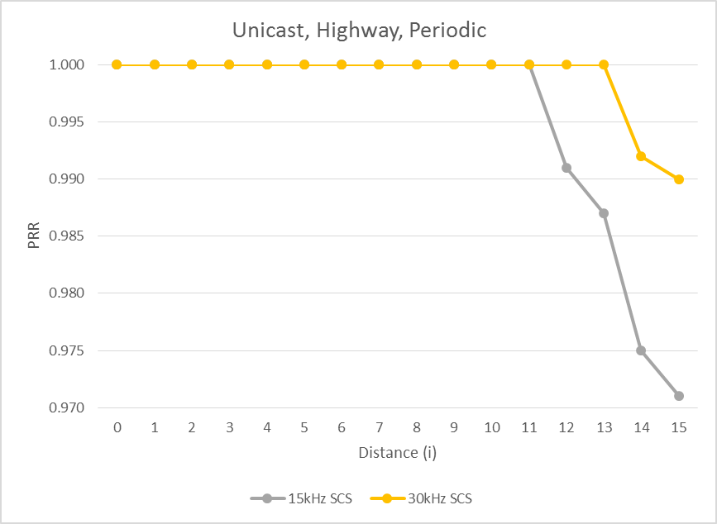
Source 7
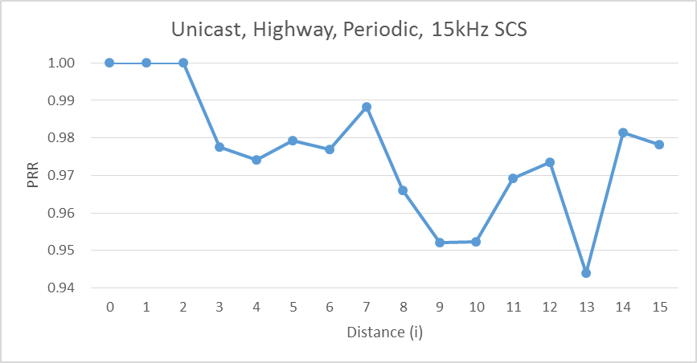
Highway aperiodic scenario
Source1

Source 2
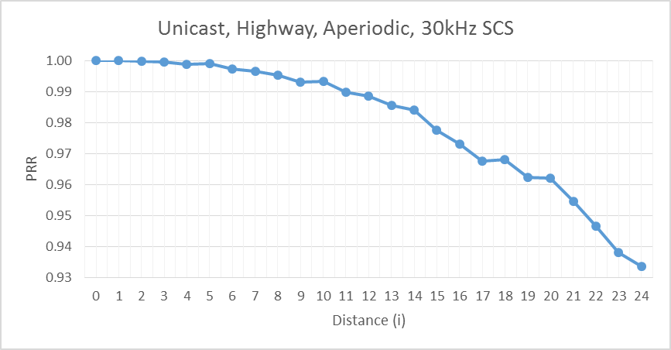
Source 3
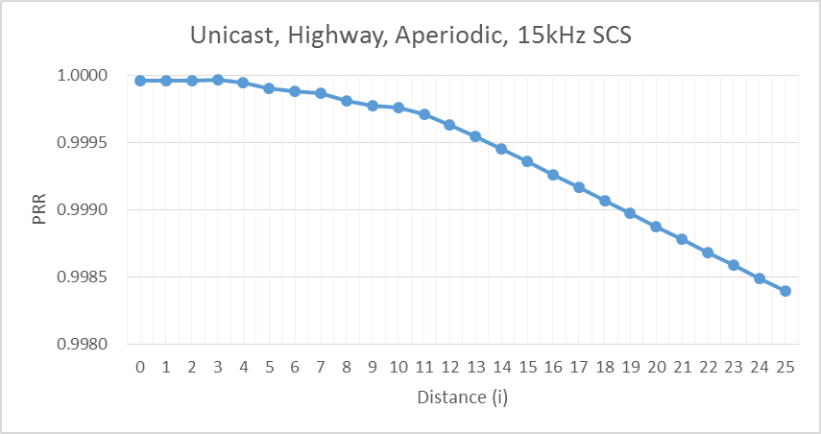
Source 4
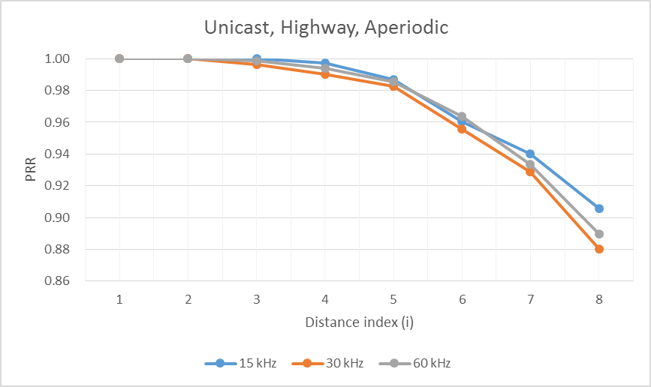
Source 5
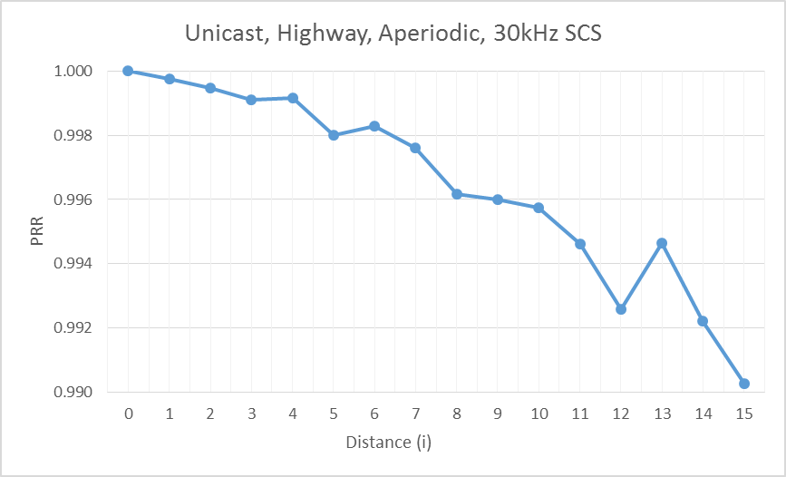
Source 6
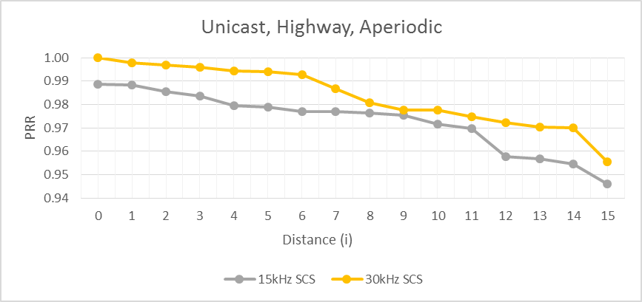
Source 7
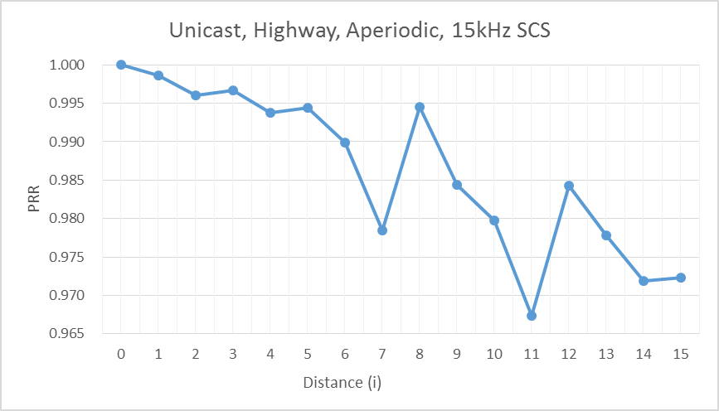
Urban periodic scenario
Source1

Source 2
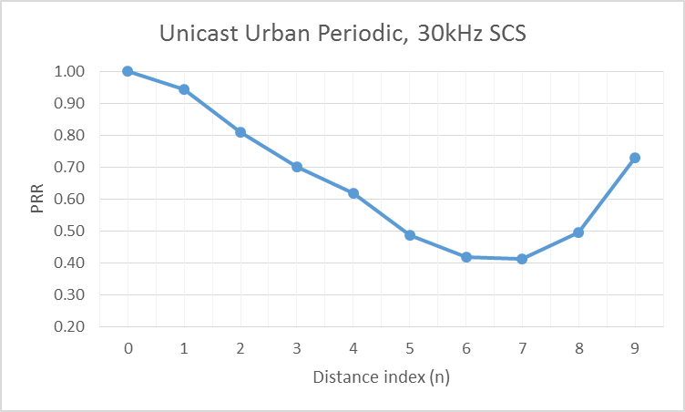
Source 3
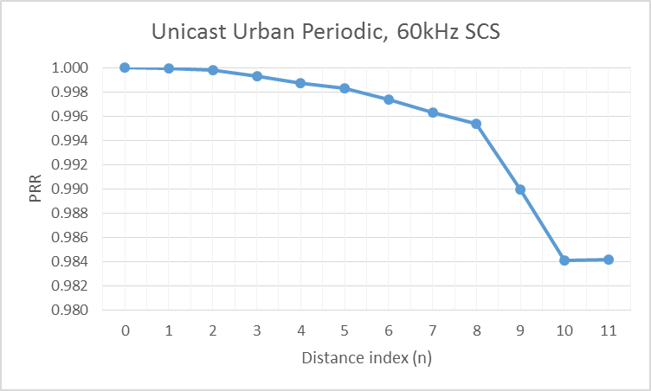
Source 5
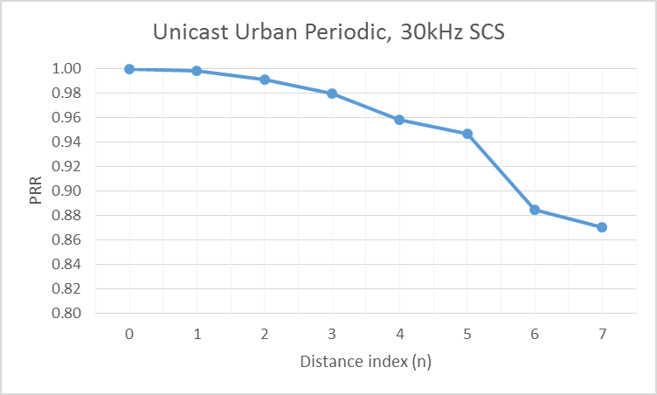
Source 6
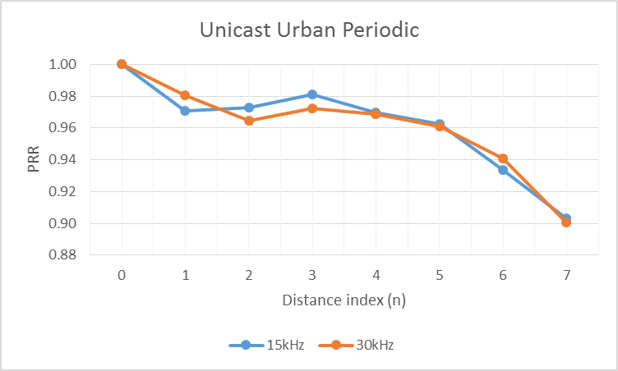
Source 7
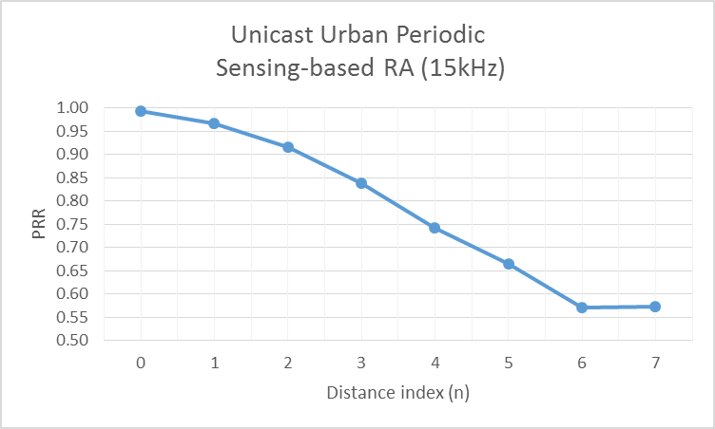
Urban aperiodic scenario
Source1

Source 2
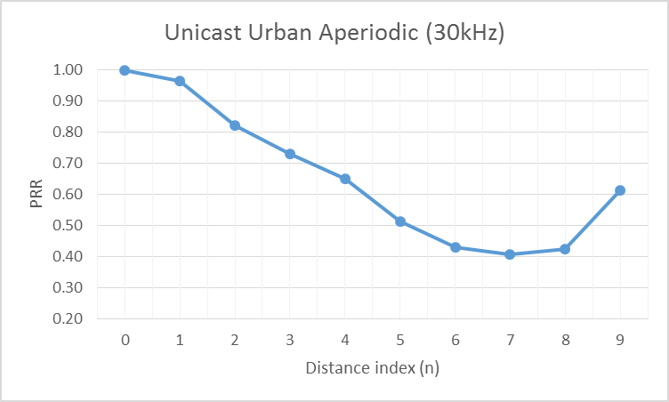
Source 3
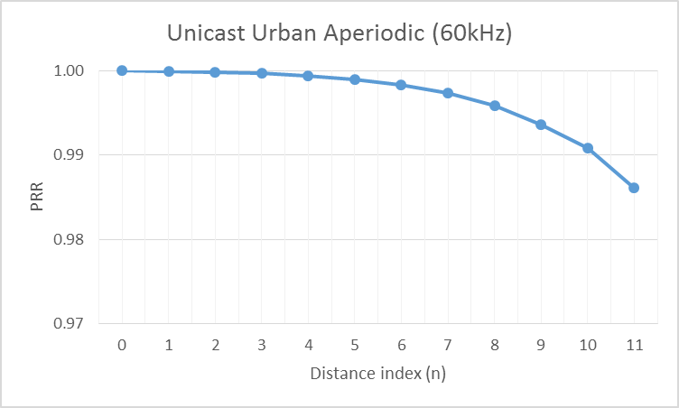
Source 5
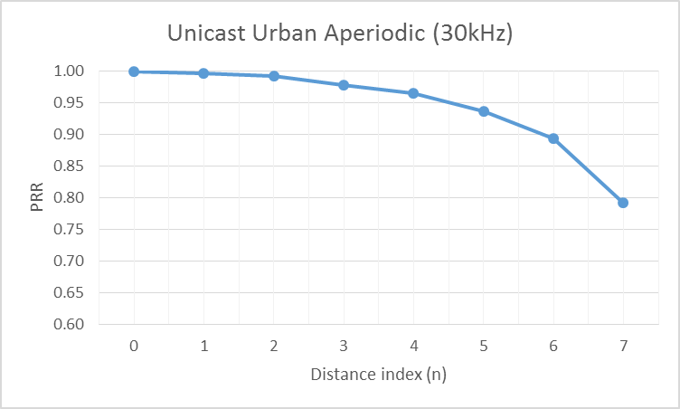
Source 6
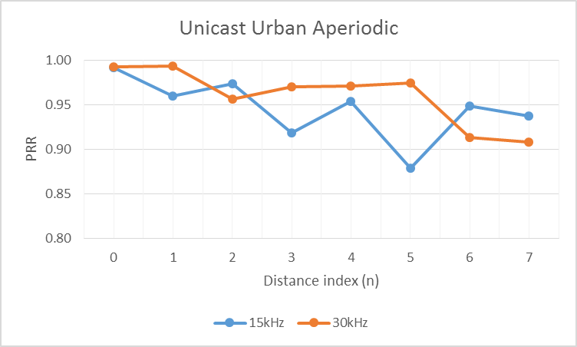
Source 7
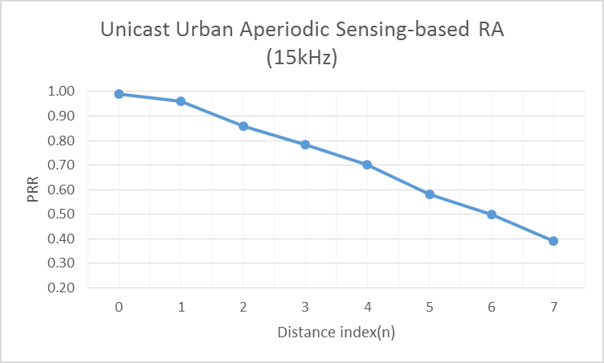

B.2.2.2 Groupcast
Highway periodic scenario
Source 1
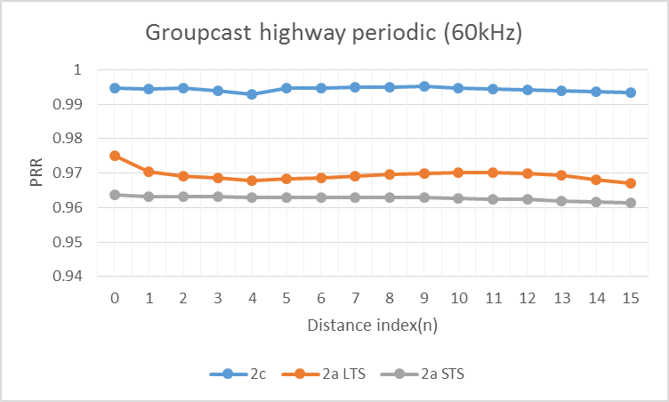
Source 2
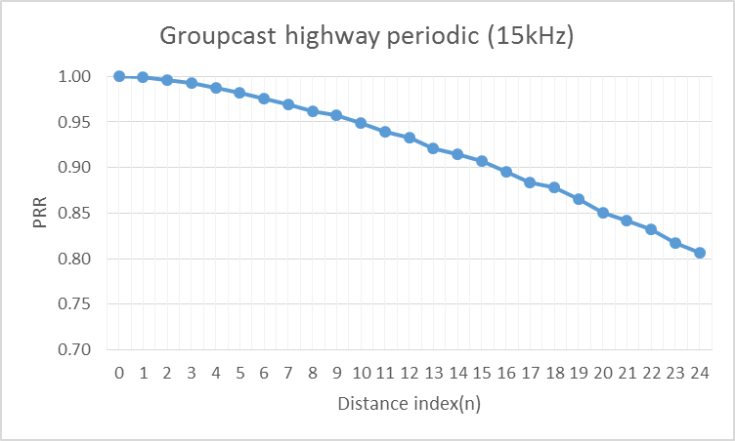
Source 3
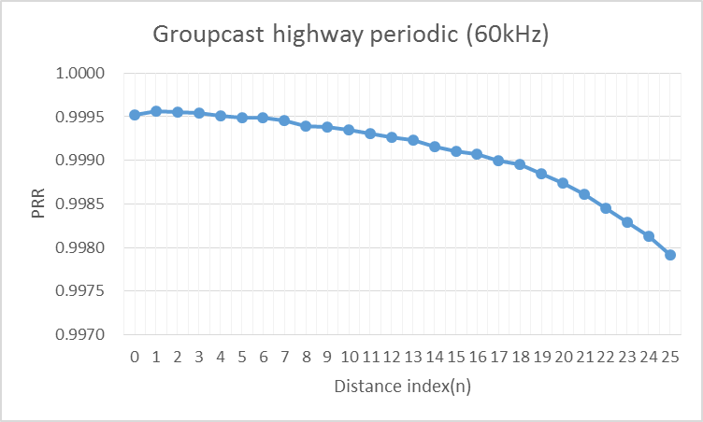
Source 4
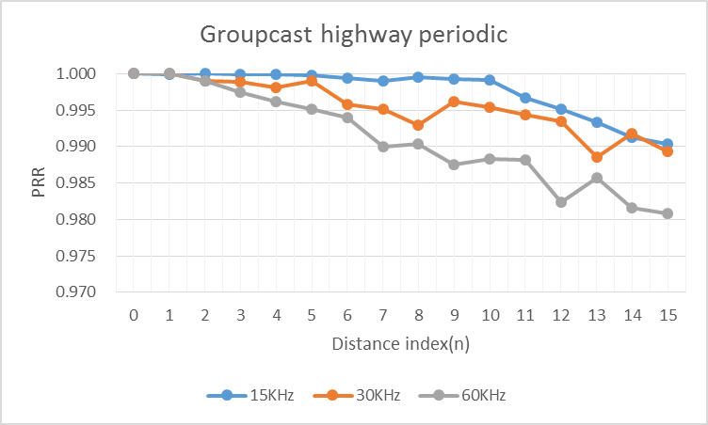
Source 5
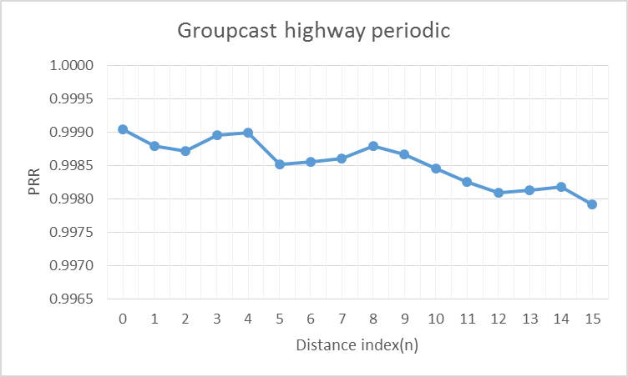
Source 6
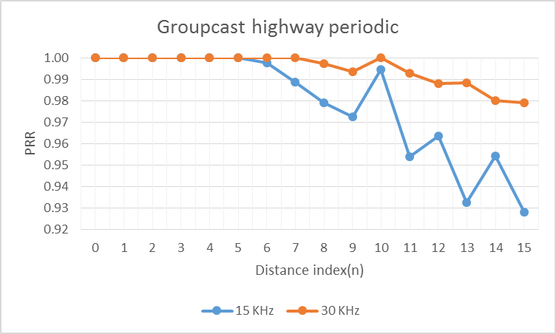
Source 7
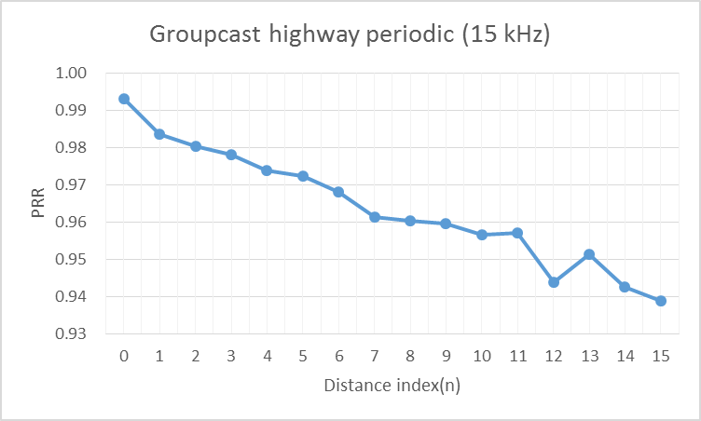
Source 8
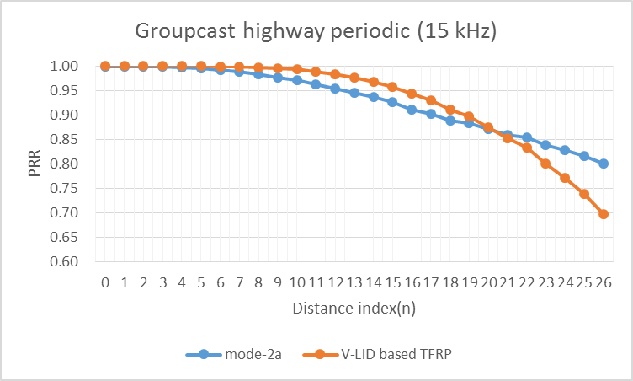
Highway aperiodic scenario
Source 1
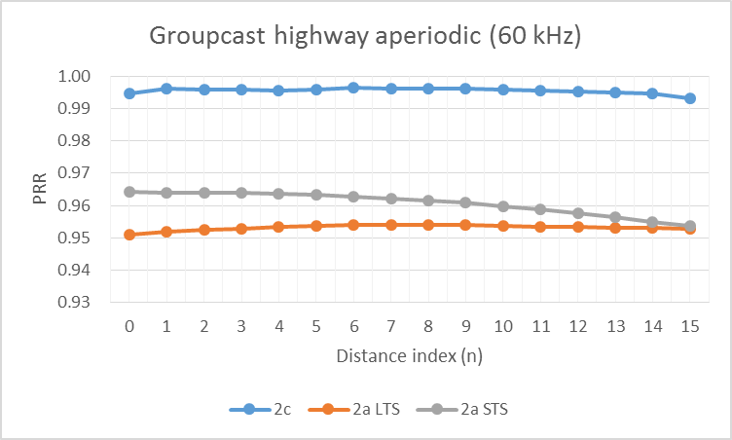
Source 2
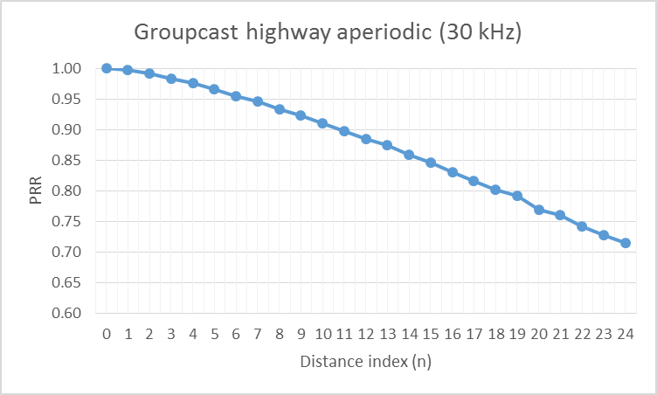
Source 3
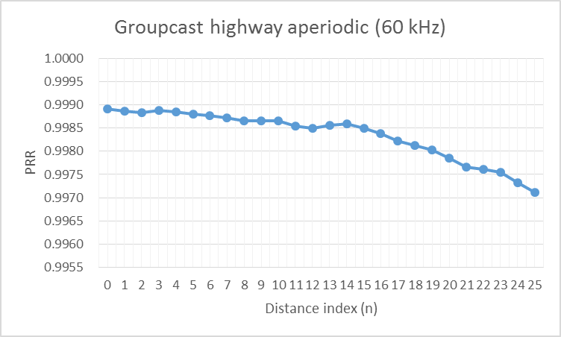
Source 4
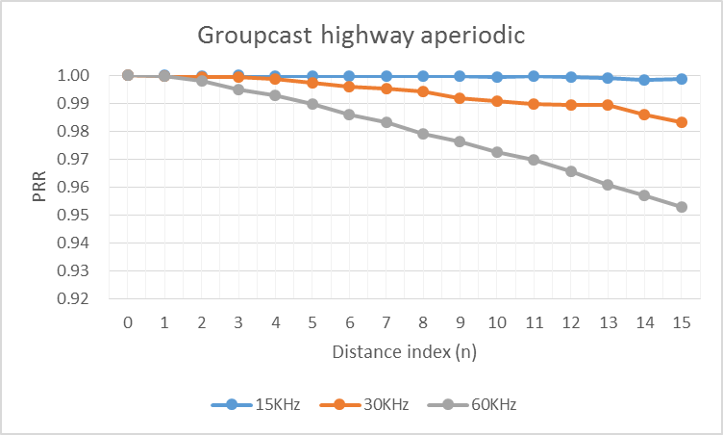
Source 5
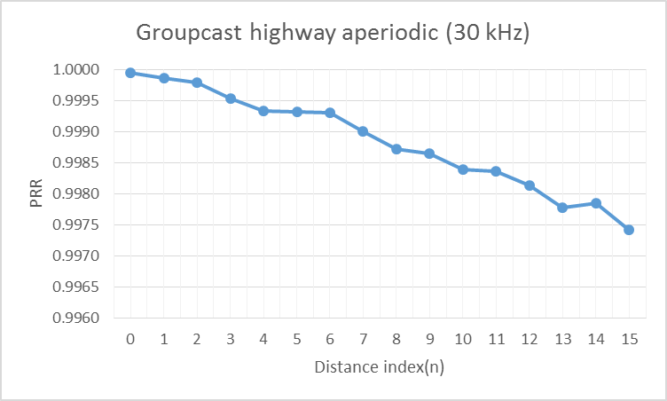
Source 6
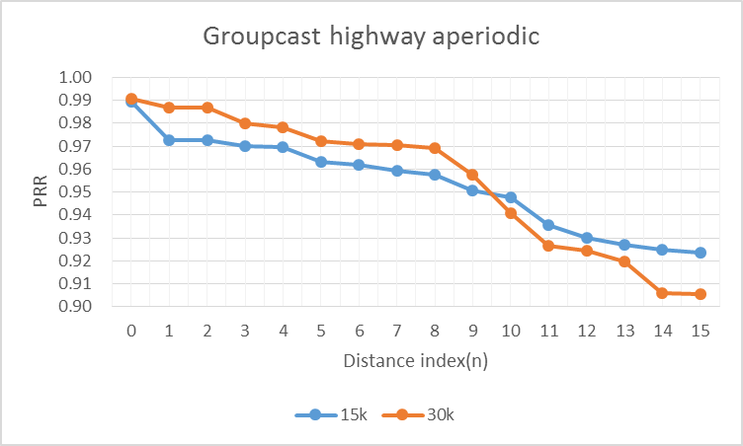
Source 7
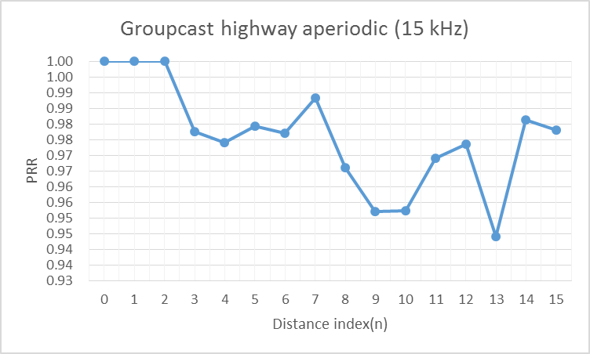
Source 8
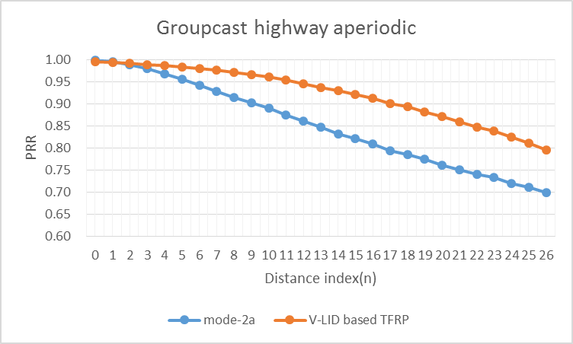
Urban periodic scenario
Source 1
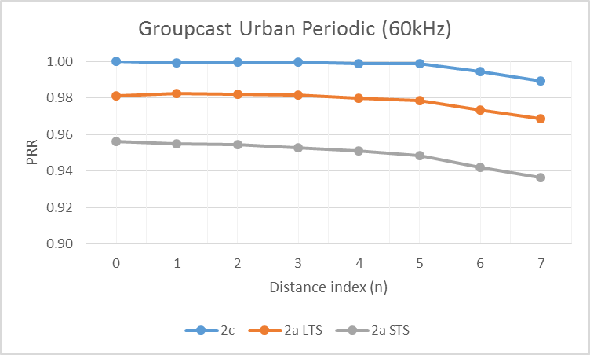
Source 2
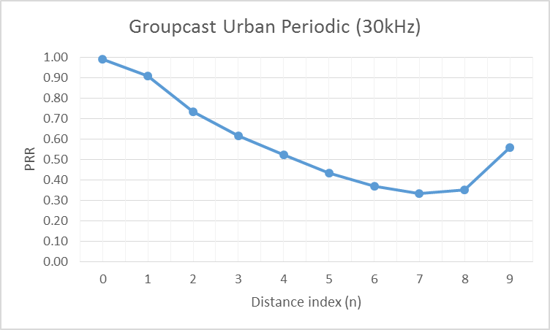
Source 3
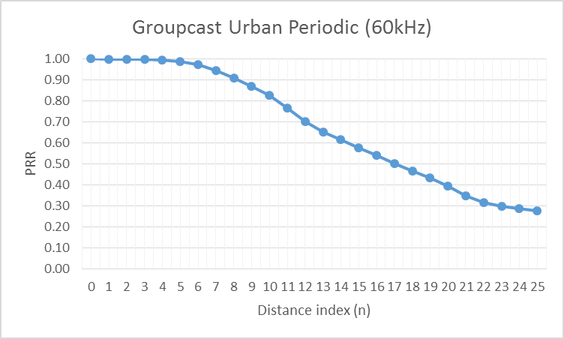
Source 5
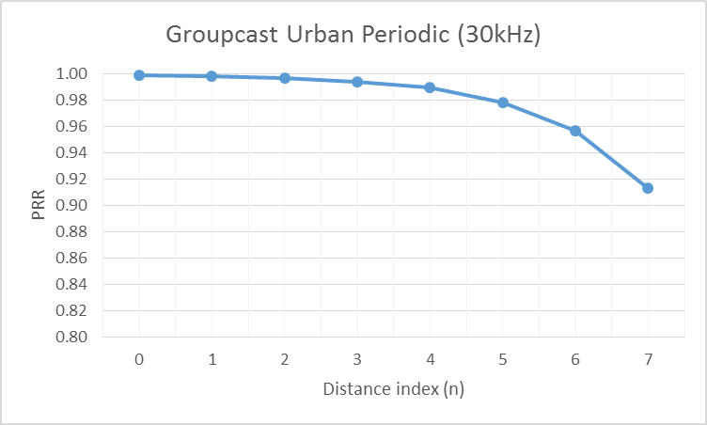
Source 6
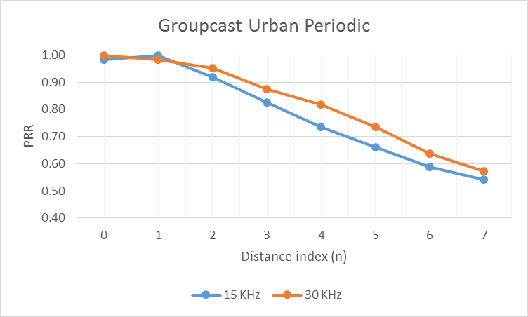
Urban aperiodic scenario
Source 1
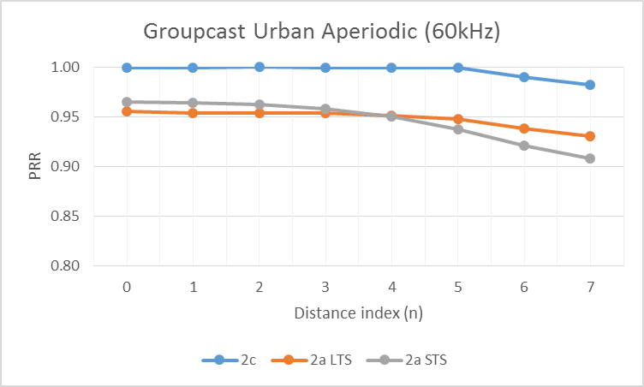
Source 2
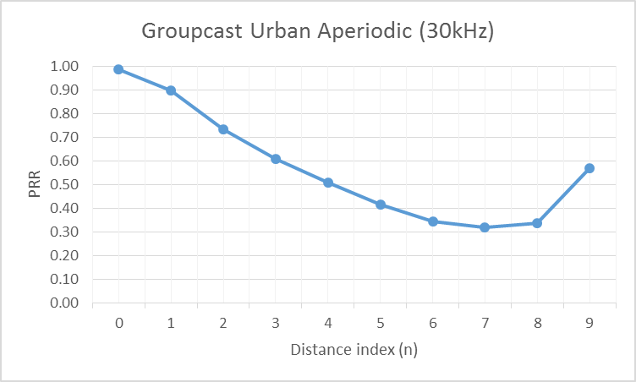
Source 3
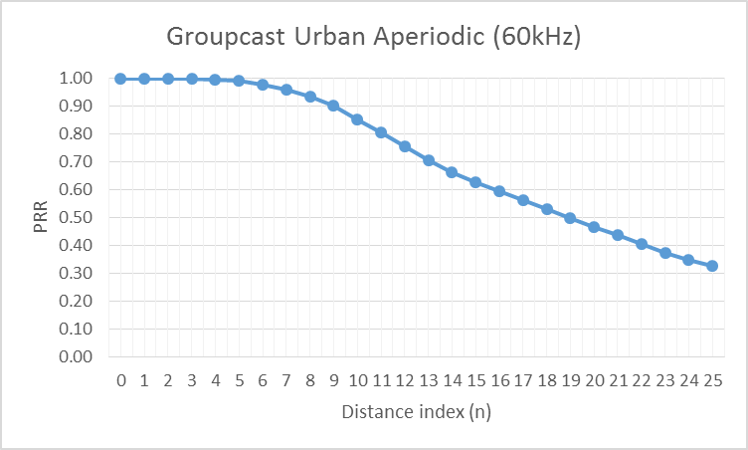
Source 5
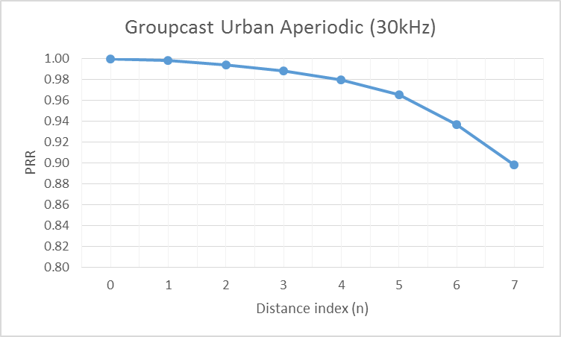
Source 6
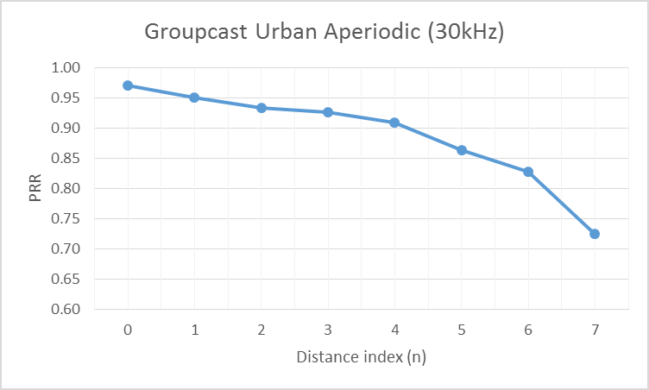

B.2.2.3 Broadcast
Highway periodic scenario
Source 1
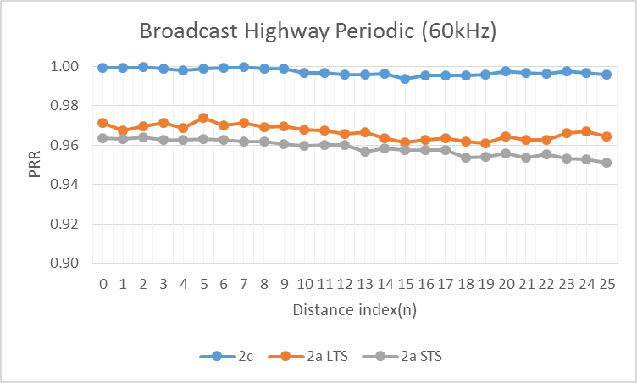
Source 2
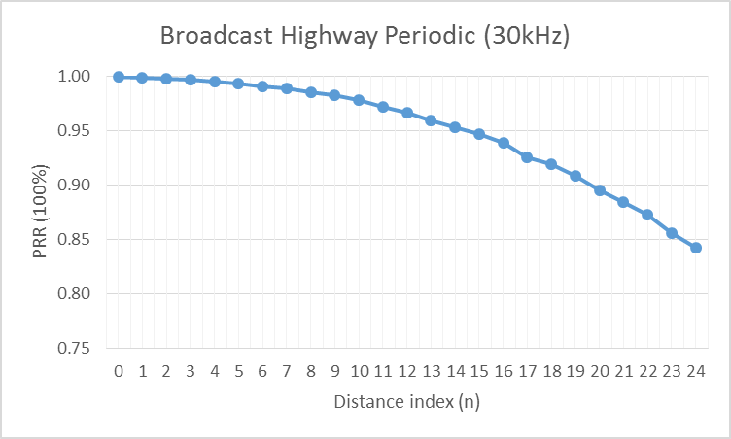
Source 3
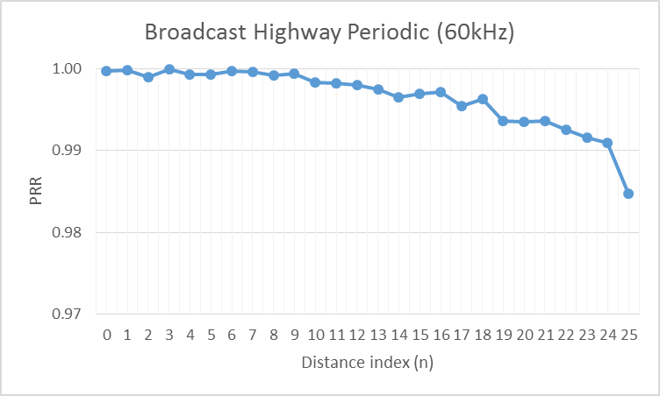
Source 4
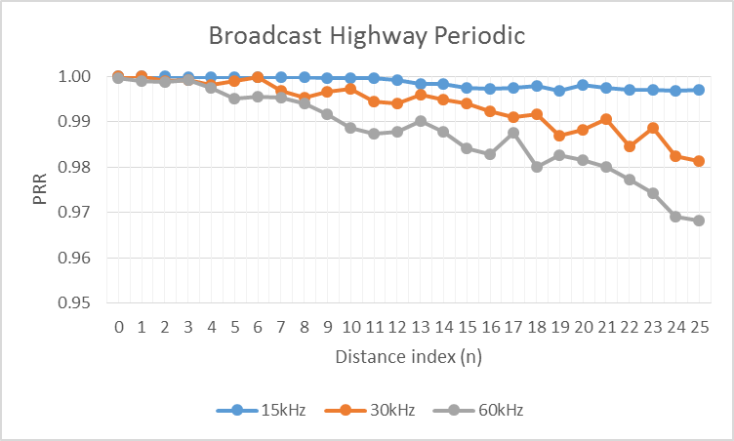
Source 5
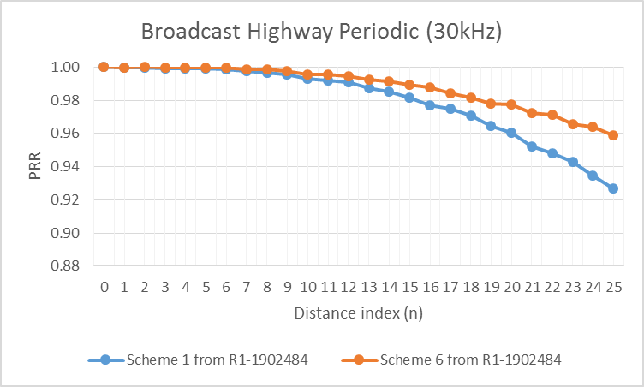
Source 6
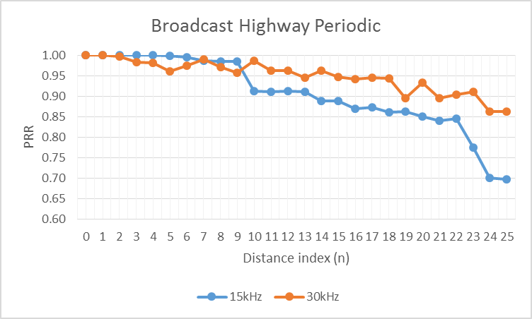
Source 7
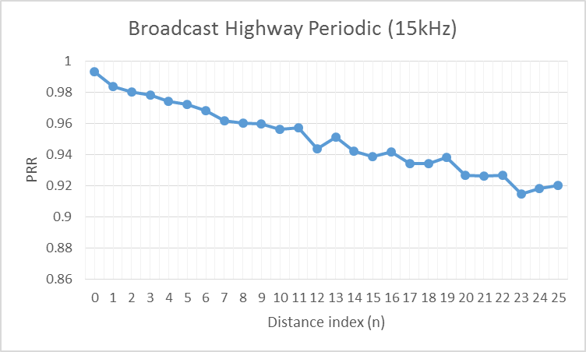
Source 9
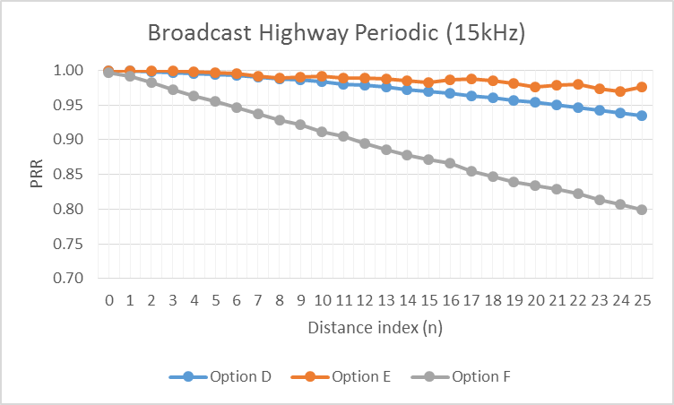
Source 11
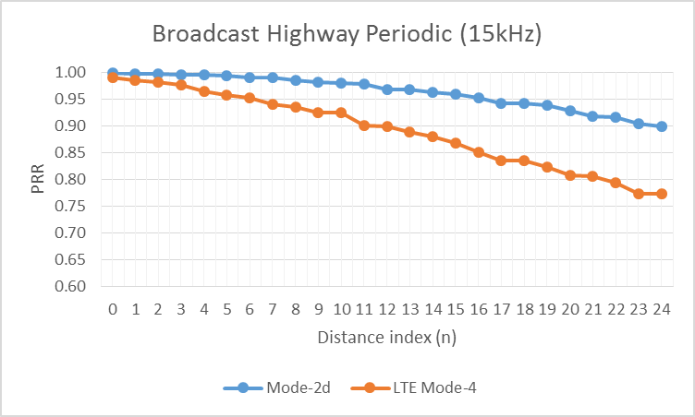
Source 13
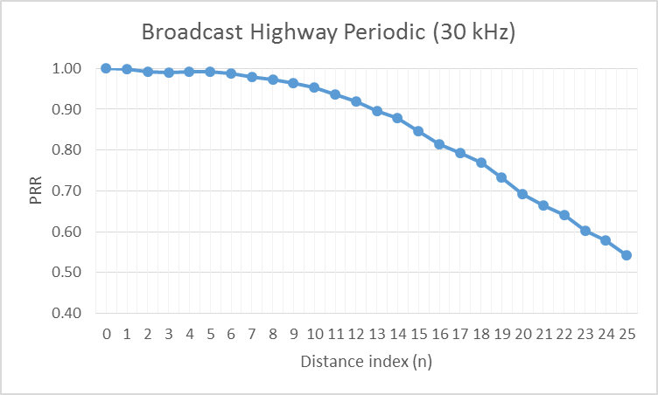
Highway aperiodic scenario
Source 1
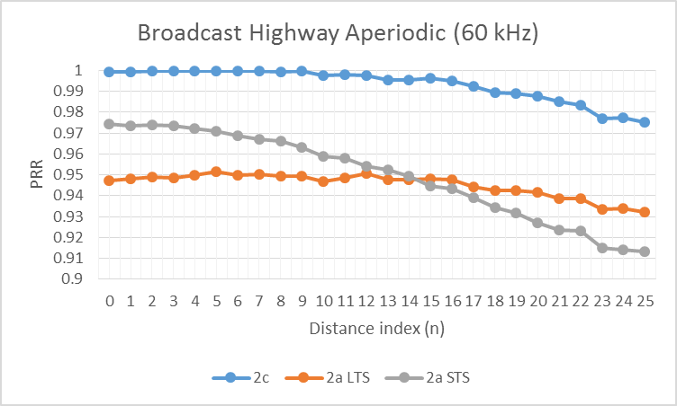
Source 2
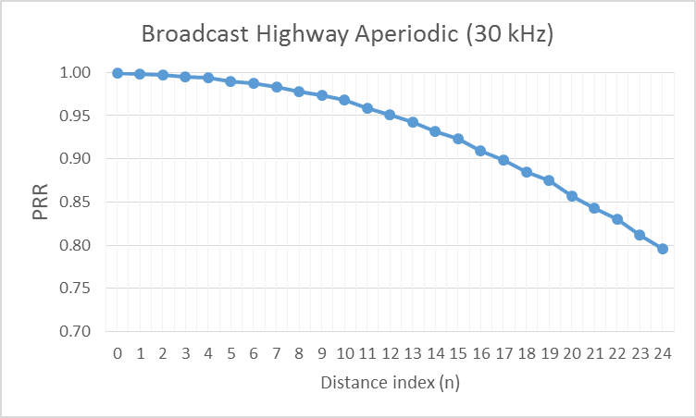
Source 3
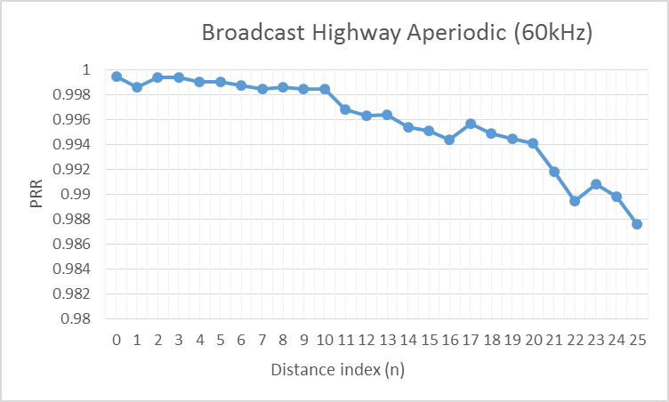
Source 4
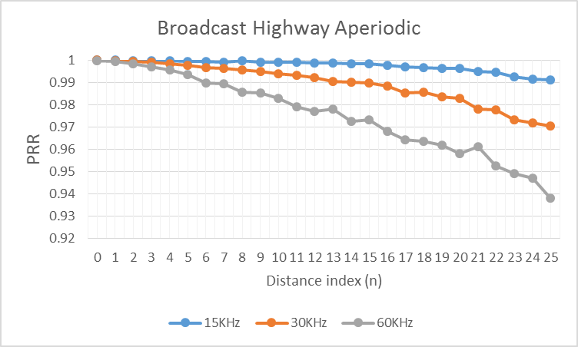
Source 5
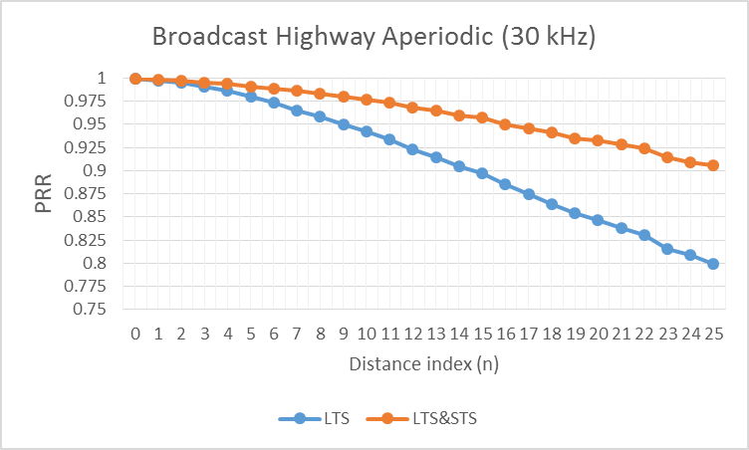
Source 6
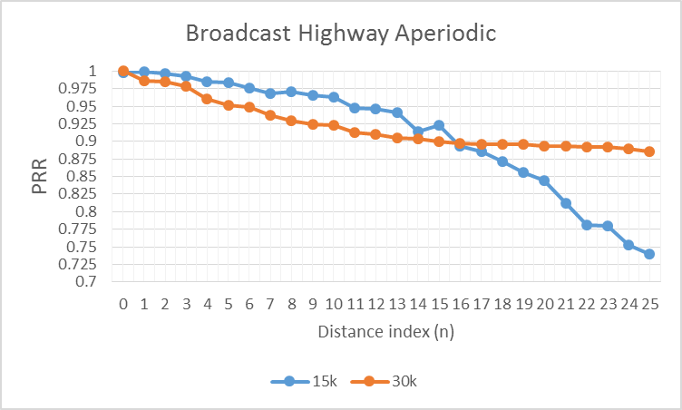
Source 7
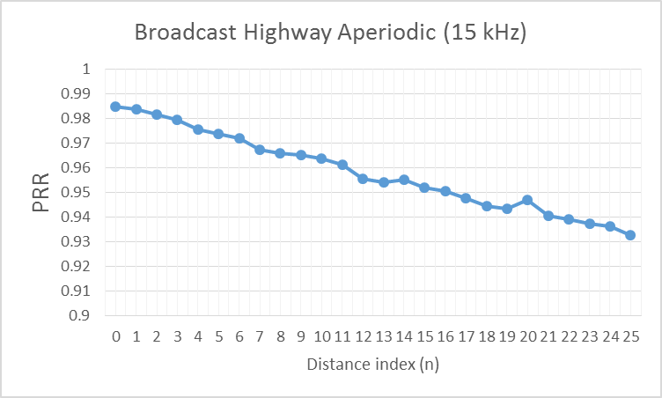
Source 9
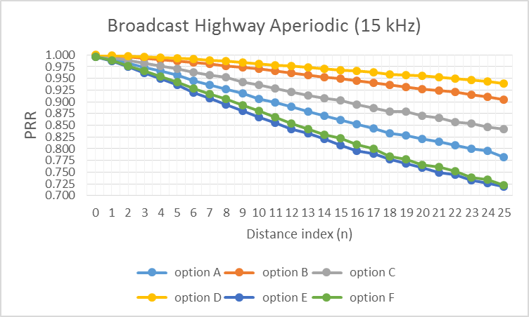
Source 10
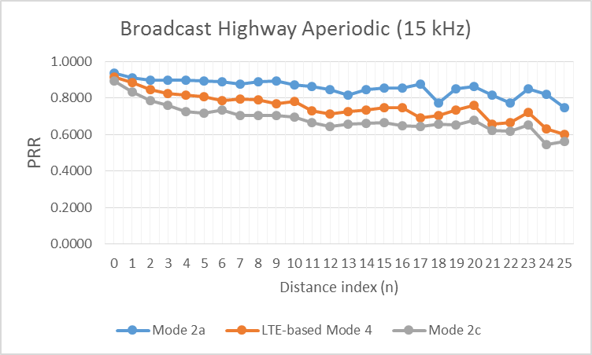
Source 11
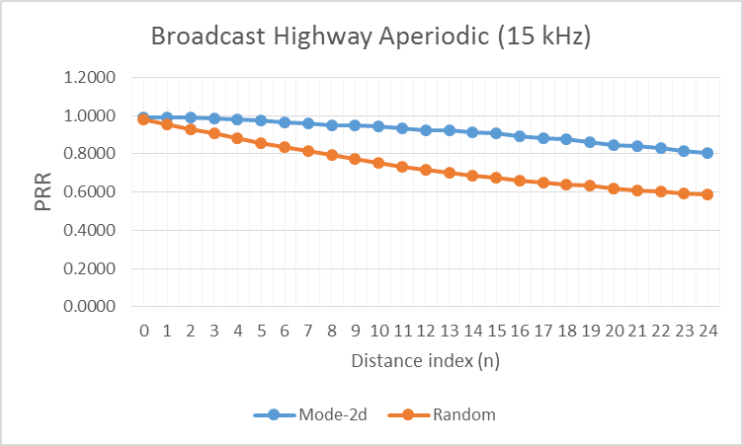
Source 12
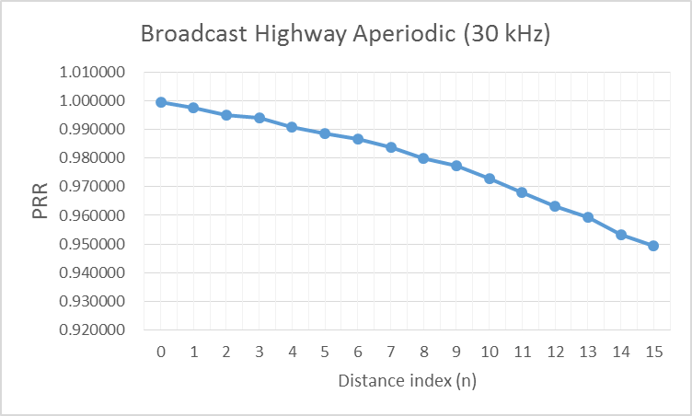
Source 13
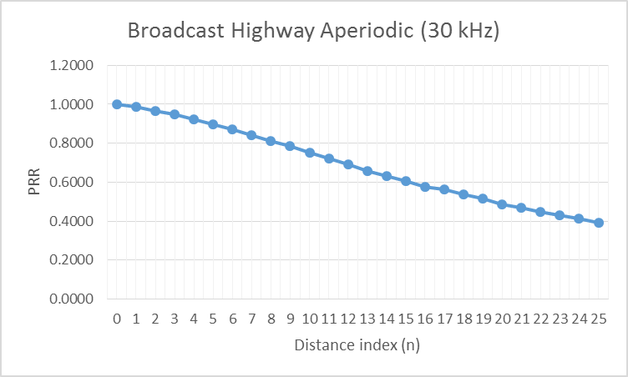
Urban periodic scenario
Source 1
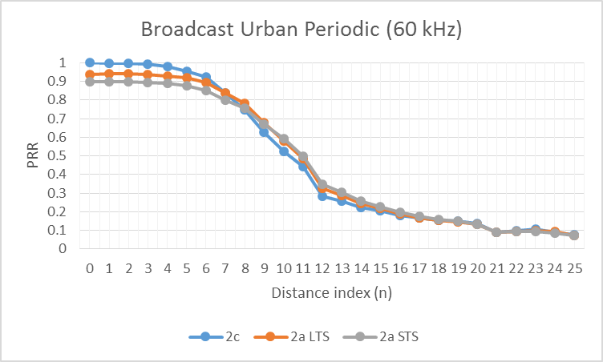
Source 2
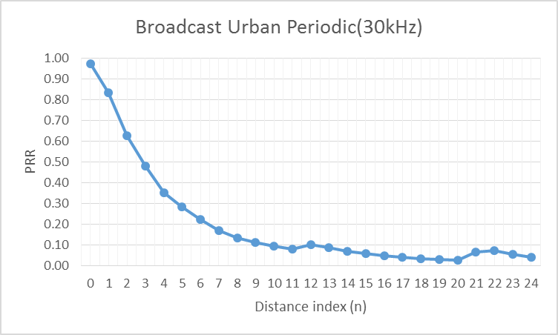
Source 3
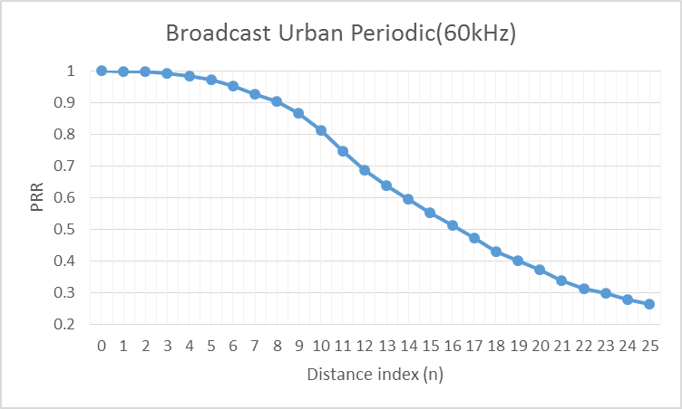
Source 5
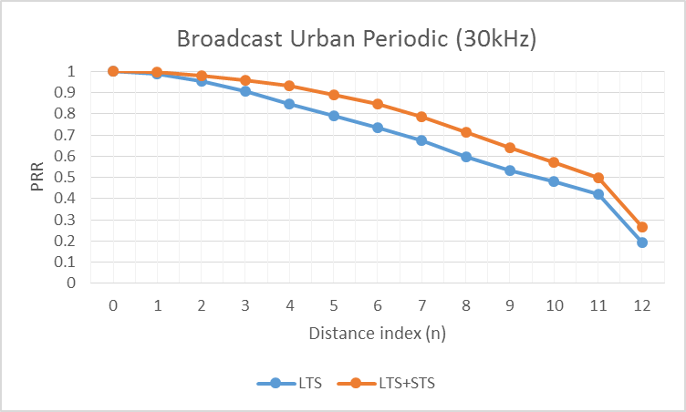
Source 6
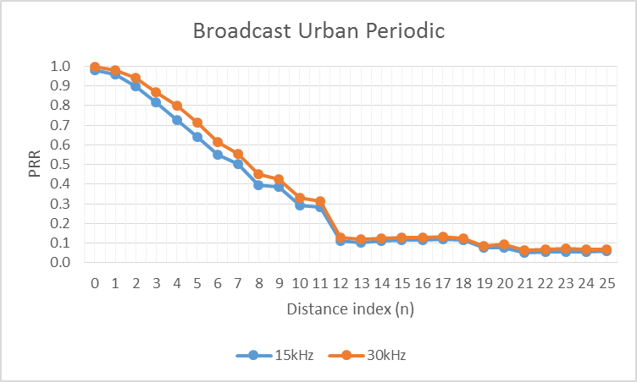
Source 7
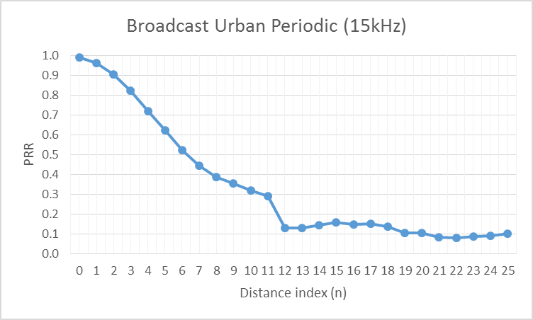
Source 11
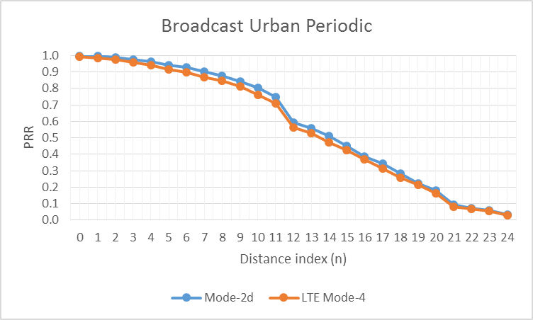
Source 14
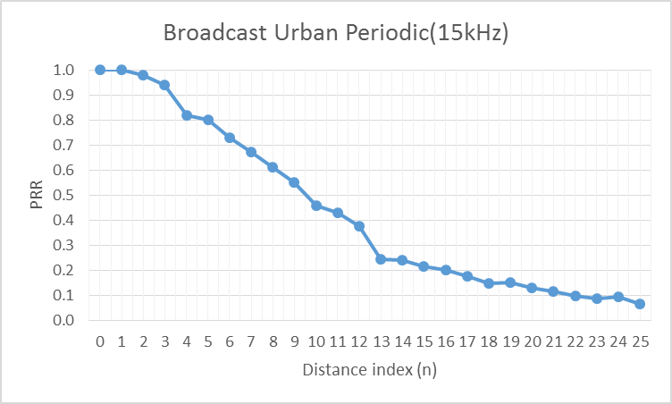
Urban aperiodic scenario
Source 1
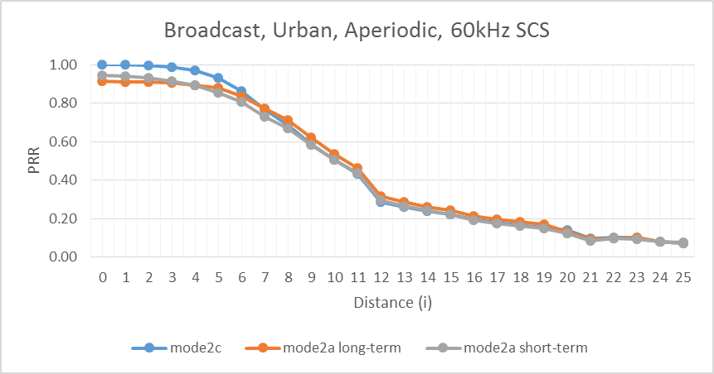
Source 2
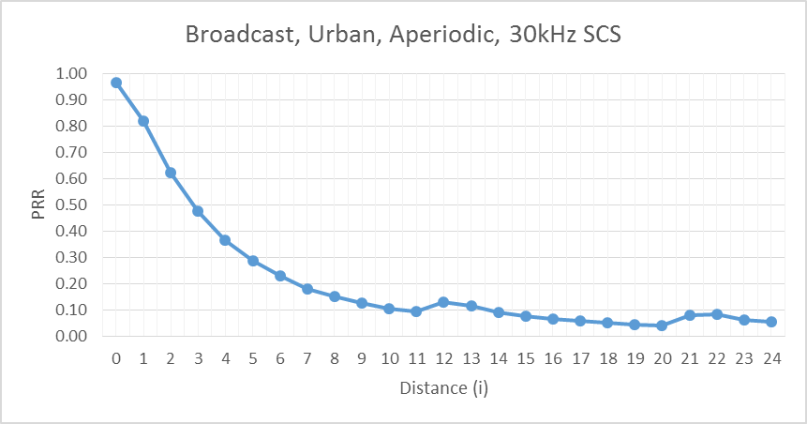
Source 3
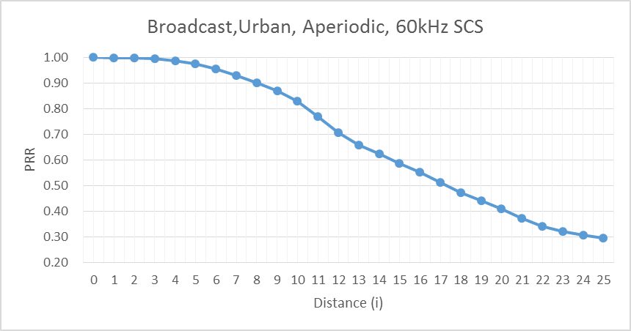
Source 5
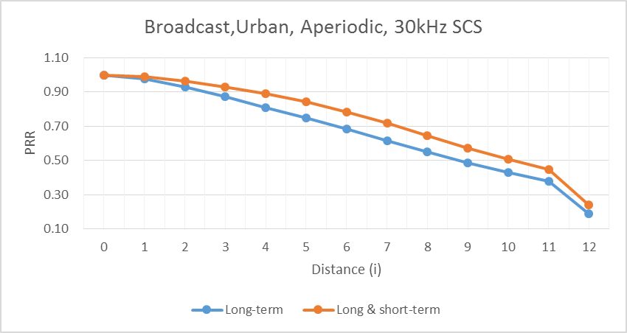
Source 6
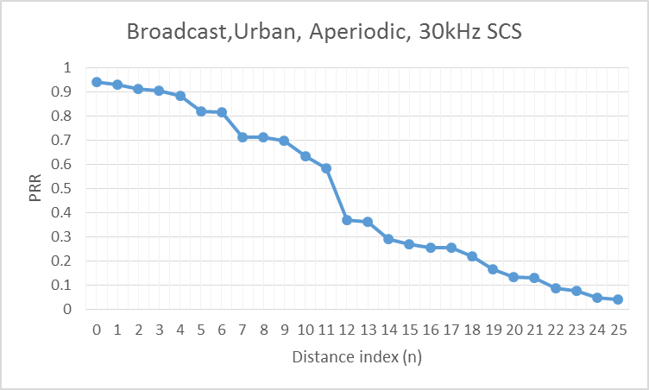
Source 7
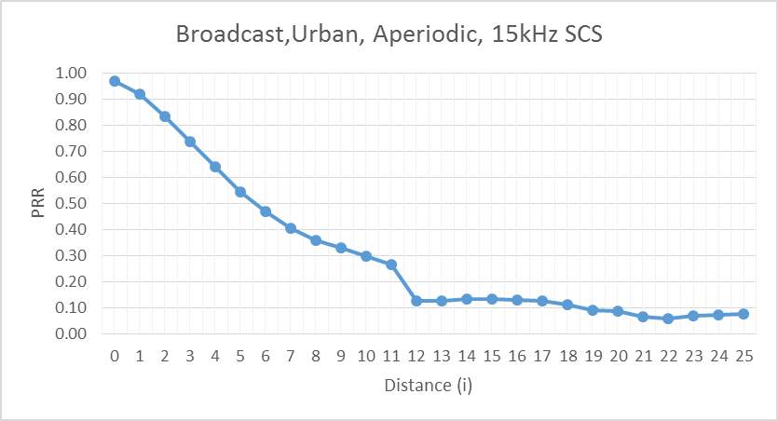
Source 10
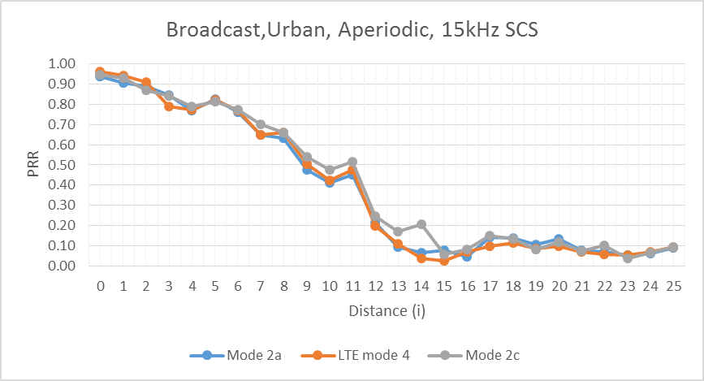
Source 11
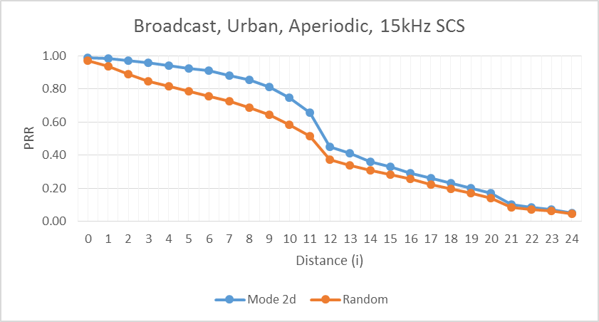
Source 12
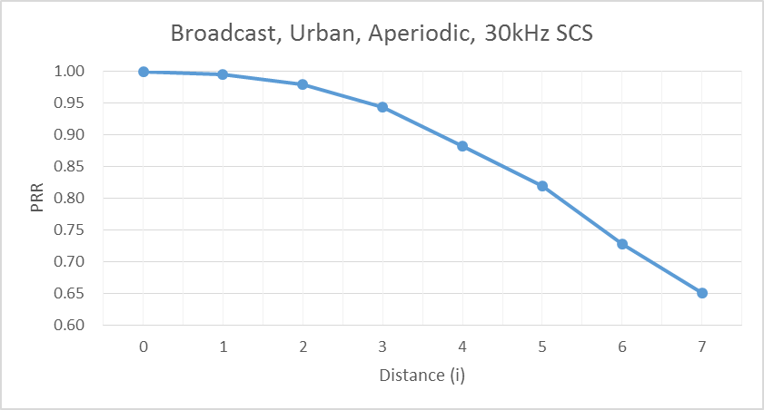

Annex C: Detailed evaluation results for synchronization

C.1 S-SSB detection

C.1.1 Simulation assumptions
This section shows the detailed results used to report the evaluations of S-SSB design combination performance in Section 11. Table C.1-1 shows the simulation assumptions used by each sourcing company.
Table C.1-1: S-SSB simulation assumptions
 | Source 1 | Source 2 | Source 3 | Source 4 | Source 5 | Source 6 | Source 7 | Source 8 | Source 9
Number of antennas | 2Tx*4Rx | 2Tx*2Rx | 2Tx*2Rx | 2Tx*2Rx | 2Tx*2Rx | 2Tx*2Rx | 2Tx*2Rx | 2Tx*2Rx | 2Tx*2Rx
CDL channel model | CDL V2X Urban NLOS | CDL V2X Urban NLOS | CDL-C | CDL V2X Urban NLOS | CDL V2X Urban NLOS | CDL V2X highway LOS/NLOSv | CDL V2X Urban LOS | CDL-C | CDL V2X Urban LOS
UE speed | 240 km/h | 240 km/h | 240 km/h | 240 km/h | 240 km/h | 240 km/h | 240 km/h | 240 km/h | 240 km/h
Interference scenario | 1 | 1 | 1 | 1 | 1 | 1 | 1 | 1 | 1

C.1.2 Detailed results
Source 1
Source 2
Source 3
Source 4
Source 5
Source 6

Source 7

Source 8
Source 9

C.2 PSBCH decoding
This section shows the detailed results used to report the evaluations of PSBCH performance in Section 11. Table C.1-1 shows the simulation assumptions used by each sourcing company.
Source 1
Source 2
Source 4
Source 7

