3GPP Call on modernization of 3GPP tools #3 6GSM-250214+Samsung

Electronic, 9th October 2025

Source: Nokia
Title: pCR on Proposal for new format for 3GPP specifications
Document for: Approval
Agenda item: 4
Spec: 3GPP TR21.802
Version: 0.1.1
Work Item: FS_ 6GSpecs

Comments
This pCR proposes a solution to write the 3GPP specifications in Markdown augmented by a small set of processing scripts to handle specialized features of our specifications. The description within demonstrates that Markdown can be used to write 3GPP specifications and present them in a professional manner. In this initial version of the solution description, the tools related to the editing of the new format are not discussed as it is intended to introduce them in a subsequent meeting.

Proposed Changes
* * * First Change * * * *

5 Proposals for new formats for 3GPP specifications
Editor's note: corresponds to objective 2.

5.X Proposal #X Markdown

5.X.1 Description
Markdown is the language used by Wikipedia to write articles. The language is simple and focused on information rather than on formatting. To that end, the language supports a small number of critical features which easily translate into HTML, the target format for conversion from Markdown. From HTML, a further conversion to PDF is supported for publishing. This section will describe the base features of Markdown, extensions to Markdown, and custom processing which was developed to support specific aspects of 3GPP specifications during the research for this solution.

5.X.1.1 Benefits of Markdown
As described in the previous section, Markdown separates information from styles. A major pain point with the way specifications are written in 5G is that it is difficult to properly select styles and that time is wasted on non-technical work. Markdown has the potential to solve this challenge to writing the specifications and the p/CRs to the specifications, which is using and maintaining the correct styles. Styles are eventually applied to the HTML file, resulting from the conversion from Markdown, through the use of Cascading Style Sheets (CSS), which can be used to apply fonts, font sizes, font colours, list styles, table header styles, and more. An additional benefit of applying styles in this manner is that it is easier to maintain a consistent appearance throughout the specifications.
A second benefit of Markdown is that the format is purely plaintext and sequential, which is required for use with modern version control tools. A docx file is different in that it is a zip file containing multiple XML files and resources such as images and different filetypes supported by docx. Prior to being extracted or opened, a docx file is a binary file, incompatible with modern version control tools. In order to compare between two version of the same document, it is necessary that the text is human-readable. The sequential nature of the Markdown file makes it simpler to identify changes because they will be localized.
A third benefit is increased performance of editing tools. When editing plaintext Markdown without rendering or preview, text editors work efficiently without crashing. There are many options for text editors, including Microsoft Visual Studio Code, Notepad++, Notepad, Emacs, and many others, depending on the user’s preference. Even with large specifications, the performance is high because fonts and images do not need to be rendered and pagination is unnecessary.
NOTE: It is essential for usability that it is possible for a user editing a CR to see be able to see the fully rendered CR, including all content - text, figures, etc.
Given the wide adoption of Markdown, there are a variety of methods to preview a rendered version of the Markdown file. One example from Microsoft Visual Studio Code, a free tool, is shown in Figure 5.X.1.1-1 below.
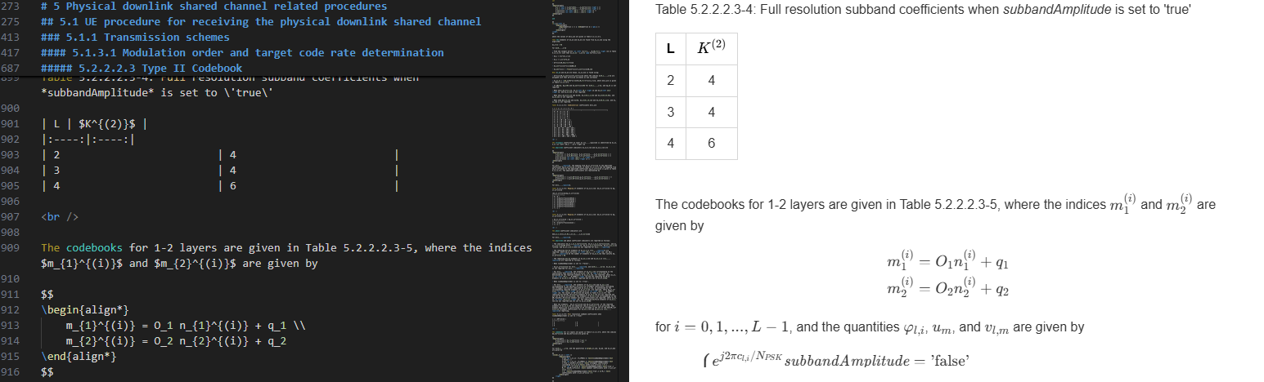
Figure 5.X.1.1-1: Markdown preview in Visual Studio Code
The sections that follow describe the base features of Markdown, commonly used extensions to Markdown, and custom 3GPP extensions to Markdown using Pandoc. Then, the high-level process to convert from Markdown to HTML and PDF will be described.

5.X.1.2 Base features of Markdown
Markdown without extensions supports the following base features, described in Table 5.X.1.2-1. These features apply to the blocks named “Source” and “Images” in Figure 5.X.1.1-2. The table names each feature and demonstrates the Markdown and HTML syntax. Because the rendered output of Markdown is represented in an HTML file, an image of the rendered output is provided in the HTML column.
Table 5.X.1.2-1: Basic features of Markdown
Feature | Markdown | HTML | Notes
Heading | # Heading 1  ## Heading 2  …  ###### Heading 6 | <h1> Heading 1 </h1>  <h2> Heading 2 </h2>  …  <h6> Heading 6 </h6>  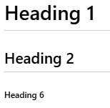 | Limited to 6 levels. A style specific to each heading level can be applied through CSS, which enables different font sizes for each heading as shown in the example.
Image | ![](path) | <img src=”path” /> | Path is the destination, i.e., the image being pointed to, e.g., fig_5.X.1.2-1.svg.  Use of this approach is not customizable as it is in Microsoft Word, e.g. to adjust the width or to center the image. All images will be rendered according to the default style for IMG. This is not a problem, but it is a reduction of the 'freedom' that exists in the use of MS Word.
Link | [text](path) | <a href=”path”>text</a> | Text is the text which would be presented as a clickable link, and path is the destination, i.e., the page or resource being linked, e.g., path.html.
List (Ordered) | 1. Item 1  2. Item 2 | <ol>  <li>Item 1</li>  <li>Item 2</li>  </ol>  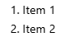
List (Unordered) | - Item 1  - Item 2  - Sub Item 2-1 | <ul>  <li>Item 1</li>  <li>Item 2</li>  <ul>  <li>Sub Item 2-1</li>  </ul>  </ul>  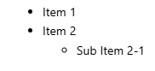 | The bullet style is set by the HTML stylesheet.
Table (Simple) – Pipe Table | | Header 1 | Header 2 |  |------------|-------------|  | Cell 1-1 | Cell 2-1 |  | Cell 1-2 | Cell 2-2 | | <table>  <thead>  <tr>  <th>Header 1</th>  <th>Header 2</th>  </tr>  </thead>  <tr>  <td>Cell 1-1</td>  <td>Cell 2-1</td>  </tr>  <tr>  <td>Cell 1-2</td>  <td>Cell 2-2</td>  </tr>  </table>  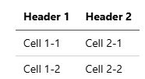 | This type of table supports word-wrapping in cells and supports multi-line cells with manual break tags (<br>). Merged cells are not supported.  For pipe tables, each row has to be in a single line (with now carriage returns): this is very difficult for a person to read, especially as a table.  For grid based tables as shown in Markdown, it is extremely difficult for a person to write or modify, since one must manually draw the text based grid, though it is possible to read.  NOTE: The above description of pipe tables and grid tables in markdown are not evaluation considerations. These are objective usability aspects.
Text Decoration (Bold) | **text** | <strong>text</strong> | Example: text
Text Decoration (Italic) | *text* | <em>text</em> | Example: text
Text Decoration (Bold+Italic) | ***text*** | <strong><em>text</em></strong> | Example: text

5.X.1.3 Extended features of Markdown
Markdown has been extended to add more features such as equation rendering, superscript and subscript, and grid tables, which enable tables with merged cells. Many popular extensions exist, including GitLab-flavoured Markdown (https://docs.gitlab.com/user/markdown/), but a specific extended Markdown version will not be explicitly discussed. Table 5.X.1.3-1 describes extended features of Markdown which could be useful in 3GPP specifications.
Table 5.X.1.3-1: Extended features of Markdown
Feature | Markdown | HTML | Notes
Equation (Block) | C(x,y)=\left \{  \begin{align*}  \begin{pmatrix} x \\ y \end{pmatrix} & x \geq y \\  0 & x < y  \end{align*}  \right. | MathML Conversion (not shown) or Image  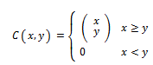 | Equations are written in the Latex format.  MathML not shown due to complexity and would not be directly entered or edited.  The block equation is entered between $$ and $$ and line breaks in the equation are supported.
Equation (Inline) | that satisfy $k_{l,i}^{(1)} > 0$, $i \neq i_{1,3,l}$, as | MathML Conversion (not shown) or Image | Equations are written in the Latex format.  MathML not shown due to complexity and would not be directly entered or edited.  The inline equation is entered between $ and $ without any line breaks in the equation.
Subscript | base~lower~ | base<sub>lower</sub> | Example: base_{lower}
Superscript | base^upper^ | base<sup>upper</sup> | Example: base^{upper}
Table (Complex) – Grid Table | +----------+----------+  | Header 1 | Header 2 |  +==========+==========+  | Cell 1-1 | Cell 2-1 |  +----------+----------+  | Merged Cell 1 |  +---------------------+ | <table>  <thead>  <tr>  <th>Header 1</th>  <th>Header 2</th>  </tr>  </thead>  <tr>  <td>Cell 1-1</td>  <td>Cell 2-1</td>  </tr>  <tr>  <td colspan="2">Merged Cell 1</td>  </tr>  </table>  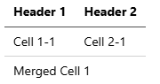 | This type of table supports multi-line cells and merged cells. Cell alignment must be manually maintained using spaces.

A guide to the Latex equation format can be found at https://tug.ctan.org/info/undergradmath/undergradmath.pdf. In the HTML format, either MathML or images in the SVG format can be used to render the equations, and in the PDF format, the image representation is necessary. Additionally, WYSIWYG editors for Latex equations are available as standalone software available offline and as online tools. In either case, an existing equation could be loaded for editing or the tool could be used to create a new equation. The result would then be copied into the Markdown file directly.

5.X.1.4 3GPP extensions to Markdown with custom processing
To support elements which are specific to 3GPP, some extensions to Markdown have been prototyped. These extensions are written in a language called Lua (https://www.lua.org/), for which an interpreter is built directly into Pandoc, the tool used to convert from Markdown to HTML. The benefit of using Lua over other languages is that the Lua interpreter built into Pandoc has direct access to the structure of the document, making it easy to iterate over custom blocks such as those used to produce the examples of Table 5.X.1.4-1.
The most straightforward mechanism to perform custom processing in Markdown is to use the code block delimiter with a custom name. Note that in the Markdown version of each feature, the inline code block starts three tildes (~~~) followed by a format name and ends with three tildes (~~~). As part of the command to convert Markdown to HTML, a series of Lua scripts can be entered, with or without parameters, depending on the conversion.
Details on how Lua filters work in Pandoc can be found at https://pandoc.org/lua-filters.html. The basic premise is that the Pandoc iterates over all the elements in a document in its intermediate document representation format, known as the Abstract Syntax Tree (AST). One element which can be found in the AST is the CodeBlock. Lua filters are called on every type of element encountered in the AST, so conditions are used to determine execution.
An example beginning to a Lua function that operates on a CodeBlock is shown below. The function takes a block as input and checks if the type of block is “mscgen”.
function CodeBlock(block)
if block.classes[1] == “mscgen” then
If there is a match, another function is called, which takes the MSC generator source and the chart type as input. The output is the binary representation of the image generated by the tool. The image is given a name, which could come directly from the figure number, and inserted into what Pandoc refers to as its media bag, containing all the images of the document.
pandoc.mediabag.insert(filename, filetype, image)
Then, the caption of the chart is created and attached to the figure.
Lastly, the entire CodeBlock is replaced with a reference to the newly generated image and its name so that when the HTML file is generated, the figure insertion is treated normally as an image insertion.
Table 5.X.1.4-1: 3GPP extensions to Markdown
Feature | Markdown | HTML | Notes
ASN.1 colorization and indentation | ~ ~ ~ asn1  DL-CCCH-MessageType ::= CHOICE {  c1 CHOICE {  rrcReject RRCReject,  rrcSetup RRCSetup,  spare2 NULL,  spare1 NULL  },  messageClassExtension SEQUENCE {}  }  ~~~ | <div class="asn1-indent-0">DL-CCCH-MessageType ::= <span class="asn1-keyword">CHOICE</span> {</div>  <div class="asn1-indent-1">c1 <span class="asn1-keyword">CHOICE</span> {</div>  <div class="asn1-indent-2">rrcReject RRCReject,</div>  <removed>  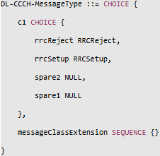 | Only an excerpt of the HTML is shown because it isn’t human-readable.  Indentation is applied with special classes named asn1-indent#, where # is the level.  Keyword colorization is applied with the class named asn1-keyword.  Comment colorization, not shown here, is applied with the class named asn1-comment.
Band combination tables insertion | ~~~ json-table  Table 5.5A.2-2: NR CA configurations and bandwidth combination sets defined for mixed intra-band contiguous and non-contiguous CA;  ../contributions/bandCombinations/38.101-1;  INTRABAND_MIXED  ~~~ | HTML table not shown.  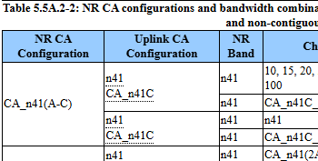 | The json-table identifier is used for this code block. The first input is the table caption. The second is the path the band combinations, and the third is a reference to which band combination.
Cover page insertion | The cover page is inserted using a Lua filter which takes the path to an HTML file as input. The HTML file is simply the cover page for the specification. | 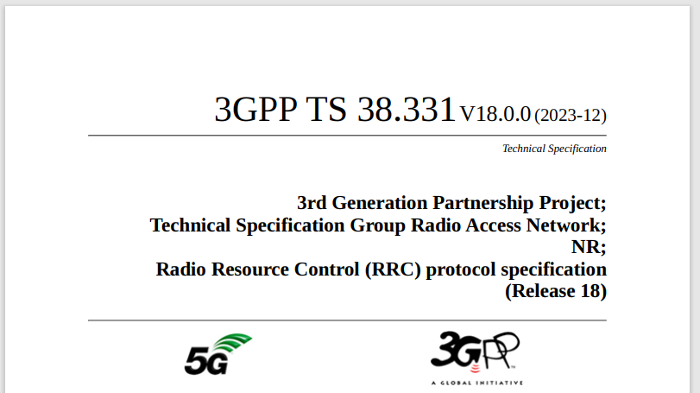 | The cover page is written in HTML because there is more freedom for layout and it is a relatively static page, not benefiting much from auto-generation.
MSC-Generator signalling diagram | ~~~ mscgen  {caption="Figure 5.3.2.1-1: Paging"}  hscale=auto;  u: UE;  n: Network;  hspace u - n 200;  n->u: Paging;  ~~~ | <img src="fig_5.3.2.1-1.svg"/>  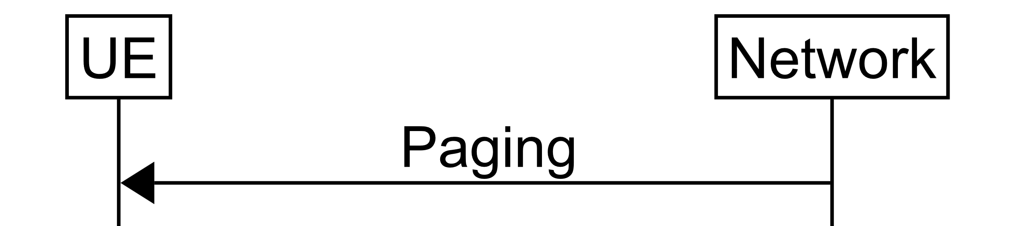 | The image of the figure is generated using msc-generator and saved as an SVG file as part of the conversion process and then inserted into the HTML using the <img> tag.
Table of contents generation and insertion | The table of contents is inserted using a Lua filter which identifies and tags all headings, extracts their titles, and creates a table of contents in HTML and inserts it between the cover page and the document body. | 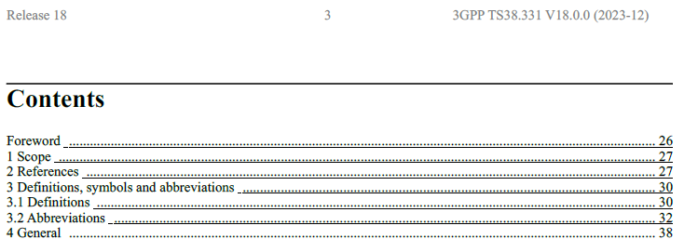 | The CSS stylesheet handles page numbering in the table of contents and in the header of each page.

Editor's Note: It is FFS how to support editable figures in Markdown that are not signalling diagrams, e.g. freely drawn architecture figures. Refering to an image for such figures is insufficient to resolve this Editor's Note, since an image is not editable.
Editor's Note: It is FFS how to support necessary styles that do not map to Markdown in any clear way. Included in this list are TF and TH which must be centered, bold, etc.
Editor's Note: It is FFS whether list-table extension to Markdown could be used to improve the ability to read, write and modify tables that are in Markdown format.

5.X.1.5 How to produce a specification using Markdown
Markdown source is not presentable on its own as it is a language intended to be converted to HTML, using a simple syntax and a subset of the features of HTML. Many tools are available for converting Markdown to HTML, but the one which will be used in this solution is called Pandoc, which can be found at https://pandoc.org/. Pandoc is capable of converting between many formats, but we will focus on the conversion from Markdown to HTML.
Figure 5.X.1.5-1 illustrates the process. The input is the Markdown source file, which has the extension “.md”, and any images and resources, and the output is an HTML file, which has the extension “.html”, and any original images and converted resources.
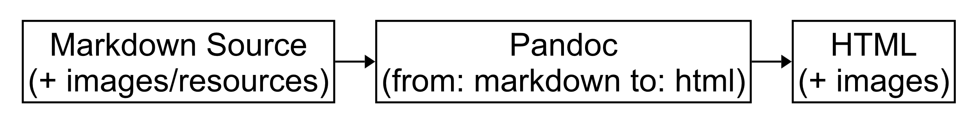
Figure 5.X.1.5-1: Process to convert from Markdown to HTML using Pandoc
The input includes markdown source, text resources, image resources, and images. Source is considered native to the base version of Markdown or to the chosen extension to Markdown, e.g., GitHub-flavoured Markdown. Text resources are those which are entered directly into the Markdown file or referenced as files from the Markdown file and converted into a different text representation in the HTML. Example text resources include equations and ASN.1 source. Image resources are those which are entered directly into the Markdown file or referenced as files from the Markdown file and converted into images. Images are simply copied into the HTML representation as they are natively supported.
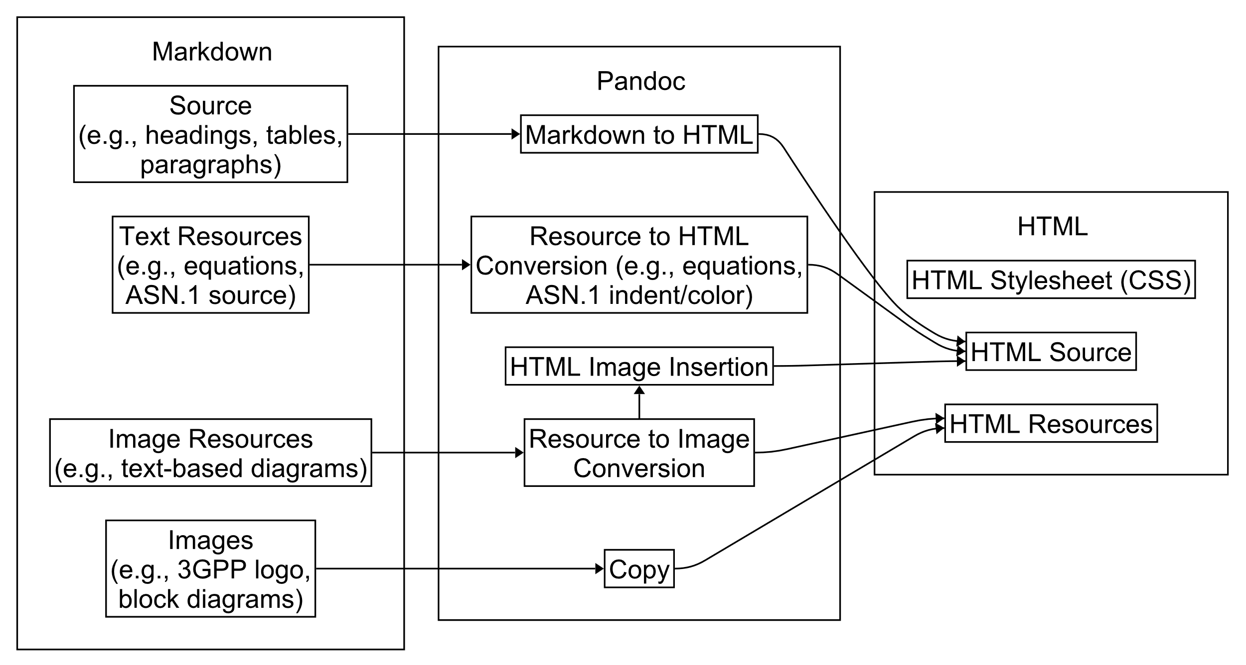
Figure 5.X.1.5-2: Detailed process to convert from Markdown to HTML using Pandoc
Each type of element in the Markdown document, whether native or not, requires a stage which converts the element into intermediate resources which are inserted into the HTML or which converts the element directly into HTML.
Figure 5.X.1.5-3 illustrates one-stage conversion of a simple type, a heading, which is further explained in Section 5.X.1.5. The Markdown formatting is stripped off and HTML formatting is wrapped around the heading title.
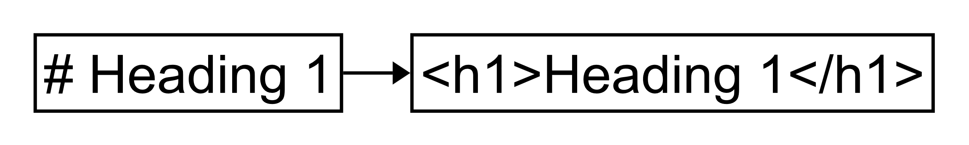
Figure 5.X.1.5-3: Conversion of a simple type from Markdown to HTML
The complex types, which typically result in images or custom formatted text, use a two-stage process. In the additional stage, the complex type is inputted to a conversion stage, the output of which is a resource, e.g., an image, and HTML which inserts the resource into the HTML document, e.g., an image tag which points to an image resource. Figure 5.X.1.5-4 shows an example of converting a signalling chart written in MSC Generator and inserting it into the resulting HTML document.
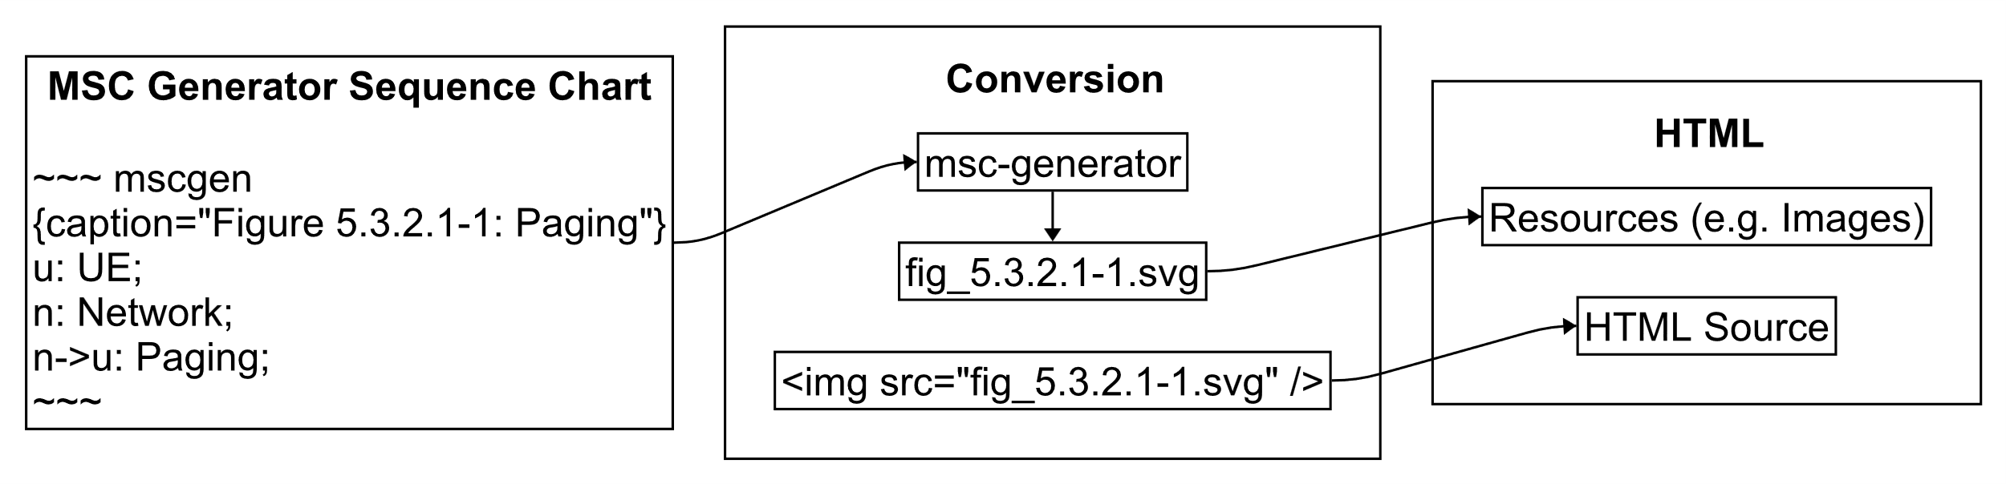
Figure 5.X.1.5-4: Conversion of a complex type, sequence chart, from Markdown to HTML
Another element to discuss is how styles are applied to the HTML document. The most common mechanism by which styles are applied to an HTML file is through the use of cascading stylesheets (CSS), which can be specified inline to the HTML or externally in a CSS file. Stylesheets work similarly to styles in Microsoft Word, except that styles are not individually applied but rather they are applied automatically depending on the type of element.
For example, the following styles were defined for heading text mimicking the current specifications. Note that the first header style has a thin border on the top, “border-top”, a larger font size than the others, 24, and has additional padding on the bottom to make it more prominent. The remaining headers use the default font and only set the size.
h1 {
font-size: 24px;
border-top: 1px solid;
width: 100%;
float:left;
padding-bottom: 3px;
}
h2 { font-size: 21px; }
h3 { font-size: 19px; }
h4 { font-size: 16px; }
h5 { font-size: 15px; }
h6 { font-size: 13px; }
These styles apply a font size to all six heading styles but treats the first heading level specially by including a black line border above the heading and applying more padding below the header than for the others.
The last step to create a publishable specification is to convert the HTML file to a PDF. A program called WeasyPrint (https://weasyprint.org/) is used. WeasyPrint creates converts HTML to a PDF with consideration to the CSS stylesheet provided with the HTML file. In this solution, the “print” view is used to automatically add headers to each page, including the title and page number, and to properly number the table of contents. All internal links are functional in the PDF version.

5.X.2 Evaluation against requirements of section 4.3
Table 5.X.2-1 provides an evaluation of Markdown as a format against the requirements of section 4.3.
Table 5.X.2-1: Evaluation against requirements of section 4.3
# | Evaluation | # | Evaluation | # | Evaluation
1 | Yes – Markdown is available globally and free and open source, as are the extensions and custom 3GPP extensions proposed. | 2 | Yes – Markdown is available globally and free and open source, as are the extensions and custom 3GPP extensions proposed. | 3 | Yes – Markdown is a plaintext format, enabling full transparency.
4 | Yes – Markdown editors exist for all major platforms. | 5 | Yes – Markdown is among the simplest of markup languages. | 6 | Yes – A single tool can be used as a Markdown editor. The formats are limited to Markdown, at least one image format, and any other formats decided upon used to generate images, e.g., MSC-Generator.
7 | Yes | 8 | Yes – Markdown is a plaintext file and opens very quickly in many text editors. Advanced text editors include syntax highlighting and navigation. | 9 | Yes – If implemented with Git, then writing a CR is as easy as opening the file and editing it directly.
10 | N/A | 11 | N/A – This requirement corresponds to the use of the format and not the format itself. | 12 | Yes – Intra-document and inter-document cross-linking is possible in Markdown and are rendered as links in HTML.
13 | Implementation – Markdown can support identification of editor’s notes through plaintext hints or extensions. | 14 | Yes | 15 | Implementation – The plaintext Markdown format is machine readable and tools could be written to parse it. The format does not change depending on which tool edits it, ensuring consistent compatibility.
16 | Yes – Once converted to HTML or PDF, searching and navigation are possible. | 17 | Yes – As with any file, it can be edited and iterated upon. | 18 | Yes – As with any file, it can be edited and iterated upon.
19 | Yes – Although this requirement is related to the storage and retrieval of the file. | 20 | N/A | 21 | Yes – Through a combination of cascading stylesheets (CSS) which apply styles to the HTML generated from Markdown.  In the case of notes, editor’s notes, and references, hints may need to be included in the Markdown file.
22 | Partial – Call flows written in Mermaid are supported by popular version of Markdown and automatic parsing of MSC-Generator call flows has been implemented by custom extension to Pandoc. Equations are supported in LaTex format. | 23 | Yes – Several Markdown preview tools, including those supported as plugins to Microsoft Visual Studio Code, support live rendering of Markdown while it is edited. An evaluation of the tools and plugins will be required to ensure support for the extensions we choose. | 24 | Yes
25 | N/A | 26 | Yes – Markdown is convertible to HTML and HTML is convertible to PDF. | 27 | Yes
28 | Yes – Styles would be implemented by cascading style sheets (CSS) which apply styles to the HTML generated form Markdown. Markdown itself does not support styling, ensuring consistency. | 29 | Partial – Markdown does not support styles. It is possible that an intermediate format used for discussion purposes, like docx, would support such styling.  Yes – Advanced text editors such as Visual Studio Code, Notepad++, Emacs, and Vim can display non-printable characters. | 30 | N/A
31 | N/A | 32 | N/A | 33 | Yes – Inline code is supported by Markdown. If code is stored in a different format, then this requirement does not apply.
34 | N/A | 35 | Yes – Consistency is enforced by the lack of the possibility to use styles in Markdown. | 36 | N/A
37 | N/A | 38 | N/A | 39 | Yes – Because styles are unimportant in the Markdown source file, drafting rules should be easier to follow.
40 | Yes – The same file can be opened more than one time or through the use of advanced text editors, a side-by-side view could be used. | 41 | Yes | 42 | Yes – Personal scripts could be used to autogenerate some Markdown like tables and equations.
43 | Needs to be explored – There are advanced text editors with support for proofing but they need to be evaluated separately. | 44 | N/A

* * * Next Change * * * *
<Proposed change in revision marks>

* * * Next Change * * * *
<Proposed change in revision marks>

* * * End of Changes * * * *

