3GPP Call on modernization of 3GPP tools #1 6GSM-250213

Electronic, 6th August 2025

Source: Nokia
Title: Pseudo-CR on Git as a new version control system for 3GPP specifications
Document for: Approval
Agenda item: 5
Spec: 3GPP TR21.802
Version: 0.1.1
Work Item: FS_6GSpecs

Comments
This pCR proposes a solution to store the 3GPP specifications using the Git version control system.

Proposed Changes
* * * First Change * * * *

6 Proposals for Tools and Ways of Working
Editor's note: corresponds to objective 3.

6.X Proposal #X Git for Version Control

6.X.1 Description
Git is an open-source distributed version control system, which tracks changes to files and enables collaboration.
Distributed means that every user can download and update a full copy of the repository, including files and their history locally (not just the current files, but also the full change history, also known as a commit graph). Changes are made and recorded locally and later synchronized with other copies using network operations (push, pull, fetch).
We can distinguish four areas in git workflow (see Figure 6.X.1-1):
- Remote repository - A copy of the project hosted on a server (e.g., 3GPP Forge, GitLab, or an SSH/git server) that acts as a shared central repository for collaborators to push to and fetch from. It stores the full history and interaction with it is done over the network.
- Local repository - The complete Git repository on your machine (.git directory) containing the full commit history and references. The user can commit, branch, and inspect history offline.
- Working directory (working tree) - The user edits the checked-out files locally, derived from a commit in the local repository. Changes in this area are unrecorded until staged and committed
- Staging area (index) - A temporary area where user place selected changes (with git add command) to build the next commit, letting user control exactly which modifications become part of that commit.
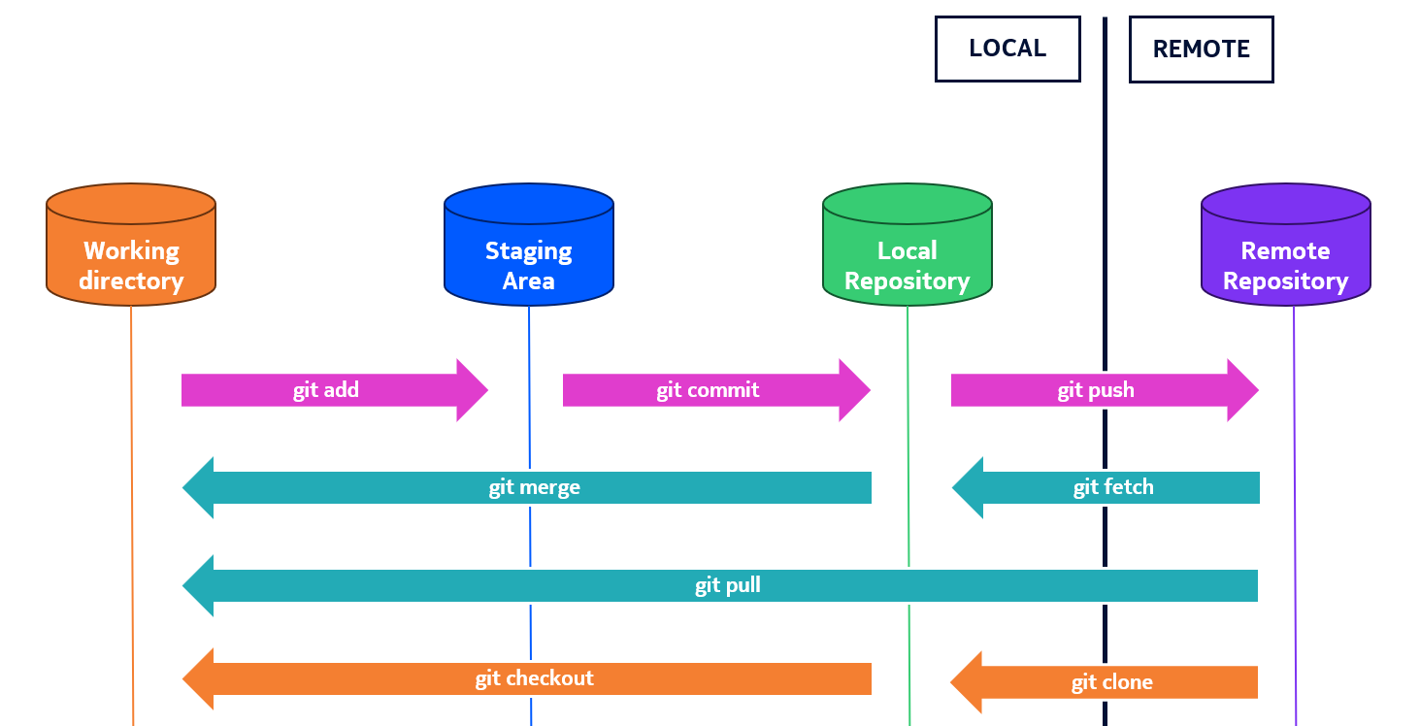
Figure 6.X.1.-1: Git workflow areas and basic procedures
Editor's Note: IIt is FFS how the databases described in this clause relate to the existing databases (tdoc database, CR database, and the meeting report. What are the impact on the processes that interact with these existing databases.

6.X.1.1 Description of tools

6.X.1.1.1 Git commit
The Git commit command records a snapshot of the project’s staged changes, capturing the state of the codebase at a particular point of time. Each commit consists of following elements:
- Metadata - Includes author, committer, message, timestamps, and a unique identifier called a SHA hash.
- Commit Message - Describes what the commit changes and why. This is crucial for understanding project history.
- Parent Reference - Points to the previous commit(s), allowing Git to track project history as a directed acyclic graph.
The Git commit message can be standardized using a pre-defined template. It can be achieved with Conventional Commits, which is a specification for writing consistent and meaningful commit messages in Git. Its goal is to make project history easier to read, automate changelogs, and enable semantic versioning. For the purpose of 3GPP, additional fields can be added, such as work item description (WID) or study item description (SID) code.
Commit message can be composed of following elements (Figure 6.X.1.1.1-1):
- Type - Nature of the change (feat, fix, docs, style, refactor, test, chore)
- Scope - Area of the codebase affected
- Subject - Short summary of the change
- Body - Detailed explanation, motivation, or context
- Footer - References to issues, breaking changes, or metadata
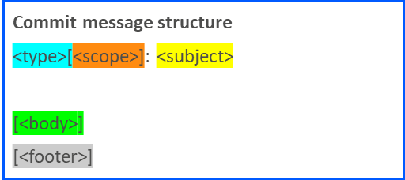
Figure 6.X.1.1.1-1 Example commit message structure

6.X.1.1.2 Git branching
Git branching is essential for managing projects efficiently in collaborative and feature-driven development workflows. Key aspects of branching include:
- Creating independent lines of development
- Isolate changes and work on new features, bug fixes, or experiments without affecting the main codebase
- Enable collaboration by allowing multiple users to work on different branches
- Maintain stability in the main branch
Git merge feature is used to combines commits from one branch into another. Any conflicts that occur during merge are resolved manually and recorded in the resulting commit. In the example of Figure 6.X.1.1.2-1, we start with the main branch, which contained v18.1.0. A branch called v18.2.0 was created to aggregate accepted changes to v18.1.0. Two CRs are shown in the diagram: CR-123 and CR-456. Both CRs were created from the same initial version, corresponding to v18.1.0 and the changes imposed by each CR were written independently from one another, enabling parallel work. Each CR went through a few revisions, i.e., CR-456:1 and CR-456:2 prior to being finally accepted and merged into the v18.2.0 branch. Once both CRs were merged, the v18.2.0 branch was merged into the main branch, becoming the latest version of the specification.
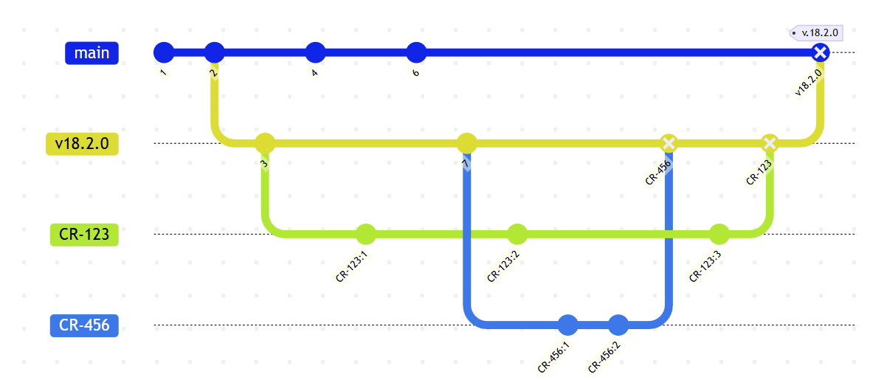
Figure 6.X.1.1.2-1: Example git branching and merging

6.X.1.1.3 Git history
Git history provides detailed information about every single change introduced by commits, including:
- Commit Details: Includes commit hashes, messages, authors, dates, and timestamps.
- Changes to Files: Tracks what changes were made to specific files over time.
- Branch Contributions: Identifies changes introduced by specific branches.
- Author Contributions: Shows who made specific changes and when.
- Line-Level History: Provides details on the last modification for each line in a file.
- Time-Based Changes: Filters commits based on specific timeframes (e.g., last two days).
- Searchable Commit Messages: Allows searching for commits related to particular functionality or keywords.
Git history can be visualized using git commit graph (Figure 6.X.1.1.3-1), which is the directed acyclic graph (DAG) that represents commits and their parent relationships in a Git repository. Visualizations called "git graphs" expose the repository history and topology. Key information a git graph provides:
- Commits as nodes: each node is a commit (hash), with author, date, and commit message.
- Parent/child edges: arrows/lines show parent relationships.
- Branch and tag labels: which commits are pointed to by refs (branch names, tags).
- Branching and merging structure: where branches diverged and were merged back.
- Topology vs time: order can be topological (ancestry) or chronological; visualization usually combines both.
- Reachability and history context: which commits are reachable from which branches.
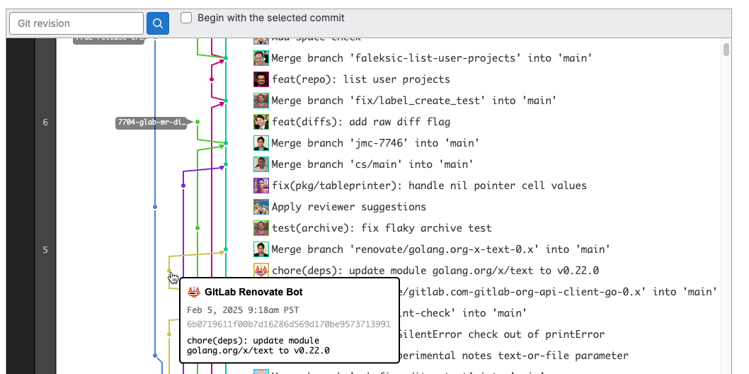
Figure 6.X.1.1.3-1: Example git graph visualization in Gitlab (source docs.gitlab.com)
Git CLI commands used to browse repository history:
- git log - Displays the commit history for current branch.
- git diff - Compare changes between different states of a repository
- git blame - Displays line-by-line history of a file, showing the author, date, and commit hash for each line.
- git show - Displays detailed information about a specific commit, including the commit message and diff of changes.

6.X.1.1.4 Git GUI tools
Git itself is a CLI (Command Line Interface) based tool, but it is also integrated in many existing GUI (Graphical User Interface) tools. Because Git repositories are decentralized, it can be completely up to user preference which tools to use. Some examples of Git tools include:
- Built-in GUIs:
  - git-gui — Simple official Tcl/Tk GUI shipped with Git for staging, committing, and basic history browsing.
  - gitk — Official repository history browser/visualizer that ships with Git for commit graph inspection.
  - Windows Git GUI (installed with Git for Windows) — Lightweight GUI wrapper for common Git tasks on Windows.
- Server / hosted tools:
  - GitLab — Full DevOps platform with repo hosting, CI/CD, issue tracking, merge requests and web-based file/PR UI. This is the same platform used by 3GPP Forge and ETSI Forge.
  - GitHub — Widely used hosted Git service with pull requests, code review, Actions CI, and web-based file and diff editors.
- IDE integrations
  - Visual Studio Code — Built-in Source Control view and many Git extensions for staging, branching, diffs and merges.
  - JetBrains IDEs (IntelliJ, PyCharm) — Integrated VCS tools with GUI for commits, branches, history, and conflict resolution.
  - Visual Studio — Integrated Git client and GitHub/GitLab extensions for full repo workflows inside the IDE.

6.X.1.2 Description of procedures

6.X.1.2.1 Git procedures description
Basic git commands for creating and saving changes (see Figure 6.X.1-1):
- git clone – Create a full local copy of a remote repository, it contains both file and changes history.
- git fetch – Download changes history (commits) and references from a remote repository into local repository without changing working files.
- git pull – Fetch changes from remote repository and merge them into working copy.
- git add – Stage changes (new / modified / deleted files) to prepare them for a commit to local repository.
- git commit – Record staged changes as a new local snapshot in the repository history.
- git push – Send local changes (commits) to a remote repository, so others can access them.
- git branch – Create, list, or switch between independent lines of development (isolated commit histories).

6.X.1.2.2 Mapping Git procedures to Change Request processes
We can compare the typical current CR procedure (Figure 6.X.1.2.2-1) to a potential future CR procedure with Git (Figure 6.X.1.2.2-2), relating each current step to the Git equivalent in the new procedure. The mapping provided is not meant to imply a solution, but rather to relate the Git flow to our current 3GPP flow. For instance, the second to last step in Figure 6.X.1.2.2-2 suggests that a TDoc representing the CR will be automatically generated and provided as a docx file which can be submitted. That is only one possibility.
- Steps with solid green borders are nearly equivalent steps.
- Steps with a dashed orange border are modified from the original procedure.
- Steps with a squiggly black border are unique to each procedure.

Figure 6.X.1.2.2-1: Current typical CR procedure

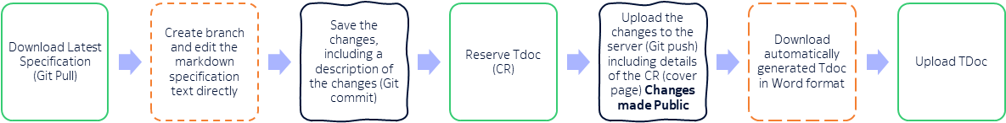
Figure 6.1.1.2.2-2: Potential new CR procedure with Git

6.X.2 Evaluation against requirements of section 4.3
Table 6.X.2-1 indicates the compliance or noncompliance of the solution with the requirements for Objective 3.
Editor's Note: Evaluation is FFS.

\* * * Next Change * * * *
<Proposed change in revision marks>

* * * Next Change * * * *
<Proposed change in revision marks>

* * * End of Changes * * * *

