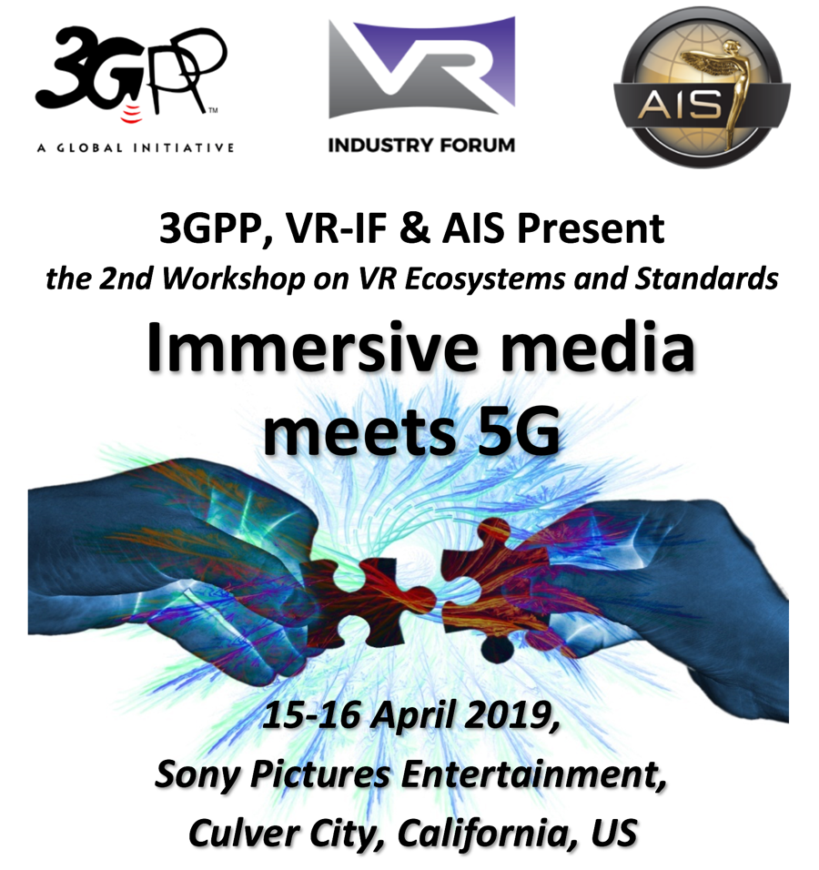

Dates: April 15th and 16th, 2019
The workshop starts at 9am on Monday 15th and ends at 5pm on Tuesday 16th April, 2019.

Location: Sony Pictures Entertainment,  10202 West Washington Blvd.,  Culver City, 90232 CA, USA  Rita Hayworth Room | 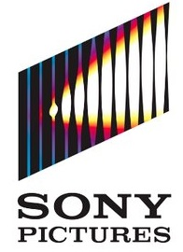

3GPP and the VRIF, in cooperation with the Advanced Imaging Society (AIS), announce the second Workshop on Ecosystems & Standards, themed “Immersive Media meets 5G”. The workshop is open to all interested parties and will take place on 15-16 April 2019 at Sony Pictures, Culver City, CA, USA. immediately after the NAB trade show.

The second edition will focus on next-generation immersive formats and services, including Virtual, Augmented & Mixed Reality, and it will investigate 5G business opportunities brought by immersive services – as well as their requirements.

Note that the workshop will follow the 3GPP SA4#103 meeting in Newport Beach, CA, USA. This workshop is integrated in the newly approved 3GPP Study item in Release 16, on Extended Reality over 5G (FS_XR5G).

Please find detailed meeting information below. Please register soon; space is limited. We look forward to seeing you in Culver City!

Frédéric Gabin, 3GPP SA4 chairman Paul Higgs, VRIF President
frederic.gabin@ericsson.com paul.higgs@huawei.com

Meeting Information
The workshop will be held at the Sony Pictures Entertainment lot, Rita Hayworth Room,
10202 West Washington Blvd., Culver City, CA 90232, USA. https://goo.gl/maps/smUHMWksvN92

The Workshop on “Immersive Media Meets 5G” will start on Monday 15th April at 9:00 h and will close on Tuesday 16th April at 17:00 h.

There is onsite parking. There are many hotels and restaurants nearby. Morning and afternoon coffee breaks and lunch will be provided on both days, as well as a drinks reception on Monday evening.

WLAN/Internet access will be available during the meeting.

Workshop registration
Registration for the workshop is mandatory, and space is limited. A registration fee will be asked to cover coffee breaks and lunch. Early registration is $99 and will be $199 after March 1st. Please register as soon as convenient on
http://www.vr-if.org/bin/c5i?mid=5&rid=6&k2=14

Demonstrations
We invite demonstrations during the drinks reception on Monday evening from 18:00 – 20:00 hours, as well as during breaks throughout the event. We ask a $950 fee, which will be used to cover the cost of the reception. This includes the registration of two attendees to the workshop. Please contact Mauricio Aracena (mauricio.aracena@ericsson.com) or one of the co-chairs for details.

Hotel Reservations
The hotels below are a short distance to Sony Pictures Entertainment.
There is no room block reserved for this meeting.

Closest:
The Culver Hotel ****, 9400 Culver Blvd, Culver City, CA 90232

Well-known chain hotels within around 10 minutes’ drive:
Double Tree by Hilton ***, 6161 W Centinela Ave, Culver City, CA 90230
Four Points by Sheraton ***, 5990 Green Valley Cir, Culver City, CA 90230
Courtyard by Marriott ***, 6333 Bristol Pkwy, Culver City, CA 90230
Best Western Royal Palace Inn & Suites ***, 2528 S Sepulveda Blvd, LA, CA 90064
Holiday Inn Express West Los Angeles ***, 11250 Santa Monica Blvd, LA, CA 90025

There are many additional smaller hotels and motels within 10 minutes’ drive.

Airport Information:
- Los Angeles International Airport (LAX), approx. 20 minutes’ drive from the venue.
- Burbank Airport (BUR) is another option, approx. 45 minutes away.

Parking
There is free parking at the Sony Pictures Entertainment facility and no permit is required.

Wireless LAN:
Wireless LAN Internet access will be provided.

Meeting host contact:

Ms. Tomoko Kamimoto,
Sony Pictures Entertainment,
10202 West Washington Blvd.,
Culver City, CA 90232
Phone: +1.310.244.8777 Tomoko_Kamimoto@spe.sony.com

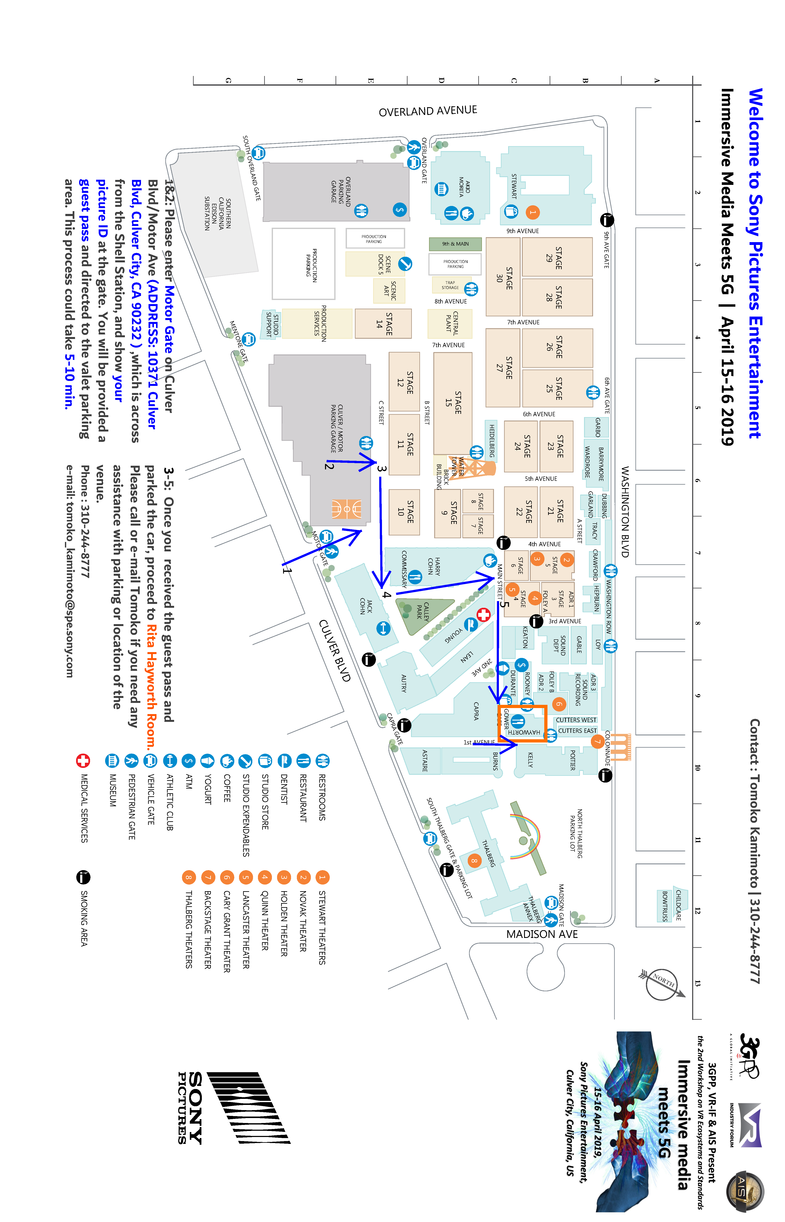
VISA Information

PLEASE NOTE: LETTERS MAY TAKE 14 DAYS TO BE PROCESSED.

Please contact Ms. Tomoko Kamimoto via email at Tomoko_Kamimoto@spe.sony.com should you require a personal letter of invitation for a visa application. Your email must include the following information in order for it to be processed:

- Family name (last name):
- Forename (first name):
- Birth date (month/date/year):
- Passport number and issuing country:
- Gender:
- Company name:
- Occupation/Position:
- Company/mailing address:
- Postal Code:
- Country:
- Telephone number:
- Fax number:
- Name of meeting:
- Location of Meeting:
- Hotel Confirmation Number:

PLEASE VERIFY THAT ALL INFORMATION IS ACCURATE AND WILL BE VALID AT THE TIME OF THE MEETING.

In addition, you may be asked for specific documentation showing strong social, economic, and other ties to your home country. Documents in a foreign language should have a notarized translation attached.

Please be aware that it may take up to 6 to 8 weeks for visa approval so make your request for the invitation letter as soon as possible. Letters of invitation will be sent to you via fax or email and only be sent via Federal Express mail upon special request.

Letters will be processed within 14 days of receiving an email request. If you have not received your letter within 14 days or have any changes after receiving a faxed copy, please contact Ms. Tomoko Kamimoto, details above.

