Madrid, 26th November 2003

To Members of 3GPP

Invitation to the 3GPP T3 Ad Hoc#103 on TS 23.048 release 5 Tests Meeting
16th to 18th March, 2004
to be held in Madrid, Spain

Dear Colleague,
Microelcetrónica Española has the pleasure to inform you of the arrangements for the above meeting.

Address of the meeting
Microelectrónica Española
C/ Sanchez Pacheco, 101
Madrid 28002 Spain

The meeting will be scheduled as follows:
Start: 09:30 on 16th March and ending not later than 17:00 on 18th March

The responsible for this meeting is Marta Ortiz Vázquez:
Tel.: +34 91 125 40 35, Email: mortiz@exceldata.es

Documents and information sources
If you wish to submit an input document to the meeting, please obtain a document number by following the instruction at:
http://www.3gpp.org/ftp/TSG_T/WG3_USIM/www/DocNumberAllocation.htm

Server locations for documents:

ftp://ftp.3gpp.org/TSG_T/WG3_USIM/adhocs/103-0402-Madrid/

Email lists:

Any further information about this meeting will be distributed via the email list 3gpp_tsg_t_wg3_test. You can subscribe to these email list (or view the archives) by going to: http://list.3gpp.org/3gpp_tsg_t_wg3_test.html

Note that like recent meetings, only electronic copies of the documents will be made available before and during the meeting. i.e. it is necessary to bring a portable PC, with a 3.5" floppy disk drive

DEADLINES

Meeting registration: 10th of March 2004
Submission of documents to email list: Documents not submitted by this time may receive a lower priority in the agenda

Meeting Registration

Registration for this meeting should be done on-line by 10th of March 2004. Please go to:

http://webapp.etsi.org/MeetingCalendar/MeetingDetails.asp?mid=24099

Notes for 3GPP meeting registration:

An ETSI server username/password (i.e. EOL account) is not essential in order to be able to register for 3GPP meetings, but it is helpful. If you have a username, it avoids the need to type in all your contact details every time you register for a meeting. If you do not yet have one, please contact Andrijana Jurisic (Andrijana.Jurisic@ETSI.ORG) specifying the following information:

First Name:
Last Name:
Company:
Address:
Tel:
Fax:
Email:

Other Information

Any further information about the meetings will be distributed via the email list 3gpp_tsg_t_wg3.
Note that like recent meetings, only electronic copies of the documents will be made available before and during the meeting. i.e. it is necessary to bring a portable PC, with a 3.5" floppy disk drive.

Arrival

The best way to reach the hotel from the airport is by taxi or Metro. Taxi ride is about 20 minutes and costs about 13-15 €.

You can also take the Metro from the airport station to Alfonso XIII station(You can see this station in the location map). You have to take the 8th line to Mar de Cristal station, then, change to line 4 until Alfonso XIII station. It is only cost 1,1 €.

Location Map
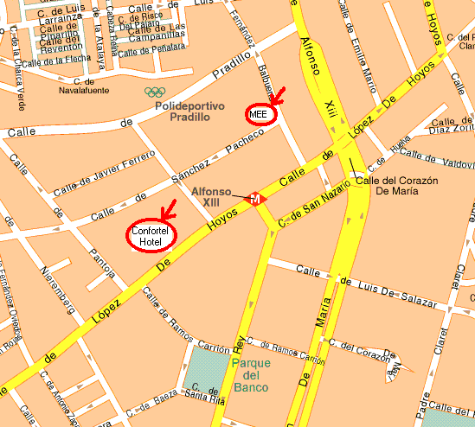

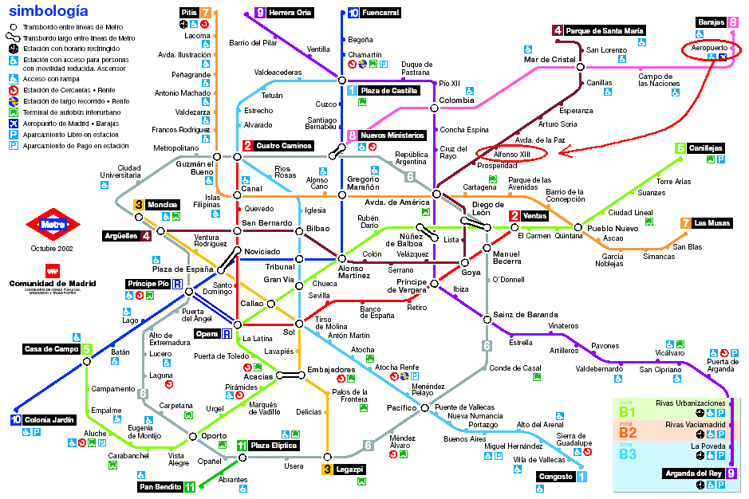

Hotel Information

Confortel Suites Madrid
C/ Lopez De Hoyos, 143
Madrid 28002
Spain

Tel.: +34 902 42 42 42
Fax.: +34 383 17 43

NH Parque Avenidas

C/ 2 Biarritz - 28028 Madrid
Tel.: +34 91 361 02 88
Fax.: +34 91 361 21 38

AC Avenida de América

C/ 83 Cartagena - 28028 Madrid
Tel.: 91 724 42 40
Fax.: 91 724 42 41

I wish you all a nice travel to Madrid,
Best regards,
Marta Ortiz

