CR-Form-v3
CHANGE REQUEST
 | TS 34.122 |  |  |  | CR |  |  |  |  rev |  |  |  |  |  |  Current version: |  |  |  |  | 3.4.0 |  | 
For HELP on using this form, see bottom of this page or look at the pop-up text over the  symbols.
Proposed change affects:  |  |  |  |  | (U)SIM |  |  | ME/UE |  | X |  | Radio Access Network |  |  |  |  |  |  |  |  | Core Network
Title:  |  | Replacement for the Conformance requirements
Source:  |  | T1/RF
Work item code:  |  |  |  |  |  |  |  |  |  |  |  |  |  |  |  | Date:  |  | 5 July, 2001
Category:  |  | D |  |  |  |  |  |  |  |  |  |  |  |  |  | Release:  |  | R99
 |  | Use one of the following categories:  F (essential correction)  A (corresponds to a correction in an earlier release)  B (Addition of feature),  C (Functional modification of feature)  D (Editorial modification)  Detailed explanations of the above categories can  be found in 3GPP TR 21.900. |  |  |  |  |  |  |  |  |  |  |  |  |  |  | Use one of the following releases:  2 (GSM Phase 2)  R96 (Release 1996)  R97 (Release 1997)  R98 (Release 1998)  R99 (Release 1999)  REL-4 (Release 4)  REL-5 (Release 5)
Reason for change:  |  |  | To keep consistency with the core specification
Summary of change:  |  |  | Replace "Conformance requirements" with "Minimum requirements"
Consequences if   not approved: |  |  | Inconsistencies with the core specification are caused.
Clauses affected:  |  |  | Chapter 5, 6 and 7
Other specs  |  |  |  | Other core specifications 
affected: |  |  |  | Test specifications
 |  |  |  | O&M Specifications
Other comments: 

How to create CRs using this form:
Comprehensive information and tips about how to create CRs can be found at: http://www.3gpp.org/3G_Specs/CRs.htm. Below is a brief summary:
1) Fill out the above form. The symbols above marked  contain pop-up help information about the field that they are closest to.
2) Obtain the latest version for the release of the specification to which the change is proposed. Use the MS Word "revision marks" feature (also known as "track changes") when making the changes. All 3GPP specifications can be downloaded from the 3GPP server under ftp://www.3gpp.org/specs/ For the latest version, look for the directory name with the latest date e.g. 2000-09 contains the specifications resulting from the September 2000 TSG meetings.
3) With "track changes" disabled, paste the entire CR form (use CTRL-A to select it) into the specification just in front of the clause containing the first piece of changed text. Delete those parts of the specification which are not relevant to the change request.


3GPP TS 34.122 V3.4.0 (2001-06)
Technical Specification
3rd Generation Partnership Project;
Technical Specification Group Terminal;
Terminal Conformance Specification;
Radio transmission and reception (TDD)
(Release 1999)

The present document has been developed within the 3rd Generation Partnership Project (3GPP TM) and may be further elaborated for the purposes of 3GPP.
The present document has not been subject to any approval process by the 3GPP Organisational Partners and shall not be implemented.
This Specification is provided for future development work within 3GPP only. The Organisational Partners accept no liability for any use of this Specification.
Specifications and reports for implementation of the 3GPP TM system should be obtained via the 3GPP Organisational Partners' Publications Offices.

Keywords
UMTS, testing, terminal
3GPP
Postal address

3GPP support office address
650 Route des Lucioles - Sophia Antipolis
Valbonne - FRANCE
Tel.: +33 4 92 94 42 00 Fax: +33 4 93 65 47 16
Internet
http://www.3gpp.org
Copyright Notification
No part may be reproduced except as authorized by written permission.
The copyright and the foregoing restriction extend to reproduction in all media.

© 2001, 3GPP Organizational Partners (ARIB, CWTS, ETSI, T1, TTA,TTC).
All rights reserved.
Keywords
terminal, testing, UMTS
Contents
Foreword 9
1 Scope 10
2 References 10
3 Definitions, abbreviations and equations 10
3.1 Definitions 10
3.2 Abbreviations 11
3.3 Equations 11
4 Frequency bands and channel arrangement 11
4.1 General 11
4.2 Frequency bands 11
4.3 TX–RX frequency separation 12
4.4 Channel arrangement 12
4.4.1 Channel spacing 12
4.4.2 Channel raster 12
4.4.3 Channel number 12
5 Transmitter Characteristics 12
5.1 General 12
5.2 User Equipment maximum output power 13
5.2.1 Definition and applicability 13
5.2.2 Minimum Requirements 13
5.2.3 Test purpose 13
5.2.4 Method of test 14
5.2.4.1 Initial conditions 14
5.2.4.2 Procedure 14
5.2.5 Test Requirements 14
5.3 UE frequency stability 15
5.3.1 Definition and applicability 15
5.3.2 Minimum Requirements 15
5.3.3 Test purpose 15
5.3.4 Method of test 15
5.3.4.1 Initial conditions 15
5.3.4.2 Procedure 16
5.3.5 Test Requirements 16
5.4 Output Power Dynamics 16
5.4.1 Uplink power control 16
5.4.1.1 Initial accuracy 16
5.4.1.1.1 Definition and applicability 16
5.4.1.1.2 Minimum requirements 16
5.4.1.1.3 Test purpose 17
5.4.1.1.4 Method of test 17
5.4.1.1.4.1 Initial conditions 17
5.4.1.1.4.2 Procedure 17
5.4.1.1.5 Test requirements 17
5.4.1.2 Differential accuracy, controlled input 18
5.4.1.2.1 Definition and applicability 18
5.4.1.2.2 Minimum requirements 18
5.4.1.2.3 Test purpose 18
5.4.1.2.3 Method of test 18
5.4.1.2.3.1 Initial conditions 18
5.4.1.2.3.2 Procedure 19
5.4.1.2.5 Test requirements 19
5.4.2 Minimum transmit output power 20
5.4.2.1 Definition and applicability 20
5.4.2.2 Minimum Requirements 20
5.4.2.3 Test purpose 20
5.4.2.4 Method of test 20
5.4.2.4.1 Initial conditions 20
5.4.2.4.2 Procedure 20
5.4.2.5 Test requirements 20
5.4.3 Transmit OFF power 20
5.4.3.1 Definition and applicability 20
5.4.3.2 Minimum Requirements 21
5.4.3.3 Test purpose 21
5.4.3.4 Method of test 21
5.4.3.5 Test requirements 21
5.4.4 Transmit ON/OFF Time mask 21
5.4.4.1 Definition and applicability 21
5.4.4.2 Minimum requirements 21
5.4.4.3 Test Purpose 22
5.4.4.4 Method of test 22
5.4.4.4.1 Initial conditions 22
5.4.4.4.2 Procedure 22
5.4.4.5 Test requirements 22
5.4.5 Out-of-synchronisation handling of output power 22
5.4.5.1 Definition and applicability 22
5.4.5.2 Minimum Requirement 22
5.4.5.3 Test purpose 23
5.4.5.4 Method of test 24
5.4.5.4.1 Initial conditions 24
5.4.5.4.2 Procedure 24
5.4.5.5 Test Requirements 24
5.5 Output RF spectrum emissions 24
5.5.1 Occupied bandwidth 24
5.5.1.1 Definition and applicability 24
5.5.1.2 Minimum Requirements 25
5.5.1.3 Test purpose 25
5.5.1.4 Method of test 25
5.5.1.4.1 Initial conditions 25
5.5.1.4.2 Procedure 25
5.5.1.5 Test requirements 25
5.5.2 Out of band emission 26
5.5.2.1 Spectrum emission mask 26
5.5.2.1.1 Definition and applicability 26
5.5.2.1.2 Minimum Requirements 26
5.5.2.1.3 Test purpose 26
5.5.2.1.4 Method of test 26
5.5.2.1.5 Test requirements 27
5.5.2.2 Adjacent Channel Leakage power Ratio (ACLR) 27
5.5.2.2.1 Definition and applicability 27
5.5.2.2.2 Minimum Requirements 27
5.5.2.2.3 Test purpose 27
5.5.2.2.4 Method of test 28
5.5.2.2.5 Test requirements 28
5.5.3 Spurious emissions 28
5.5.3.1 Definition and applicability 28
5.5.3.2 Minimum Requirements 29
5.5.3.3 Test purpose 29
5.5.3.4 Method of test 29
5.5.3.4.1 Initial conditions 29
5.5.3.4.2 Procedure 29
5.5.3.5 Test requirements 30
5.6 Transmit Intermodulation 30
5.6.1 Definition and applicability 30
5.6.2 Minimum Requirements 30
5.6.3 Test purpose 31
5.6.4 Method of test 31
5.6.4.1 Initial conditions 31
5.6.4.2 Procedure 31
5.6.5 Test requirements 31
5.7 Transmit Modulation 32
5.7.1 Error Vector Magnitude 32
5.7.1.1 Definition and applicability 32
5.7.1.2 Minimum Requirements 32
5.7.1.3 Test purpose 32
5.7.1.4 Method of test 32
5.7.1.4.1 Initial conditions 32
5.7.1.4.2 Procedure 32
5.7.1.5 Test requirements 32
5.7.2 Peak code domain error 33
5.7.2.1 Definition and applicability 33
5.7.2.2 Minimum Requirement 33
5.7.2.3 Test purpose 33
5.7.2.4 Method of test 33
5.7.2.4.1 Initial conditions 33
5.7.2.4.2 Procedure 33
5.7.2.5 Test requirements 33
6 Receiver Characteristics 34
6.1 General 34
6.2 Reference sensitivity level 34
6.2.1 Definition and applicability 34
6.2.2 Minimum Requirements 34
6.2.3 Test purpose 34
6.2.4 Method of test 35
6.2.4.1 Initial conditions 35
6.2.4.2 Procedure 35
6.2.5 Test requirements 35
6.3 Maximum Input Level 35
6.3.1 Definition and applicability 35
6.3.2 Minimum requirements 35
6.3.3 Test purpose 36
6.3.4 Method of test 36
6.3.4.1 Initial conditions 36
6.3.4.2 Procedure 36
6.3.5 Test requirements 36
6.4 Adjacent Channel Selectivity (ACS) 36
6.4.1 Definition and applicability 36
6.4.2 Minimum Requirements 36
6.4.3 Test purpose 37
6.4.4 Method of test 37
6.4.4.1 Initial conditions 37
6.4.4.2 Procedure 37
6.4.5 Test Requirements 37
6.5 Blocking Characteristics 37
6.5.1 Definition and applicability 37
6.5.2 Minimum Requirements 38
6.5.3 Test purpose 39
6.5.4 Method of test 39
6.5.4.1 Initial conditions 39
6.5.4.2 Procedure 39
6.5.5 Test requirements 39
6.6 Spurious Response 40
6.6.1 Definition and applicability 40
6.6.2 Minimum Requirements 40
6.6.3 Test purpose 40
6.6.4 Method of test 40
6.6.4.1 Initial conditions 40
6.6.4.2 Procedure 41
6.6.5 Test requirements 41
6.7 Intermodulation Characteristics 41
6.7.1 Definition and applicability 41
6.7.2 Minimum Requirements 41
6.7.3 Test purpose 42
6.7.4 Method of test 42
6.7.4.1 Initial conditions 42
6.7.4.2 Procedure 42
6.7.5 Test requirements 42
6.8 Spurious Emissions 42
6.8.1 Definition and applicability 42
6.8.2 Minimum Requirements 42
6.8.3 Test purpose 43
6.8.4 Method of test 43
6.8.4.1 Initial conditions 43
6.8.4.2 Procedure 43
6.8.5 Test requirements 43
7 Performance Requirements 44
7.1 General 44
7.2 Demodulation in static propagation conditions 44
7.2.1 Demodulation of DCH 44
7.2.1.1 Definition and applicability 44
7.2.1.2 Minimum requirements 44
7.2.1.3 Test purpose 45
7.2.1.4 Method of test 45
7.2.1.4.1 Initial conditions 45
7.2.1.4.2 Procedure 45
7.2.1.5 Test requirements 45
7.3 Demodulation of DCH in multipath fading conditions 45
7.3.1 Multipath fading Case 1 45
7.3.1.1 Definition and applicability 45
7.3.1.2 Minimum requirements 46
7.3.1.3 Test purpose 46
7.3.1.4 Method of test 46
7.3.1.4.1 Initial conditions 46
7.3.1.4.2 Procedure 46
7.3.1.5 Test requirements 47
7.3.2 Multipath fading Case 2 47
7.3.2.1 Definition and applicability 47
7.3.2.2 Minimum requirement 47
7.3.2.3 Test purpose 47
7.3.2.4 Method of test 48
7.3.2.4.1 Initial conditions 48
7.3.2.4.2 Procedure 48
7.3.2.5 Test requirements 48
7.3.3 Multipath fading Case 3 48
7.3.3.1 Definition and applicability 48
7.3.3.2 Minimum requirements 48
7.3.3.3 Test purpose 49
7.3.3.4 Method of test 49
7.3.3.4.1 Initial conditions 49
7.3.3.4.2 Procedure 49
7.3.3.5 Test requirements 49
7.4 Base station transmit diversity mode 50
7.4.1 Demodulation of BCH in Block STTD mode 50
7.4.1.1 Minimum requirements 50
7.5 Power control in downlink 50
7.5.1 Minimum requirements 50
8 Requirements for Support of RRM 51
8.1 General 51
8.2 Idle Mode Tasks 51
8.2.1 Introduction 51
8.2.2 RF Cell Selection Scenario 51
8.2.2.1 Requirements for Cell Selection single carrier single cell case 51
8.2.2.2 Requirements for Cell Selection multicarrier carrier multi cell case 51
8.2.3 RF Cell Re-Selection Scenario 51
8.2.3.1 Requirements for Cell Re-Selection single carrier multi cell case 51
8.2.4 PLMN Selection and Re-Selection Scenario 51
8.2.5 Location Registration Scenario 51
8.3 RRC Connection mobility 51
8.3.1 Handover 51
8.3.1.1 Introduction 51
8.3.1.2 Handover 3G to 3G 52
8.3.1.2.1 TDD/TDD Handover 52
8.3.1.2.2 TDD/FDD Handover 52
8.3.1.3 Handover 3G to 2G 52
8.3.1.3.1 Handover to GSM 52
8.3.2 Radio Link Management 52
8.3.2.1 Link adaptation 52
8.3.3 Cell Update 52
8.3.4 URA Update 52
8.4 RRC Connection Control 52
8.4.1 Radio Access Bearer Control 52
8.5 Dynamic Channel Allocation 52
8.6 Timing characteristics 52
8.6.1 Timing Advance (TA) Requirements 52
8.7 Measurements Performance Requirements 52
8.7.1 Measurements Performance for UE 52
Annex A (informative): Connection Diagrams 53
Annex B (normative): Global In-Channel TX-Test 57
B.1 General 57
B.2 Definition of the process 57
B.2.1 Basic principle 57
B.2.2 Output signal of the TX under test 57
B.2.3 Reference signal 57
B.2.4 void 58
B.2.5 Classification of measurement results 58
B.2.6 Process definition to achieve results of type “deviation” 58
B.2.7 Process definition to achieve results of type "residual" 59
B.2.7.1 Error Vector Magnitude (EVM) 59
B.2.7.2 Peak Code Domain Error (PCDE) 59
B.3 Notes 60
Annex C (normative): Measurement channels 62
C.1 General 62
C.2 UL Reference measurement channels 62
C.2.1 UL reference measurement channel (12.2 kbps) 62
C.2.2 UL multi code reference measurement channel (12.2 kbps) 63
C.2.3 UL reference measurement channel (64 kbps) 64
C.2.4 UL reference measurement channel (144 kbps) 65
C.2.5 UL reference measurement channel (384 kbps) 66
C.3 DL Reference measurement channels 67
C.3.1 DL reference measurement channel (12.2 kbps) 67
C.3.2 DL reference measurement channel (64 kbps) 68
C.3.3 DL reference measurement channel (144 kbps) 69
C.3.4 DL reference measurement channel (384 kbps) 70
C.3.5 BCH reference measurement channel 71
Annex D (normative): Propagation conditions 72
D.1 Test Environments 72
D.2 Propagation Conditions 72
D.2.1 Static propagation condition 72
D.2.2 Multi-path fading propagation conditions 72
Annex E (normative): Common RF test conditions 73
E.1 General 73
E.2 Connection Set-up 73
E.3 During connection 73
E.3.1 Measurement of Tx Characteristics 73
E.3.2 Measurement of Rx Characteristics 74
E.3.3 Measurement of Performance requirements 74
Annex F (normative): General test conditions and declarations 75
F.1 Acceptable uncertainty of Test System 75
F.1.1 Measurement of test environments 75
F.1.2 Measurement of transmitter 76
F.1.3 Measurement of receiver 77
F.1.4 Performance requirement 77
F.1.5 Requirements for support of RRM 77
F.2 Test Tolerances (This subclause is informative) 77
F.2.1 Transmitter 78
F.2.2 Receiver 78
F.2.3 Performance requirements 78
F.2.4 Requirements for support of RRM 79
F.3 Interpretation of measurement results 79
F.4 Derivation of Test Requirements (This subclause is informative) 79
F.5 Acceptable uncertainty of Test Equipment (This subclause is informative) 83
F.5.1 Transmitter measurements 83
F.5.2 Receiver measurements 83
F.5.3 Performance measurements 83
F.6 General rules for statistical testing 84
Annex G (normative): Environmental conditions 85
G.1 General 85
G.2 Environmental requirements 85
G.2.1 Temperature 85
G.2.2 Voltage 85
G.2.3 Vibration 86
Annex H (normative): Terminal Baseline and Service Implementation Capabilities (TDD) 87
H.1 Baseline Implementation Capabilities: 87
H.2 Service Implementation Capabilities: 87
Annex I (informative): Change history 88

Foreword
This Technical Specification (TS) has been produced by the 3rd Generation Partnership Project (3GPP).
The contents of the present document are subject to continuing work within the TSG and may change following formal TSG approval. Should the TSG modify the contents of the present document, it will be re-released by the TSG with an identifying change of release date and an increase in version number as follows:
Version x.y.z
where:
x the first digit:
1 presented to TSG for information;
2 presented to TSG for approval;
3 or greater indicates TSG approved document under change control.
y the second digit is incremented for all changes of substance, i.e. technical enhancements, corrections, updates, etc.
z the third digit is incremented when editorial only changes have been incorporated in the document.

1 Scope
This present document specifies the measurement procedure for the conformance test of the mobile station that contain transmitting characteristics, receiving characteristics and performance requirements and requirements for support of RRM (Radio Resource Management)in TDD mode.

2 References
The following documents contain provisions which, through reference in this text, constitute provisions of the present document.
• References are either specific (identified by date of publication, edition number, version number, etc.) or non-specific.
• For a specific reference, subsequent revisions do not apply.
• For a non-specific reference, subsequent revisions do apply.
[1] 3GPP TS 25.102: "UE Radio transmission and reception (TDD)".
Note: The current version reflects 3G TS 25.102 version 3.2.0.
In addition CRs agreed on RAN4 level (Meeting #13, Turku, Finland, May 2000) are taken into account.
[2] 3GPP TS 25.123: "Requirements for Support of Radio Resource Management (TDD)".
[3] 3GPP TS 34.108 "Common Test Environments for User Equipment (UE) Conformance Testing"
[4] 3GPP TS 34.109: "Logical Test Interface; Special conformance testing functions".
[5] 3GPP TS 25.224: "Physical Layer Procedures (TDD)".
[6] 3GPP TR 21.905: "Vocabulary for 3GPP Specifications".
[7] 3GPP TR 25.990: "Vocabulary".
[8] ITU-R Recommendation SM.328-9: "Spectra and bandwidth of emissions".
[9] 3GPP TS 25.331: "Radio Resource Control (RRC) Protocol Specification".

3 Definitions, abbreviations and equations
Definitions, symbols, abbreviations and equations used in the present document are listed in TR 21.905 [6] and TR 25.990 [7].

3.1 Definitions
For the purpose of the present document, the following additional definitions apply:
Average power: [TBD]

3.2 Abbreviations
For the purpose of the present document, the following additional abbreviations apply.
AFC Automatic Frequency Control
ATT Attenuator
EVM Error Vector Magnitude
FFS For Further Study
HYB Hybrid
OBW Occupied Bandwidth
OCNS Orthogonal Channel Noise Simulator, a mechanism used to simulate the users or control signals on the other orthogonal channels of a downlink.
PCDE Peak Code Domain Error
PRBS Pseudo Random Bit Sequence
SS System Simulator
TBD To Be Defined
TS Time Slot
RRC Root-Raised Cosine

3.3 Equations
For the purpose of the present document, the following additional equations apply.
IBTS | Interference signal power level at BTS in dBm, which is broadcasted on BCH
Ioac | The power spectral density of the adjacent frequency channel as measured at the UE antenna connector.
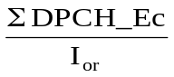 | The ratio of the sum of DPCH_Ec for one service in case of multicode to the total transmit power spectral density of the downlink at the BS antenna connector

4 Frequency bands and channel arrangement

4.1 General
The information presented in this section is based on a chip rate of 3.84 Mcps.
NOTE: Other chip rates may be considered in future releases.

4.2 Frequency bands
UTRA/TDD is designed to operate in the following bands;
a) 1900 – 1920 MHz: Uplink and downlink transmission
2010 – 2025 MHz Uplink and downlink transmission
b)* 1850 – 1910 MHz: Uplink and downlink transmission
1930 – 1990 MHz: Uplink and downlink transmission
c)* 1910 – 1930 MHz: Uplink and downlink transmission
* Used in ITU Region 2.
Additional allocations in ITU region 2 are for further study.
Deployment in existing or other frequency bands is not precluded.

4.3 TX–RX frequency separation
No TX-RX frequency separation is required as Time Division Duplex (TDD) is employed. Each TDMA frame consists of 15 timeslots where each timeslot can be allocated to either transmit or receive.

4.4 Channel arrangement

4.4.1 Channel spacing
The nominal channel spacing is 5 MHz, but this can be adjusted to optimise performance in a particular deployment scenario.

4.4.2 Channel raster
The channel raster is 200 kHz, which means that the carrier frequency must be a multiple of 200 kHz.

4.4.3 Channel number
The carrier frequency is designated by the UTRA absolute radio frequency channel number (UARFCN). The value of the UARFCN in the IMT2000 band is defined as follows:
Nt = 5 ∗ F | 0.0 MHz ≤ F ≤ 3276.6 MHz | where F is the carrier frequency in MHz

5 Transmitter Characteristics

5.1 General
Transmitting performance test of the UE is implemented during communicating with the SS via air interface. The procedure is uses normal call protocol until the UE is communicating on traffic channel basically. (Refer to TS 34.108 [3] Common Test Environments for User Equipment (UE) Conformance Testing) On the traffic channel, the UE provides special function for testing that is called Logical Test Interface and the UE is tested using this function. (Refer to TS 34.109 [4] Logical Test Interface; Special conformance testing functions).
Unless detailed the transmitter characteristic are specified at the antenna connector of the UE. For UE with integral antenna only, a reference antenna with a gain of 0 dBi is assumed. Transmitter characteristics for UE(s) with multiple antennas/antenna connectors are for further study.
The UE antenna performance has a significant impact on system performance, and minimum requirements on the antenna efficiency are therefore intended to be included in future versions of this specification. It is recognized that different requirements and test methods are likely to be required for the different types of UE.
The common RF test conditions are defined in annex E, and each test conditions in this Chapter should refer annex E. Individual test conditions are defined in the paragraph of each test.

5.2 User Equipment maximum output power

5.2.1 Definition and applicability
The maximum output power and its tolerance are defined according to the Power Class of the UE.
The output power, Pout, of the UE is the power when averaged (in the sense of thermal power) over the useful part of the TS at the maximum power control setting delivered in to a load with resistance equal to the nominal load impedance.
The requirements in this test apply to all UTRA – TDD- UEs
Notes copied from TS 25.102 clause 6.2.1 :
1. The maximum output power refers to.....
2. For multi-code operation the maximum output power will be reduced by the difference of peak to average ratio between single and multi-code transmission.
3. The tolerance of the maximum power is below the prescribed value even at the multi-code transmission mode
4. For UE using directive antennas for transmission, a class dependent limit will be placed on the maximum EIRP (Equivalent Isotropic Radiated Power).

5.2.2 Minimum Requirements
The error of the UE maximum output power shall not exceed the tolerance shown in Tables 5.2.2 a and b for single and multi-code.
Table 5.2.2.a: Maximum Output Power single code
Power Class | Maximum output power | Tolerance
1 | +30 dBm | +1dB/-3dB
2 | +24 dBm | +1dB /-3dB
3 | +21 dBm | +2dB /-2dB
4 | +10 dBm | +4dB/-4dB

Table 5.2.2.b: Maximum Output Power multi code
Power Class | Maximum output power | Tolerance
1 | [+27 ¹⁾]dBm | +1dB/-3dB
2 | [ 21 ¹⁾ ] dBm | +1dB /-3dB
3 | [ 18 ¹⁾ ] dBm | +2dB /-2dB
4 | [+7 ¹⁾] dBm | +4dB/-4dB

Note 1: These figures are not mentioned in 25.102. Instead there is a note, saying:
“For multi-code operation the maximum output power will be reduced by the difference of peak to average ratio between single and multi-code transmission.”
The figures are calculated from maximum output power single code (table 5.2.2.a) and UL multicode reference measurement channel (12.2 kbit/s) (annex C.2.2.) containing two code signals with equal level.
The normative reference for this requirement is 25.102 clause 6.2.

5.2.3 Test purpose
For the following reasons:
Limit interference.
Verify that the maximum output power is achievable.
It is the purpose of the test to verify that the UE’s maximum output power is within its tolerance limits under all environmental conditions.

5.2.4 Method of test

5.2.4.1 Initial conditions
1) Connect the SS to the UE antenna connector as shown in Figure A.1.
2) Calls are set up according to the Generic call setup procedure using parameters as specified in Tables 5.2.4.a and b
3) Enter the UE into loopback test mode and start the loopback test.
Table 5.2.4.a: Test parameters for Maximum Output Power single code
Parameter | Value/description
UL Reference measurement channel | 12.2kbps, according to annex C.2.1
Uplink Power Control | SS level and signalling values such that UE transmits maximum power.
Data content | real life (sufficient irregular)

Table 5.2.4.b: Test parameters for Maximum Output Power multicode
Parameter | Value/description
Reference measurement channel | Multicode 12.2kbps, according to annex C.2.2
Uplink Power Control | SS level and signalling values such that UE transmits maximum power
Data content | real life (sufficient irregular)

5.2.4.2 Procedure
1) Measure thermal power over the useful part of the burst.
with a measurement bandwidth of at least 5 MHz.
2) Average over TBD time slots.
3) Run step 1) and 2) for RF channels Low / Mid / High

5.2.5 Test Requirements
The output power, measured in step 2) of subclause 5.2.4.2, shall not exceed the prescribed tolerance in Table 5.2.5 a and b.
Table 5.2.5.a: Maximum Output Power single code
Power Class | Maximum output power | Tolerance
1 | +30 dBm | +1.7 dB / -3.7 dB
2 | +24 dBm | +1.7 dB / -3.7dB
3 | +21 dBm | +2.7 dB / -2.7dB
4 | +10 dBm | +4.7 dB / -4.7 dB

Table 5.2.5.b: Maximum Output Power multi code
Power Class | Maximum output power | Tolerance
1 | [ 27 ] dBm | +1.7 dB / -3.7 dB
2 | [ 21 ] dBm | +1.7dB / -3.7 dB
3 | [ 18 ] dBm | +2.7dB / -2.7 dB
4 | [ 7 ] dBm | +4.7 dB / -4.7 dB

NOTE: If the above Test Requirement differs from the Minimum Requirement then the Test Tolerance applied for this test is non-zero. The Test Tolerance for this test is defined in Annex F.2 and the explanation of how the Minimum Requirement has been relaxed by the Test Tolerance is given in Annex F.4.

5.3 UE frequency stability

5.3.1 Definition and applicability
The frequency stability is the difference of the modulated carrier frequency between the RF transmission from the UE and the RF transmission from the BS. The UE shall use the same frequency source for both RF frequency generation and chip clocking.
The requirements of this test apply to all types of UTRA- UE.

5.3.2 Minimum Requirements
The UE frequency stability, observed over a period of one timeslot, shall be within ±0.1 ppm compared to signals received from the BS.
The normative reference for this requirement is [1] TS 25.102 subclause 6.3.

5.3.3 Test purpose
Reliable frequency stability of the UE’s transmitter in certain tolerance limits is prerequisite for connectivity.
This test stresses the ability of the UE’s receiver to derive correct frequency information from the received signal for the transmitter.

5.3.4 Method of test

5.3.4.1 Initial conditions
1) Connect the SS to the UE antenna connector as shown in Figure A.1.
2) A call is set up according to the Generic call setup procedure using parameters as specified in table 5.3.4.1.
3) Enter the UE into loopback test mode and start the loopback test.
Table 5.3.4.1: Test parameters for Frequency Stability
Parameter | Value/description
SS level | –105 dBm  (reference sensitivity)
UL reference measurement channel | 12.2kbps according to annex C.2.1.
Data content | real life (sufficient irregular)

5.3.4.2 Procedure
1) Measure the frequency error delta f across the TS according to annex B.
2) Repeat step 1) for 200 bursts (time slots).
3) Run Step 1) and 2) for RF channels Low /Mid/ High.

5.3.5 Test Requirements
For all measured bursts (time slots) , the frequency error, derived in subclause 5.3.4.2, shall not exceed ± (0.1 ppm+10Hz).
NOTE: If the above Test Requirement differs from the Minimum Requirement then the Test Tolerance applied for this test is non-zero. The Test Tolerance for this test is defined in Annex F.2 and the explanation of how the Minimum Requirement has been relaxed by the Test Tolerance is given in Annex F.4

5.4 Output Power Dynamics
Power control is used to limit the interference level.

5.4.1 Uplink power control
Uplink power control is the ability of the UE transmitter to sets its output power in accordance with measured downlink path loss, values determined by higher layer signalling and path loss weighting parameter α as defined in TS 25.331 [9]. The output power is defined as the average power of the transmit timeslot, and is measured with a filter that has a Root-Raised Cosine (RRC) filter response with a roll off α = 0.22 and a bandwidth equal to the chip rate.

5.4.1.1 Initial accuracy

5.4.1.1.1 Definition and applicability
Initial Uplink power control is the ability of the UE transmitter to sets its output power in accordance with measured downlink path loss, and signalling values: IBTS and Constant value, received from the BCH and applicable for the PRACH
The requirements and this test apply to all types of UTRA - UEs.

5.4.1.1.2 Minimum requirements
The UE power control, initial accuracy, is given in Table 5.4.1.1.2.
Table 5.4.1.1.2: Initial uplink power control tolerance
Normal conditions | ± 9 dB
Extreme conditions | ± 12 dB

The reference for this requirement is [1] TS 25.102 clause 6.4.1.1.

5.4.1.1.3 Test purpose
The power of the received signal at the UE and the BCCH information control the power of the transmitted UE signal with the target to transmit at lowest power, acceptable for proper communication.
The test stresses the ability of the receiver to measure the received power over the receiver dynamic range and to derive from this correct transmitter-power

5.4.1.1.4 Method of test

5.4.1.1.4.1 Initial conditions
Connect the SS to the MS antenna connector as shown in Figure A.1.
A call is set up according to the generic call setup procedure [3] using parameters as specified in Table 5.4.1.1.4. The RACH procedure within the call setup is used for the test.
Table 5.4.1.1.4: Test parameters for uplink Power Control
 | RX-Upper dynamic end | RX-middle | RX-Sensitivity level
SS transmit power | -25 dBm/3.84 MHz | -65 dBm/3.84 MHz | -105 dBm/3.84 MHz
Broadcasted transmit- power CCPCH | 35 dBm | 35 dBm | 24 dBm
Simulated path loss =  Broadcasted TX – SS TX Power | 60 dB | 100 dB | 129 dB
I BTS (UL interference) | -75 dBm | -100 dBm | -110 dBm
Constant value | -10 dB | -10 dB | -10 dB
Nominal expected UE TX power | -25 dBm | -10 dBm | +9 dBm2)

Note 1: While the SS transmit power shall cover the UE receiver input dynamic range, the logical parameters: broadcasted transmit power, IBTS, and RACH constant value are chosen to achieve a UE TX power, located within the TX output power dynamic range of a class 3 UE.
Note 2: Nominal TX output power 9 dBm allows to check the uplink power control algorithm within the entire tolerance range (9 dBm +-12 dB: 9 dBm +12 dB =21 dBm = max power class 3).

5.4.1.1.4.2 Procedure
1) Set the SS transmit power according to table 5.4.1.1.4.
2) Measure the RACH output power of the UE according to Annex B.
3) Repeat the test for all SS transmit powers and parameters in table 5.4.1.1.4.

5.4.1.1.5 Test requirements
The deviation with respect to the nominal expected UE TX power ( table 5.4.1.1.2.) , derived in step 2, shall not exceed the prescribed tolerance in Table 5.4.1.1.5.
Table 5.4.1.1.5: Test parameters for uplink Power Control
Expected UE TX power, normal conditions | -25 dBm ±10 dB | -10 dBm±10 dB | +9 dBm ±10 dB
Expected UE TX power, extreme conditions | -25 dBm ±13 dB | -10 dBm±13 dB | +9 dBm ±13 dB

NOTE: If the above Test Requirement differs from the Minimum Requirement then the Test Tolerance applied for this test is non-zero. The Test Tolerance for this test is defined in Annex F.2 and the explanation of how the Minimum Requirement has been relaxed by the Test Tolerance is given in Annex F.4.

5.4.1.2 Differential accuracy, controlled input

5.4.1.2.1 Definition and applicability
Uplink power control, differential accuracy, is the ability of the UE transmitter to sets its output power in accordance with measured downlink path loss, and the signalling values: I BTS, SIR Target, Constant Value, received from higher layers and applicable for the DPCH.
Specifically, the uplink power control, differential accuracy, controlled input, is defined as the error in the UE transmitter power step as a result of a step in SIRTARGET when the path loss weighting parameter α=0, α calculated in the UE.
The requirements of this test apply to all types of UTRA -UE.

5.4.1.2.2 Minimum requirements
The step in SIRTARGET shall be rounded to the closest integer dB value. The error shall not exceed the values in table 5.4.1.2.2.
Table 5.4.1.2.2.: Transmitter power step tolerance as a result of control power step
ΔSIRTARGET [dB] | Transmitter power step tolerance [dB]
ΔSIRTARGET ≤ 1 | ± 0.5
1 < ΔSIRTARGET ≤ 2 | ± 1
2 < ΔSIRTARGET ≤ 3 | ± 1.5
3 < ΔSIRTARGET ≤ 10 | ± 2
10 < ΔSIRTARGET ≤ 20 | ± 4
20 < ΔSIRTARGET ≤ 30 | ± 6
30 < ΔSIRTARGET | ± 9 (1)

(1) Value is given for normal conditions. For extreme conditions value is ±12
The reference for this requirement is [1] TS 25.102 clause 6.4.1.2.

5.4.1.2.3 Test purpose
It is verified if the UE sets correct uplink power steps in response to steps in the signalling value SIR Target , signalled via the downlink to the UE
under the following conditions: keeping the other signalling parameters constant and deactivating any influence due to varying pathloss.

5.4.1.2.3 Method of test

5.4.1.2.3.1 Initial conditions
1) Connect the SS to the MS antenna connector as shown in Figure A.1.
2) A call is set up according to the generic call setup procedure using parameters as specified in Table 5.4.1.2.4
Table 5.4.1.2.4. Test parameters for Uplink Power Control, Differential Accuracy, Controlled Input
Parameter | Value/description
UL reference measurement channel | 12.2kbps according to annex C.2.1.
BS Transmit to UE Tansmit delay | 7 TSs--> α=0
SSTransmit power | [-65 dBm]
Reference transmit power broadcast on BCH | [35 dBm]
IBTS | [-100]
Constant value | [-10]
Data content | real life  (sufficient irregular)

5.4.1.2.3.2 Procedure
Using the SIR Target -value in the downlink,
cover the UE-transmitter dynamic range by commanding the UEs power with the signalling value SIR Target in a step resolution (positive and negative direction) of
1 dB approx. 68 steps up and 68 steps down
2 dB approx. 34 steps up and 34 steps down
3 dB approx. 22 steps up and 22 steps down
10 dB approx. 7 steps up and 7 steps down
20 dB approx. 3 steps up and 3 steps down
30 dB approx. 2 step up and 2 step down
maximum stepsize 1 step up and 1 step down
Measure the power according to Annex B.

5.4.1.2.5 Test requirements
For the UE output power laying between
Max Power minus tolerance and Min Power
the step response shall not exceed the prescribed tolerance in Table 5.4.1.2.5.
Table 5.4.1.2.5.: Transmitter power step tolerance as a result of control power step
ΔSIRTARGET [dB] | Transmitter power step tolerance [dB]
ΔSIRTARGET ≤ 1 | ± 0.6
1 < ΔSIRTARGET ≤ 2 | ± 1.15
2 < ΔSIRTARGET ≤ 3 | ± 1.7
3 < ΔSIRTARGET ≤ 10 | ± 2.5
10 < ΔSIRTARGET ≤ 20 | ± 4.7
20 < ΔSIRTARGET ≤ 30 | ± 6.7
30 < ΔSIRTARGET | ± 10

NOTE: If the above Test Requirement differs from the Minimum Requirement then the Test Tolerance applied for this test is non-zero. The Test Tolerance for this test is defined in Annex F.2 and the explanation of how the Minimum Requirement has been relaxed by the Test Tolerance is given in Annex F.4.

5.4.2 Minimum transmit output power

5.4.2.1 Definition and applicability
The minimum controlled output power of the UE is when the power control setting is set to a minimum value. This is when the uplink power control indicates a minimum transmit output power is required.
The normative requirements of this test apply to all types of UTRA- UE.

5.4.2.2 Minimum Requirements
The minimum transmit power shall be lower than or equal to –44 dBm
The normative reference for this requirement is TS 25.102 [1] subclause 6.4.5.1.

5.4.2.3 Test purpose
The test purpose is to verify the ability of the UE to reduce its output power to a specified value.

5.4.2.4 Method of test

5.4.2.4.1 Initial conditions
1) Connect the SS to the UE antenna connector as shown in Figure A.1.
2) A call is set up according to the Generic call setup procedure using parameters as specified in table E.3.1.2
3) Enter the UE into loopback test mode and start the loopback test.

5.4.2.4.2 Procedure
1) Configure the UE transmitter to enable power control steps of size 1 dB.
2) Measure power of the UE output signal over the useful part of the active time slot according to annex B.
NOTE: Annex B returns the power in the decision points (displayed as reference power and power offset). This is equivalent to thermal power at the air-interface. Insofar 5.4.2 minimum output power is consistent with 5.2 maximum output power.
3) Average over TBD time slots.
4) Configure the UE transmitter to enable power control steps of 2 dB and of 3 dB, respectively, and repeat steps 2) to 3).
5) Run step 2) to 3) for RF channels Low Mid and High.

5.4.2.5 Test requirements
For all measurements, the minimum transmit power derived in step 3), 4) and 5) of 5.4.2.4.2 shall be below –43 dBm.
NOTE: If the above Test Requirement differs from the Minimum Requirement then the Test Tolerance applied for this test is non-zero. The Test Tolerance for this test is defined in Annex F.2 and the explanation of how the Minimum Requirement has been relaxed by the Test Tolerance is given in Annex F.4.

5.4.3 Transmit OFF power

5.4.3.1 Definition and applicability
The transmit OFF power state is when the UE does not transmit. This parameter is defined as the maximum output transmit power within the channel bandwidth when the transmitter is OFF.
The requirements of this test apply to all types of UTRA-UE.

5.4.3.2 Minimum Requirements
The transmit OFF power shall be below −65 dBm.
The normative reference for this requirement is TS 25.102 subclause 6.5.1.

5.4.3.3 Test purpose
refer clause 5.4.4.3.

5.4.3.4 Method of test
refer clause 5.4.4.4

5.4.3.5 Test requirements
The transmit OFF power shall be below −63.5 dBm.
NOTE: If the above Test Requirement differs from the Minimum Requirement then the Test Tolerance applied for this test is non-zero. The Test Tolerance for this test is defined in Annex F.2 and the explanation of how the Minimum Requirement has been relaxed by the Test Tolerance is given in Annex F.4

5.4.4 Transmit ON/OFF Time mask

5.4.4.1 Definition and applicability
The transmit ON/OFF time mask defines the ramping time allowed for the UE between transmit OFF power and transmit ON power.
This test applies for all UTRA TTD UEs.

5.4.4.2 Minimum requirements
The transmit power level versus time shall meet the mask specified in figure 5.4.4.2, where the transmission period refers to the burst without guard-period for a single transmission slot, and to the period from the beginning of the burst in the first transmission slot to the end of the burst without guard period in the last transmission timeslot for consecutive transmission slots.
The reference for this requirement is TS25.102 subclause 6.5.2.1.
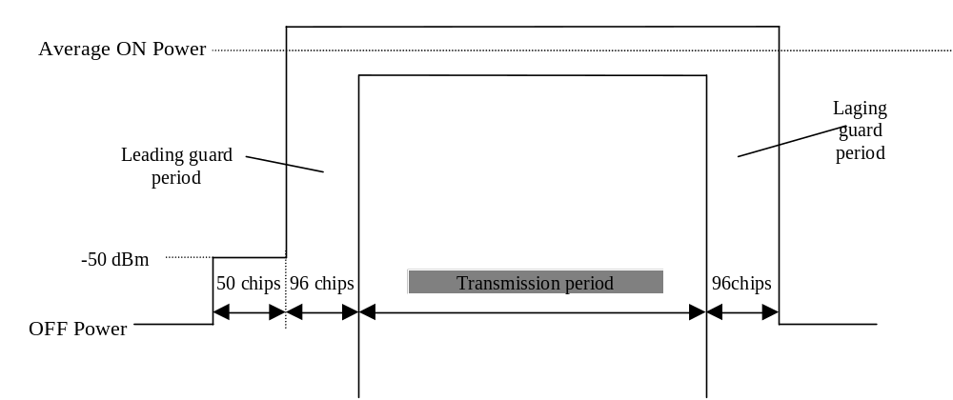
Figure 5.4.4.2: Transmit ON/OFF template

5.4.4.3 Test Purpose
It is tested if the UE TX signal uses the guard period for on-to-off and off-to-on transitions, where the time position of guard period is derived from the burst under test itself.
It is furtheron tested, if the UE TX signal is below certain limits outside transmission period and guard periods where the position in time is derived from the burst under test itself.
With this test interference to other UTRA TDD users are limited
Editor’s note:
For the transmission period other tests apply.
For the absolute burst position in time other tests apply

5.4.4.4 Method of test

5.4.4.4.1 Initial conditions
Connect the SS to the UE antenna connector as shown in Figure A.1.
A call is set up according to the generic call setup procedure using parameters as specified in Table E.3.1.2.
Enter the UE into loopback test mode and start the loopback test.

5.4.4.4.2 Procedure
1) The time position of the midamble of the burst under test (TimeSlot s in Frame f) shall be the reference for the time position of the leading and laging guard-periods of the burst under test and, alternatively, for the equivalent guard periods of the next 2 bursts.
2) Record the following time periods with at least 2 samples /chip through a matched filter (RRC 0.22, BW equal to the chiprate) : TS s-1 and TS s+1 in frame f or f+1 or f+2
3) Calculate power samples by averaging the recorded samples of one chip duration.

5.4.4.5 Test requirements
Each power sample shall be below the limits (off Power (subclause 5.4.3.) and – 50 dBm), indicated in figure 5.4.4.2.
Editor’s note: In this test no power limits apply during guard period.

5.4.5 Out-of-synchronisation handling of output power

5.4.5.1 Definition and applicability
The UE shall monitor the DPCH quality in order to detect a loss of the signal on Layer 1, as specified in TS 25.224. [5] The thresholds Qout and Qin specify at what DPCH quality levels the UE shall shut its power off and when it shall turn its power on, respectively. The thresholds are not defined explicitly, but are defined by the conditions under which the UE shall shut its transmitter off and turn it on, as stated in this clause.
The requirement of this subclause shall apply to all types of UTRA-UE.

5.4.5.2 Minimum Requirement
The parameters in Table 5.4.5.1 are defined using the DL reference measurement channel (12.2) kbps specified in Annex C where the CRC bits are replaced by data bits, and with static propagation conditions.
Table 5.4.5.1: DCH parameters for test of Out-of-synch handling
Parameter | Unit |  | Value
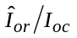 |  | dB | -1
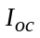 |  | dBm/3.84 MHz | -60
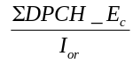 | dB |  | See figure yy
Information Data Rate | kbps |  | 13
TFCI | - |  | On

The conditions for when the UE shall shut its transmitter off and when it shall turn it on are defined by the parameters in Table 5.4.5.1 together with the DPCH power level as defined in Figure 5.4.5.1.
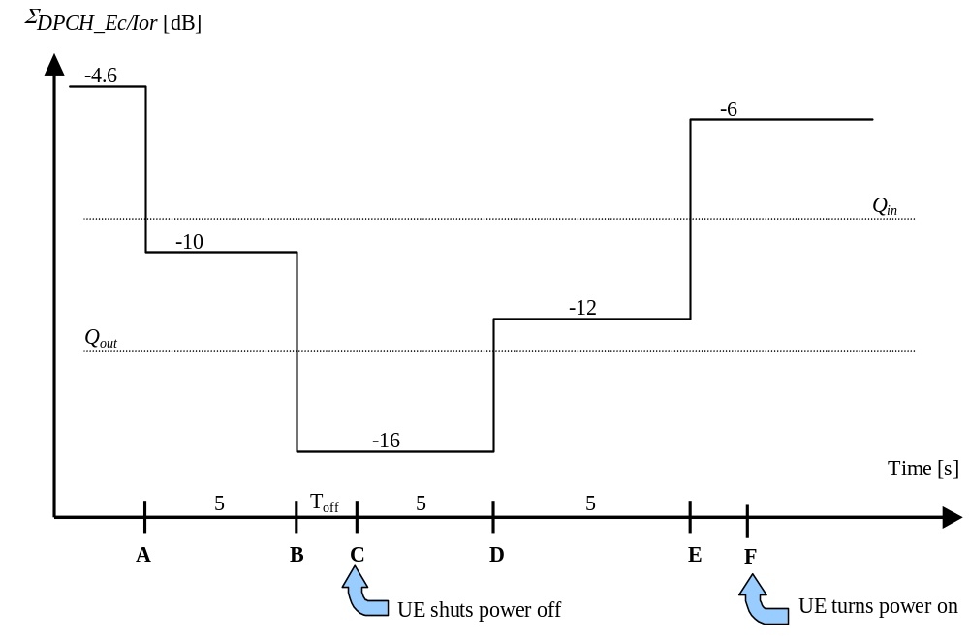
Figure 5.4.5.1. Conditions for out-of-synch handling in the UE. The indicated thresholds Qout andQin are only informative
The requirements for the UE are that:
1) The UE shall not shut its transmitter off before point B.
2) The UE shall shut its transmitter off before point C, which is T_{off} = 200 ms after point B
3) The UE shall not turn its transmitter on between points C and E.
4) The UE shall turn its transmitter on before point F, which is Ton = 200 ms after Point E.
The normative reference for this test is 25.102 clause 6.4.3.

5.4.5.3 Test purpose
To verify that the UE monitors the DPCH quality and turns its transmitter on or off according to DPCH level diagram specified in figure5.4.5.1

5.4.5.4 Method of test

5.4.5.4.1 Initial conditions
1) Connect the SS to the UE antenna connector as shown in Figure A.1.
2) Calls are set up according to the Generic call setup procedure using parameters as specified in table 5.4.5.1
3) Enter the UE into loopback test mode and start the loopback test.

5.4.5.4.2 Procedure
1) The SS sends continuously Up power control commands to the UE until the UE transmitter power reaches maximum level
2) Set the SS TX signal quality to 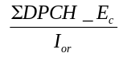 = -4.6+[0.3] dB and verify that the UE TX signal is on.
3) Set the SS TX signal quality to = -10+[0.3] dB and verify that the UE TX signal remains on continuously for at least 5 seconds.
4) Set the SS TX signal quality to = -16-[0.3] dB and verify that the UE TX signal turns off 200 ms or earlier with respect to that instant.
5) Set the SS TX signal quality to = -12-[0.3] dB and verify that the UE TX signal remains off continuously for at least 5 seconds.
6) Set the SS TX signal quality to = -6+[0.3] dB and verify that the UE TX signal is switched on 200 ms or earlier with respect to that instant.

5.4.5.5 Test Requirements
The UE TX on-criterion including tolerance window is derived from the initial conditions and is verified with the method of 5.4.2 minimum transmit power.The UE transmitter is considered to be on if the UE transmitted power is higher than the minimum output power.
The UE TX off criterion including tolerance is verified according to clause 5.4.3 of this TS (Transmit off power)
To pass the test, steps 1 through 6 of the procedure must be fulfilled.

5.5 Output RF spectrum emissions

5.5.1 Occupied bandwidth

5.5.1.1 Definition and applicability
Occupied bandwidth is a measure of the bandwidth containing 99% of the total integrated power for transmitted spectrum and is centered on the assigned channel frequency.
The requirements in this subclause shall apply to all types of UTRA - UE.

5.5.1.2 Minimum Requirements
The occupied bandwidth shall be less than 5 MHz based on a chip rate of 3,84 Mcps.
The normative reference for this requirement is TS 25.102 [1] subclause 6.6.1.

5.5.1.3 Test purpose
The occupied bandwidth, defined in the Radio Regulations of the International Telecommunication Union ITU, is a useful concept for specifying the spectral properties of a given emission in the simplest possible manner; see also ITU-R Recommendation SM.328-9 [8].
The test purpose is to verify that the emission of the UE is sufficiently concentrated in the bandwidth for the service to be provided and is, therefore, not likely to create interference to other users of the spectrum beyond undue limits.

5.5.1.4 Method of test

5.5.1.4.1 Initial conditions
1) Connect the SS to the UE antenna connector as shown in Figure A.1.
2) A call is set up according to the generic call setup procedure using parameters as specified in table E.3.1.2.
3) Enter the UE into loopback test mode and start the loopback test.

5.5.1.4.2 Procedure
1) Measure the power of the transmitted signal with a measurement filter of bandwidth [30 kHz]. The characteristic of the filter shall be approximately Gaussian (typical spectrum analyzer filter). The center frequency of the filter shall be stepped in contiguous 30 kHz steps from a minimum frequency, which shall be [7,5 – 0,015] MHz below the assigned channel frequency of the transmitted signal, up to a maximum frequency, which shall be [7,5 – 0,015] MHz above the assigned channel frequency of the transmitted signal. The step duration shall be sufficient slow to capture the active TS. The measured power shall be recorded for each step.
2) Determine the total transmitted power by accumulating the recorded power measurements results of all steps.
3) Sum up the power upward from the lower boundary of the measured frequency range in ‘(2)’ and seek the limit frequency point by which this sum becomes 0.5 % of "Total Power" and save this point as "Lower Frequency".
4) Sum up the power downward from the upper boundary of the measured frequency range in ‘(2)’ and seek the limit frequency point by which this sum becomes 0.5 % of "Total Power" and save this point as "Upper Frequency".
5) Calculate the difference ("Upper Frequency" – "Lower Frequency" = "Occupied Bandwidth") between two limit frequencies obtained in ‘(4)’ and ‘(5)’.

5.5.1.5 Test requirements
The measured Occupied Bandwidth, derived in step 5), shall not exceed 5 MHz.
NOTE: If the above Test Requirement differs from the Minimum Requirement then the Test Tolerance applied for this test is non-zero. The Test Tolerance for this test is defined in Annex F.2 and the explanation of how the Minimum Requirement has been relaxed by the Test Tolerance is given in Annex F.4.

5.5.2 Out of band emission
Out of band emissions are unwanted emissions immediately outside the nominal channel resulting from the modulation process and non-linearity in the transmitter but excluding spurious emissions. This out of band emission limit is specified in terms of a spectrum emission mask and adjacent channel power ratio.

5.5.2.1 Spectrum emission mask

5.5.2.1.1 Definition and applicability
The spectrum emission mask of the UE is a requirement that applies to frequencies which are between 2.5 and 12.5MHz to both sides of the carrier frequency. The out of channel emission is specified relative to the UE output power in a 3.84 MHz bandwidth.
The requirements of this test apply to all types of UTRA-UE.

5.5.2.1.2 Minimum Requirements
The power of any UE emission shall not exceed the levels specified in table 5.5.2.1.2.
The normative reference for this requirement is 3G TS 25.102 clause 6.6.2.1.1
Table 5.5.2.1.2: Spectrum Emission Mask Requirement
Frequency offset from carrier ?f | Minimum requirement | Measurement bandwidth
2.5 - 3.5 MHz | -35 -15*(Δf – 2.5) dBc | 30 kHz
3.5 - 7.5 MHz | -35- 1*(Δf-3.5) dBc | 1 MHz
7.5 - 8.5 MHz | -39 - 10*(Δf – 7.5) dBc | 1 MHz
8.5 - 12.5 MHz | -49 dBc | 1 MHz

Note
1. The first and last measurement position with a 30 kHz filter is 2.515 MHz and 3.485 MHz.
2. The first and last measurement position with a 1 MHz filter is 4 MHz and 12 MHz.
3. The lower limit shall be –50dBm/3.84 MHz or which ever is higher.

5.5.2.1.3 Test purpose
This test supplements Occupied Bandwidth (verifying the spectral concentration of the UE’s emissions) and Adjacent Channel Leakage Ratio (simulating the perception of other UTRA receivers) in a system independent way. It is the purpose of this test to limit interferences to other systems (wideband or narrowband).

5.5.2.1.4 Method of test
5.5.2.1.4.1 Initial conditions
1) Connect the SS to the UE antenna connector as shown in Figure A.1.
2) A call is set up according to the generic call setup procedure using parameters as specified in table E.3.1.2.
3) Enter the UE into loopback test mode and start the loopback test.
5.5.2.1.4.2 Procedure
1) Measure the power of the transmitted signal with a measurement filter of bandwidths according to table 5.5..2.1.2. The characteristic of the filter shall be approximately Gaussian (typical spectrum analyzer filter). The center frequency of the filter shall be stepped in contiguous steps according to table 5.5.2.1.2. The step duration shall be sufficient slow to capture the active TS. The measured power shall be recorded for each step.
2) Measure the wanted output power according to annex B.
3) Display the results of 1) in dBc with respect to 2).

5.5.2.1.5 Test requirements
The result 5.5.2.1.4.2. step 3) shall fulfil the requirements of table 5.5.2.1.5.
Table 5.5.2.1.5: Spectrum Emission Mask Requirement
Frequency offset from carrier ?f | Minimum requirement | Measurement bandwidth
2.5 - 3.5 MHz | -33.5 -15*(Δf – 2.5) dBc | 30 kHz
3.5 - 7.5 MHz | -33.5- 1*(Δf-3.5) dBc | 1 MHz
7.5 - 8.5 MHz | -37.5 - 10*(Δf – 7.5) dBc | 1 MHz
8.5 - 12.5 MHz | -47.5 dBc | 1 MHz

Note:
1. The first and last measurement position with a 30 kHz filter is 2.515 MHz and 3.485 MHz.
2. The first and last measurement position with a 1 MHz filter is 4 MHz and 12 MHz.
3. The lower limit shall be –48.5dBm/3.84 MHz or which ever is higher
NOTE: If the above Test Requirement differs from the Minimum Requirement then the Test Tolerance applied for this test is non-zero. The Test Tolerance for this test is defined in Annex F.2 and the explanation of how the Minimum Requirement has been relaxed by the Test Tolerance is given in Annex F.4.

5.5.2.2 Adjacent Channel Leakage power Ratio (ACLR)

5.5.2.2.1 Definition and applicability
Adjacent Channel Leakage power Ratio (ACLR) is the ratio of the wanted power to the power in an adjacent channel. Both the wanted power and adjacent channel power are measured with a Root-Raised Cosine (RRC) filter with roll-off α = 0.22 and a bandwidth equal to the chip rate.
The requirements in this subclause shall apply to all types of UTRA-UE.

5.5.2.2.2 Minimum Requirements
If the adjacent channel power is greater than –50dBm then the ACLR shall be better than the value specified in table 5.5.2.2.2.
The normative reference for this requirement is 3G TS 25.102 clause 6.6.2.2.1
Table 5.5.2.2.2: UE ACLR
Power Class | Adjacent channel | ACLR limit
2, 3 | UE-channel  ± 5 MHz | -33 dB
2, 3 | UE-Channel  ± 10 MHz | -43 dB

5.5.2.2.3 Test purpose
The test purpose is to verify the ability of the UE to limit the interference produced by the transmitted signal to other UTRA receivers operating at the first or second adjacent RF channel.

5.5.2.2.4 Method of test
5.5.2.2.4.1 Initial conditions
1) Connect the SS to the UE antenna connector as shown in Figure A.1.
2) A call is set up according to the generic call setup procedure using parameters as specified in table E.3.1.2.
3) Enter the UE into loopback test mode and start the loopback test.
5.5.2.2.4.2 Procedure
1) Measure the wanted transmitted power of the active timeslot using the method in annex B.
2) Average over TBD time slots.
3) Measure interference power at the first lower adjacent RF channel (center frequency 5 MHz below the assigned channel frequency of the transmitted signal) over the useful part of the active TS with a measurement filter that has a RRC filter response with a roll off α = 0,22 and a bandwidth equal to the chip rate.
4) Average over TBD time slots.
5) Calculate the ACLR by
Transmitted power acc. to 2) / interference power acc. to 4).
6) Repeat steps 3), 4) and 5) for the second lower adjacent RF channel (center frequency 10 MHz below the assigned channel frequency of the transmitted signal) and also for the first and second upper adjacent RF channel (center frequency 5 MHz and 10 MHz, respectively).

5.5.2.2.5 Test requirements
The ACLR calculated in steps 5) and 6) of subclause 5.5.2.2.4.2 shall be equal or greater than the limits given in table 5.5.2.2.5.
Table 5.5.2.2.5: UE ACLR
Power Class | Adjacent channel | ACLR limit
2, 3 | UE-channel  ± 5 MHz | -32.2 dB
2, 3 | UE-Channel  ± 10 MHz | -42.2 dB

NOTE: If the above Test Requirement differs from the Minimum Requirement then the Test Tolerance applied for this test is non-zero. The Test Tolerance for this test is defined in Annex F.2 and the explanation of how the Minimum Requirement has been relaxed by the Test Tolerance is given in Annex F

5.5.3 Spurious emissions

5.5.3.1 Definition and applicability
Spurious emissions are emissions which are caused by unwanted transmitter effects such as harmonics emission, parasitic emission, intermodulation products and frequency conversion products, but exclude out of band emissions.
The frequency boundary and the detailed transitions of the limits between the requirement for out band emissions and spectrum emissions are based on ITU-R Recommendations SM.329 [8].

5.5.3.2 Minimum Requirements
These requirements are only applicable for frequencies which are greater than 12.5 MHz away from the UE center carrier frequency.
The normative reference for this requirement is 3G TS 25.102 clause 6.6.3.1.
Table 5.5.3.2a: General Spurious emissions requirements
Frequency Bandwidth | Resolution Bandwidth | Minimum requirement
9 kHz ≤ f < 150 kHz | 1 kHz | -36 dBm
150 kHz ≤ f < 30 MHz | 10 kHz | -36 dBm
30 MHz ≤ f < 1000 MHz | 100 kHz | -36 dBm
1 GHz ≤ f < 12.75 GHz | 1 MHz | -30 dBm

Table 5.5.3.2b: Additional Spurious emissions requirements
Frequency Bandwidth | Resolution Bandwidth | Minimum requirement
925 MHz ≤ f ≤ 935 MHz | 100 kHz | -67 dBm*
935 MHz < f ≤ 960 MHz | 100 kHz | -79 dBm*
1805 MHz ≤ f ≤ 1880 MHz | 100 kHz | -71 dBm*

NOTE: The measurements are made on frequencies which are integer multiples of 200 kHz. As exceptions, up to five measurements with a level up to the applicable requirements defined in table 5.5.3.2b are permitted for each UARFCN used in the measurement.

5.5.3.3 Test purpose
The test purpose is to verify the ability of the UE to limit the interference caused by unwanted transmitter effects to other systems operating at frequencies which are more than 12,5 MHz away from of the UE’s carrier frequency.

5.5.3.4 Method of test

5.5.3.4.1 Initial conditions
1) Connect the SS to the UE antenna connector as shown in Figure A.1.
2) A call is set up according to the generic call setup procedure using parameters as specified in table E.3.1.2.
3) Enter the UE into loopback test mode and start the loopback test.

5.5.3.4.2 Procedure
Measure the power of the spurious emissions applying measurement filters with bandwidths as specified in the relevant tables of 5.5.3.2. The characteristic of the filters shall be approximately Gaussian (typical spectrum analyzer filters). The center frequency of the filter shall be swept over the frequency bands as given in the tables. The sweep time shall be sufficiently low to capture the active time slots.

5.5.3.5 Test requirements
The spurious emissions measured according to subclause 5.5 .3.4.2 shall not exceed the limits specified in the relevant tables of 5.5.3.5.a and 5.5.3.5.b
Table 5.5.3.5a: General Spurious emissions requirements
Frequency Bandwidth | Resolution Bandwidth | Test requirement
9 kHz ≤ f < 150 kHz | 1 kHz | -36 dBm
150 kHz ≤ f < 30 MHz | 10 kHz | -36 dBm
30 MHz ≤ f < 1000 MHz | 100 kHz | -36 dBm
1GHz ≤ f < 12.75GHZ | 1MHz | -30 dBm

Table 5.5.3.5b: Additional Spurious emissions requirements
Frequency Bandwidth | Resolution Bandwidth | Test requirement
925 MHz ≤ f ≤ 935 MHz | 100 kHz | -67 dBm*
935 MHz < f ≤ 960 MHz | 100 kHz | -79 dBm*
1805 MHz ≤ f ≤ 1880 MHz | 100 kHz | -71 dBm*

NOTE: The measurements are made on frequencies which are integer multiples of 200 kHz. As exceptions, up to five measurements with a level up to the applicable requirements defined in table 5.5.3.5b. are permitted for each UARFCN used in the measurement.
NOTE: If the above Test Requirement differs from the Minimum Requirement then the Test Tolerance applied for this test is non-zero. The Test Tolerance for this test is defined in Annex F.2 and the explanation of how the Minimum Requirement has been relaxed by the Test Tolerance is given in Annex F.4.

5.6 Transmit Intermodulation

5.6.1 Definition and applicability
The transmit intermodulation performance is a measure of the capability of the transmitter to inhibit the generation of signals in its non linear elements caused by the presence of the wanted signal and an interfering signal reaching the transmitter via the antenna.
The UE intermodulation attenuation is defined by the ratio of the output power of the wanted signal to the output power of the intermodulation product when an interfering CW signal is added at a level below the wanted signal. Both the wanted signal power and the intermodulation product power are measured with a filter response that is root-raised cosine (RRC) with roll-off α=0.22 and with a bandwidth equal to the chip rate.
The requirements of this test shall apply for all UTRA-UE.

5.6.2 Minimum Requirements
The requirement of transmitting intermodulation for carrier spacing 5 MHz is prescribed in the table below.
The normative reference for this requirement is 3G TS 25.102 clause 6.7.1
Table 5.6.2: Transmit Intermodulation
Interference Signal Frequency Offset | 5MHz | 10MHz
Interference Signal Level | -40 dBc
Interferer Modulation | CW  Note: BS Test uses a CDMA modulated signal
Minimum requirement | -31dBc | -41dBc

5.6.3 Test purpose
User Equipment(s) transmitting in close vicinity of each other can produce intermodulation products, which can fall into other UE, or BS receive band as an unwanted interfering signal.
It is the purpose of this test to limit interferences to the own and other systems due to intermodulation products.

5.6.4 Method of test

5.6.4.1 Initial conditions
1) Connect the SS and the interferer to the UE antenna connector as shown in Figure A.2.
2) A call is set up according to the generic call setup procedure using parameters as specified in table E.3.1.2.
3) Enter the UE into loopback test mode and start the loopback test.
Parameters of the interferer according to table 5.6.2.

5.6.4.2 Procedure
1) Measure the unwanted emissions according to 5.6.2. in a carrier offset spacing of 5 MHz and in a frequency range [5 MHz to 12.75 GHz], using an interferer +5MHz offset.
The frequency occupied by the interferer is excluded from the measurement.
2) Repeat 1) with the other 3 interferer-configurations (-5Mz. +10 MHz, -10 MHz).
3) Measure the wanted power according to annex B.
4) Display 1) and 2) in dBc with respect to 3).

5.6.5 Test requirements
The results in 4) from subclause 5.6.4.2 shall not exceed the predescribed values in table 5.6.5.
Table 5.6.5: Transmit Intermodulation
Interference Signal Frequency Offset | 5MHz | 10MHz
Interference Signal Level | -40 dBc
Interferer Modulation | CW  Note: BS Test uses a CDMA modulated signal
Requirement | [-31+TT] dBc | [-41+TT] dBc

NOTE: If the above Test Requirement differs from the Minimum Requirement then the Test Tolerance applied for this test is non-zero. The Test Tolerance for this test is defined in Annex F.2 and the explanation of how the Minimum Requirement has been relaxed by the Test Tolerance is given in Annex F.4.

5.7 Transmit Modulation

5.7.1 Error Vector Magnitude

5.7.1.1 Definition and applicability
The Error Vector Magnitude (EVM) is a measure of the difference between the measured waveform and the theoretical modulated waveform (the error vector). It is the square root of the ratio of the mean error vector power to the mean reference signal power expressed as a %. The measurement interval is one timeslot.
The requirement of this subclause shall apply to all types of UTRA-UE.

5.7.1.2 Minimum Requirements
The Error Vector Magnitude shall not exceed 17.5 % for the parameters specified in Table 5.7.2.1.
Table 5.7.1.2.: Test parameters for Error Vector Magnitude/Peak Code Domain Error

Parameter | Level | Unit
UE Output Power | ≥-20 | dBm
Operating conditions | Normal conditions
Power control step size | 1 | dB

The normative reference for this requirement is TS 25.102 [1] subclause 6.8.2.

5.7.1.3 Test purpose
The transmitter shall generate a sufficient precise waveform, to enable the receiver to achieve the specified receiver performances.

5.7.1.4 Method of test

5.7.1.4.1 Initial conditions
1) Connect the SS to the UE antenna connector as shown in Figure A.1.
2) A call is set up according to the generic call setup procedure using parameters as specified in table E.3.1.2.
3) Enter the UE into loopback test mode and start the loopback test.

5.7.1.4.2 Procedure
1) Starting from the initial conditions, measure EVM (Error Vector Magnitude) of the UE according to annex B.
2) Set SS-level and signalling values such that the power level of the UE is between –20 and –19 dBm
3) Measure EVM of the UE according to annex B.

5.7.1.5 Test requirements
The results in step 1) and 2) shall not exceed 17.5% for parameters specified in table 5.7.1.2.
NOTE: If the above Test Requirement differs from the Minimum Requirement then the Test Tolerance applied for this test is non-zero. The Test Tolerance for this test is defined in Annex F.2 and the explanation of how the Minimum Requirement has been relaxed by the Test Tolerance is given in Annex F.4.

5.7.2 Peak code domain error

5.7.2.1 Definition and applicability
The code domain error is computed by projecting the error vector power onto the code domain at a specific spreading factor. The error power for each code is defined as the ratio to the mean power of the projetion onto the code, to the mean power of the composite reference waveform expressed in dB. And the Peak Code Domain Error is defined as the maximum value for Code Domain Error. The measurement interval is one timeslot.
This specification is applicable for multi-code transmission only.
The requirement of this test applies to all UTRA-UE, applicable for multi-code transmission.

5.7.2.2 Minimum Requirement
The peak code domain error shall not exceed -21dB at spreading factor 16.
The normative reference for this requirement is TS 25.102 [1] subclause 6.8.3.1.

5.7.2.3 Test purpose
It is the purpose of this test to limit crosstalk among codes.

5.7.2.4 Method of test

5.7.2.4.1 Initial conditions
1) Connect the SS to the UE antenna connector as shown in Figure A.1.
2) A call is set up according to the generic call setup procedure using parameters as specified in table 5.7.2.4.1.
3) Enter the UE into loopback test mode and start the loopback test.
Table 5.7.2.4.1: Test parameters for Peak code Domain Error
Parameter | Value/description
Reference measurement channel | Multicode 12.2kbps, according to annex C.2.2
Uplink Power Control | SS level and signalling values such that UE transmits maximum power
Data content | real life  (sufficient irregular)

5.7.2.4.2 Procedure
1) Starting from the initial conditions, measure peak code error(PCDE)of the UE according to annex B.
2) Set SS-level and signalling values such that the power level of the UE is between –20 and –19 dBm
3) Measure PCDE of the UE according to annex B.

5.7.2.5 Test requirements
The results in step 1) and 2) shall nor exceed -20 dB. for parameters specified in table 5.7.1.2.
Note: If the above Test Requirement differs from the Minimum Requirement then the Test Tolerance applied for this test is non-zero. The Test Tolerance for this test is defined in Annex F.2 and the explanation of how the Minimum Requirement has been relaxed by the Test Tolerance is given in Annex F.4.

6 Receiver Characteristics

6.1 General
Receiving performance test of the UE is implemented during communicating with the SS via air interface. The procedure uses normal call protocol until the UE is communicating on traffic channel basically. (Refer to TS 34.108 [3] Common Test Environments for User Equipment (UE) Conformance Testing) On the traffic channel, the UE provides special function for testing that is described in Logical Test Interface and the UE is tested using this function. (Refer to TS 34.109 [3] Logical Test Interface (FDD/TDD) Special conformance testing functions)
Unless otherwise stated the receiver characteristics are specified at the antenna connector of the UE. For UE(s) with an integral antenna only, a reference antenna with a gain of 0 dBi is assumed. UE with an integral antenna may be taken into account by converting these power levels into field strength requirements, assuming a 0 dBi gain antenna. Receiver characteristics for UE(s) with multiple antennas/antenna connectors are for further study.
The UE antenna performance has a significant impact on system performance, and minimum requirements on the antenna efficiency are therefore intended to be included in future versions of this specification. It is recognized that different requirements and test methods are likely to be required for the different types of UE.
All the parameters in clause 6 are defined using the DL reference measurement channel (12.2 kbps) specified in subclause C.3.3.

6.2 Reference sensitivity level

6.2.1 Definition and applicability
The reference sensitivity is the minimum receiver input power measured at the antenna connector at which the BER does not exceed the specific value.
The requirements in this subclause shall apply to all types of UTRA UE.

6.2.2 Minimum Requirements
For the DL reference measurement channel 12.2 kBit/s specified in annex C, the BER shall not exceed 0.001 for the parameters specified in Table 6.2.2.
Table 6.2.2. Test parameters for reference sensitivity
Parameter | Level | Unit
 | 0 | dB
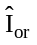 | -105 | dBm/3.84 MHz

The normative reference for this requirement is TS 25.102 [1] subclause 7.3.

6.2.3 Test purpose
The test purpose is to verify the ability of the UE to receive a prescribed test signal at the lower end of the dynamic range under defined conditions (no interference, no multipath propagation) with a BER not exceeding a specified level. This test is also used as a reference case for other tests to allow the assessment of degradations due to various sources of interference.

6.2.4 Method of test

6.2.4.1 Initial conditions
1) Connect the SS to the UE antenna connector as shown in Figure A.3.
2) A call is set up according to the Generic call setup procedure..
3) Enter the UE into loopback test mode and start the loopback test.
4) The level of SS output signal measured at the UE antenna connector shall be –105 dBm.

6.2.4.2 Procedure
1) Measure the BER of DCH received from the UE at the SS.

6.2.5 Test requirements
The measured BER, derived in step 1), shall not exceed 0.001 under conditions described in Table 6.2.5.
Table 6.2.5. Test parameters for reference sensitivity
Parameter | Level | Unit
 | 0 | dB
 | -104.3 | dBm/3.84 MHz

NOTE: If the above Test Requirement differs from the Minimum Requirement then the Test Tolerance applied for this test is non-zero. The Test Tolerance for this test is defined in Annex F.2 and the explanation of how the Minimum Requirement has been relaxed by the Test Tolerance is given in Annex F.4.

6.3 Maximum Input Level

6.3.1 Definition and applicability
This is defined as the maximum receiver input power, measured at the antenna connector, which does not degrade the specified BER performance.
The requirements in this subclause shall apply to all types of UTRA UE.

6.3.2 Minimum requirements
The BER shall not exceed 0,001 for the parameters specified in table 6.3.2.
Table 6.3.2: Maximum input level
Parameter | Level | Unit
 | -7 | dB
 | -25 | dBm/3.84 MHz

The reference for this requirement is TS 25.102 [1] subclause 7.4.

6.3.3 Test purpose
The test purpose is to verify the ability of the UE to receive a prescribed test signal at the upper end of the dynamic range under defined conditions (no interference, no multipath propagation) with BER not exceeding a specified value.

6.3.4 Method of test

6.3.4.1 Initial conditions
1) Connect the SS to the UE antenna connector as shown in Figure A.3.
2) A call is set up according to the Generic call setup procedure.
3) Enter the UE into loopback test mode and start the loopback test.
4) The level of SS output signal measured at the UE antenna connector shall be according to table 6.3.2.

6.3.4.2 Procedure
Measure the BER of DCH received from the UE at the SS.

6.3.5 Test requirements
The measured BER, derived in step 1), shall not exceed 0,001.

6.4 Adjacent Channel Selectivity (ACS)

6.4.1 Definition and applicability
Adjacent Channel Selectivity is a measure of a receiver’s ability to receive a wanted signal at its assigned channel frequency in the presence of an adjacent channel signal.
The requirements of this test apply to all UTRA UE.

6.4.2 Minimum Requirements
For the UE of power class 2 and 3, the BER shall not exceed 0,001 for parameters specified in table 6.4.2. This test condition is equivalent to the ACS value 33 dB.
Table 6.4.2: Test parameters for Adjacent Channel Selectivity
Parameter | Unit | Level
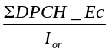 | dB | 0
Îor | dBm/3.84 MHz | -91
Ioac | dBm/3.84 MHz | -52
Fuw offset | MHz | +5 or -5

Explanatory note:
Within the reference sensitivity BER= 0.001 corresponds to a testsignal = -105 dBm/3.84 MHz and a noise level –99 dBm /3.84 MHz BW (S/I -6 dB)
Within ACS BER=0.001 is directly verified
Known from the reference sensitivity, this corresponds to S/I –6dB in the wanted BW.
As a wanted signal of –91 dBm applied, an in-channel-interfering-signal of –85 dBm can be assumed.
Verifying a filter suppression of 33 dB indirectly, an adjacent-channel-interferer of –52 dBm is needed
The normative reference of this requirement is TS 25.102 [1] subclause 7.5.

6.4.3 Test purpose
The test purpose is to verify the ability of the UE-receiver to sufficiently suppress the interfering signal in the channel adjacent to the wanted channel.

6.4.4 Method of test

6.4.4.1 Initial conditions
1) Connect the SS and the interferer to the UE antenna connector as shown in Figure A.4.
2) A call is set up according to the Generic call setup procedure.
3) Enter the UE into loopback test mode and start the loopback test.
4) Set the signal generator to produce an interference signal. The interference signal shall be equivalent to a continuously running wideband CDMA signal with one code and chip frequency 3.84 Mchip/s and rolloff 0.22.

6.4.4.2 Procedure
1) Set the interference signal 5 MHz above the assigned channel frequency of the wanted signal.
2) Measure the BER of the wanted signal received from the UE at the SS.
3) Set the interference signal 5 MHz below the assigned channel frequency of the wanted signal and repeat 2).

6.4.5 Test Requirements
The measured BER, derived in step 2), shall not exceed 0,001 under conditions described in table 6.4.5.
Table 6.4.5: Test parameters for Adjacent Channel Selectivity
Parameter | Unit | Level
 | dB | 0
Îor | dBm/3.84 MHz | -91
Ioac | dBm/3.84 MHz | -52
Fuw offset | MHz | +5 or -5

NOTE: If the above Test Requirement differs from the Minimum Requirement then the Test Tolerance applied for this test is non-zero. The Test Tolerance for this test is defined in Annex F.2 and the explanation of how the Minimum Requirement has been relaxed by the Test Tolerance is given in Annex F.4.

6.5 Blocking Characteristics

6.5.1 Definition and applicability
The blocking characteristics is a measure of the receiver ability to receive a wanted signal at its assigned channel frequency in the presence of an unwanted interferer on frequencies other than those of the spurious response or the adjacent channels without this unwanted input signal causing a degradation of the performance of the receiver beyond a specified limit.. The blocking performance shall apply at all frequencies except those at which a spurious response occur.
The requirements of this test apply to all UTRA UE

6.5.2 Minimum Requirements
The BER shall not exceed 0,001 for the parameters specified in table 6.5.2a and table 6.5.2b. For table 6.5.2b up to 24 exceptions are allowed for spurious response frequencies in each assigned frequency channel when measured using a 1MHz step size for the interference signal.
The normative reference for this requirement is 3G TS 25.102 clause 7.6.1
Table 6.5.2a: In-band blocking
Parameter | Offset 1 | Offset 2 | Unit
 | 0 | 0 | dB
Îor | <REFSENS> + 3 dB | <REFSENS> + 3 dB | dBm/3.84 MHz
Iblocking (modulated) | -56 | -44 | dBm/3.84 MHz
Fuw offset | +10 or -10 | +15 or -15 | MHz

Table 6.5.2b: Out of band blocking
Parameter | Band 1 | Band 2 | Band 3 | Unit
 | 0 | 0 | 0 | dB
Îor | <REFSENS> + 3 dB | <REFSENS> + 3 dB | <REFSENS> + 3 dB | dBm/3.84 MHz
Iblocking (CW) | -44 | -30 | -15 | dBm
Fuw  For operation in frequency bands as definded in subclause 4.2(a) | 1840 <f <1885  1935 <f <1995  2040 <f <2085 | 1815 <f <1840  2085 <f <2110 | 1< f <1815  2110< f <12750 | MHz
Fuw  For operation in frequency bands as definded in subclause 4.2(b) | 1790 < f < 1835  2005 < f < 2050 | 1765 < f < 1790  2050 < f < 2075 | 1 < f < 1765  2075 < f < 12750 | MHz
Fuw  For operation in frequency bands as definded in subclause 4.2(c) | 1850 < f < 1895  1945 < f < 1990 | 1825 < f < 1850  1990 < f < 2015 | 1 < f < 1825  2015 < f < 12750 | MHz

Note: 1. For operation referenced in 4.2(a), from 1885 <f< 1900 MHz, 1920 <f< 1935 MHz, 1995 <f< 2010 MHz and 2025<f< 2040 MHz , the appropriate in-band blocking or adjacent channel selectivity in section 6.5.2. shall be applied.
2. For operation referenced in 4.2(b), from 1835 < f < 1850 MHz and 1990< f < 2005 MHz, the appropriate in-band blocking or adjacent channel selectivity in section 6.5.2. shall be applied.
3. For operation referenced in 4.2(c), from 1895 < f < 1910 MHz and 1930< f < 1945 MHz, the appropriate in-band blocking or adjacent channel selectivity in section 6.5.2. shall be applied.

6.5.3 Test purpose
"The test stresses the ability of the UE receiver to withstand high-level interference from unwanted signals at frequency offsets of 10 MHz or more, without undue degradation of its sensitivity."

6.5.4 Method of test

6.5.4.1 Initial conditions
1) Connect the SS and the interfering Signal generator to the antenna connector as shown in Figure A.5.
2) A call is set up according to the Generic call setup procedure
3) Enter the UE into loopback test mode and start the loopback test.

6.5.4.2 Procedure
1) The wanted signal frequency channel is set into the middle of the band.
2) The interfering Signal Generator is stepped through the frequency range indicated in table 6.5.2.a. with a step size of 1 MHz.
3) The interference signal shall be equivalent to a continuously running wideband CDMA signal with one code and chip frequency 3.84 Mchip/s and rolloff 0.22.
4) Measure the BER of the wanted signal received from the UE at the SS for each step of the interferer.
5) Repeat the inband blocking for wanted frequency channels low–band and high-band.
6) The wanted signal frequency channel is set into the middle of the band.
7) The interfering Signal Generator is stepped through the frequency range indicated in table 6.4.2.b. with a step size of 1 MHz.
8) The interference signal is a CW signal.
9) Measure the BER of the wanted signal received from the UE at the SS for each step of the interferer.
NOTE: Due to the large amount of time-consuming BER tests it is recommended to speed up a single BER test by reducing the 0.001-BER confidence level [10 000 bits under test or 10 errors] for screening the critical frequencies. Critical frequencies must be identified using standard BER confidence level. [30 000 bits or 30 errors].

6.5.5 Test requirements
The measured BER, derived in step 4 ) and 5), shall not exceed 0,001 (without exception) under test conditions described in table 6.5.5a.
The measured BER, derived in step 9), shall not exceed 0,001 except for up to 24 different frequencies of the interfering signal under test conditions described in table 6.5.5b.
These frequencies are further processed in subclause 5.6 Spurious response.
Table 6.5.5a: Test conditions In-band blocking
Parameter | Offset 1 | Offset 2 | Unit
 | 0 | 0 | dB
Îor | <REFSENS> + 3 dB | <REFSENS> + 3 dB | dBm/3.84 MHz
Iblocking (modulated) | -56 | -44 | dBm/3.84 MHz

Table 6.5.5b: Test conditions Out of band blocking
Parameter | Band 1 | Band 2 | Band 3 | Unit
 | 0 | 0 | 0 | dB
Îor | <REFSENS> + 3 dB | <REFSENS> + 3 dB | <REFSENS> + 3 dB | dBm/3.84 MHz
Iblocking (CW) | -44 | -30 | -15 | dBm

NOTE: If the above Test Requirement differs from the Minimum Requirement then the Test Tolerance applied for this test is non-zero. The Test Tolerance for this test is defined in Annex F.2 and the explanation of how the Minimum Requirement has been relaxed by the Test Tolerance is given in Annex F.4

6.6 Spurious Response

6.6.1 Definition and applicability
Spurious response is a measure of the receiver’s ability to receive a wanted signal on its assigned channel frequency without exceeding a given degradation due to the presence of an unwanted CW interfering signal at any other frequency at which a response is obtained i.e. for which the blocking limit is not met.
The requirements of this test apply to all types of UTRA for the UE.

6.6.2 Minimum Requirements
The BER shall not exceed 0,001 for the parameters specified in table 6.6.2.
The normative reference for this requirement is 3G TS 25.102 clause 7.7.1
Table 6.6.2: Spurious Response
Parameter | Value | Unit
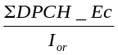 | 0 | dB
Îo | <REFSENS> + 3 | dBm/3.84 MHz
Iblocking (CW) | -44 | dBm
Fuw | Spurious response frequencies | MHz

6.6.3 Test purpose
Spurious response frequencies, identified in the blocking test, are measured against a less stringent test requirement. The test stresses the ability of the receiver to withstand high level interference signals without undue degradation of its sensitivity due to the receiver’s frequency conversion concept.

6.6.4 Method of test

6.6.4.1 Initial conditions
1) Connect the SS and the unwanted signal to the UE antenna connector as shown in Figure A.6.
2) A call is set up according to the Generic call setup procedure.
3) Enter the UE into loopback test mode and start the loopback test.

6.6.4.2 Procedure
1) Repeat the wanted signal frequency setting from the blocking test. Set the level according to table 6.6.2.
2) Repeat the frequency settings of the interferer signal, at which the blocking test failed. Set the level according to table 6.6.5.
3) Measure the BER of DCH received from the UE at the SS for each of the settings 1) and 2).

6.6.5 Test requirements
The measured BER, derived in step 3), shall not exceed 0,001 under. test conditions described in Table 6.6.5.
Table 6.6.5: Test Parameters Spurious Response
Parameter | Value | Unit
 | 0 | dB
Îo | <REFSENS> + 3 | dBm/3.84 MHz
Iblocking (CW) | -44 | dBm
Fuw | Spurious response frequencies | MHz

NOTE: If the above Test Requirement differs from the Minimum Requirement then the Test Tolerance applied for this test is non-zero. The Test Tolerance for this test is defined in Annex F.2 and the explanation of how the Minimum Requirement has been relaxed by the Test Tolerance is given in Annex F.4.

6.7 Intermodulation Characteristics

6.7.1 Definition and applicability
Third and higher order mixing of the two interfering RF signals can produce an interfering signal in the band of the desired channel. Intermodulation response rejection is a measure of the capability of the receiver to receiver a wanted signal on its assigned channel frequency in the presence of two or more interfering signals which have a specific frequency relationship to the wanted signal.
The requirements of this test shall apply to all UTRA UE.

6.7.2 Minimum Requirements
The BER shall not exceed 0,001 for the parameters specified in table 6.7.2
The normative reference for this requirement is 3G TS 25.102 subclause 7.8.1.
Table 6.7.2: Receive intermodulation characteristics
Parameter | Value | Unit
 | 0 | dB
ÎorWanted Signal Level | <REFSENS> + 3 dB | dBm/3.84 MHz
Iouw1(CW) | -46 | dBm
Iouw2(modulated) | -46 | dBm/3.84 MHz
Fuw1 (CW) | |10| | MHz
Fuw2 (Modulated) | |20| | MHz

6.7.3 Test purpose
The test stresses the ability of the receiver to withstand two or more high level interference signals without undue degradation of its sensitivity due to the receiver’s non-linear elements.

6.7.4 Method of test

6.7.4.1 Initial conditions
1) Connect the SS and the unwanted signals to the UE antenna connector as shown in Figure A.7.
2) A call is set up according to the Generic call setup procedure.
3) Enter the UE into loopback test mode and start the loopback test.

6.7.4.2 Procedure
1) Set the interfering signals as indicated in table 6.7.2. with positive offset with respect to the wanted signal.
2) Measure the BER of DCH received from the UE at the SS.
3) Set the interfering signals as indicated in table 6.7.2. with negative offset with respect to the wanted signal and repeat 2).

6.7.5 Test requirements
The measured BER, derived in step 2) and 3), shall not exceed 0,001 under test conditions described in Table 6.7.5.
Table 6.7.5: Test parameters Receive intermodulation characteristics
Parameter | Value | Unit
 | 0 | dB
ÎorWanted Signal Level | <REFSENS> + 3 dB | dBm/3.84 MHz
Iouw1(CW) | -46 | dBm
Iouw2(modulated) | -46 | dBm/3.84 MHz
Fuw1 (CW) | |10| | MHz
Fuw2 (Modulated) | |20| | MHz

NOTE: If the above Test Requirement differs from the Minimum Requirement then the Test Tolerance applied for this test is non-zero. The Test Tolerance for this test is defined in Annex F.2 and the explanation of how the Minimum Requirement has been relaxed by the Test Tolerance is given in Annex F.4.

6.8 Spurious Emissions

6.8.1 Definition and applicability
The Spurious Emissions Power is the power of emissions generated or amplified in a receiver that appear at the UE antenna connector.
The requirements of this test are applicable for all UTRA UE.

6.8.2 Minimum Requirements
The power of any spurious emission shall not exceed:
Table 6.8.2.: Receiver spurious emission requirements
Band | Maximum level | Measurement Bandwidth | Note
9 kHz – 1 GHz | -57 dBm | 100 kHz
1 GHz – 1.9 GHz and  1.92 GHz – 2.01 GHz and  2.025 GHz – 2.11 GHz | -47 dBm | 1 MHz | With the exception of frequencies between 12.5MHz below the first carrier frequency and 12.5MHz above the last carrier frequency used by the UE.
1.9 GHz – 1.92 GHz and  2.01 GHz – 2.025 GHz and  2.11 GHz – 2.170 GHz | -60 dBm | 3.84 MHz | With the exception of frequencies between 12.5MHz below the first carrier frequency and 12.5MHz above the last carrier frequency used by the UE.
2.170 GHz – 12.75 GHz | -47 dBm | 1 MHz

The normative reference for this requirement is TS 25.102 [1] subclause 7.9.

6.8.3 Test purpose
The test purpose is to verify the UE’s ability to limit interference caused by receiver spurious emissions to the own and the other systems. The test requirements are tighter than in 5.5.3 ((TX) Spurious Emissions) because the time of Receive–Only-Operation is generally much longer than RX-TX-Operation.

6.8.4 Method of test

6.8.4.1 Initial conditions
1) Connect the measurement equipment to the UE antenna connector according to figure A.8.
2) The measurement equipment shall measure power through
a 100 kHz filter with a approximately gaussian filter-characteristic (typical spectrum analyzer), or
a 1MHz filter with a approximately gaussian filter-characteristic (typical spectrum analyzer), or
a matched filter with a bandwidth equal to the chip frequency 3.84 Mchip/s and rolloff 0.22.
3) Enable the UE receiver and set Cell Search Mode on a PCCPCH. Since there is no down link signal, the UE should not pass the Cell Search mode.
<Editor's Note: The method to set Cell Search Mode should be defined.>

6.8.4.2 Procedure
Measure the power of spurious emissions by covering the frequency ranges of table 6.8.2. Cover the UTRA/TDD and UTRA/FDD UE receive band in contiguous steps of [200 kHz]. Cover the other frequency ranges in contiguous steps of 100 kHz. Apply the corresponding filters of table 6.8.2.. The step duration shall be sufficient slow to capture intermittent spurious emissions.

6.8.5 Test requirements
The spurious emissions shall be according to table 6.8.5.
Table 6.8.5.: Receiver spurious emission test requirements
Band | Maximum level | Measurement Bandwidth | Note
9 kHz – 1 GHz | -57 dBm | 100 kHz
1 GHz – 1.9 GHz and  1.92 GHz – 2.01 GHz and  2.025 GHz – 2.11 GHz | -47 dBm | 1 MHz | With the exception of frequencies between 12.5MHz below the first carrier frequency and 12.5MHz above the last carrier frequency used by the UE.
1.9 GHz – 1.92 GHz and  2.01 GHz – 2.025 GHz and  2.11 GHz – 2.170 GHz | -60 dBm | 3.84 MHz | With the exception of frequencies between 12.5MHz below the first carrier frequency and 12.5MHz above the last carrier frequency used by the UE.
2.170 GHz – 12.75 GHz | -47 dBm | 1MHz

NOTE: If the above Test Requirement differs from the Minimum Requirement then the Test Tolerance applied for this test is non-zero. The Test Tolerance for this test is defined in Annex F.2 and the explanation of how the Minimum Requirement has been relaxed by the Test Tolerance is given in Annex F.4.

7 Performance Requirements

7.1 General
The performance requirements for the UE in this section is specified for the measurement channels specified in annex C and the test environments specified in annex D.

7.2 Demodulation in static propagation conditions

7.2.1 Demodulation of DCH

7.2.1.1 Definition and applicability
The performance requirement of DCH in static propagation conditions is determined by the maximum Block Error Ratio (BLER ). The BLER is specified for each individual data rate of the DCH. DCH is mapped into the Dedicated Physical Channel (DPCH).
The UE shall be tested only according to the datarates, supported. The data-rate-corresponding requirements shall apply to the UE.

7.2.1.2 Minimum requirements
For the parameters specified in table 7.2.1.2a the BLER shall not exceed the piece-wise linear BLER curve specified in table 7.2.1.2b. . These requirements are applicable for TFCS size 16.
The reference for this requirement is 3G TS 25.102 clause 8.2.1.1.
Table 7.2.1.2a: DCH parameters in static propagation conditions
Parameters | Unit | Test 1 | Test 2 | Test 3 | Test 4
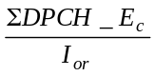 | dB | -6 | -3 | 0 | 0
Ioc | dBm/3.84 MHz | -60
Information Data Rate | kbps | 12.2 | 64 | 144 | 384

Table 7.2.1.2.b: Performance requirements in AWGN channel
Test Number | 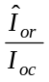[dB] | BLER
1 | 0.1 | 10-2
2 | 2.3 | 10-1
 | 2.6 | 10-2
3 | 2.2 | 10-1
 | 2.4 | 10-2
4 | 1.6 | 10-1
 | 1.8 | 10-2

7.2.1.3 Test purpose
While the receiver tests in clause 6 aims for the RF hardware, this performance requirement aims for the receiver’s signal processing.
The test purpose is to verify the ability of the receiver to receive a predefined test signal ,representing a static propagation channel for the wanted and for the co-channel signals from serving and adjacent cells, with a block error ratio (BLER) not exceeding a specified value.

7.2.1.4 Method of test

7.2.1.4.1 Initial conditions
1) Connect the SS, AWGN Generator and additional components to the UE antenna connector as shown in Figure A.9.
2) A call is set up according to the Generic call setup procedure. The characteristic of the call shall be according to the DL reference measurement channels (12.2 kbit/s) (64 kbit/s), (144 kbit/s), and (384 kbit/s) specified in annex C.
3) Enter the UE into loopback test mode and start the loopback test. (test 1) and/or activate the Ack/Nack test mode (test 1 to test 4).
4) The levels of the wanted signal and the co-channel signals are set according to table 7.2.1.2a and b.

7.2.1.4.2 Procedure
Measure the BLER of DCH received from the UE at the SS for all 4 tests.

7.2.1.5 Test requirements
The measured BLER shall not exceed the values indicated in table 7.2.1.2b.

7.3 Demodulation of DCH in multipath fading conditions

7.3.1 Multipath fading Case 1

7.3.1.1 Definition and applicability
The performance requirement of DCH is determined by the maximum Block Error Ratio (BLER). The BLER is specified for each individual data ratio of the DCH. DCH is mapped into the Dedicated Physical Channel (DPCH).
The UE shall be tested only according to the dataratios, supported. The data-ratio-corresponding requirements shall apply to the UE.

7.3.1.2 Minimum requirements
For the parameters specified in table 7.3.1.2a the BLER shall not exceed the piece-wise linear BLER curve specified in table 7.3.1.2b. . These requirements are applicable for TFCS size 16.
The reference for this requirement is 3G TS 25.102 clause 8.3.1.1.
Table 7.3.1.2a: DCH parameters in multipath Case 1 channel
Parameters | Unit | Test 1 | Test 2 | Test 3 | Test 4
 | dB | -6 | -3 | 0 | 0
Ioc | dBm/3.84 MHz | -60
Information Data Ratio | kbps | 12.2 | 64 | 144 | 384

Table 7.3.1.2b: Performance requirements in multipath Case 1 channel
Test Number | [dB] | BLER
1 | 13.5 | 10-2
2 | 13.3 | 10-1
 | 19.6 | 10-2
3 | 13.3 | 10-1
 | 19.7 | 10-2
4 | 13.5 | 10-1
 | 20.2 | 10-2

7.3.1.3 Test purpose
While the receiver tests in clause 6 aims for the RF hardware, this performance requirement aims for the receiver’s signal processing.
The test purpose is to verify the ability of the receiver to receive a predefined test signal, representing a multipath propagation channel for the wanted and for the co-channel signals from serving and adjacent cells, with a block error ratio (BLER) not exceeding a specified value.

7.3.1.4 Method of test

7.3.1.4.1 Initial conditions
1) Connect the SS, , the fading simulator, the AWGN generator and additional components to the UE antenna connector as shown in Figure A.10.
2) A call is set up according to the Generic call setup procedure. The characteristic of the call shall be according to the DL reference measurement channels (12.2 kbit/s), (64 kbit/s), (144 kbit/s), and (384 kbit/s) specified in annex C.
3) Enter the UE into loopback test mode and start the loopback test. (test 1) and/or activate the Ack/Nack test mode (test 1 to test 4).
4) The levels of the wanted signal and the co-channel signals are set according to table 7.3.1.2a and b.

7.3.1.4.2 Procedure
Measure the BLER of DCH received from the UE at the SS for all 4 tests.

7.3.1.5 Test requirements
The measured BLER shall not exceed the values indicated in table 7.3.1.2b.

7.3.2 Multipath fading Case 2

7.3.2.1 Definition and applicability
The performance requirement of DCH is determined by the maximum Block Error Ratio (BLER ). The BLER is specified for each individual data rate of the DCH. DCH is mapped into the Dedicated Physical Channel (DPCH).
The UE shall be tested only according to the datarates, supported. The data-rate-corresponding requirements shall apply to the UE.

7.3.2.2 Minimum requirement
For the parameters specified in table 7.3.2.2a the BLER should not exceed the piece-wise linear BLER curve specified in table 7.3.2.2b. . These requirements are applicable for TFCS size 16.
The reference for this requirement is 3G TS 25.102 clause 8.3.2.1
Table 7.3.2.2a: DCH parameters in multipath Case 2 channel
Parameters | Unit | Test 1 | Test 2 | Test 3 | Test 4
 | DB | -3 | 0 | 0 | 0
Ioc | dBm/3.84 MHz | -60
Information Data Rate | kbps | 12.2 | 64 | 144 | 384

Table 7.3.2.2b: Performance requirements in multipath Case 2 channel
Test Number | [dB] | BLER
1 | 5.5 | 10-2
2 | 5.8 | 10-1
 | 9.7 | 10-2
3 | 9.5 | 10-1
 | 13.2 | 10-2
4 | 8.5 | 10-1
 | 12.6 | 10-2

7.3.2.3 Test purpose
While the receiver tests in clause 6 aims for the RF hardware, this performance requirement aims for the receiver’s signal processing.
The test purpose is to verify the ability of the receiver to receive a predefined test signal, representing a multipath propagation channel for the wanted and for the co-channel signals from serving and adjacent cells, with a block error ratio (BLER) not exceeding a specified value.

7.3.2.4 Method of test

7.3.2.4.1 Initial conditions
1) Connect the SS, the fading simulator, the AWGN generator and additional components to the UE antenna connector as shown in Figure A.10.
2) A call is set up according to the Generic call setup procedure. The characteristic of the call shall be according to the DL reference measurement channels (12.2 kbit/s) (64 kbit/s), (144 kbit/s), and (384 kbit/s) specified in annex C.
3) Enter the UE into loopback test mode and start the loopback test. (test 1) and/or activate the Ack/Nack test mode (test 1 to test 4).
4) The levels of the wanted signal and the co-channel signals are set according to table 7.3.2.2a and b.

7.3.2.4.2 Procedure
Measure the BLER of DCH received from the UE at the SS for all 4 tests.

7.3.2.5 Test requirements
The measured BLER shall not exceed the values indicated in table 7.3.2.2b.

7.3.3 Multipath fading Case 3

7.3.3.1 Definition and applicability
The performance requirement of DCH is determined by the maximum Block Error Ratio (BLER ). The BLER is specified for each individual data rate of the DCH. DCH is mapped into the Dedicated Physical Channel (DPCH).
The UE shall be tested only according to the datarates, supported. The data-rate-corresponding requirements shall apply to the UE.

7.3.3.2 Minimum requirements
For the parameters specified in table 7.3.3.2a the BLER should not exceed the piece-wise linear BLER curve specified in table 7.3.3.2b. . These requirements are applicable for TFCS size 16.
The reference for this requirement is 3G TS 25.102 clause 8.3.3.1
Table 7.3.3.2a: DCH parameters in multipath Case 3 channel
Parameters | Unit | Test 1 | Test 2 | Test 3 | Test 4
 | dB | -3 | 0 | 0 | 0
Ioc | dBm/3.84 MHz | -60
Information Data Rate | kbps | 12.2 | 64 | 144 | 384

Table 7.3.3.2b: Performance requirements in multipath Case 3 channel
Test Number | [dB] | BLER
12.2 kbps | 4.7 | 10-2
64 kbps | 5.2 | 10-1
 | 8.4 | 10-2
 | 12.1 | 10-3
144 kbps | 11.7 | 10-1
 | 15.2 | 10-2
 | 17.8 | 10-3
384 kbps | 8.2 | 10-1
 | 11.3 | 10-2
 | 13.0 | 10-3

7.3.3.3 Test purpose
While the receiver tests in clause 6 aims for the RF hardware, this performance requirement aims for the receiver’s signal processing.
The test purpose is to verify the ability of the receiver to receive a predefined test signal ,representing a multipath propagation channel for the wanted and for the co-channel signals from serving and adjacent cells, with a block error ratio (BLER) not exceeding a specified value.

7.3.3.4 Method of test

7.3.3.4.1 Initial conditions
1) Connect the SS, the fading simulator, the AWGN generator and additional components to the UE antenna connector as shown in Figure A.10.
2) A call is set up according to the Generic call setup procedure. The characteristic of the call shall be according to the DL reference measurement channels (12.2 kbit/s)(64 kbit/s), (144 kbit/s), and (384 kbit/s) specified in annex C.
3) Enter the UE into loopback test mode and start the loopback test. (test 1) and/or activate the Ack/Nack test mode (test 1 to test 4).
4) The levels of the wanted signal and the co-channel signals are set according to table 7.3.3.2a and b.

7.3.3.4.2 Procedure
Measure the BLER of DCH received from the UE at the SS for all 4 tests.

7.3.3.5 Test requirements
The measured BLER shall not exceed the values indicated in table 7.3.3.2.b.

7.4 Base station transmit diversity mode

7.4.1 Demodulation of BCH in Block STTD mode
The performance requirement of BCH is determined by the maximum Block Error Rate (BLER). The BLER is specified for the BCH. BCH is mapped into the Primary Common Control Physical Channel (P-CCPCH).

7.4.1.1 Minimum requirements
For the parameters specified in Table 7.4.1.1.a the BLER should not exceed the BLER specified in Table 7.4.1.1.b
The reference for this requirement is 3G TS 25.102 clause 8.4.1.
Table 7.4.1.1.a: P-CCPCH parameters in multipath Case 1 channel
Parameters | Unit | Test 1
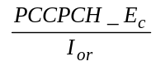 | dB | -3
I | dBm/3.84 MHz | -60
Information Data Rate | Kbps | 12.3

Table 7.4.1.1.b: Performance requirements in multipath Case 1 channel.
Test Number | [dB] | BLER
1 | 8.4 | 10-2

7.5 Power control in downlink
Power control in the downlink is the ability of the UE receiver to converge to the required link quality set by the network while using minimum downlink power.

7.5.1 Minimum requirements
For the parameters specified in Table 7.5.1.a the average downlink 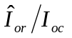power shall not exceed the values specified in Table 7.5.1.b. Downlink power control is ON during the test.
Table 7.5.1.a: Test parameters for downlink power control
Parameter | Unit | Test 1 | Test 2
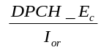 | dB | 0 | [ ]
 | dBm/3.84 MHz | -60
Information Data Rate | kbps | 12.2
Target quality value on DTCH | BLER | 0.01
Propagation condition |  | Case 4

Table 7.5.1.b: Requirements for downlink power control
Parameter | Unit | Test 1 | Test 2
 | dB | [ ] | [ ]
Measured quality on DTCH | BLER | 0.01±30% | 0.01±30%

8 Requirements for Support of RRM

8.1 General

8.2 Idle Mode Tasks

8.2.1 Introduction

8.2.2 RF Cell Selection Scenario

8.2.2.1 Requirements for Cell Selection single carrier single cell case

8.2.2.2 Requirements for Cell Selection multicarrier carrier multi cell case

8.2.3 RF Cell Re-Selection Scenario

8.2.3.1 Requirements for Cell Re-Selection single carrier multi cell case

8.2.4 PLMN Selection and Re-Selection Scenario

8.2.5 Location Registration Scenario

8.3 RRC Connection mobility

8.3.1 Handover

8.3.1.1 Introduction

8.3.1.2 Handover 3G to 3G

8.3.1.2.1 TDD/TDD Handover

8.3.1.2.2 TDD/FDD Handover

8.3.1.3 Handover 3G to 2G

8.3.1.3.1 Handover to GSM

8.3.2 Radio Link Management

8.3.2.1 Link adaptation

8.3.3 Cell Update

8.3.4 URA Update

8.4 RRC Connection Control

8.4.1 Radio Access Bearer Control

8.5 Dynamic Channel Allocation

8.6 Timing characteristics

8.6.1 Timing Advance (TA) Requirements

8.7 Measurements Performance Requirements

8.7.1 Measurements Performance for UE

Annex A (informative):
Connection Diagrams
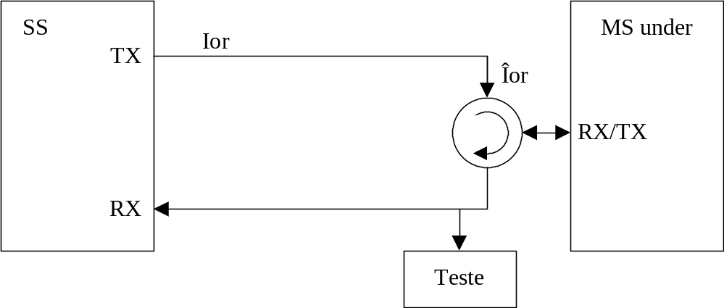
Figure A.1: Connection for Basic TX Test

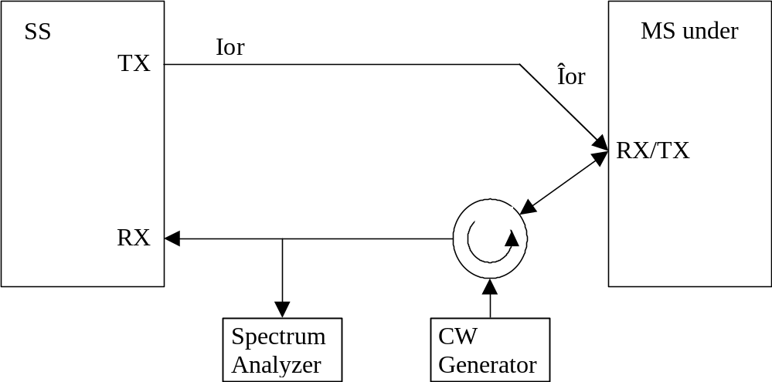
Figure A.2: Connection for TX Intermodulation Test

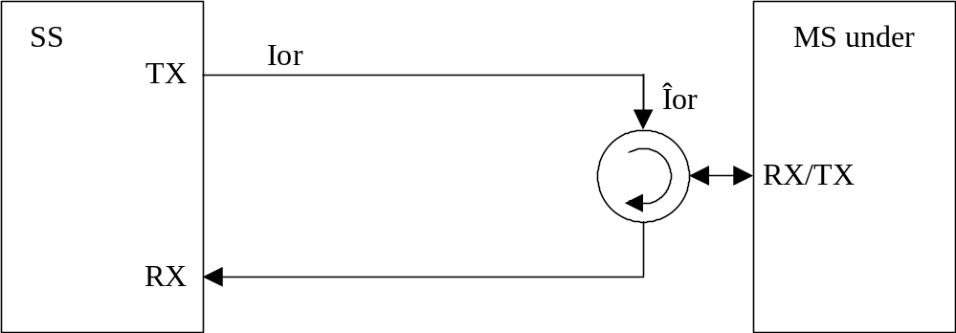
Figure A.3: Connection for Basic RX Test

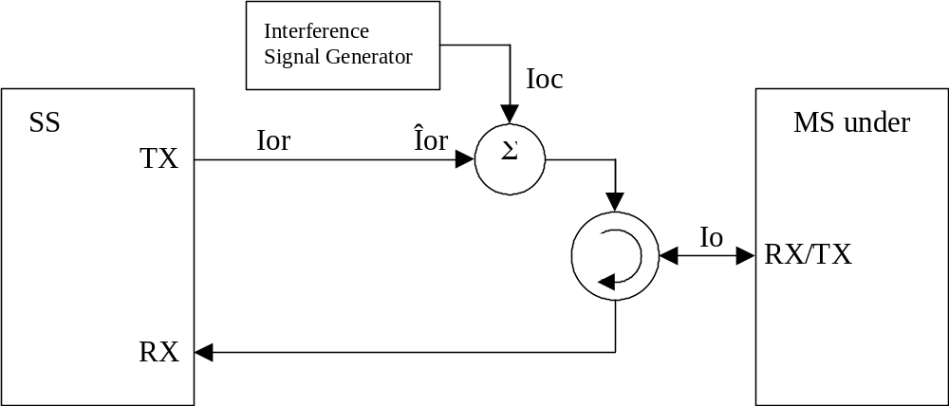
Figure A.4: Connection for RX Test with Interference

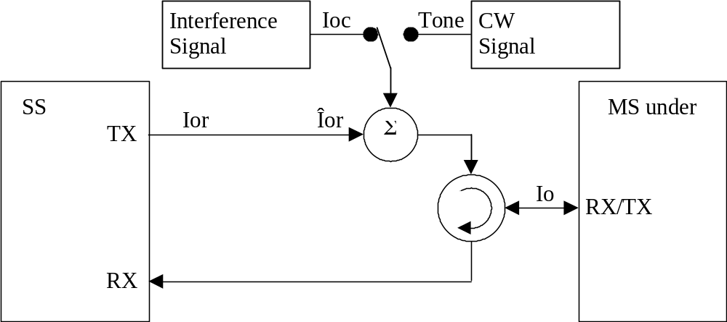
Figure A.5: Connection for RX Test with Interference or additional CW

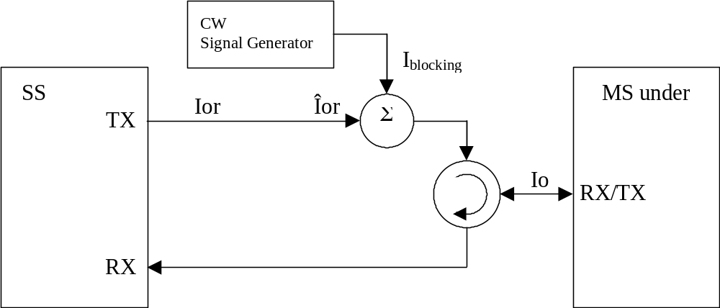
Figure A.6: Connection for RX Test with additional CW

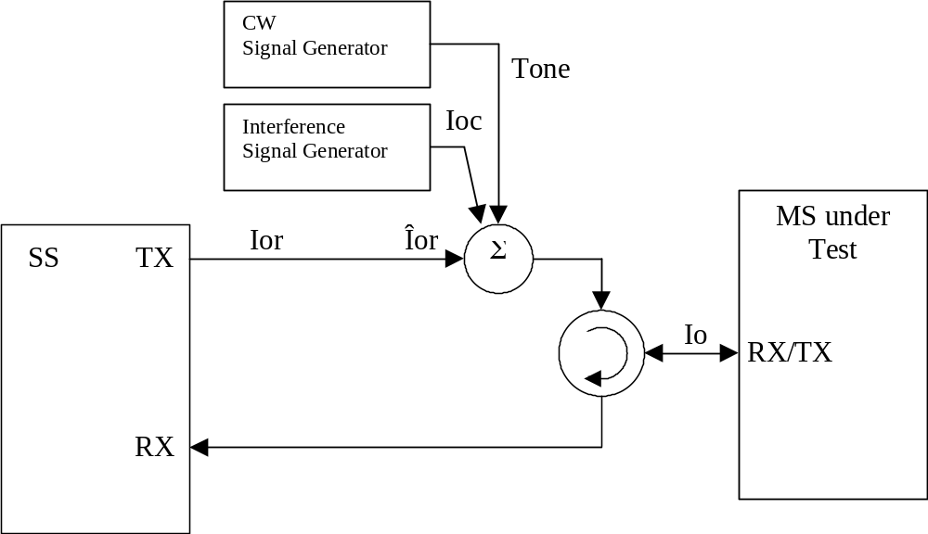
Figure A.7: Connection for RX Test with both Interference and additional CW

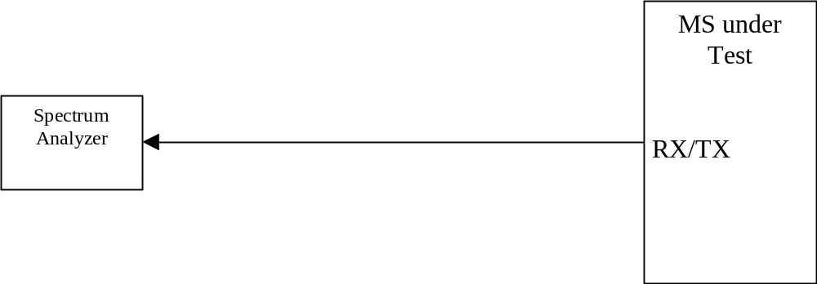
Figure A.8: Connection for Spurious Emission Test

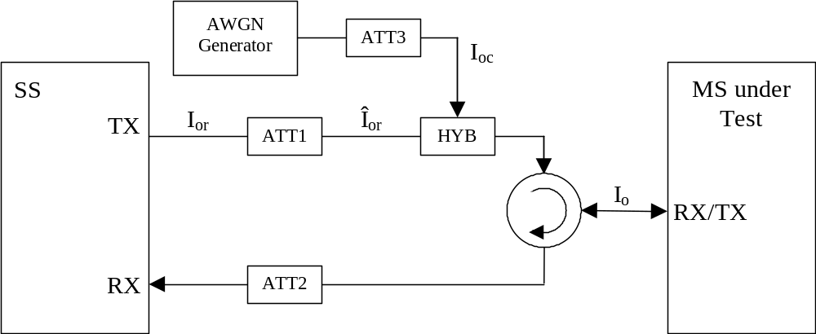
Figure A.9: Connection for Static Channel Test

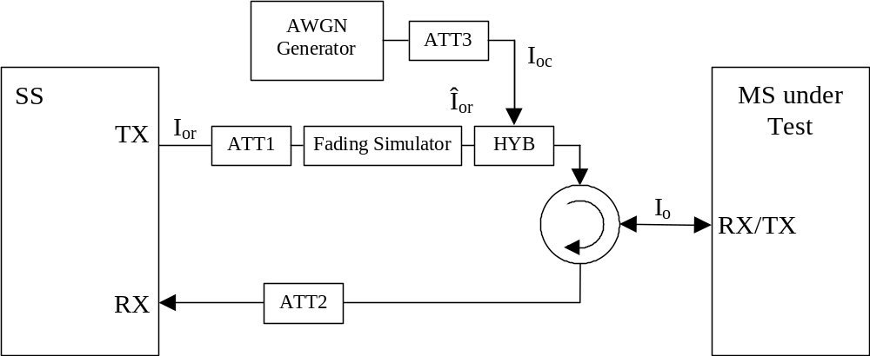
Figure A.10: Connection for Multiple Fading Channel Test

Annex B (normative):
Global In-Channel TX-Test

B.1 General
The global in-channel Tx test enables the measurement of all relevant parameters that describe the in-channel quality of the output signal of the Tx under test in a single measurement process.
The parameters describing the in-channel quality of a transmitter, however, are not necessarily independent. The algorithm chosen for description inside this annex places particular emphasis on the exclusion of all interdependencies among the parameters. Any other algorithm (e.g. having better computational efficiency) may be applied, as long as the results are the same within the accuracy limits.
All notes referred in the various subclauses of B.2 are put together in B.3

B.2 Definition of the process

B.2.1 Basic principle
The process is based on the comparison of the actual output signal of the TX under test, received by an ideal receiver, with a reference signal, that is generated by the measuring equipment and represents an ideal error free received signal. All signals are represented as equivalent (generally complex) baseband signals.

B.2.2 Output signal of the TX under test
The output signal of the TX under test is acquired by the measuring equipment, filtered by a matched filter (RRC 0.22, correct in shape and in position on the frequency axis) and stored at one sample per chip at the Inter-Symbol-Interference free instants.
The following form represents the physical signal in the entire measurement interval:
one vector Z, containing N = ns x sf + ma complex samples;
with
ns: number of symbols in the measurement interval;
sf: number of chips per symbol. (sf: spreading factor) (see Note: Symbol length)
ma: number of midamble chips (only in TDD)

B.2.3 Reference signal
The reference signal is constructed by the measuring equipment according to the relevant TX specifications.
It is filtered by the same matched filter, mentioned in B.2.2., and stored at the Inter-Symbol-Interference free instants. The following form represents the reference signal in the entire measurement interval:
one vector R, containing N = ns x sf + ma complex samples;
ns, sf, ma: see B.2.2

B.2.4 void

B.2.5 Classification of measurement results
The measurement results achieved by the global in-channel TX test can be classified into two types:
Results of type “deviation”, where the error-free parameter has a non-zero magnitude. (These are the parameters that quantify the integral physical characteristic of the signal).These parameters are:
RF Frequency
Power (in case of single code)
Code Domain Power (in case of multi code)
Timing (only for UE)
(Additional parameters: see Note: Deviation)
Results of type “residual”, where the error-free parameter has value zero. (These are the parameters that quantify the error values of the measured signal, whose ideal magnitude is zero). These parameters are:
Error Vector Magnitude (EVM);
Peak Code Domain Error (PCDE).
(Additional parameters: see Note residual)

B.2.6 Process definition to achieve results of type “deviation”
The reference signal (R; see subclause B.2.3) is varied with respect to the parameters mentioned in subclause B.2.5 under "results of type deviation" in order to achieve best fit with the recorded signal under test (Z; see subclause B.2.2). Best fit is achieved when the RMS difference value between the signal under test and the varied reference signal is an absolute minimum. The varied reference signal, after the best fit process, will be called R’.
The varying parameters, leading to R’ represent directly the wanted results of type “deviation”. These measurement parameters are expressed as deviation from the reference value with units same as the reference value.
In case of multi code, the type-“deviation”-parameters (frequency, timing and (RF-phase)) are varied commonly for all codes such that the process returns one frequency-deviation, one timing deviation, (one RF-phase –deviation).
(These parameters are not varied on the individual codes signals such that the process returns k frequency errors... . (k: number of codes)).
The only type-“deviation”-parameters varied individually are code powers such that the process returns k code power deviations (k: number of codes).

B.2.7 Process definition to achieve results of type "residual"
The difference between the varied reference signal (R’; see subclauseB.2.6.) and the TX signal under test (Z; see subclauseB.2.2) is the error vector E versus time:
E = Z – R’.
Depending on the parameter to be evaluated, it is appropriate to represent E in one of the following two different forms:
Form EVM (representing the physical error signal in the entire measurement interval)
One vector E, containing N = ns x sf + ma complex samples;
ns, sf, ma: see B.2.2
Form PCDE (derived from Form EVM by separating the samples into symbol intervals)
ns time-sequential vectors e with sf complex samples comprising one symbol interval.
E gives results of type “residual” applying the two algorithms defined in subclauses B 2.7.1 and B 2.7.2.

B.2.7.1 Error Vector Magnitude (EVM)
The Error Vector Magnitude EVM is calculated according to the following steps:
1) Take the error vector E defined in subclause B.2.7 (Form EVM) and calculate the RMS value of E; the result will be called RMS(E).
2) Take the varied reference vector R' defined in subclause B.2.6 and calculate the RMS value of R'; the result will be called RMS(R').
3) Calculate EVM according to:
 (here, EVM is relative and expressed in %)
(see note TDD)

B.2.7.2 Peak Code Domain Error (PCDE)
The Peak Code Domain Error is calculated according to the following steps:
1) Take the error vectors e defined in subclause B.2.7 (Form PCDE)
2) Take the orthogonal vectors of the channelisation - code set C (all codes belonging to one spreading factor) as defined in TS 25.213 and TS 25.223 (range +1, -1). (see Note: Symbol length)
3) To achieve meaningful results it is necessary to descramble e, leading to e’ (see Note1: Scrambling code)
4) Calculate the inner product of e’ with C. Do this for all symbols of the measurement interval and for all codes in the code space.
This gives an array of format k x ns, each value representing an error-vector representing a specific symbol and a specific code, which can be exploited in a variety of ways.
k: number of codes
ns: number of symbols in the measurement interval
5) Calculate k RMS values, each RMS value unifying ns symbols within one code.
(These values can be called "Absolute CodeEVMs" [Volt].)
6) Find the peak value among the k "Absolute CodeEVMs".
(This value can be called "Absolute PeakCodeEVM" [Volt].)
7) Calculate PCDE according to:
.
(“Absolute PeakCodeEVM”)2
10*lg ------------------------------------ dB (a relative value in dB).
(RMS(R'))2
(see Note: Denominator)
(see Note2: Scrambling code)
(see Note IQ)
(see Note TDD)
(see Note Synch channel)

B.3 Notes
Note: Symbol length)
A general code multiplexed signal is multicode and multirate. In order to avoid unnecessary complexity, the measurement applications use a unique symbol-length, corresponding to a spreading factor, regardless of the really intended spreading factor. Nevertheless the complexity with a multicode / multirate signal can be mastered by introducing appropriate definitions.
Note: Deviation)
It is conceivable to regard more parameters as type „deviation“ e.g. Chip frequency and RF-phase.
As chip-frequency and RF-frequency are linked together by a statement in the core specifications [1] it is sufficient to process RF frequency only.
A parameter RF-phase must be varied within the best fit process (B 2.6.). Although necessary, this parameter-variation doesn’t describe any error, as the modulation schemes used in the system don’t depend on an absolute RF-phase.
Note: residual)
It is conceivable to regard more parameters as type „residual“ e.g. IQ origin offset. As it is not the intention of the test to separate for different error sources, but to quantify the quality of the signal, all such parameters are not extracted by the best fit process, instead remain part of EVM and PCDE.
Note: Denominator)
If the denominator stems from mutual time shifted signals of different code powers, (e.g. BS, FDD ) the measurement result PCDE should be expressed absolutely instead.
Note1: Scrambling Code)
In general a TX signal under test can use more than one scrambling code. Note that PCDE is processed regarding the unused channelisation - codes as well. In order to know which scrambling code shall be applied on unused channelisation - codes, it is necessary to restrict the test conditions: TX signal under test shall use exactly one scrambling code.
Note2 Scrambling Code)
To interpret the measurement results in practice it should be kept in mind that erroneous code power on unused codes is generally de-scrambled differently under test conditions and under real life conditions, whereas erroneous code power on used codes is generally de-scrambled equally under test conditions and under real life conditions. It might be indicated if a used or unused code hits PCDE.
Note IQ)
As in FDD/uplink each code can be used twice, on the I and on the Q channel, the measurement result may indicate on which channel (I or Q) PCDE occurs.
Note TDD)
EVM covers the midamble part as well as the data part; however PCDE disregards the midamble part.
Note: Synch Channel)
A BS signal contains a physical synch channel, which is non orthogonal, related to the other DPCHs. In this context note: The code channel bearing the result of PCDE is exactly one of the DPCHs (never the synch channel). The origin of PCDE (erroneous code power) can be any DPCH and/or the synch channel.

Annex C (normative):
Measurement channels

C.1 General

C.2 UL Reference measurement channels

C.2.1 UL reference measurement channel (12.2 kbps)
Parameter
Information data rate | 12.2 kbps
RU´s allocated | 2 RU
Midamble | 512 chips
Interleaving | 20 ms
Power control | 2 Bit/user
TFCI | 16 Bit/user
Inband signalling DCCH | 2 kbps
Puncturing level at Code rate 1/3 : DCH / DCCH | 5% / 0%

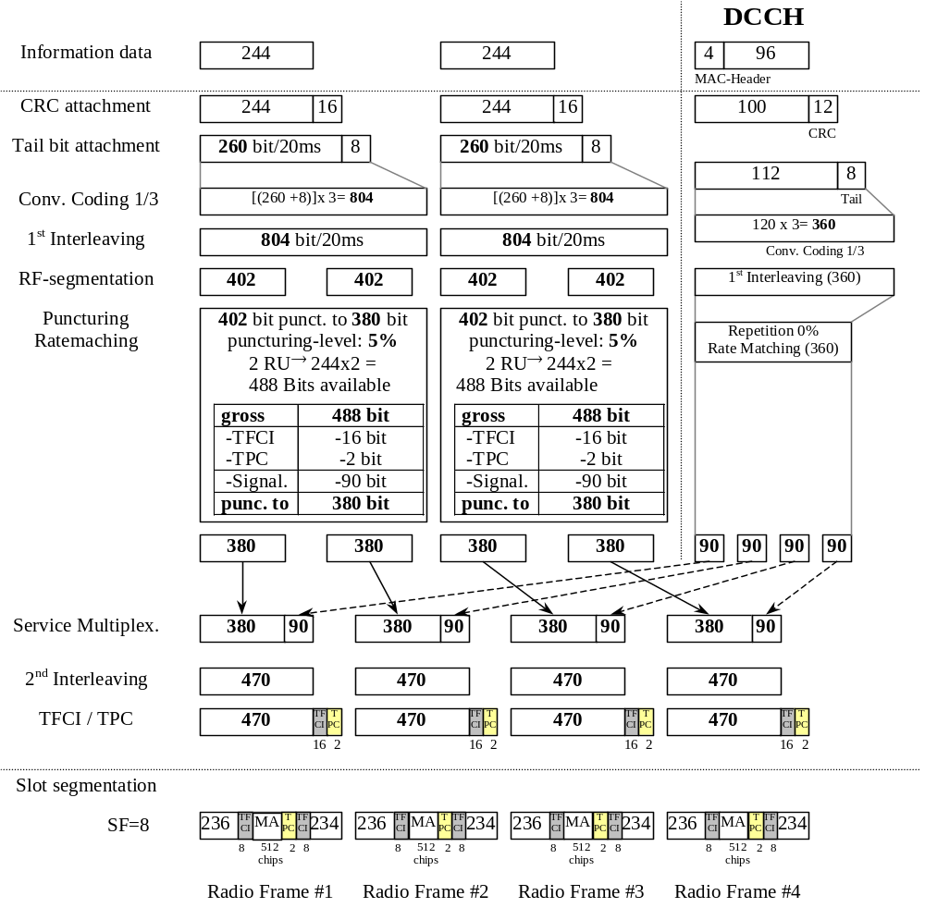

C.2.2 UL multi code reference measurement channel (12.2 kbps)
Parameter
Information data rate | 12.2 kbps
RU´s allocated | 2 RU
Midamble | 512 chips
Interleaving | 20 ms
Power control | 2 Bit/user
TFCI | 16 Bit/user
Inband signalling DCCH | 2 kbps
Puncturing level at Code rate 1/3 : DCH / DCCH | 5% / 0 %

C.2.3 UL reference measurement channel (64 kbps)
Parameter
Information data rate | 64 kbps
RU´s allocated | 1 SF4 + 1 SF16 = 5RU
Midamble | 512 chips
Interleaving | 20 ms
Power control | 2 Bit/user
TFCI | 16 Bit/user
Inband signalling DCCH | 2 kbps
Puncturing level at Code rate : 1/3 DCH / ½ DCCH | 41.2% / 10%

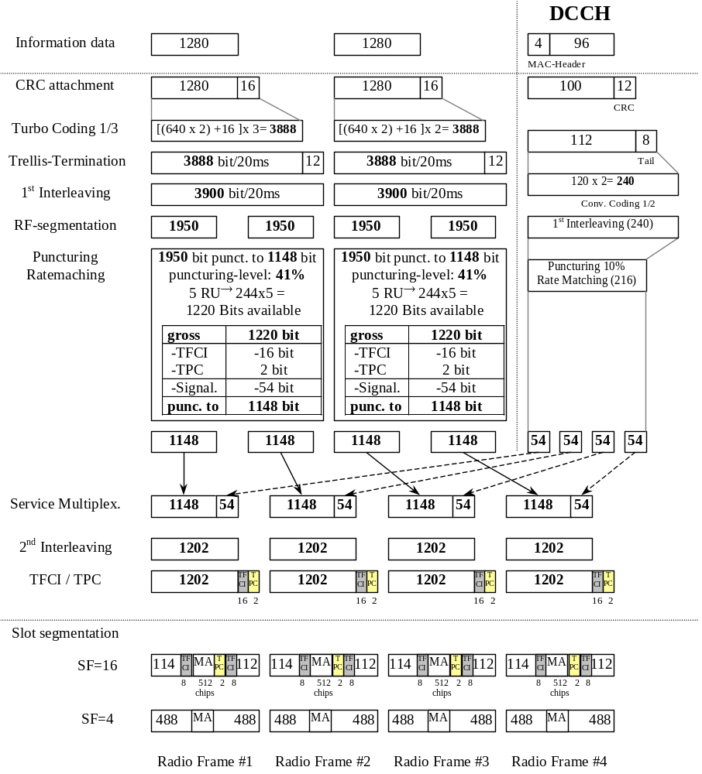

C.2.4 UL reference measurement channel (144 kbps)
Parameter
Information data rate | 144 kbps
RU´s allocated | 1 SF2 + 1 SF16 = 9RU
Midamble | 256 chips
Interleaving | 20 ms
Power control | 2 Bit/user
TFCI | 16 Bit/user
Inband signalling DCCH | 2 kbps
Puncturing level at Code rate : 1/3 DCH / ½ DCCH | 44.4% / 16.6%

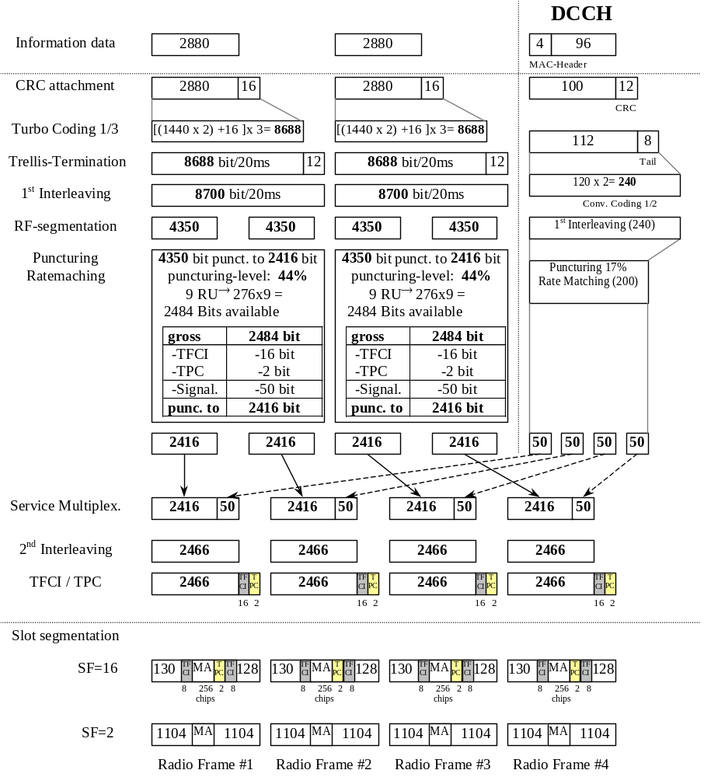

C.2.5 UL reference measurement channel (384 kbps)
Parameter
Information data rate | 384 kbps
RU´s allocated | 8*3TS = 24RU
Midamble | 256 chips
Interleaving | 20 ms
Power control | 2 Bit/user
TFCI | 16 Bit/user
Inband signalling DCCH | 2 kbps
Puncturing level at Code rate : 1/3 DCH / ½ DCCH | 43.4% / 15.3%

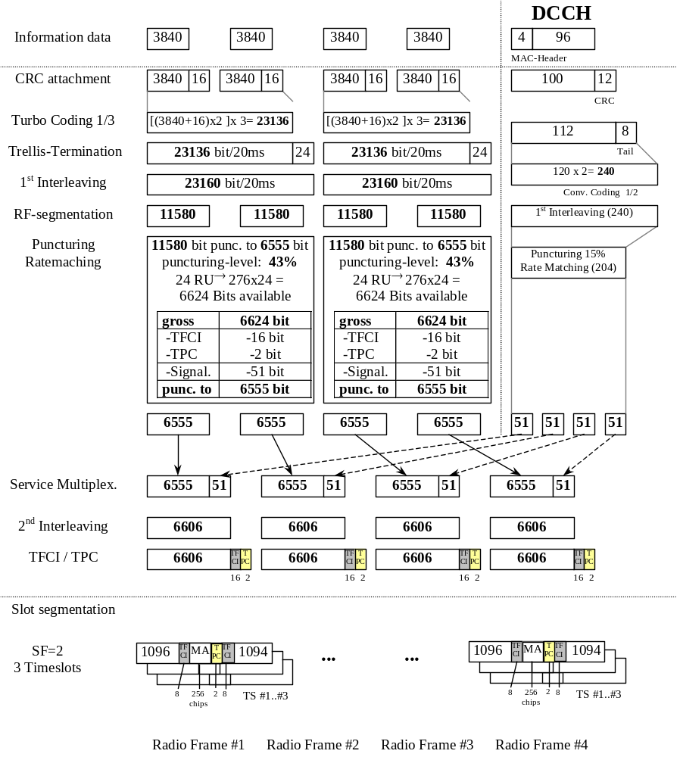

C.3 DL Reference measurement channels

C.3.1 DL reference measurement channel (12.2 kbps)
Parameter
Information data rate | 12.2 kbps
RU´s allocated | 2 RU
Midamble | 512 chips
Interleaving | 20 ms
Power control | 0 Bit/user
TFCI | 16 Bit/user
Inband signalling DCCH | 2 kbps
Puncturing level at Code rate 1/3 : DCH / DCCH | 5% / 0 %

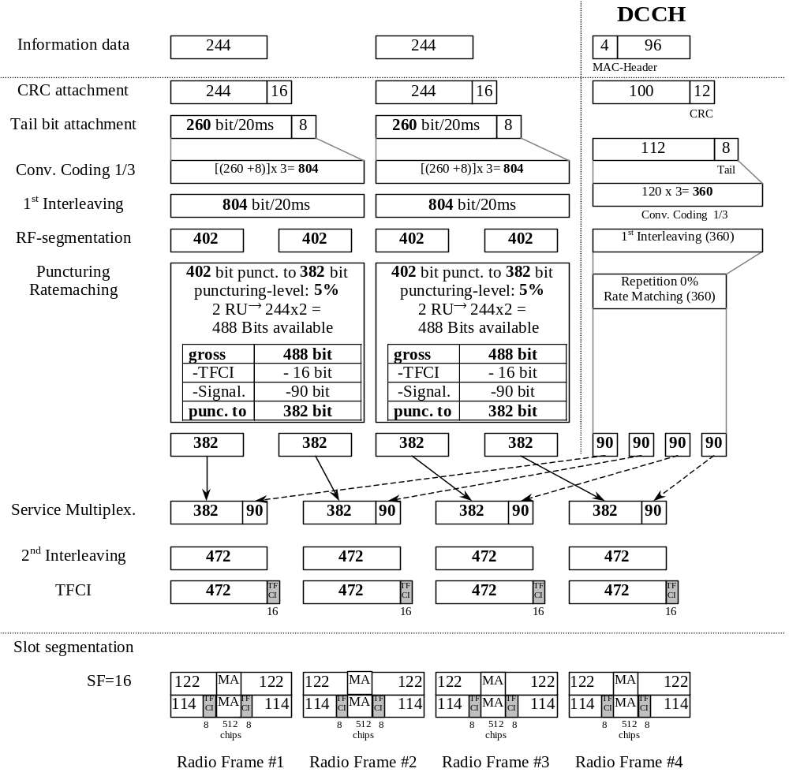

C.3.2 DL reference measurement channel (64 kbps)
Parameter
Information data rate | 64 kbps
RU´s allocated | 5 codes SF16 = 5RU
Midamble | 512 chips
Interleaving | 20 ms
Power control | 0 Bit/user
TFCI | 16 Bit/user
Inband signalling DCCH | 2 kbps
Puncturing level at Code rate : 1/3 DCH / ½ DCCH | 41.1% / 10%

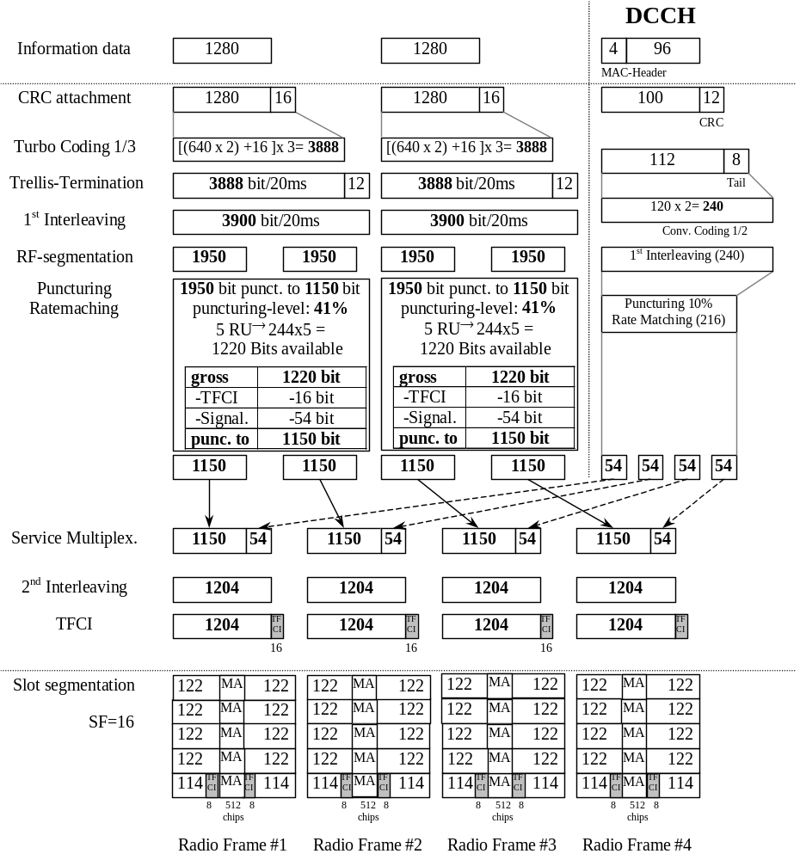

C.3.3 DL reference measurement channel (144 kbps)
Parameter
Information data rate | 144 kbps
RU´s allocated | 9 codes SF16 = 9RU
Midamble | 256 chips
Interleaving | 20 ms
Power control | 0 Bit/user
TFCI | 16 Bit/user
Inband signalling DCCH | 2 kbps
Puncturing level at Code rate: 1/3 DCH / ½ DCCH | 44.5% / 16.6%

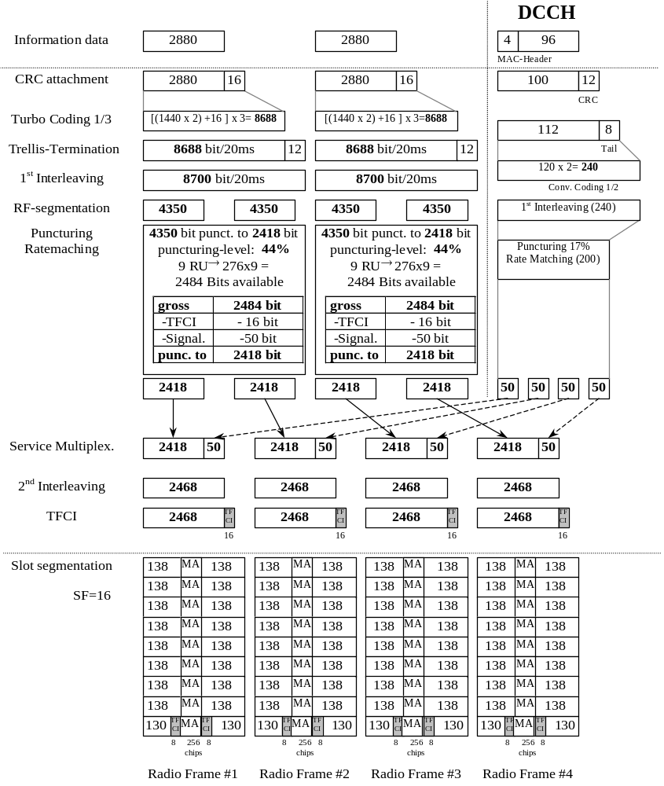

C.3.4 DL reference measurement channel (384 kbps)
Parameter
Information data rate | 384 kbps
RU´s allocated | 8*3TS = 24RU
Midamble | 256 chips
Interleaving | 20 ms
Power control | 0 Bit/user
TFCI | 16 Bit/user
Inband signalling DCCH | 2 kbps
Puncturing level at Code rate : 1/3 DCH / ½ DCCH | 43.4% / 15.3%

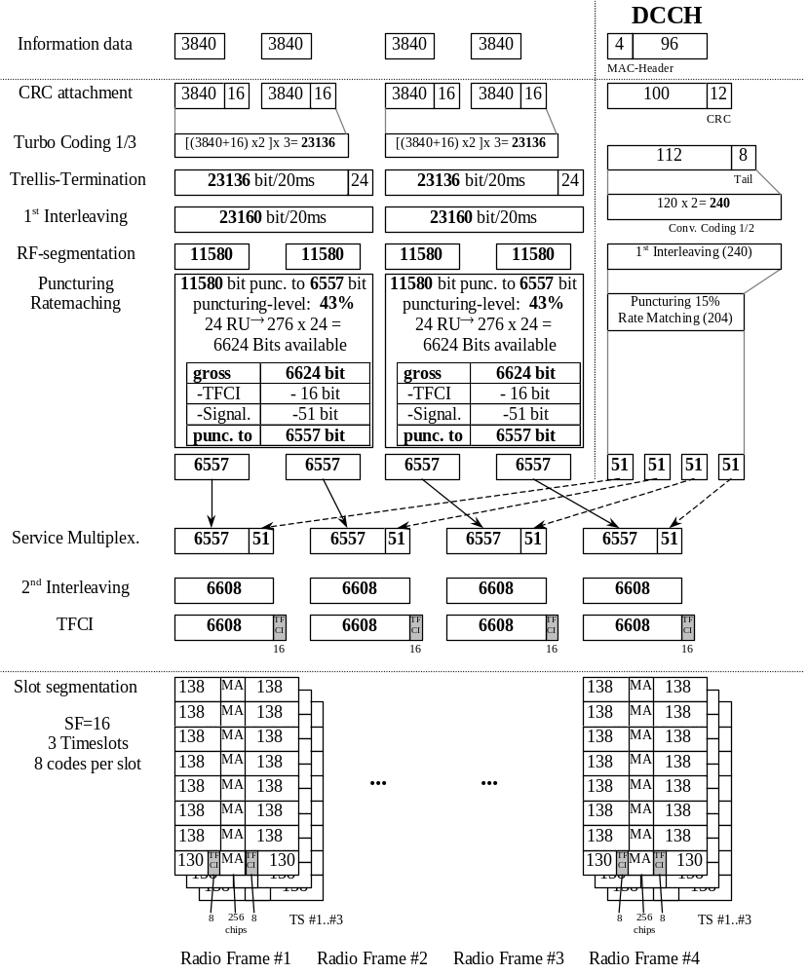

C.3.5 BCH reference measurement channel
[mapped to 1 code SF16]
Parameter
Information data rate: | 12.3 kbps
RU´s allocated | 1 RU
Midamble | 512 chips
Interleaving | 20 ms
Power control | 0 bit
TFCI | 0 bit
Puncturing level | 10%

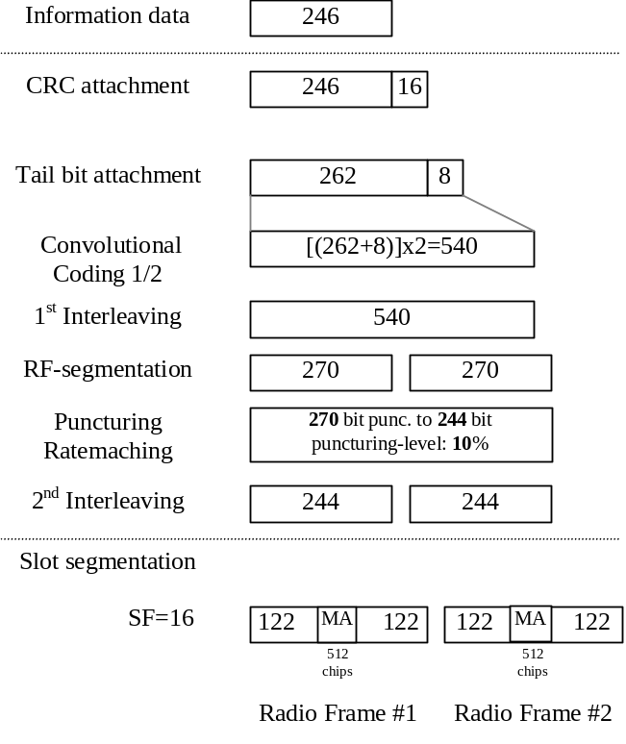

Annex D (normative):
Propagation conditions

D.1 Test Environments
Table D.1 details the test services, the information data and the propagation conditions
Table D.1: Test Environments for UE Performance Specifications
Test Services | Information Data Rate | Static | Multipath  Case 1 | Multipath  Case 2 | Multipath  Case 3
 |  | Performance metric
Paging Message |  |  | - | - | -
FACH Message |  |  | - | - | -
Circuit Switched Services | 12.2 kbps | BLER  < | BLER  < | BLER  < | BLER  <
 | 64 kbps | BLER  < | BLER  < | BLER  < | BLER  <
 | 144 kbps | BLER  < | BLER  < | BLER  < | BLER  <
 | 384 kbps | BLER  < | BLER  < | BLER  < | BLER  <
 | 2048 kbps | BLER  < | - | - | -
Packet Switched Data | TBD | TBD | TBD | TBD | TBD

D.2 Propagation Conditions

D.2.1 Static propagation condition
The propagation for the static performance measurement is an Additive White Gaussian Noise (AWGN) environment. No fading and multi-paths exist for this propagation model.

D.2.2 Multi-path fading propagation conditions
Table D.2 shows propagation conditions that are used for the performance measurements in multi-path fading environment. All taps have classical Doppler spectrum.
Table D.2: Propagation Conditions for Multi path Fading Environments
Case 1, speed 3km/h |  | Case 2, speed 3 km/h |  | Case 3, 120 km/h |  | Case 4, 3 km/h
Relative Delay [ns] | Average Power [dB] | Relative Delay [ns] | Average Power [dB] | Relative Delay [ns] | Average Power [dB] | Relative Delay [ns] | Average Power [dB]
0 | 0 | 0 | 0 | 0 | 0 | 0 | 0
976 | -10 | 976 | 0 | 260 | -3 | 976 | 0
 |  | 12000 | 0 | 521 | -6
 |  |  |  | 781 | -9

Annex E (normative):
Common RF test conditions

E.1 General
This normative annex specifies the common RF test conditions that are needed for setting a connection and channels that are needed during a connection.

E.2 Connection Set-up
Table E.2 describes the downlink Physical Channels that are required for connection set up.
Table E.2: Downlink Physical Channels required for connection set-up
Physical Channel
PSCH
PCCPCH
DPCH
PICH

E.3 During connection
The following clauses describes the uplink and downlink Physical Channels that are transmitted during a connection i.e., when measurements are done.

E.3.1 Measurement of Tx Characteristics
Table E.3.1 is applicable for measurements on the Transmitter Characteristics (Section 5) with the exception of clause 5.2 (UE maximum output power), 5.3 (Frequency Stability), 5.4.1 (Uplink Power Control). For these cases certain parameters are defined individually.
Table E.3.1.1: Common downlink test condition RF parameters
Physical Channel | Power
DPCH | -93 dBm Data content PRBS
PSCH | TBD
PCCPCH | TBD
PICH | TBD
OCNS | Nothing

Table E.3.1.2: Common TX test parameters
Parameter | Value/description
UL Reference measurement channel | 12.2kbps, according to annex C.2.1
Uplink Power Control | SS level and signalling values such that UE transmits maximum power.
Data content | real life (sufficient irregular)

E.3.2 Measurement of Rx Characteristics
Table E.3.2 is applicable for measurements on the Receiver Characteristics (Section 6)
Table E.3.2: Downlink Physical Channels transmitted during a connection.
Physical Channel | Power
CPICH | TBD
PCCPCH | TBD
SCH | TBD
PICH | TBD
DPCH | TBD

E.3.3 Measurement of Performance requirements
Table E.3.3 is applicable for measurements on the Performance requirements (Section 7)
Table E.3.3: Downlink Physical Channels transmitted during a connection.
Physical Channel | Power | Note
CPICH | TBD
PCCPCH | TBD
SCH | TBD
PICH | TBD
DPCH | TBD
OCNS | TBD

Annex F (normative):
General test conditions and declarations
The requirements of this clause apply to all applicable tests in this specification.
Many of the tests in this specification measure a parameter relative to a value that is not fully specified in the UE specifications. For these tests, the Minimum Requirement is determined relative to a nominal value specified by the manufacturer.
When specified in a test, the manufacturer shall declare the nominal value of a parameter, or whether an option is supported.
.In all the relevant subclauses in this clause all Bit Error Ratio (BER), Block Error Ratio (BLER) measurements shall be carried out according to the general rules for statistical testing in annex F.6.

F.1 Acceptable uncertainty of Test System
The maximum acceptable uncertainty of the Test System is specified below for each test, where appropriate. The Test System shall enable the stimulus signals in the test case to be adjusted to within the specified range, and the equipment under test to be measured with an uncertainty not exceeding the specified values. All tolerances and uncertainties are absolute values, and are valid for a confidence level of 95 %, unless otherwise stated.
A confidence level of 95% is the measurement uncertainty tolerance interval for a specific measurement that contains 95% of the performance of a population of test equipment.
For RF tests it should be noted that the uncertainties in subclause F.1 apply to the Test System operating into a nominal 50 ohm load and do not include system effects due to mismatch between the DUT and the Test System.

F.1.1 Measurement of test environments
The measurement accuracy of the UE test environments defined in Annex G, Test environments shall be.
- Pressure ±5 kPa.
- Temperature ±2 degrees.
- Relative Humidity ±5 %.
- DC Voltage ±1,0 %.
- AC Voltage ±1,5 %.
- Vibration 10 %.
- Vibration frequency 0,1 Hz.
The above values shall apply unless the test environment is otherwise controlled and the specification for the control of the test environment specifies the uncertainty for the parameter.

F.1.2 Measurement of transmitter
Table F.1.2 Maximum Test System Uncertainty for transmitter tests
Subclause | Maximum Test System Uncertainty
5.2 UE Maximum Output Power | ±0.7 dB
5.3 Frequency Stability | ± 10Hz
5.4.1 Uplink power control | Relative  ±[0.3] dB
5.4.2 Minimum Transmit Power | ±1.0 dB
5.4.3 Transmit OFF Power | ±1.5 dB
5.4.4 Transmit ON/OFF Power | TBD
5.4.5 Out-of-synchronisation handling of output power | TBD
5.5.1 Occupied Bandwidth | ±100 kHz
5.5.2.1 Spectrum emission mask | ±1.5 dB
5.5.2.2 ACLR | 5 ΜΗz offset: ± 0.8 dB  10 ΜΗz offset: ± 0.8 dB
5.5.3 Spurious emissions | ± 2.0 dB for UE and coexistenece bands for results > -60 dBm  ± 3.0 dB for results < -60 dBm  Outside above:  f≤2.2GHz : ± 1.5 dB  2.2 GHz < f ≤ 4 GHz :  ± 2.0 dB  f > 4 GHz : ±4.0 dB
5.6 Transmit intermodulation: | Will be based on BS, need to work out freq and level ranges.
5.7.1 Transmit modulation: EVM | ±2.5 %
5.7.2 Transmit modulation: peak code domain error | ±1 dB

F.1.3 Measurement of receiver
Table F.1.3 Maximum Test System Uncertainty for receiver tests
Subclause | Maximum Test System Uncertainty
6.2 Reference Sensitivity Level | ± 0.7 dB
6.3 maximum input level: | TBD
6.4 Adjacent Channel Selectivity (ACS) | Overall system uncertainty  ± 1.1 dB
6.5 Blocking Characteristics | Using ± 0.7 dB for signal and interferer as currently defined, and 68 dB ACLR @ 10 MHz.System error with f <15 MHz offset:  ± 1.4 dB  f >= 15 MHz offset and f ≤ 2.2 GHz: ± [1.0] dB  2.2 GHz < f ≤ 4 GHz : ±[1.7] dB  f > 4 GHz: ±[3.1] dB
6.6 Spurious Response | f < 2.2 GHz: ±1.0dB  2.2 < f < 4GHz: ±1.7dB  f > 4 GHz: ±3.1dB
6.7 Intermodulation Characteristics | Assume ± 0.7 dB for all signals. Overall uncertainty = ± [0.6] dB  Needs further analysis
6.8 Spurious Emissions | ± 3.0 dB for UE receive band (-78 dBm)  Outside above:  f≤2.2GHz : ± 2.0dB (-57 dBm)  2.2 GHz < f ≤ 4 GHz : ± 2.0 dB (-47 dBm)  f > 4 GHz : ±4.0 dB (-47 dBm)

F.1.4 Performance requirement
Table F.1.4 Maximum Test System Uncertainty for Performance Requirements
Subclause | Maximum Test System Uncertainty
TBD | TBD

F.1.5 Requirements for support of RRM
TBD

F.2 Test Tolerances (This subclause is informative)
The Test Tolerances defined in this subclause have been used to relax the Minimum Requirements in this specification to derive the Test Requirements.
The Test Tolerances are derived from Test System uncertainties, regulatory requirements and criticality to system performance. As a result, the Test Tolerances may sometimes be set to zero.
The test tolerances should not be modified for any reason e.g. to take account of commonly known test system errors (such as mismatch, cable loss, etc.).

F.2.1 Transmitter
Table F.2.1 Test Tolerances for transmitter tests.
Subclause | Test Tolerance
5.2 Maximum Output Power | 0.7 dB
5.3 UE Frequency Stability | 10 Hz
5.4.1.1 Uplink Power Control, Initial Accuracy | +1.0 dB
5.4.1.2 Uplink Power Control, differential Accuracy | 1dB step: 0.1 dB  2 dB step: 0.15 dB  3dB step: 0.2 dB  10 dB step: 0.5 dB  20 dB step: 0.7 dB  30 dB step: 0.7 dB  >30 dB step: 1.0 dB
5.4.2 Minimum Transmit Power | 1.0 dB
5.4.5 Out-of-synchronisation handling of output power: 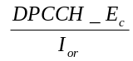 | [0.3] dB
5.4.5 Out-of-synchronisation handling of output power: transmit ON/OFF time | 0 ms
5.5.1 Transmit OFF power | 1.5 dB
5.5.1 Occupied Bandwidth | 0 kHz
5.5.2.1 Spectrum emission mask | 1.5 dB
5.5.2.2 Adjacent Channel Leakage Power Ratio (ACLR) | 0.8 dB
5.5.3 Spurious Emissions | 0 dB
5.6 Transmit Intermodulation | 0 dB
5.7.1 Error Vector Magnitude | 0%
5.7.2 Peak code domain error | 1.0 dB

F.2.2 Receiver
Table F.2.2 Test Tolerances for receiver tests.
Subclause | Test Tolerance
6.2 Reference sensitivity level | 0.7 dB
6.4 Adjacent channel selectivity | 0 dB
6.5 Blocking characteristics | 0 dB
6.6 Spurious Response | 0 dB
6.7 Intermodulation Characteristics | 0 dB
6.8 Spurious emissions | 0 dB

F.2.3 Performance requirements
Table F.2.3 Test Tolerances for Performance Requirements.
Subclause | Test Tolerance
7.2, Demodulation in Static Propagation Condition
7.3, Demodulation of DCH in Multiplath Fading conditions
7.4, Base Station Transmit diversity modes

F.2.4 Requirements for support of RRM
TBD

F.3 Interpretation of measurement results
The measurement results returned by the Test System are compared - without any modification - against the Test Requirements as defined by the shared risk principle.
The Shared Risk principle is defined in ETR 273 Part 1 sub-part 2 section 6.5.
The actual measurement uncertainty of the Test System for the measurement of each parameter shall be included in the test report.
The recorded value for the Test System uncertainty shall be, for each measurement, equal to or lower than the appropriate figure in subclause F.1 of this specification.
If the Test System for a test is known to have a measurement uncertainty greater than that specified in subclause F.1, it is still permitted to use this apparatus provided that an adjustment is made value as follows.
Any additional uncertainty in the Test System over and above that specified in subclause F.1 shall be used to tighten the Test Requirement – making the test harder to pass. (For some tests e.g. receiver tests, this may require modification of stimulus signals). This procedure will ensure that a Test System not compliant with subclause F.1does not increase the chance of passing a device under test where that device would otherwise have failed the test if a Test System compliant with subclause F.1 had been used.

F.4 Derivation of Test Requirements (This subclause is informative)
The Test Requirements in this specification have been calculated by relaxing the Minimum Requirements of the core specification using the Test Tolerances defined in subclause F.2. When the Test Tolerance is zero, the Test Requirement will be the same as the Minimum Requirement. When the Test Tolerance is non-zero, the Test Requirements will differ from the Minimum Requirements, and the formula used for this relaxation is given in table F.4.
Table F.4. Derivation of Test Requirements
Test | Minimum Requirement in TS 25.102 |  |  |  | Test Tolerance  (TT) | Test Requirement in TS 34.122
5.2 Maximum Output Power | Power single code  Power class 1 (30 dBm)  Tolerance = +1/-3 dB  Power class 2 (24 dBm)  Tolerance = +1/-3 dB  Power class 3 (21 dBm)  Tolerance = +2/-2 dB  Power multi code  Power class 2 (21 dBm)  Tolerance = +1/-3 dB  Power class 3 (18 dBm)  Tolerance = ±2 dB  Power class 4 (10 dBm)  Tolerance = ± 4 dB |  |  |  | 0.7 dB | Formula: Upper Tolerance limit + TT  Lower Tolerance limit – TT  For power classes 1 and 2 (single and multi):  Upper Tolerance limit = +1.7 dB  Lower Tolerance limit = -3.7 dB  For power class 3 (single and milti):  Upper Tolerance limit = +2.7 dB  Lower Tolerance limit = -2.7 dB  For power class 4 (single and multi)  Upper Tolerance limit = +4.7 dB  Lower Tolerance limit = -4.7 dB
5.3 UE Frequency Stability | The UE modulated carrier frequency shall be accurate to within ±0.1 ppm compared to the carrier frequency received from the Node B. |  |  |  | 10 Hz | Formula: modulated carrier frequency error + TT  modulated carrier frequency error = ±(0.1 ppm + 10 Hz).
5.4.1.1 Uplink Pwer Control, Initial accuracy | ± 9dB normal conditions  ± 12dB extreme conditions |  |  |  | 1.0 dB | Formula: Upper Tolerance limit + TT  Lower Tolerance limit – TT  Nominal expected TX power  ± 10dB (normal conditions)  ± 13dB (extreme conditions)
5.4.1.2 Uplink Power Control, differential accuracy | SIR Target Pow Step Tol  <1 dB 0.5 dB  <2dB 1 dB  <3 dB 1.5 dB  <10 dB 2 dB  <20dB 4 dB  <30 dB 6 dB  > 30 dB 9 dB |  |  |  | TT  0.1 dB  0.15 dB  0.2 dB  0.5 dB  0.7 dB  0.7 dB  1.0 dB | Formula: Upper Tolerance limit + TT  Lower Tolerance limit – TT
5.4.2 Minimum Transmit Power | UE minimum transmit power shall be less than –44 dBm |  |  |  | 1.0 dB | Formula:  UE minimum transmit power + TT  UE minimum transmit power = –43 dBm
5.4.5 Out-of-synchronisation handling of output power: | 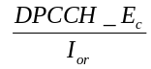levels  before A –4.6 dB  AB: -10 dB  BD: -16 dB  DE: -12 dB  EF: -6 dB  transmit ON/OFF time  200ms |  |  |  | [0.3] dB  for  0 ms for timing measurement | Formulas:  Ratio between A and B + TT  Ratio between B and D - TT  Ratio between D and E - TT  Ratio between E and F + TT  transmit ON/OFF time + TT timing  levels:  Before A: -4.6  AB: -10 + [0.3] dB  BD: -16 – [0.3] dB  DE: -12 - [0.3] dB  EF: -6 + [0.3] dB  Uncertainty of OFF power measurement is handled by Transmit OFF power test and uncertainty of ON power measurement is handled by Minimum output power test.transmit ON/OFF time  200ms
5.5.1 Transmit OFF power | Transmit OFF power shall be less than –65 dBm |  |  |  | 1.5 dB | Formula: Transmit OFF power + TT  Transmit OFF power = –63.5 dBm
5.5.1 Occupied Bandwidth | The occupied channel bandwidth shall be less than 5 MHz based on a chip rate of 3.84 Mcps. |  |  |  | 0 kHz | Formula: occupied channel bandwitdh: + TT  occupied channel bandwidth = 5.0 MHz
5.5.2.1 Spectrum emission mask | Minimum requirement defined in TS25.101 Table 6.10.  The lower limit shall be −50 dBm / 3.84 MHz or which ever is higher. |  |  |  | 1.5 dB | Formula: Minimum requirement + TT  Lower limit + TT  Add 1.5 to Minimum requirement entries in TS25.101 Table 6.10  The lower limit shall be −48.5 dBm / 3.84 MHz or which ever is higher.
5.5.2.2 Adjacent Channel Leakage Power Ratio (ACLR) | Power Classes 2 and 3:  UE channel +5 MHz or -5 MHz, ACLR limit: 33 dB  UE channel +10 MHz or -10 MHz, ACLR limit: 43 dB |  |  |  | 0.8 dB | Formula: ACLR limit - TT  Power Classes 2 and 3:  UE channel +5 MHz or -5 MHz, ACLR limit: 32.2 dB  UE channel +10 MHz or -10 MHz, ACLR limit: 42.2 dB
5.5.3 Spurious Emissions |  |  |  |  |  | Formula: Minimum Requirement+ TT  Add zero to all the values of Minimum Requirements in table 5.5.3
5.5.3 Spurious Emissions | Frequency Band |  |  | Minimum Requirement |  | Frequency Band | Minimum Requirement
5.5.3 Spurious Emissions | 9 kHz ≤ f < 150 kHz |  |  | −36dBm  /1kHz | 0 dB | 9kHz ≤ f < 1GHz | −36dBm  /1kHz
5.5.3 Spurious Emissions | 150 kHz ≤ f < 30 MHz |  | −36dBm  /10kHz |  | 0 dB | 150 kHz ≤ f < 30 MHz | −36dBm  /10kHz
5.5.3 Spurious Emissions | 30 MHz ≤ f < 1000 MHz |  | −36dBm  /100kHz |  | 0 dB | 30 MHz ≤ f < 1000 MHz | −36dBm  /100kHz
5.5.3 Spurious Emissions | 1 GHz ≤ f < 12.75 GHz |  | −30dBm  /1MHz |  | 0 dB | 1 GHz ≤ f < 2.2 GHz | −30dBm  /1MHz
5.5.3 Spurious Emissions |  |  |  |  | 0 dB | 2.2 GHz ≤ f < 4 GHz | −30dBm  /1MHz
5.5.3 Spurious Emissions |  |  |  |  | 0 dB | 4 GHz ≤ f < 12.75 GHz | −30dBm  /1MHz
5.5.3 Spurious Emissions | 925 MHz < f < 935 MHz |  | −67dBm  /100kHz |  | 0 dB | 925 MHz < f < 935 MHz | −67dBm  /100kHz
5.5.3 Spurious Emissions | 935 MHz ≤ f ≤ 960 MHz |  | −79dBm  /100kHz |  | 0 dB | 935 MHz ≤ f ≤ 960 MHz | −79dBm  /100kHz
5.5.3 Spurious Emissions | 1805 MHz < f ≤ 1880 MHz |  | −71dBm  /100kHz |  | 0 dB | 1805 MHz < f ≤ 1880 MHz | −71dBm  /100kHz
5.5.3 Spurious Emissions | 1805 MHz ≤ f ≤ 1880 MHz |  | −71dBm  /100kHz |  | 0 dB | 1805 MHz ≤ f ≤ 1880 MHz | −71dBm  /100kHz
5.6 Transmit Intermodulation | Intermodulation Product  5MHz -31 dBc  10MHz -41 dBc |  |  |  | 0 dB | Formula: Intermodulation Product + TT  Intermodulation Product  5MHz -31 dBc  10MHz -41 dBc
5.7.1 Error Vector Magnitude | The Error Vector Magnitude shall not exceed 17.5 % |  |  |  | 0% | Formula: EVM limit + TT  EVM limit = 17.5 %
5.7.2 Peak code domain error | The peak code domain error shall not exceed -21dB |  |  |  | ±1.0 dB | Formula: Peak code domain error + TT  Peak code domain error = -20 dB
6.2 Reference sensitivity level | Îor = -105 dBm / 3.84 MHz  BER limit = 0.001 |  |  |  | 0.7 dB | Formula: Îor+ T  BER limit unchanged  Îor = -104.3 dBm / 3.84 MHz
6.4 Adjacent Channel Selectivity | Îor = -91 dBm / 3.84 MHz  Ioac (modulated) = -52 dBm/3.84 MHz  BER limit = 0.001 |  |  |  | 0 dB | Formula: Îor unchanged  Ioac - TT  BER limit unchanged  Ioac = -52 dBm/3.84 MHz
6.5 Blocking Characteristics | See Table 6.5.2a and 6.5.2b. in TS34.122  BER limit = 0.001 |  |  |  | 0 dB | Formula:  I _{blocking} (modulated) - TT (dBm/3.84MHz)  I _{blocking} (CW) - TT (dBm)  BER limit unchanged
6.6 Spurious Response | Iblocking(CW) –44 dBm  Fuw:  Spurious response frequencies  BER limit = 0.001 |  |  |  | 0 dB | Formula: I _{blocking} (CW) - TT (dBm)  Fuw unchanged  BER limit unchanged  Iblocking(CW) -44 dBm
6.7 Intermodulation Characteristics | Iouw1 (CW) -46 dBm  Iouw2 (modulated) –46 dBm / 3.84 MHz  Fuw1 (offset) 10 MHz  Fuw2 (offset) 20 MHz  BER limit = 0.001 |  |  |  | 0 dB | Formula: TBD  BER limit unchanged.
6.8 Spurious  Emissions |  |  |  |  |  | Formula: Maximum level+ TT  Add zero to all the values of Maximum Level in table 6.8.1.
6.8 Spurious  Emissions | Frequency Band | Maximum level |  |  |  | Frequency Band | Maximum level
6.8 Spurious  Emissions | 9kHz ≤ f < 1GHz | -57dBm  /100kHz |  |  | 0 dB | 9kHz ≤ f < 1GHz | -57dBm  /100kHz
6.8 Spurious  Emissions | 1.9-1.92 GHz  2.01-2.025GHz  2.11-2.170GHz | -60 dBm / 3.84MHz |  |  | 0 dB | 1.9-1.92 GHz  2.01-2.025GHz  2.11-2.170GHz | -60 dBm / 3.84MHz
6.8 Spurious  Emissions | 1 –1.9GHz,  1.92–2.01 GHz  2.025–2.11GHz | -47 dBm/1MHz |  |  | 0 dB | 1 –1.9GHz,  1.92–2.01 GHz  2.025–2.11GHz | -47 dBm/1MHz
6.8 Spurious  Emissions | 1GHz ≤ f ≤ 12.75GHz | -47dBm  /1MHz |  |  | 0 dB | 1GHz ≤ f ≤ 2.2GHz | -47dBm  /1MHz
6.8 Spurious  Emissions | 1GHz ≤ f ≤ 12.75GHz |  |  |  | 0 dB | 2.2GHz < f ≤ 4GHz | -47dBm  /1MHz
6.8 Spurious  Emissions | 1GHz ≤ f ≤ 12.75GHz |  |  |  | 0 dB | 4GHz < f ≤ 12.75GHz | -47dBm  /1MHz

F.5 Acceptable uncertainty of Test Equipment (This subclause is informative)
This informative subclause specifies the critical parameters of the components of an overall Test System (e.g. Signal generators, Signal Analyzers etc.) which are necessary when assembling a Test System that complies with subclause F.1 Acceptable Uncertainty of Test System. These Test Equipment parameters are fundamental to the accuracy of the overall Test System and are unlikely to be improved upon through System Calibration.

F.5.1 Transmitter measurements
Table F.5.1 Equipment accuracy for transmitter measurements
Test | Equipment accuracy | Test conditions
5.2 UE Maximum Output Power | Not applicable
5.3 Frequency Stability | ± 10Hz
5.4.1 Uplink power control
5.4.2 Minimum Transmit Power
5.4.3 Transmit OFF Power
5.4.4 Transmit ON/OFF Power
5.4.5 Out-of-synchronisation handling of output power
5.4.5 Out-of-synchronisation handling of output power: transmit ON/OFF time
5.5.1 Occupied Bandwidth | 100 kHz
5.5.2.1 Spectrum emission mask | Not applicable
5.5.2.2 ACLR

5.5.3 Spurious emissions
5.5.3 Spurious emissions: additional
5.6 Transmit intermodulation: | Not applicable
5.7.1 Transmit modulation: EVM | 2.5 %
5.7.2 Transmit modulation: peak code domain error | ±[1 dB]

F.5.2 Receiver measurements
Table F.5.2 Equipment accuracy for receiver measurements
Subclause | Equipment accuracy | Test conditions
6.2 Reference Sensitivity Level | Not applicable
6.3 maximum input level: | Not applicable
6.4 Adjacent Channel Selectivity (ACS) | Not applicable
6.5 Blocking Characteristics | Not applicable
6.6 Spurious Responce | Not applicable
6.7 Intermodulation Characteristics | Not applicable
6.8 Spurious Emissions | Not applicable

F.5.3 Performance measurements
Table G.3 Equipment accuracy for performance measurements
Subclause | Equipment accuracy | Test conditions
TBD | TBD

F.6 General rules for statistical testing
[TBD]

Annex G (normative):
Environmental conditions

G.1 General
This normative annex specifies the environmental requirements of the UE. Within these limits the requirements of this specifications shall be fulfilled.

G.2 Environmental requirements
The requirements in this clause apply to all types of UE(s)

G.2.1 Temperature
The UE shall fulfil all the requirements in the full temperature range of:
+15°C to +35°C | for normal conditions (with relative humidity of 25 % to 75 %)
-10°C to +55°C | for extreme conditions (see IEC publications 68-2-1 and 68-2-2)

Outside this temperature range the UE, if powered on, shall not make ineffective use of the radio frequency spectrum. In no case shall the UE exceed the transmitted levels as defined in TS 25.101 [1] for extreme operation.

G.2.2 Voltage
The UE shall fulfil all the requirements in the full voltage range, i.e. the voltage range between the extreme voltages.
The manufacturer shall declare the lower and higher extreme voltages and the approximate shutdown voltage. For the equipment that can be operated from one or more of the power sources listed below, the lower extreme voltage shall not be higher, and the higher extreme voltage shall not be lower than that specified below.
Power source | Lower extreme  voltage | Higher extreme  voltage | Normal conditions  voltage
AC mains | 0,9 * nominal | 1,1 * nominal | nominal
Regulated lead acid battery | 0,9 * nominal | 1,3 * nominal | 1,1 * nominal
Non regulated batteries:  Leclanché / lithium  Mercury/nickel & cadmium | 0,85 * nominal  0,90 * nominal | Nominal  Nominal | Nominal  Nominal

Outside this voltage range the UE if powered on, shall not make ineffective use of the radio frequency spectrum. In no case shall the UE exceed the transmitted levels as defined in [1] TS 25.101 for extreme operation. In particular, the UE shall inhibit all RF transmissions when the power supply voltage is below the manufacturer declared shutdown voltage.

G.2.3 Vibration
The UE shall fulfil all the requirements when vibrated at the following frequency/amplitudes:
Frequency | ASD (Acceleration Spectral Density) random vibration
5 Hz to 20 Hz | 0,96 m2/s3
20 Hz to 500 Hz | 0,96 m2/s3 at 20 Hz, thereafter –3 dB/Octave

Outside the specified frequency range the UE, if powered on, shall not make ineffective use of the radio frequency spectrum. In no case shall the UE exceed the transmitted levels as defined in TS 25.101 [1] for extreme operation.

Annex H (normative):
Terminal Baseline and Service Implementation Capabilities (TDD)

H.1 Baseline Implementation Capabilities:
Table H.1: Baseline implementation capabilities
Capability TDD | Section | UE* | Comments
Chip rate 3.84 Mcps |  | M
Frequency bands: (uplink and downlink)  _______________________________  1900-1920 MHz  2010-2025 MHz  _______________________________  1850-1910 MHz  1930-1990 MHz  _______________________________  1910-1930 MHz  _______________________________ |  | M  M  M  M  M
Other spectrum |  | O | As Declared
Carrier raster 200 kHz |  | M
UE maximum output power | 6.2.1 | M | 2, 3

(* M = mandatory, O = optional)
- The special conformance testing functions and the logical test interface as specified in TS 34.109 [3]. This issue is currently under investigation.
- Uplink reference measurement channel 12.2 kbps (FDD), TS 25.102 [1] subclause A.2.1.
- Downlink reference measurement channel 12.2 kbps (FDD), TS 25.102 [1] subclause A.2.2.

H.2 Service Implementation Capabilities:
- Downlink reference measurement channel 64 kbps (TDD), TS 25.102 subclause A.2.3.
- Downlink reference measurement channel 144 kbps (TDD), TS 25.102 subclause A.2.4.
- Down-link reference measurement channel 384 kbps (TDD), TS 25.102 subclause A.2.5.
- BCH Reference Measurement Channel.

Annex I (informative):
Change history
Meeting-1st-Level | Doc-1st-Level | CR | Rev | Subject | Cat | Version-Current | Version-New | Doc-2nd-Level
TP-08 |  |  |  | Approval of the specification |  | 2.0.0 | 3.0.0
TP-09 | TP-000134 | 001 |  | Corrections to EVM and PCDE formulae (B.2.7.1, B2.7.2) | F | 3.0.0 | 3.1.0 | T1-000150
TP-10 | TP-000217 | 002 |  | Update of 34.122 according to RAN#9-approved CRs to 25.102 | F | 3.1.0 | 3.2.0 | T1-000256
TP-10 | TP-000217 | 003 |  | Update according to former CRs to 25.102 | F | 3.1.0 | 3.2.0 | T1-000257
TP-10 | TP-000217 | 004 |  | editorial corrections for: Global In-Channel TX- Test | D | 3.1.0 | 3.2.0 | T1-000259
TP-10 | TP-000217 | 005 |  | Handling of measurement uncertainties in UE conformance testing (TDD) | F | 3.1.0 | 3.2.0 | T1-000262
TP-10 | TP-000217 | 006 |  | Uplink Power control | F | 3.1.0 | 3.2.0 | T1-000258
TP-10 | TP-000217 | 007 |  | UE maximum output power multicode | F | 3.1.0 | 3.2.0 | T1-000260
TP-10 | TP-000217 | 008 |  | Out-of-synchronisation handling of output power | F | 3.1.0 | 3.2.0 | T1-000261
TP-11 | TP-010020 | 009 |  | Test tolerance for 5.7.1 TDD EVM | F | 3.2.0 | 3.3.0 | T1-010048
TP-11 | TP-010020 | 010 |  | Test tolerance for 5.7.2 TDD PCDE | F | 3.2.0 | 3.3.0 | T1-010049
TP-11 | TP-010020 | 011 |  | Test tolerance for 5.2 Maximum Output Power test case | F | 3.2.0 | 3.3.0 | T1-010050
TP-11 | TP-010020 | 012 |  | Test tolerance for 5.3 Frequency Stability | F | 3.2.0 | 3.3.0 | T1-010051
TP-11 | TP-010020 | 013 |  | Test tolerance for 5.4.2 Minimum Transmit Output Power | F | 3.2.0 | 3.3.0 | T1-010052
TP-11 | TP-010020 | 014 |  | Test Tolerance for 5.4.3 Transmit OFF power | F | 3.2.0 | 3.3.0 | T1-010053
TP-11 | TP-010020 | 015 |  | Test tolerance for 5.4.5 Out-of-synchronisation handling of output power | F | 3.2.0 | 3.3.0 | T1-010054
TP-11 | TP-010020 | 016 |  | Test tolerance for 5.5.1 Occupied Bandwidth | F | 3.2.0 | 3.3.0 | T1-010055
TP-11 | TP-010020 | 017 |  | Test tolerance for 5.5.2.1 Spectrum Emission Mask | F | 3.2.0 | 3.3.0 | T1-010056
TP-11 | TP-010020 | 018 |  | Test tolerance for 5.5.2.2 ACLR test case | F | 3.2.0 | 3.3.0 | T1-010057
TP-11 | TP-010020 | 019 |  | Test Tolerance for 5.5.3 Spurious emissions | F | 3.2.0 | 3.3.0 | T1-010058
TP-11 | TP-010020 | 020 |  | Test Tolerance for 5.6 Transmit Intermodulation | F | 3.2.0 | 3.3.0 | T1-010059
TP-11 | TP-010020 | 021 |  | Test Tolerance for 6.2 Reference Sensitivity Level | F | 3.2.0 | 3.3.0 | T1-010060
TP-11 | TP-010020 | 022 |  | Test Tolerance for 6.4 Adjacent Channel Selectivity | F | 3.2.0 | 3.3.0 | T1-010061
TP-11 | TP-010020 | 023 |  | Test tolerances to 6.5 Blocking Characteristics | F | 3.2.0 | 3.3.0 | T1-010062
TP-11 | TP-010020 | 024 |  | Test tolerances to 6.6 Spurious Response | F | 3.2.0 | 3.3.0 | T1-010063
TP-11 | TP-010020 | 025 |  | Test tolerances to 6.7 Intermodulation Characteristics | F | 3.2.0 | 3.3.0 | T1-010064
TP-11 | TP-010020 | 026 |  | Test Tolerance for 6.5 RX Spurious Emissions | F | 3.2.0 | 3.3.0 | T1-010065
TP-11 | TP-010020 | 027 |  | Test tolerance for Annex F in TS34.122 | F | 3.2.0 | 3.3.0 | T1-010068
TP-11 | TP-010020 | 028 |  | Correction concerning the coexistence of TDD and FDD in the same band | F | 3.2.0 | 3.3.0 | T1-010045
TP-11 | TP-010020 | 029 |  | Clarification of the mentioned parameter alpha | F | 3.2.0 | 3.3.0 | T1-010046
TP-11 | TP-010020 | 030 |  | Correction concerning the channel number calculation | F | 3.2.0 | 3.3.0 | T1-010047
TP-11 | TP-010020 | 031 |  | Correction concerning UE maximum output power classes | F | 3.2.0 | 3.3.0 | T1-010066
TP-11 | TP-010020 | 032 |  | Correction of Out-of-Sync criteria | F | 3.2.0 | 3.3.0 | T1-010067
TP-12 | TP-010120 | 033 |  | CR:New Power Classes require new test tolerances | F | 3.3.0 | 3.4.0 | T1-010154
TP-12 | TP-010120 | 034 |  | CR:Test tolerances for Output Power Dynamic | F | 3.3.0 | 3.4.0 | T1-010155

