3GPP TSG-SA3 Meeting #110Ad-Hoc-e draft_S3-232029-r2

Electronic meeting, Online, 17 - 21 April 2023 (revision of S3-232029)

Source: Xiaomi

Title: 33.893: Additional Evaluation for Solution #1

Document for: Approval
Agenda Item: 5.19

1 Decision/action requested
SA3 is kindly asked to approve the proposed additional evaluation for solution #1 in TR 33.893.

2 References
[1] TR 33.893 v0.6.0 Study on Security Aspects of Ranging Based Services and Sidelink Positioning

3 Rationale
This pCR proposes additional evaluation for solution #1 in TR 33.893 [1].

4 Detailed proposal
*************** Start of the 1st Change ****************

2 References
The following documents contain provisions which, through reference in this text, constitute provisions of the present document.
- References are either specific (identified by date of publication, edition number, version number, etc.) or non-specific.
- For a specific reference, subsequent revisions do not apply.
- For a non-specific reference, the latest version applies. In the case of a reference to a 3GPP document (including a GSM document), a non-specific reference implicitly refers to the latest version of that document in the same Release as the present document.
[1] 3GPP TR 21.905: "Vocabulary for 3GPP Specifications".
[2] 3GPP TR 23.700-86: "Study on Architecture Enhancement to support Ranging based services and sidelink positioning"
[3] 3GPP TS 23.287: "Architecture enhancements for 5G System (5GS) to support Vehicle-to-Everything (V2X) services".
[4] 3GPP TS 23.304: "Proximity based Services (ProSe) in the 5G System (5GS)".
[5] 3GPP TS 33.536: "Security aspects of 3GPP support for advanced Vehicle-to-Everything (V2X) services".
[6] 3GPP TS 33.503: "Security Aspects of Proximity based Services (ProSe) in the 5G System (5GS)".
[7] 3GPP TS 22.261: "Service requirements for the 5G system".
[8] 3GPP TS 33.501: "Security architecture and procedures for 5G system".
[9] 3GPP TS 23.273: "5G System (5GS) Location Services (LCS); Stage 2".
[10] 3GPP TR 38.859: "Study on expanded and improved NR positioning".
[xy] 3GPP TS 23.586: "Architectural Enhancements to support Ranging based services and Sidelink Positioning".
*************** Start of the 2nd Change ****************

6.1 Solution #1: Privacy protection for UEs in Ranging

6.1.1 Introduction
This solution resolves Key Issue #1 for privacy protection for Ranging/SL Positioning services. In particular, this solution tries to acquire the UE’s authorization. In addition, configuration information is exchanged between the UEs to decide the entity for result calculation.

6.1.2 Solution details
The high-level procedure as shown in Figure 6.1.2-1 is based on the procedure descripted in solution 3 of TR 23.700-86 [2].

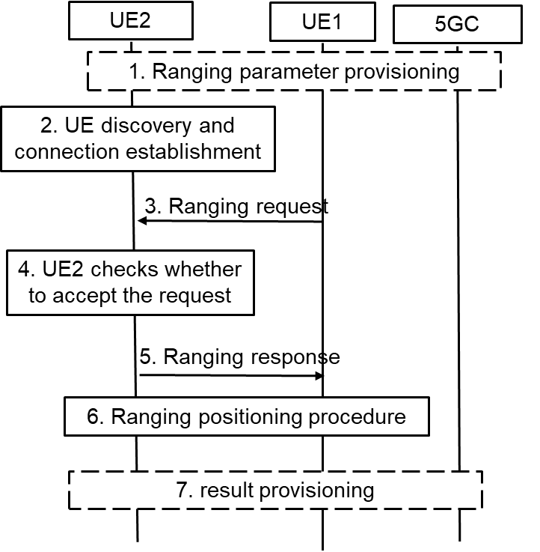
Figure 6.1.2-1: High-level Procedure for Ranging Operation Control
1. UE1 and UE2 may get the ranging parameters from 5GC during registration. UE1 gets the ranging request from the application layer, UE3 or 5GC NF. The ranging request includes the consumer info and/or the purpose of ranging positioning. For example, if the AF wants to acquire the distance between UE1 and UE2 for V2X service. The AF ID and purpose for V2X are included.
2. Discovery and the connection establishment procedure are performed between UE1 and UE2.
NOTE 1: The solution assumes that Ranging authorization is not performed during discovery and communication establishment procedures.
3. UE1 sends the ranging request in the Ranging/SL Positioning layer to the UE2 to check the authorization and negotiate the ranging parameters. The ranging request includes the ranging parameters, e.g. the Ranging role (Reference UE or Target UE), consumer info, purpose, result calculation entity. For example, UE1 decides to calculate the result and not share with UE2, then the result calculation entity means that “UE1 will calculate the ranging result”. If it is implied by the ranging role, the result calculation entity is not needed.
4. UE2 checks whether to accept the ranging request in step #3 in the Ranging/SL Positioning layer based on configuration. For example, UE2 checks whether to allow the ranging result to be provided to the consumer for the claimed purpose based on local policy. UE2 decides whether to accept the ranging role as assigned by UE1. Based on received result calculation entity info, UE2 confirms whether the result can be acquired by UE1 or not.
NOTE 2: The configuration for privacy protection in the Ranging/SL Positioning layer is provided from application layer or other means. It is left to implementation.
5. UE2 sends the ranging response to the UE1. For example, if UE2 does not authorize the ranging positioning for the purpose or the consumer, the reject message with cause will be responded. If UE2 wants to change the Ranging role or result calculation entity, for example due to its privacy consideration, a new Ranging role or result calculation entity is included.
NOTE 3: The solution assumes that UE1 and UE2 can trust each other on the authorization operations during the ranging parameter negotiation.
6. Ranging positioning procedure is performed. The ranging result is calculated based on the negotiation result in step #5.
7. The ranging results may not be shared between the UEs according to the negotiation result. The result calculation entity will provide the result to the application layer, UE3 or 5GC NF.

6.1.3 Evaluation
The solution fulfilled the requirement in Key Issue #1 for privacy protection for Ranging/SL Positioning services.

Ranging authorization on consumer info, purpose or result calculation entity is performed in the Ranging/SL Positioning layer based on configuration, which may be provided from application layer. The UE determines whether to continue the ranging process according to the authorization and negotiation result.
Coordination with RAN2 is required for accommodating the signalling elements required for privacy negotiation in the Ranging/SL Positioning layer.

Editor’s Note: Further evaluation is FFS.
*************** End of the Change ****************

