3GPP TSG-SA3 Meeting #110Ad-Hoc-e draft_S3-231946-r1

Electronic meeting, Online, 17 - 21 April 2023 (revision of S3-yyxxxx)

Source: Nokia, Nokia Shanghai Bell

Title: Sol#1 Adding evaluation - being not in line with OAuth 2.0 architecture

Document for: Approval
Agenda Item: 5.11

1 Decision/action requested
Please approve the additional evaluation for Sol#1 proposed in this solution.

2 References
[1] 3GPP TR 33.884: " Study on security of application enablement aspects for subscriber-aware northbound API access "

3 Rationale
Nokia sees usage of the OAuth authorization code flow proposed in Sol#1 as valid option for the case that the API invoker is part of a third-party application.
However, in our understanding authentication the solution is lacking a mechanism to verify that authorization is provided by the user of a UE. That is, even if a person is authenticated as the subscriber, this person might not be the user of the UE.
Furthermore, the introduction of new interfaces CAPIF-10, CAPIF-8 and the Authorization API is not in line with OAuth 2.0 conventions.
We propose to capture both aspects in the evaluation section of the solution.

4 Detailed proposal
Please accept the following changes to TR 33.884 [1]:
**** START OF CHANGE ****

6.1 Solution #1: Resource Owner Authorization in API Invocation using OAuth Token

6.1.1 Introduction
This solution addresses the requirement in KI#2.
This solution proposes to reuse OAuth 2.0 with authorization code grant model to obtain resource owner’s authorization in case that an API invocation of network exposure is to process the resource owner’s data.
NOTE1: how the API invoker is authenticated to the authorization server is out of scope of this solution.
NOTE2: how the Resource owner is authenticated to the authorization server is out of scope of this solution.

6.1.2 Solution details

6.1.2.1 Architecture
Figure 6.1.2.1-1 architecture for CAPIF with SNA enhancement
The architecture is derived from solution 2 in TR 23.700-95 [3]. Definition of the authorization function, CAPIF-8, CAPIF-10, and CAPIF-10e is the same. Triggerer has the same definition of resource owner client(s).
It is proposed that the authorization function is collocated with the CCF.
However, the difference is that CAPIF-9 is not needed in this solution because there is no communication with AEF. CAPIF-8 is application layer, which is out of 3GPP

6.1.2.2 Procedure
Figure 6.1.2.2-1 Procedure of Obtaining Resource owner Authorization
As shown in the Figure 6.1.2.2-1, the details of obtaining resource owner authorization in API invocation is summarized as following:
1. API invoker obtains authentication and authorization method (e.g. method 1: TLS-PSK, or method 2: PKI, or method 3: TLS with OAuth token) as specified in clause 6.1 in TS 33.122 [5].
NOTE 3: CCF needs to pre-configure with TLS with OAuth token method.
NOTE 4: Onboarding procedure is reused.
2. API invoker discovers service API as specified in clause 6.3.1.3 in TS 33.122 [5].
3. Resource owner triggers the API invocation. If resource owner authorization is needed for the invoked API and the method 3: TLS with OAuth token is selected, then the API invoker obtains token_{CAPIF} via OAuth 2.0 with authorization code grant model as depicted in clause 6.1.2.3.
4. The API invoker invokes northbound API to the AEF as depicted in clause 6.5.2.1 or 6.5.2.2 in TS 33.122 [5]. The API Invocation message includes token_{CAPIF}.
The API invoker is pre-configured with a certificate and use TLS to authenticate with AEF.
5. The AEF verifies the token_{CAPIF} in the message, and the profile of this token is depicted in clause 6.1.2.4. The AEF verifies the integrity of tokenCAPIF and shall check whether IDs in the scope are align with the IDs in the API invocation message. If the verification is successful, it means the CCF has authorized the API Invoker to access the API and the resource owner has authorized the API invoker to access its resource.
Editor’s Note: Details of content and verification of token is ffs.

6.1.2.3 OAuth 2.0 role mapping
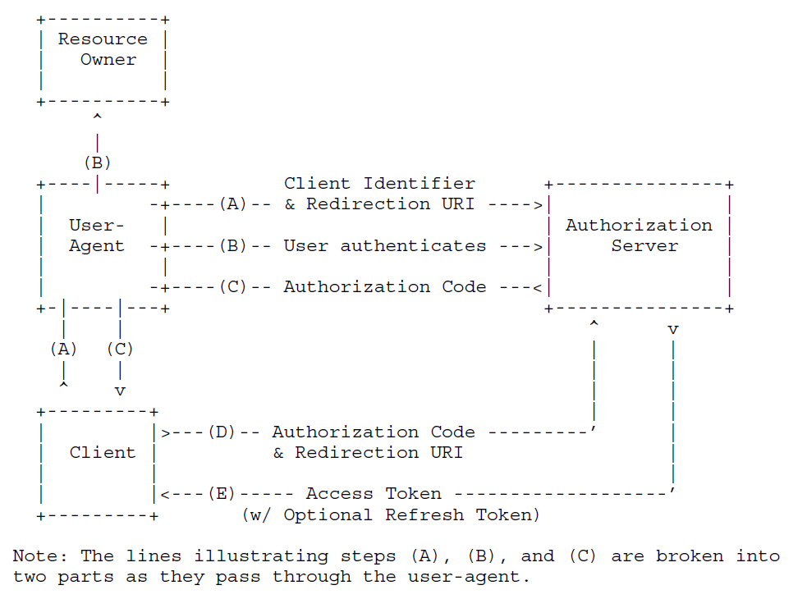
Figure 6.1.2.3-1 Procedure of Obtaining Resource owner Authorization (from RFC 6749 [4])
OAuth 2.0 with authorization code grant model is depicted in clause 4.1 in RFC 6749 [4]. In this solution, the API invoker endorses the role of client, the triggerer endorses the role of user-agent. The Authorization Function authenticates the resource owner in step B, which depends on existing mechanism and is out of this solution. The API invoker (i.e. client) retrieves token_{CAPIF} from the Authorization function in CCF. The scope of the token_{CAPIF} includes API invoker ID, service API ID and resource owner ID (i.e. GPSI).
Authorization can be revoked according to mechanism defined in IETF RFC 7009 [7].
The resource owner ID is equal to the UE ID in the API invocation message, e.g. GPSI.
It takes use case 1 defined in Annex A.1 in TR 23.700-95 [3] as an example. An end user (i.e. resource owner) is playing a time-sensitive game using a game client application (i.e. triggerer) on the end user’s UE communicating with a game server (i.e. API invoker), and wants to have a high-quality and low-latency communication for better service experience.
In step A, the end user requests the game client application, and the game client application requests game server to try to invoke the QoS API via application layer. The game server discoveries QoS API, and initiates OAuth procedure by contacting the game client application, and the game client application sends the requests to authorization server via CAPIF-8.
In step B, the Authorization Server requests the game client application to do user authentication and authorization via CAIPF-8, the end user may type in his MNO username and password and click “consent” for extra charging for QoS enhancement.
NOTE: It is assumed that authorization server has linkage between resource owner and GPSI.
Editor’s Note: How Authorization Function maps username to ID of the UE that the user is using when the user has multiple subscriptions is FFS.
In step C, after successful authentication and authorization, the authorization server provides authorization code to the game client application via CAPIF-8, and the game client application sends the authorization code to the game server via application layer.
In step D, the game server sends authorization code to authorization server via CAPIF-10/CAPIF-10e.
In step E, the game server gets token_{CAPIF} from authorization server. The game server uses the token_{CAPIF} to invoke QoS API via CAPIF-2/CAPIF-2e to modify the end user’s QoS.
Editor’s Note: More clarification of Integration of out scope and in scope messages is FFS.

6.1.2.4 Token_{CAPIF} Profile
The token_{CAPIF} is protected by the JSON signature profile as specified in IETF RFC 7515 [8].
The claim in the token_{CAPIF} includes the parameters defined in C.2.2 in TS 33.122 [5]. In addition, “resource owner ID” related to the list services is also added in scope. The resource owner ID is equal to the UE ID in the API invocation message, e.g. GPSI.

6.1.3 Evaluation
The solution works when the TLS with OAuth token is selected.
This solution assumes that the resource owner is human user.
This solution addresses the requirements Authz-1, Authz-2, Authz-3 and Authz-4, but does not address the following requirements in KI#2:
This solution doesn’t touch authentication of the resource owner or API invoker by the authorization server, it may be addressed by other solution.
This solution doesn’t touch authentication between API invoker and CCF and authentication between API invoker and AEF, it may be addressed by other solution.
This solution doesn’t touch revocation of authorization, it may be addressed by other solution.
This solution doesn’t touch privacy of the UE's external identity against the third-party, it may be addressed by other solution. This solution doesn’t address a static token claim issue after token revocation.
Editor’s Note: How to guarantee that the resource owner is really the user of the UE is FFS. In other words, how to ensure that the authenticated human user is really the UE's user (i.e., the resource owner). Somebody could just use the UE of another person and make the authorization server believe that he/she is using his/her own UE.
In general, an OAuth 2.0 authorization server exhibits a token and an authorization endpoint. In the proposed architecture the token endpoint is exposed via new CAPIF-10 reference point (misleadingly called "Authorization API"), instead of using the existing CAPIF-1 interface, which is already implementing the token endpoint. On the other hand, the new CAPIF-8 interface, which actually is using the OAuth 2.0 authorization endpoint, is not terminating in the "Authorization API".
Editor’s Note: Evaluation of alignment of the solution architecture with OAuth is FFS.

Editor’s Note: Mapping to SA6 defined use case is ffs.
Editor’s Note: Further evaluation is FFS

**** END OF CHANGE ****

