3GPP TSG-SA3 Meeting #110e AdHoc draft_S3-231906-r1

e-meeting, 17 - 21 April 2023

Source: Huawei, HiSilicon

Title: Add evaluation to solution #18

Document for: Approval
Agenda Item: 5.5

1 Decision/action requested
Approve the proposed evaluation to solution#18 in TR 33.876 [1].

2 References
[1] 3GPP TR 33.876 "Study on Automated Certificate Management in SBA"

3 Rationale
This contribution adds an evaluation to solution#18.

4 Detailed proposal
*************** Start of 1st Change ****************

6.18 Solution #18: Slice specific initial enrolment procedure

6.18.1 Introduction
This contribution proposes a solution for key issue #9. In particular, the solution is based on solution #3 which provides initial trust between NF and operator CA. For the scenario of the automated certificate management for network slices where different 3rd party slices may co-exist and interoperate, the initial trust between NF and the 3rd party CA can be established using the mechanism in solution #3, where the initial certificate is issued by the operator CA and the entity certificate can be issued by the 3rd party CA. During the process, the certificate management NF can take the role of interacting with the 3rd party CA.
The solution concept is represented in the figure 6.18.1-1.
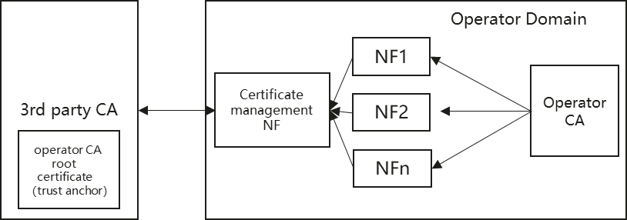
Figure 6.X.1-1: Secure initial enrolment through Operator CA and Certificate Management NF

6.18.2 Solution details
For NFs in 5GC SBA to fetch end entity X.509 certificates signed by a 3rd party CA, the NFs are expected to have an identity that is trusted and accepted by the operator CA and can obtain a certificate from the operator CA. This certificate issued by the operator CA can be used to protect the process of requesting the certificate signed by the 3rd party CA. The solution details are similar with the process of certificate enrolment in solution #3 with the following differences:
- The private CA is replaced with the operator CA.
- The operator CA is replaced with the 3rd party CA.

6.18.3 Evaluation

The solution addresses the security requirement of KI#9 related to the scenario of the automated certificate management for network slices by proposing a procedure for the NF to fetch a certificate from a 3rd party CA, owned/managed by the slicing customer.The procedure proposes to use an initial certificate for authentication to the 3rd party CA, signed by an operator CA. The normal certificate management like certificate update, revocation can follow the normal process addressed by KI #3 and KI#5. Other aspects like the alignment between NF lifecycle and certificate lifecycle in the certificate management for network slicing are not covered.
The prerequisite of this solution is that the NFs have obtained certificates issued by the operator CA using mechanisms addressing KI#2.
The solution requires the implementation of an operator CA, the root certificate of that operator CA is pre-configured as trust anchor in the 3rd party CA to enable the authentication of the NF during the initial certificate enrolment in 3rd party CA.
*************** End of 1st Change ****************

