3GPP TSG-SA3 Meeting #107-bis-e S3-221384

e-meeting, 16 - 20 May 2022

Source: Huawei, HiSilicon

Title: New solution for AKMA roaming when both UE and AF are in VPLMN

Document for: Approval
Agenda Item: 5.9

1 Decision/action requested
This contribution is accepted by the group.

2 References
NA

3 Rationale
The current solutions in TS 33.535 can be directly reused in roaming scerion with minor optimization, i.e. by clearly stating out where is the UE, AF and the NEF.
This solution addresses the case when both UE and the AF are in the VPLMN.

4 Detailed proposal
********* Begin 1st change*********

6.Y Solution #Y: New solution for AKMA roaming when both UE and AF are in VPLMN

6.Y.1 Introduction
This solution addresses the requirement in KI#1 about the AKMA roaming.
This solution provides a method that when both UE and the AF in the same visited network. When the AF is inside 5GC, it can communicate with the UE’s AAnF in HPLMN directly. Otherwise, when AF is outside 5GC, it first connects to the NEF in HPLMN, and then the NEF will receive and send the message for the UE and the AAnF.

6.Y.2 Solution details

6.Y.2.1 Architecture
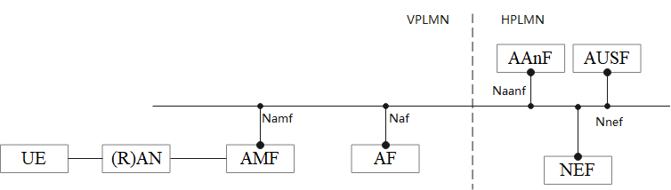
Figure 6.Y.2.1-1: Reference Model when UE and the AF are in the VPLMN
The Figure 6.Y.2.1-1 shows an architecture model when UE and the AF are in the VPLMN.

6.Y.2.2 Solution detail

6.Y.2.2.1 Deriving AKMA Application Key for a specific AF
Clause 6.2 in TS 33.535[2] applies with additionall descriptions:
- replace the AF with the AF in visited network.
- replace the UE with the UE in visited network.

6.Y.2.2.2 AKMA Application Key request via NEF
As described in clause 6.3 in TS 33.535[2] applies with additionall descriptions:
- replace the NEF with the NEF in home network.
- relace the AF with the AF in visited network.
- replace the UE with the UE in visited network.

6.Y.3 Evaluation
TBD
******** End of change*********

